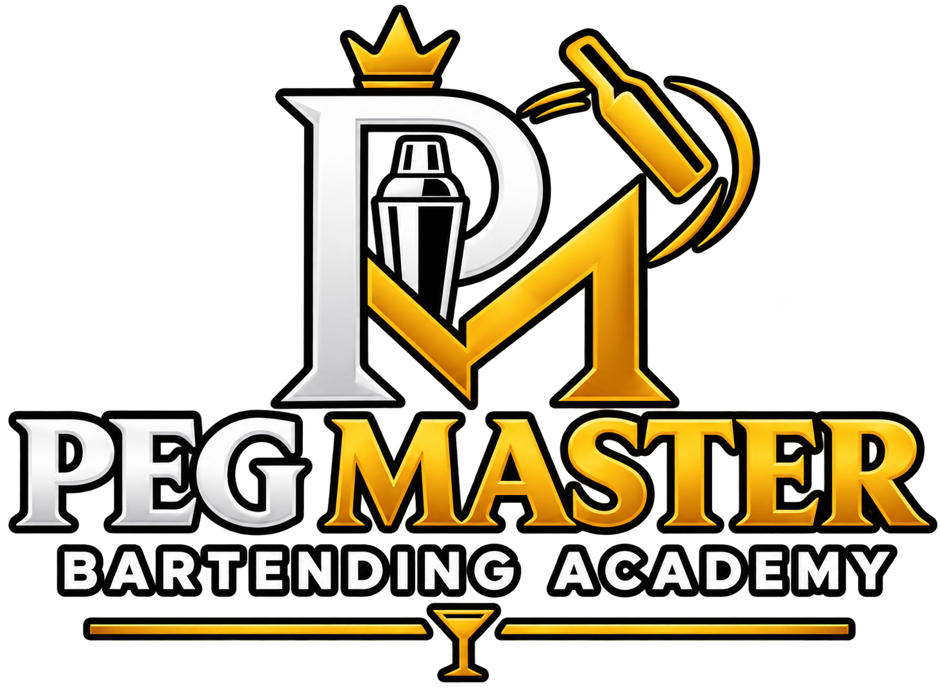

PEG MASTER
BARTENDING ACADEMY
6-MONTH ADVANCED MIXOLOGY COURSE
DETAILED SYLLABUS

LEARN • CREATE • MASTER
Advanced techniques • Creative development • Industry exposure • Professional growth
Course Overview
This syllabus expands the approved eight-section course outline into a more detailed learning guide. The topics below are intended to support theory, demonstrations, supervised practice, reflection and assessment. The exact sequence may be adapted to equipment availability, instructor expertise and industry-visit schedules.

Course Structure
- Duration: 6 months
- Delivery: classroom learning, demonstrations, supervised practical sessions and industry exposure where available
- Learning approach: understand the technique, practise it safely, document the recipe or process, and explain the result
- Assessment approach: practical demonstrations, recipe records, costing exercises, reflective journal and final project

Professional Practice & Safety
All practical work should follow instructor supervision, equipment guidance, hygiene standards and applicable local laws. Alcohol service must be limited to legal-age participants and handled responsibly. Use appropriate PPE and safe procedures for smoke, fire, pressure, dry ice, sharp tools and temperature-sensitive ingredients. Never serve a drink with dry ice still present.

1. Advanced Molecular Mixology
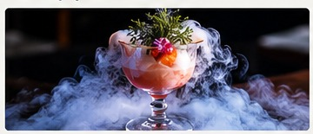
MODULE CONTENT & LEARNING FOCUS
Introduction to Molecular Mixology: Understand how food science and modern culinary methods can be applied to drink creation, texture, aroma and presentation.
Molecular Mixology Equipment: Identify specialist tools, safe handling procedures, cleaning, storage and the correct use of bar equipment.
Gelification: Explore gelling agents, suitable liquid bases, texture control and the preparation of cocktail gels.
Spherification: Learn the principles of forming liquid-centred spheres, including ingredient preparation, timing and rinsing.
Foams & Emulsification: Create stable foams and emulsions while understanding texture, flavour intensity and service life.
Reverse Spherification: Understand when reverse spherification is suitable and practise controlled preparation and presentation.
Molecular Caviar: Prepare small flavour pearls and apply them as a garnish or a component of a signature serve.
Flavour Encapsulation: Explore ways to contain and release aroma or flavour as part of a modern cocktail experience.
Smoke & Bubble Cocktails: Learn presentation methods that use aroma and bubbles, with attention to ventilation and guest safety.
Dry Ice Applications: Study professional safety rules and controlled demonstrations; dry ice must never be swallowed or served in contact with guests.
Smoky Techniques & Smoking Gun: Apply smoke to glassware or ingredients using controlled exposure and safe equipment handling.
Dehydration & Molecular Garnishes: Prepare dehydrated fruit and contemporary garnishes, focusing on consistency, hygiene and visual balance.
Modern Presentation Techniques: Build a complete serve using glassware, garnish, colour, aroma and a clear service rationale.

2. Advanced Cocktail Development
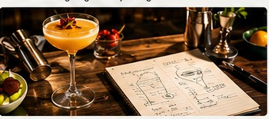
MODULE CONTENT & LEARNING FOCUS
Flavour Profiling: Identify primary flavour families and build combinations using aroma, sweetness, acidity, bitterness, salinity and spirit character.
Understanding Balance: Practise adjusting a drink in measured increments and documenting the recipe until the flavour is balanced.
Sensory Evaluation: Use structured observation of appearance, aroma, texture and flavour to review a cocktail consistently.
Texture & Mouthfeel: Compare body, dilution, carbonation, creaminess and viscosity, and choose techniques that support the concept.
Signature Cocktail Development: Move from a brief or inspiration to a test recipe, ingredient selection, trials and a repeatable final specification.
Modern Cocktail Techniques: Select appropriate preparation methods and explain how each method affects the final drink.
Concept to Final Serve: Present the story, recipe, method, glassware, garnish, costing and service steps for a finished cocktail.

3. Homemade Mixology Ingredients
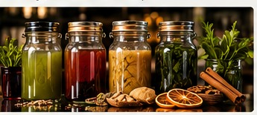
MODULE CONTENT & LEARNING FOCUS
Homemade Syrups: Prepare simple, flavoured and seasonal syrups; record ratios, preparation dates and storage instructions.
Shrubs: Explore fruit-and-vinegar preparations and how acidity can add structure to a cocktail.
Bitters: Understand the role of bittering ingredients, aromatic complexity, measured dosing and recipe consistency.
Spirit Infusions: Plan controlled infusions with herbs, spices, fruit and other suitable ingredients; label and track batches.
Flavoured Spirits: Compare infusion methods and evaluate extraction, aroma, colour and flavour intensity.
Custom Cocktail Ingredients: Develop cordials, mixers, purées, reductions and other components suited to a specific menu concept.
Hygiene, Storage & Shelf Life: Apply clean preparation, date labelling, refrigeration where appropriate and conservative shelf-life practices.

4. Advanced Cocktail Techniques
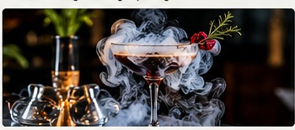
MODULE CONTENT & LEARNING FOCUS
Clarification: Explore methods for producing a clearer drink while preserving the intended flavour profile.
Fat Washing: Learn the principles of extracting aroma from a suitable fat into a spirit, followed by safe chilling and separation.
Carbonation: Understand carbonation equipment, pressure safety, temperature and how bubbles affect aroma and texture.
Infusion Techniques: Compare time-based, temperature-controlled and other suitable infusion approaches.
Layering: Practise controlled pouring and understand how density, ingredients and technique affect visible layers.
Flambé & Smoking: Discuss fire and smoke risks, controlled demonstrations, ventilation and safe professional practice.
Ice Techniques: Understand clear, crushed and cubed ice, dilution, temperature and choosing ice for the drink style.
Advanced Garnishing & Presentation: Practise clean cuts, edible garnishes, aroma placement and consistent presentation.
Stirring, Shaking, Rolling & Building: Choose the appropriate mixing technique based on ingredients, dilution, aeration and desired texture.

5. Industry Revisit & Practical Learning
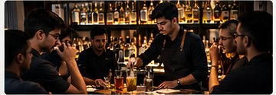
MODULE CONTENT & LEARNING FOCUS
Industry Revisit: Observe professional service standards, workflow, guest experience and how theory is applied in real venues.
Distillery Revisit: Where access is available, study production stages, maturation, quality checks and responsible brand education.
Brewery Revisit: Observe brewing fundamentals, fermentation, packaging and quality-control practices.
Winery Revisit: Learn about grape varieties, fermentation, maturation and the basics of wine service.
Meadery Revisit: Explore honey-based fermentation and the production factors that influence flavour.
Bar Visit: Review mise en place, station organisation, stock movement, speed, hygiene and guest communication.
Student Review Journal: Record what was learned, what was observed, new techniques and questions for further study.
Production Process & New Techniques: Document a process from observation to practical takeaway, without claiming hands-on access where it was not provided.
Personal Observations: Reflect on service, teamwork, professional conduct and potential improvements.

6. Bar Management & Costing — Basics

MODULE CONTENT & LEARNING FOCUS
Beverage Costing: Calculate ingredient cost per serve and understand how wastage and portion control affect margins.
Average Costing: Use consistent methods to estimate average ingredient costs across recipes and menu items.
Menu Pricing Basics: Set a price using ingredient cost, target margin, operating expenses and the venue’s positioning.
Inventory Management: Practise stock counts, receiving, rotation, par levels, breakage records and variance checks.
Basic Bar Management: Understand opening and closing checklists, staff roles, service flow and day-to-day control.
Basic Bar Operations: Apply mise en place, equipment care, hygiene, safe storage and standard operating procedures.
Understanding Profit Margins: Distinguish sales, cost of goods, gross profit and operating expenses using simple examples.
Responsible Service & Compliance: Introduce age checks, responsible service, local licensing awareness and applicable food-safety requirements.

7. Social Media & Career Development

MODULE CONTENT & LEARNING FOCUS
Social Media Content Creation as a Bartender: Plan educational and entertaining content around techniques, ingredients, service and professional learning.
Building a Professional Bartender Profile: Create a clear bio, portfolio and professional introduction that accurately represents skills and experience.
Personal Branding: Define a consistent visual style, content pillars, tone and professional reputation.
Brand Collaborations: Learn how to review deliverables, timelines, usage rights, exclusivity, payment terms and disclosure requirements.
Networking: Build professional relationships with bars, hotels, educators, brand teams and industry communities.
Connecting with Industry Professionals: Practise concise outreach, follow-ups and professional communication.
Career Opportunities in India & Abroad: Explore possible pathways in bars, hotels, cruise lines, events, beverage education and entrepreneurship.
Portfolio, Resume & Interview Preparation: Prepare a skills-based CV, practical portfolio and interview answers; employment outcomes are not guaranteed.

8. Final Practical Project
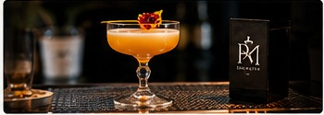
MODULE CONTENT & LEARNING FOCUS
Create Your Own Signature Cocktail: Develop an original cocktail concept with a clear flavour idea and a repeatable recipe.
Molecular Cocktail Project: Use an appropriate molecular technique and explain its purpose, process and safety considerations.
Costing Sheet: Submit recipe quantities, ingredient costs, cost per serve and a reasoned menu price.
Presentation & Garnish: Deliver a consistent final serve with suitable glassware, garnish and service explanation.
Cocktail Concept Explanation: Present the inspiration, flavour choices, technique, target guest and intended experience.
Final Practical Assessment: Demonstrate preparation, hygiene, measurement, workflow, communication and responsible service.
Final Presentation: Present the completed project, receive feedback and submit the final recipe and costing documentation.

