Student Details
Field | Details
- Student Name
- Batch
- Admission No.
- Start Date
- Trainer
- Emergency Contact
- Student Signature

photo

Course Contents
Part 1 — Fundamentals of Professional Bartending
1. Introduction to Bartending
2. History & Evolution of Bartending
3. Professional Bartender: Role, Skills & Workplaces
4. Hygiene, Sanitation & Personal Safety
5. Grooming & Professional Etiquette
Part 2 — Bar Tools, Glassware & Service
6. Bar Tools & Equipment
7. Glassware
8. Measuring, Jiggering & Pouring
9. Ice
10. Garnishes
11 Basic Knife Skills
12. Guest Handling
Part 3 — Beverage Fundamentals
13. Fermentation
14. Distillation
15. Classification of Alcoholic Beverages
16. Liqueurs
17. Mixers & Soft Drinks
Part 4 — Spirits & Beverages
18. Whisky
19. Vodka
20. Gin
21. Rum
22. Tequila & Mezcal
23. Brandy & Cognac
24. Beer
25. Wine
26. Cider
27. Bitters
28. Absinthe
29. Sake
30.Mead
Part 5 —Bottle Level Measurement & spirit Stock Control

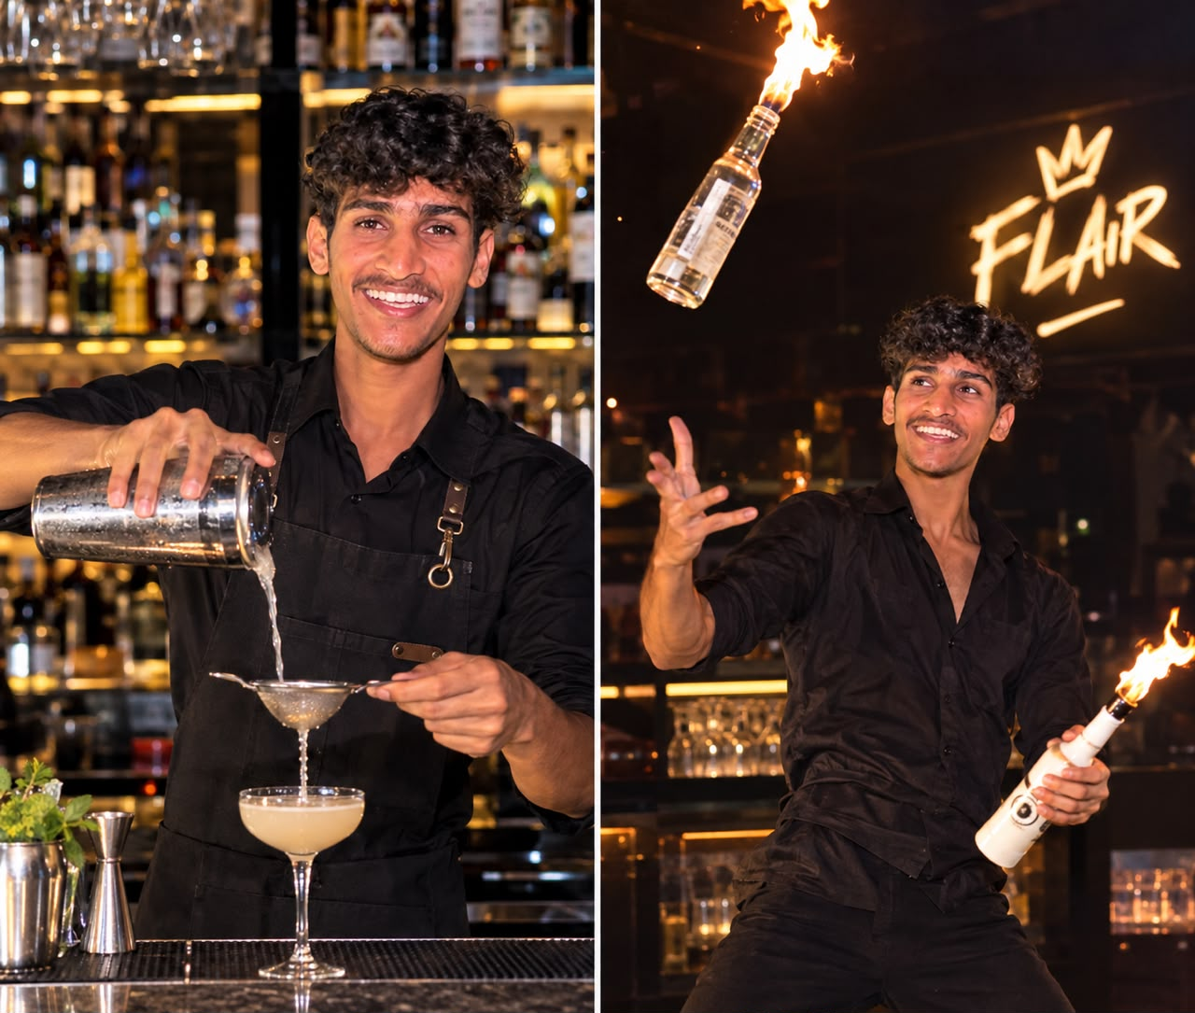
Introduction to Bartending

WHAT IS BARTENDING?
Bartending is the professional practice of preparing,
presenting and serving beverages while delivering
a welcoming hospitality experience. It combines beverage
knowledge, technical accuracy, cleanliness, communication,
presentation and responsible service.
Who is BARTENDER?
A bartender is a trained hospitality professional who prepares Drink
maintains the bar workstation and interacts with guests. Professional
bartending requires more than pouring: the bartender must understand
ingredients, recipes, tools, glassware, ice, service standards and guest
expectations.
Who is MIXOLOGIST?
A mixologist is a beverage professional who focuses strongly on cocktail creation, flavour balance, ingredients and technique. Mixology may involve recipe development, experimentation and understanding how sweetness, acidity, bitterness, dilution, temperature and aroma work together.
Who is FLAIR BARTENDER?
Flair bartending is the controlled handling of bottles, shakers
and bar tools through practiced movements. Working flair
can be incorporated into service, while exhibition flair is performed
mainly for entertainment. Safety, control and guest awareness
always come
CORE RESPONSIBILITIES
* Prepare beverages accurately and consistently.
* Maintain hygiene, sanitation, mise en place and equipment.
* Measure ingredients and control portions, stock and wastage.
* Communicate professionally and create a comfortable guest experience.
* Work safely, responsibly and efficiently during service.

2 Types of Bar
Bar- A bar is a professional beverage-service area designed for the preparation, storage and service of alcoholic and non-alcoholic beverages. Bars can be classified according to their location, service style, purpose and target guests.
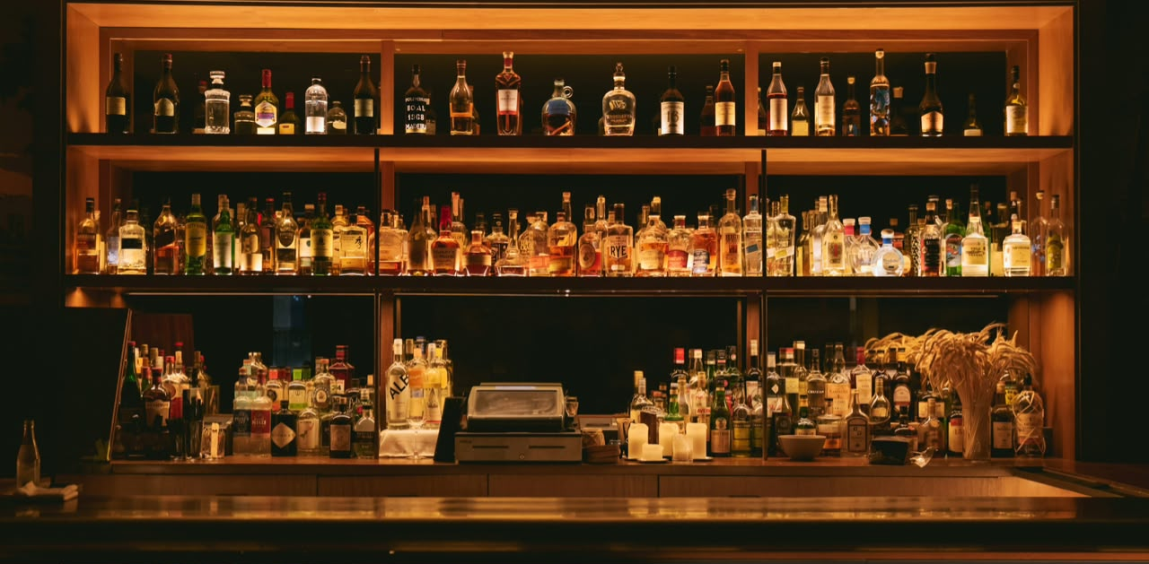
Common Types of Bar
1. Front Bar
The guest-facing area where bartenders interact with guests, take orders, prepare and serve beverages.
2. Back Bar
The area behind the bartender used mainly for displaying bottles, storing products and keeping additional bar equipment.
3. Service Bar
A bar primarily used to prepare drinks for restaurant or banquet servers rather than directly serving guests.
4. Mini Bar
A small beverage setup inside hotel rooms, offering selected drinks and snacks for in-room consumption.
5. Poolside Bar
Located near a swimming pool or leisure area, serving refreshing beverages to guests.
6. Wine Bar
Specializes mainly in wine service, wine tasting and wine-focused food pairings.
7. Cocktail Bar
Focuses on cocktails, mixology techniques, presentation and customized beverage experiences.
8. Cash Bar
Common at events where guests pay individually for each beverage they order.
9. Captain Bar
A temporary bar setup commonly used for banquets, weddings, parties and large events.

10. Hotel Bar
A bar located within a hotel, serving hotel guests and visitors.
11. Restaurant Bar
A bar located inside or alongside a restaurant, providing beverages before, during or after meals.
12. Lounge Bar
Designed for relaxed socializing, usually offering comfortable seating, beverages and a quieter atmosphere.
13. Pool Bar
A leisure-focused bar serving guests around a pool area, often emphasizing quick and refreshing drinks.
14. Sports Bar
Designed around sports viewing, typically offering beverages, food and multiple screens.
15. Rooftop Bar
Located on a rooftop and designed around views, socializing, food and beverage service.
16. Nightclub Bar
Located within a nightclub and focused on high-volume beverage service during entertainment and nightlife operations.
17. Tiki Bar
A themed bar inspired by tropical and Polynesian-style décor and beverages.
18. Beer Bar
Specializes primarily in beer, including bottled, canned and draft selections.
19. Craft Beer Bar
Focuses on a wider selection of craft and specialty beers, often highlighting breweries and beer styles.
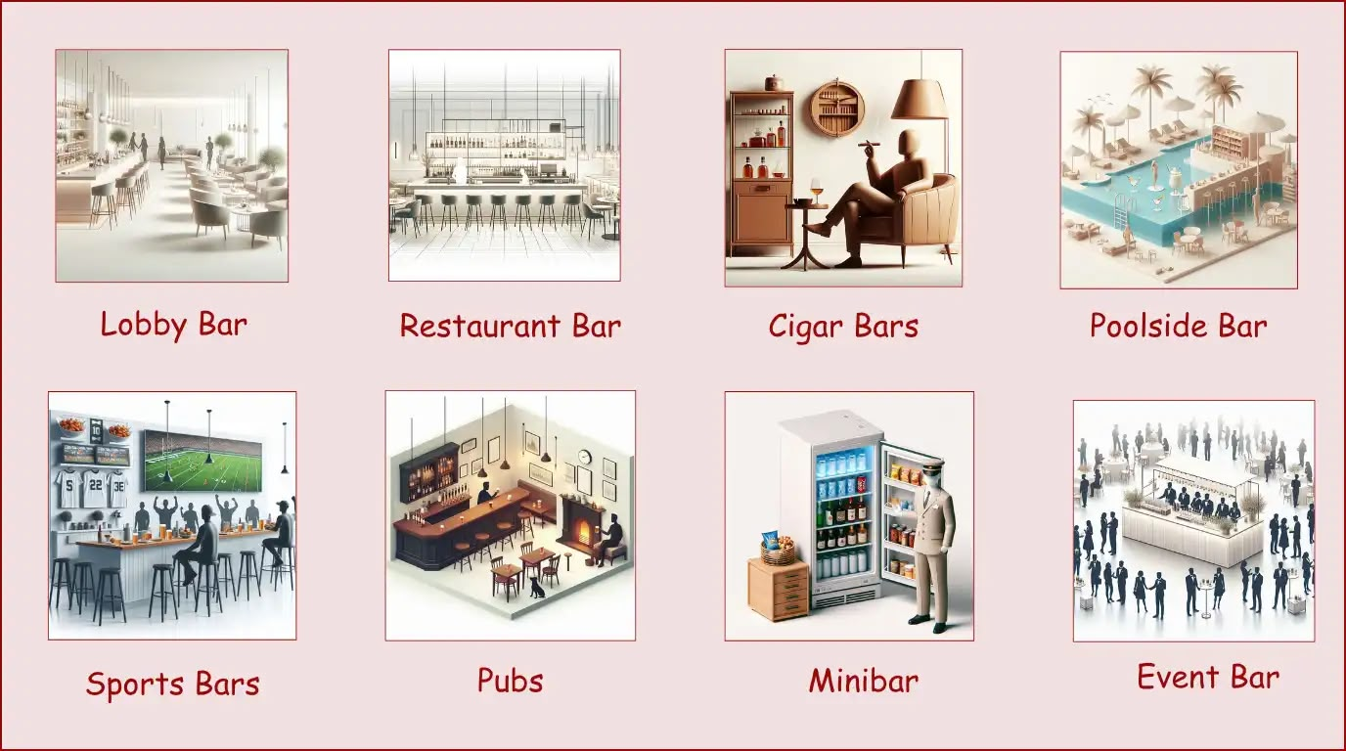

3. Professional Bartender: Role, Skills & Workplaces
A professional bartender combines beverage knowledge, technical skills, communication, sales awareness and teamwork.

Key Learning Points
- Communication, speed, accuracy, memory and organization.
- Hotels, restaurants, cocktail bars, breweries and events.
- Menu and allergen awareness.
- Punctuality, teamwork and professional behavior.

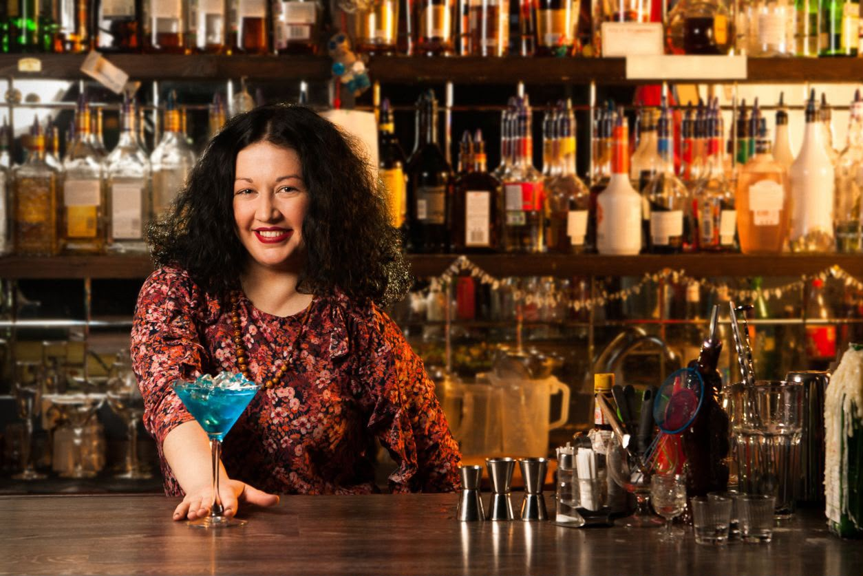

Practical
Role-play a pre-shift briefing.
Create a personal skill checklist.

4. Hygiene, Sanitation & Personal Safety
Hygiene and sanitation prevent contamination and protect guests and staff.

Key Learning Points
- Handwashing.
- Clean and sanitized surfaces/tools.
- Hygienic ice handling.
- Safe storage of chemicals.
- Safe broken-glass procedure.
- Know venue emergency procedures.

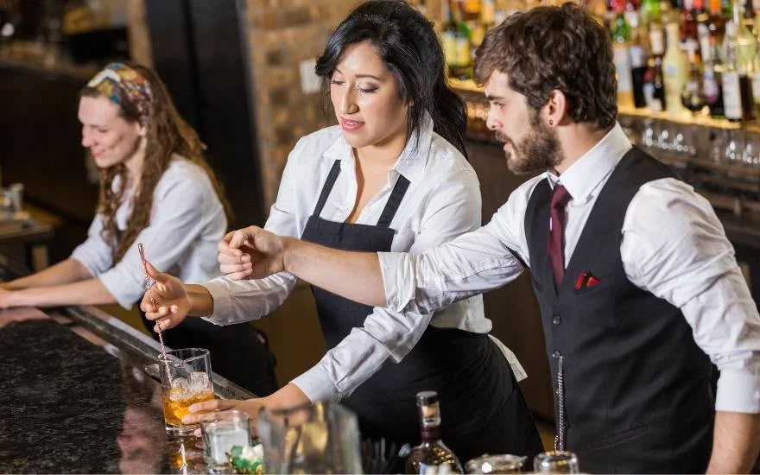

Practical
Clean and sanitize a station.
Demonstrate safe broken-glass response.

5. Grooming & Professional Etiquette
Professional grooming and etiquette support hygiene, confidence and hospitality.

Key Learning Points
- Clean uniform and suitable footwear.
- Neat hair and nails.
- Respectful language and body language.
- Complaint handling and escalation.

Practical
Pre-shift grooming inspection.
Role-play greeting and complaint handling.

6. Bar Tools & Equipment
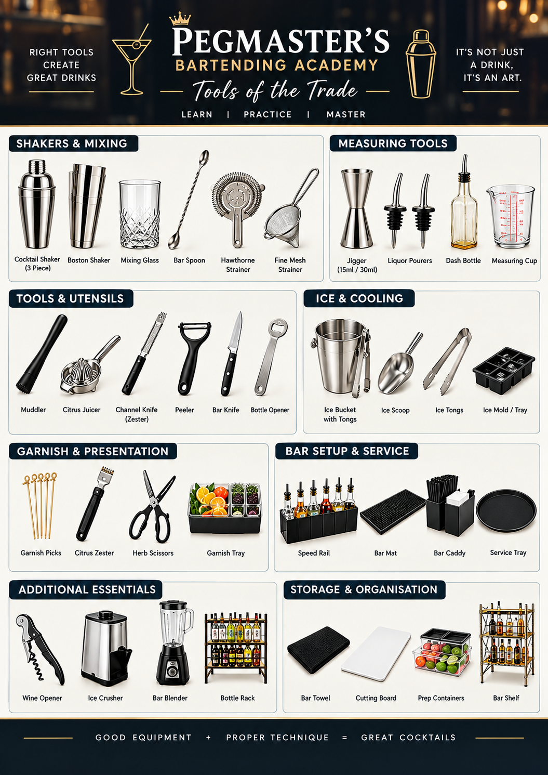

7. Glassware

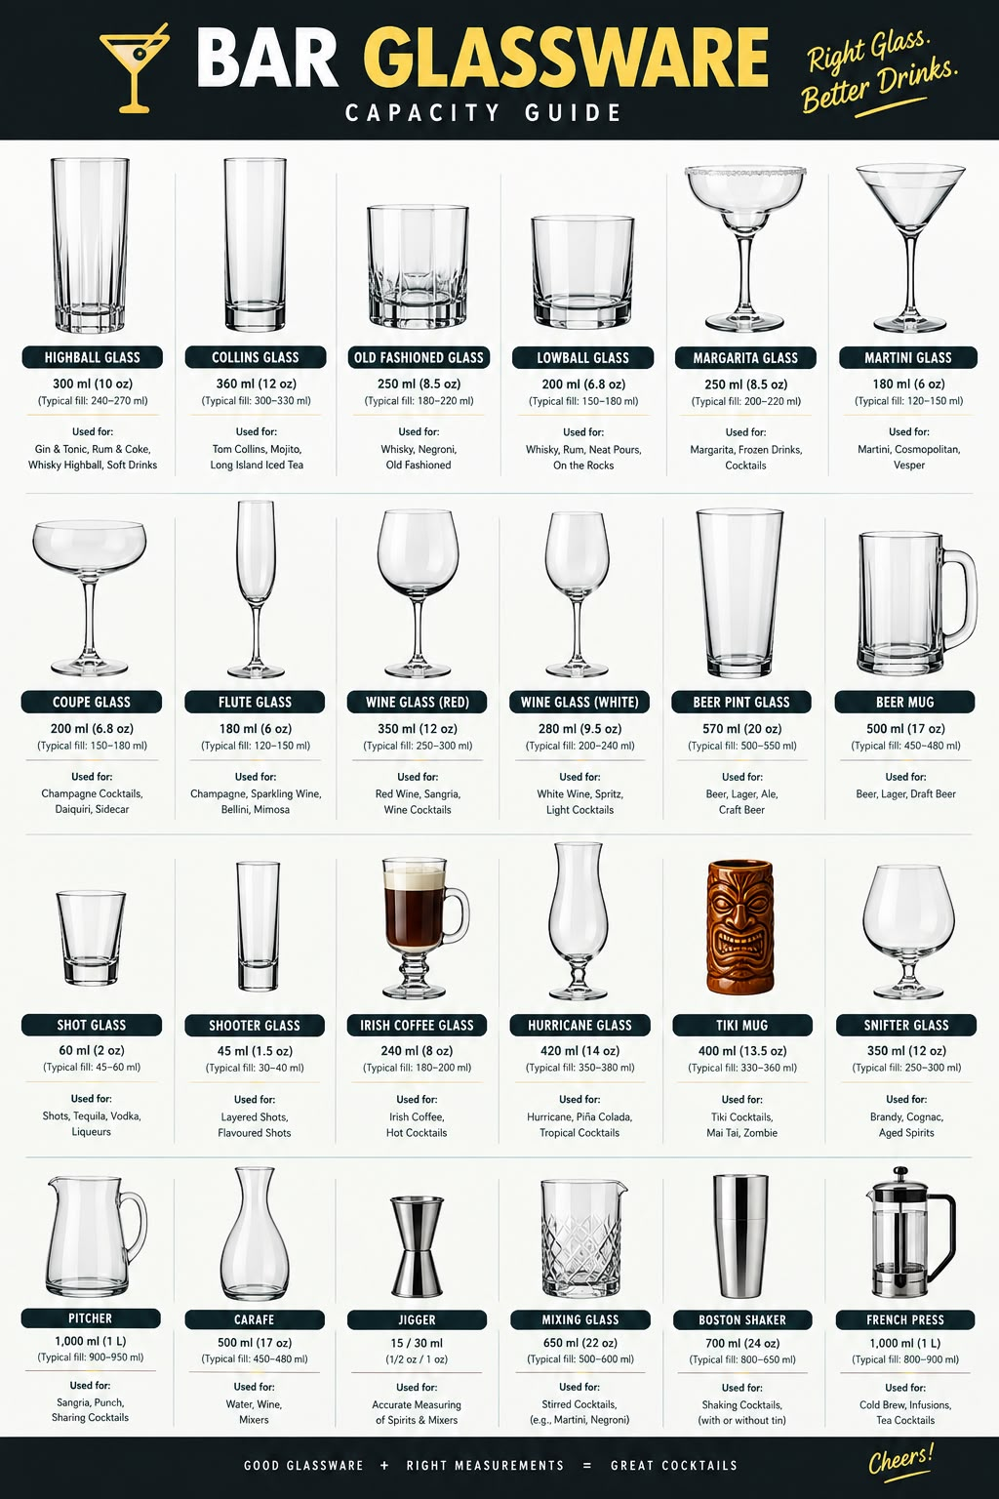

8. Measuring, Jiggering & Pouring
Accurate measurement supports consistency, portion control and costing
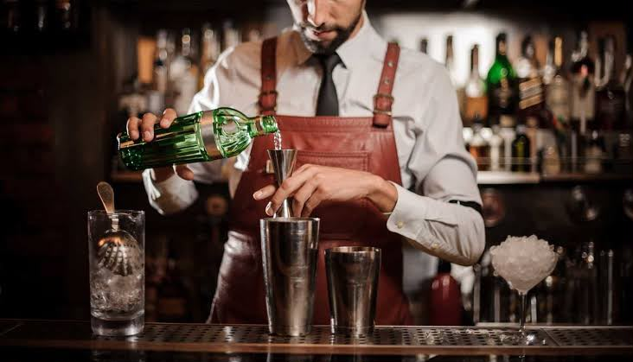
Standard Measurement Chart
Measuerment Approximate volume
- 1 Dash 0.9–1 ml*
- 2 Dashes 1.8–2 ml*
- 1 Teaspoon (tsp) 5 ml
- 1 Tablespoon (tbsp) 15 ml
- ½ oz 15 ml
- ¾ oz 22.5 ml
- 1 oz 30 ml
- 1¼ oz 37.5 ml
- 1½ oz 45 ml
- 1¾ oz 52.5 ml
- 2 oz 60 ml
- 2½ oz 75 ml
- 3 oz 90 ml
- 4 oz 120 ml

9. Ice

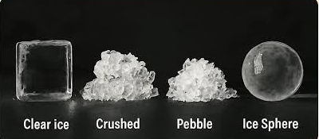

10. Garnishes

Garnishes enhance the drink’s presentation, aroma, and flavour experience.

Fruit garnishes include wedges, wheels, and skewered fruits. Citrus peels include twists and flamed peels. Herb garnishes include mint, rosemary, and basil. Smoky garnishes include smoked rosemary or similar aromatic smoke elements, Dehydrated garnishes include dried orange wheels or similar dried fruit.
- Always select garnishes that suit the drink’s flavour and maintain strict hygiene while handling.
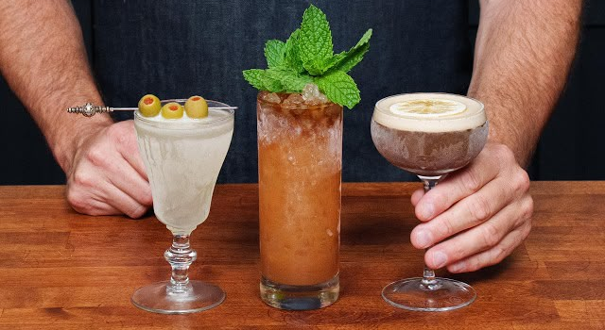

11. Basic knife skills
1. Proper Grip: Hold the knife firmly and comfortably.
2. Claw Grip: Curl your fingertips inward to protect them while cutting.
3. Slicing: Cut fruits into thin, even slices.
4. Dicing: Cut ingredients into small, uniform cubes.
5. Chopping: Cut fruits, herbs, and other ingredients into smaller pieces.
6. Mincing: Finely chop ingredients such as herbs and ginger.
7. Peeling: Remove the outer skin of fruits using a peeler or knife.
8. Zesting: Remove the colored outer layer of citrus fruits without the bitter white pith.
9. Wedges and Segments: Cut citrus fruits into wedges or segments for garnishing.
10. Knife Safety: Use a sharp, clean knife and a stable cutting board.

12. Guest Handling
Guest service combines communication, product knowledge, courtesy, speed and responsible hospitality.

Key Learning Points
- Greet promptly.
- Confirm orders.
- Explain menu items clearly.
- Escalate difficult situations.
- Do not encourage excessive consumption.

Practical
Role-play full guest interaction.
Handle a menu question and complaint.

13. Fermentation

Fermentation is a biological process in which microorganisms, mainly yeast, convert fermentable sugars into alcohol, carbon dioxide, and other compounds.

Basic Fermentation Process: Fermentable Sugars → Yeast → Alcohol + Carbon Dioxide (CO₂) + Flavour Compounds.

Yeast: Yeast is a microorganism that plays a major role in alcoholic fermentation by converting fermentable sugars into alcohol, carbon dioxide (CO₂), and flavour compounds.

MAIN TYPES OF YEAST
1. Ale Yeast — Saccharomyces cerevisiae
Used for: Ales, many wines, ciders, and mead.
Fermentation: Generally warmer/top fermentation.
2. Lager Yeast — Saccharomyces pastorianus
Used for: Lager beers such as Pilsner, Helles, and Bock.
Fermentation: Generally cooler/bottom fermentation.
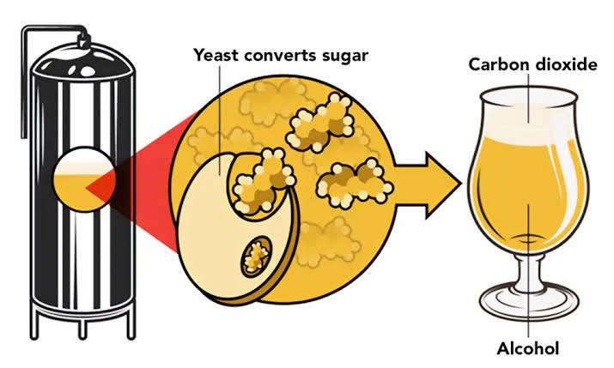
Note: There are many other yeast species and specialized strains, but these are the two main categories relevant to basic bartending and beverage education.

.Key Learning Points
- Yeast role.

Practical
Explain fermentation using a diagram.
Classify three fermented beverages.

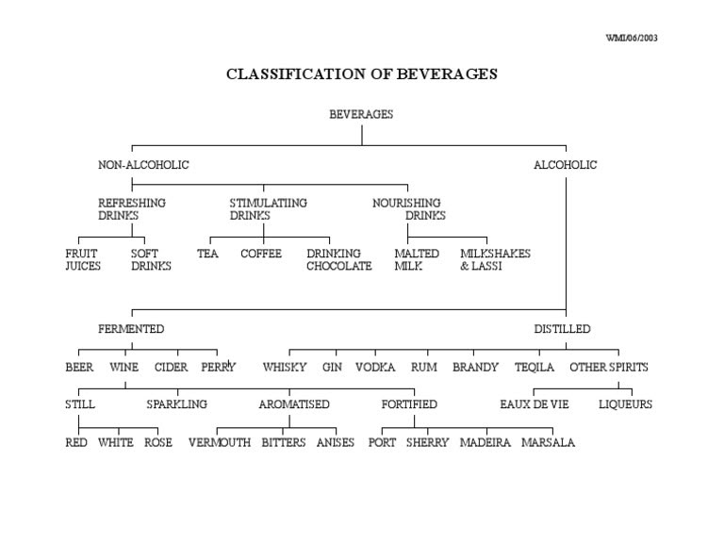
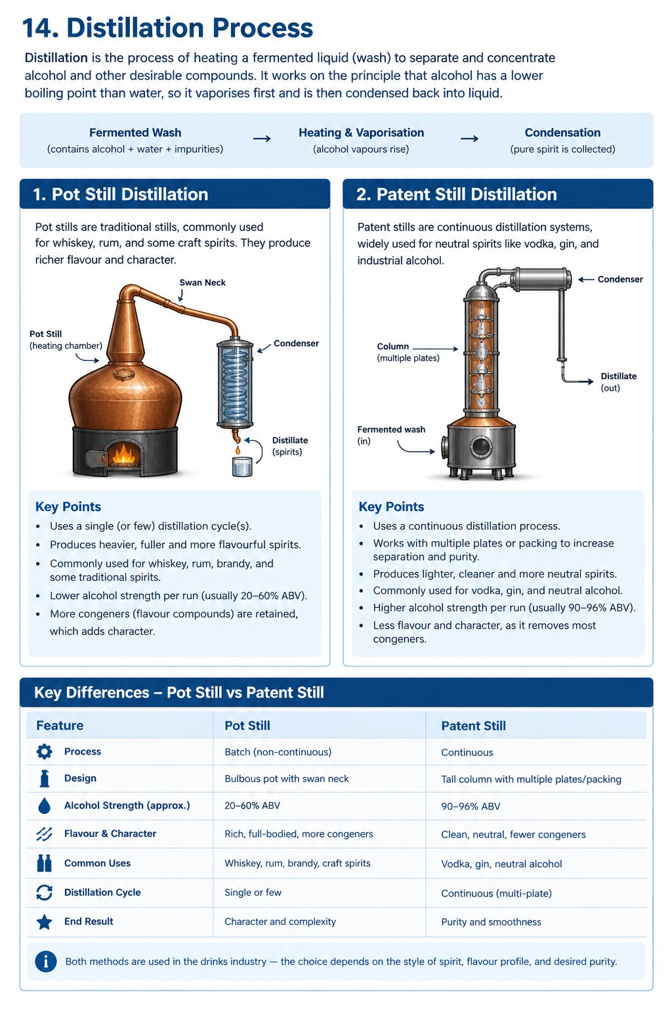15. Classification of Alcoholic Beverages

16. Liqueurs
A liqueur is a sweetened and flavored alcoholic beverage made by combining a base spirit with ingredients such as fruits, herbs, spices, nuts, coffee, chocolate, flowers, or cream.

Liqueurs are commonly used in cocktails, served neat or over ice, and sometimes used in desserts.

Unlike most basic spirits, liqueurs are characterized by their added sweetness and distinctive flavors.
Base Spirit of Liqueurs
The base spirit is the alcoholic foundation used to produce a liqueur.
Common base spirits include:
* Neutral grain spirit
* Vodka
* Brandy
* Rum
* Whisky
* Fruit spirits
Most liqueurs use a neutral spirit because it allows the added flavors to stand out. However, some producers use a flavorful spirit to give the liqueur additional character.

Raw Materials Used in Liqueurs
The main raw materials used in liqueur production are:
Category Examples
Fruits Orange, lemon, cherry, peach, apple
Herbs Mint, rosemary, thyme
Spices Cinnamon, clove, nutmeg
Nuts Almond, hazelnut
Seeds Anise, caraway, coriander
Flowers Rose, lavender, chamomile
Other ingredients Coffee, cocoa, chocolate, cream, honey

Alcohol Content (ABV)
ABV stands for Alcohol by Volume. It indicates the percentage of pure alcohol present in a beverage by volume.
Liqueurs have varying alcohol concentrations. Many commonly fall within approximately 15%–35% ABV, although some products are outside this range.
The exact ABV should always be checked on the individual bottle’s label.
Orange Liqueurs
Brand name Base ABV Country
- Cointreau Cognac 40% France
- Tripple sec Cognac 40% France
- Grand Marnier Cognac 40% France
- Tuaca Brandy 35% Italy
Cream Liqueurs
- Baileys whisky 17% Ireland
- Amrula Brandy 17% South A.
Coffee Liqueurs
- Kahlua Rum 20% Mexico
- Tai Maria Rum 27% Jamaican
- Sabra Rum 26% Israel

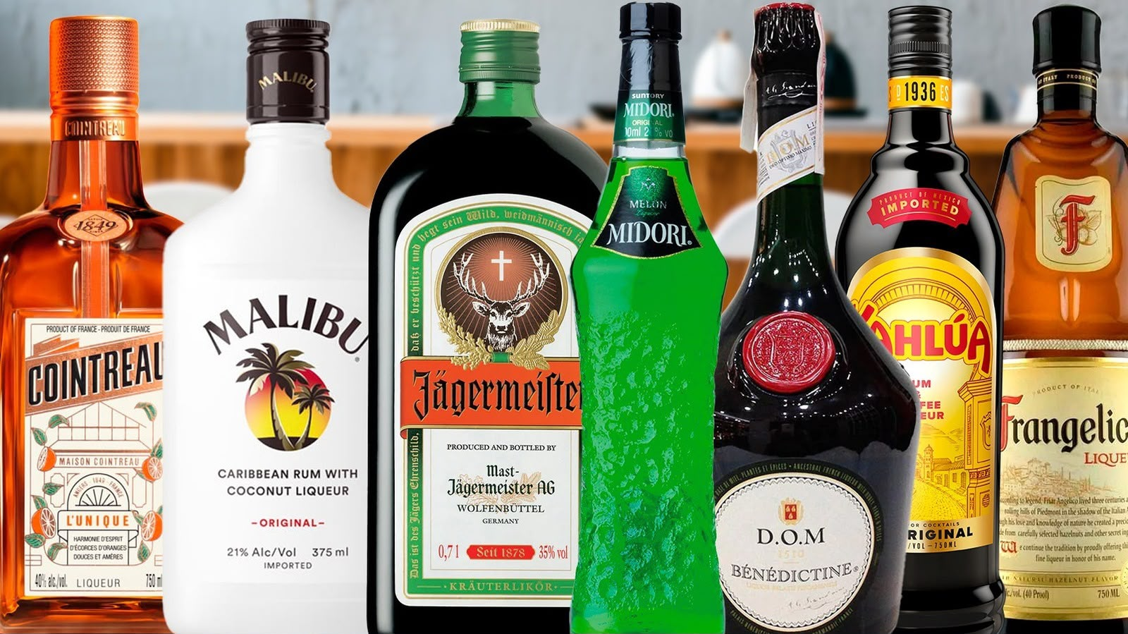

17. Mixers & Soft Drinks
Mixers provide dilution, carbonation, sweetness, acidity and flavor.
Types of Mixers and Soft Drinks
- Carbonated Mixers – Soda, Tonic Water, Ginger Ale, and Ginger Beer
- Cola and Lemon-Lime Soft Drinks
- Citrus Mixers – Lemon Juice, Lime Juice, and Grapefruit Juice
- Fruit Juices – Orange, Pineapple, Cranberry, Apple, and Tomato
- Energy Drinks and Their Uses in Beverage Preparation
- Coconut Water and Other Natural Mixers
- Iced Tea, Lemonade, and Ready-to-Drink Beverages
- Dairy-Based Mixers – Milk, Cream, and Buttermilk
- Non-Alcoholic Sparkling Beverages
MIXERS AND NON-ALCOHOLIC BEVERAGES
1. Tonic Water
Tonic water is a carbonated beverage containing quinine, sweeteners, and other flavouring ingredients. It has a distinctive bitter taste with a refreshing, slightly sweet finish
2. Ginger Beer
Ginger beer is a ginger-flavoured beverage traditionally produced through fermentation, although many modern commercial versions are made by other methods. It has a strong ginger flavour, with a spicy, sweet, and refreshing taste.
3. Ginger Ale
Ginger ale is a carbonated soft drink flavoured with ginger. It generally has a lighter, milder ginger flavour and a sweeter taste than ginger beer.
4. Lime Cordial
Lime cordial is a sweetened lime-flavoured beverage concentrate made using lime juice or lime flavouring, sugar, water, and sometimes other ingredients. It provides sweetness and citrus acidity to beverages. It is commonly used in cocktails, mocktails, and refreshing long drinks.
5. Lemonade
Lemonade is a refreshing beverage generally prepared using lemon juice, water, and sugar. Depending on the region and style, it may be still or carbonated. It provides a balance of sweetness and citrus acidity and is widely used in cocktails, mocktails, and other refreshing beverages.
6. Non-Alcoholic Sparkling Beverages
Non-alcoholic sparkling beverages are drinks containing dissolved carbon dioxide, which creates bubbles and a refreshing mouthfeel. They include sparkling water, sparkling fruit drinks, and non-alcoholic sparkling grape beverages. They can be served on their own or used in mocktails and other beverage preparations.
7. Energy Drinks
Energy drinks are beverages formulated with ingredients such as caffeine, sweeteners, and flavourings. Some varieties also contain taurine, vitamins, or other added ingredients. They are used in certain mixed beverages, but their caffeine content and other ingredients should be considered when serving drinks.
8. Fruit Purées
Fruit purées are preparations made by crushing or blending fruit into a thick, smooth mixture. They provide concentrated fruit flavour, colour, and texture. Common examples include mango, strawberry, passion fruit, and raspberry purées.
9. Simple Syrup
Simple syrup is a sweetening ingredient prepared by dissolving sugar in water. It is used in cocktails and mocktails to add sweetness and help balance acidic ingredients. It can also be flavoured with ingredients such as mint, ginger, or vanilla.
10. Non-Alcoholic Sparkling Grape Beverage
A non-alcoholic sparkling grape beverage is a carbonated drink made from grape juice or grape-based ingredients. It provides fruity flavours and bubbles without being intended as an alcoholic wine. It can be served on its own or used in mocktails.
Difference Between Sugar Syrup and Simple Syrup
Sugar Syrup: Sugar syrup is a general term for a liquid sweetener made by dissolving sugar in water. It can be prepared in different concentrations and may contain additional flavouring ingredients.
Simple Syrup: Simple syrup is a basic type of sugar syrup made by dissolving sugar in water, commonly using equal parts sugar and water by weight (1:1 ratio). It is widely used in cocktails and mocktails to provide consistent sweetness and help balance flavours.

18. Whisky
DEFINITION OF WHISKY
Whisky is a distilled alcoholic beverage produced by fermenting a mash of cereal grains, such as barley, corn, wheat, or rye, and then distilling the fermented liquid. Depending on the category and regulations of the producing country, whisky may be matured in wooden casks to develop its flavour, aroma, colour, and character.
Whisky is traditionally associated with countries such as Scotland and Ireland, but it is now produced in many parts of the world, including India, the United States, Canada, and Japan.
Note: The spelling whisky is commonly used in Scotland, Canada, and Japan, while whiskey is commonly used in Ireland and the United States. Both spellings refer to the same general category of spirit.

HISTORY AND EVOLUTION OF WHISKY
Whisky has a long history associated with the development of distillation techniques in Europe. Although its exact origin remains uncertain, Scotland and Ireland became particularly important centres for its development.
Early History
Distillation techniques gradually spread through Europe during the medieval period. Early distilled spirits were often associated with medicinal and practical uses.
Over time, distillers began producing spirits from fermented grains, creating the foundations of modern whisky production.

Development in Scotland and Ireland
Scotland and Ireland developed distinctive traditions of grain-based spirit production.
Historical records document the production of distilled spirits in these regions during the late medieval period. Whisky gradually became an important part of their agricultural, commercial, and cultural traditions.
Commercial Development
As distillation equipment and production techniques improved, whisky production expanded.
The development of more efficient stills, improved fermentation methods, and the introduction of different maturation practices helped establish whisky as an internationally traded spirit.
Modern Whisky Industry
Today, whisky is produced in numerous countries, each developing its own styles and production traditions.
Modern whisky production combines traditional craftsmanship with technological advancements in fermentation, distillation, maturation, blending, and quality control.

MEANING AND ORIGIN OF THE NAME WHISKY
The word whisky is derived from the Gaelic expression uisge beatha, meaning “water of life.”
The expression developed from the Latin term aqua vitae, which was used historically to describe distilled spirits.
Over time, uisge beatha was shortened and adapted into the word whisky.
The term whiskey is the spelling commonly associated with Ireland and the United States.
RAW MATERIALS USED IN WHISKY PRODUCTION
The main raw materials used in whisky production are:
1 Grains
Grains provide the starch that is converted into fermentable sugars during production.Commonly used grains include:
* Barley: Commonly used in malt whisky production.
* Corn (Maize): Frequently used in American whiskey production and some grain whiskies.
* Wheat: Used in certain grain whiskies and wheat-based whiskey styles.
* Rye: Used to produce rye whiskey and other rye-based whisky styles.
2 Water
Water is used during mashing, fermentation preparation, and other production stages.
Its mineral composition can influence certain aspects of the production process.
3 Yeast
Yeast converts fermentable sugars into alcohol and carbon dioxide during fermentation.
It also produces flavour and aroma compounds that contribute to the final character of the spirit.
4 Wooden Casks
Wooden casks are used for maturation where required by the relevant whisky category and regulations.
During maturation, the spirit interacts with the wood and develops additional colour, aroma, and flavour.
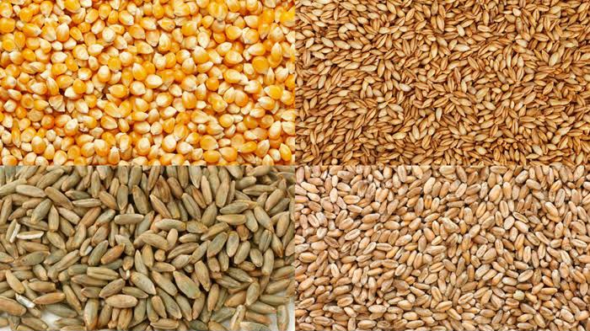

TYPES OF WHISKY BASED ON PRODUCTION
Whisky can be classified into different categories according to the grains used, the distillation process, the production location, and the applicable regulations.
Two important production categories are:
1 Malt Whisky
Malt whisky is produced using malted cereal grain. In traditional Scotch malt whisky production, the grain used is malted barley.
Malt whisky is commonly associated with pot-still distillation, although production requirements vary between countries and categories.
2 Grain Whisky
Grain whisky is produced using cereal grains such as corn, wheat, or unmalted barley, depending on the applicable category and regulations.
Grain whisky is often produced using continuous column stills, which allow efficient large-scale production.
Important: Malt whisky and grain whisky are production categories. Their exact legal definitions vary between countries.

PRODUCTION OF MALT WHISKY
Malt whisky production involves converting the starch in malted grain into fermentable sugars, fermenting those sugars, distilling the resulting liquid, and maturing the spirit where required.

Steps in Malt Whisky Production
Step 1: Malting
Barley is soaked in water to encourage germination.
During germination, natural enzymes develop that help convert starch into fermentable sugars during mashing.
Germination is stopped by drying the barley in a kiln.
Some producers use peat smoke during drying to introduce smoky characteristics into the malt.
Step 2: Milling
The dried malted barley is ground into a coarse material known as grist.
The grist must have a suitable consistency to allow efficient extraction of sugars during mashing.

Step 3: Mashing
The grist is mixed with hot water in a vessel called a mash tun.
Enzymes convert the available starch into fermentable sugars.
The resulting sugary liquid is known as wort.
Step 4: Fermentation
The wort is transferred into a fermentation vessel, commonly called a washback.
Yeast is added to convert fermentable sugars into alcohol and carbon dioxide.
The resulting liquid is known as wash. It contains alcohol and various flavour compounds.
Step 5: Distillation
The wash is distilled to separate and concentrate alcohol and selected flavour compounds.
Traditional Scotch malt whisky is commonly distilled in copper pot stills.
Many Scotch malt whisky distilleries use two distillation stages:

* First distillation: The wash is distilled in a wash still to produce a low-strength alcoholic liquid known as low wines.
* Second distillation: The low wines are distilled in a spirit still to produce new make spirit.
The distiller selects the appropriate portion of the distillate for maturation.
Step 6: Maturation
The new make spirit is filled into suitable wooden casks.
During maturation, the spirit interacts with the wood and undergoes chemical changes.
Maturation can contribute:
* Colour
* Vanilla and caramel-like notes
* Oak and spice characteristics
* Greater complexity and integration of flavours
The final character depends on factors such as the cask type, previous cask use, climate, maturation time, and spirit style.
Step 7: Bottling
After maturation and any necessary finishing processes, the whisky may be blended, reduced to bottling strength with water, filtered, and bottled according to the applicable production standards.

FLOWCHART: PRODUCTION OF MALT WHISKY
BARLEY
↓
MALTING
Soaking → Germination → Kilning
↓
MILLING
Malted barley is ground into grist.
↓
MASHING
Grist + Hot Water → Sugary Wort
↓
FERMENTATION
Wort + Yeast → Wash
↓
FIRST DISTILLATION
Wash Still → Low Wines
↓
SECOND DISTILLATION
Spirit Still → New Make Spirit
↓
MATURATION
New make spirit interacts with wooden casks.
↓
BLENDING OR FINISHING
Where applicable.
↓
BOTTLING
Finished Malt Whisky
PRODUCTION OF GRAIN WHISKY
Grain whisky production uses cereal grains such as corn, wheat, and unmalted barley, depending on the whisky category and production regulations.
Grain whisky is commonly produced using continuous column stills, which allow a steady flow of liquid through the distillation system.
Steps in Grain Whisky Production
Step 1: Grain Selection and Preparation
Suitable cereal grains are selected according to the intended whisky style.
The grains are cleaned and prepared for processing.
Some grains may require cooking to make their starch available for conversion.
Step 2: Milling
The grains are ground into a suitable consistency to help release their starch during processing.
Step 3: Mashing
The prepared grains are mixed with water.
Enzymes convert starch into fermentable sugars.
Depending on the grain mixture, malted barley or other suitable enzymes may be used to assist starch conversion.
The resulting sugary liquid is known as wort.
Step 4: Fermentation
Yeast is added to the prepared wort.
The yeast converts fermentable sugars into alcohol and carbon dioxide.
This produces a fermented liquid known as wash.
Step 5: Distillation
The wash is commonly distilled in continuous column stills.
The liquid passes through the column, where alcohol and other volatile compounds are separated and concentrated.
The distiller controls the process to produce spirit with the desired strength and characteristics.
Step 6: Maturation
The spirit may be matured in wooden casks according to the requirements of the relevant whisky category.
During maturation, the spirit develops additional colour, aroma, and flavour.
Step 7: Blending and Bottling

FLOWCHART: PRODUCTION OF GRAIN WHISKY
GRAINS
Corn / Wheat / Other Permitted Grains
↓
GRAIN PREPARATION
Cleaning and Cooking Where Required
↓
MILLING
Grains are ground into a suitable consistency.
↓
MASHING
Prepared Grains + Water + Suitable Enzymes
↓
SUGARY WORT
↓
FERMENTATION
Wort + Yeast → Wash
↓
CONTINUOUS COLUMN DISTILLATION
Wash → Grain Spirit
↓
MATURATION
Where required by the applicable category.
↓
BLENDING OR FINISHING
Where applicable.
↓
BOTTLING

Finished Grain Whisky
INTRODUCTION TO BLENDED WHISKY
Blended whisky is produced by combining different whiskies to achieve a desired flavour profile, aroma, texture, and consistency.
A blend may contain malt whisky and grain whisky, depending on the category and the regulations of the producing country.
Blending allows producers to combine different spirit characteristics and maintain a consistent house style.
Common Blended Whisky Categories
Blended Scotch Whisky: A blend of one or more single malt Scotch whiskies with one or more single grain Scotch whiskies.
Blended Irish Whiskey: A blend of two or more whiskey types permitted under Irish whiskey regulations.
Other Blended Whiskies: Other countries may have their own blended whisky categories and legal definitions.
INTERNATIONAL WHISKY CATEGORIES AND CLASSIFICATIONS
Whisky is produced in different countries using a variety of cereal grains, fermentation techniques, distillation equipment, maturation methods, and blending practices.
Although all whisky begins with fermented grain, the final spirit can differ significantly according to its production method and geographical origin.
The major international whisky traditions include:
1. Scotch Whisky – Scotland
2. Irish Whiskey – Ireland
3. American Whiskey – United States
4. Canadian Whisky – Canada
5. Japanese Whisky – Japan
6. Indian Whisky – India
Other countries, including Australia, England, Wales, and several European nations, also produce whisky.
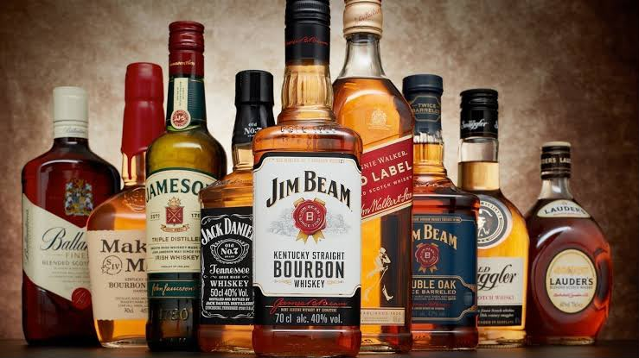
1 SCOTCH WHISKY
Definition Scotch Whisky is whisky produced and matured in Scotland in accordance with the legal requirements governing Scotch Whisky.
Scotch Whisky is commonly made from malted barley, other permitted cereal grains, or a combination of grains, depending on its category.
Types of Scotch Whisky
Scotch Whisky is legally divided into five categories:
1. Single Malt Scotch Whisky
Single Malt Scotch Whisky is produced at one distillery using water and malted barley, with production carried out using pot stills.
Characteristics:
* Produced at a single distillery.
* Made using malted barley.
* Distilled in pot stills.
* May display fruity, malty, floral, spicy, or smoky characteristics.
Brand examples:
* Glenfiddich
* The Glenlivet
* The Macallan
* Laphroaig
* Talisker
2. Single Grain Scotch Whisky
Single Grain Scotch Whisky is produced at one distillery using permitted cereal grains. It may contain malted barley and other malted or unmalted cereals.
It is commonly produced using continuous distillation equipment.
Characteristics:
* Produced at a single distillery.
* May use grains such as wheat, corn, and barley.
* Often has a lighter flavour profile than many malt whiskies.
* Can be bottled independently or used in blends.

3. Blended Malt Scotch Whisky
Blended Malt Scotch Whisky is made by combining two or more Single Malt Scotch Whiskies from different distilleries.
Brand example:
* Monkey Shoulder
4. Blended Grain Scotch Whisky
Blended Grain Scotch Whisky is made by combining two or more Single Grain Scotch Whiskies from different distilleries.
5. Blended Scotch Whisky
Blended Scotch Whisky is produced by combining one or more Single Malt Scotch Whiskies with one or more Single Grain Scotch Whiskies.
Brand examples:
* Johnnie Walker
* Chivas Regal
* Ballantine’s
* Dewar’s
Scotch Whisky Regions
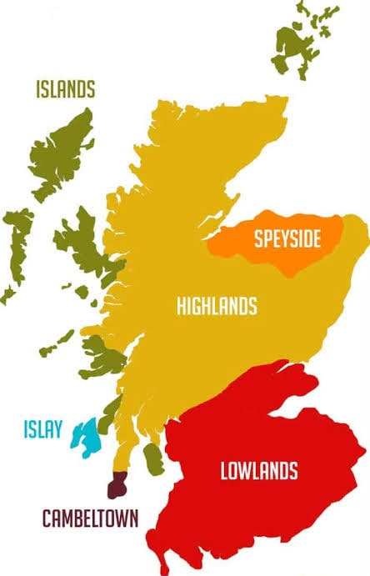
Scotch Whisky is associated with five principal geographical classifications:

1. Highlands
The Highlands is a large whisky-producing region with considerable variation in landscape and distillery styles.
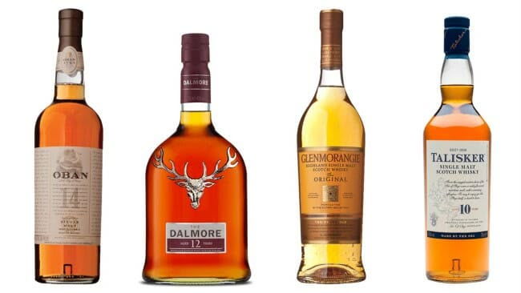
Whiskies from the region may display fruity, floral, malty, spicy, or smoky characteristics.
Brand examples:
* Glenmorangie
* Dalmore
* Oban
2. Speyside
Speyside is an important whisky-producing area within the Highlands, centred around the River Spey.
It is particularly associated with malt whisky production.
Whiskies from Speyside often display fruity, honeyed, malty, and sometimes sherried characteristics.
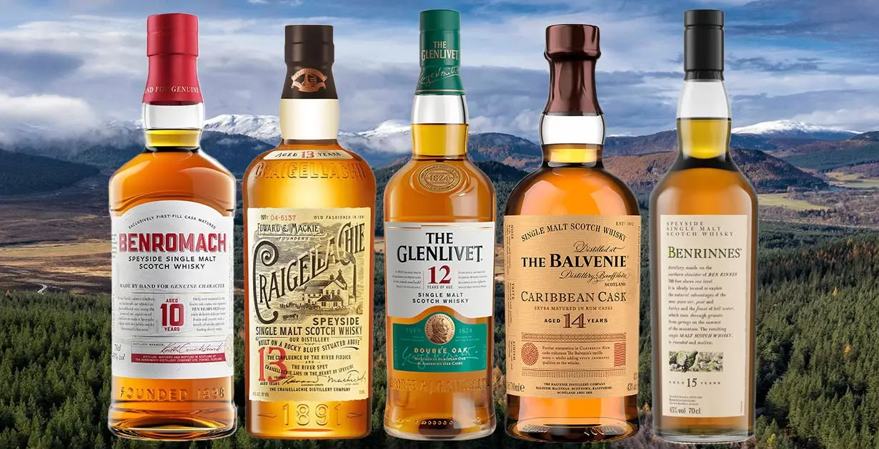
Brand examples:
* Glenfiddich
* The Glenlivet
* The Macallan
* Aberlour
3. Lowlands
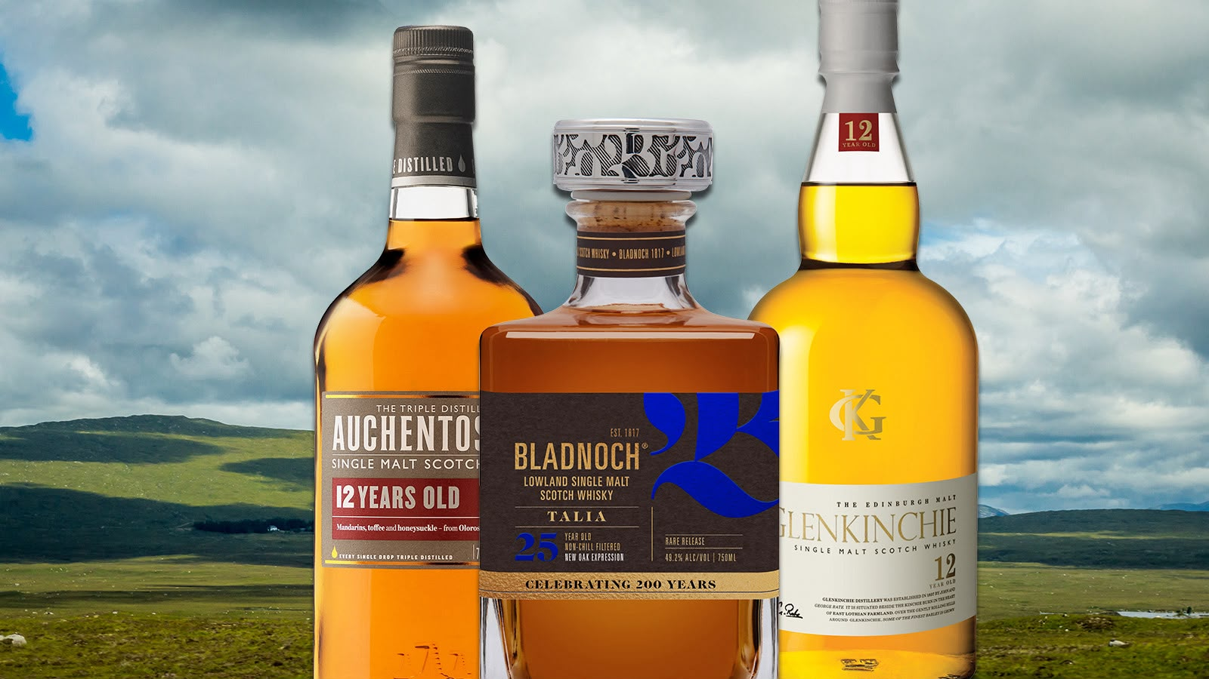
The Lowlands is traditionally associated with lighter and often delicate whisky styles, although individual distilleries vary.
Brand examples:
* Auchentoshan
* Glenkinchie
* Bladnoch
4. Islay
Islay is an island off Scotland’s west coast known for several distinctive smoky and peated malt whiskies.
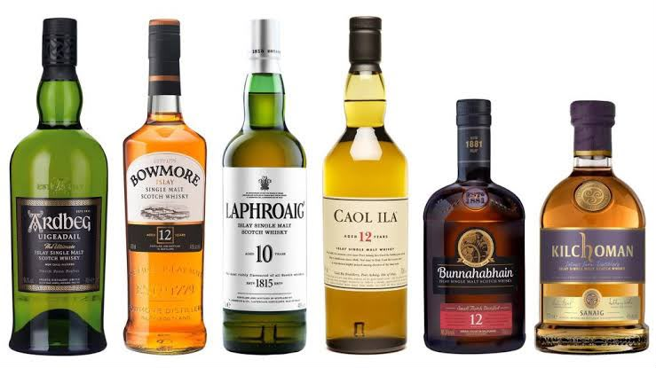
Some Islay whiskies also display maritime, medicinal, earthy, or coastal aromas.
Brand examples:
* Laphroaig
* Ardbeg
* Lagavulin
* Bowmore
5. Campbeltown
Campbeltown is a historic whisky-producing town on the Kintyre peninsula.
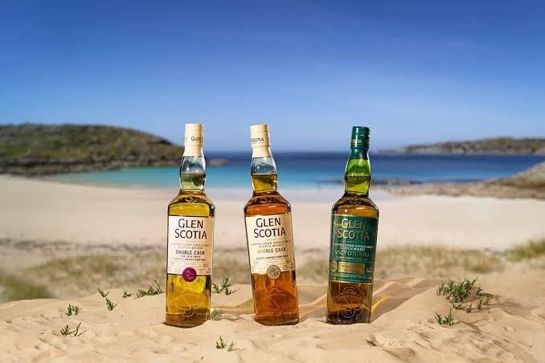
Its whiskies may display maritime, oily, fruity, smoky, or complex characteristics, depending on the distillery.
Brand examples:
* Springbank
* Glen Scotia
* Kilkerran

Important learning point: Regional flavour descriptions are general tendencies, not guarantees. A whisky’s flavour depends on its ingredients, fermentation, distillation, maturation, and blending.

IRISH WHISKEY
Definition Irish Whiskey is a protected geographical indication. It must comply with the applicable Irish Whiskey production specifications and originate on the island of Ireland.
Irish Whiskey production includes several distinct styles, each with its own characteristics.
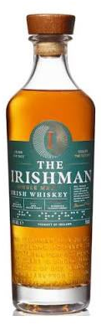
Types of Irish Whiskey
1. Single Malt Irish Whiskey
Single Malt Irish Whiskey is made from malted barley at a single distillery.
It is commonly associated with pot-still distillation.
Brand examples:
* Bushmills Single Malt
* The Tyrconnell
2. Single Pot Still Irish Whiskey
Single Pot Still Irish Whiskey is produced using a mash of malted and unmalted barley, with other permitted cereals where allowed by the specification.
It is distilled in pot stills.
Characteristics:
* Combines malted and unmalted barley.
* Often has a distinctive cereal, spicy, creamy, or oily character.
* Represents a traditional Irish whiskey style.

Brand examples:
* Redbreast
* Green Spot
* Powers John’s Lane
3. Single Grain Irish Whiskey
Single Grain Irish Whiskey is produced at one distillery using a mash containing permitted grains.
It is commonly associated with column-still distillation.
Brand example:
* Teeling Single Grain
4. Blended Irish Whiskey
Blended Irish Whiskey combines two or more whiskey types permitted under Irish Whiskey regulations.
A blend may combine malt, pot still, and grain whiskey styles.
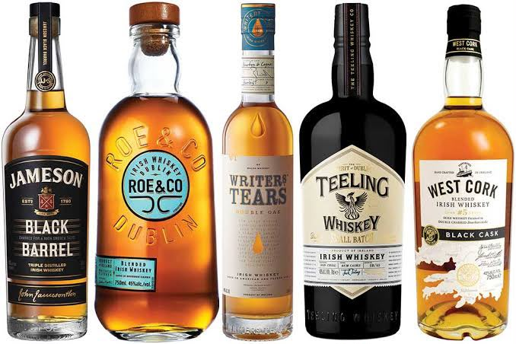
Brand examples:
* Jameson
* Tullamore D.E.W.
* Bushmills Original

General Characteristics
Irish Whiskey is often associated with smooth, fruity, cereal, and gently spicy characteristics. However, flavour varies considerably between individual products.
Important: Triple distillation is common in Irish whiskey production but is not a universal requirement for all Irish Whiskey.

AMERICAN WHISKEY

Definition American Whiskey is a broad category of whiskey produced in the United States.
American whiskey includes several legally defined styles, each with requirements relating to grain composition, distillation, maturation, and production.
Major Types of American Whiskey
1. Bourbon Whiskey
Bourbon is an American whiskey made from a fermented mash containing at least 51% corn.

For bourbon to meet the standard of identity, it must also satisfy the applicable distillation, entry-proof, and new charred oak container requirements.
Characteristics:
* At least 51% corn in the mash bill.
* Must be produced in the United States.
* Commonly displays notes of vanilla, caramel, oak, and sweet grain.
* Straight Bourbon must meet additional requirements, including at least two years of ageing in new charred oak containers.
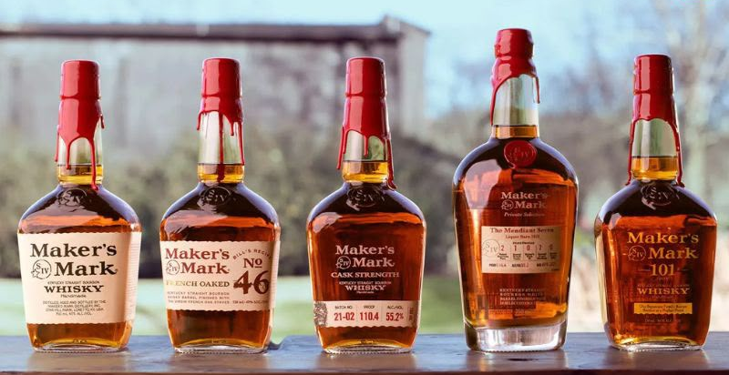
Brand examples:
* Jim Beam
* Maker’s Mark
* Buffalo Trace
* Wild Turkey
* Woodford Reserve
2. Tennessee Whiskey
Tennessee Whiskey is associated with the state of Tennessee and is subject to applicable legal requirements.
Many Tennessee whiskeys are made using a bourbon-style mash bill and undergo charcoal mellowing before maturation.
The Lincoln County Process is a well-known charcoal-mellowing method.
Brand examples:
* Jack Daniel’s
* George Dickel
Important: Tennessee Whiskey should not automatically be treated as a separate grain recipe. Its classification depends on the relevant legal requirements and production specifications.
3. Rye Whiskey
American Rye Whiskey must contain at least 51% rye in its fermented mash.
Characteristics:
* Rye contributes spicy, herbal, peppery, and sometimes fruity notes.
* Often used in classic whiskey cocktails.
* Commonly matured in new charred oak containers.

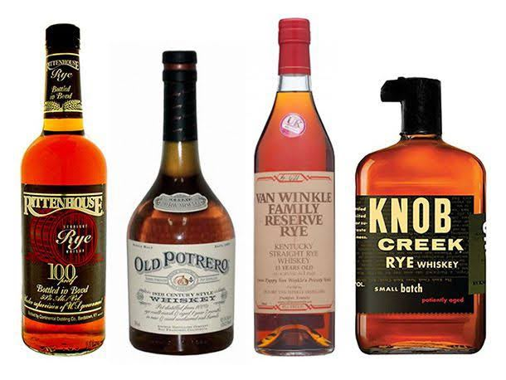
Brand examples:
* Rittenhouse Rye
* Bulleit Rye
* Sazerac Rye
4. Wheat Whiskey
American Wheat Whiskey must contain at least 51% wheat in its fermented mash.
It may display softer cereal, bread, and gentle spice characteristics, depending on production.
5. Corn Whiskey
American Corn Whiskey must contain at least 80% corn in its fermented mash.
Its production and storage requirements differ from those of bourbon.
6. American Single Malt Whiskey
American Single Malt Whiskey is a category defined by US regulations.
It is made from 100% malted barley and produced at a single US distillery, subject to the applicable requirements.
Brand examples:
* Westland
* Balcones
Straight Whiskey
The term Straight Whiskey applies to qualifying American whiskey that meets additional legal requirements, including the required maturation period and restrictions on additions.
For many American straight whiskey categories, the minimum ageing requirement is two years in new charred oak containers.
CANADIAN WHISKY
Definition Canadian Whisky is a protected geographical indication associated with whisky produced in Canada under the applicable Canadian regulations.
Canadian whisky production is known for its use of cereal grains and blending techniques.
Production Characteristics
Canadian whisky commonly uses grains such as corn, rye, and wheat.
Many products are made using continuous distillation, although production techniques differ between distilleries.
Canadian whisky is often associated with a lighter style, but flavour can vary according to the grain mixture, distillation, maturation, and blending.
Important learning point: The meaning of rye whisky differs between Canada and the United States. Students should not assume that the American 51% rye requirement applies to Canadian whisky.
JAPANESE WHISKY
Definition Japanese whisky is associated with Japan’s whisky-making traditions.
The Japan Spirits & Liqueurs Makers Association introduced standards for labelling Japanese whisky to distinguish qualifying Japanese whisky from products that do not meet those standards.
Production Characteristics
Japanese whisky production was strongly influenced by Scottish whisky-making traditions.
Japanese producers use different grains, still types, fermentation methods, cask types, and blending techniques.
The industry includes both malt and grain whisky production.
Major Styles
1. Japanese Single Malt Whisky
Produced at a single distillery using malted barley, subject to the relevant Japanese whisky standards.
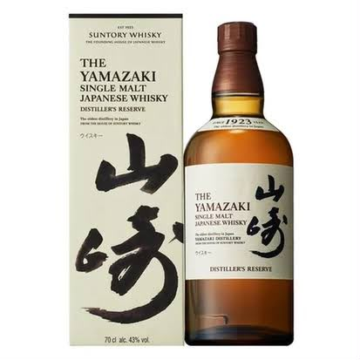
Brand examples:
* Yamazaki
* Hakushu
* Yoichi
2. Japanese Blended Whisky
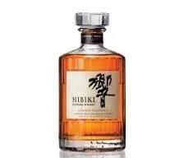
Made by combining different qualifying whiskies to achieve a desired style.
Brand examples:
* Hibiki
* Suntory Kakubin
* Nikka From the Barrel
3. Japanese Grain Whisky
Produced using permitted grains and production methods.
Brand example:
* Nikka Coffey Grain
General Characteristics
Japanese whiskies can display fruity, floral, delicate, malty, smoky, or complex characteristics.
Their flavour depends on the producer, distillery, production method, and maturation conditions.
Important: When identifying a product as Japanese whisky, students should distinguish between whisky that meets the Japanese labelling standards and other whisky products marketed in Japan.

INDIAN WHISKY

Definition India produces a broad range of whisky products using different raw materials and production methods.
Indian whisky classifications must be understood according to the applicable Indian regulations and the specific product’s production details.
Major Styles and Production Approaches
1. Indian Single Malt Whisky
Indian Single Malt Whisky is produced at one distillery using malted barley, in accordance with the applicable category requirements.
Indian single malts are known for their varied maturation conditions, which are influenced by the country’s climate.
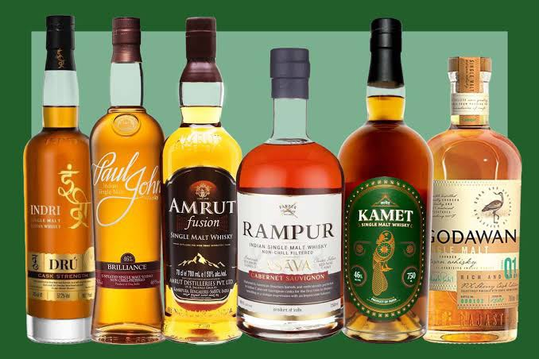
Brand examples:
* Amrut
* Paul John
* Rampur
* Indri
2. Indian Blended Whisky
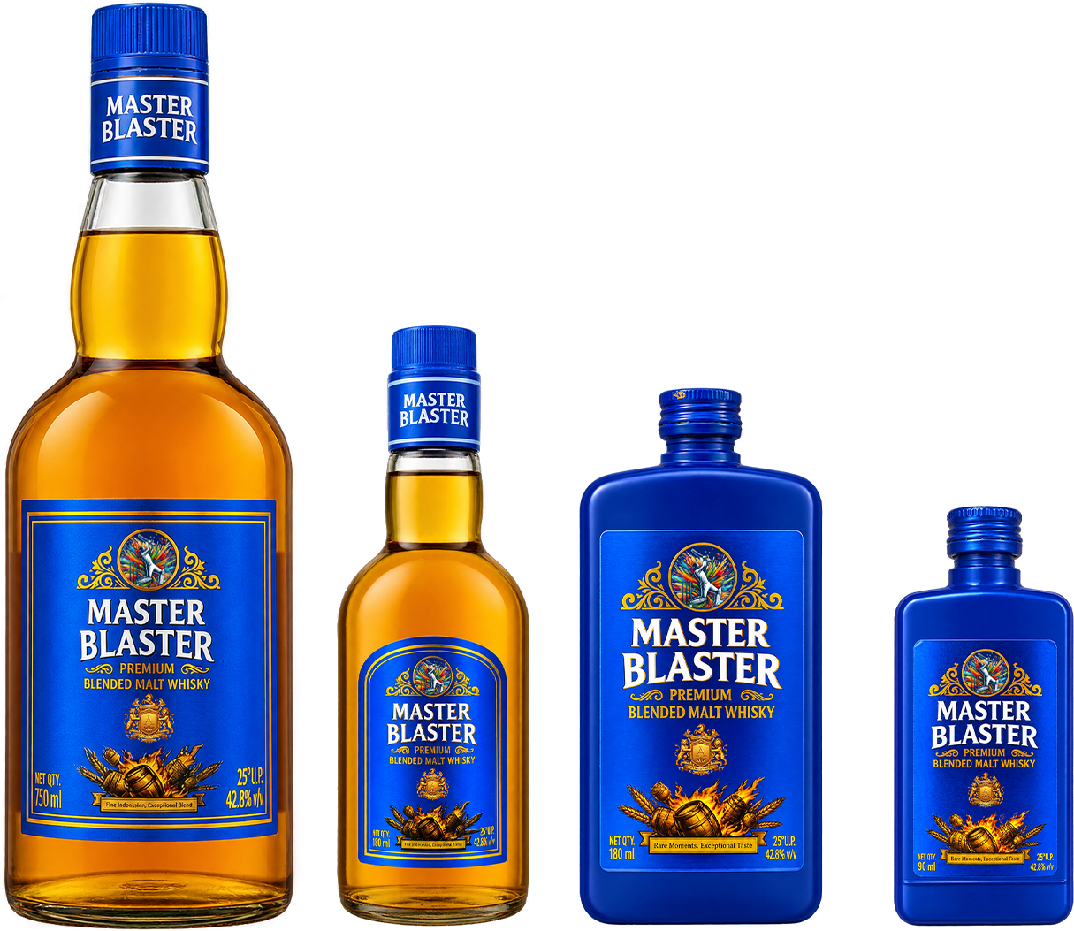
Indian blended whisky products may combine different whisky components according to their production specifications and applicable regulations.
The composition can vary between products.
Brand examples:
* Master Blaster
* Blenders Pride
* Royal Stag
India has a diverse whisky industry, and not every product marketed as whisky belongs to the same production category.
Students should examine the label and applicable classification rather than assuming that all Indian whisky is produced from the same raw materials.
Indian Whisky and Climate
India’s generally warm climate can accelerate certain aspects of interaction between spirit and wood compared with cooler climates.
However, maturation depends on several factors, including temperature variation, humidity, cask size, cask history, warehouse conditions, and the spirit itself.

OTHER WHISKY-PRODUCING COUNTRIES
Whisky is also produced in several other countries.
England
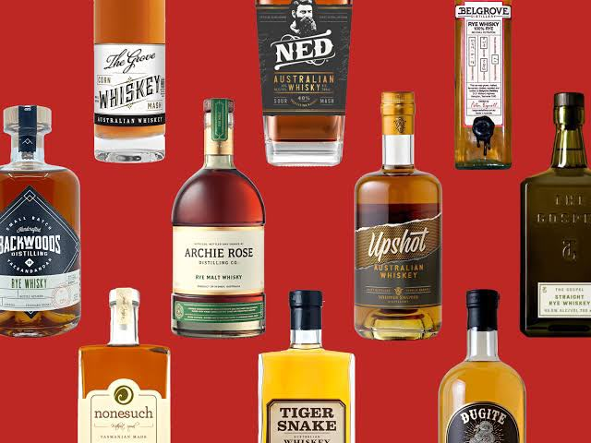
Brand examples:
* The English Whisky Co.
* Cotswolds Distillery

Wales
Brand example:
* Penderyn

Australia
Brand examples:
* Starward
* Sullivan’s Cove

IMPORTANT TECHNICAL FACTS FOR STUDENTS
1. Bourbon: The mash must contain at least 51% corn.
2. American Rye Whiskey: The mash must contain at least 51% rye.
3. American Wheat Whiskey: The mash must contain at least 51% wheat.
4. American Corn Whiskey: The mash must contain at least 80% corn.
5. Single Malt Scotch Whisky: Must be produced at one distillery using malted barley and pot stills.
6. Blended Malt Scotch Whisky: Combines Single Malt Scotch Whiskies from two or more distilleries.
7. Blended Scotch Whisky: Combines malt and grain Scotch whiskies.
8. Irish Whiskey: Includes malt, pot still, grain, and blended categories.
9. Canadian Rye Whisky: Does not automatically require 51% rye.
10. Whisky spelling: Whisky is common in Scotland, Canada, and Japan; whiskey is common in Ireland and the United States.

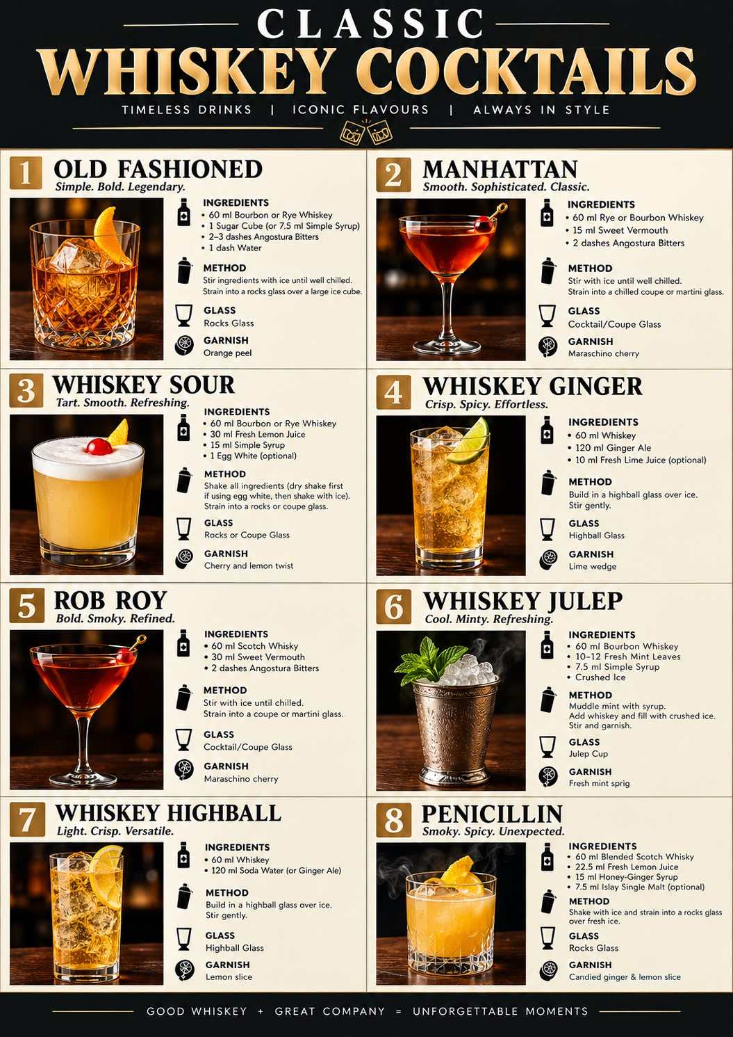

19. Vodka
Definition Vodka is a distilled alcoholic spirit traditionally produced from grains or potatoes. It is known for its relatively neutral flavour, clear appearance, and versatility in cocktails.
Vodka is made by fermenting suitable agricultural raw materials, distilling the fermented liquid to produce a high-strength spirit, and then reducing its strength with water before bottling.
Vodka is widely used in classic cocktails, contemporary mixed drinks, and flavoured spirit preparations.
Typical Bottling Strength: Approximately 40% ABV, although vodka is available at different strengths depending on the brand and market.
ABV: Alcohol by Volume, which indicates the percentage of alcohol present in a beverage.
WHY IS VODKA CLEAR AND COLOURLESS?
Vodka is generally clear and colourless because of the way it is produced.
1. High-strength distillation: Vodka is commonly distilled to a high level of alcohol purity, reducing many flavour and aroma compounds.
2. Rectification: Repeated separation during distillation helps produce a relatively neutral spirit.
3. Filtration: Some producers use activated charcoal or other filtration materials to remove selected unwanted compounds.
4. No conventional wood ageing: Traditional vodka is generally bottled without maturation in wooden barrels, so it does not acquire the colour associated with aged whisky or brandy.
5. Water dilution: The concentrated spirit is blended with suitable water to achieve the desired bottling strength.
Important: Clear appearance does not mean vodka is completely flavourless or chemically pure. Different vodkas can have subtle differences in aroma, flavour, and mouthfeel.
HISTORY AND ORIGIN OF VODKA
The precise origin of vodka is disputed. Russia and Poland both have long-standing traditions of vodka production, and both countries are associated with its early development.
The word vodka is related to the Slavic word for water. Its Russian form is associated with voda, meaning water.
Early Development
* Early distilled alcoholic beverages in Eastern Europe were often produced for medicinal, household, and other purposes.
* Over time, distillation techniques developed, allowing producers to make spirits from locally available agricultural ingredients.
* Grains such as rye and wheat became important raw materials in Eastern European vodka traditions.
* Potatoes also became an important raw material in some vodka-producing regions.

Historical note: The exact date and location of vodka’s invention remain subjects of historical debate. It is more accurate to describe vodka as a spirit with deep roots in Eastern Europe than to assign its invention conclusively to one individual or country.
RAW MATERIALS USED IN VODKA PRODUCTION
Vodka can be produced from agricultural materials that contain fermentable sugars or starch that can be converted into sugars.
A. Grains
Grains are widely used in vodka production.
Examples:
* Wheat
* Rye
* Corn (maize)
* Barley
B. Potatoes
Potatoes contain starch that can be converted into fermentable sugars during production.
Some producers use potatoes to create vodkas with distinctive texture and flavour characteristics.
C. Other Agricultural Raw Materials
Depending on the producer and applicable regulations, vodka may also be made from:
* Grapes
* Sugar beet molasses
* Rice
* Other suitable starch-containing or sugar-containing agricultural materials
Role of Raw Materials
The choice of raw material can influence the spirit’s texture, aroma, and subtle flavour characteristics, even when the final vodka is intended to be relatively neutral.
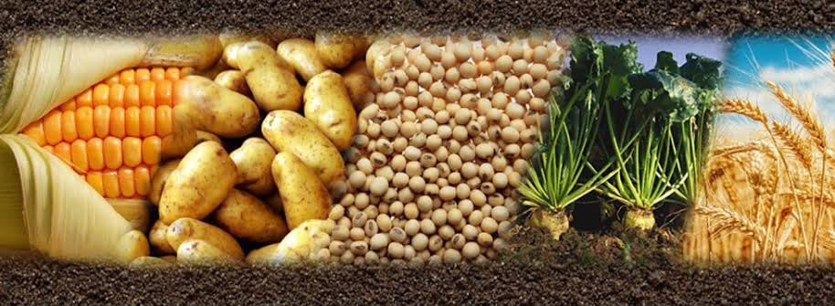
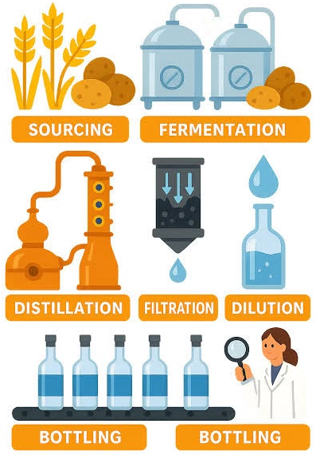
PRODUCTION OF VODKA
Vodka production generally involves the following stages:
1. Selection of raw materials
2. Milling and preparation
3. Mashing and starch conversion, where required
4. Fermentation
5. Distillation
6. Rectification and purification
7. Filtration, where used
8. Dilution with water
9. Quality control and bottling
VODKA PRODUCTION FLOW DIAGRAM
RAW MATERIALS
(Grains, potatoes, or other suitable agricultural materials)
↓
PREPARATION
(Cleaning, milling, and cooking where required)
↓
MASHING AND STARCH CONVERSION
(Converting starch into fermentable sugars)
↓
FERMENTATION
(Yeast converts sugars into alcohol)
↓
FERMENTED WASH
(Alcohol-containing liquid)
↓
DISTILLATION
(Separating and concentrating alcohol)
↓

RECTIFICATION
(Further purification and adjustment of spirit character)
↓
FILTRATION
(Where used by the producer)
↓
DILUTION WITH WATER
(Adjusting to the desired bottling strength)
↓
QUALITY CONTROL
↓
BOTTLING AND LABELLING
↓
FINISHED VODKA
Bartending note: The number of distillations or filtration stages alone does not establish the quality of a vodka. Raw materials, production choices, water, and the finished spirit’s sensory characteristics also matter.
TYPES AND STYLES OF VODKA
Vodka can be classified according to its production method, raw materials, and flavour profile.
A. Neutral or Unflavoured Vodka
This is the traditional style of vodka, generally characterised by a clean, relatively neutral flavour and aroma.
It is commonly used in cocktails because it allows other ingredients to contribute their flavours.
B. Flavoured Vodka
Flavoured vodka is produced by incorporating flavouring ingredients or using other permitted flavouring methods.
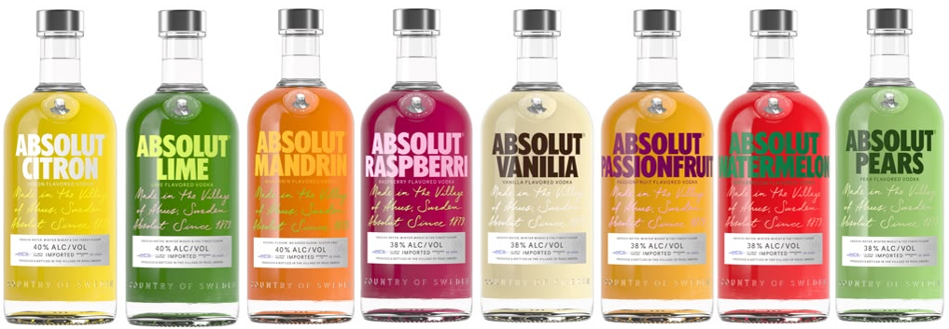
Common flavour profiles include:
* Citrus
* Vanilla
* Raspberry
* Green apple
* Pepper
* Orange
Flavoured vodka is used in cocktails where a particular fruit, spice, or other flavour is desired.
C. Grain Vodka
Grain vodka is produced using agricultural grains such as wheat, rye, corn, or barley.
Depending on the grain and production method, it may display subtle differences in texture and flavour.
D. Potato Vodka
Potato vodka is produced using potatoes as its agricultural base.
Some examples have a fuller texture or distinctive earthy characteristics, although the finished profile depends on the production method.
E. Fruit-Based Vodka
Some vodkas are produced from fruit-based agricultural raw materials, such as grapes.
These products can display subtle characteristics associated with their raw materials.
FAMOUS VODKA BRANDS AND THEIR COUNTRIES OF ORIGIN
Brand Country associated with the brand Commonly identified base ingredient
Absolut Vodka Sweden Winter wheat
Grey Goose France Wheat
Belvedere Poland Rye
Finlandia Finland Barley
Ketel One Netherlands Wheat
Cîroc France Grapes
Smirnoff Russian heritage Grain
Russian Standard Russia Wheat
Chopin Poland Potato in its potato-vodka expression
Tito’s Handmade Vodka United States Corn
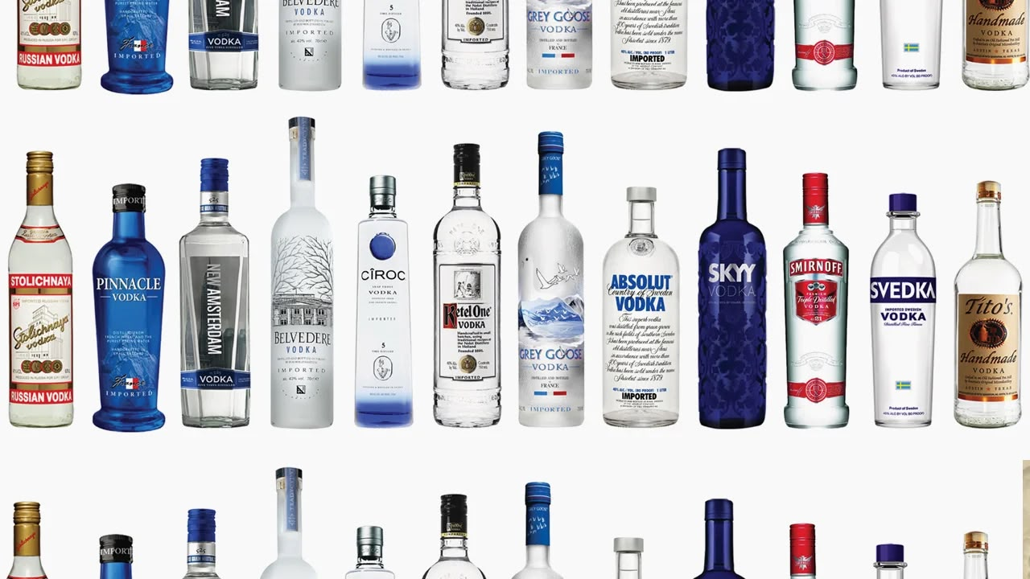
Skyy Vodka United States Grain
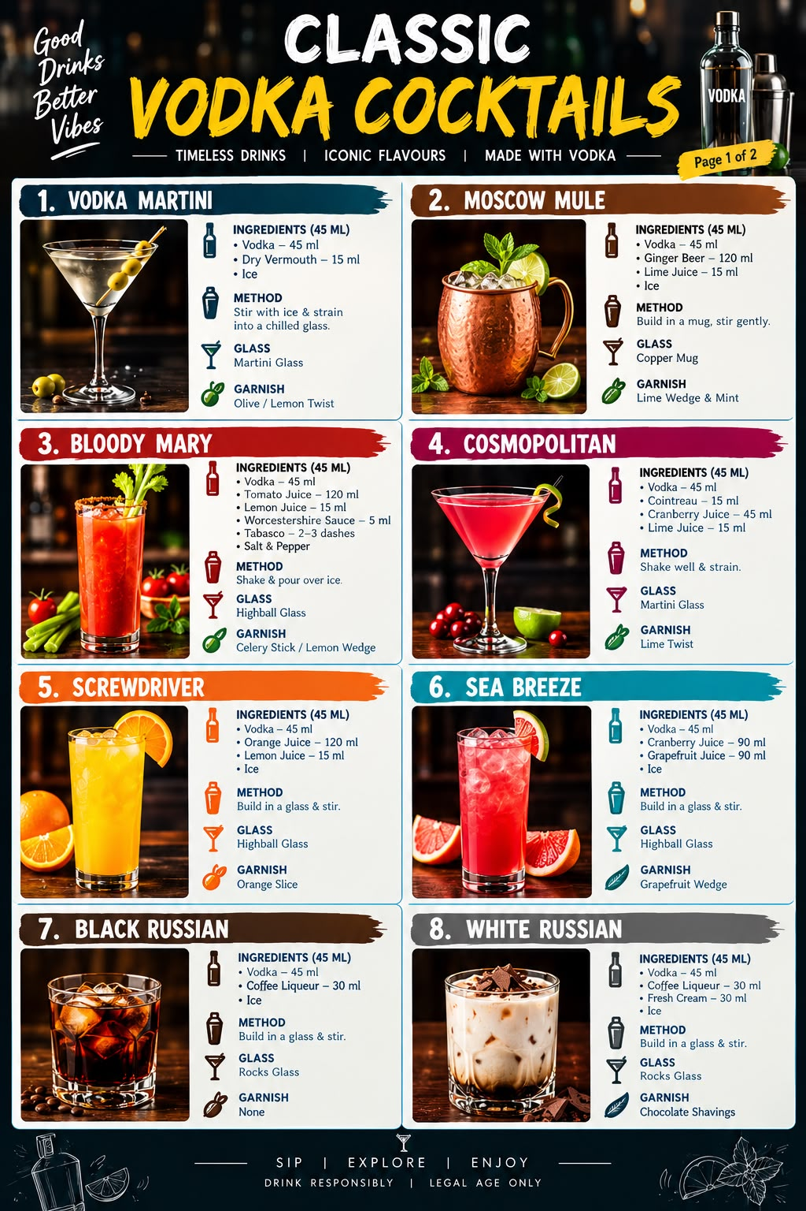
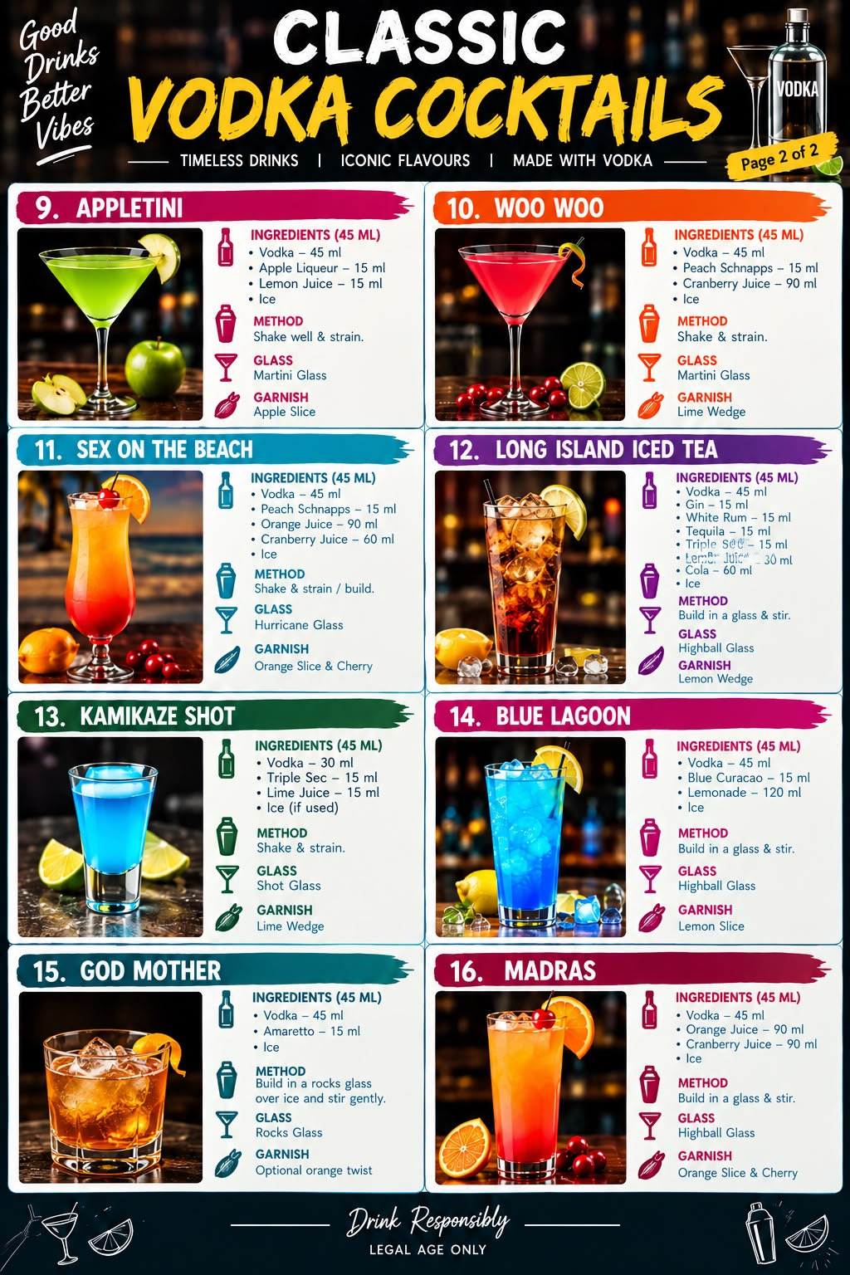

20. Gin
Definition Gin is a distilled or flavoured alcoholic spirit in which the predominant characteristic flavour is juniper berries. It is generally made using a neutral spirit of agricultural origin, flavoured with juniper and other botanicals such as coriander seeds, angelica root, citrus peel and spices.
The minimum alcoholic strength for gin under European Union spirit-drink regulations is 37.5% alcohol by volume (ABV).
Important characteristics of gin
1. Juniper is the defining flavour of gin.
2. Gin can contain a combination of herbs, spices, roots, flowers and fruits known as botanicals.
3. It may be produced through distillation, redistillation or the addition of flavourings, depending on its category.
4. Gin can have a dry, citrusy, floral, spicy, herbal or fruity flavour profile.
5. It is commonly used in cocktails such as the Martini, Negroni, Gin and Tonic, and Tom Collins.
What are botanicals?
Botanicals are natural plant materials used to give gin its aroma, flavour and character.
Botanical Contribution to flavour
Juniper berries Piney, resinous, woody
Coriander seeds Citrus-like, spicy
Angelica root Earthy, woody
Orris root Floral, powdery
Lemon peel Fresh citrus
Orange peel Sweet citrus
Cardamom Warm, aromatic spice
Cinnamon Sweet, warming spice
Liquorice root Sweet, earthy
Cassia bark Warm, spicy
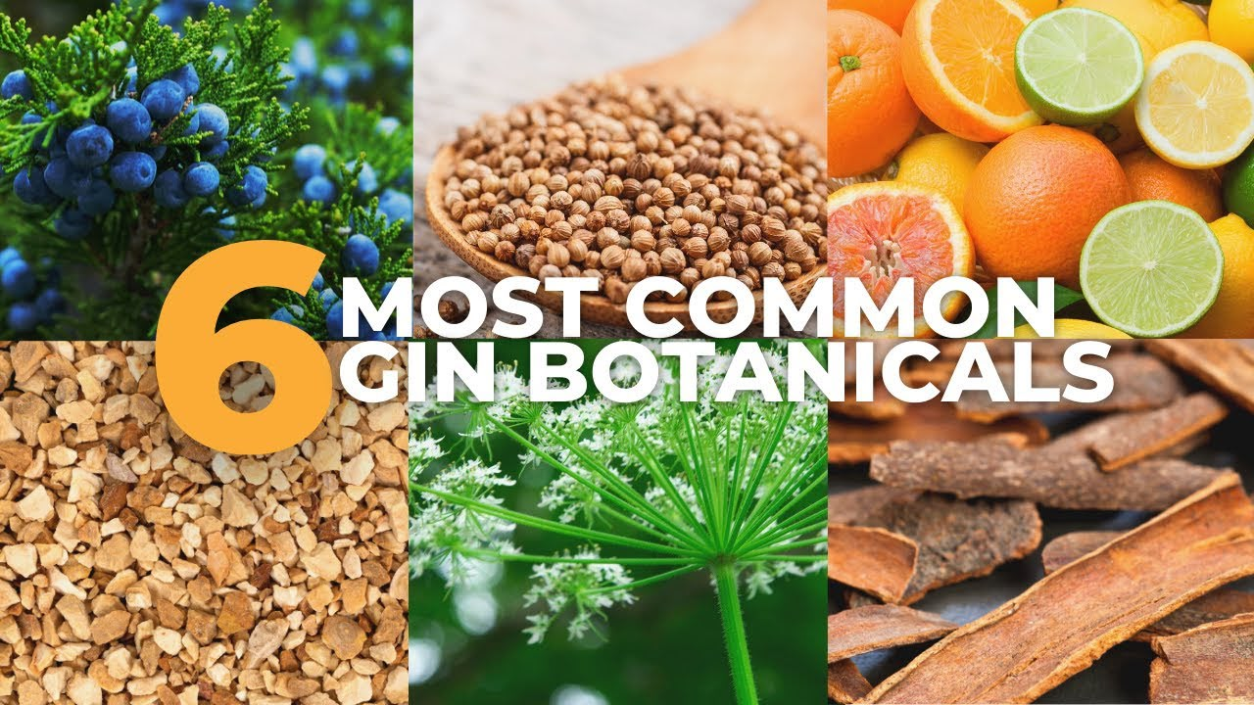
GIN PRODUCTION PROCESS
▼
1. SELECTION OF RAW MATERIALS
Wheat / Barley / Corn / Other
▼
2. PREPARATION OF BASE ALCOHOL
Milling → Mashing → Fermentation
▼
3. DISTILLATION OF BASE SPIRIT
Production of neutral agricultural
alcohol
▼
4. SELECTION OF BOTANICALS
Juniper berries + Coriander seeds
Citrus peel + Angelica + Other herbs
▼
5. BOTANICAL EXTRACTION
Maceration and/or vapour infusion
▼
6. REDISTILLATION
Alcohol vapours extract botanical
aromas and flavours in the still
▼
7. COLLECTION OF GIN DISTILLATE
Separation and collection of the
desired aromatic spirit
▼
8. RESTING AND QUALITY CONTROL
Evaluation of aroma, flavour and clarity
▼
9. DILUTION WITH WATER
Adjustment to the required ABV
▼
10. FILTRATION (IF REQUIRED)
Removal of unwanted particles
▼
11. BOTTLING AND LABELLING
FINISHED GIN
Category or style Main identifying feature Representative brand
Compound Gin Flavourings added without botanical Redistillation Verify production method for the specific product
Distilled Gin Botanicals introduced through distillation Bombay Sapphire
London Dry Gin Strict dry production style; flavours imparted through distillation tanqueray London Dry
Old Tom Gin Traditional style, often softer or sweeter Hayman’s Old Tom
Plymouth Gin Geographically protected Plymouth designation Plymouth Gin
Navy Strength Gin High-strength gin, commonly around 57% ABV Plymouth Navy Strength
Contemporary Gin Greater emphasis on botanicals beyond Aviation American Gin
Flavoured Gin Additional fruit or other flavour profile Bombay Bramble
Sloe Gin Sloe-berry liqueur made with gin or an appropriate spirit base Plymouth Sloe Gin
Genever Traditional juniper spirit with a characteristic malt-wine component Bols Genever
Barrel-Aged Gin Gin matured or rested in wooden casks Citadelle Réserve
Japanese botanical gin Gin featuring Japanese botanical ingredients Roku Gin
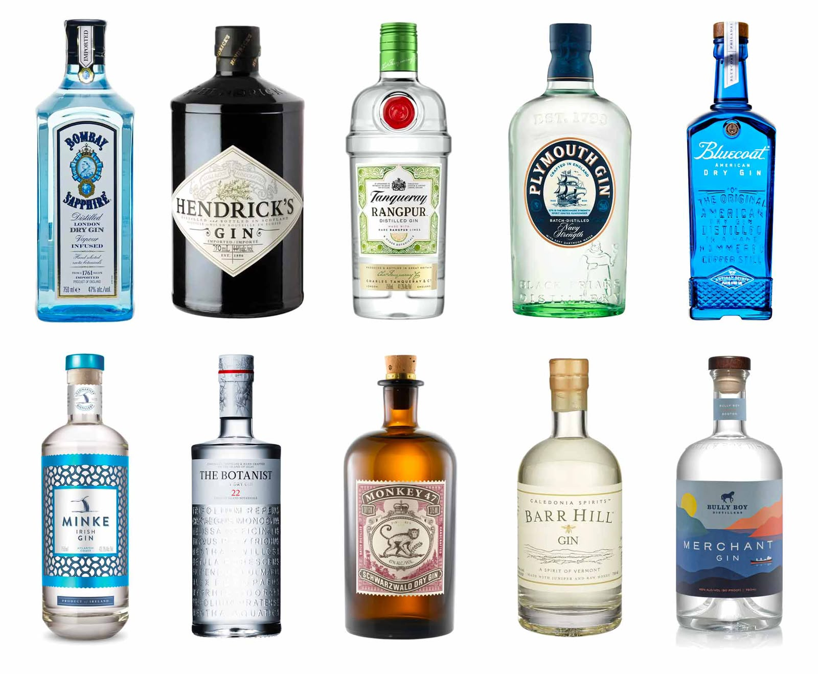
Indian botanical gin Gin featuring Indian or regional botanical ingredients Hapusa Himalayan Dry Gin

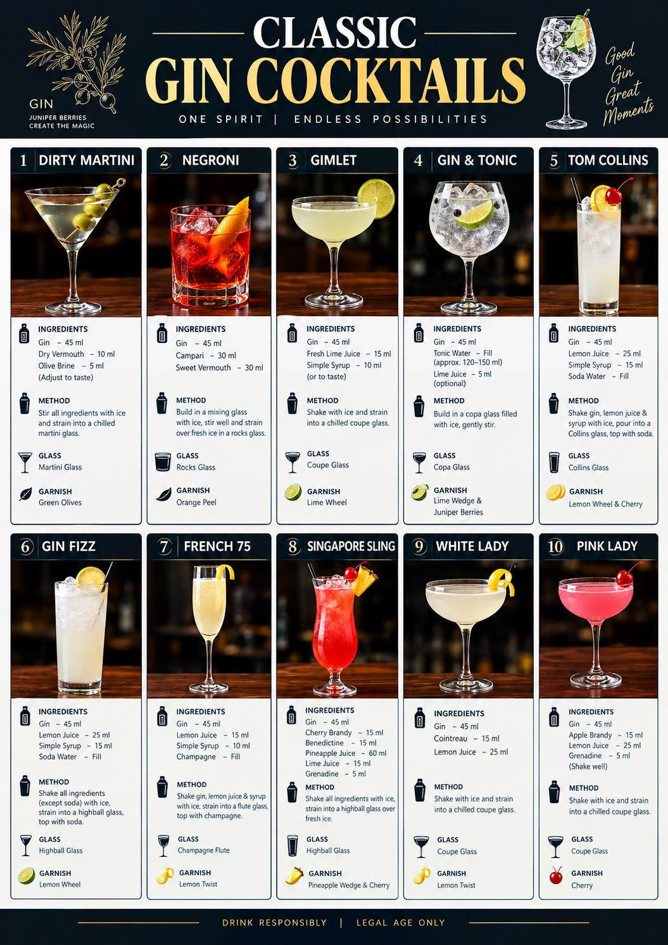
21. Rum
Definition Rum is a distilled alcoholic spirit produced by fermenting and distilling sugarcane-derived materials, primarily molasses, sugarcane juice, or sugarcane syrup.
Rum is produced in many countries, particularly throughout the Caribbean and Latin America, and is available in a wide range of styles, flavours, colours, and strengths.
Its flavour depends on several factors:
* Raw material used.
* Yeast strain and fermentation duration.
* Type of still used for distillation.
* Maturation and barrel type.
* Blending, filtration, and finishing techniques.
PART 2: HISTORY AND ORIGIN OF RUM
Historical background
Sugarcane cultivation and sugar production played a major role in the development of rum.
The history of rum is closely connected to the Caribbean sugar industry and the colonial plantation economy.
Historical timeline
Ancient period
* Sugarcane was cultivated in parts of Asia and gradually spread to other regions.
* Fermented beverages made from sugarcane-derived materials existed before modern rum production.
15th century
* European expansion helped spread sugarcane cultivation to the Atlantic islands and the Americas.
* Sugarcane was introduced to Hispaniola during Christopher Columbus’s second voyage in 1493, according to historical accounts.
17th century
* Sugarcane plantations expanded across the Caribbean.
* Sugar production generated molasses, which became an important raw material for distillation.
* Rum developed as a commercial spirit in the Caribbean during this period.
18th century
* Rum became an important commodity in Atlantic trade.
* Its history was closely associated with colonial commerce, slavery, and the exploitation of enslaved African people on sugar plantations.

19th century
* Improvements in distillation technology helped producers develop different rum styles.
* Continuous stills increased production efficiency.
* Fresh sugarcane juice-based rum developed further in French Caribbean territories.
20th century to the present
* Rum production expanded internationally.
* Producers developed a wider variety of white, golden, dark, aged, spiced, and specialty rums.
* Premium aged rums and craft rum production became established parts of the international spirits market.
SUGARCANE HARVESTING
↓
SUGARCANE CRUSHING
↓
SUGARCANE JUICE
↓
SUGAR EXTRACTION
↓
MOLASSES
↓
DILUTION WITH WATER
↓
YEAST ADDED TO THE MIX
↓
FERMENTATION
↓
ALCOHOLIC WASH
(Low ABV liquid)
↓
DISTILLATION
(Pot still / Column still)
↓
NEW MAKE RUM
↓
┌────────┴────────┐
↓ ↓
UNAGED RUM MATURATION
↓ IN WOODEN
FILTRATION CASKS
↓ ↓
DILUTION AGED RUM
↓ ↓
BOTTLING BLENDING
↓
DILUTION
↓
BOTTLING

STYLES AND CLASSIFICATIONS OF RUM
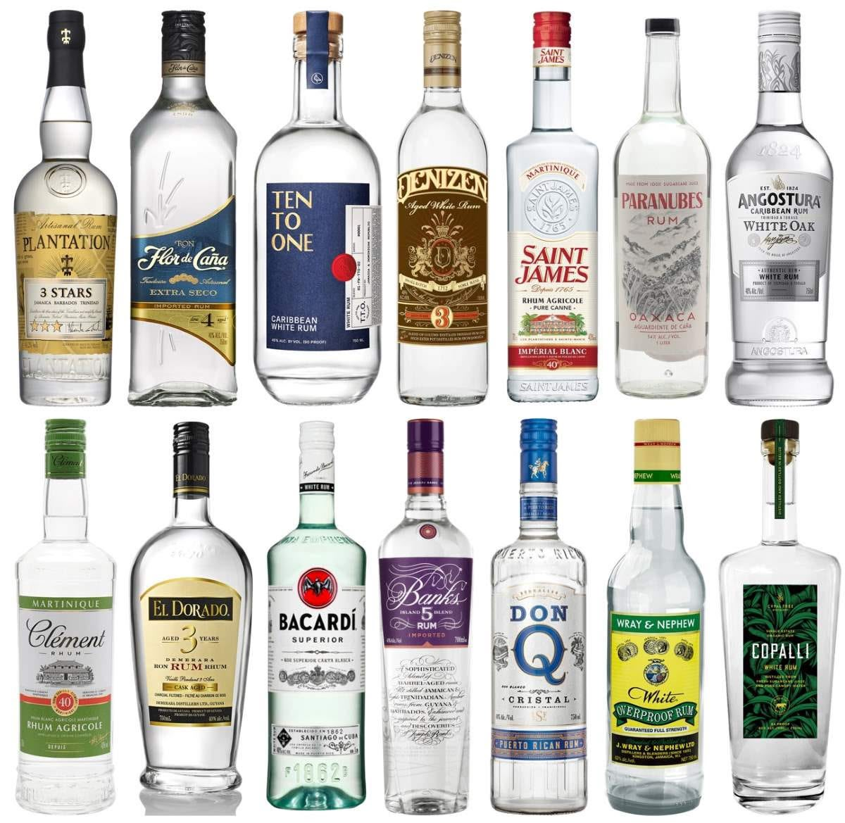
1. White rum
Also known as light rum or silver rum.
Characteristics:
* Clear or nearly clear appearance.
* Usually light-bodied, although flavour intensity varies.
* May be unaged or aged and subsequently filtered.
* Commonly used in refreshing cocktails.
Common cocktail applications: Mojito, Daiquiri, Piña Colada.
Brand examples:
* Bacardi Carta Blanca
* Havana Club 3 Años
* Don Q Cristal
2. Gold rum
Also called amber rum or oro.
Characteristics:
* Golden or amber appearance.
* May be matured in wooden casks.
* Often has more body and flavour than a light rum.
* Colour can be influenced by maturation and, where permitted, colouring.
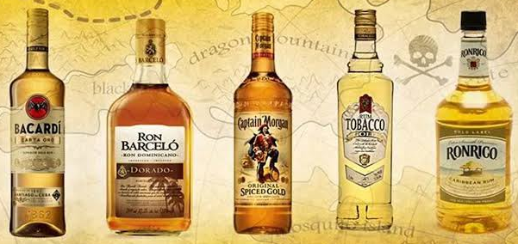
Brand examples:
* Mount Gay Eclipse
* Appleton Estate Signature
* Bacardi Gold
3. Dark rum
Also called black rum in some markets.
Characteristics:
* Dark brown or deep amber appearance.
* May have rich molasses, caramel, spice, or toasted notes.
* Colour may result from barrel maturation, permitted colouring, or a combination of production techniques.
* Often used in cocktails that require a pronounced rum character.
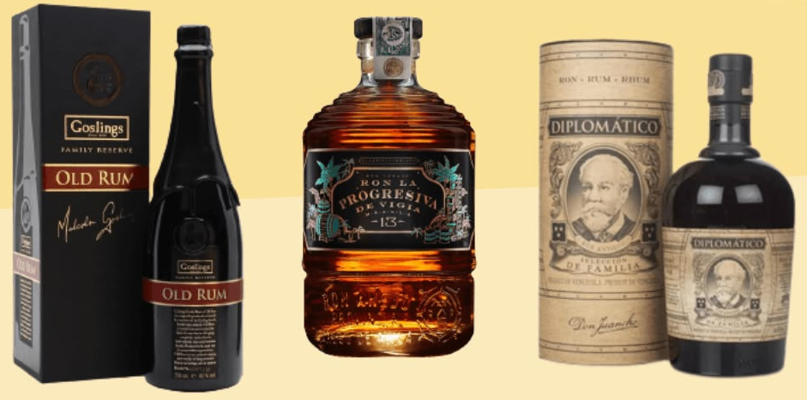
Brand examples:
* Goslings Black Seal
* Myers’s Original Dark
* The Kraken Black Spiced Rum
Important: Dark colour alone does not prove that a rum is old. Always distinguish colour from a stated maturation age.
4. Aged rum
Aged rum is matured in wooden casks for a period of time.
It may be golden, amber, or dark in appearance.
Characteristics:
* May develop vanilla, oak, spice, and dried-fruit notes.
* Can be enjoyed neat or used in cocktails.
* Its flavour depends on the spirit, cask, climate, and maturation conditions.
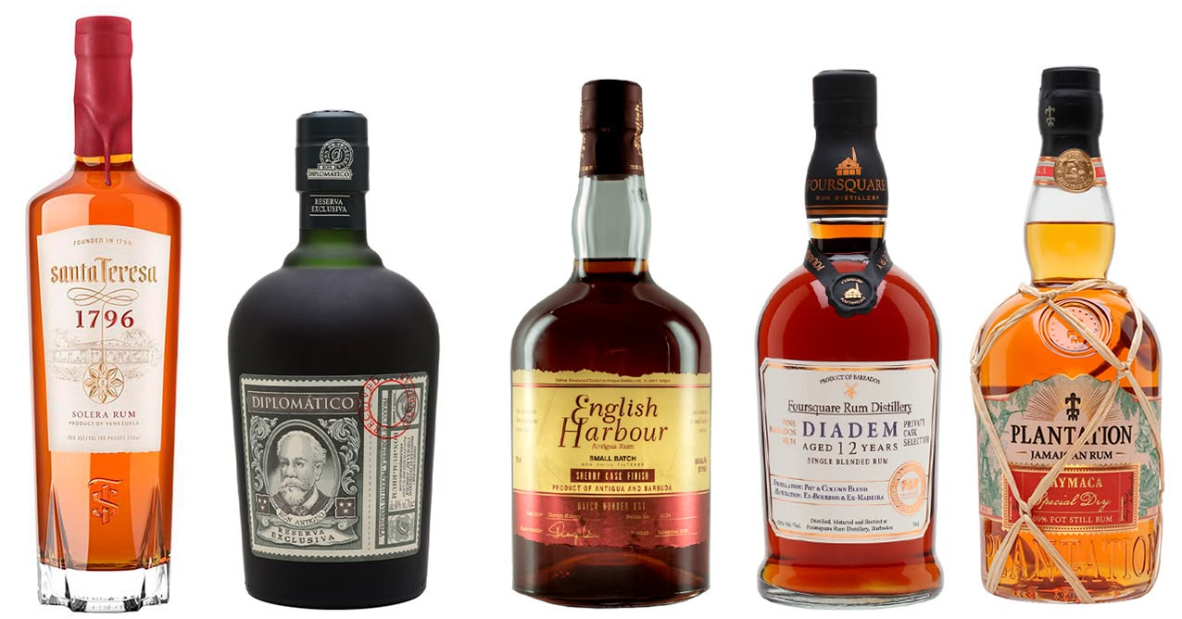
Brand examples:
* Appleton Estate 12 Year Old
* Mount Gay XO
* Ron Zacapa 23

5. Spiced rum
Spiced rum is rum flavoured with spices and other flavouring ingredients.
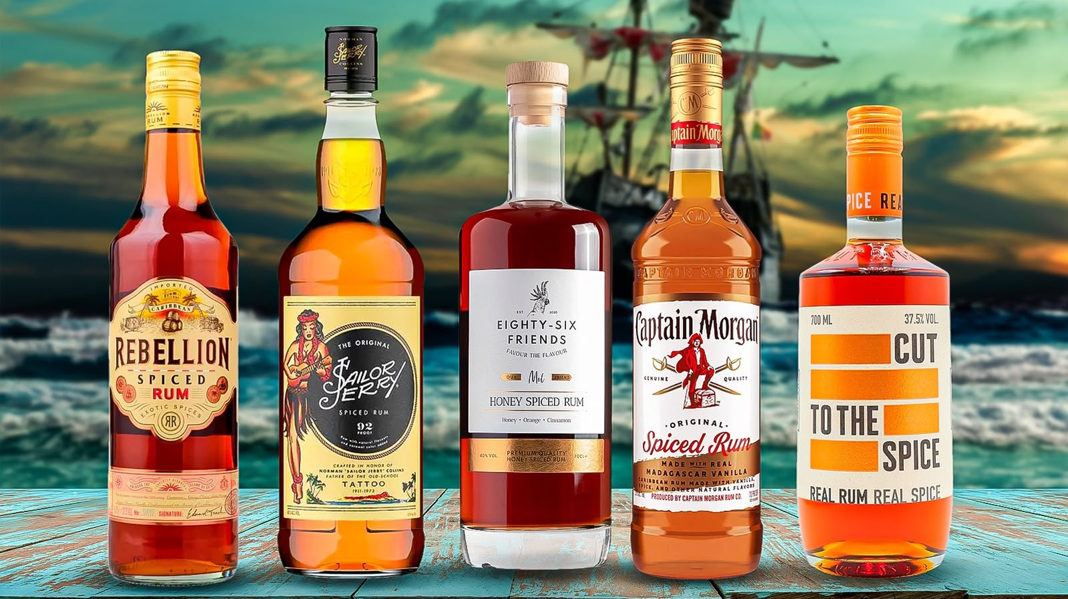
Common flavourings:
* Vanilla.
* Cinnamon.
* Clove.
* Ginger.* Other spices and botanicals.
Characteristics:
* Often has a pronounced sweet-spice aroma.
* May be based on light or dark rum.
* The final flavour depends on the ingredients and production method.
Brand examples:
* Captain Morgan Original Spiced Gold
* The Kraken Black Spiced Rum
* Sailor Jerry
6. Overproof rum
Overproof rum is bottled at a higher alcohol strength than standard-strength rum.
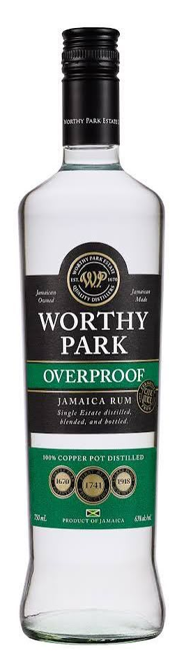
The exact threshold used can vary by market or classification system. A commonly used bartending reference is above 50% ABV.
Characteristics:
* High alcohol concentration.
* May be white or dark.
* Often used in small quantities in punches and cocktails.
* Requires careful measuring and responsible handling.
Brand examples:
* Wray & Nephew White Overproof
* Lemon Hart 151

Cachaça
Cachaça is a Brazilian distilled alcoholic spirit made from fermented sugarcane juice. It is recognised as a distinct spirit category and is particularly well known as the principal spirit used in the Caipirinha cocktail.
Cachaça is produced in Brazil and has its own production traditions and regulatory requirements.
Although it shares sugarcane as its agricultural source with rum, it should not simply be treated as another name for rum.
History of Cachaça
* Cachaça developed in Brazil during the colonial sugarcane era.
* Its history is connected to sugar production and the development of sugarcane-based alcoholic beverages.
* It became an important part of Brazilian drinking culture.
* Today, it is internationally recognised, particularly through the Caipirinha cocktail.
Main raw material
The primary raw material is fresh sugarcane juice.
The juice is fermented and then distilled to produce the spirit.
Cachaça production shares several basic steps with juice-based rum production, but the spirits are distinguished by their respective definitions, geographical origins, and production traditions.
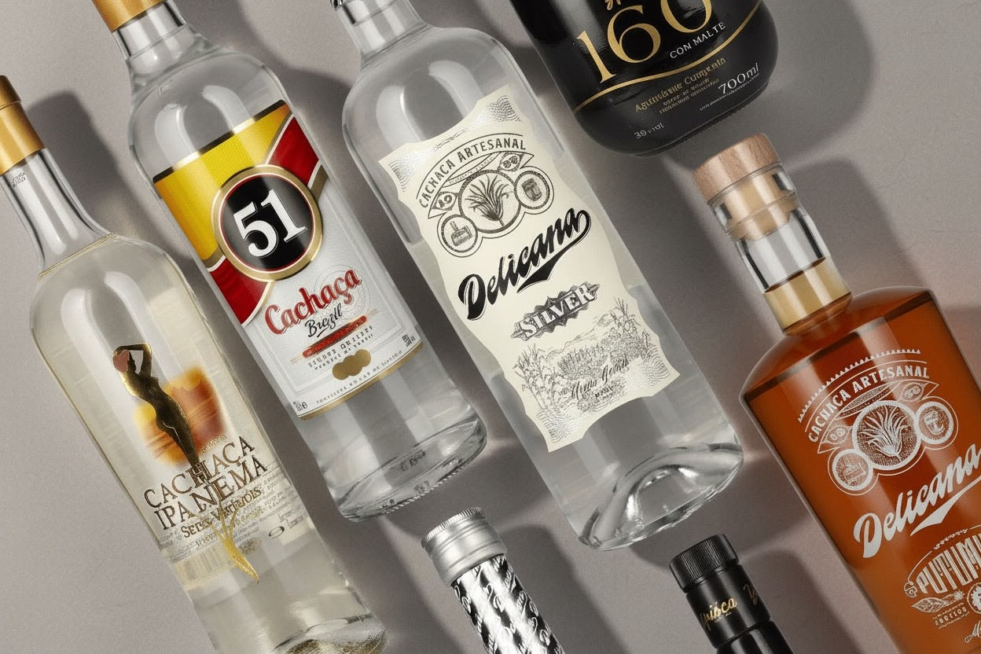
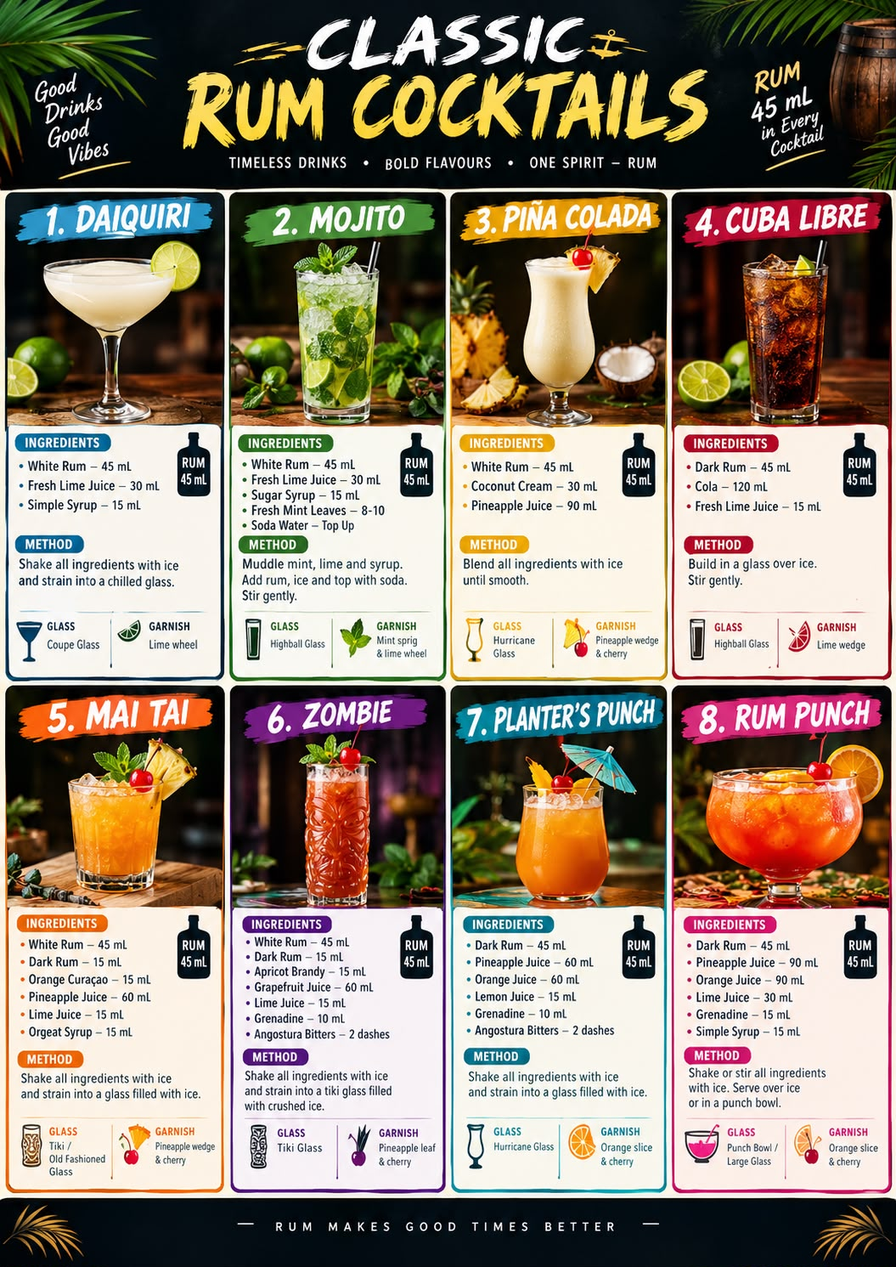
22. Tequila
DEFINITION Tequila is a Mexican distilled alcoholic spirit produced from the fermented sugars of the Blue Weber Agave (Agave tequilana Weber, blue variety).
It is manufactured in legally authorised regions of Mexico according to specific production standards. Authentic tequila must be produced using the permitted agave variety and follow the regulations governing its production.
Tequila generally has an alcoholic strength of 35%–55% ABV under Mexican regulations.
What ia Agave
Agave is a succulent plant native to the Americas. It is often mistaken for a cactus, but it belongs to a different botanical family.
The plant used to produce tequila is Blue Weber Agave.
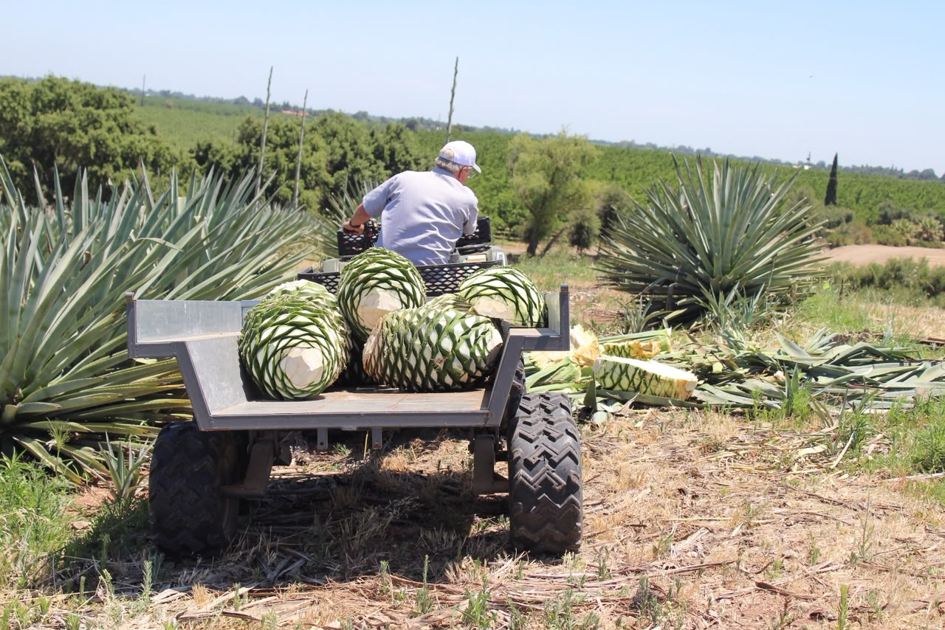
Important facts about agave
* Scientific name: Agave tequilana Weber, blue variety
* Main part used: The heart of the plant, known as the piña.
* Appearance: Long, pointed, blue-green leaves surrounding a large central heart.
* Sugar: The piña contains carbohydrates, including inulin, which must be converted into fermentable sugars during production.
* Growth period: The plant commonly takes approximately 5–8 years to mature for harvesting, although the time varies with growing conditions and agricultural practices.
Remember: Tequila must be made from Blue Weber Agave. Other agave species may be used to produce different agave spirits, but those spirits cannot automatically be classified as tequila.

Tequila Production process
BLUE WEBER AGAVE CULTIVATION
↓
Agave plants grow until mature
↓
HARVESTING (JIMA)
↓
Leaves are removed by a jimador
↓
The agave heart (piña) is collected
↓
COOKING / HYDROLYSIS
↓
Inulin is converted into fermentable sugars
↓
EXTRACTION
↓
Juice containing sugars is extracted
from the cooked agave
↓
FERMENTATION
↓
Yeast converts sugars into alcohol
↓
DISTILLATION
↓
The fermented liquid is distilled,
usually in two stages
↓
TEQUILA BLANCO
↓
┌──────┴─────────┐
↓ ↓
Bottling Maturation
without extended ↓
ageing Oak barrels
↓
┌──── ────┴────────┐
↓ ↓
Reposado Añejo
↓
↓ Extra Añejo
FILTRATION
↓
BOTTLING
↓
FINISHED TEQUILA

TEQUILA-PRODUCING REGIONS OF MEXICO

Tequila has a protected Designation of Origin. Its authorised production territory covers municipalities in five Mexican states.

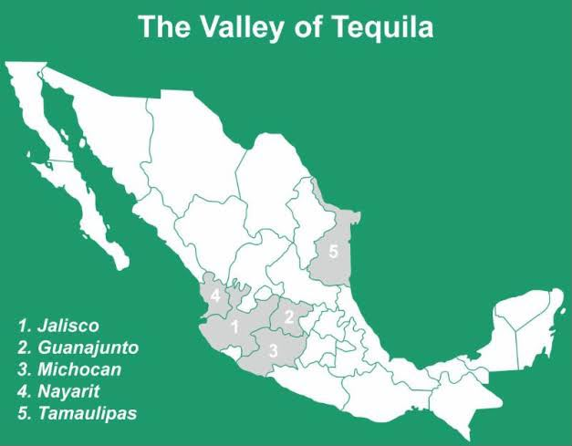

CLASSES OF TEQUILA
There are five principal classes of tequila.
1. Blanco / Silver / Plata
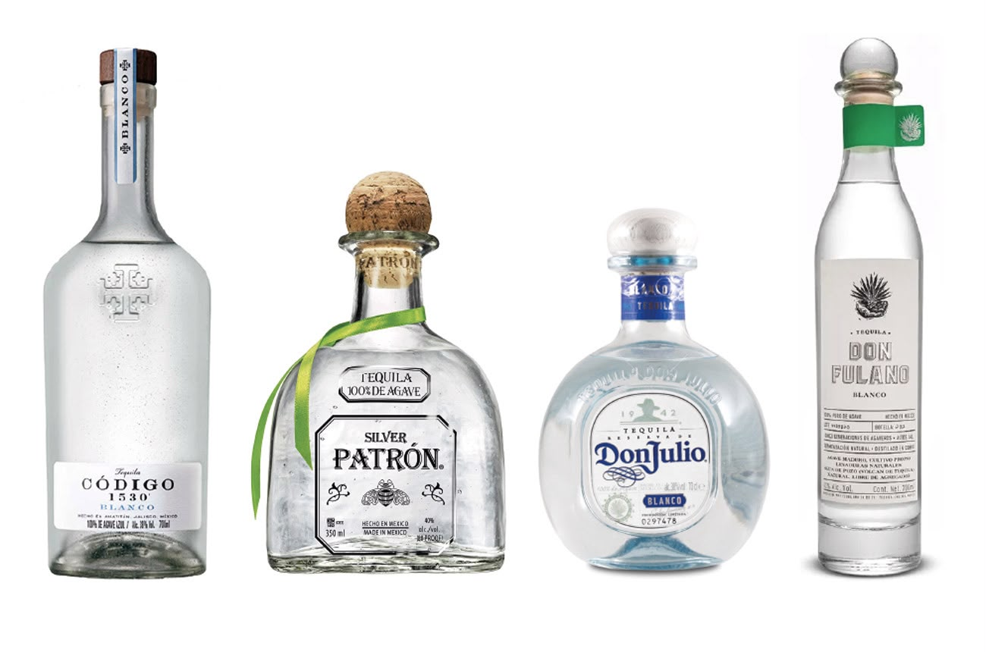
Definition: Tequila bottled without extended maturation. It may be rested briefly in permitted containers, but it does not undergo the minimum maturation required for Reposado.
Brand examples:
* Patrón Silver
* Don Julio Blanco
* 1800 Silver
* Espolòn Blanco

2. Joven / Gold / Oro
Definition: A tequila class that may be produced by blending Blanco tequila with older classes, or through other permitted processes that adjust its colour and characteristics.
Brand examples:
* Jose Cuervo Especial Gold
* Sauza Gold
3. Reposado
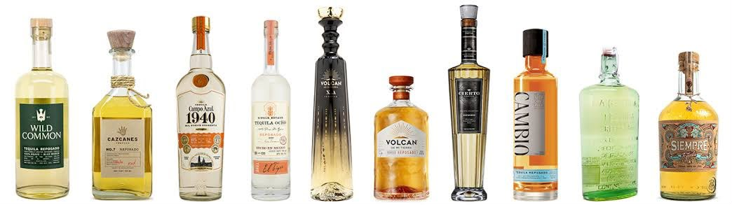
Definition: Tequila matured for a minimum of 2 months in direct contact with permitted oak or holm oak containers.
Brand examples:
* Patrón Reposado
* Don Julio Reposado
* 1800 Reposado
* Espolòn Reposado
4. Añejo
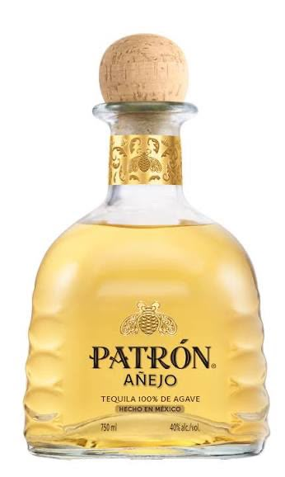
Definition: Tequila matured for a minimum of 1 year in oak or holm oak barrels with a maximum capacity of 600 litres.
Brand examples:
* Patrón Añejo
* Don Julio Añejo
* 1800 Añejo
5. Extra Añejo
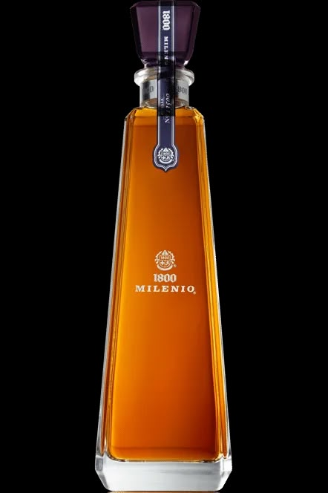
Definition: Tequila matured for a minimum of 3 years in oak or holm oak barrels with a maximum capacity of 600 litres.
Brand examples:
* Patrón Extra Añejo
* 1800 Milenio Extra Añejo

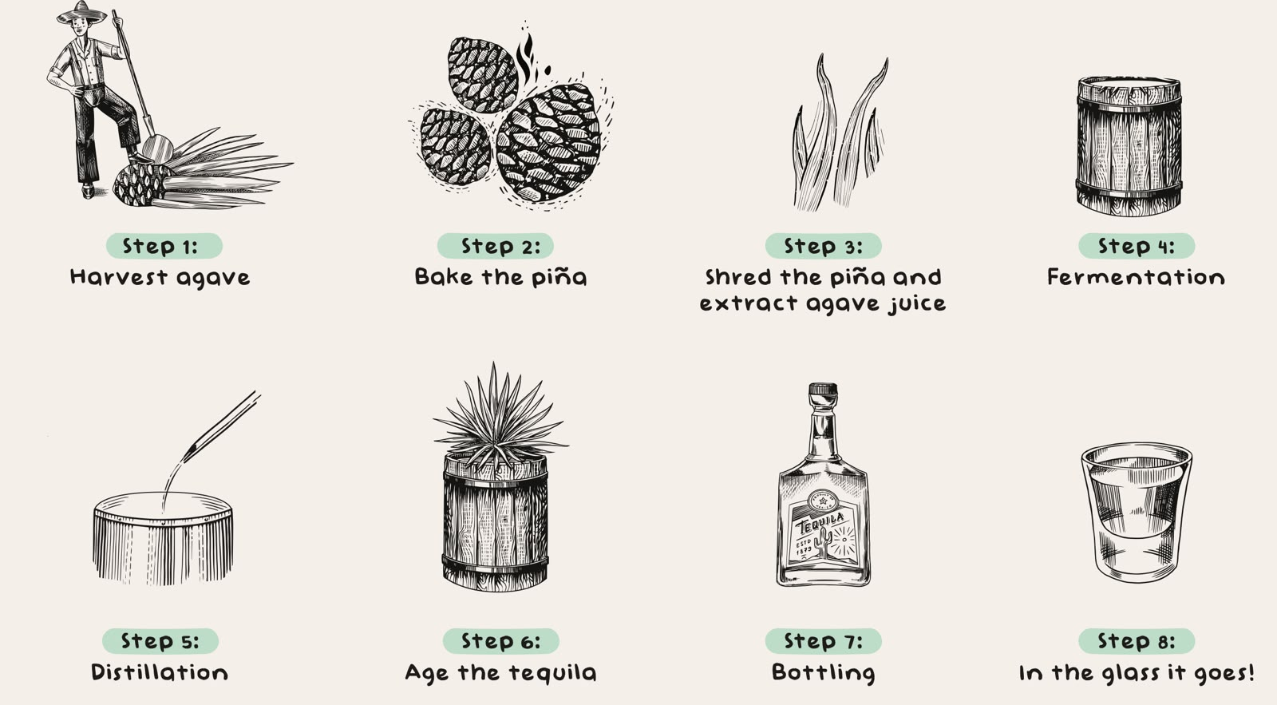

MEZCAL
DEFINITION Mezcal is a Mexican distilled alcoholic beverage made from cooked agave or maguey hearts. The extracted sugars are fermented and the resulting liquid is distilled.
Mezcal is protected by a Mexican Designation of Origin and must comply with the applicable production regulations.
Unlike tequila, mezcal can be produced from several authorised agave species. Its aroma and flavour depend on the agave variety, growing conditions and production techniques.
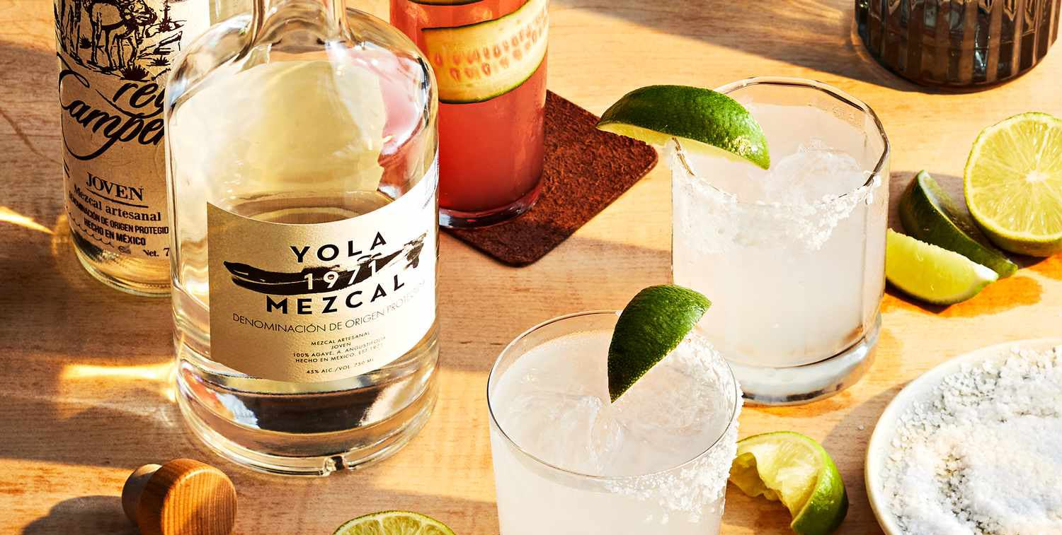
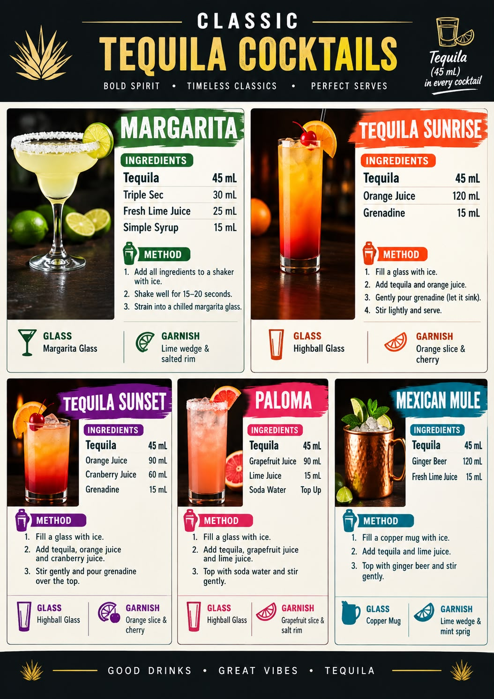

23. Brandy & Cognac
DEFINITION Brandy is a distilled alcoholic beverage produced by distilling fermented fruit juice, fruit mash or wine. Grapes are the most commonly used raw material, but other fruits such as apples, pears, cherries and plums can also be used.
Main raw material: Grapes and other fruits
BRANDY PRODUCTION PROCESS
Grape Harvesting
↓
Crushing and Pressing
↓
Grape Juice Extraction
↓
Fermentation
↓
Base Wine Production
↓
Distillation
↓
Brandy Spirit (Eau-de-vie)
↓
Oak Barrel Maturation (if required)
↓
Blending (if required)
↓
Strength Adjustment
↓
Filtration
↓
Bottling
↓
FINISHED BRANDY
Explanation
* Fermentation: Yeast converts grape sugars into alcohol, producing wine.
* Distillation: Alcohol and aromatic compounds are concentrated from the fermented wine.
* Maturation: Wooden barrels can contribute colour, vanilla, spice and woody flavours.
* Blending: Different brandies may be combined to create a consistent flavour profile.
MAIN TYPES OF BRANDY
Brandy is classified according to its raw material, production method and geographical origin.

Type Country / Region Main Raw Material
Cognac France Grapes
Armagnac France Grapes
Calvados Normandy, France Apples and permitted pears
Brandy de Jerez Spain Grapes
Pisco Peru and Chile Grapes
Grappa Italy Grape pomace
Kirschwasser Central Europe Cherries
Slivovitz Central and Eastern Europe Plums
Applejack United States Apples
COGNAC
Cognac is a grape brandy produced in the legally designated Cognac region of France. It is made according to specific production regulations governing grape varieties, fermentation, distillation and maturation.
Origin
* Country: France
* Region: Cognac, southwestern France
* Main grape variety: Ugni Blanc
* Distillation: Traditionally double-distilled in copper pot stills.
* Maturation: Aged in oak barrels.

Cognac Age Classifications
VS – Very Special 2 years
VSOP – Very Superior Old Pale 4 years
XO – Extra Old 10 years
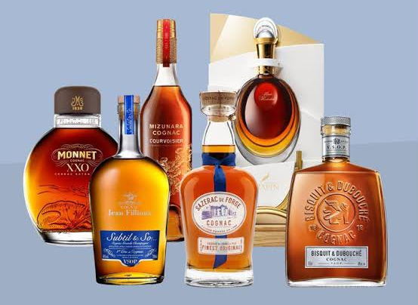
XXO – Extra Extra Old 14 years
Brand Product Examples
Hennessy VS, VSOP, XO
Rémy Martin VSOP, XO
Martell VS, VSOP, Cordon Bleu
Courvoisier VS, VSOP, XO
Camus VS, VSOP, XO
ARMAGNAC
Armagnac is a French grape brandy produced in the Armagnac region of Gascony in southwestern France. It is known for traditional production methods and distinctive regional characteristics.
Origin
* Country: France
* Region: Gascony
* Main grape varieties: Ugni Blanc, Baco, Folle Blanche and Colombard.
* Distillation: Commonly associated with traditional continuous distillation; double distillation is also permitted.
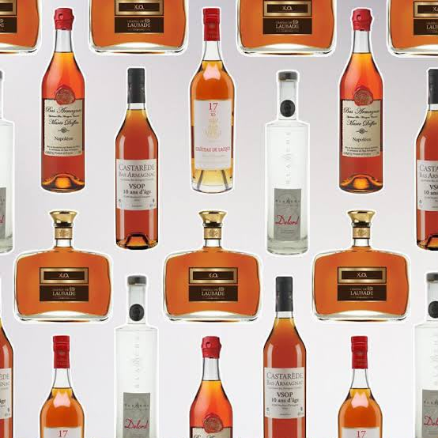
* Maturation: Often aged in oak barrels.
Armagnac Age Classifications
VS / 3-star 1 year
VSOP 4 years
XO / Hors d’Âge 10 years
Brand Product Examples
Château de Laubade VSOP, XO
Delord VSOP, XO
Janneau VSOP, XO
Dartigalongue VSOP, XO
Baron de Sigognac VSOP, XO

OTHER IMPORTANT BRANDY STYLES
A. CALVADOS
Country: France
Region: Normandy
Raw material: Apples and, in certain appellations, pears
Production: Fruit fermentation → cider → distillation → maturation where required.
Brands: Père Magloire, Boulard, Christian Drouin.
B. BRANDY DE JEREZ
Country: Spain
Region: Jerez, Andalusia
Raw material: Grapes
Production: Wine fermentation → distillation → maturation in approved casks, commonly using the Solera system.
Brands: Fundador, Cardenal Mendoza, Lepanto.
C. PISCO
Countries: Peru and Chile
Raw material: Grapes
Production: Grape fermentation → distillation → resting or maturation according to the relevant country’s regulations.
Brands: Barsol, Portón, Capel, Mistral.
D. GRAPPA
Country: Italy
Raw material: Grape pomace – the skins, seeds and other solid residues left after winemaking.
Production: Pomace preparation → distillation → optional maturation → bottling.
Brands: Nonino, Poli, Nardini.
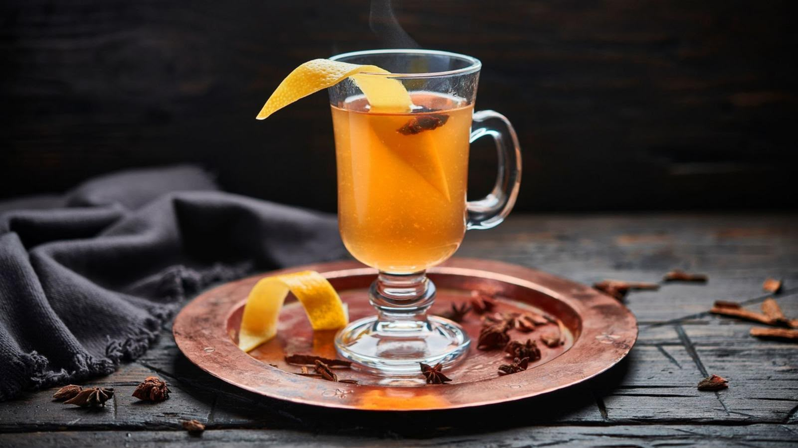
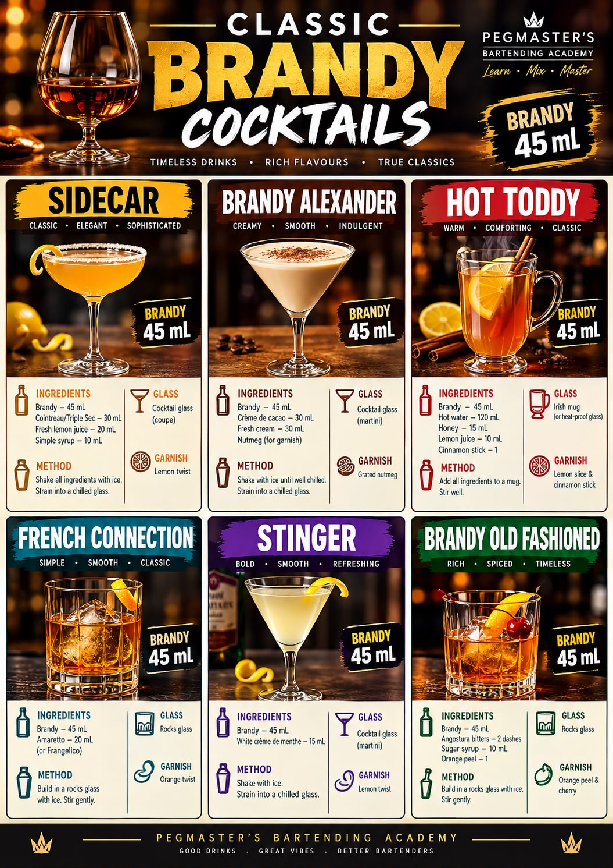

24. Beer
Definition Beer is an alcoholic beverage produced by fermenting sugars extracted from malted grains, usually barley, with water, yeast and often hops.
Main ingredients of beer:
1. Water – The main component of beer.
2. Malt – Usually malted barley; provides fermentable sugars, colour and flavour.
3. Hops – Add bitterness, aroma and flavour.
4. Yeast – Converts fermentable sugars into alcohol and carbon dioxide.
Other grains, such as wheat, corn and rice, may also be used.
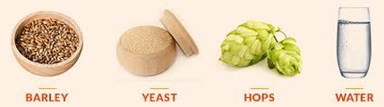
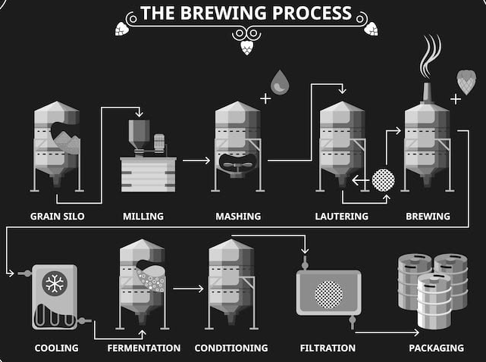
Beer Production Flow Chart
BARLEY
↓
MALTING
(Germination and drying of barley)
↓
MILLING
(Crushing the malted grains)
↓
MASHING
(Mixing crushed malt with hot water
to convert starch into sugars)
↓
LAUTERING
(Separating the sweet liquid wort
from the spent grains)
↓
BOILING
(Boiling the wort and adding hops)
↓
WHIRLPOOL
(Removing hop particles and solids)
↓
COOLING
(Cooling the wort to fermentation
temperature)
↓
FERMENTATION
(Adding yeast to convert sugars
into alcohol and CO₂)
↓
MATURATION / CONDITIONING
(Developing flavour and improving
beer quality)
↓
FILTRATION (IF REQUIRED)
(Removing remaining yeast and particles)
↓
CARBONATION
(Adjusting the carbon dioxide level)
↓
PACKAGING
(Bottles / Cans / Kegs)
↓
FINISHED BEER
Important: Some breweries skip filtration, and certain beers undergo natural carbonation or additional fermentation in the bottle or keg.

Styles of Beer
LAGER BEER
Definition Lager is a beer generally fermented using bottom-fermenting lager yeast at cooler temperatures, followed by a period of conditioning known as lagering.
Yeast Used: Saccharomyces pastorianus
Typical Fermentation Temperature: Approximately 7–15°C, although temperatures vary by brewery and style.

Characteristics of Lager Beer
* Generally has a clean, crisp and refreshing flavour.
* Often has fewer fruity esters than traditionally fermented ales.
* Can range from pale gold to amber, brown and dark colours.
* Can be light-bodied, medium-bodied or full-bodied.
* Its bitterness depends on the amount and type of hops used.
* Some lagers are light and delicate, while others are strong, rich and malty.
* Lagering helps develop a smoother and more rounded flavour.

Important Styles of Lager Beer

1. Pale Lager
A light-coloured lager known for its clean, crisp and refreshing character.
Brand Examples:
* Heineken
* Carlsberg
* Budweiser Budvar
2. Pilsner
A pale lager traditionally associated with the Czech Republic. It is known for its crisp character and noticeable hop bitterness.
Brand Examples:
* Pilsner Urquell
* Bitburger Premium Pils
* Warsteiner Premium Pilsener
3. Helles
A traditional German pale lager with a smooth, malty character and balanced bitterness.
Brand Examples:
* Augustiner Helles
* Paulaner Münchner Hell
* Spaten Münchner Hell
4. Dunkel
A traditional dark German lager with toasted bread, caramel and malt flavours.
Brand Examples:
* Ayinger Altbairisch Dunkel
* Paulaner Münchner Dunkel
5. Bock
A stronger lager traditionally associated with Germany. It generally has a rich malt character and a fuller body.
Brand Examples:
* Einbecker Ur-Bock
* Ayinger Celebrator Doppelbock
* Weihenstephaner Korbinian Doppelbock

ALE BEER
Definition Ale is a beer generally fermented using ale yeast at warmer temperatures than traditional lager fermentation.
Yeast Used: Saccharomyces cerevisiae
Typical Fermentation Temperature: Approximately 15–24°C, depending on the yeast strain and beer style.

Characteristics of Ale Beer
* Often develops fruity, floral, spicy or complex flavours.
* Can have a more noticeable yeast character than many traditional lagers.
* Available in pale gold, amber, brown and dark colours.
* Can range from light-bodied to full-bodied.
* May be mildly bitter, strongly bitter, sweet, roasted or sour depending on the style.
* Some ales are highly aromatic because of their hop varieties.
* Ale is a broad family that includes many traditional European and modern craft beer styles.

Important Styles of Ale Beer

1. Pale Ale
A golden to amber ale with a balance of malt flavour and hop character.
Brand Examples:
* Sierra Nevada Pale Ale
* Fuller’s London Pride
2. India Pale Ale (IPA)
A hop-forward ale known for its distinctive hop aroma and bitterness. Modern examples may also have fruity or tropical flavours.
Brand Examples:
* BrewDog Punk IPA
* Stone IPA
* Lagunitas IPA
3. Wheat Beer
A beer brewed with a significant proportion of wheat. Many traditional wheat ales have a soft texture and fruity or spicy yeast character.
Brand Examples:
* Hoegaarden Witbier
* Weihenstephaner Hefeweissbier
* Schneider Weisse Original
4. Stout
A dark ale commonly associated with roasted malt flavours, which may include coffee, cocoa and roasted grain notes.
Brand Examples:
* Guinness Draught
* Murphy’s Irish Stout
* Beamish Irish Stout
5. Porter
A dark ale that often features roasted, chocolate-like, caramel or coffee flavours.

Brand Examples:
* Fuller’s London Porter
* Samuel Smith’s Taddy Porter
6. Belgian Dubbel
A Belgian ale that is typically dark, malt-rich and known for fruity and sometimes spicy flavours.
Brand Examples:
* Westmalle Dubbel
* Chimay Red
7. Belgian Tripel
A strong golden Belgian ale that often has fruity and spicy flavours with a relatively dry finish.
Brand Examples:
* Westmalle Tripel
* Chimay White
* Tripel Karmeliet

HYBRID AND SPECIALTY BEER
Hybrid and specialty beers include beers produced using fermentation methods that combine characteristics of traditional ale and lager brewing, as well as beers made with distinctive ingredients, microorganisms, maturation methods or brewing techniques.
Yeast Used: Depends on the style. Ale yeast, lager yeast, mixed cultures or other microorganisms may be used.

Characteristics
* Flavour, aroma, colour and body vary widely.
* Some combine warm fermentation with cool conditioning.
* Some use mixed cultures or spontaneous fermentation.
* Certain styles include fruit, spices, smoked malt or barrel ageing.
* They may have clean, fruity, smoky, tart, sour or complex flavours.
Important Hybrid and Specialty Styles
1. Kölsch
2. California Common
3. Lambic
4. Fruit Beer
Beer made with fruit or fruit ingredients to contribute flavour and aroma.
5. Sour Beer
A beer with a noticeable tart or acidic character, produced through various brewing and fermentation methods.
6. Rauchbier
7. Kellerbier

IMPORTANT BEER TERMS FOR BARTENDERS
IBU – International Bitterness Units: A measurement associated with beer bitterness.
Wort: The sugary liquid extracted from malt before fermentation.
Malt: Grain that has undergone controlled germination and drying for brewing.
Hops: Flowers used to contribute bitterness, flavour and aroma to beer.
Head: The foam that forms on top of beer when it is poured.
Body: The perceived fullness or weight of beer in the mouth.
Draft Beer: Beer served from a keg or cask through a dispensing system.
Craft Beer: Beer produced by a brewery that focuses on brewing character, quality and variety. Definitions of craft beer vary by market.
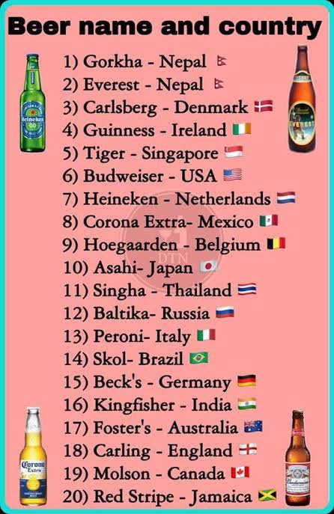

25. Wine
HISTORY OF WINE
Wine is one of the oldest alcoholic beverages in the world. It has been produced for thousands of years through the fermentation of grapes.
* Around 6000–5000 BCE: Archaeological evidence indicates early winemaking in the South Caucasus region, including present-day Georgia.
* Ancient Egypt: Wine was used in religious ceremonies, royal households, and important social occasions.
* Ancient Greece: Wine became an important part of social life, trade, and cultural traditions.
* Roman Empire: The Romans expanded vineyards and introduced viticultural practices across many parts of Europe.
* Middle Ages: Monasteries played an important role in maintaining vineyards and developing winemaking knowledge.
* Modern period: Advances in fermentation science, temperature control, bottling, and vineyard management helped develop the modern wine industry.
Today, wine is produced in many countries, including France, Italy, Spain, Portugal, Germany, the United States, Australia, Chile, Argentina, South Africa, and India.
DEFINITION OF WINE
Wine is an alcoholic beverage produced by the fermentation of fresh grapes or grape juice (grape must).
During fermentation, yeast converts the natural sugars present in grape juice into alcohol and carbon dioxide.
Main ingredients
1. Grapes or grape must
2. Yeast
3. Sulphur dioxide, where permitted, for protection against oxidation and unwanted microorganisms
Wine can be still, sparkling, or fortified, depending on its production method and characteristics.
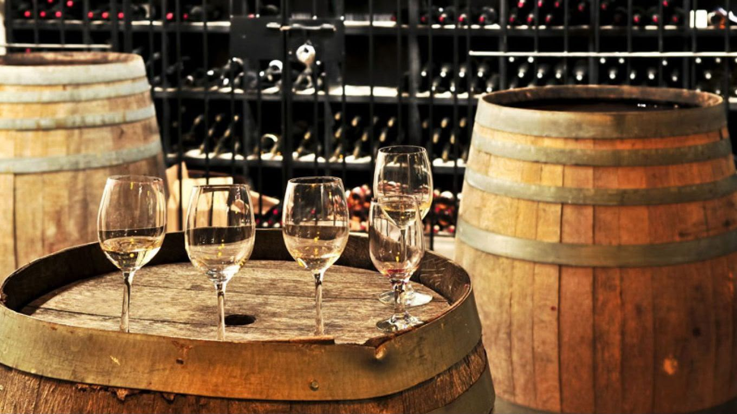

CLASSIFICATION OF WINE
Wine can be classified according to its colour, carbonation, alcohol content, sweetness, and production method.
A. According to carbonation
1. Still wine: Wine without significant effervescence.
2. Sparkling wine: Wine containing noticeable bubbles due to carbon dioxide.
3. Semi-sparkling wine: Wine containing a lower level of carbonation than typical sparkling wine.
B. According to colour
1. Red wine
2. White wine
3. Rosé wine
4. Orange wine
C. According to production and alcohol content
1. Table wine or still wine
2. Sparkling wine
3. Fortified wine
4. Sweet or dessert wine
Note: These classifications can overlap. For example, a wine can be red, sparkling, and sweet at the same time. Table wine is generally a category of still wine rather than a separate colour classification.
STILL WINE
Definition: Still wine is wine that does not contain significant carbonation and does not produce a noticeable stream of bubbles when served.
Still wines are commonly made as red, white, or rosé wines.
Characteristics
* No significant effervescence.
* Can be dry, off-dry, medium-sweet, or sweet.
* Usually has an alcohol content of approximately 8–15% ABV, although exceptions exist.
* Can be served as an aperitif, with food, or as a beverage on its own.
Examples
* Red: Cabernet Sauvignon, Merlot
* White: Sauvignon Blanc, Chardonnay
* Rosé: Provence-style Rosé
RED WINE
Definition: Red wine is produced primarily from dark-skinned grapes, with the grape skins usually kept in contact with the juice during fermentation to extract colour, tannins, and flavour compounds.
Characteristics
* Colour ranges from purple and ruby to garnet and deep brick red.
* Often contains noticeable tannins.
* Flavours may include dark berries, red fruits, spices, and oak-related notes.
* Can be light-bodied, medium-bodied, or full-bodied.

Red Wine Production Process

Dark-skinned grapes
↓
Harvesting
↓
Destemming and crushing
↓
Fermentation with grape skins
↓
Extraction of colour, tannins, and flavour
↓
Pressing
↓
Malolactic fermentation (where used)
↓
Maturation in tanks or barrels
↓
Clarification and filtration (where used)
↓
Bottling

Important: Skin contact is the main reason red wine obtains its colour and much of its tannin structure.
Major Red Grape Varieties
1. Cabernet Sauvignon
* Characteristics: Blackcurrant, firm tannins, and a full-bodied structure.
* Examples: Bordeaux red blends (France), Napa Valley Cabernet Sauvignon (United States).
2. Merlot
* Characteristics: Plum, black cherry, softer tannins, and a smooth texture.
* Examples: Pomerol (France), Merlot from Chile.
3. Pinot Noir
* Characteristics: Red cherry, raspberry, delicate aromas, and generally lighter tannins.
* Examples: Burgundy Pinot Noir (France), Oregon Pinot Noir (United States).
4. Syrah / Shiraz
* Characteristics: Blackberry, black pepper, spice, and a medium- to full-bodied structure.
* Examples: Northern Rhône Syrah (France), Barossa Shiraz (Australia).
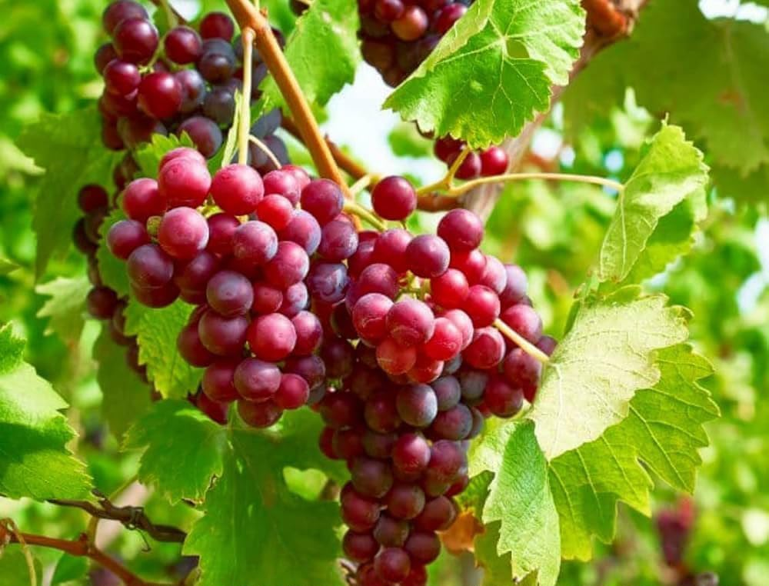
5. Malbec
* Characteristics: Dark fruits, deep colour, and noticeable tannins.
* Examples: Mendoza Malbec (Argentina), Cahors (France).
6. Sangiovese
* Characteristics: Cherry, high acidity, and savoury notes.
* Examples: Chianti (Italy), Brunello di Montalcino (Italy).
7. Tempranillo
* Characteristics: Red fruits, earthy notes, and flavours that can develop through oak ageing.
* Examples: Rioja (Spain), Ribera del Duero (Spain).
8. Zinfandel
* Characteristics: Ripe berries, spice, and often relatively high alcohol.
* Examples: California Zinfandel (United States).
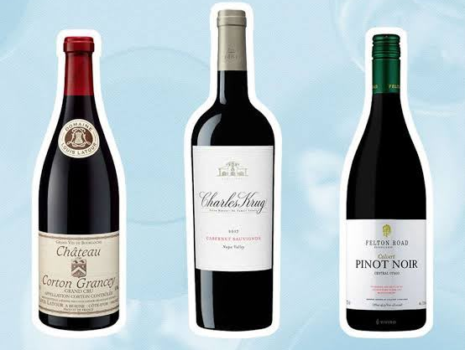
Examples of Red Wines
* Bordeaux Red Blend – France
* Chianti – Italy
* Rioja Red – Spain
* Barossa Shiraz – Australia
* Malbec – Argentina
WHITE WINE
Definition: White wine is wine produced from white grapes or, in some cases, dark-skinned grapes, with little or no skin contact during juice fermentation.
Characteristics
* Colour ranges from pale lemon and straw to golden yellow.
* Usually has little tannin compared with red wine.
* Common flavours include citrus, apple, pear, peach, and tropical fruits.
* Some wines develop buttery, creamy, vanilla, or nutty notes through winemaking and maturation.

White Wine Production Process

White or dark-skinned grapes
↓
Harvesting
↓
Destemming and crushing (where used)
↓
Pressing to separate juice from skins
↓
Juice clarification
↓
Fermentation
↓
Maturation in stainless-steel tanks or oak barrels
↓
Clarification and filtration (where used)
↓
Bottling

White wine is commonly fermented without grape skins. Fermentation may take place in stainless-steel tanks or oak barrels.
Major White Grape Varieties
1. Chardonnay
* Characteristics: Apple, citrus, and tropical fruits; may develop buttery or oak-related notes.
* Examples: Chablis (France), California Chardonnay (United States).
2. Sauvignon Blanc
* Characteristics: Citrus, gooseberry, green fruit, and herbal notes.
* Examples: Sancerre (France), Marlborough Sauvignon Blanc (New Zealand).
3. Riesling
* Characteristics: High acidity, citrus, floral notes; can be dry or sweet.
* Examples: Mosel Riesling (Germany), Alsace Riesling (France).
4. Pinot Grigio / Pinot Gris
* Characteristics: Pear, apple, and citrus; styles range from light and crisp to richer and fuller.
* Examples: Pinot Grigio from northern Italy, Pinot Gris from Alsace (France).
5. Chenin Blanc
* Characteristics: Apple, quince, honey, and refreshing acidity; can be dry or sweet.
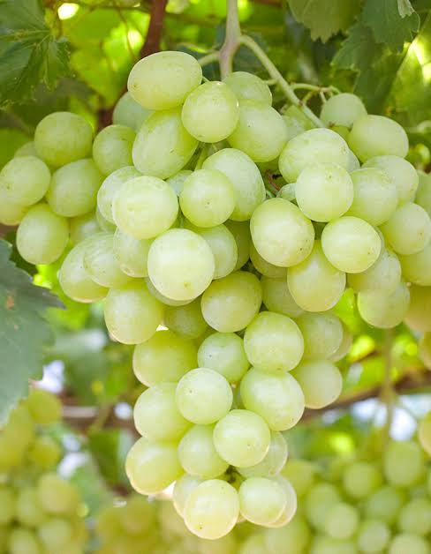
* Examples: Vouvray (France), Chenin Blanc from South Africa.
6. Gewürztraminer
* Characteristics: Highly aromatic, with floral, lychee, and spice notes.
* Examples: Alsace Gewürztraminer (France).
7. Viognier
* Characteristics: Peach, apricot, and floral aromas; often has a rich texture.
* Examples: Condrieu (France).
8. Moscato / Muscat
* Characteristics: Grapey, floral, and aromatic; can be still, sparkling, dry, or sweet.
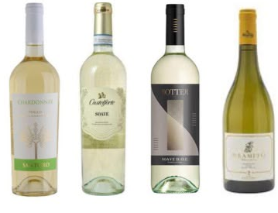
* Examples: Moscato d’Asti (Italy), Muscat wines from France.
Examples of White Wines
* Chablis – France
* Sancerre Blanc – France
* German Riesling – Germany
* Soave – Italy
* Marlborough Sauvignon Blanc – New Zealand
ROSÉ WINE
Definition: Rosé wine is a wine with a pink colour produced mainly from dark-skinned grapes using controlled skin contact or other permitted winemaking techniques.
Characteristics
* Colour ranges from pale pink and salmon to deeper pink.
* Often has flavours of strawberry, raspberry, watermelon, and citrus.
* Usually has refreshing acidity.
* Can be dry, off-dry, or sweet.
Rosé Wine Production Methods
Method 1: Short Maceration Method
Dark-skinned grapes are crushed and left in contact with their skins for a short period. The juice is then separated and fermented.
Method 2: Direct Pressing
Dark-skinned grapes are gently pressed, allowing a small amount of colour to enter the juice before fermentation.
Method 3: Blending
Red wine and white wine are blended to produce a pink wine where permitted. This method is restricted for certain protected wine categories.
Rosé Wine Production Process
Dark-skinned grapes
↓
Harvesting
↓
Gentle crushing or pressing
↓
Short skin contact (where used)
↓
Separation of juice from skins
↓
Fermentation
↓
Maturation
↓
Clarification and filtration (where used)
↓
Bottling
Examples
* Provence Rosé – France
* White Zinfandel – United States
* Rosado – Spain
* Rosato – Italy
SPARKLING WINE
Definition: Sparkling wine is wine containing carbon dioxide that produces bubbles and effervescence when the bottle is opened and the wine is served.
Carbon dioxide may be produced by a second fermentation or introduced through an authorised carbonation process, depending on the type of wine.
Characteristics
* Contains dissolved carbon dioxide.
* Produces bubbles and foam when poured.
* Can be white, rosé, or red.
* Can range from very dry to sweet.
* Often served as an aperitif or at celebrations.
A. Traditional Method
Also known as the traditional bottle-fermentation method.
In this method, the second fermentation takes place inside the bottle.
Examples: Champagne, Cava, and Crémant.
B. Tank Method
Also called the Charmat method or Martinotti method.
The second fermentation takes place in a sealed pressure tank rather than in individual bottles.
Example: Prosecco made by the tank method.
C. Ancestral Method
In this method, fermentation begins before the wine is bottled and finishes inside the bottle.
It can produce naturally sparkling wines with a range of appearances and flavour profiles.
Example: Some Pét-Nat wines.
D. Carbonation Method
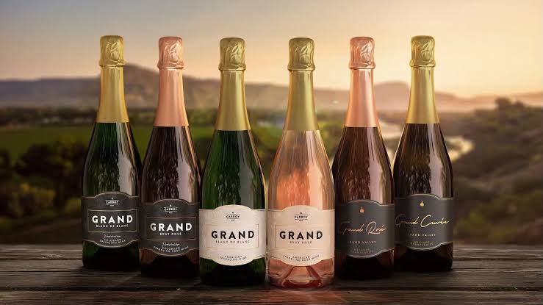
In this method, carbon dioxide is introduced into the wine rather than being produced through a second fermentation in the bottle or tank.
The resulting wine is bottled under pressure
Examples of Sparkling Wine Styles
1. Champagne – France
A protected sparkling wine from the Champagne region.
2. Prosecco – Italy
Commonly produced using the tank method.
3. Cava – Spain
Traditionally produced using bottle fermentation.
4. Crémant – France
Traditional-method sparkling wine produced outside Champagne.
5. Asti – Italy
Aromatic sparkling wine made primarily from Moscato Bianco.
6. Franciacorta – Italy
Traditional-method sparkling wine.
7. Sekt – Germany and other countries
A German-language term for sparkling wine.
8. Pét-Nat – Various countries
Often made using the ancestral method.

WHAT IS CHAMPAGNE?
Definition: Champagne is a protected sparkling wine produced in the Champagne wine region of France according to its appellation regulations.
Not every sparkling wine can legally be called Champagne.
Main Grape Varieties
1. Chardonnay
2. Pinot Noir
3. Meunier
Main Production Method
Champagne is produced using the traditional method, with the second fermentation taking place inside the bottle.

Champagne Production Process
Grape harvesting
↓
Pressing
↓
Primary fermentation
↓
Blending (where used)
↓
Tirage
↓
Bottling
↓
Second fermentation in bottle
↓
Lees ageing
↓
Riddling
↓
Disgorgement
↓
Dosage (where used)
↓
Corking and labelling
Important Champagne Styles
1. Non-Vintage (NV)
A blend of wines from different harvest years, made to maintain a house style.
2. Vintage Champagne
Made from grapes harvested in a declared vintage year, according to the applicable regulations.
3. Blanc de Blancs
Champagne made exclusively from white grape varieties, commonly Chardonnay.
4. Blanc de Noirs
Champagne made exclusively from permitted dark-skinned grapes, commonly Pinot Noir and/or Meunier.
5. Rosé Champagne
Pink Champagne made using permitted rosé production techniques.
6. Prestige Cuvée
A producer’s specially selected premium cuvée. The term is not itself a guarantee of a particular sweetness level.

Champagne Label Terminology
Label term Meaning
Brut Nature / Zero Dosage Very low residual sugar; no sugar added in the dosage
Extra Brut Very dry, with low residual sugar
Brut Dry style of sparkling wine
Extra Dry Despite the name, sweeter than Brut
Sec Sweeter than Extra Dry
Demi-Sec Medium-sweet to sweet style
Doux Sweet style
Blanc de Blancs Made exclusively from white grape varieties
Blanc de Noirs Made exclusively from dark-skinned grape varieties
Rosé Pink Champagne
Vintage / Millésimé Identifies a particular harvest year
Non-Vintage / NV Blend of wines from more than one harvest year
Grand Cru / Premier Cru Terms associated with designated vineyard villages under Champagne’s classification system
Champagne sweetness terms are defined by residual sugar ranges. The terms and legal requirements should be interpreted according to the applicable wine regulations.
SWEETNESS CLASSIFICATION OF SPARKLING WINE
The following are commonly used sweetness categories. The exact permitted sugar ranges can vary according to the applicable regulations and wine category.
- Label term General description
- Brut Nature Extremely dry
- Extra Brut Very dry
- Brut Dry
- Extra Dry Slightly sweeter than Brut
- Dry / Sec Noticeably sweeter than Brut
- Demi-Sec Medium-sweet
- Doux Sweet

Bartender’s knowledge: Extra Dry is generally sweeter than Brut. This is a common point of confusion when reading sparkling wine labels.

FORTIFIED WINE
Definition: Fortified wine is wine to which distilled grape spirit, usually grape brandy, has been added during or after fermentation.
Fortification increases the alcohol content and can influence the sweetness, stability, and flavour of the wine.
Characteristics
* Generally has a higher alcohol content than ordinary table wine.
* Commonly ranges from approximately 15–22% ABV, depending on the style.
* Can be dry, medium-sweet, or sweet.
* Often served in smaller portions than ordinary table wine.
Fortified Wine Production Process

Grape harvesting
↓
Crushing and pressing
↓
Fermentation
↓
Addition of grape spirit during or after fermentation
↓
Maturation
↓
Blending (where used)
↓
Bottling
The timing of fortification affects the final style. For example, adding spirit during fermentation can leave more natural grape sugar in the wine.
Major Types of Fortified Wine
A. Port
Country: Portugal
Port is a fortified wine traditionally associated with the Douro region.
Production: Fermentation is commonly interrupted by the addition of grape spirit, preserving some natural grape sweetness.
Main styles:
* Ruby Port
* Tawny Port
* Vintage Port
* Late Bottled Vintage (LBV)
* White Port
B. Sherry
Country: Spain
Sherry is a fortified wine from the Jerez region of Spain.
Production: The base wine is fermented and then fortified. Depending on the style, it may be aged under a layer of yeast called flor or exposed to oxygen during maturation.
Main styles:
* Fino
* Manzanilla
* Amontillado
* Oloroso
* Palo Cortado
* Pedro Ximénez (PX)
* Cream Sherry
C. Madeira
Country: Portugal
Madeira is a fortified wine from the Madeira Islands.
It is known for its distinctive maturation process, which involves controlled heat and oxidation.
Main styles:
* Sercial – generally dry
* Verdelho – generally medium-dry
* Bual – generally medium-sweet
* Malmsey – generally sweet
D. Marsala
Country: Italy
Marsala is a fortified wine from Sicily.
It can be dry or sweet and is used both as a beverage and in cooking.
E. Vermouth
Vermouth is an aromatised, fortified wine flavoured with botanicals, including herbs and spices.
Main styles:
* Dry Vermouth
* Sweet Vermouth
* Bianco Vermouth
* Rosso Vermouth
Vermouth is particularly important in classic cocktails such as the Martini and Manhattan.
TABLE WINE
Definition: Table wine generally refers to ordinary still wine intended for everyday drinking, rather than sparkling or fortified wine.
The exact legal meaning of table wine varies between countries. In some wine-producing countries, the term also has a specific regulatory meaning.
Characteristics
* Usually still, without significant carbonation.
* Commonly has an alcohol content of approximately 8–15% ABV.
* Can be red, white, or rosé.
* Can be dry, off-dry, or sweet, depending on the wine.
* Commonly served with meals.
Examples
* Cabernet Sauvignon
* Merlot
* Chardonnay
* Sauvignon Blanc
* Pinot Grigio
* Rosé
Important: Table wine does not mean low-quality wine. It is a category or style designation, and the precise meaning depends on the country’s regulations.
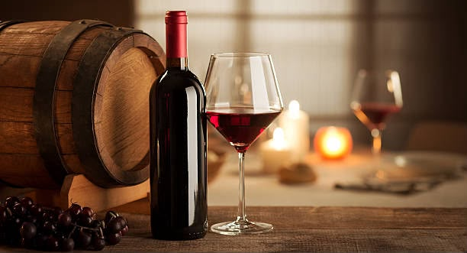

DESSERT WINE
Definition: Dessert wine is a broad category of wines that are sweet or intended to be served with desserts or as a dessert course.
Dessert wines may be produced through different methods, including late harvesting, drying grapes, noble rot, freezing grapes while on the vine in suitable climates, or fortification.
Common Styles
1. Late-Harvest Wine
Made from grapes harvested later, often with higher sugar levels.
2. Noble-Rot Wine
Made using grapes affected by beneficial Botrytis cinerea under suitable conditions.
3. Ice Wine
Made from grapes that freeze naturally on the vine under suitable conditions.
4. Passito Wine
Made using grapes that have been dried to concentrate sugars and flavours.
5. Sweet Fortified Wine
Sweet wine whose production involves fortification.
Examples: Sauternes, Tokaji, Icewine, and certain styles of Port.
HOW TO READ A WINE LABEL
A wine label provides information about the wine’s origin, grape variety, producer, vintage, and style.
Important Terms on Wine Labels
Label information Meaning
Producer / Winery The company or individual responsible for producing the wine
Country / Region The geographical origin of the wine
Appellation A legally defined wine-producing area with specific production rules
Grape variety The grape used to make the wine, when stated
Vintage The year in which the grapes were harvested
Non-Vintage (NV) Wine made using grapes or base wines from multiple harvest years
ABV Alcohol by volume, expressed as a percentage
Dry A wine with little residual sugar, according to the applicable definition
Reserve A term whose meaning and legal requirements vary by country and region
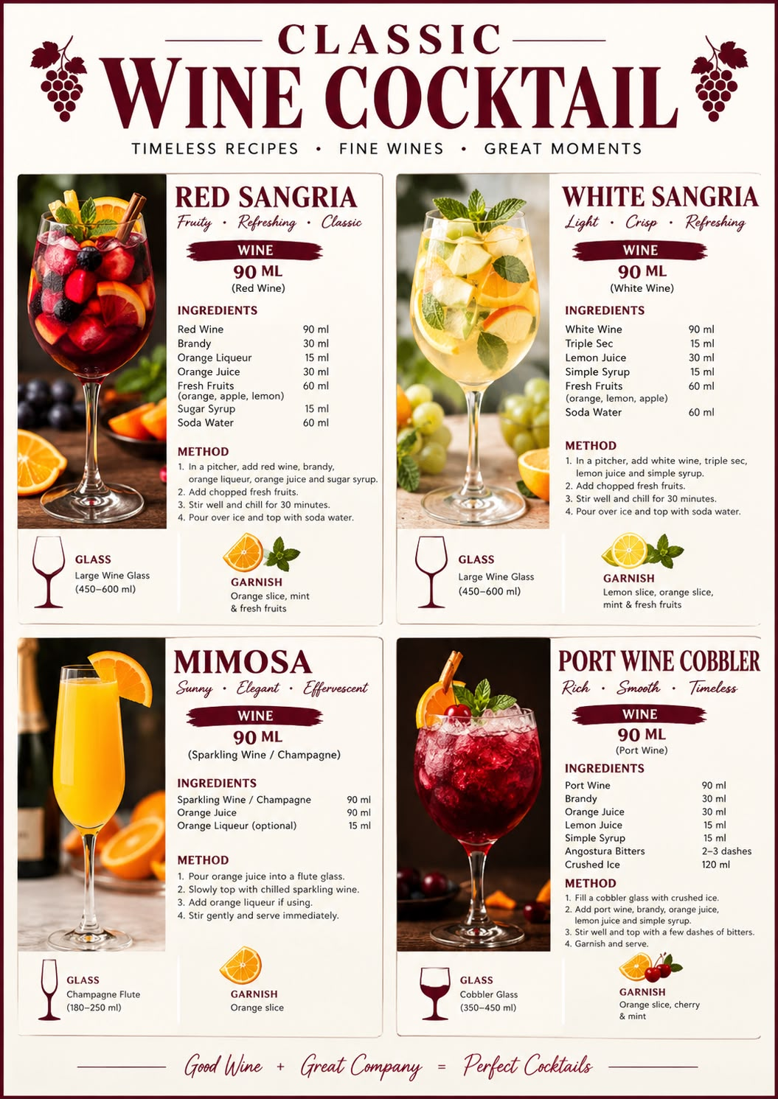

26. Cider
Cider is an alcoholic beverage produced by fermenting the juice of apples. It is generally refreshing, fruity, and slightly acidic. Cider can be still or carbonated, and its alcohol content commonly ranges from approximately 3% to 8% ABV, depending on the style and production method.
Production of Cider:
Apples → Washing and Crushing → Juice Extraction → Fermentation → Maturation → Filtration (Optional) → Carbonation (Optional) → Bottling
Types of Cider:
* Still Cider: Cider without noticeable carbonation.
* Sparkling Cider: Carbonated cider with a fizzy texture.
* Sweet Cider: Contains a higher level of residual sugar.
* Dry Cider: Contains little residual sugar and has a less sweet taste.
* Fruit Cider: Cider flavoured with fruits such as berries, pears, or other fruits.
Brand Examples:
* Somersby
* Strongbow
* Magners
* Thatchers
Uses of Cider:
* Served chilled as a refreshing alcoholic beverage.
* Used as an ingredient in cocktails and mixed drinks.
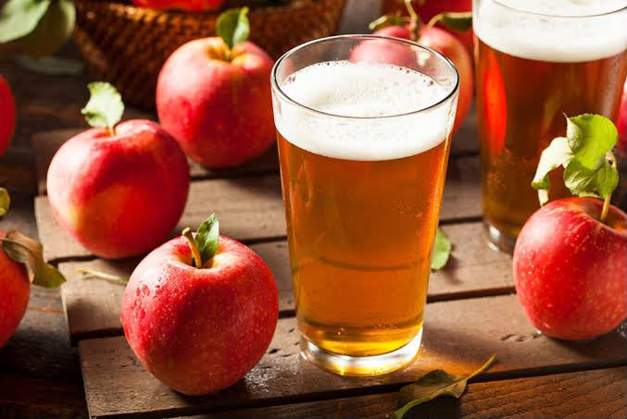
* Paired with dishes such as grilled meats, cheese, and light snacks.
* Used in cooking and certain beverage preparati

27. Bitters
Bitters are concentrated alcoholic or non-alcoholic preparations flavoured with herbs, roots, spices, fruits, and botanicals. They have a predominantly bitter taste and are used in small quantities to add complexity, aroma, and balance to beverages.
Production of Bitters:
Herbs, Roots, Spices and Botanicals → Infusion or Maceration in Alcohol or Water → Extraction of Flavours → Blending → Filtration → Bottling
Types of Bitters:
* Aromatic Bitters: Provide complex herbal and spicy flavours.
* Orange Bitters: Add citrus aroma and flavour.
* Herbal Bitters: Made using various herbs and botanicals.
* Digestive Bitters: Traditionally served before or after meals in some drinking cultures.
Brand Examples:
* Angostura Aromatic Bitters
* Peychaud’s Bitters
* Regans’ Orange Bitters
* Fee Brothers
Uses of Bitters:
* Used in small quantities to balance sweetness and enhance flavour in cocktails.
* Add aroma, depth, and complexity to mixed drinks.
* Used in classic cocktails such as the Old Fashioned, Manhattan, and Sazerac.
* Some bitters are traditionally served as aperitifs or digestifs.
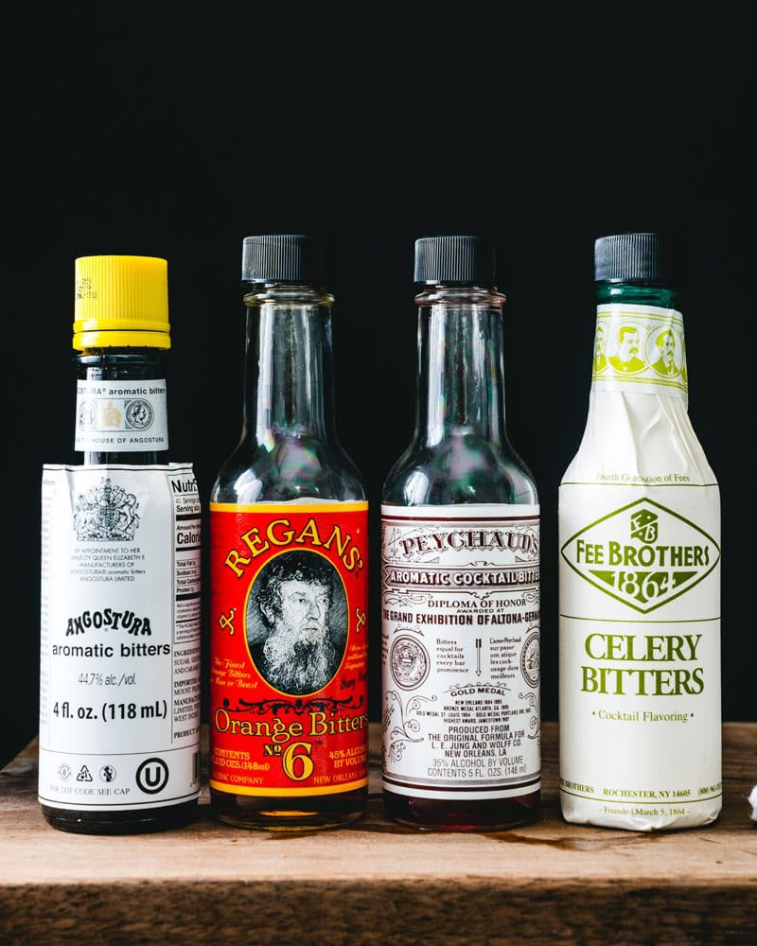

28. Absinthe
Absinthe is a high-alcohol, anise-flavoured distilled spirit traditionally made using wormwood, green anise, fennel, and other botanicals. It is known for its herbal aroma, strong flavour, and traditionally green colour.
Absinthe is commonly known as the “Green Fairy” (La Fée Verte).
History
Absinthe originated in Switzerland during the late 18th century and became particularly popular in France during the 19th century. It was associated with artists, writers, and café culture.
Due to health concerns and controversy surrounding its consumption, absinthe was prohibited in several countries during the early 20th century. Modern absinthe is legally produced in many countries under applicable regulations.
Main Ingredients
* Grand Wormwood (Artemisia absinthium)
* Green Anise
* Sweet Fennel
* Other herbs and botanicals, depending on the recipe
Production of Absinthe
Neutral Alcohol + Wormwood + Anise + Fennel + Other Botanicals
↓
Maceration or Infusion
↓
Distillation (Traditional Distilled Style)
↓
Blending and Dilution to Bottling Strength
↓
Natural Colouring (Optional)
↓
Filtration (Optional)
↓
Bottling
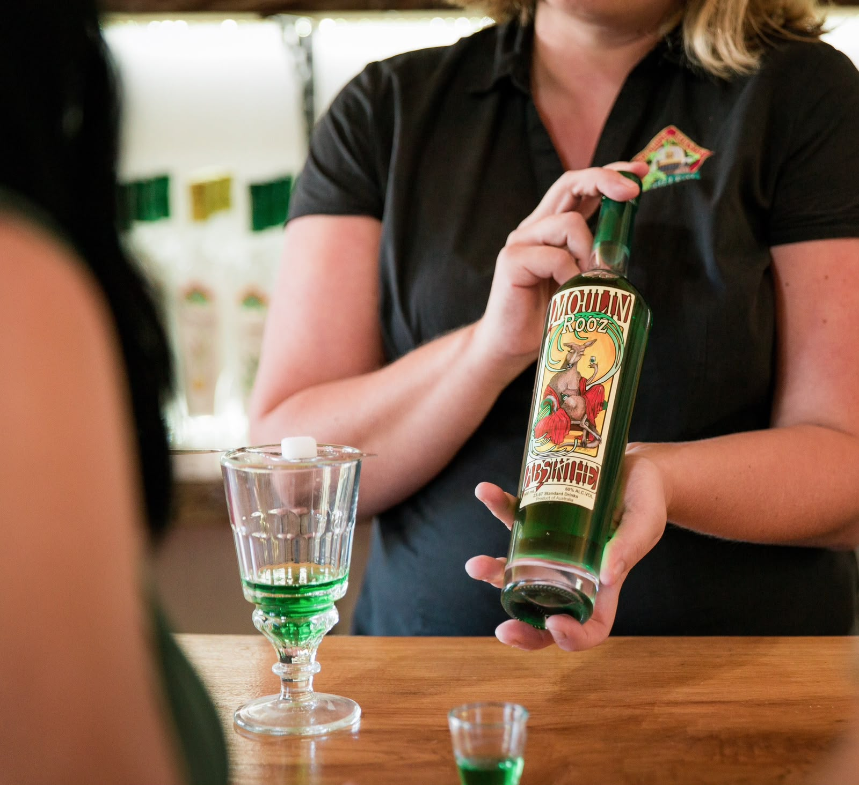

Types of Absinthe
Verte (Green Absinthe): Traditionally obtains its green colour from chlorophyll extracted from herbs during colouring.
Blanche (White Absinthe): A clear or colourless style, generally bottled without the traditional green colouring stage.
Bohemian-Style Absinthe: Often characterised by a different flavour profile and production approach, sometimes with a reduced emphasis on the traditional anise flavour.
Alcohol Content
Absinthe is generally a high-strength spirit, commonly bottled at approximately 45%–74% ABV, although strengths vary by brand and style.
Traditional Serving Method
Absinthe → Pour into a glass → Place a slotted absinthe spoon with a sugar cube over the glass → Slowly drip cold water over the sugar → Allow the drink to turn cloudy → Serve.
This cloudy effect is known as the “Louche.”
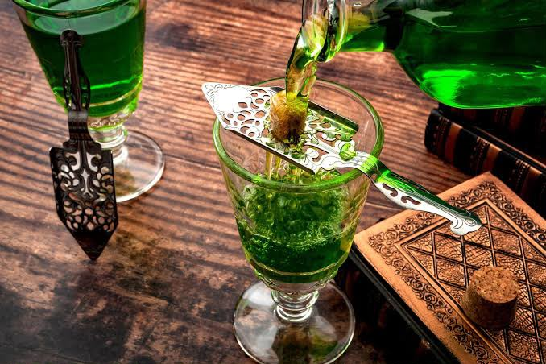

29. Sake
What Is Sake?
Sake is a traditional Japanese alcoholic beverage made from fermented rice. It is often called rice wine, but its production process is more similar to beer because the starch in rice must first be converted into fermentable sugars.
Country of Origin
* Country: Japan 🇯🇵
* National Beverage: Sake is one of Japan’s traditional and culturally significant alcoholic beverages.
Main Ingredients
* Rice
* Water
* Koji (Aspergillus oryzae)
* Yeast
Production Process
Rice Polishing → Washing & Steaming → Koji Preparation → Fermentation → Pressing → Filtration → Bottling
Types of Sake
1. Junmai: Made using rice, water, koji and yeast, without added brewing alcohol.
2. Honjozo: Made with polished rice, koji, water and a small amount of added brewing alcohol.
3. Ginjo: Premium sake made using highly polished rice and a carefully controlled brewing process.
4. Daiginjo: A premium category of sake made using very highly polished rice.
5. Nigori: Cloudy sake containing fine rice particles.
Alcohol Content
Typically around 13–16% ABV, although some varieties may fall outside this range.
Serving Methods
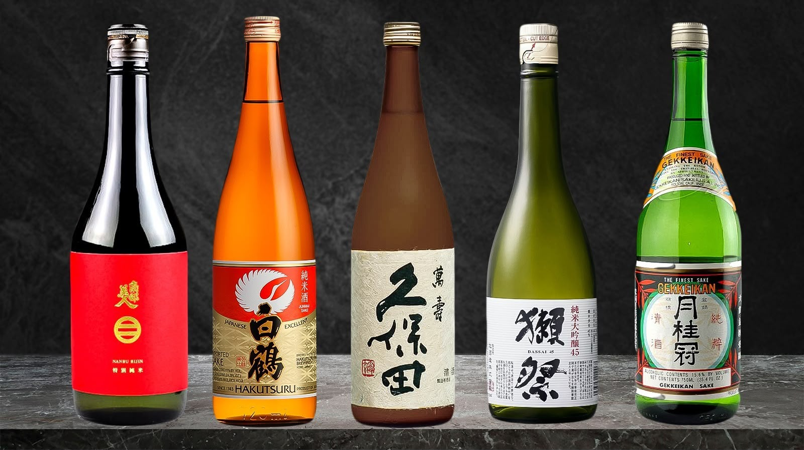
* Served chilled.
* Served at room temperature.
* Served gently warmed, depending on the style of sake..
Popular Japanese Sake Brands
* Gekkeikan
* Hakutsuru
* Dass

30. Mead
Definition Mead is an alcoholic beverage produced by fermenting honey mixed with water using yeast. It is commonly known as honey wine and can be sweet, semi-sweet, or dry. It may also contain fruits, herbs, or spices.
History
Mead is considered one of the oldest alcoholic beverages in the world. Archaeological evidence from Jiahu, China, dating to approximately 7000 BCE, indicates the presence of an ancient fermented beverage containing honey, rice, and fruit. Mead was also popular among ancient European cultures, including the Vikings.
Making Process
1. Preparation: Honey is mixed with water to create a fermentable solution called must.
2. Yeast Addition: Yeast is added to convert the natural sugars into alcohol and carbon dioxide.
3. Fermentation: The mixture is allowed to ferment under controlled conditions.
4. Clarification: The fermented liquid is separated from the yeast sediment and clarified.
5. Maturation: The mead is aged to develop its flavour and aroma.
6. Bottling: The finished mead is filtered if required and bottled.
Brand Examples
* Moonshine Meadery – India
* Gosnells of London – United Kingdom
* Superstition Meadery – United States
* All-Wise Meadery – United States
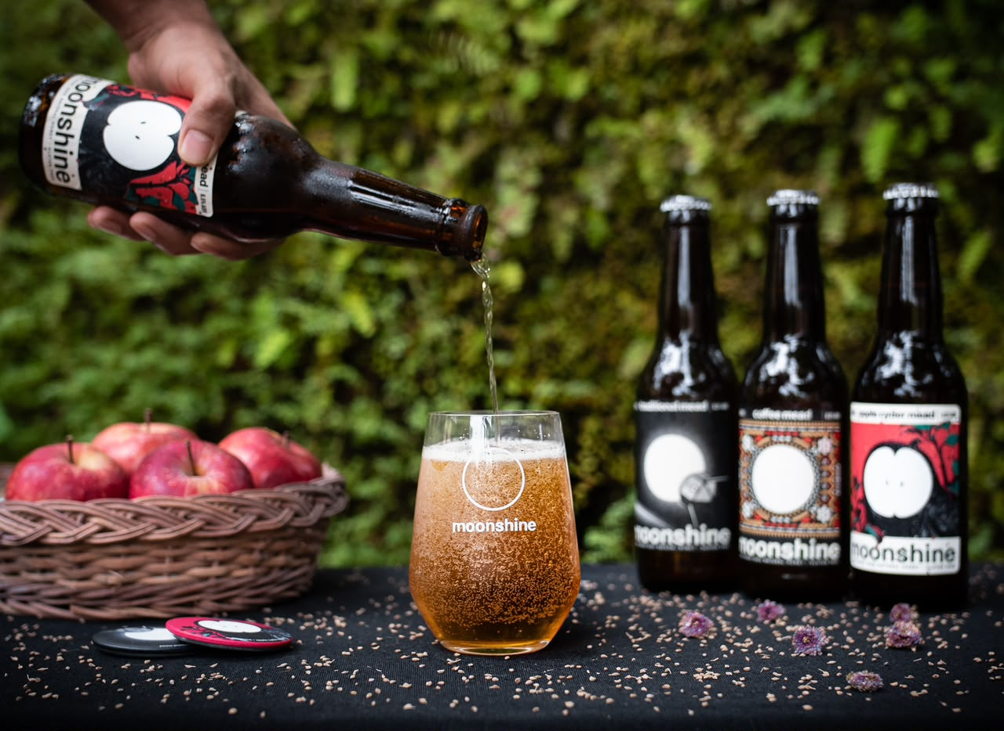

Bottle Level Measurement & spirit Stock Control
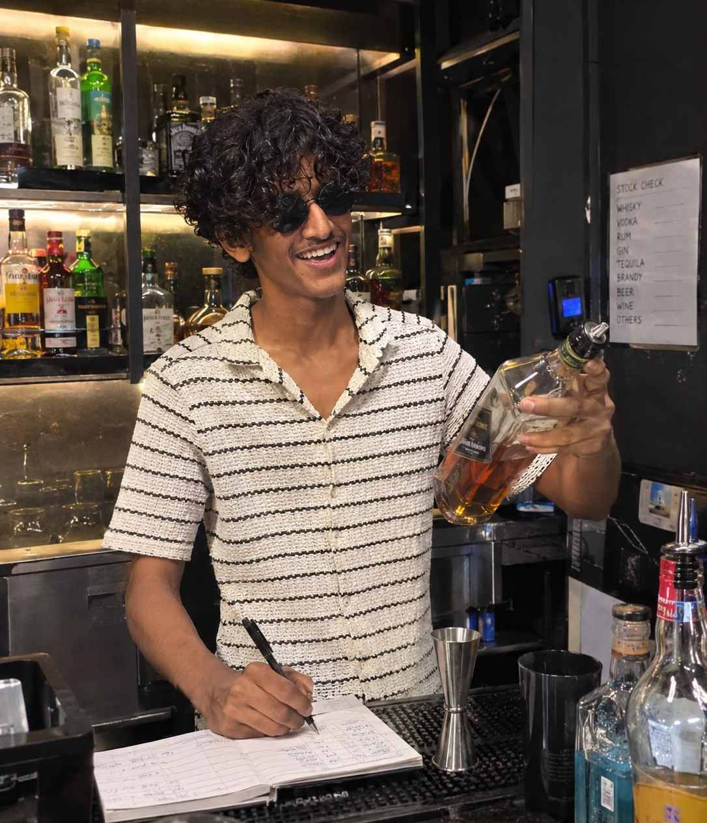

Importance of Bottle Level Measurement and Spirit Stock Control
1. Helps maintain accurate records of the remaining spirits in each bottle.
2. Prevents unnecessary wastage, overpouring, and stock discrepancies.
3. Helps identify possible pilferage and unauthorized consumption.
4. Ensures proper inventory management and timely reordering of stock.
5. Helps control beverage costs and improve bar profitability.
6. Supports accurate daily sales and consumption reports.
7. Maintains accountability among bartenders and bar staff.
8. Ensures smooth bar operations and efficient stock management.

