Crime Rate Prediction & Analysis using K-Means Clustering Algorithm

In this project we have added RMSE and MSE comparison between different attributes such as Theft, Murder and Rape. RMSE and MSE refers to difference between actual value and test value so the lower the MSE the better is the forecasting algorithm.

We have added comparison inside admin module, when admin upload dataset then all algorithms get trained on Rape, murder and theft attributes and then calculate MSE values.

Below is the comparison output

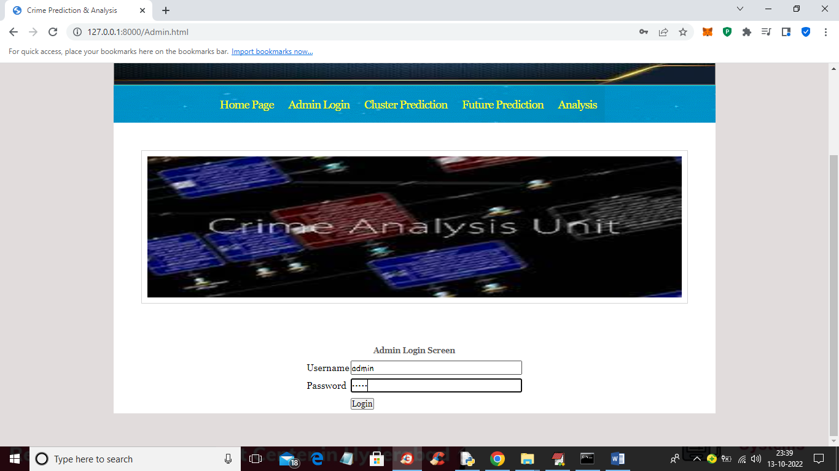

In above screen admin is login and after login will get below screen

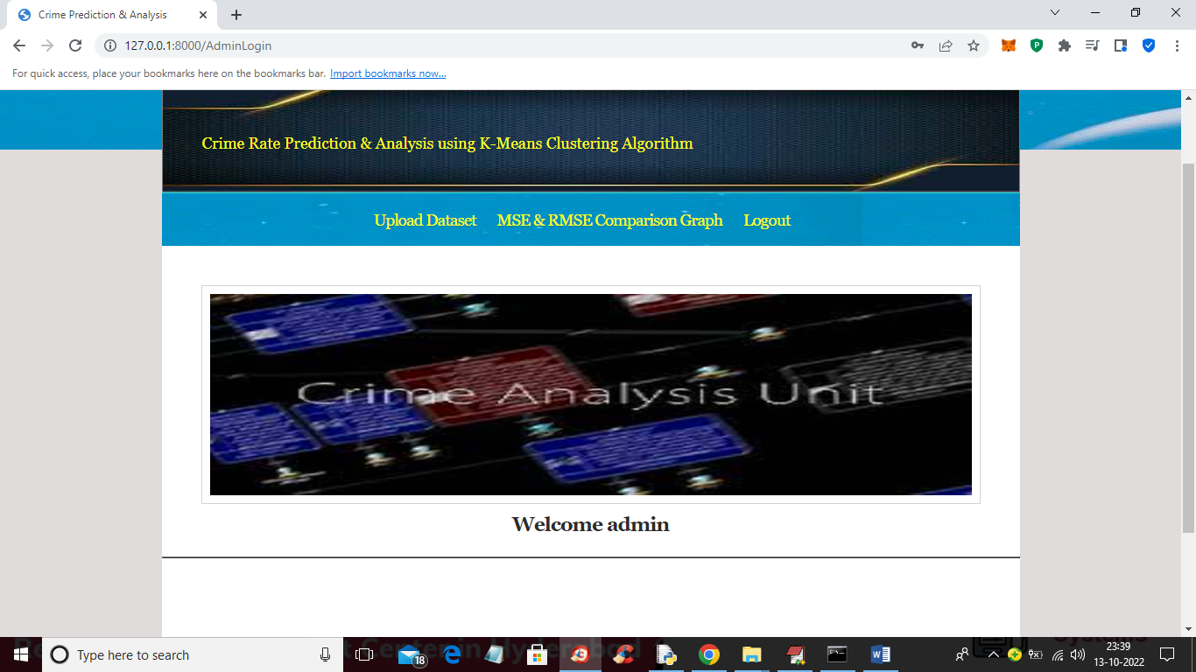

In above screen click on ‘Upload Dataset’ link to get below screen

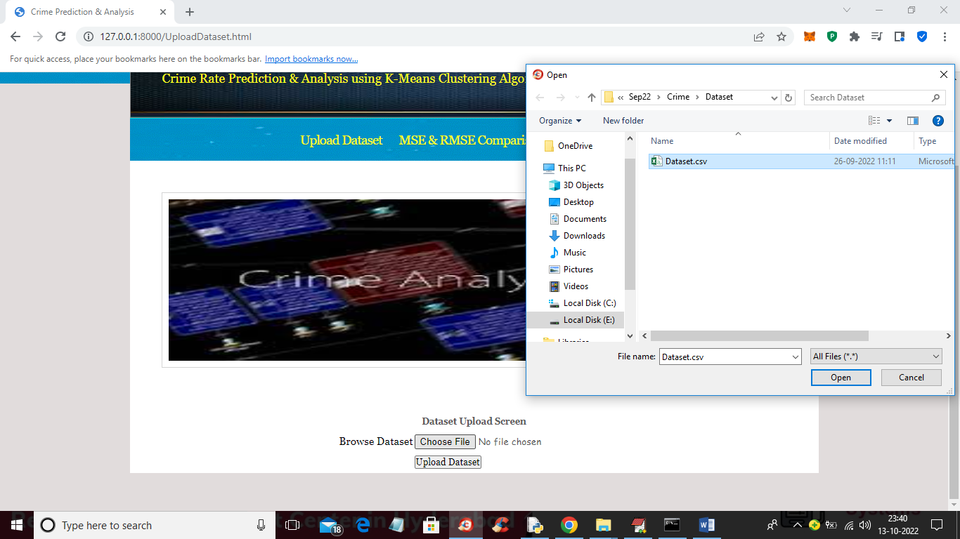

In above screen selecting and uploading ‘Dataset.csv’ file and then click on ‘Open’ and ‘Upload Dataset’ button to load dataset and get below output

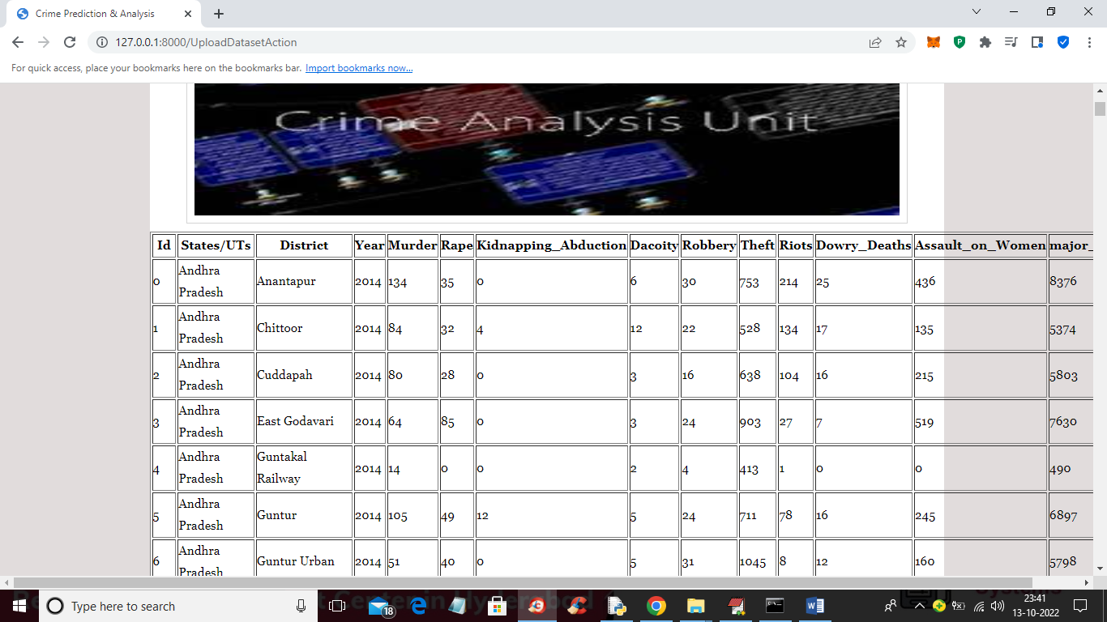

In above screen dataset loaded and all algorithms get trained and now click on ‘MSE & RMSE Comparison Graph’ link to get below comparison graph

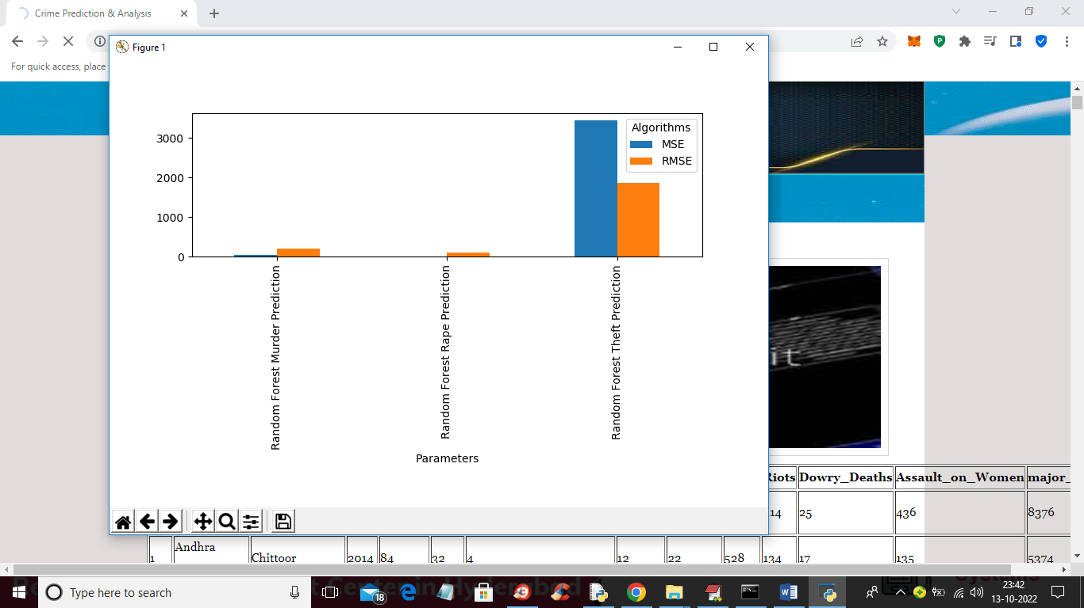

In above graph x-axis represents algorithm training on Theft, murder and rape and y-axis represents MSE and RMSE error. Blue bar represents MSE and orange bar represents RMSE. In all attributes Rape and Murder training got less error rate and now close above graph to get same values in tabular format

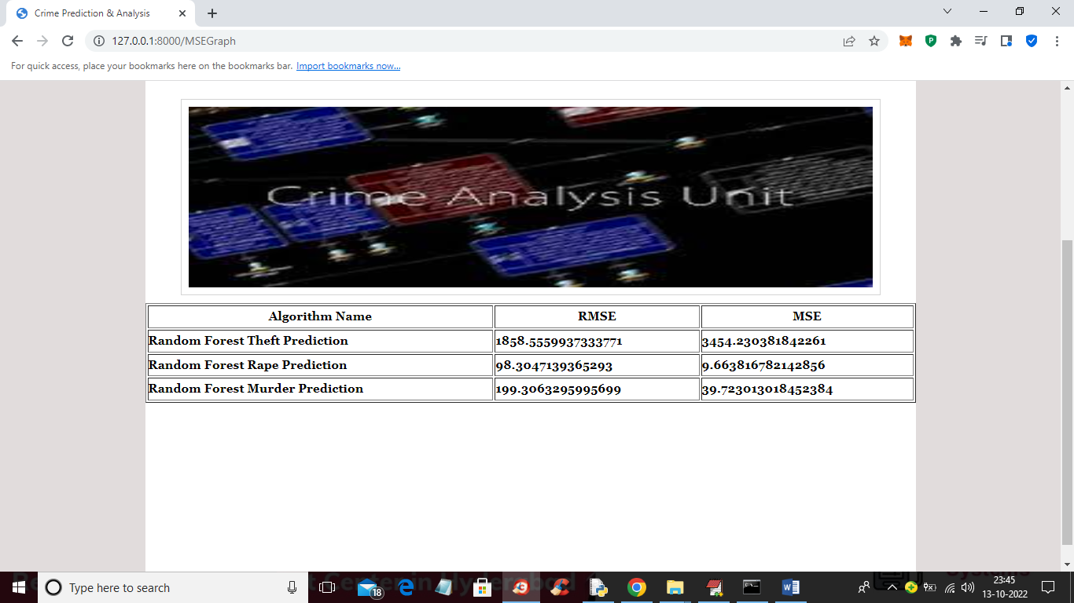

In above screen we can see RMSE and MSE comparison values of Random Forest on 3 different attributes such as Rape, murder and Theft. In all attributes Rape training got less RMSE and MSE.