Software Requirements Specification

Supervisor TA / Dalia Elalfy

for

(46) - Election Management System

Version 1.0

Prepared by

|  |  |  |  |
| --- | --- | --- | --- |
| Name | ID | department | Section |
| مروان أحمد محمد فوزي | 20191700616 | IS | 5 |
| أمل يوسف صالح يوسف | 20191700133 | SC | 1 |
| محمود ابراهيم محمود عبدالفتاح | 20191700591 | IS | 0 |
| ندى محمد تعلب عبداللاه | 20191700686 | SC | 5 |
| نيفين أحمد ابراهيم | 20191700722 | SC | 5 |
| فوزي أحمد فوزي أحمد | 20191700442 | NOT YET |  |
| عمر إسماعيل محمد عبدالرحمن | 20201701111 | NOT YET | 18 |

# Introduction

## Document Purpose

**The purpose of this document is to describe the Election Management System. It will contain the behavior of the System and its functional and non-functional requirements and constrains, and it will illustrate the Mechanism of the System.**

## Intended Audience

**The Election Management System is made for those who overseas, senior citizens, and disabled people. Using an online voting system eases the voting process, as traditionally the Citizen must vote in Voting Centers, which is quite complicated for the intended audience, this allows all sorts of people to vote**

# Context diagram

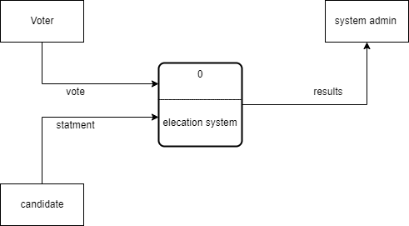

# User Requirements

1. **Election system shall let the user to record their votes for specific candidate.**
2. **Election system shall make it possible to every candidate to add their statement.**
3. **Election system shall generate result after the election period ends.**
4. **Election system shall allow candidate to modify their statement, and personal data.**
5. **Admin of Election system shall approve user information.**
6. **Every user shall be let to view any statement from any candidate.**
7. **Deleting user shall be the authority of admin only.**
8. **User can’t vote without having an approved account.**

# Functional Requirements:

## Show all candidates

– Description/ Action: user can see a list which contains all candidate names and a clickable button to show the statement of specific candidate

– Requirements/ Inputs: click on view button

– Source: User

– Pre-condition:

1. Registered and validated
2. Logged in

– Post-condition: None

– Output: list with all candidates preview (name, photo, and sign)

## Show Candidate statement

– Description/ Action: user will be shown a page with the chosen candidate statement

– Requirements/ Inputs: click on show statement button

– Source: User

– Pre-condition:

1. Registered and Validated
2. Logged in

– Post-condition: None

– Output: A page with specific candidate statement

## Result Generation

– Description/ Action: Admin can show results of Election

– Requirements/ Inputs: Button click

– Source: Admin

– Pre-condition:

1. Admin account is performing the action
2. Election period has ended (Otherwise show exception message)

– Post-condition: Winner must be selected

– Output: Results of Election and the winner candidate with number of votes

## Voting

– Description/ Action: User can vote for a specific candidate

– Requirements/ Inputs: Button click

– Source: User

– Pre-condition:

1. After selecting a candidate and showing his statement.
2. Election period has started.
3. Election period hasn’t ended.
4. Registered and validated.
5. Logged in.

– Post-condition:

1. Candidate votes is incremented.
2. User ability to vote is disabled.

– Output: User is shown a dialog “successfully voted”

## Approving User account

– Description/ Action: Admin will accept or decline Registered account

– Requirements/ Inputs: Button click

– Source: Admin

– Pre-condition:

1. Admin account

– Post-condition:

1. Account must be deleted if declined.
2. User ability is enabled if accepted.

– Output: None

# Non-Functional Requirements:

1. **System can’t be down for more than five minutes a day.**
2. **System must lemmatize user errors for exactly one error per user.**
3. **System is easy to use after of 30 minutes of training.**
4. **User data must be secured and encrypted.**
5. **The used language is C#**
6. **Response time for any operation must be less than 5 seconds.**
7. **Database must be developed using SQL development tool.**
8. **Database is always up to date.**

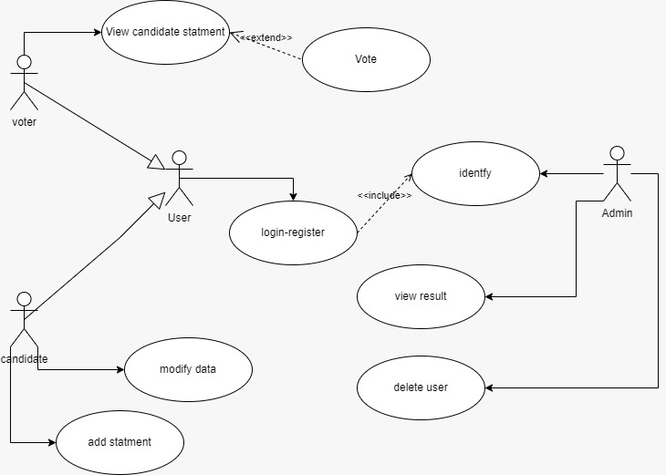

# Use Case:

# 7 Sequence Diagram for view candidate statement use case:

