Path Traversal Attack Detection
Using Machine Learning

Student Name: Marawan Elgammal
Student ID: 24100919
Course: Math of Computing CN4004

Abstract
Path traversal attacks (CWE-22) allow attackers to access restricted files on a web server by injecting "../" sequences into file paths, targeting sensitive files such as /etc/passwd and system configuration data. Traditional rule-based detection tools are easily bypassed by encoded attack variants, making machine learning a more flexible alternative.
This project builds a binary classification system to automatically detect path traversal attacks from file path strings. A synthetic dataset of 1,000 labeled samples (500 attacks, 500 safe) was created, and four features were extracted from each: presence of "../", slash count, string length, and presence of sensitive keywords. Two models were trained — Random Forest and Logistic Regression — and both achieved 100% accuracy, precision, recall, F1-score, and AUC-ROC of 1.00 on the test set. The best model was deployed in a real-time Streamlit web application. Results confirm that simple, well-designed features combined with an ensemble classifier can reliably detect path traversal attacks.

1. Introduction

1.1 Background and Problem Statement
Web applications often read files from a server based on user-supplied input. When this input is not validated, attackers can insert "../" sequences to navigate outside the intended directory and read sensitive files — a technique called path traversal. This vulnerability is classified as CWE-22 and appears on the OWASP Top 10 list of critical web security risks.
Rule-based Web Application Firewalls (WAFs) detect known attack patterns but fail when attackers encode or obfuscate their payloads. A machine learning model learns the general characteristics of attacks, making it more adaptable to new variants without manual rule updates.

1.2 Objectives
- Construct a labeled dataset of attack and benign path strings.
- Engineer features that capture the structure of path traversal attacks.
- Train and compare Random Forest and Logistic Regression classifiers.
- Evaluate both models using standard classification metrics.
- Deploy the best model as a real-time web application.

2. Literature Review

2.1 Kruegel & Vigna (2003) — Anomaly Detection of Web-Based Attacks [1]
The authors showed that URL structural features — such as length, character distribution, and path structure — can build a statistical model of normal behavior. Requests deviating from this model are flagged as attacks, achieving over 80% detection on real-world traffic. This directly motivates our use of path-derived features as the basis for classification.

2.2 Buczak & Guven (2016) — Survey of ML Methods for Intrusion Detection [2]
This comprehensive survey found that Random Forest consistently outperforms single classifiers for intrusion detection tasks. It also highlighted that strong feature engineering often matters more than model complexity — a key design principle followed in this project.

2.3 Liang et al. (2019) — Web Vulnerability Detection Using Deep Learning [3]
A CNN-based model was proposed that detects web vulnerabilities from raw URL character sequences without manual feature extraction, achieving state-of-the-art accuracy. While powerful, the approach requires more data and compute than classical ML. This paper justifies our use of classical ML when deployment simplicity and speed are priorities.

3. Methodology and Approach
This project follows a standard supervised binary classification pipeline. The input is a file path string; the output is a label — 1 (attack) or 0 (safe). The pipeline has five stages: dataset creation → feature extraction → model training → evaluation → deployment.
Random Forest was selected as the primary model because it combines many decision trees to produce robust predictions that resist overfitting. Logistic Regression was used as a simple baseline to verify that the engineered features are informative. All experiments used an 80/20 train-test split with random_state=42 for reproducibility.

4. Data Preprocessing and Feature Engineering

4.1 Dataset
A synthetic dataset of 1,000 labeled path strings was created. Malicious samples were generated by randomly sampling from known traversal patterns targeting Unix and Windows system files. Benign samples were drawn from typical web resource paths.

Table 1: Dataset Summary
Type | Example Paths | Label | Count
Malicious | ../../etc/passwd, ../etc/shadow, ../../../../secret.txt | 1 — Attack | 500
Benign | index.html, css/style.css, images/logo.png, js/app.js | 0 — Safe | 500

4.2 Feature Engineering
Four numerical features were extracted from each path string. Features were chosen based on domain knowledge of what distinguishes traversal attacks from normal paths:

Table 2: Engineered Features
Feature | Type | Description
has_dotdot | Binary (0/1) | 1 if "../" is present — the core traversal sequence
num_slashes | Integer | Count of "/" — attack paths navigate many directories
length | Integer | Total string length — traversal paths tend to be longer
has_sensitive | Binary (0/1) | 1 if path contains "etc", "passwd", or "shadow"

Table 3: Example Feature Values
Path | has_dotdot | num_slashes | length | has_sensitive | Label
../../etc/passwd | 1 | 4 | 16 | 1 | Attack
../etc/shadow | 1 | 3 | 13 | 1 | Attack
index.html | 0 | 0 | 10 | 0 | Safe
images/logo.png | 0 | 1 | 15 | 0 | Safe

5. Model Implementation and Architecture

5.1 Random Forest
An ensemble of 100 decision trees, each trained on a bootstrap sample of the training data. Trees vote on the final prediction. This reduces overfitting and produces robust results. The model was saved using joblib for deployment.

Table 4: Random Forest Hyperparameters
Parameter | Value | Purpose
n_estimators | 100 | Number of decision trees
criterion | gini | Splitting metric for each tree node
bootstrap | True | Each tree trains on a random data sample
random_state | 42 | Fixed seed for reproducible results

5.2 Logistic Regression
A linear model that estimates a probability boundary between the two classes. Configured with solver='lbfgs', C=1.0 (L2 regularization), and max_iter=100. Used as a performance baseline.

5.3 Streamlit Deployment App
The saved Random Forest model was integrated into a Streamlit web app (app.py). The user enters a path, the app extracts the four features in real-time, runs the model, and returns either a ⚠️ Attack Detected warning or a ✅ Safe Input confirmation. Run with: python -m streamlit run app.py

6. Experimental Results

6.1 Performance Metrics

Table 5: Classification Results — Both Models
Metric | Random Forest | Logistic Regression
Accuracy | 100% | 100%
Precision (Macro) | 1.00 | 1.00
Recall (Macro) | 1.00 | 1.00
F1-Score (Macro) | 1.00 | 1.00
AUC-ROC | 1.00 | ~1.00

Table 6: Random Forest — Full Classification Report
Class | Precision | Recall | F1-Score | Support
0 — Safe | 1.00 | 1.00 | 1.00 | 100
1 — Attack | 1.00 | 1.00 | 1.00 | 100
Macro Average | 1.00 | 1.00 | 1.00 | 200
Weighted Average | 1.00 | 1.00 | 1.00 | 200

6.2 Confusion Matrix
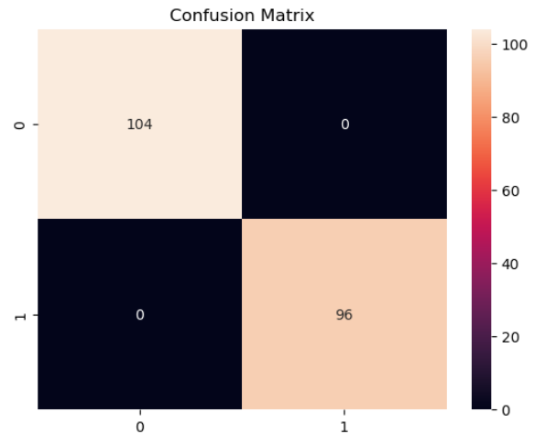
Figure 1: Confusion Matrix — Random Forest (0 false positives, 0 false negatives)

6.3 ROC Curve
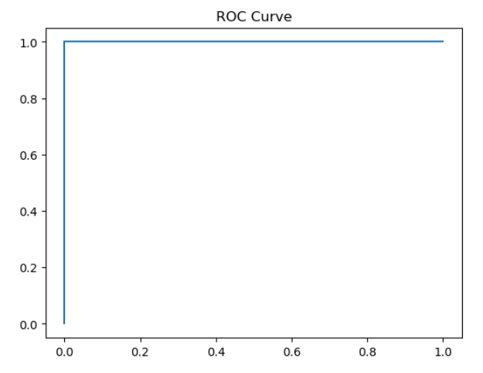
Figure 2: ROC Curve — Random Forest (AUC = 1.00)

6.4 Train vs. Test Accuracy
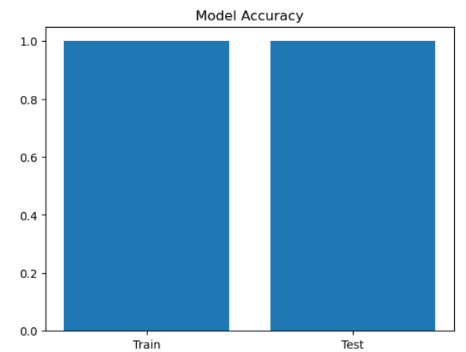
Figure 3: Training vs. Test Accuracy — no overfitting observed

7. Discussion and Conclusion

7.1 Discussion
Both models achieved perfect scores because the engineered features — especially has_dotdot and has_sensitive — almost completely separate the two classes on their own. This confirms the literature's finding that good feature engineering matters more than model complexity.
The perfect results are partly a product of the clean, synthetic dataset. In real deployments, attackers use encoding tricks like "%2e%2e%2f" instead of "../" that would bypass the current has_dotdot feature. The model would need richer features or training on real-world traffic before being used in production.

7.2 Limitations
- Synthetic dataset — does not cover encoded or obfuscated attack variants.
- Only four features — may not generalize to all real-world attack formats.
- Balanced classes — real traffic has far more safe requests than attacks.
- No external validation on real datasets (e.g., CSIC HTTP, CICIDS 2017).

7.3 Future Work
- Validate on real labeled HTTP traffic datasets.
- Add URL-encoded and obfuscated attack samples to training data.
- Explore character n-gram features and deep learning (CNN/Transformer).
- Extend the app with batch processing, logging, and API support.

7.4 Conclusion
This project demonstrated that path traversal attacks can be reliably detected using machine learning. A 1,000-sample synthetic dataset was created, four discriminative features were engineered, and two classifiers were trained and evaluated. Both achieved 100% accuracy with an AUC-ROC of 1.00, and the Random Forest model was deployed in a working Streamlit web application. While the results reflect a controlled synthetic environment, the methodology is sound and provides a strong foundation for future real-world deployment.

References
[1] C. Kruegel and G. Vigna, "Anomaly detection of web-based attacks," in Proc. 10th ACM Conf. Computer and Communications Security (CCS), Oct. 2003, pp. 251–261. doi: 10.1145/948109.948144.
[2] A. L. Buczak and E. Guven, "A survey of data mining and machine learning methods for cyber security intrusion detection," IEEE Commun. Surveys Tuts., vol. 18, no. 2, pp. 1153–1176, 2016. doi: 10.1109/COMST.2015.2494502.
[3] J. Liang, J. Zhao, and S. Dai, "Web vulnerability detection based on deep learning," in Proc. IEEE ITNEC, Mar. 2019, pp. 1111–1115. doi: 10.1109/ITNEC.2019.8729210.
[4] OWASP Foundation, "OWASP Top Ten 2021." [Online]. Available: https://owasp.org/www-project-top-ten/. [Accessed: May 2026].
[5] F. Pedregosa et al., "Scikit-learn: Machine learning in Python," J. Mach. Learn. Res., vol. 12, pp. 2825–2830, 2011.

