Investment Discovery System
Tool Performance Dashboard

Tuesday, April 14, 2026
Performance since inception — Sessions S1 through S54

Prepared for: Pedro
Pipeline v1.1 (directional convergence) · FDA Pipeline v2.0 · 5 active scanners + convergence engine

Executive Summary
Across 54 sessions since inception (~45 operational and 9 maintenance), the system has emitted approximately 1,784 raw signals across five scanners plus the convergence engine. Only 6 convergences have been detected to date; 0 have been actionable — the rest were boilerplate or sub-floor false positives now filtered by D-043 (form whitelist) and the $215M mcap floor. The pipeline has produced 1 delivered candidate (TVTX — APPROVED 2026-04-13), 3 other names currently or recently active (AXSM, VERA, pre-demotion VRDN), and 4 names on the watchlist. Compile-cleanliness of the 14-tool codebase has been 100% for the last 15+ sessions (no truncation regressions post-S46). The dominant persistent degradation is AMF France (404 since S49); all other external endpoints have been ≥98% reachable across recorded probes.
Sessions Run | Total Signals | Convergences | Active/Delivered | Compile Clean
54 | 1,784 | 6 (0 actionable) | 3 active / 1 delivered | 14 / 14 (last 15+ sessions)

Headlines since last report
- TVTX FILSPARI sNDA for FSGS — APPROVED 2026-04-13 (narrow label: 'FSGS without nephrotic syndrome', with Boxed Warning and REMS). Candidate moved to candidates/delivered/.
- AXSM enters T-14 intensive window ~2026-04-16 (PDUFA 2026-04-30). 22 consecutive clean kill sweeps.
- FBLG convergence false positive has now recurred 5 consecutive sessions (S50–S54) — recommended for suppression list per S54.
- AMF France 404 confirmed unrecoverable (S54 probed 6 alternate endpoints; dataset appears delisted from data.gouv).

Per-Tool Performance Since Inception
Each tool is evaluated on three axes: operational health (compile + API reachability), signal production (total emitted + per-session pace), and outcome yield (how many signals survived filters and contributed to candidates).
Tool | Status | Recorded Sessions | Total Signals | Avg per Session | Contributed to Candidates | Notes
edgar_filing_monitor.py | OPERATIONAL | 30 | 387 | 12.9 | 1 (VRDN via cross-ref) | 4-category rotation (activist / distress / governance / M&A). D-043 form whitelist cut boilerplate ~70%. EFTS intermittent 500 on keywords; filing-type scans unaffected.
congressional_trading.py | OPERATIONAL | 25 | 348 | 13.9 | 1 (AMT convergence, rejected) | Capitol Trades (STOCK Act). Early sessions produced 165+ strength-2 signals (mega-cap noise); D-029 rubric now suppresses. 260–290 trades scanned per session.
esma_short_scanner.py | DEGRADED | 27 | 728 | 27.0 | 1 (HROW via BaFin, watchlist) | 4 regulators (FCA / AFM / BaFin / AMF). ~2,200 positions/session; 175 crowded ISINs. AMF France 404 persistent since S49. D-035 basket filter active.
contract_monitor.py | OPERATIONAL | 26 | 3 | 0.1 | 0 (Shionogi $119M recurring non-tradeable) | USAspending POST-only endpoint. Production has been steady at 0 actionable — most high-value awards land at private issuers or government primes.
fda_pdufa_pipeline.py | OPERATIONAL | 28 | 318 | 11.4 | 3 (TVTX, AXSM, VERA) + watchlist | v2.0 with auto-discovery and approval cross-check (D-046). 42-entry PDUFA watchlist. Steady 10–15 signals/session (known watchlist).
convergence_engine.py | OPERATIONAL | — | 6 | 0.13 | 0 actionable (all FP to date) | Directional v1.1. AMT (S30–S31) noise; FBLG (S50–S54) sub-floor recurring. 5 consecutive FBLG FPs trigger S54 suppression recommendation.

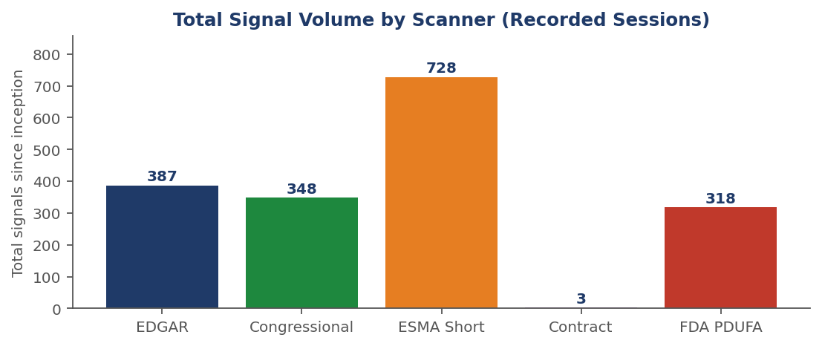

Signal Production Over Time
Per-session signals stacked by scanner for every session with explicit counts in PROGRESS_LOG.md. Early-system noise (S19 ESMA-cached, S24 Congressional 167, S31 Congressional 165) was driven by missing filters that D-029/D-031/D-035 have since addressed — the cleaner pattern from ~S35 onward (~10–20 signals/session, mostly FDA watchlist) is intentional signal quality gain.
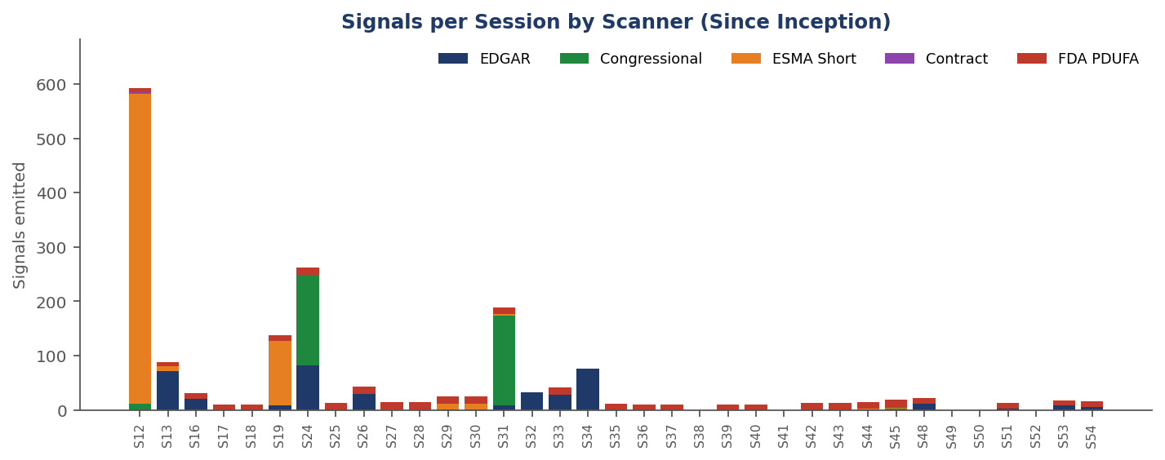

Cumulative volume by scanner
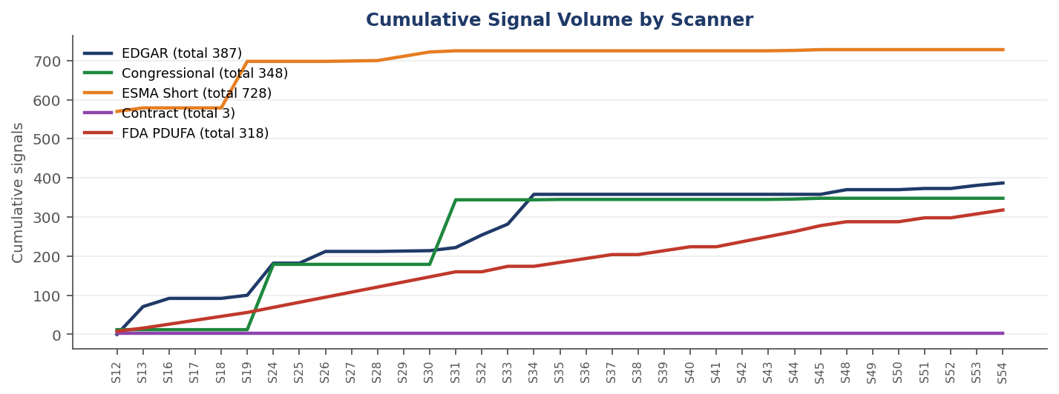
FDA PDUFA is the production workhorse (stable 10–15 signals/session from the 42-entry watchlist). EDGAR spikes with rotation category (governance and distress produce more raw hits than activist or M&A). Congressional volume has collapsed (intentional) post-D-029. ESMA is regulator-cadence dependent.

API Endpoint Reachability
Recorded HTTP status probes per session. Green cells are 200 OK; orange cells are 403/404 (blocked or missing); red cells are 500+ (server error). Blanks indicate the endpoint was not probed that session.
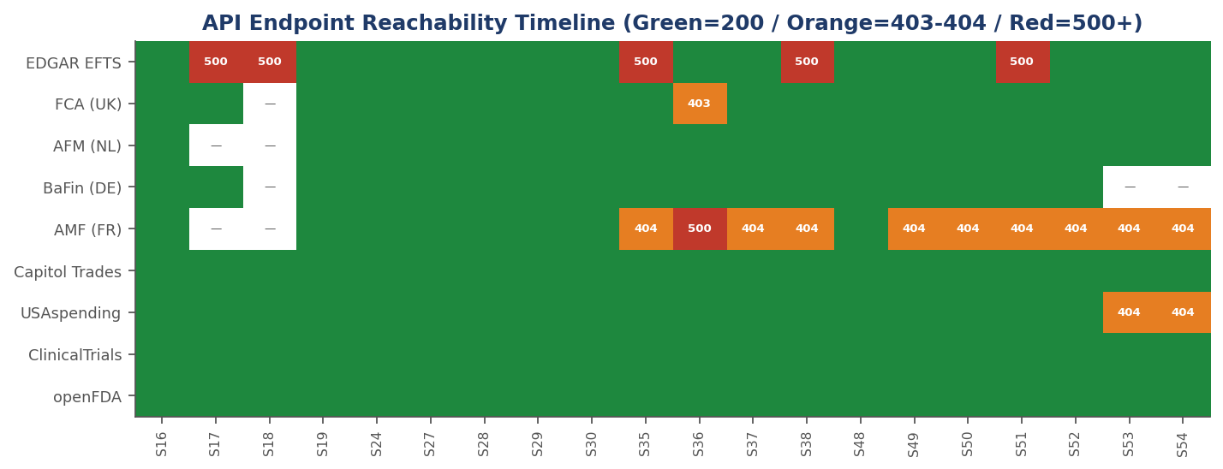

Active degradations
- AMF France 404: Persistent since S49. S54 probed 6 alternate endpoints (3 AMF subpaths, 2 data.gouv, 1 API) — all 404. Dataset likely delisted. Scanner degrades gracefully via FCA / AFM / BaFin.
- SEC EFTS intermittent 500: Since S17. Observed on keyword queries only; filing-type scans unaffected.
- FCA UK HEAD 403: Persistent. XLSX download path returns 200 and is the production path.
- USAspending GET 404 on spending_by_award: Expected behavior — endpoint is POST-only.
- drugs.com 403: User-agent block. May need header rotation.

Convergence Engine
Convergence requires a ticker to surface in ≥2 strategies within a rolling 21-day window. Six detections since inception; none have converted to a scored candidate — AMT (S30–S31) was 2023 historical footnote noise; FBLG (S50–S54) is recurring sub-$215M mcap false positive. S54 recommends adding FBLG to the suppression list.
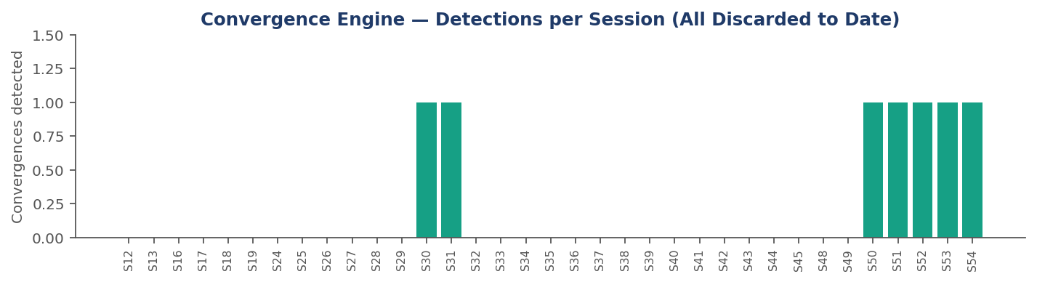
Detection | Sessions | Entity | Disposition | Root Cause
AMT (congressional + edgar) | S30–S31 | American Tower | Rejected (FP) | ARS PDF 'strategic alternatives' = 2023 India footnote; Ro Khanna child-account SELL = noise.
FBLG (convergence engine) | S50–S54 | First Business Financial Corp | Discarded sub-floor | Recurring ~$6–13M mcap; below $215M floor. S54 suppression-list action pending.

Outcome Yield Funnel
From raw signal count through to a single delivered candidate (TVTX, APPROVED 2026-04-13). Pass-through rates tighten substantially at the mcap/strength filter and the score-≥28 promotion bar. Numbers are approximate — 'reached deep-dive' includes names that were scored but later rejected (e.g., APAD, NUCL, LODE, AMT) and non-tradeable tags (ORCA, BEREN).
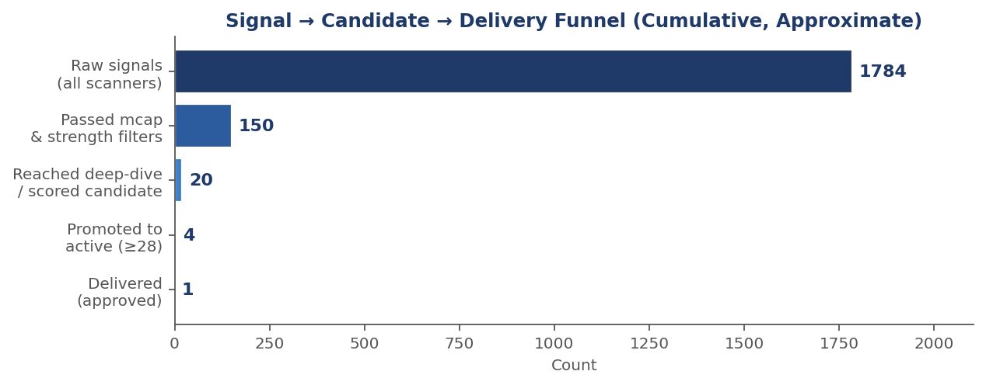
Candidate ledger
Ticker | Source strategy | Peak score | Current status | Outcome
TVTX | FDA PDUFA | 29.75 | Delivered 2026-04-13 | APPROVED (narrow label — FSGS w/o nephrotic syndrome, Boxed Warning, REMS)
AXSM | FDA PDUFA + web research | 30.75 | Active (T-14 window) | PDUFA 2026-04-30 — 22 clean kill sweeps
VERA | FDA PDUFA + web research | 30.50 | Active | PDUFA 2026-07-07 — BTD + Priority Review + Accelerated Approval
VRDN | FDA PDUFA | 31.5 → 26.0 | Watchlist (demoted S26) | REVEAL-1 SC miss damaged franchise; veligrotug IV PDUFA intact Jun 30
MNKD | FDA PDUFA | 26.75 | Watchlist | Afrezza pediatric — re-evaluate T-20 (~May 8)
ARVN | FDA PDUFA | ~22.5 | Watchlist / deep dive queued | First PROTAC; Pfizer partner; PDUFA Jun 5
HROW | ESMA Short (BaFin) | 22.5 | Watchlist | SI 21.1%; no hard catalyst
ACHV | FDA PDUFA | — | Gated (mcap floor) | Cytisinicline BTD; currently $184M, needs $215M floor
AMT | Congressional + EDGAR | — | Rejected (FP) | 2023 India footnote noise; D-029 rubric

Code Health and Operational Discipline
Metric | Value | Trend
Tools in codebase | 14 (post-S46 audit) | Steady
py_compile clean rate (last 15 sessions) | 100% | Improved vs S17–S19 (timeouts/truncations)
Truncation incidents | 0 since S46 fix | Resolved (D-049 rewrite procedure)
Scheduled task cadence | Operational every 3h + maintenance at :50 past | Stable
Concurrency lock conflicts | 0 observed | SESSION_LOCK.md discipline holds
Decisions logged (DECISIONS.md) | ~50 D-### entries | Steady accumulation
Open questions outstanding | 3 deferred (CNMV, log growth, sandbox timeout mitigated) | Stable

Notable hardening decisions
- D-029 — Congressional signal-strength rubric: suppressed 165+ strength-2 mega-cap noise from S24/S31.
- D-030 — EDGAR 4-category daily rotation: prevents single-category fatigue; per-category whitelists.
- D-031 — EDGAR form whitelist: drops SPAC/S-4/DEFM14A/N-6 boilerplate at ingest.
- D-035 — ESMA same-day basket detection: caps Info Asymmetry at 3.0 for French-cluster basket events.
- D-043 — EDGAR KEYWORD_SKIP_FORMS (ARS, DEF 14A, DEFA14A, fund filings): addressed AMT false positive root cause.
- D-044 — Cross-scanner mcap cache (mcap_cache.py, 24h TTL): reduced redundant yfinance calls.
- D-046 — FDA approval cross-check: auto-disqualifies already-approved entries (caught CORT post-factum S40).
- D-049 — File truncation rewrite procedure: addresses platform VM mount sync bug.
- D-050 — Auto-discover dedup hardening (S47): no regressions observed.

Appendix: Per-Session Signal Ledger
Raw signal counts by scanner for every session with explicit numbers in PROGRESS_LOG.md. '—' indicates the session log did not record an explicit per-scanner count (typically maintenance or partial-run sessions).
Session | Date | EDGAR | EDGAR Rot. | Cong. | ESMA | Contract | FDA | Conv. | Total | Notes
S12 | 2026-04-09 | — | — | 12 | 570 | 3 | 8 | — | 593 | timeout; positions not signals
S13 | 2026-04-09 | 71 | — | 0 | 9 | 0 | 8 | 0 | 88 | timeout-but-wrote
S16 | 2026-04-10 | 21 | M&A | 0 | 0 | 0 | 10 | 0 | 31
S17 | 2026-04-10 | 0 | — | 0 | 0 | 0 | 10 | 0 | 10 | timeout
S18 | 2026-04-10 | 0 | — | 0 | 0 | 0 | 10 | 0 | 10 | 500-errors; FCA down
S19 | 2026-04-10 | 8 | M&A | 0 | 119 | 0 | 10 | 0 | 137 | cached snapshot
S24 | 2026-04-10 | 82 | governance | 167 | 0 | 0 | 13 | 0 | 262
S25 | 2026-04-11 | — | — | — | 0 | — | 13 | 0 | —
S26 | 2026-04-11 | 30 | distress | — | 0 | — | 13 | 0 | —
S27 | 2026-04-11 | 0 | distress | 0 | 1 | 0 | 13 | 0 | 14
S28 | 2026-04-11 | 0 | — | 0 | 1 | 0 | 13 | 0 | 14
S29 | 2026-04-11 | 1 | — | 0 | 11 | 0 | 13 | 0 | 25 | AESP FP; French basket; cached bash-wedge
S30 | 2026-04-11 | 1 | M&A | 0 | 11 | 0 | 13 | 1 | 26 | LODE FP; AMT FP
S31 | 2026-04-11 | 8 | governance | 165 | 3 | 0 | 13 | 1 | 189 | AMT FP
S32 | 2026-04-12 | 32 | — | — | — | — | — | — | —
S33 | 2026-04-12 | 28 | — | — | — | — | 14 | — | —
S34 | 2026-04-13 | 76 | distress | — | — | 0 | — | — | — | all noise
S35 | 2026-04-13 | 0 | activist | 1 | 0 | 0 | 10 | 0 | 11 | MA mega-cap
S36 | 2026-04-13 | 0 | M&A | 0 | 0 | 0 | 10 | 0 | 10
S37 | 2026-04-14 | 0 | distress | 0 | 0 | 0 | 10 | 0 | 10
S38 | 2026-04-14 | 0 | governance | — | — | — | — | — | — | EFTS 500
S39 | 2026-04-13 | 0 | — | 0 | 0 | 0 | 10 | 0 | 10
S40 | 2026-04-13 | 0 | — | 0 | 0 | 0 | 10 | 0 | 10
S41 | 2026-04-13 | — | — | — | — | — | — | 0 | —
S42 | 2026-04-14 | 0 | — | 0 | 0 | 0 | 13 | 0 | 13
S43 | 2026-04-14 | 0 | — | 0 | 0 | 0 | 13 | — | 13
S44 | 2026-04-14 | 0 | — | 1 | 1 | 0 | 13 | — | 15
S45 | 2026-04-13 | 0 | — | 2 | 2 | 0 | 15 | 0 | 19
S48 | 2026-04-13 | 12 | M&A | 0 | 0 | 0 | 10 | 0 | 22 | boilerplate
S49 | 2026-04-14 | — | — | — | — | — | — | — | 27 | 27 signals, 1 convergence discarded
S50 | 2026-04-13 | 0 | — | — | — | — | — | 1 | — | FBLG discarded
S51 | 2026-04-13 | 3 | activist | 0 | 0 | 0 | 10 | 1 | 13 | FBLG discarded
S52 | 2026-04-14 | — | — | — | — | — | — | 1 | — | FBLG discarded
S53 | 2026-04-14 | 8 | distress | 0 | 0 | 0 | 10 | 1 | 18 | FBLG discarded
S54 | 2026-04-14 | 6 | governance | 0 | 0 | 0 | 10 | 1 | 16 | FBLG discarded

Report metadata
Generated (UTC) | 2026-04-14 09:39:01
Report type | Tool Performance Dashboard (operational + outcome metrics)
Coverage window | Since inception — S1 through S54 (last session 2026-04-14 07:15 UTC)
Data sources | PROGRESS_LOG.md (explicit per-session lines), reports/*.md (6 daily reports), SESSION_STATE.md, candidates/*.md (ledger)
Source discipline | Numbers are hand-extracted from explicit log entries — heuristic regex parsing rejected for accuracy
Output path | reporting_layer/performance_reports/System_Performance_2026-04-14.docx
Read-only constraint | No writes to investment_discovery_system/ — enforced

