HL7® FHIR® Foundational Implementer Exam Study Notes

Table of Contents
1. FHIR Fundamentals 2
What is FHIR? 2
Core Concepts and Terminology 2
Resource-Based Architecture 2
RESTful API Approach 3
FHIR Versions and Maturity Levels 3
2. FHIR Resources 4
Resource Structure and Components 4
Common Resources Overview 6
Resource References and Relationships 7
Extensions and Profiles 9
Provenance resource 10
3. FHIR Data Types and Elements 11
Primitive Data Types 11
Complex Data Types 12
Choice Properties 14
Resource Elements and Cardinality 15
FHIR Backbone element 16
Working with Coding and Terminology 17
4. FHIR Exchange 20
RESTful Operations 20
Search Parameters and Capabilities 22
Transactions and Batch Operations 24
Operations Framework 25
Capability Statement 27
Messaging 27
Other FHIR Exchange Mechanisms 28
5. FHIR Implementation Guides 30
Understanding Implementation Guides 30
Common Implementation Guides 30
Profiles, Extensions, and Constraints 30
Validation Against Profiles 34
6. Security and Privacy in FHIR 36
Authentication and Authorization 36
Consent Resources 36
Audit Logging 37
Data Protection Considerations 38
Security Implementation Checklist 38
SMART on FHIR 39
FHIR Licensing and IP 39

1. FHIR Fundamentals

What is FHIR?
Fast Healthcare Interoperability Resources (FHIR) is a standard for exchanging healthcare information electronically. Developed by Health Level Seven International (HL7), FHIR combines the best features of previous standards (HL7 v2, HL7 v3, CDA) with modern web technologies to create a more accessible, implementable, and widely usable healthcare interoperability standard.
FHIR is designed to:
- Facilitate seamless exchange of healthcare data
- Support modern web implementation approaches
- Provide a consistent, logical structure for healthcare information
- Enable rapid implementation and adoption
The most widely used version is FHIR R4 (https://hl7.org/fhir/R4/), which provides stable APIs for many healthcare scenarios.

Core Concepts and Terminology
To understand FHIR, you need to grasp several key concepts:
- Resources: The fundamental building blocks of FHIR, representing small, logically discrete units of healthcare information (e.g., Patient, Observation, Medication)
- Profiles: Customizations of resources for specific use cases or requirements
- Extensions: Mechanisms to add new data elements to resources without modifying the base specification
- Implementation Guides (IGs): Collections of profiles, extensions, and rules for implementing FHIR in specific contexts
- Terminology: Coded vocabularies and value sets that provide meaning to healthcare data
- RESTful API: The primary way to interact with FHIR resources over HTTP using standard web methods

Resource-Based Architecture
FHIR's architecture is modular and resource-based. Each resource:
- Represents a specific healthcare concept
- Has a defined behavior, meaning, identity, and location
- Is accessible via a unique URL
- Can be standalone or linked to other resources
- Follows a consistent structure
This approach allows for:
- Flexible implementation
- Incremental adoption
- Focused solutions for specific problems
- Clear separation of concerns

RESTful API Approach
FHIR adopts REST (Representational State Transfer) principles, which means:
- Resources are manipulated using standard HTTP methods (GET, POST, PUT, DELETE)
- Resources have predictable URLs
- Resources can be represented in different formats (JSON, XML, RDF/Turtle)
- Interactions are stateless
- Resources can link to each other using URLs
This approach leverages existing web infrastructure and development patterns, making FHIR easier to implement than previous healthcare standards.

FHIR Versions and Maturity Levels
FHIR evolves through regular releases:
- DSTU1 (2014): Initial draft
- DSTU2 (2015): Improved version
- STU3 (2017): Significant enhancements
- R4 (2019): The first release with normative content
- R5 (2023): Latest version with additional resources and capabilities
Individual resources within FHIR also have maturity levels:
- Level 0 (Draft): First draft, subject to significant changes
- Levels 1-3: Going through review and testing
- Levels 4-5: Being trialed in real-world implementations
- Normative: Stable and not subject to breaking changes
For production systems, prioritize using normative resources to ensure long-term stability and interoperability.

2. FHIR Resources

Resource Structure and Components
Every FHIR resource includes:
- resourceType: Identifies the type of resource (e.g., "Patient", "Observation")
- id: A unique identifier for this specific resource instance
- meta: Metadata about the resource, including version and security tags
- text: A human-readable representation of the resource content
- contained: Other resources contained within this resource (for resources that can't stand alone)
Here’s a simplified example of a FHIR Patient resource in JSON format:
{
"resourceType": "Patient",
"id": "example",
"meta": {
"versionId": "1",
"lastUpdated": "2023-05-22T15:30:40Z"
},
"text": {
"status": "generated",
"div": "<div xmlns=\"http://www.w3.org/1999/xhtml\">John Smith</div>"
},
"identifier": [
{
"system": "http://example.org/identifiers",
"value": "12345"
}
],
"active": true,
"name": [
{
"use": "official",
"family": "Smith",
"given": ["John"]
}
],
"gender": "male",
"birthDate": "1974-12-25"
}

The description of each resource in the IG, should include:
- Scope and Usage: The resource's purpose and intended use
- Boundaries: What data belongs in the resource and what doesn't
- Relationships: How the resource relates to other resources
- Structure View: A hierarchical, tree-like view of resource elements
- Data Elements: The specific data points within the resource, each with a defined: Element ID, Definition, Short Display, and Notes.

Resource Narrative
The text element provides a human-readable version of the resource content, which is important for:
- Ensuring data can be understood even without FHIR-specific tools
- Providing a fallback when receiving systems don't recognize extensions
- Supporting human validation of resource content
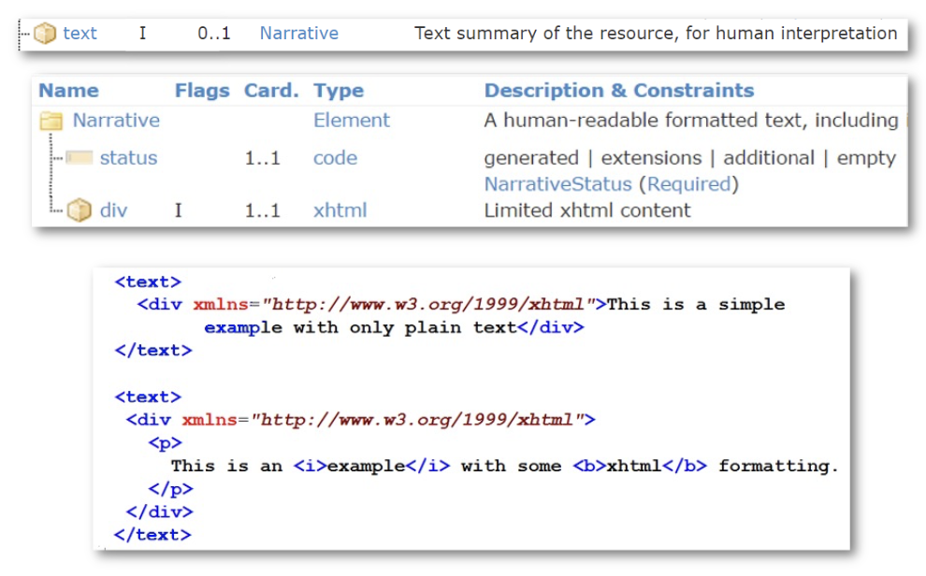
Human readability is key. In FHIR, all resources SHOULD have a human-readable narrative.

Resource Identification
Resources can be identified through several mechanisms:
- Logical ID: The id element unique within a FHIR server
- Business Identifiers: The identifier element containing domain-specific identifiers
- URL-based Identity: Full URL path to the resource on a specific server
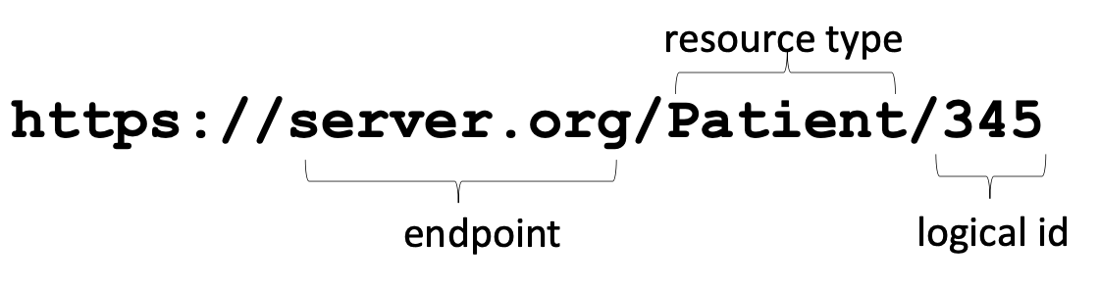
Logical id as used by a FHIR-enabled application; the “primary key” of the database entry

Common Resources Overview

To locate the full list of available FHIR resources (https://hl7.org/fhir/R4/resourcelist.html), navigate
to the FHIR R4 landing page and from the header, click on Resources.
Some fundamental FHIR resources include:
- Patient: Demographic and administrative information about a person receiving healthcare services
- Practitioner: Information about healthcare providers
- Organization: Details about healthcare organizations
- Encounter: An interaction between a patient and healthcare providers
- Observation: Measurements, test results, or assertions about a patient
- Condition: Clinical conditions, problems, or diagnoses
- Procedure: Actions performed on or for a patient
- MedicationRequest: Orders for medications
- DiagnosticReport: Results of diagnostic tests or procedures
These core resources represent the most common healthcare concepts and form the foundation of most FHIR implementations.

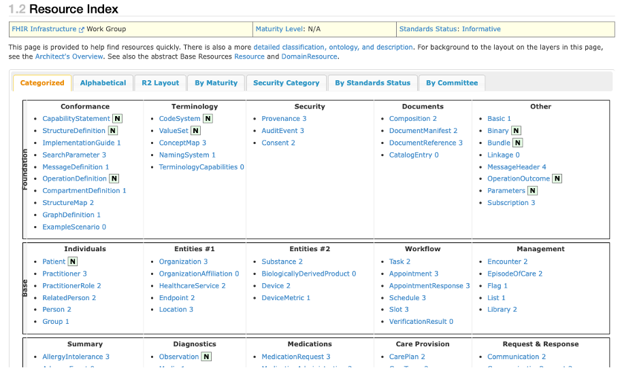
The Resource Index displays all the resources available by categories.

Resource References and Relationships
Resources reference each other to create a connected web of healthcare information.
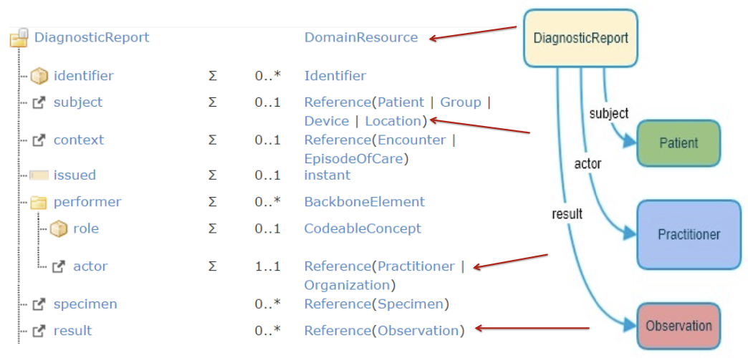
Examples of references

Reference Types
FHIR supports different types of references:
- Literal References: Direct references to a specific resource by URL (e.g., https://example.org/fhir/Patient/456)
- Logical References: References using a resource type and identifier (e.g., Patient/123)
- Contained Resources: Resources embedded directly within another resource

Reference Example
A MedicationRequest referencing both a patient and a medication:
{
"resourceType": "MedicationRequest",
"id": "med-request-123",
"status": "active",
"intent": "order",
"subject": {
"reference": "Patient/pat123",
"display": "John Smith"
},
"medicationReference": {
"reference": "Medication/med456",
"display": "Lisinopril 10mg tablet"
}
}

Reference Resolution
When a system receives a resource with references, it may need to:
- Resolve those references to access complete information
- Follow a chain of references to understand the full clinical context
- Bundle related resources together for complete information transfer

Reference Integrity
FHIR systems must maintain reference integrity:
- References should point to valid resources
- When resources are deleted, systems must handle dangling references
- Circular references should be avoided or handled carefully
The Reference data type includes:
- reference: The actual reference path
- type: Resource type being referenced
- identifier: Business identifier for the referenced resource
- display: Human-readable text representing the reference

Extensions and Profiles
FHIR's extension mechanism allows for customization while maintaining interoperability.

Extensions
Extensions add elements not present in the base resource definition. They consist of:
- A URL that uniquely identifies the extension
- A value that provides the extended data

Extension Example
Adding a patient's preferred pharmacy to a Patient resource:
{
"resourceType": "Patient",
"id": "example",
"extension": [
{
"url": "http://example.org/fhir/StructureDefinition/preferred-pharmacy",
"valueReference": {
"reference": "Organization/pharm123",
"display": "Downtown Pharmacy"
}
}
],
"name": [
{
"family": "Smith",
"given": ["John"]
}
]
}

Profiles
Profiles constrain resources for specific use cases by:
- Restricting cardinality (making optional fields required)
- Limiting allowed values
- Adding must-support flags on elements
- Incorporating extensions consistently
- Providing implementation guidance
Profiles are represented as StructureDefinition resources and are typically part of Implementation Guides.

Modifiers vs. Regular Extensions
- Regular Extensions: Add information without changing the meaning of the resource
- Modifier Extensions: Change the interpretation of the resource and are flagged with isModifier=true

Best Practices for Extensions
- Reuse existing extensions when possible
- Define extensions clearly with StructureDefinition resources
- Use URLs that you control for extension definitions
- Document extensions thoroughly
- Consider creating profiles when using extensions consistently

Provenance resource
The Provenance resource is used to track the origin and history of FHIR resources. It records information about who created, modified, or deleted a resource, and when and how these actions occurred. Provenance is essential for audit trails and data integrity.

3. FHIR Data Types and Elements
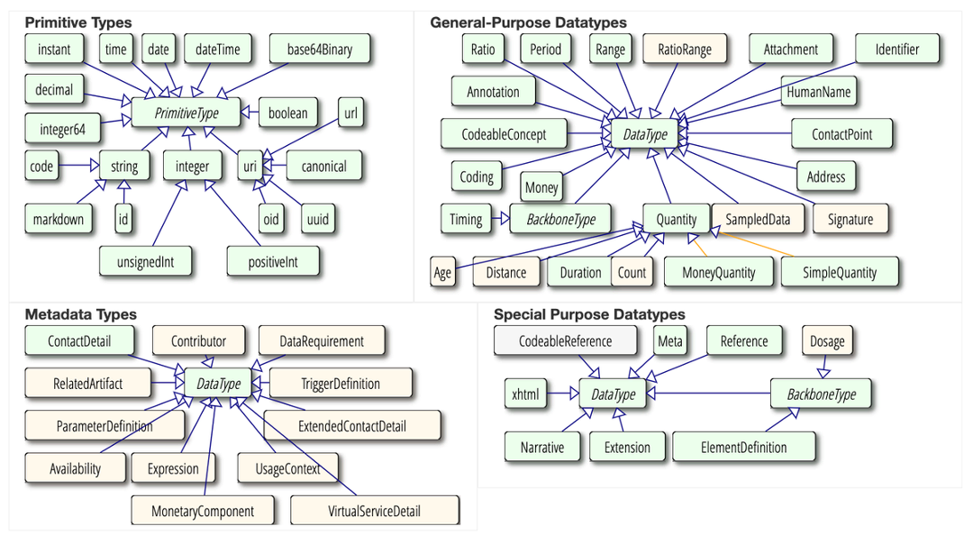
Overview of the different data types by categories

Primitive Data Types
FHIR defines several primitive data types for basic values:
Type | Description | Example
boolean | True or false | true
integer | Whole number | 42
decimal | Decimal number | 3.14159
string | Unicode character sequence | "Hello World"
uri | Uniform Resource Identifier | "http://example.org"
url | Uniform Resource Locator | "http://fhir.example.org/Patient/123"
canonical | Canonical URL | "http://hl7.org/fhir/StructureDefinition/Patient"
base64Binary | Base64 encoded data | "SGVsbG8gV29ybGQ="
instant | Precise timestamp | "2023-05-23T15:30:40.123Z"
date | Calendar date | "2023-05-23"
dateTime | Date and optional time | "2023-05-23T15:30:40-05:00"
time | Time of day | "15:30:40"
code | Restricted string (code values) | "male"
oid | Object Identifier | "1.2.840.114350"
id | Resource identifier | "pat123"
markdown | Markdown formatted text | "# Heading\nText"
unsignedInt | Non-negative integer | 123
positiveInt | Positive integer | 42

Complex Data Types
Complex data types combine multiple elements into reusable structures:

Identifier
Used for business identifiers like medical record numbers:
{
"use": "official",
"system": "http://hospital.example.org/identifiers/mrn",
"value": "123456789"
}

HumanName
Structured representation of a person's name:
{
"use": "official",
"family": "Smith",
"given": ["John", "Jacob"],
"prefix": ["Mr."],
"suffix": ["Ph.D."]
}

Address
Physical or postal addresses:
{
"use": "home",
"line": ["123 Main St", "Apt 4B"],
"city": "Anytown",
"state": "CA",
"postalCode": "12345",
"country": "USA"
}

ContactPoint
Phone numbers, email addresses, etc.:
{
"system": "phone",
"value": "+1-555-123-4567",
"use": "home",
"rank": 1
}

CodeableConcept
Represents coded values with translations:
{
"coding": [
{
"system": "http://snomed.info/sct",
"code": "73211009",
"display": "Diabetes mellitus"
},
{
"system": "http://hl7.org/fhir/sid/icd-10",
"code": "E11.9",
"display": "Type 2 diabetes mellitus without complications"
}
],
"text": "Type 2 Diabetes"
}

Quantity
Measurements with units:
{
"value": 70,
"unit": "kg",
"system": "http://unitsofmeasure.org",
"code": "kg"
}

Reference
Links to other resources:
{
"reference": "Patient/123",
"display": "John Smith"
}

Choice Properties
Some FHIR elements allow for a choice of data types. For example, an element might be able to hold a string or an integer. When terminology is involved, sometimes you'll see a choice between a CodeableConcept or a Coding. This allows for flexibility in how coded information is represented.

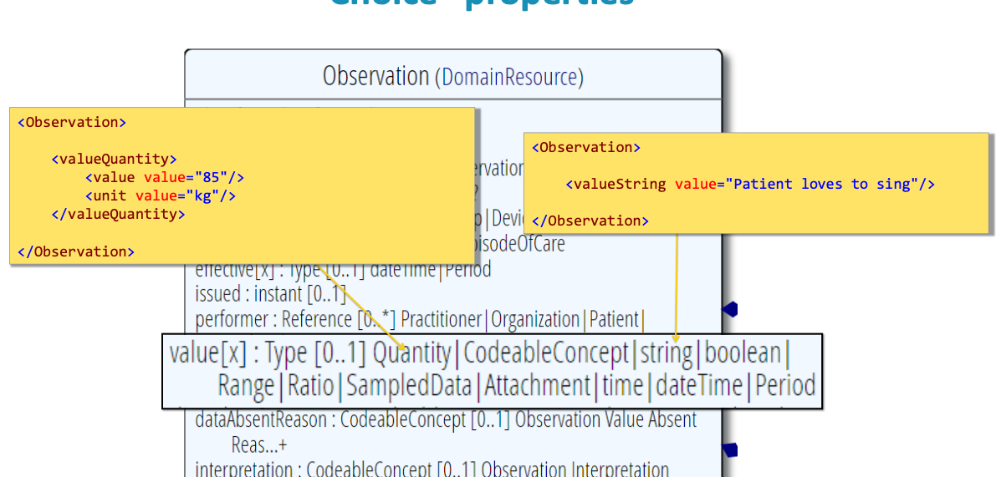
Example of Choice Properties

Resource Elements and Cardinality
Each element in a FHIR resource has defined cardinality indicating how many times it can appear:

Cardinality Notation
- 0..1: Optional, maximum one occurrence
- 1..1: Required, exactly one occurrence
- 0..*: Optional, any number of occurrences
- 1..*: Required, at least one occurrence
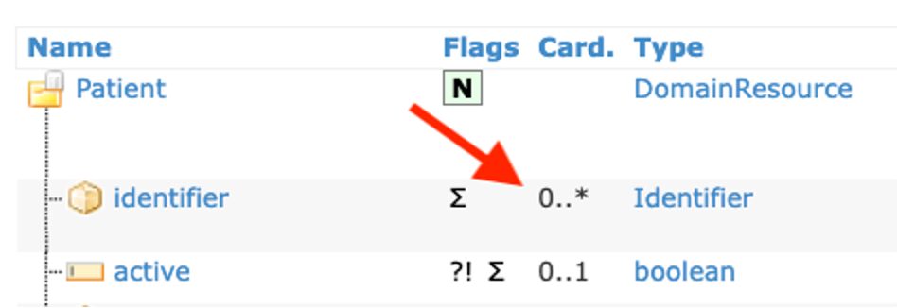
Here we can see how cardinality is displayed in the resource description per each element.

Element Properties
Elements have additional properties, which are also called flags:
- Must Support: Systems must recognize and handle these elements
- Modifier: Elements that change resource interpretation
- Summary: Elements that appear in resource summaries
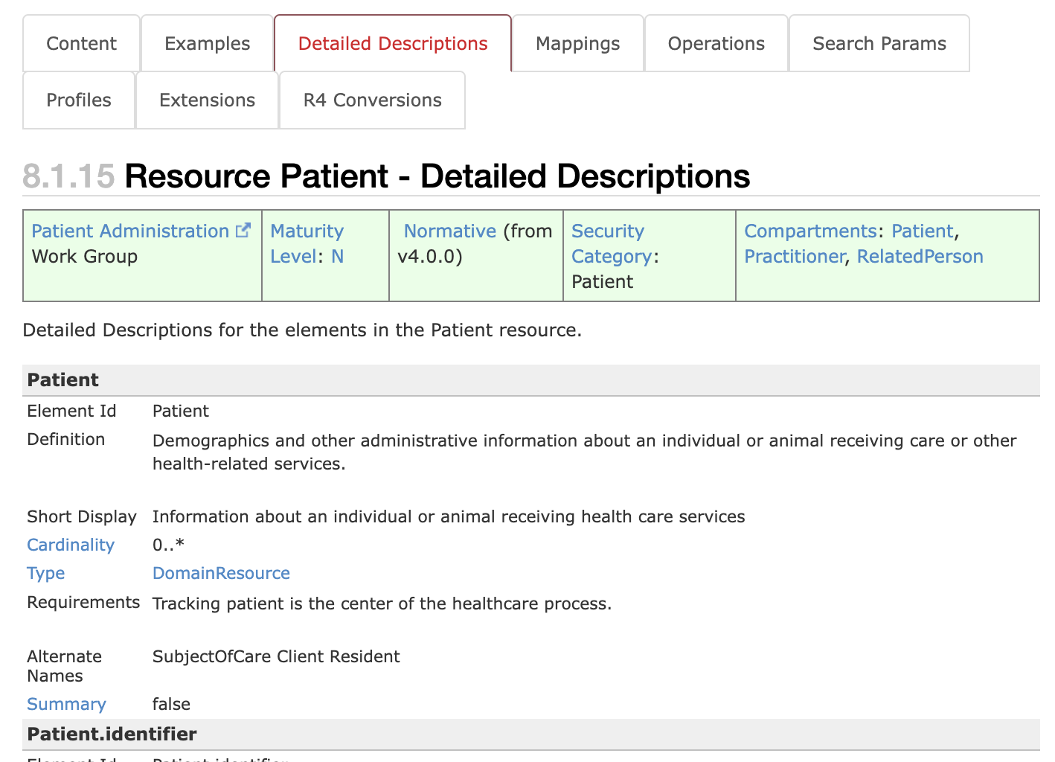
Detailed descriptions of these properties for each data element can be found in the Detailed Descriptions tabs.

Elements vs. Extensions
- Standard Elements: Defined in the base resource and universally recognized
- Extensions: Custom additions that may not be recognized by all systems

FHIR Backbone element
In FHIR, a BackboneElement is a base type for elements that are complex and contained within other resources. It's used to define repeating patterns of elements.
Unlike FHIR data types, which define the type of data (e.g., string, date), BackboneElement defines a structure within a resource.
Example: In the Patient resource, the contact element is a BackboneElement, containing elements like relationship, name, and address.

Working with Coding and Terminology
FHIR includes robust support for coded terminology:

Coding Data Types
- code: Simple string code from a defined value set
- Coding: Code from a specific coding system:
{
"system": "http://snomed.info/sct",
"code": "44054006",
"display": "Type 2 diabetes mellitus"
}
- CodeableConcept: Multiple translations of the same concept:
{
"coding": [
{
"system": "http://snomed.info/sct",
"code": "44054006",
"display": "Type 2 diabetes mellitus"
},
{
"system": "http://hl7.org/fhir/sid/icd-10",
"code": "E11.9",
"display": "Type 2 diabetes mellitus without complications"
}
],
"text": "Type 2 diabetes"
}
Key terminology resources:
- CodeSystem: Defines a set of codes and their meanings
- ValueSet: Defines a set of codes selected from one or more CodeSystems
- ConceptMap: Defines mappings between codes in different CodeSystems
These resources enable precise representation of clinical concepts and facilitate semantic interoperability.

Terminology Example
Here's an example to illustrate how code, CodeSystem, ValueSet, and ConceptMap work together:
Terminology Example: Blood Pressure
CodeSystem:
- We might have a CodeSystem (e.g., LOINC - http://loinc.org) that defines codes for clinical observations.
- LOINC includes a code like "8480-6" for "Systolic blood pressure".
- In FHIR, the CodeSystem resource would represent LOINC and its codes.
Code:
- The specific code "8480-6" is a code within the LOINC CodeSystem.
- This code is used within a Coding element.
Coding and CodeableConcept:
- A Coding instance:
{
"system": "http://loinc.org",
"code": "8480-6",
"display": "Systolic blood pressure"
}
- A CodeableConcept might include this Coding, and potentially codes from other systems:
{
"coding": [
{
"system": "http://loinc.org",
"code": "8480-6",
"display": "Systolic blood pressure"
},
{
"system": "http://snomed.info/sct",
"code": "162673000",
"display": "Systolic blood pressure"
}
],
"text": "Systolic BP"
}
ValueSet:
A ValueSet might be defined for "Blood Pressure Measurements".
- This ValueSet would include the LOINC code "8480-6" (and other relevant codes) to specify the allowed codes for recording blood pressure.
- FHIR elements would then bind to this ValueSet.
ConceptMap:
- A ConceptMap could be used to map the LOINC code "8480-6" to an equivalent code in a different coding system (e.g., a local hospital coding system).
- This allows for translation and interoperability between systems using different terminologies.

FHIR Terminology Services
FHIR Terminology Services provide standardized access to code systems, value sets, and concept maps.
FHIR defines standard operations for terminology services:
- $validate-code: Validate a code in a value set or code system
- $expand: Expand a value set into its constituent codes
- $translate: Translate a code from one system to another
- $lookup: Look up a code's details
- $subsumes: Check if one code subsumes (includes) another

4. FHIR Exchange
FHIR defines several exchange paradigms, which are methods for exchanging FHIR resources between systems. The choice of paradigm depends on the specific requirements of the interoperability scenario.
- Four paradigms: REST, Documents, Messages and Services.
- Architectures will be driven by legacy requirements, architectural preferences, enterprise architecture commitments, etc.
- Data (generally) shared easily across paradigm boundaries

RESTful Operations
FHIR implements the standard HTTP operations in a RESTful manner:

Basic CRUD Operations
Operation | HTTP Method | URL Pattern | Description
Create | POST | /[resourceType] | Create a new resource
Read | GET | /[resourceType]/[id] | Retrieve a specific resource
Update | PUT | /[resourceType]/[id] | Update an existing resource
Delete | DELETE | /[resourceType]/[id] | Delete a resource

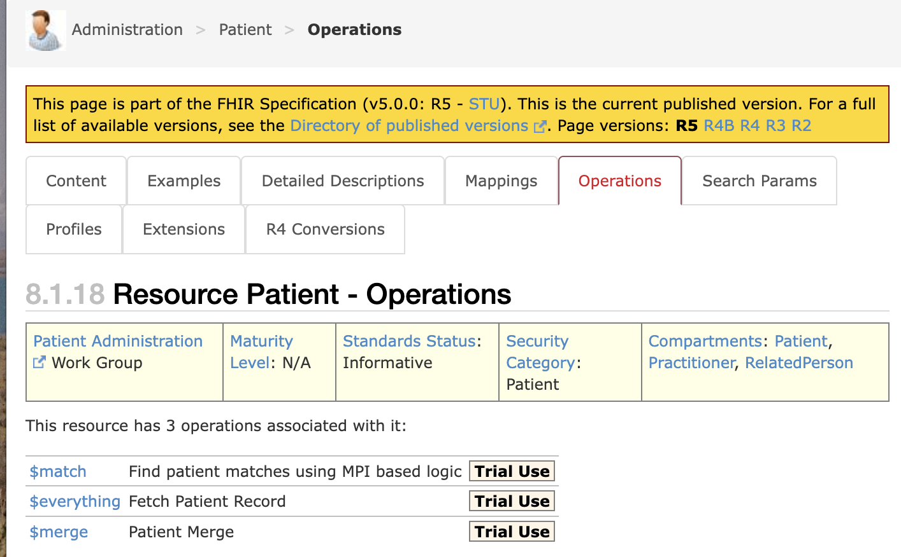
Each FHIR resource definition includes an "Operations" section, detailing specific actions that can be performed on instances of that resource.

Additional Standard Operations
- vread: GET /[resourceType]/[id]/_history/[version] - Read a specific version
- history: GET /[resourceType]/[id]/_history - Get resource version history
- patch: PATCH /[resourceType]/[id] - Partial update of a resource

Example: Creating a New Patient
POST /Patient HTTP/1.1
Host: fhir.example.org
Content-Type: application/fhir+json

{
"resourceType": "Patient",
"name": [
{
"family": "Smith",
"given": ["John"]
}
],
"gender": "male",
"birthDate": "1980-01-15"
}

HTTP/1.1 201 Created
Content-Type: application/fhir+json
Location: http://fhir.example.org/Patient/123

{
"resourceType": "Patient",
"id": "123",
"meta": {
"versionId": "1",
"lastUpdated": "2023-05-24T10:15:30Z"
},
"name": [
{
"family": "Smith",
"given": ["John"]
}
],
"gender": "male",
"birthDate": "1980-01-15"
}

Search Parameters and Capabilities
FHIR provides a powerful search framework for finding resources.

Search Parameter Types
- string: Simple string matching
- token: Code or identifier matching
- reference: References to other resources
- quantity: Numeric comparisons with units
- date: Date/time comparisons
- number: Numeric comparisons
- uri: URI matching
- special: Special purpose parameters

Common Search Parameters
Resource | Parameter | Type | Description
Patient | name | string | Search by name
Patient | identifier | token | Search by identifier
Observation | patient | reference | Observations for a patient
Observation | code | token | Search by observation type
Observation | date | date | Search by observation date
MedicationRequest | patient | reference | Medications for a patient
Encounter | patient | reference | Encounters for a patient
* | _id | token | Search by resource id
* | _lastUpdated | date | Search by update date

Search Modifiers
- exact: Exact string match
- contains: Contains substring
- missing: Whether element exists
- not: Negates the search condition
- gt, lt, ge, le: Greater than, less than operators
In FHIR search, these modifiers allow for more precise control over how search parameters are applied. For example:
- name:exact=Smith would match only the exact name "Smith"
- name:contains=mi would match "Smith", "Smithson", "Hamilton", etc.
- telecom:missing=true would find patients with no contact information
- status:not=completed would find items that don't have a "completed" status
- date=gt2023-01-01 would find dates greater than January 1, 2023

Combining Search Parameters
- Multiple parameters are combined with logical AND
- Use the , operator for OR within a parameter
- Complex combinations require the _filter parameter

Example: Search Queries
Find patients with name "Smith":
GET /Patient?name=Smith
Find observations of type "blood pressure" for a specific patient:
GET /Observation?patient=Patient/123&code=85354-9
Find all active medication requests for a patient:
GET /MedicationRequest?patient=Patient/123&status=active

Paging and Limiting Results
- _count: Control number of results per page
- _offset: Skip a number of results (less common)
- page navigation: Using Bundle.link elements

Search Result Structure
Search results are returned as a Bundle resource of type "searchset":
{
"resourceType": "Bundle",
"type": "searchset",
"total": 35,
"link": [
{
"relation": "self",
"url": "http://fhir.example.org/Patient?name=Smith&_count=10"
},
{
"relation": "next",
"url": "http://fhir.example.org/Patient?name=Smith&_count=10&_page=2"
}
],
"entry": [
{
"fullUrl": "http://fhir.example.org/Patient/123",
"resource": {
"resourceType": "Patient",
"id": "123",
"name": [
{
"family": "Smith",
"given": ["John"]
}
]
},
"search": {
"mode": "match",
"score": 1.0
}
},
// More results...
]
}

Transactions and Batch Operations
FHIR allows sending multiple operations in a single request using Bundle resources.

Types of Bundle Operations
- Batch: Collection of operations processed independently
- Transaction: All-or-nothing set of operations

Bundle Structure
{
"resourceType": "Bundle",
"type": "transaction",
"entry": [
{
"fullUrl": "urn:uuid:61ebe359-bfdc-4613-8bf2-c5e300945f0a",
"resource": {
"resourceType": "Patient",
"name": [
{
"family": "Smith",
"given": ["John"]
}
]
},
"request": {
"method": "POST",
"url": "Patient"
}
},
{
"request": {
"method": "GET",
"url": "Patient?name=Jones"
}
}
]
}

Transaction Processing Rules
- Resources can reference each other using temporary IDs
- Operations are processed in the order provided
- For transactions, if any operation fails, all changes are rolled back
- For batch operations, each entry is processed independently

Common Use Cases
- Creating a patient and related resources in one request
- Bulk updates to related resources
- Atomic updates across multiple resources

Operations Framework
Beyond basic CRUD operations, FHIR defines a framework for more complex operations.

Named Operations
Called using the $ prefix, e.g., $everything or $validate:
POST /Patient/123/$everything

Common Standard Operations
- $everything: Get all resources related to a specific resource
- $validate: Validate a resource against profiles
- $expand: Expand a value set
- $translate: Translate between code systems
- $meta: Get or add metadata to a resource
- $process-message: Process a FHIR message

Operation Definition
Operations are defined using OperationDefinition resources:
{
"resourceType": "OperationDefinition",
"name": "everything",
"status": "active",
"kind": "operation",
"code": "everything",
"resource": ["Patient"],
"system": false,
"type": false,
"instance": true,
"parameter": [
{
"name": "start",
"use": "in",
"min": 0,
"max": "1",
"type": "date"
},
{
"name": "end",
"use": "in",
"min": 0,
"max": "1",
"type": "date"
},
{
"name": "return",
"use": "out",
"min": 1,
"max": "1",
"type": "Bundle"
}
]
}

Custom Operations
Organizations can define custom operations for specific use cases:
- Must be defined using OperationDefinition resources
- Should follow the same patterns as standard operations
- Should be documented in Implementation Guides

Simple vs. Complex Operations
- Simple operations are usually invoked with GET and parameters in the URL.
  - Example: GET /Patient/123/$everything?start=2023-01-01
- Complex operations often use POST and pass parameters in the request body.
  - Example: POST /Patient/$validate (because the resource being validated is a complex input).
This distinction is important for practical implementation because:
- GET operations are easier to debug and can be executed in a browser
- POST operations can handle larger inputs and more complex parameter structures
- Some operations can be invoked using either method, depending on parameter complexity

Capability Statement
A CapabilityStatement resource describes the capabilities of a FHIR server. It provides information about:
- Supported resources.
- Supported RESTful interactions (e.g., CREATE, READ, UPDATE, DELETE, SEARCH).
- Supported operations.
- Supported search parameters.
- Security features.
The CapabilityStatement is crucial for clients to understand how to interact with a FHIR server.

Messaging
FHIR Messaging enables asynchronous exchange of information between systems. It's useful for event-driven scenarios where systems need to be notified of specific events.
Key aspects of FHIR Messaging:
- Asynchronous Communication: Messaging doesn't require an immediate, synchronous response, allowing systems to communicate even if they are temporarily unavailable. This is in contrast to REST, which is typically synchronous.
- Loosely Coupled Systems: Messaging promotes loose coupling between systems, meaning they don't need to be tightly integrated or have detailed knowledge of each other's implementation.
- Store-and-Forward: Messaging often uses a store-and-forward architecture, where messages are stored and forwarded to the destination system, ensuring delivery even if the system is temporarily offline.
- Trigger Events: Messaging is often triggered by specific business events, which initiate the exchange of information and define the context of the message.
- Message Bundles: Messages are often packaged within a Bundle resource, with the type element set to "message". This allows for the inclusion of multiple related resources within a single message.
- MessageHeader Resource: A MessageHeader resource is used to define the purpose, source, and destination of a message, as well as any correlation information. It provides context for the message and helps with routing and processing.
- Request/Response Patterns: While primarily asynchronous, messaging can also support request/response interactions, where a system sends a message and expects a response.
- Example Structure:
{
"resourceType": "Bundle",
"type": "message",
"entry": [
{
"resource": {
"resourceType": "MessageHeader",
// ... MessageHeader details ...
}
},
// ... Other resources ...
]
}

Other FHIR Exchange Mechanisms
FHIR also supports other exchange paradigms:

Services:
- For interactions and workflows that go beyond simple CRUD operations.
- Used when REST's capabilities are insufficient.
- Examples include operations other than CRUD (e.g., decision support), complex workflows, and scenarios needing a mix of document persistence and workflow behavior

Database/Persistence:
- This paradigm involves using FHIR resources directly for data storage within a database system.
- FHIR can be employed as a repository model.
- This approach can be part of various architectural patterns, such as FHIR as a REST API, FHIR Facade, or FHIR Data Repository

Subscriptions Framework:
- Provides a mechanism for real-time notifications of events.
- Involves a server that checks for resource creation, updates, or deletions that match predefined criteria.
- When a match occurs, a notification is sent to a defined channel.
- Notifications are delivered as Bundles, with the first entry being a SubscriptionStatus resource.
- Search criteria are used to define the conditions that trigger notifications.
- In R4, these criteria are search strings (query URLs).
- In R5, SubscriptionTopic resources define the queryCriteria.

Bulk Data Access:
- FHIR defines a mechanism for efficiently exchanging large sets of FHIR resources. This is important for use cases like population health reporting or analytics.
- It uses a format called FHIR NDJSON (Newline Delimited JSON), where each resource is on a separate line.
- Bulk data access is typically initiated using an operation at the server level (e.g., GET /fhir/$export).
- This paradigm is designed for asynchronous processing, as retrieving large datasets can take time.

5. FHIR Implementation Guides

Understanding Implementation Guides
Implementation Guides (IGs) provide practical guidance for implementing FHIR in specific contexts:
- Purpose: Define how FHIR should be used to solve specific healthcare interoperability problems
- Components: Profiles, extensions, terminology, examples, and documentation
- Audience: Developers implementing FHIR-based systems for particular use cases
- Authority: May be published by standards bodies, governments, or organizations
IGs translate FHIR's general capabilities into specific, implementable solutions for real-world healthcare scenarios.

Common Implementation Guides
Notable FHIR Implementation Guides include:
- US Core: Base profiles for the US healthcare system
- International Patient Summary (IPS): Standardized health data for cross-border care
- SMART App Launch: Framework for launching apps from EHRs
- Argonaut Project: Industry-led implementation guides for common healthcare scenarios
- Da Vinci Project: Payer-provider exchange implementation guides
- QI-Core: Quality improvement core profiles
- Bulk Data Access: Framework for efficiently transferring large FHIR datasets
The FHIR IG Registry (https://registry.fhir.org/guides) provides a comprehensive listing of published guides.

Profiles, Extensions, and Constraints
Implementation Guides use profiles to constrain resources for specific use cases.

Profile Components
- Cardinality Changes: Making optional fields required
- Value Constraints: Limiting possible values
- Slicing: Defining patterns for repeated elements
- Extension Definitions: Adding new elements
- Terminology Bindings: Specifying code systems and value sets

Profile Definition
Profiles are defined using StructureDefinition resources:
{
"resourceType": "StructureDefinition",
"url": "http://example.org/fhir/StructureDefinition/pediatric-patient",
"name": "PediatricPatient",
"status": "active",
"kind": "resource",
"abstract": false,
"type": "Patient",
"baseDefinition": "http://hl7.org/fhir/StructureDefinition/Patient",
"derivation": "constraint",
"differential": {
"element": [
{
"id": "Patient.birthDate",
"path": "Patient.birthDate",
"min": 1
},
{
"id": "Patient.contact",
"path": "Patient.contact",
"min": 1
}
]
}
}

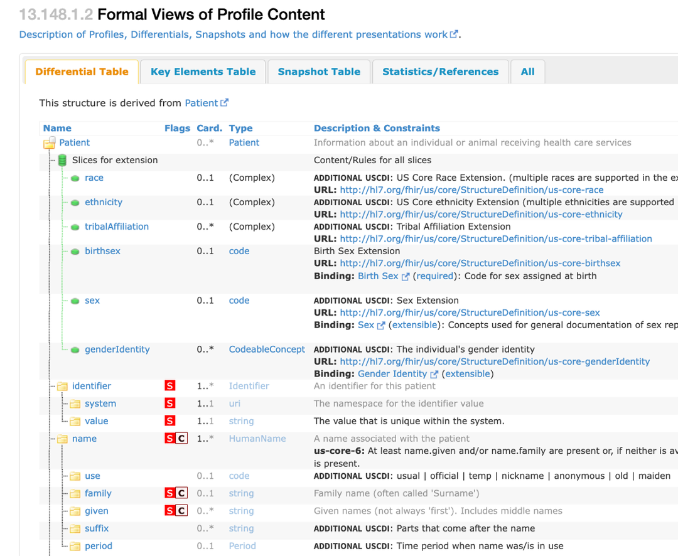
Here is an example of the same Patient resource we saw earlier, but as profiled by the US Core FHIR Profile

Extension Definition
Custom extensions are also defined using StructureDefinition resources:
{
"resourceType": "StructureDefinition",
"url": "http://example.org/fhir/StructureDefinition/birth-weight",
"name": "BirthWeight",
"status": "active",
"kind": "complex-type",
"abstract": false,
"type": "Extension",
"baseDefinition": "http://hl7.org/fhir/StructureDefinition/Extension",
"derivation": "constraint",
"differential": {
"element": [
{
"id": "Extension.url",
"path": "Extension.url",
"fixedUri": "http://example.org/fhir/StructureDefinition/birth-weight"
},
{
"id": "Extension.value[x]",
"path": "Extension.value[x]",
"type": [
{
"code": "Quantity"
}
]
}
]
}
}

Using Profiles in Resources
Resources declare conformance to profiles using the meta.profile
{
"resourceType": "Patient",
"meta": {
"profile": [
"http://example.org/fhir/StructureDefinition/example-patient-profile"
]
},
"id": "patient-example",
"text": {
"status": "generated",
"div": "<div xmlns=\"http://www.w3.org/1999/xhtml\">Patient example</div>"
},
"identifier": [
{
"system": "http://example.org/fhir/identifier/mrn",
"value": "12345"
}
],
"active": true,
"name": [
{
"use": "official",
"family": "Smith",
"given": [
"John"
]
}
],
"gender": "male",
"birthDate": "1974-12-25",
"address": [
{
"use": "home",
"line": [
"123 Main St"
],
"city": "Anytown",
"state": "CA",
"postalCode": "12345",
"country": "USA"
}
]
}
The meta.profile element contains a list of URLs that identify the profiles the resource claims to conform to. Systems processing the resource can use these profile references to understand the context of the resource and to validate that the resource meets the requirements of the referenced profiles.

Constraints
- Limit value sets for specific elements
- Enforce business rules and relationships
- Ensure consistency across implementations

Bindings
FHIR uses "bindings" to connect elements (especially those with coded data types like CodeableConcept) to ValueSets. A binding specifies the set of codes that should or may be used for that element.
FHIR defines different binding strengths:
- Required: Only codes from the specified ValueSet can be used. The server must reject resources with codes outside the ValueSet.
- Extensible: Codes from the ValueSet are preferred, but codes outside the ValueSet may be used. The server should provide a warning if an unknown code is used.
- Preferred: Codes from the ValueSet are preferred, but codes

Validation Against Profiles
Validation ensures resources conform to profiles:
Methods:
- Server-side validation using $validate operation
- Client-side validation using FHIR validators
- Validation during testing and quality assurance
Process:
- Choose validation method
- Execute validation against specific profiles
- Interpret results (success or errors)
- Address validation issues
Handling Issues:
- Locate errors in the resource
- Determine corrective actions
- Consider message severity (error, warning, information)
- Revalidate after corrections

6. Security and Privacy in FHIR

Authentication and Authorization
FHIR implementations require robust security:
Authentication Methods:
- OAuth 2.0 (recommended)
- SMART on FHIR extensions
- OpenID Connect integration
- Basic authentication (limited scenarios)
Authorization Models:
- Role-based access control (RBAC)
- Attribute-based access control (ABAC)
- Scopes for granular permissions
- Resource-level permissions
Implementation Patterns:
- Token-based authentication
- JWT (JSON Web Tokens)
- Refresh token flows
- Session management
Best Practices:
- Use HTTPS/TLS for all communications
- Implement token validation
- Apply principle of least privilege
- Regular credential rotation

Consent Resources
FHIR provides specific resources for managing patient consent:
Consent Resource:
- Records patient privacy choices
- Specifies what information can be shared
- Defines who can access information
- Documents consent status and verification
Consent Categories:
- Treatment consent
- Research participation
- Information sharing
- Advanced directives
Implementation Approach:
- Create and store Consent resources
- Link consents to relevant patients
- Enforce consent rules during access
- Maintain consent versioning and history
Integration Points:
- Authorization systems
- Data access policies
- Audit logging
- User interfaces for consent management

Audit Logging
Proper audit logging is essential for security and compliance:
AuditEvent Resource:
- Records security-relevant events
- Captures who, what, when, where, and how
- Documents success or failure
- Links to affected resources
Auditable Events:
- Authentication events
- Data access
- Data modification
- System administration actions
Implementation Guidance:
- Log all security-relevant events
- Include adequate context
- Ensure logs are tamper-resistant
- Implement retention policies
Standards and Patterns:
- Basic Audit Log Patterns IG
- IHE ATNA (Audit Trail and Node Authentication)
- DICOM audit message format
- Local regulatory requirements

Data Protection Considerations
FHIR implementations must address data protection:
Data Encryption:
- Transport Layer Security (TLS) for data in transit
- Database encryption for data at rest
- Field-level encryption for sensitive data
- Key management procedures
Data Minimization:
- Only access necessary data
- Implement resource filtering
- Use _summary and _elements parameters
- Apply "need to know" principle
De-identification:
- Remove direct identifiers
- Generalize quasi-identifiers
- Implement k-anonymity techniques
- Consider statistical disclosure control
Regulatory Compliance:
- HIPAA (US)
- GDPR (Europe)
- Local healthcare privacy laws
- Industry best practices

Security Implementation Checklist
- Risk Assessment: Identify threats and vulnerabilities
- Authentication: Implement strong user authentication
- Authorization: Control access to resources
- Transport Security: Secure data in transit
- Audit Logging: Track all security-relevant events
- Consent Management: Handle patient privacy preferences
- Data Protection: Secure data at rest
- Incident Response: Plan for security incidents
- Regular Testing: Conduct security assessments
- Policy Documentation: Document security practices
By following these guidelines and applying FHIR's capabilities appropriately, healthcare organizations can build secure, interoperable systems that protect patient privacy while enabling effective data exchange.

SMART on FHIR
SMART (Substitutable Medical Applications, Reusable Technologies) on FHIR provides:
App Launch Framework:
- Standardized app launch process
- Integration with EHR systems
- User context and session management
Authentication and Authorization:
- OAuth 2.0 authorization
- OpenID Connect integration
- Scoped permissions for resources
App Registration:
- Client registration process
- Scopes and permissions
- Redirect URI configuration
Implementation Steps:
- Register app with SMART server
- Implement OAuth 2.0 flow
- Request appropriate scopes
- Process authorization response
- Access FHIR resources with obtained token

FHIR Licensing and IP

FHIR Licensing and Trademark Use
FHIR, developed by HL7, is licensed under Creative Commons CC0, effectively placing it in the public domain and allowing for unrestricted use. However, HL7® and FHIR® are registered trademarks of HL7 International, requiring specific usage.

Usage Rights and Restrictions
Users can redistribute FHIR and create derivative specifications or implementation products. However, one cannot redefine FHIR conformance, claim HL7 endorsement for derived works, or publish altered versions without clear identification.

Trademark Application
When using the "FHIR" trademark or logo, include the ® symbol and acknowledge HL7's ownership. The first prominent mention should be "HL7® FHIR® standard," with subsequent uses as "FHIR® standard" or "FHIR®." The logo must be used in its entirety, unaltered, with the same trademark notices applied.

