Random Walks with Restart
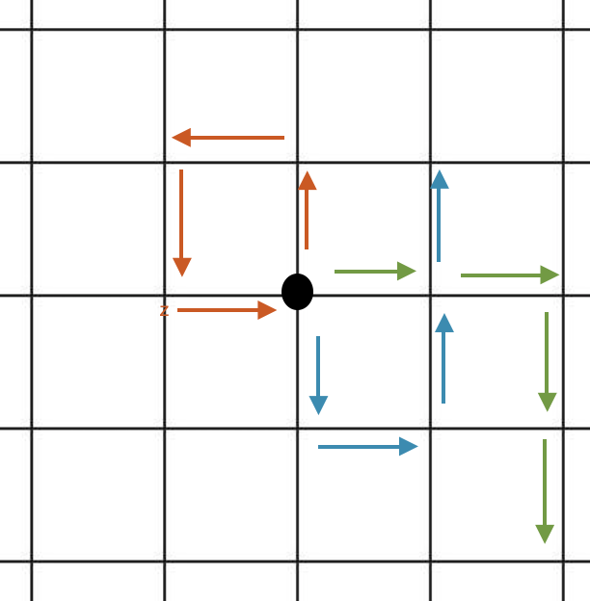
Introduction:
- Simple to understand algorithm
- Firstly formally introduced by Karl Pearson (mathematician)
- Common problems where its applied: Recommendation Systems, Community Detection, Clustering and Image Segmentation

Random Walk:
- Type of stochastic process
- This algorithm explores the relationship to each step that you would take and its distance from the starting point

RW with Restart:
- Random walk with an extra component; restart probability
- For every step taken in any direction there is a probability associated to going back to the initial starting position

Advantages:
- Provides a strong representation of similarity between two nodes in a weighted & unweighted graph
- Has a variety of applications and can be used in joint with other stochastic models like Markov Chains

Disadvantages:
- Using the same restart probability for every node
- There is no systematic way of choosing the restart probability for each application

Implementation:
- Simple one-liner implementation through networkX → PageRank

import networkx as nx
G = nx.DiGraph(nx.path_graph(4)) # create the network
pr = nx.pagerank(G, alpha=0.9) #apply PageRank

Disadvantages:

https://towardsdatascience.com/random-walks-with-restart-explained-77c3fe216bca
https://medium.com/@chaitanya_bhatia/random-walk-with-restart-and-its-applications-f53d7c98cb9
http://www.cs.cmu.edu/~christos/PUBLICATIONS/icdm06-rwr.pdf

