Team Luna

Team Lead- Grayton Savickas, Fred Marble, & Perry Fulfs

Abstract

Redesign for Nodeflix’s offerings to make them more efficient when customers sign up.

Table of contents

Business Proposal & Executive Summary

Goals of the Website

Core Users of the Website

Personas

Top Five Requirements- User

Top Five Requirements- Developer & Designer

Wireframes

Business Rules

ORD

Document Model

JSON Structure

Executive Summary

## Goals of the Website

The main goals of this website it to provide a movie and series entertainment experience to a wide user base in a user-friendly web-based application. The application should use mongoDB and other scalable technology for future application growth.

## Identify the core users of the website / Top 5 requirements for each

### 1. Budget Conscious:

* As much entertainment at a low cost
* Share with roommates if possible
* Multi-accounts
* Budget conscious
* Save favorites
* See what my friends are watching

### 2. Family Account:

* Premium account to get as much as possible
* Share with family
  + Kids accounts with limited parental guard
  + Kids time can be limited
* Easy to use or can configure
* Save favorites for each person in house
* Live events (sports or concerts)

### 3. Older Single Viewer:

* Only need one account
* Easily get to frequently watched shows
* Need ability to enlarge menus
* Wants ability to add more content at later stages

### 4. Physically Impaired:

* Need to add device to connect to tablet
* Ability to use only keyboard for menus & navigation on site
* Wants ability to save programs for later viewing
* Most content provided for sports
* Wants multiple accounts so care giver can access

### 5. Youth Account:

* Able to stream YouTube & or Twitch
* Keep account private
* Share content directly to friends for watch parties
  + Comments section
* Stream on any device – TV, Phone, or Tablet

# Personas 1 - 5

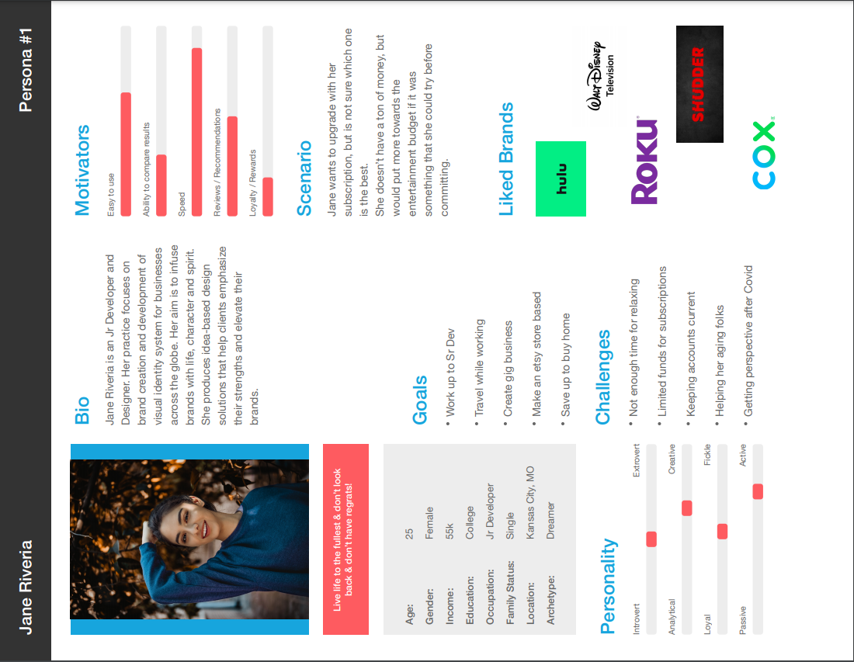

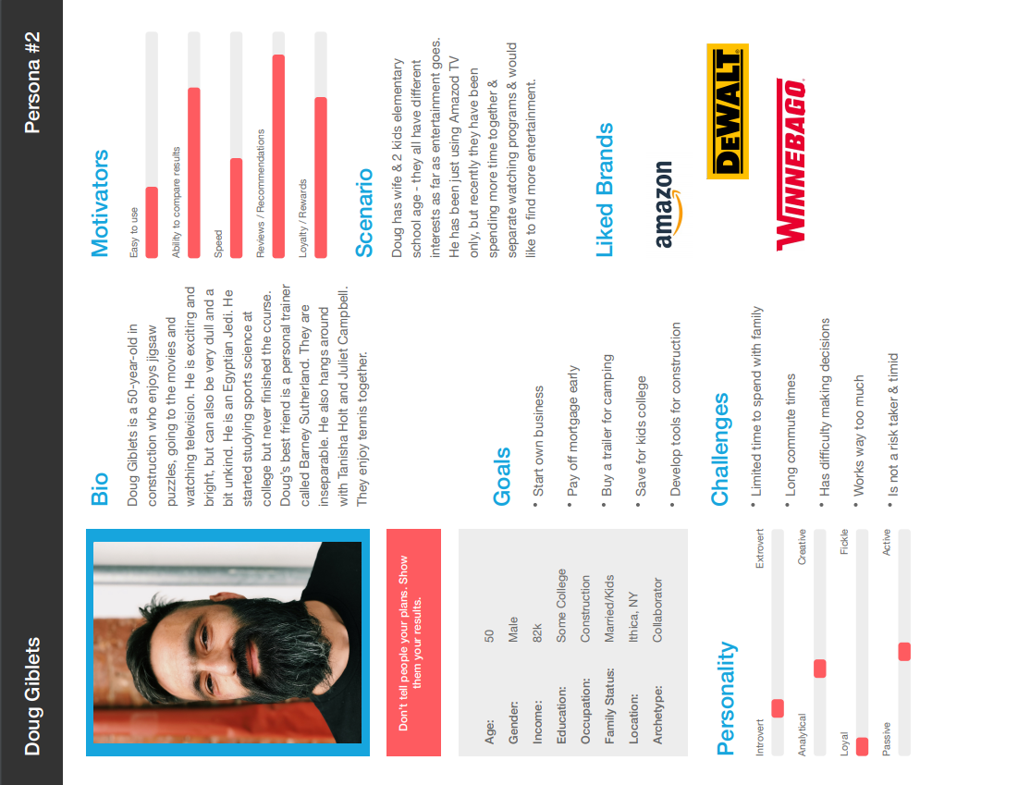

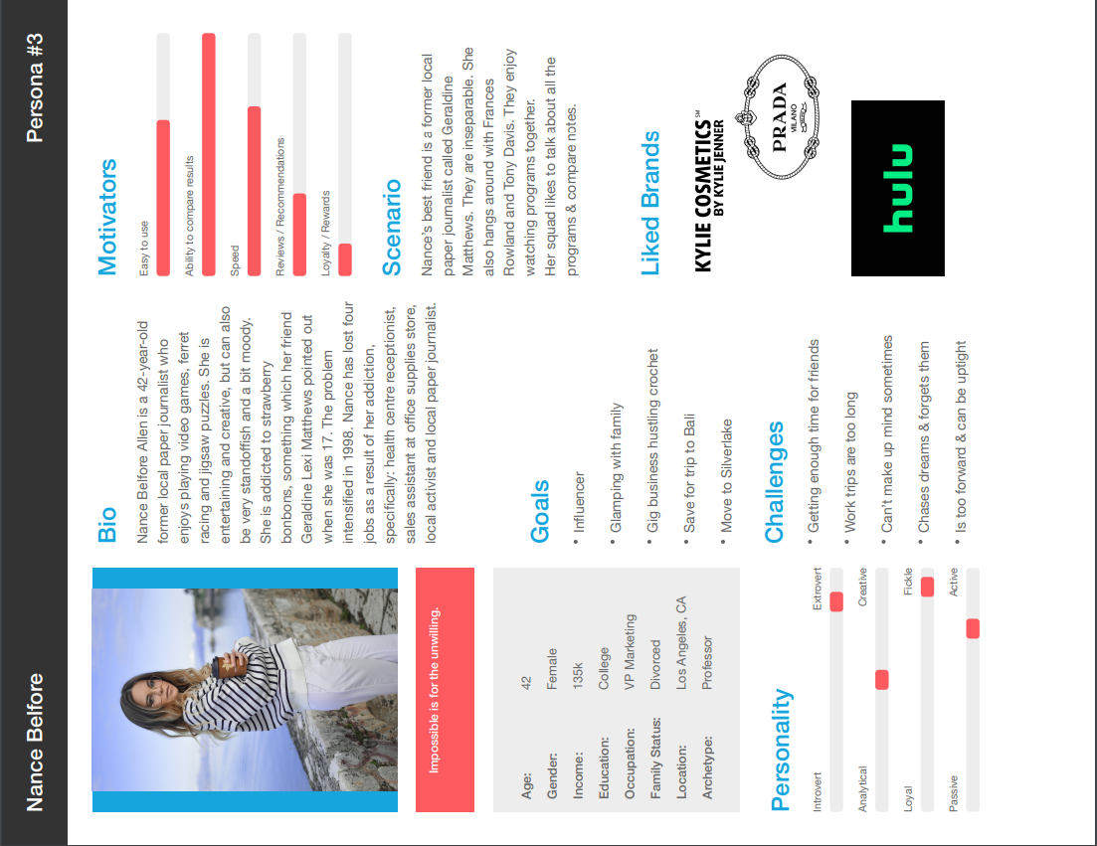

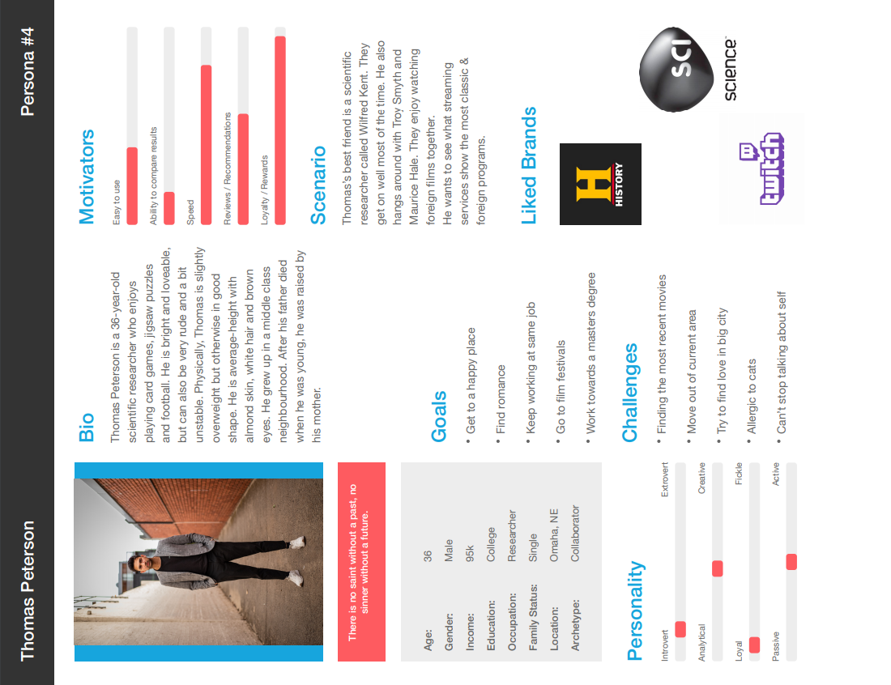

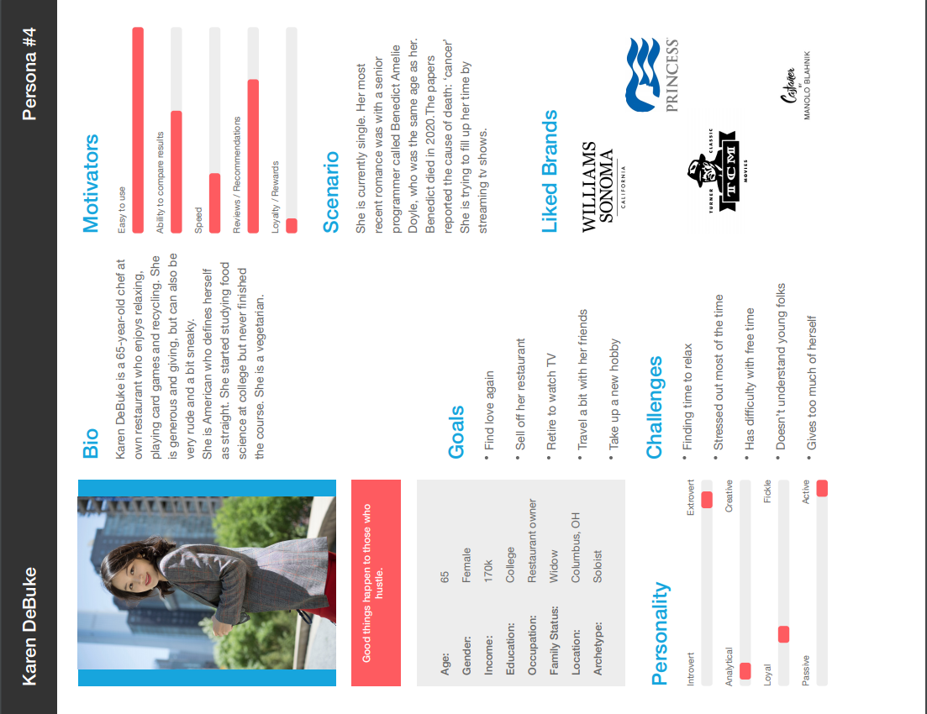

## Identify a list of the top five (5) requirements from the standpoint of the user.

1. As a user, I would like the ability to have multiple profiles on my account, because I have a family and we have diverse taste in Movies & TV Shows.
2. As a user, I would like the ability to switch between devices that I am watching on, so that when I am in the middle of a show, I can take it on the road with me.
3. As a user, I would like the ability to pause a live event just in case I need to step away, so that I don’t miss a moment of the action.
4. As a user, I need to have the ability to block certain ratings, so that I can make sure my children don’t watch anything inappropriate.
5. As a user, I would like the ability to limit the time that the children can watch TV or Movies, so that they get their work done.

## Identify a list of the top five (5) requirements from the standpoint of a user interface designer/developer.

1. As a developer, I would like to differentiate between all three levels, so that if something is broken for one level it doesn’t replicate across to the other levels.
2. As a designer, I would like a slightly different feel for each level, so that each level has a unique experience.
3. As a developer, we need to have it so that each user is easily identified and things that are appropriate for the user, so that we don’t offer an R rated movie to a 6-year-old.
4. As a designer, we need a way to show the different levels that we have available to our clientele that already have access to a level, so that if they are thinking about getting a higher or lower level they can.
5. As a developer, I need a way to make sure that the client is only offered what is available for their level, so that we don’t give a way “free merchandise”.

## Wireframes

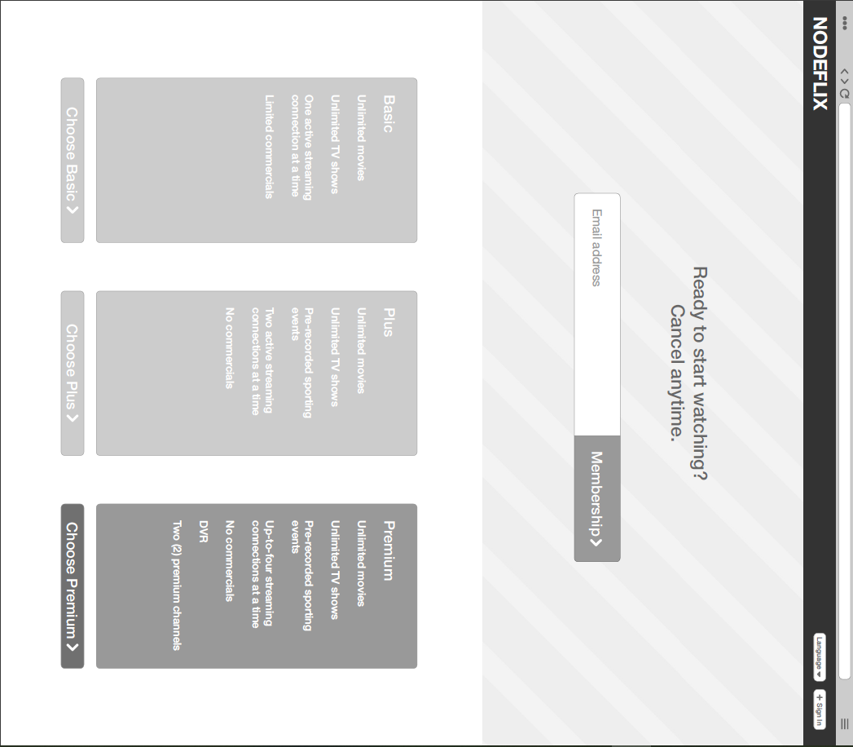

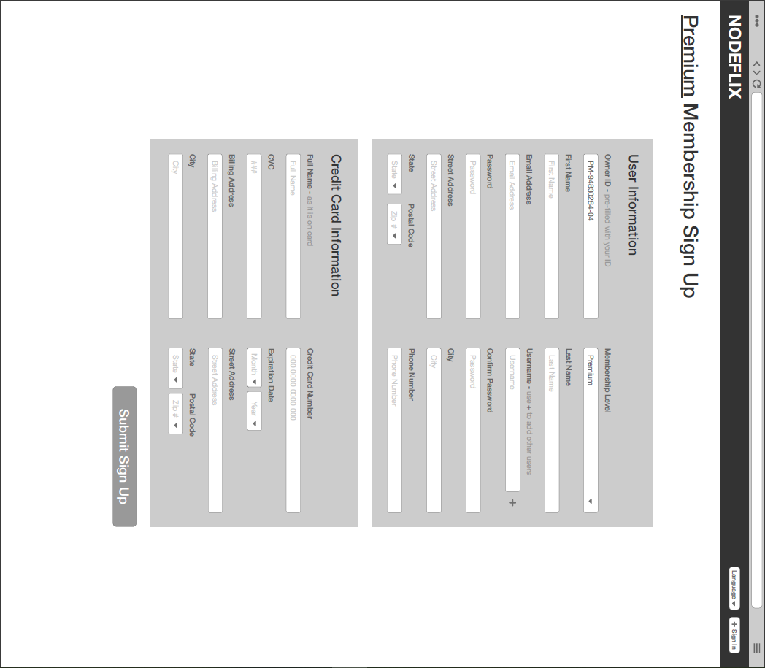

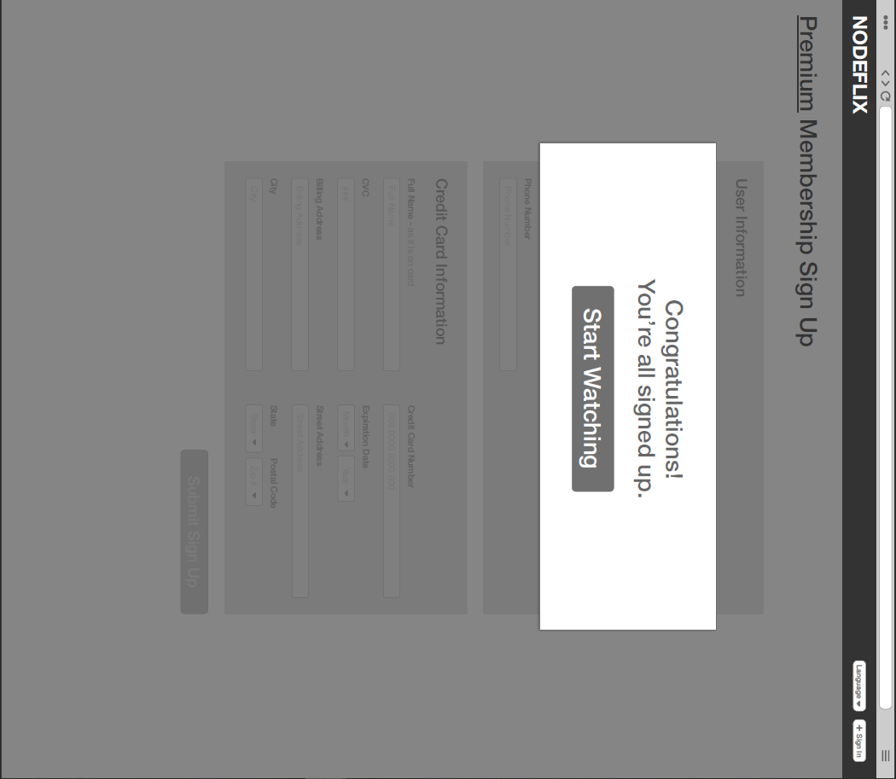

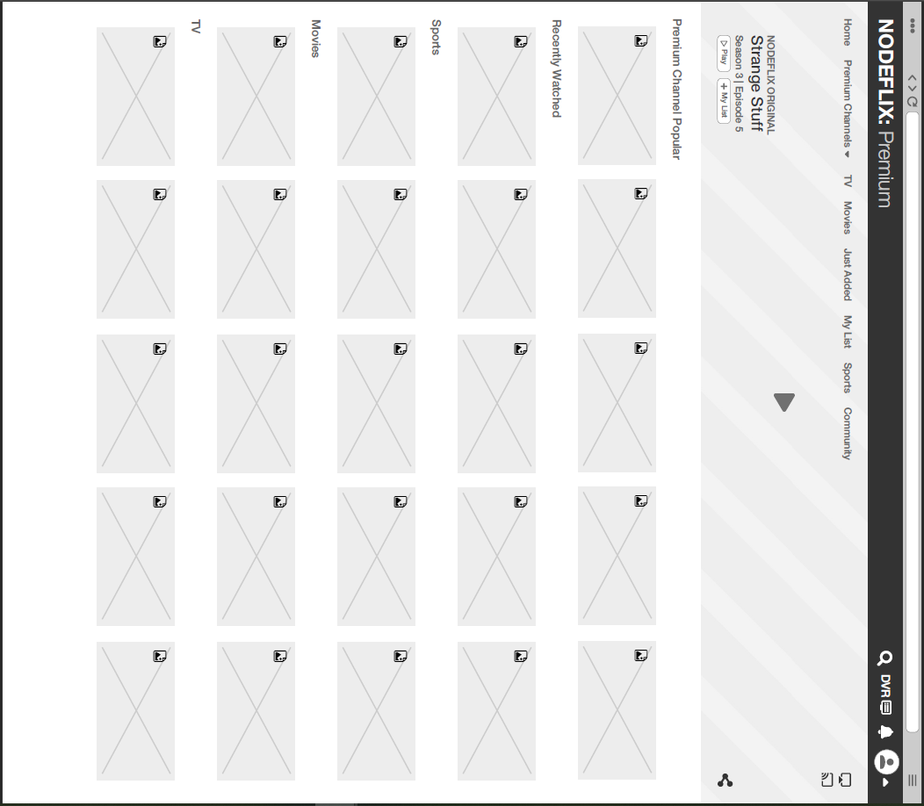

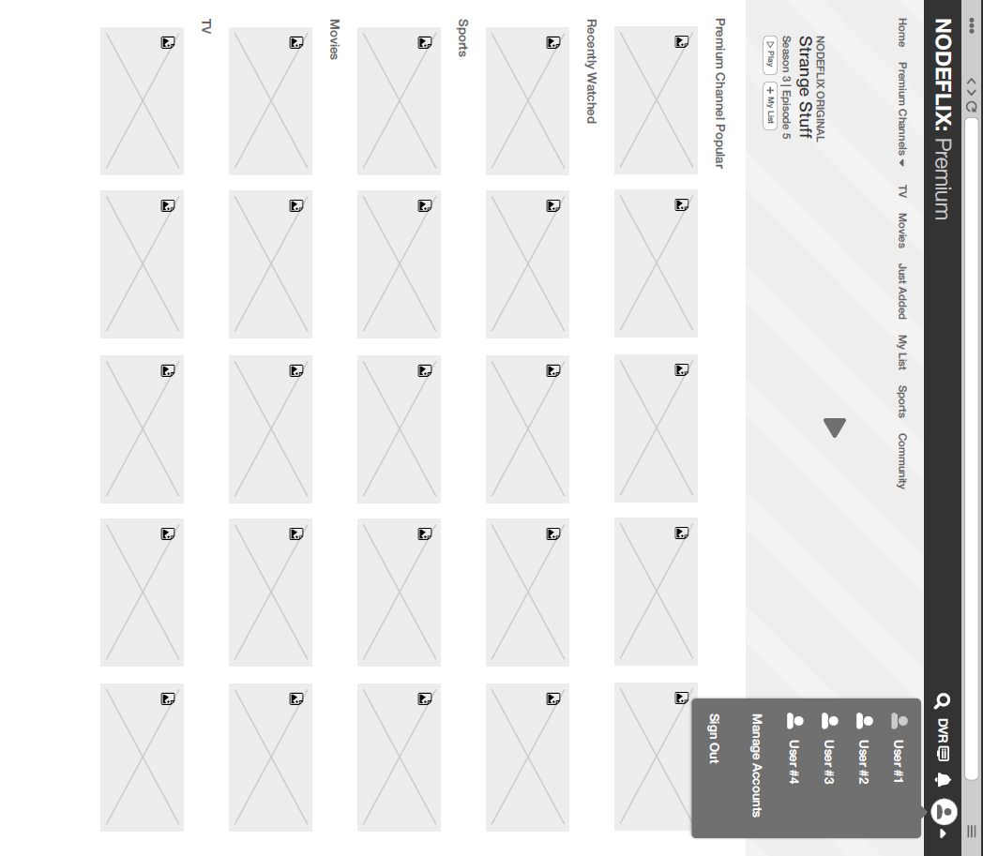

## Business Rules

*A customer(s) can have -*

## Basic

* user id
* first name
* last name
* user nae
* password
* age
* phone number
* email address
* access level (basic)
* payment
  + fulll name
  + cc number
  + expiration date
  + Cvc
* address
  + street 1
  + street 2
  + city
  + state
  + postal code

## Plus

* user id owner
* first name
* last name
* user name
  + user name 2
* password
* age
* phone number
* email address
* access level (plus)
* payment
  + full name
  + cc number
  + expiration date
  + Cvc
* billingAddress
  + street 1
  + street 2
  + city
  + state
  + postal code

## Premium:

* user id owner
* first name
* last name
* user name
  + user name 2
  + user name 3
  + user name 4
* password
* age
* phone number
* email address
* access level (plus)
* payment
  + fulll name
  + cc number
  + expiration date
  + Cvc
* address
  + street 1
  + street 2
  + city
  + state
  + postal code

## ORD

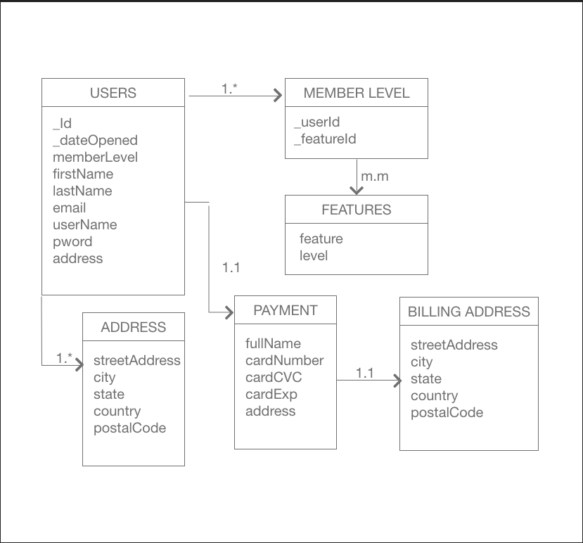

## Document Model

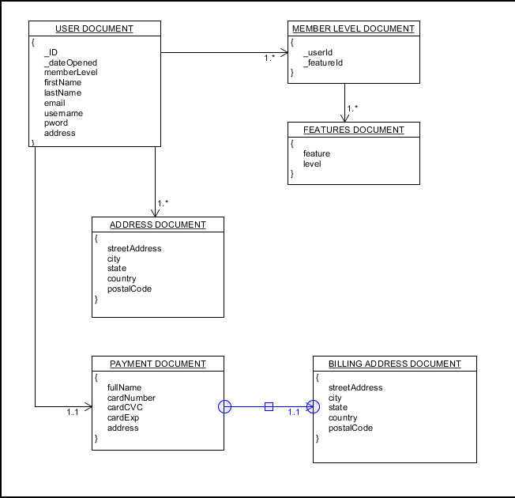

## JSON Structure

# Database Setup

## Collection Creation

db.createCollection(users,

{

“_dateOpened”: new Date();

“firstName”: “ “,

“lastName”: “ “,

“username”: “ “,

“pword”: “ “,

“email”: “ “,

}

);

db.createCollection(level,

{

“_id”: db.users.id,

“memberLevel” :[

{

“_featureId”:[

{

“feature”: “”,

“level”: “”

}

]

}

],

}

db.createCollection(address,

{

“_id”: db.users.id,

“streetAddress”: “ “,

“city”: “ “,

“state”: “ “,

“country”: “ “,

“postCode”: “ “

}

);

db.createCollection(paymentMethod,

{

“_id”: db.users.id,

"fullName": " ",

"cardNumber": " ",

"cardCVC": " ",

"cardExp": " "

}

);

db.createCollection(billingAddress,

{

“_id”: db.users.id,

"streetAddress": "",

"city": "",

"state": "",

"country": "",

"postCode": " "

}

);

## Population Queries

user = {

“_dateOpened”: new Date();

“firstName”: “Craig“,

“lastName”: “Todd“,

“username”: “ctodd“,

“pword”: “a8b6t4fzdj“,

“email”: “ctodd@sme.com“

}

db.users.insert(user);

address ={

“_id”: db.users.id,

“streetAddress”: “P Sherman 42 Wallaby Way“,

“city”: “Sydney“,

“state”: “Austraila“,

“country”: “Austraila“,

“postCode”: “6Z0 A8B“

}

db.address.instert(address);

## Queries

db.users.find({$where users.id = “”});

db.address.find({$where users.id = “”});

db.billingAddress.find({$where users.id = “”});

db.level.find({$where users.id = “”});

db.paymentMethod.find({$where users.id = “”});

# Executive Summary

## Our Mission

Team Luna is known for quality web development services. Team Luna has the possibility of redesigning Nodeflix’s newest Customer Plans - a three-tier pricing plan for its services to be rolled out by the end of the year.

Team Luna has developed solutions to help Nodeflix stay ahead of customer trends and propose that we implement a solution focused on tier-based services and delivery of new customer sign-up and current customer options. Our solution easily integrates with a wide range of systems like MongoDB and can enable Nodeflix to fully realize the benefits of improved productivity throughout the entire website life cycle. We provide all the training and support for your new solution that ensures your staff can quickly navigate and realize genuine upswing in sales, customer satisfaction, and provide sales metrics.

## Assumptions

**Resources:** Team Luna has a full staff to complete the specified work to be done. We also work with a top staffing agency to provide our team with supplementary staffing if a need arises.

**Technologies:** After our consultations with Nodeflix we’ve predetermined that we will work with your IT and DBAs on staff at Nodeflix to implement our solutions.

**Scheduling:** We have provided a Project Execution Timeline and this was signed and agreed upon by both parties.

**Business Capabilities:** Team Luna has the ability to act fast on moving realities in order to achieve gains and manage risks.

**Decision Making:** Both company teams realize that we must refer to contract information and consider unknowns to make reasonably optimal and timely decisions.

## Items in Scope

1. Sign Up Landing Page for 3 Tier Plans
   1. Design
   2. Develop
   3. Hand-off to Nodeflix IT
2. Credit Card Vendor Liaison
   1. Work with Nodeflix vendor to provide guidance on application
3. Sign Up (Basic/Plus/Premium)
   1. Design
   2. Develop
   3. Build
   4. Implement with Nodeflix DBs
4. Sign In - DropDown Navigation (Basic/Plus/Premium)
   1. Design
   2. Develop
   3. Build
   4. Implement with Nodeflix DBs
5. Training/Support
   1. 30 days after project go-live

## Items Out Of Scope

1. How-To Documents
2. Asset Creation (to be provided by Nodeflix Branding)
3. Troubleshoot Previous Issues
4. Navigation
   1. All navigation paths will be created and maintained by Nodeflix IT
   2. Unless specified in requirements
5. Marketing Materials

## Risks

1. Risk assessment completed on 05/16/21
2. The aim of the risk assessment process is to evaluate pain points and issues that may arise, then remove that threat or minimize the level of its risk by adding control measures, as necessary.

|  |  |  |  |  |  |  |  |
| --- | --- | --- | --- | --- | --- | --- | --- |
| ID | Risk Descrption | Likelihood of the risk occurring | Impact if the risk occurs | Severity | Owner | Mitigating action | Contingent action |
| 1 | Project purpose and need is not well-defined. | Medium | High | High | Project Sponsor | Complete a business case if not already provided and ensure purpose is well defined on Project Charter | Escalate to the Project Board with an assessment of the risk of runaway costs/never-ending project |
| 2 | Estimating/or scheduling errors | Medium | High | High | Project Manager | Break this two risks 'cost estimating' and 'scheduling errors'. | Raise change request for change to budget or schedule. Pull down contingency. |
| 3 | No control over staff priorities | Medium | Medium | Medium | Project Manager | Identify back ups for each human resource on the project. | Escalate to the Project Sponsor and bring in back up resource. |

## Technology/ Innovation to Be Employed or Developed

1. Node.js, Angular with TypeScript, MongoDB, and Express
2. GitHub, BitBucket, Docker, SoapUI
3. 4 Servers for Dev, QA, Prod (one back up)
4. Work with Nodeflix IT and DBAs on standing up product environments
5. Develop new Sign-Up and Sign-In

If you have questions on this summary, feel free to contact Team Luna at your convenience by email or phone. We will be in touch with you next week to arrange a follow-up conversation on the proposal.

Thank you for your consideration, Team Luna