Fred Marble

Professor Krasso

WEB 335

4/2/21

Assignment 3.3

1. 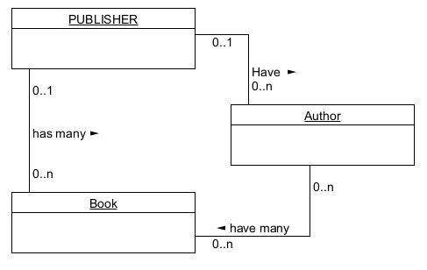
2. 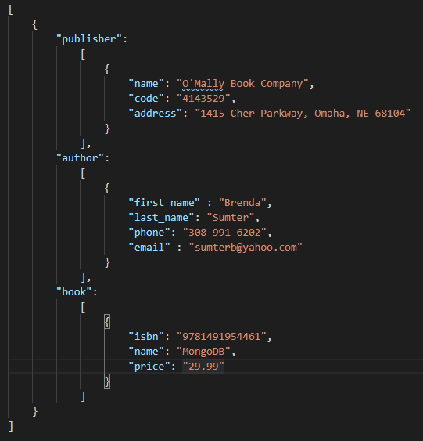
3. Publishers have many books

A book can have many authors

Publishers have many authors