Laboratorio 1:

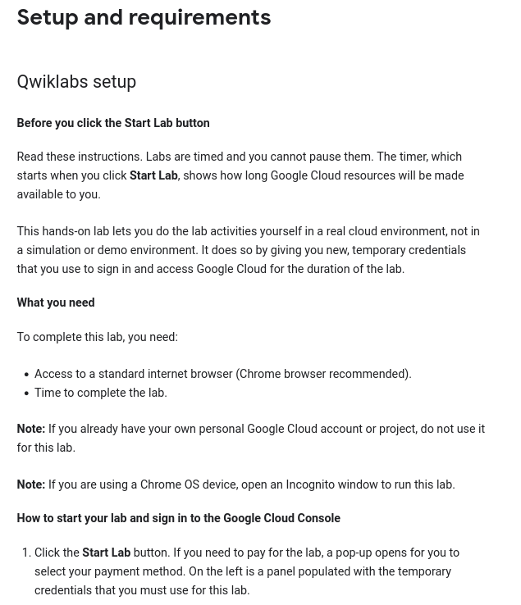

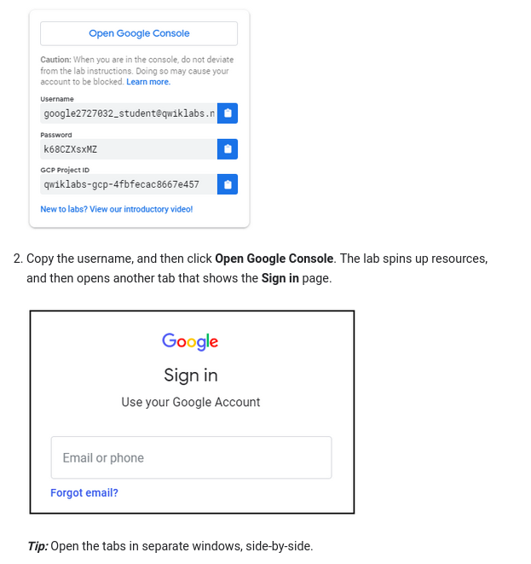

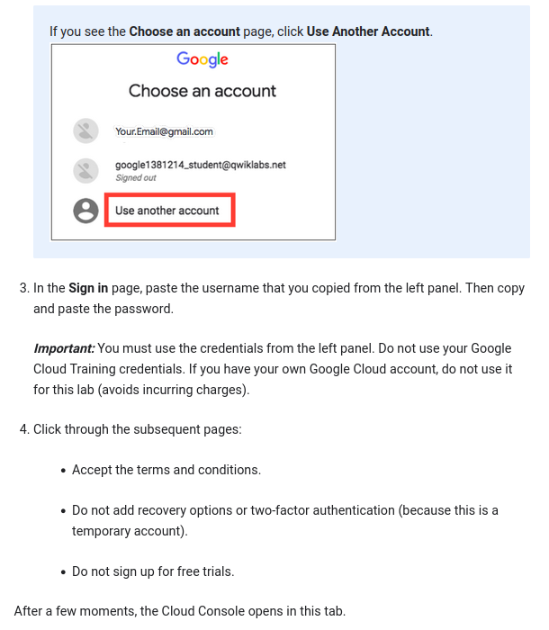

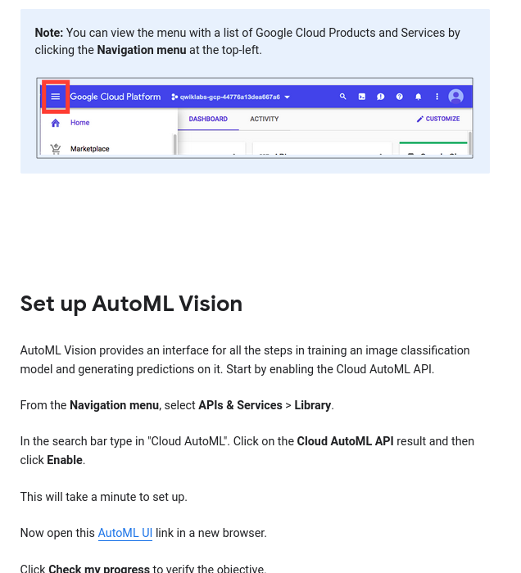

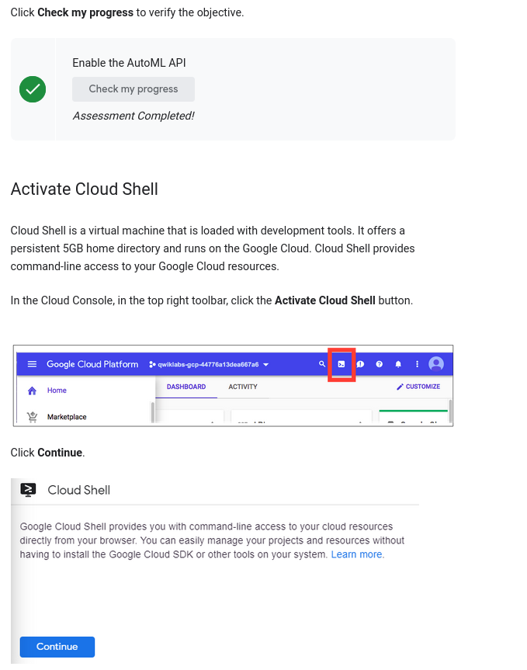

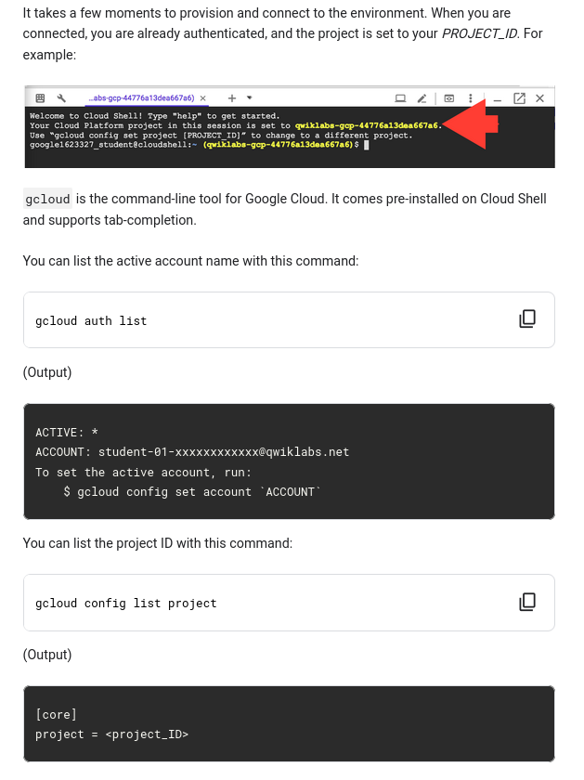

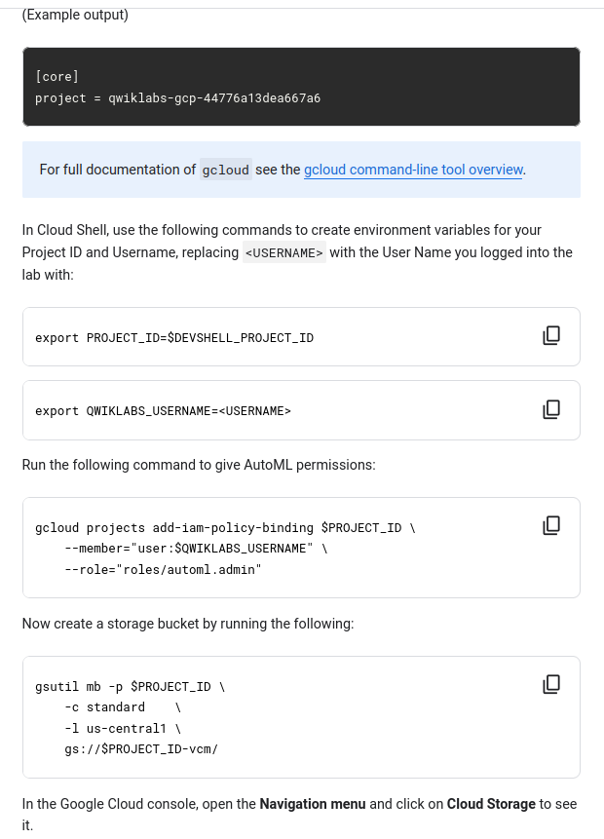

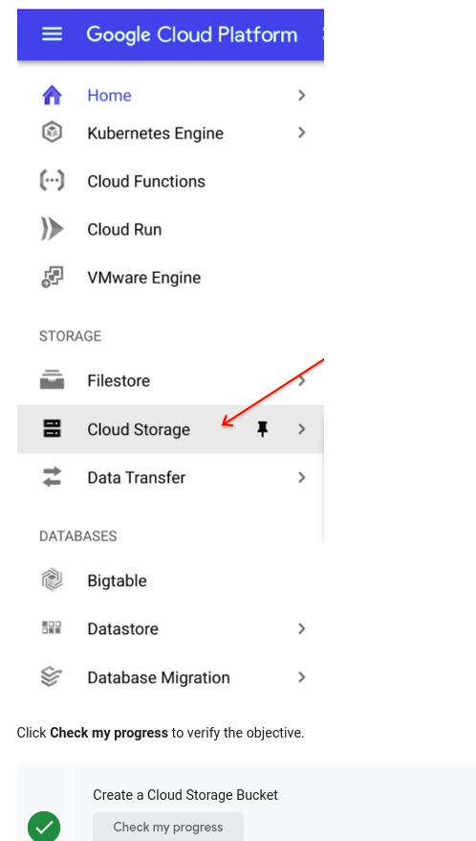

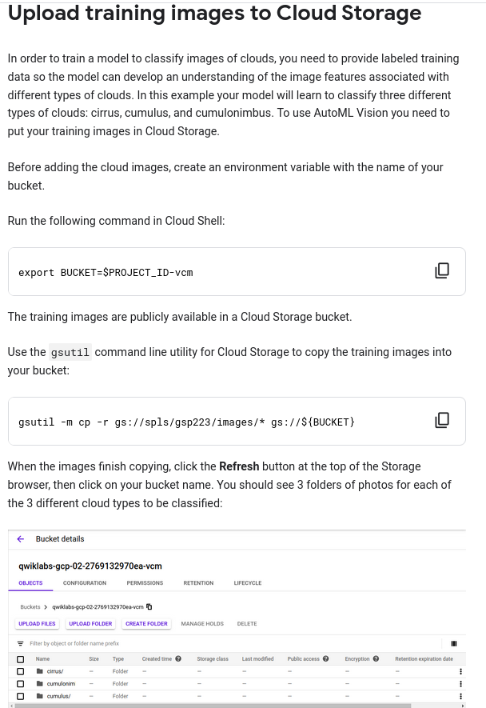

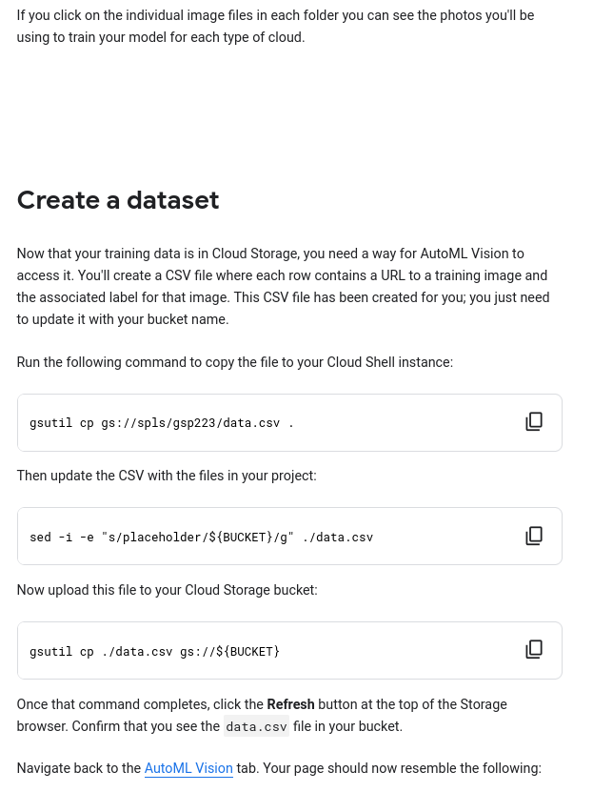

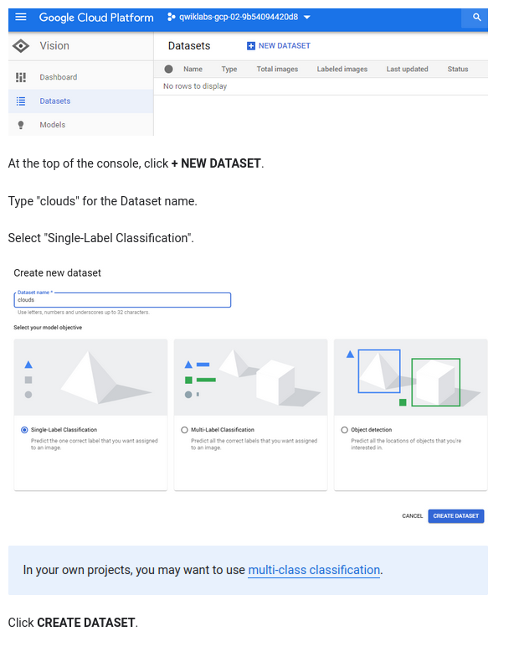

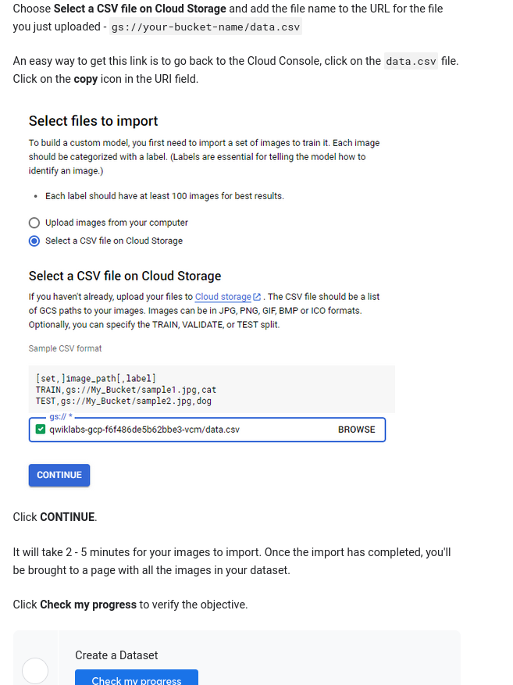

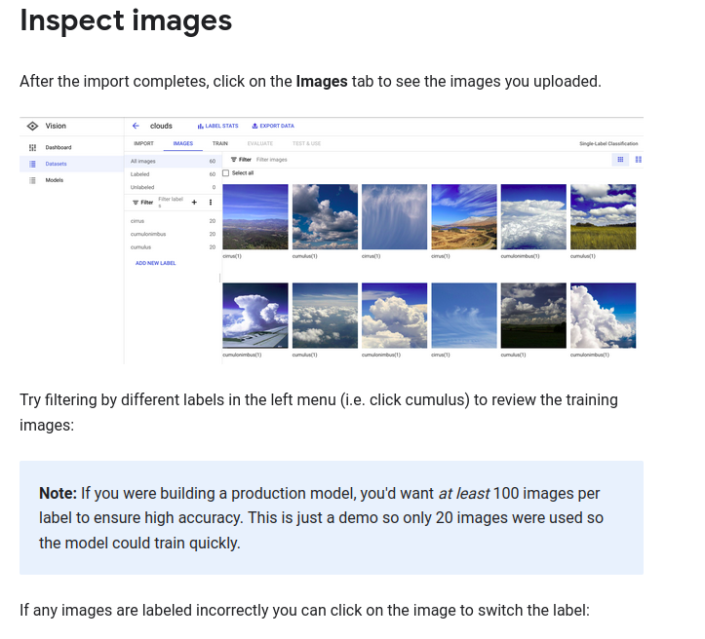

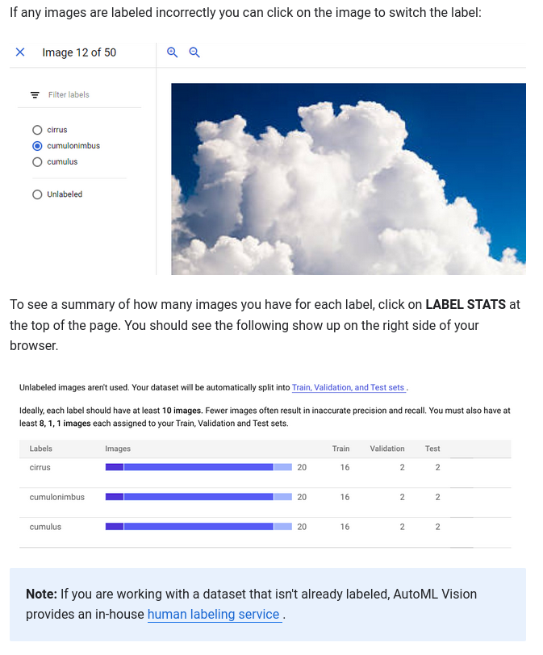

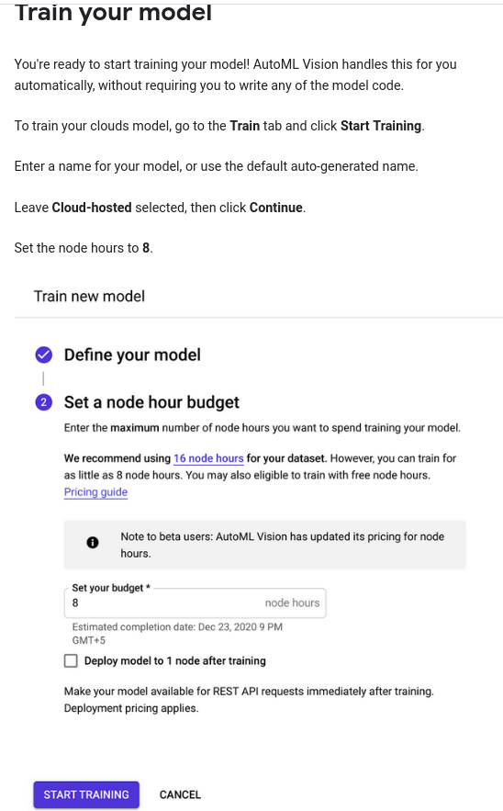

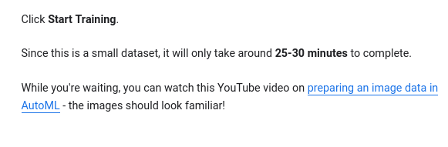

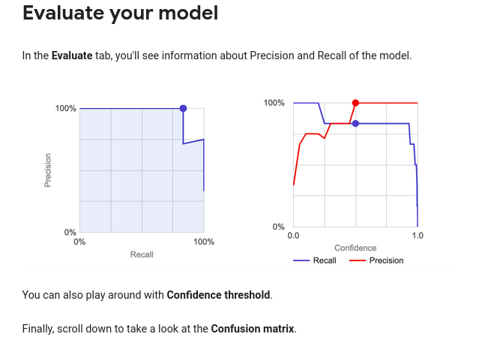

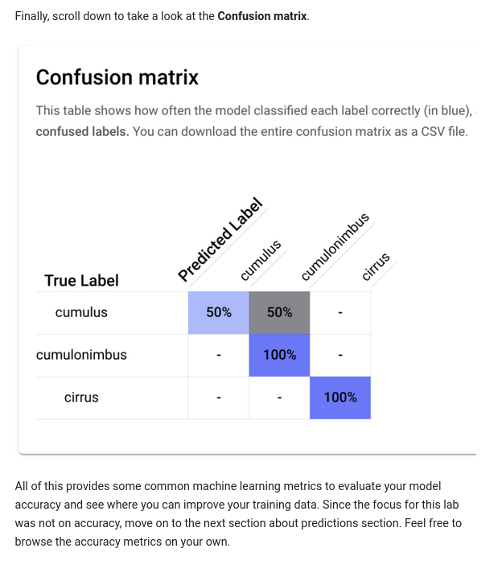

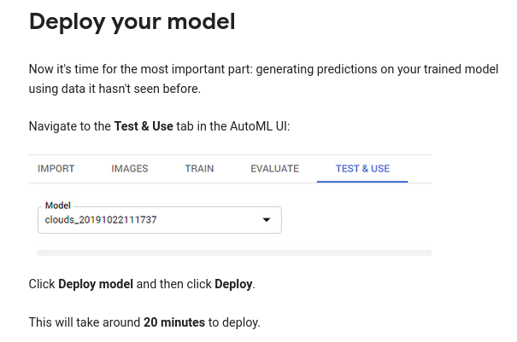

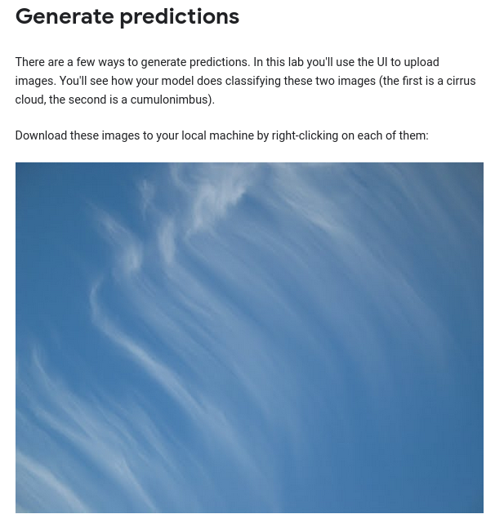

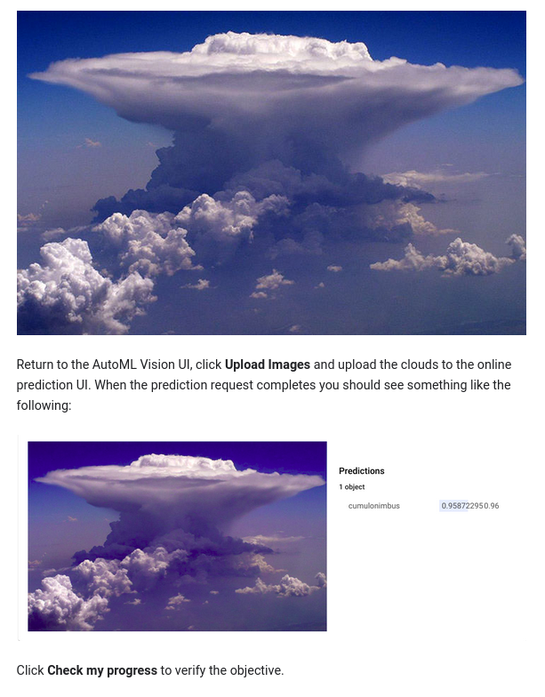

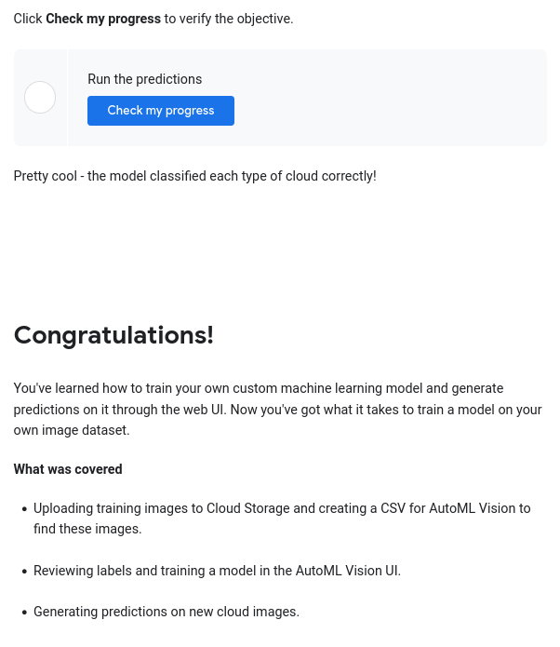

### Finish your Quest

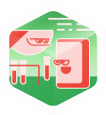

This self-paced lab is part of the Qwiklabs [Machine Learning APIs](https://google.qwiklabs.com/quests/32) and [Intro to ML: Image Processing](https://google.qwiklabs.com/quests/85) Quests. A Quest is a series of related labs that form a learning path. Completing a Quest earns you a badge to recognize your achievement. You can make your badge (or badges) public and link to them in your online resume or social media account. Enroll in these Quests and get immediate completion credit if you've taken this lab. [See other available Qwiklabs Quests](https://google.qwiklabs.com/catalog).

### Take your next lab

Continue your Quest with [Detect Labels, Faces, and Landmarks in Images with the Cloud Vision API](https://google.qwiklabs.com/catalog_lab/1112), or check out these suggestions:

* [Awwvision: Cloud Vision API from a Kubernetes Cluster](https://google.qwiklabs.com/catalog_lab/1041)
* [Entity and Sentiment Analysis with the Natural Language API](https://google.qwiklabs.com/catalog_lab/1113)

### Next steps / learn more

* Watch the [intro video](https://www.youtube.com/watch?v=GbLQE2C181U)
* Learn more about how AutoML Vision works by listening to the [Google Cloud Podcast episode](https://www.gcppodcast.com/post/episode-109-cloud-automl-vision-with-amy-unruh-and-sara-robinson/)
* Read the announcement [blog post](https://www.blog.google/topics/google-cloud/cloud-automl-making-ai-accessible-every-business/)
* Learn how to [perform each step with the API](https://cloud.google.com/vision/automl/docs/beginners-guide)

### Google Cloud Training & Certification

...helps you make the most of Google Cloud technologies. [Our classes](https://cloud.google.com/training/courses) include technical skills and best practices to help you get up to speed quickly and continue your learning journey. We offer fundamental to advanced level training, with on-demand, live, and virtual options to suit your busy schedule. [Certifications](https://cloud.google.com/certification/) help you validate and prove your skill and expertise in Google Cloud technologies.

##### Manual Last Updated April 20, 2022

##### Lab Last Tested April 20, 2022

Copyright 2022 Google LLC All rights reserved. Google and the Google logo are trademarks of Google LLC. All other company and product names may be trademarks of the respective companies with which they are associated.