**EPA and Army Define Waters of the U.S.**

EPA and the U.S. Army have published their revised definition of the Waters of the United States (WOTUS). The definition of WOTUS has been at the point of contention between regulators, industry and environmental groups since the Clean Water Act amendment in 2015.   The definition has been at the heart of a number of legal battles, and an item of regulatory enforcement uncertainty. The rules containing it were in a state of stay by the Supreme Court.

“This proposed rule would provide clarity, predictability and consistency so that regulators and the public can understand where the Clean Water Act applies — and where it does not,” EPA says in a published fact sheet about the new rule, “…there is a clear distinction between federal waters and waters subject to the sole control of the states and tribes.”

What Is Included in WOTUS?

The proposed rule lists six categories of waters to be included:

**Traditional Navigable Waters**

This includes territorial seas such as the Atlantic Ocean, Mississippi River, Great Lakes, large rivers and lakes, tidal waters, tidally influenced waterbodies including wetlands, along coastlines — used in interstate or foreign commerce.

**Tributaries**

These are rivers and streams that flow to traditional navigable waters either directly or through other non-jurisdictional surface waters. The flow must be perennial or intermittent, not just when it rains.

**Certain Ditches**

A ditch in this rule would be an artificial channel used to convey water when they are tributaries or built in adjacent wetlands. They would also be included if they are traditional navigable waters like the Erie Canal.

**Certain Lakes and Ponds**

These are included when they are traditional navigable waters like the Great Salt Lake in Utah or where they contribute intermittent flow to a traditional navigable water so water is conveyed in a perennial or intermittent flow. Lakes and ponds flooded by an included WOTUS are also included.

**Impoundments**

Impoundments, or dammed water/reservoirs made from WOTUS are included.

**Adjacent Wetlands**

Wetlands that physically touch other included WOTUS are included if they result from inundation from a WOTUS or if there is perennial or intermittent flow between the wetland and a WOTUS.

What is NOT Included

Anything that doesn’t meet the above definitions, and:

* Groundwater;
* Wetlands which are not adjacent to WOTS or are separated by a berm, levee or upland and do not have a surface water connection;
* Farm and roadside ditches;
* Prior converted cropland (except in the case where the cropland has been abandoned/not used for previous five years and has reverted to wetlands);
* Ephemeral features (wetlands, springs, streams, ponds, lakes, etc.) that only have water in them during or in response to rainfall;
* Stormwater control features excavated or constructed in upland to convey, treat, infiltrate, or store stormwater runoff;
* Wastewater recycling structures such as detention, retention, and infiltration basis and ponds, and groundwater recharge basins when they’re constructed in upland; and,
* Waste treatment systems, that is, lagoons, treatment ponds, settling and cooling ponds, and all components designed to convey or retain, concentrate, settle, reduce or remove pollutants either actively or passively from wastewater or stormwater prior to discharge.

*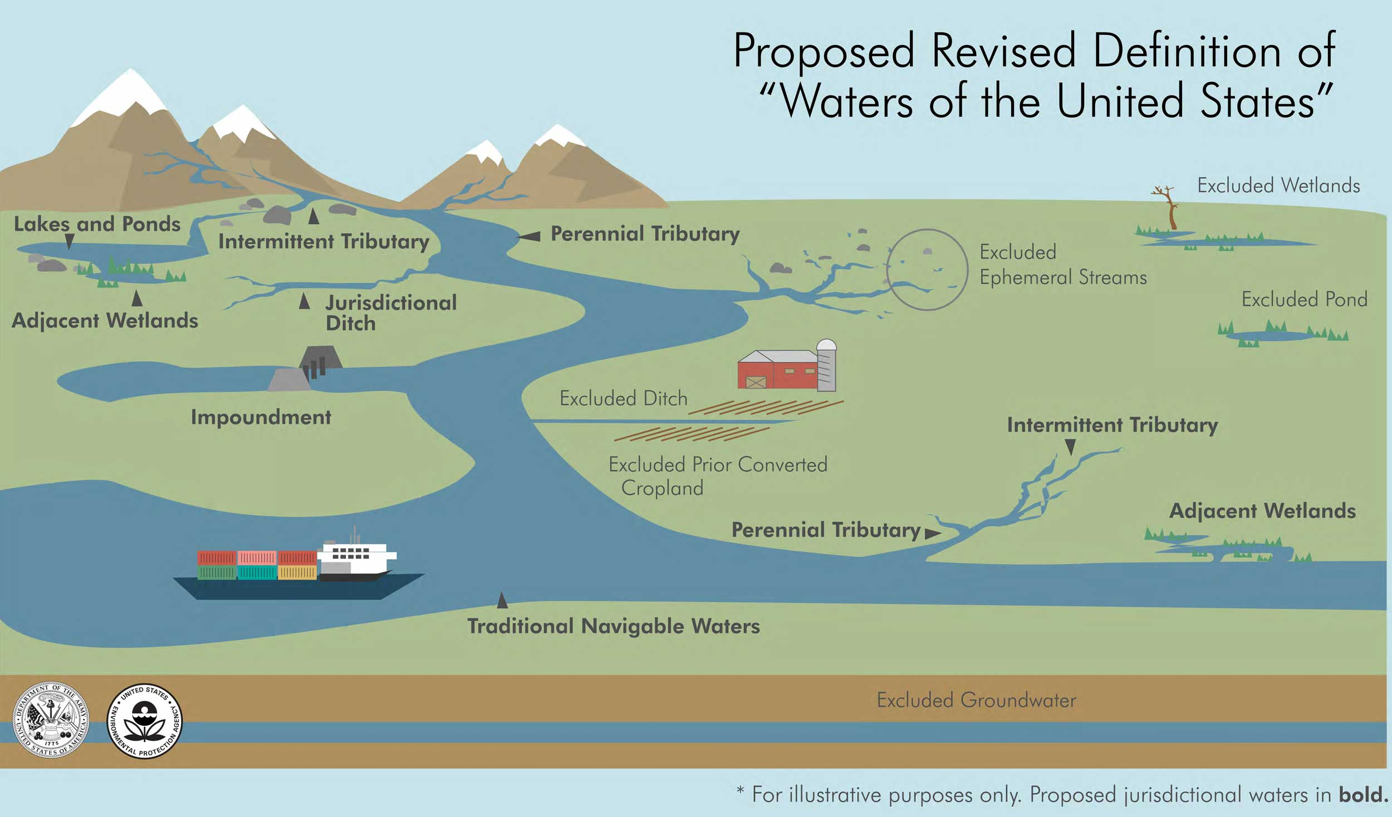Source: EPA.gov*