What’s really driving the late develop economies bond yield rise?

To answer that question we must set a difference between the Breakeven inflation and the Yield Premium.
As we see in the image below, breakeven inflation have been decreasing after the first month of the homruz-strait conflict (May 2026)
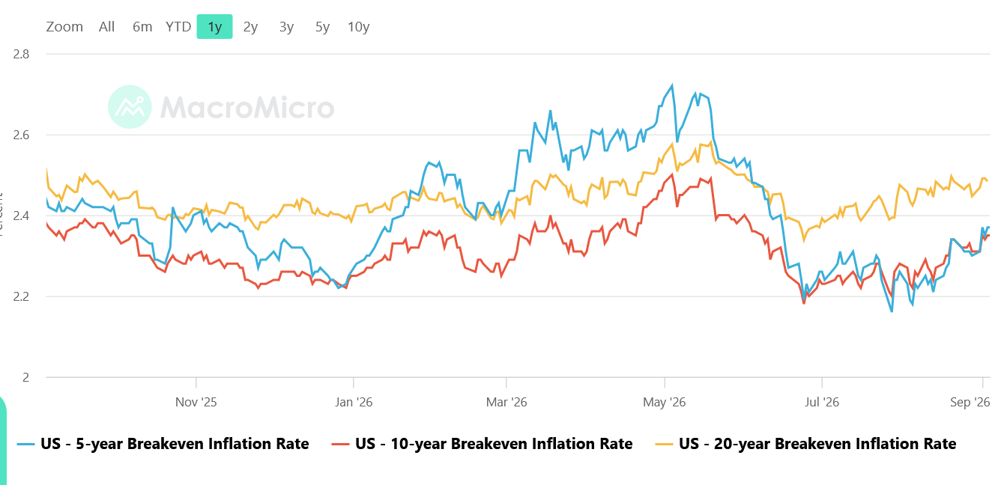

In contrast, US treasury yields have been going up since that date (MAY 2026)
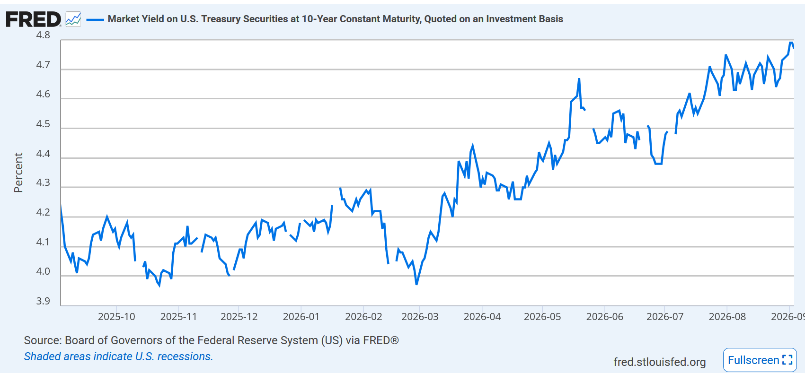
So, the question that arise is WHY?
We saw before that the main driver isn’t the Breakeven inflation ( were basically is the result of Nominal Bond Yield minus TIPS bonds)

That leads us to the subsequent consequences that is, Term Premium.
This Term Premium is what inverstors requires as an extra return just to invest in the bonds due all the risk they are taking. Before covid-19 era that Term Premium was negative, due the FED was constantly buying bonds. However the image has shifted due the Fiscal Imprudence of governments based on keynesianims economics.

Now the Term Premium is around 0.88%, that means if US10Y is around 4.8%, 0.88 of that yield is not correlated with inflation of interest rates.

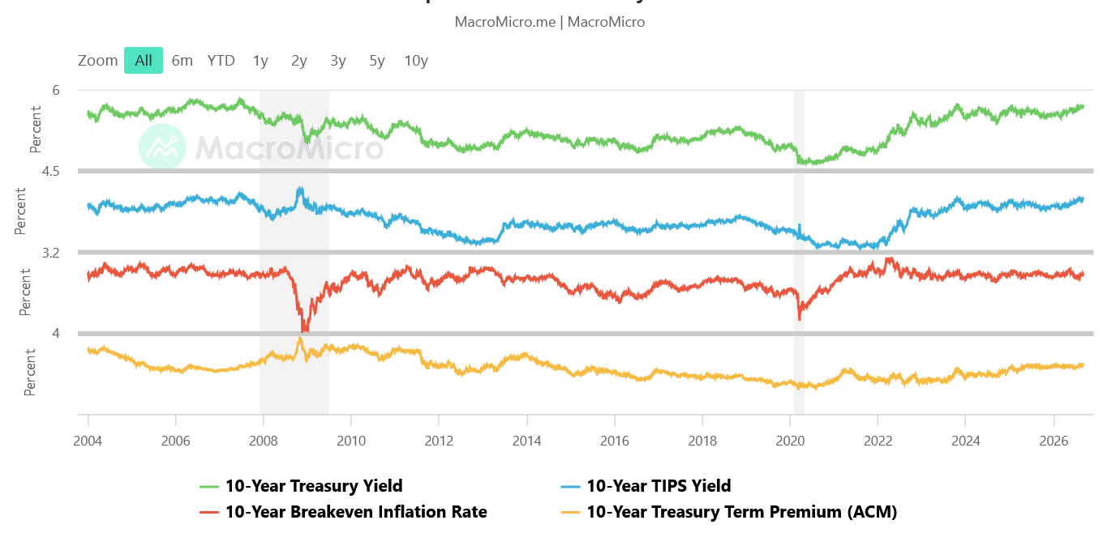

Not only that, now we are facing a bond battle with AI companies and Government bonds,
In the past decade big AI companies have funded their investment from CAPEX. However, that era is ending due the high amount of resocurces that hyperscalers needs.
Between 2020 and 2024, the five hyperscalers combined issued roughly $35 billion of debt each year, on average. And Year to date, they have issued approximately $132 billion, including one multitranche offering of roughly $53 billion, among the largest corporate bond sales on record, and a exotic bond that matures 100 years from issuance. Estimates of total AI-related debt issuance for full-year 2026—extending beyond the hyperscalers to the wider ecosystem of chipmakers, data-center developers, and utilities—range from roughly $300 billion to $570 billion.

