**Physical ERD**

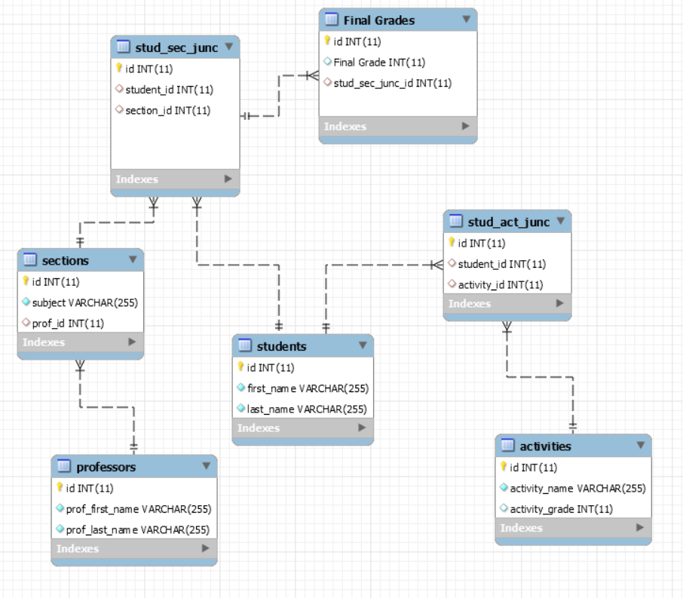

**Logical ERD**

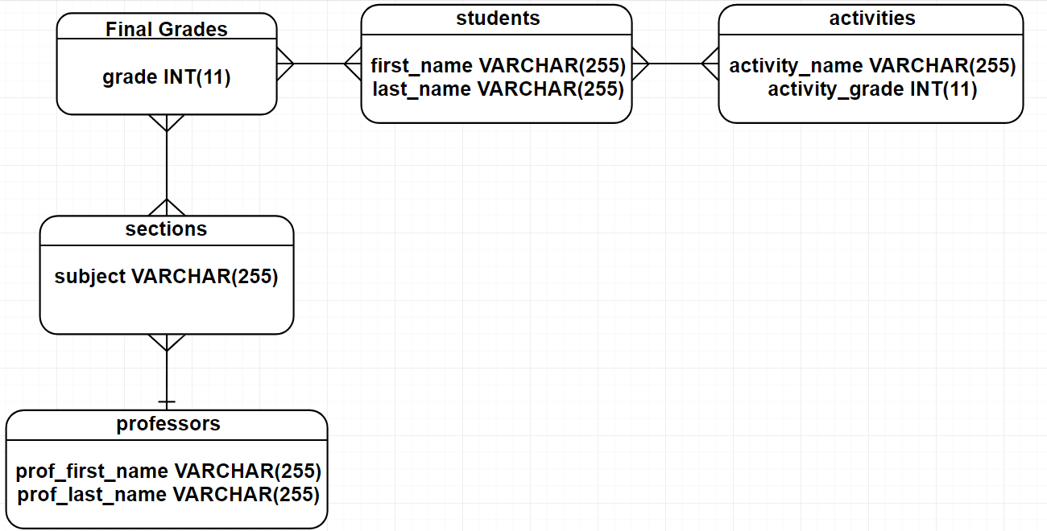

**Conceptual ERD**

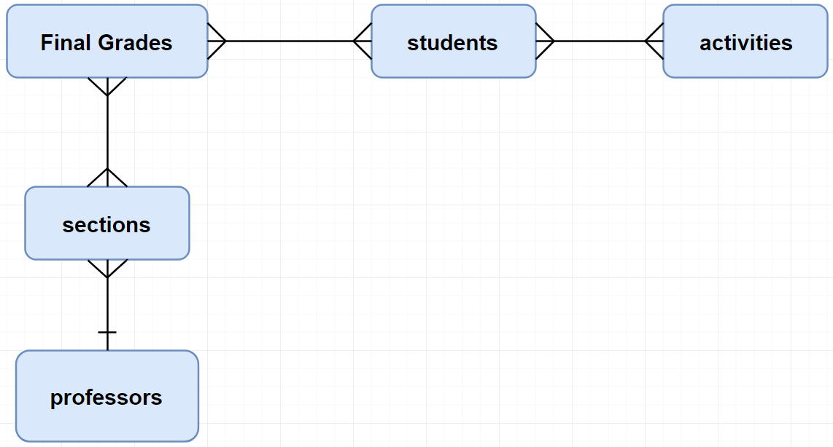

**STORED PROCEDURES**

1. A. Procedure Name: GetNumberOfStudents

B. Parameters: None

C. Query Returned: Number of students per section

1. A. Procedure Name: GetGradeOfStudents

B. Parameters: None

C. Query Returned: total grade of each students in a section

1. A. Procedure Name: GetGradeHigherThan

B. Parameters: [in] x (int)

C. Query Returned: Number of students whose total grade is > x

1. A. Procedure Name: GetPercentageHigherThan

B. Parameters: [in] x (float), [out] count (float)

C. Query Returned: count = Percentage of students whose total grade is > x

1. A. Procedure Name: CreateStudent

B. Parameters: [in] fn (varchar(50)), [in] ln (varchar(50))

C. Query Returned: Returns ID of created Student

1. A. Procedure Name: ReadStudent

B. Parameters: [in] x (int)

C. Query Returned: Returns all fields of Student where ID = x

1. A. Procedure Name: UpdateStudent

B. Parameters: [in] x (int), [in] fn (varchar(50)), [in] ln (varchar(50))

C. Query Returned: Updates information of Selected Student where ID = x

1. A. Procedure Name: DeleteStudent

B. Parameters: [in] x (int)

C. Query Returned: Deletes row in Students where ID = x

9. A. Procedure Name: CreateProfessor

B. Parameters: [in] fn (VARCHAR(50)), [in] ln (VARCHAR(56))

C. Query Returned: Returns ID of created Professor

10. A. Procedure Name: ReadProfessor

B. Parameters: [in] x (int)

C. Query Returned: Returns all fields of Professor where ID = x

11. A. Procedure Name: UpdateProfessor

B. Parameters: [in] x (int), [in] fn (VARCHAR(50)), [in] ln (VARCHAR(56))

C. Query Returned: Updates information of Selected Professor where ID = x

12. A. Procedure Name: DeleteProfessor

B. Parameters: [in] x (int)

C. Query Returned: Deletes row in Professors where ID = x

13. A. Procedure Name: CreateActivity

B. Parameters: [in] an (VARCHAR(50)), [in] ag (int)

C. Query Returned: Returns ID of created Activity

14. A. Procedure Name: ReadActivity

B. Parameters: [in] x (int)

C. Query Returned: Returns all fields of Activity where ID = x

15. A. Procedure Name: UpdateActivity

B. Parameters: [in] x (int), [in] an (VARCHAR(50)), [in] ag (VARCHAR(56))

C. Query Returned: Updates information of Selected Activity where ID = x

16. A. Procedure Name: DeleteActivity

B. Parameters: [in] x (int)

C. Query Returned: Deletes row in Activities where ID = x

17. A. Procedure Name: CreateSection

B. Parameters: [in] sub (VARCHAR(50)), [in] p_id (int)

C. Query Returned: Returns ID of created Section

18. A. Procedure Name: ReadSection

B. Parameters: [in] x (int)

C. Query Returned: Returns all fields of Section where ID = x

19. A. Procedure Name: UpdateSection

B. Parameters: [in] x (int), [in] sub (VARCHAR(50)), [in] p_id (VARCHAR(56))

C. Query Returned: Updates information of Selected Section where ID = x

20. A. Procedure Name: DeleteSection

B. Parameters: [in] x (int)

C. Query Returned: Deletes row in Sections where ID = x

21. A. Procedure Name: Get3PerSection

B. Parameters: none

C. Query Returned: Top 3 students for each section

22. A. Procedure Name: CreateGrade

B. Parameters: [IN] grade (INT), [IN] ss_junc_id (INT)

C. Query Returned: Returns ID of created Grade

23. A. Procedure Name: ReadGrade

B. Parameters: [in] req_id (int)

C. Query Returned: Returns all fields of Grade where ID = x

24. A. Procedure Name: UpdateGrade

B. Parameters: [IN] req_id (INT), [IN] u_grade (INT), [IN] ss_junc_id (INT)

C. Query Returned: Updates information of Selected Grade where ID = x

25. A. Procedure Name: DeleteGrade

B. Parameters: [in] req_id (int)

C. Query Returned: Deletes row in Final_Grades where ID = x