# Databaseserver - H1PD021123

## Installation af SQL Server

1. Gå til <https://www.microsoft.com/da-dk/sql-server/sql-server-downloads?rtc=1>, og download **developer** version

1. Kør **SQL2022-SSEI-Dev.exe** og vælg **Basics**

1. Server navn er computerens **host navn**, og vælg derefter **Windows Authentication**

## Administration og brugerrettigher på SQL server

### Opgave 1 - Authentication Mode

1. Authentication mode kan ændres under **properties->security**

### Opgave 2 - Opret et login

#### Must_change

SQL Serveren beder brugeren om en ny adgangskode, første gang det nye login bruges.

#### Check_expiration

Tjekker for udløb af adgangskode skal håndhæves ved dette login.

#### Check_policy

Windows-adgangskodepolitikkerne for serveren, som SQL Serveren kører på, skal håndhæves ved login.

### Opgave 3 - Fixed Server Roles

Kilde: <https://learn.microsoft.com/en-us/sql/relational-databases/security/authentication-access/server-level-roles?view=sql-server-ver16>

|  |  |
| --- | --- |
| **sysadmin** | Members of the **sysadmin** fixed server role can perform any activity in the server. |
| **serveradmin** | Members of the **serveradmin** fixed server role can change server-wide configuration options and shut down the server. |
| **securityadmin** | Members of the **securityadmin** fixed server role manage logins and their properties. They can GRANT, DENY, and REVOKE server-level permissions. They can also GRANT, DENY, and REVOKE database-level permissions if they have access to a database. Additionally, they can reset passwords for SQL Server logins.  **IMPORTANT:** The ability to grant access to the Database Engine and to configure user permissions allows the security admin to assign most server permissions. The **securityadmin** role should be treated as equivalent to the **sysadmin** role. As an alternative, starting with SQL Server 2022 (16.x), consider using the new fixed server role **##MS_LoginManager##**. |
| **processadmin** | Members of the **processadmin** fixed server role can end processes that are running in an instance of SQL Server. |
| **setupadmin** | Members of the **setupadmin** fixed server role can add and remove linked servers by using Transact-SQL statements. (**sysadmin** membership is needed when using Management Studio.) |
| **bulkadmin** | Members of the **bulkadmin** fixed server role can run the BULK INSERT statement.  The **bulkadmin** role or ADMINISTER BULK OPERATIONS permissions isn't supported for SQL Server on Linux. Only the **sysadmin** can perform bulk inserts for SQL Server on Linux. |
| **diskadmin** | The **diskadmin** fixed server role is used for managing disk files. |
| **dbcreator** | Members of the **dbcreator** fixed server role can create, alter, drop, and restore any database. |
| **public** | Every SQL Server login belongs to the **public** server role. When a server principal hasn't been granted or denied specific permissions on a securable object, the user inherits the permissions granted to **public** on that object. Only assign public permissions on any object when you want the object to be available to all users. You can't change membership in public.  **Note:** **public** is implemented differently than other roles, and permissions can be granted, denied, or revoked from the public fixed server roles. |

### Opgave 4 - Fixed Database Role

Kilde: <https://learn.microsoft.com/en-us/sql/relational-databases/security/authentication-access/database-level-roles?view=sql-server-ver16>

|  |  |
| --- | --- |
| **db_owner** | Members of the **db_owner** fixed database role can perform all configuration and maintenance activities on the database, and can also drop the database in SQL Server. (In SQL Database and Azure Synapse, some maintenance activities require server-level permissions and cannot be performed by **db_owners**.) |
| **db_securityadmin** | Members of the **db_securityadmin** fixed database role can modify role membership for custom roles only and manage permissions. Members of this role can potentially elevate their privileges and their actions should be monitored. |
| **db_accessadmin** | Members of the **db_accessadmin** fixed database role can add or remove access to the database for Windows logins, Windows groups, and SQL Server logins. |
| **db_backupoperator** | Members of the **db_backupoperator** fixed database role can back up the database. |
| **db_ddladmin** | Members of the **db_ddladmin** fixed database role can run any Data Definition Language (DDL) command in a database. Members of this role can potentially elevate their privileges by manipulating code that may get executed under high privileges and their actions should be monitored. |
| **db_datawriter** | Members of the **db_datawriter** fixed database role can add, delete, or change data in all user tables. In most use cases this role will be combined with **db_datareader** membership to allow reading the data that is to be modified. |
| **db_datareader** | Members of the **db_datareader** fixed database role can read all data from all user tables and views. User objects can exist in any schema except *sys* and *INFORMATION_SCHEMA*. |
| **db_denydatawriter** | Members of the **db_denydatawriter** fixed database role cannot add, modify, or delete any data in the user tables within a database. |
| **db_denydatareader** | Members of the **db_denydatareader** fixed database role cannot read any data from the user tables and views within a database. |

### Opgave 5 - Custom roles

#### Kan man selv oprette en database rolle? Hvordan og hvornår kunne det blive aktuelt?

Ja, se billeder…

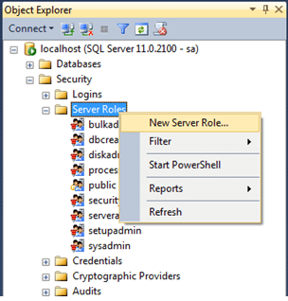

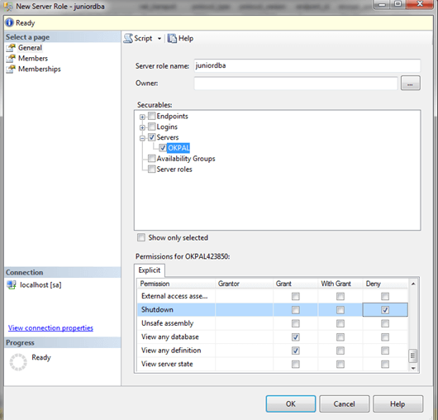

### Opgave 6 - Opret bruger

1. Object Explorer->Security
2. Højre klik på **Security**, vælg **new** og derefter **Login**

### Opgave 8 - Select i SQLCMD

1. Sqlcmd -S **REPLACE_WITH_SERVER_NAME**
2. select "USB rocket launcher (Gray)" from WideWorldImporters.Sales.OrderLines

## Backup og recovery

### Back-up model sættes til Full. Hvorfor? Hvad er forskellen på Simple og Full?

Simple backup kan først laves, når man som minimum har lavet en full backup. Et fornuftigt backupplan, ville være en full backup om ugen og så ellers simple backup nightly.

### Full backup guide via SSMS

1. Opret en mappe, som skal bruges til output for database backup
2. Højre klik på en database, og vælg task->backup…

### Hvad gør back-up the tail of the log?

En backup, der er baseret på tail loggen, registrerer alle log records, der endnu ikke er sikkerhedskopieret (tail loggen) for at forhindre tab af arbejde og for at holde loggen intakt.

### Samlede backup statement

backup database WideWorldImporters to disk = 'd:\TechCollege\H1PD021123\Databaseserver\WideWorldImporters_BAK2.bak'

backup log WideWorldImporters to disk = 'D:\TechCollege\H1PD021123\Databaseserver\WideWorldImporters_BAK.trn'

backup database WideWorldImporters to disk = 'D:\TechCollege\H1PD021123\Databaseserver\WideWorldImporters_BAK.bak'

with differential

backup log WideWorldImporters to disk = 'D:\TechCollege\H1PD021123\Databaseserver\WideWorldImporters_BAK2.trn'

### Mirrored backup

BACKUP DATABASE WideWorldImporters

TO DISK = 'D:\TechCollege\H1PD021123\Databaseserver\WideWorldImporters_BAK_Mirror01.bak'

MIRROR TO DISK = 'D:\TechCollege\H1PD021123\Databaseserver\WideWorldImporters_BAK_Mirror02.bak'

WITH FORMAT

### Restoring af databaser