marcguerra.ga server: ip → 34.215.116.39 // port → 22
https://wiket.esteveterradas.cat/index.php?title=Usuari:Marc98_sjd&action=submit

http://awseducate.qwiklabs.com/

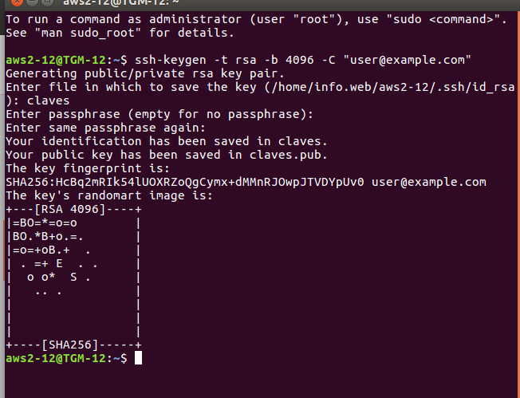

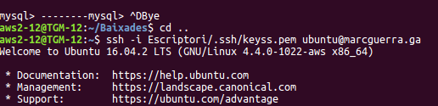

create database wpm;
create user wpm@localhost identified by «mapache123»;
grant all on wpm.* to wpm@localhost;

