Project 1: Static Foundations
Feedback for Marc Flores Mendoza's portfolio
Student: Marc Flores Mendoza Course: CSC 436, Fall 2026 Reviewed at: 04196c2
Repo: github.com/marcaflores/CSC436Assignment1 Live: marcfloresdev.netlify.app

Grade: 86 / 100
Category | Points | Earned | One line
Semantic HTML | 20 | 18 | All four pages validate clean; skip link, aria everywhere; nav links are not a list, nav sits below a full-screen hero
CSS layout | 25 | 23 | 909 lines of real CSS: tokens, fluid type, Flexbox and Grid both earning their keep, two themes; desktop-first
Responsive design | 15 | 13 | No horizontal scroll on any page; the nav wraps onto two lines at 375px
JavaScript interaction | 15 | 12 | Theme toggle, carousel and scroll-reveal all vanilla and verified; the contact form goes nowhere
Repository and deployment | 15 | 12 | README complete, 19 descriptive commits, AI skill files kept as evidence; all in one 13-hour window
Content and polish | 10 | 8 | Real portfolio, real projects, optimized images; a form that says Send and does not
Total | 100 | 86 | The most complete site in the class. The form and the nav need the same care as the CSS.

How this review was made
Your instructor reviewed this project with Claude (Anthropic's AI) as a second set of eyes. Claude cloned the repo, read all four pages, the stylesheet and both scripts, loaded the site at phone, tablet and desktop widths, ran the W3C validator on every page, clicked the theme toggle and confirmed it persisted, advanced the project carousel, submitted the contact form, read the console, and read the development log you submitted. Every note and every point in this document was read and approved by your instructor. Same standard, same rubric, just more time spent looking at your code than one human has in a grading week.

The short version
This is a finished portfolio. Four pages, all valid, one h1 each, a skip link, aria-current on the active nav item, a real headshot, a real resume PDF, three real projects with nine optimized screenshots, and a stylesheet with a token system, fluid type, both layout models, and a light theme that respects reduced motion. The JavaScript is vanilla, which is what the brief asked for, and all three interactions work. Your development log documents every step, which is exactly what the AI policy wants.
The deductions are about the edges. The contact form has no handler and no destination, so clicking Send reloads the page with the visitor's message in the address bar and nothing else happens, while the README calls it "a working form." The nav is placed after a 100vh hero, so on first paint nobody can see it. And all 19 commits are inside one 13-hour stretch on the due date, with the last seven timestamped after midnight.
One more thing, and it is not a deduction. Your log shows the AI redesigned the site three times, diagnosed a Chrome repaint bug, found a Grid order quirk, re-encoded an image, and audited the rubric. The brief allows all of that. The rule that comes with it is that you can explain every line. This review names five spots. Be ready for them.

What Claude measured
Check | Result
Horizontal scroll at 375 / 768 / 1280 px | None on home, projects or contact
W3C validator, all 4 pages | 0 errors, 0 warnings
Heading order | h1 > h2 > h3 on every page, no skipped levels
Semantic elements, home page | header, nav, main, 4 section, footer, plus a skip link
Nav position at first paint, 375px | Starts at y = 666px, below the fold; same pattern on desktop
Theme toggle | Works; sets data-theme, writes localStorage, flips aria-pressed, survives navigation
Project carousel | 9 images, all with alt; Next advances slide 0 to 1; dots and buttons are real buttons
Contact form | No action, no method, no handler. Submitting reloads the page with the fields in the URL and shows nothing
Console | 1 stray console.log per page, 0 errors
styles.css | 909 lines, 37 custom properties, 14 flex rules, 5 grid rules, 7 media queries, 10 clamp(), 0 !important
Images | 11 files, 1.44 MB total including the resume PDF; largest 255 KB
Files in repo | 282; 260 are under .claude/skills/, kept as a record of the AI tooling used (your instructor asked for that)
Commits | 19, from Sep 15 12:41 PM to Sep 16 1:27 AM; 7 are after the 11:59 PM deadline
README | Title, description, run locally, live URL: all four

The site at three widths
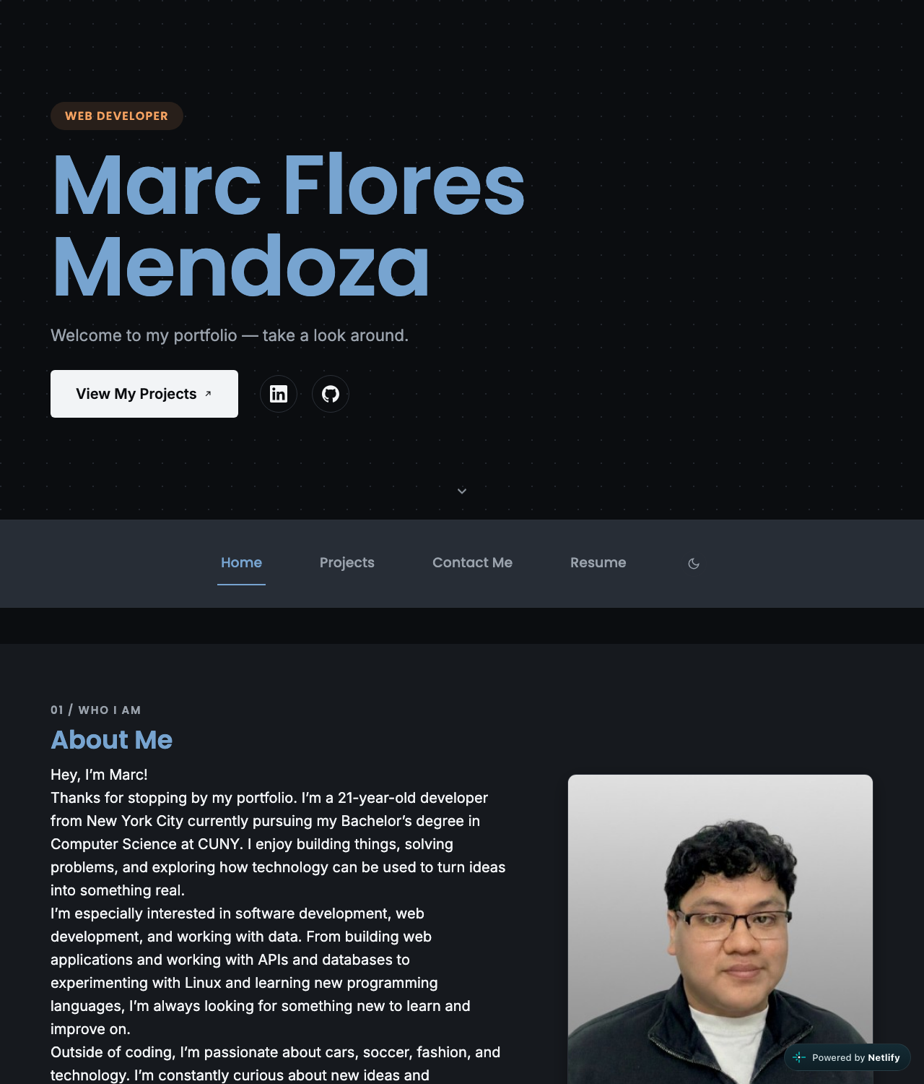
Desktop, 1280px. Full-screen hero, then the nav, then About.
  Phone, 375px. The nav is at the bottom of the first screen, with Resume wrapped to a second line. | 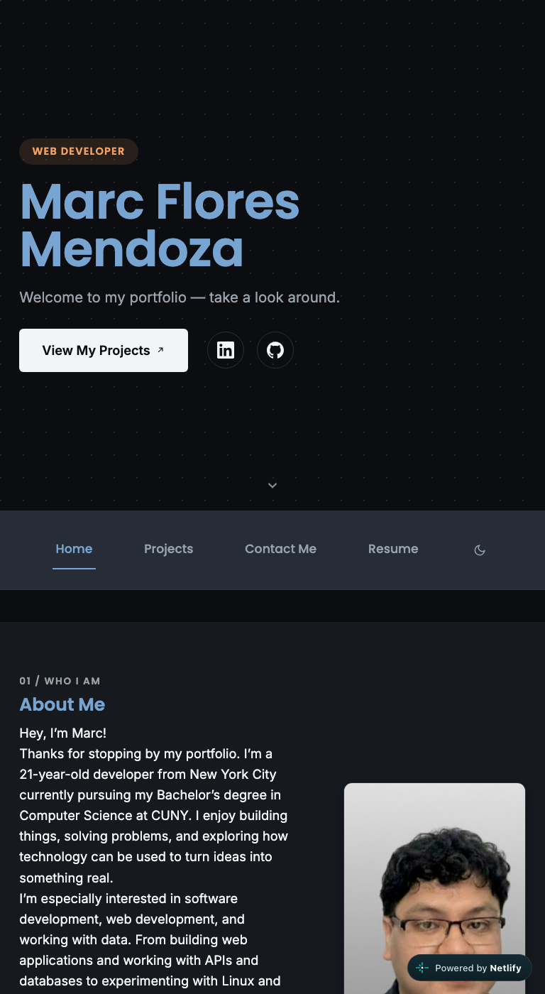  Tablet, 768px.

Semantic HTML: 18 / 20

What is working
- Every page validates with zero messages. One h1 per page, h2 per section, h3 inside. header wraps the hero and nav, main has id="main-content" and a skip link points at it (index.html line 27). aria-current="page" on the active nav link, aria-label on icon-only links and the theme toggle, aria-hidden on decorative SVGs and the duplicate tech-icon grid. Every image has descriptive alt text. This is the most careful markup in the class.

What to change
- Nav links are not a list. Lines 54 to 65 are four a elements and a button in a div. A nav with several links is a ul > li > a so assistive tech announces "list, 4 items." Your Flexbox rules keep working unchanged.
- The nav is below the fold. The header puts a min-height: 100vh hero first and the sticky nav second (lines 31 and 54). On first paint, on every device, there is no visible navigation; Claude measured the nav starting at 666px on a 375px phone. The scroll indicator helps, but a visitor on the Projects page has to scroll past the hero to get to Contact. Put the nav first and subtract its height from the hero.
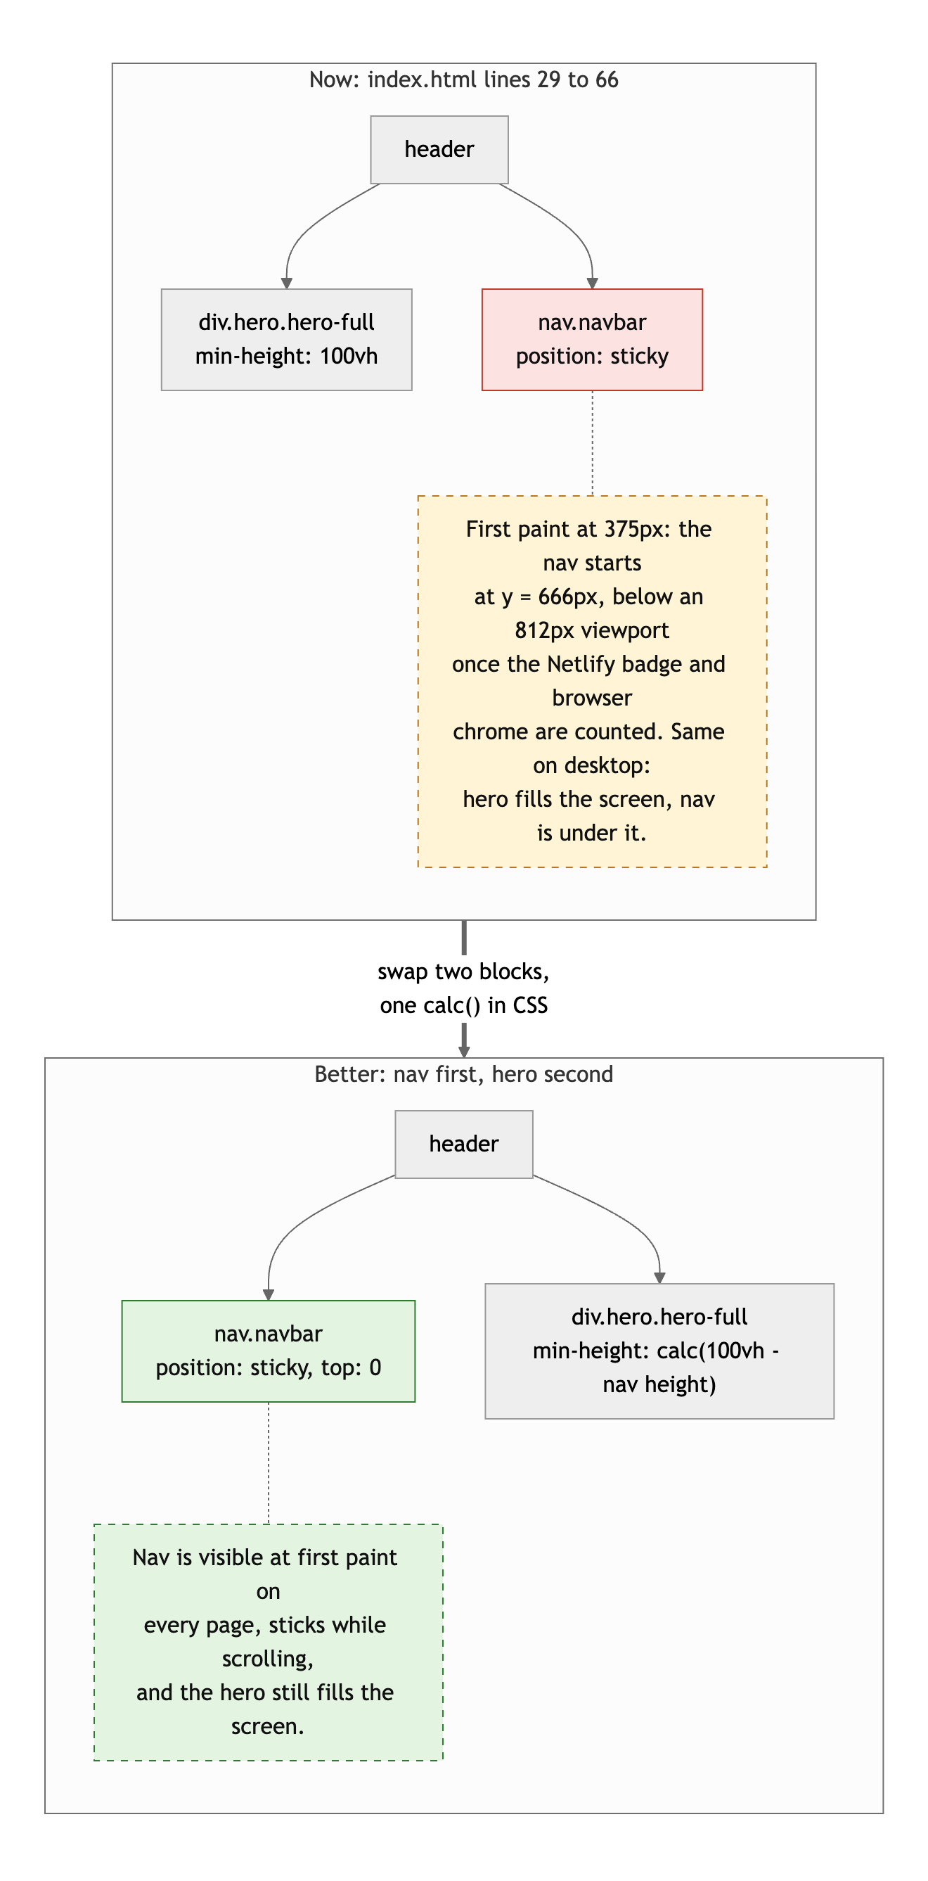
Diagram 1. The header order now (top) and with the nav first (bottom).
- Small: each project on the Projects page is a self-contained unit with its own heading, which is what article is for; they are sections. And the hero is a div where section would do.

CSS layout: 23 / 25

What is working
- This is a real stylesheet. 37 custom properties for color, spacing, radius and motion (styles.css lines 1 to 29). A light theme as a single override block (lines 35 to 49). A fluid root font size in clamp() so every rem in the file scales with the viewport and still respects browser zoom (lines 55 to 62). Zero !important.
- Flexbox and Grid both earn their place. Flex for the hero stack, the action row, the nav, the chip lists, the carousel controls. Grid for the About two-column layout, the numbered content bands, the skills layout, the four-column tech-icon grid, and the alternating project bands. Each choice is the right one.
- prefers-reduced-motion is honored three separate times, which most professional sites do not manage.

What to change
- Desktop-first. Every width query is max-width (lines 388, 735, 892, 905). The brief asked for mobile-first. With a sheet this size the flip is a real refactor, but it is the shape the class will keep asking for.
- The nav wraps at 375px. "Home, Projects, Contact Me" fit; "Resume" and the toggle drop to a second line. A smaller gap under 480px, or a hamburger, keeps it on one line.
- Bootstrap is loaded and barely used. All four pages pull Bootstrap's CSS and bundle from the CDN, and your 909 lines override or ignore nearly all of it. If nothing depends on it, dropping two tags saves 200 KB per page load.

Responsive design: 13 / 15

What is working
- No horizontal scroll at 375, 768 or 1280 on any of the three pages tested. The About grid collapses to one column, the project bands stack, the carousel keeps its aspect ratio, section heights are clamp()ed so they fill the screen without leaving gaps on tall monitors. The mobile fixes in your log (the PayCore carousel specificity bug, the centered icons) are both confirmed working.

What to change
- Desktop-first (see CSS). The base styles describe a desktop and four queries undo them.
- The nav's second line on phones (see CSS). It is the first thing a phone user sees after the hero.

JavaScript interaction: 12 / 15

What is working
- Three interactions, all vanilla, all verified. The theme toggle (app.js lines 6 to 30) applies the saved theme before first paint, flips aria-pressed, and persisted across page navigation when Claude tested it. The carousel (lines 32 to 84) builds dot buttons with aria labels, wraps with (i + slides.length) % slides.length, and hides its controls for single-image galleries. The scroll reveal (lines 86 to 108) uses IntersectionObserver, unobserves after firing, and falls back to visible when the API is missing. Zero console errors.

What to change
- The contact form goes nowhere. contact.html line 75 has no action, no method and no handler in app.js. Claude filled it in and clicked Send: the page reloaded with the name, email and message in the address bar, and nothing else happened. Your README calls it "a working form." Either wire it to Netlify Forms (two attributes, no code) or write a submit handler with validation feedback, which is one of the brief's own examples of an interaction.
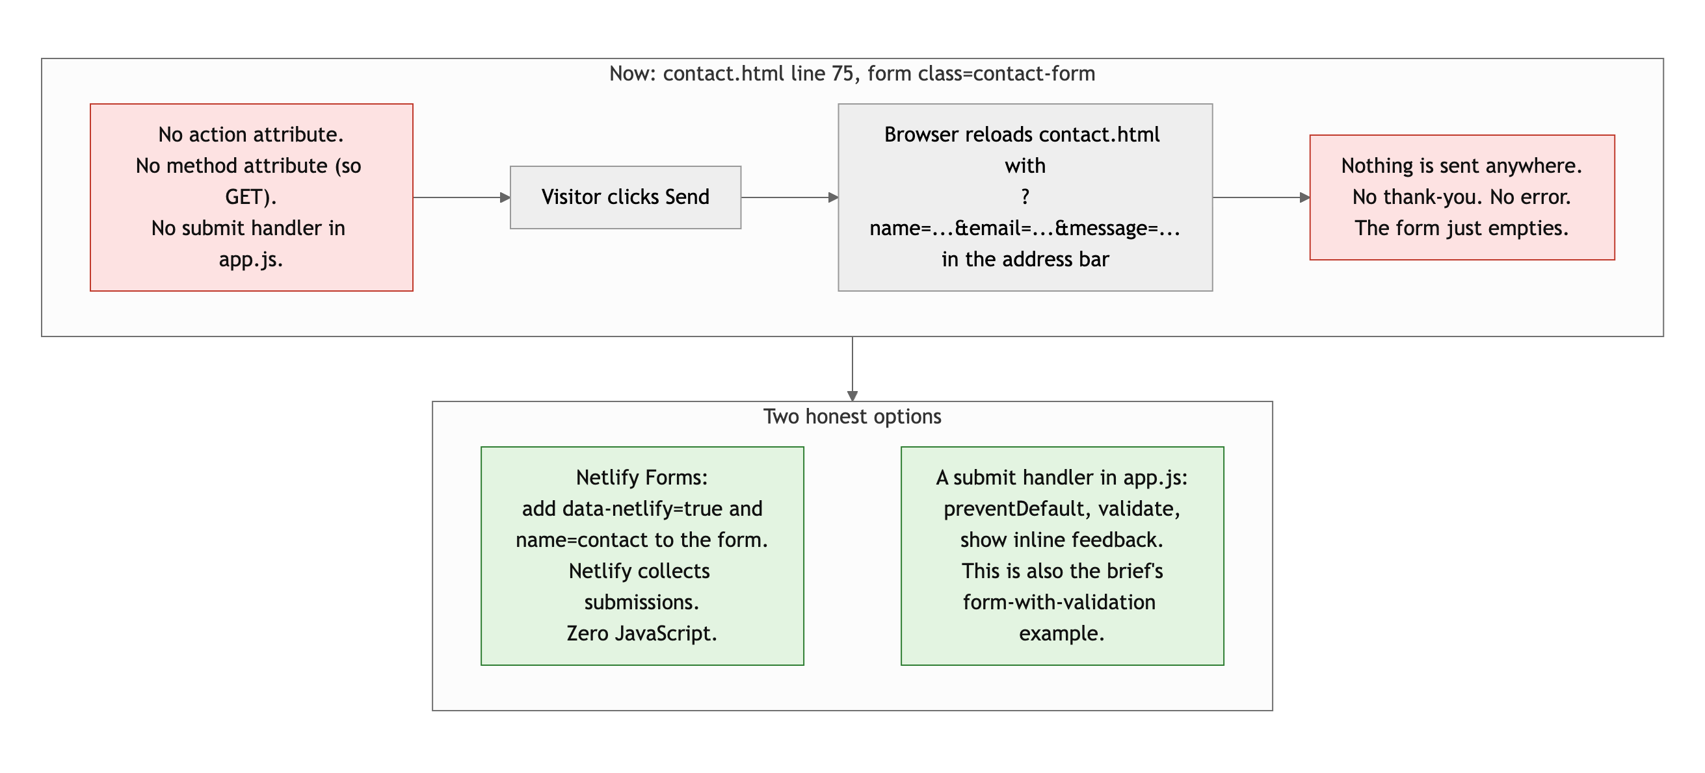
Diagram 2. What happens when someone clicks Send today, and the two honest fixes.
- data.js is const data = []; and nothing reads it. It is loaded on all four pages. Delete it, or use it.
- console.log("Static Foundations loaded") on line 1 fires on every page. Fine while building; remove before shipping.
- On the development log. Entries 3, 6, 10, 11 and 17 describe the AI choosing the design direction, diagnosing a repaint bug, re-encoding an image, finding a Grid order quirk, and building the theme system. Be ready to explain these five in office hours: why the root font size is a clamp() in rem and not px (styles.css line 63); what threshold: 0.15 means on app.js line 98 and why the observer unobserves; what (i + slides.length) % slides.length does on line 71 when i is -1; why CSS order on a Grid child swapped which column track it landed in (log entry 11); and why the theme script runs before body and what "no attribute means dark" buys you.

Repository and deployment: 12 / 15

What is working
- README has all four items and the run instructions are correct. Nineteen commits with real messages: "added navbar, jumbotron and links," "fixed carousel bug, added consistent scaling," "fix: corrected link to pokemon project." Anyone can read the log and follow the build. Live site works in a private window and matches the repo.

What to change
- The .claude/skills/ folder stays. 260 of the 282 files in the repo are Claude Code skill files. Normally that is editor tooling that does not belong in a project repo, but your instructor wants it kept as a record of what the AI was given to work with. No points off. Just know that on a job it would go in .gitignore next to node_modules/.
- One 13-hour window. All 19 commits are between 12:41 PM on September 15 and 1:27 AM on September 16. The messages are good; the timeline is the night before. The brief asked for history that shows the project developing over time, and two weeks were available.
- Seven commits are timestamped after the 11:59 PM deadline, including the theme toggle and the README. This review does not deduct for that. What it means is your instructor's call.
- The README says the contact form works. It does not. Say what is true.

Content and polish: 8 / 10

What is working
- Real headshot, real resume (80 KB, embedded and downloadable), three real projects with real screenshots, real skills, a real internship. Every image is optimized: the largest is 255 KB and the whole assets folder including the PDF is 1.44 MB. Consistent type (Poppins + Inter), consistent spacing, a dark theme and a light theme that both pass contrast. This looks like a site someone would hire from.

What to change
- A button that says Send and does not. That is the one thing on the site a recruiter might actually use.
- The Experience entry is a title, a date and an employer. Two or three bullets on what you did at the HPC Center would make it a resume line instead of a placeholder.
- Small: the Skills section shows every technology twice, once as a chip and once as an icon. Pick one, or make the icons the chips.

Your next three moves
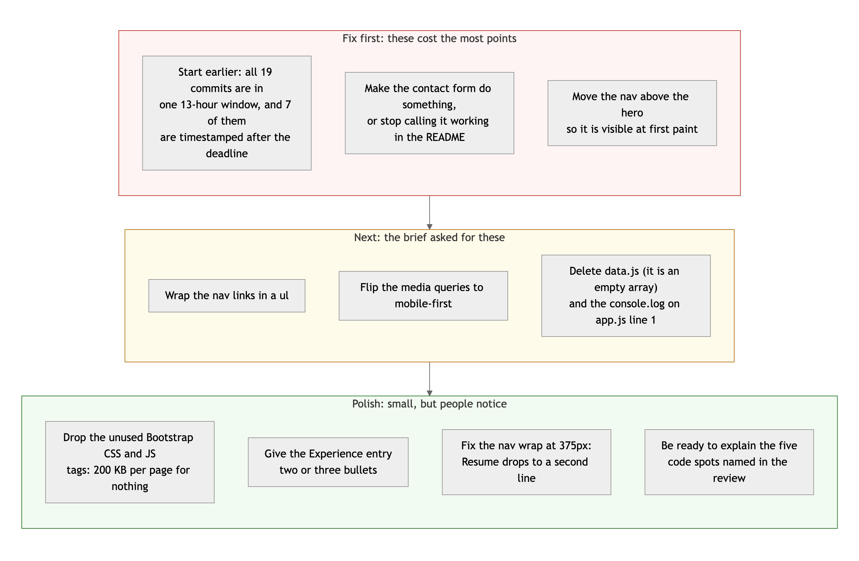
Diagram 3. Priority order. Top row first: it is where the points are.
- Start Project 2 the day it is assigned. Nineteen good commits in thirteen hours is still one night. Spread the same work over two weeks and the history tells a better story.
- Wire the form. Netlify Forms is two attributes. Or write the handler and get a validation interaction out of it.
- Put the nav where people can see it, and while you are in the header, make the links a list.

You shipped the most complete site in the class, and you documented how. Now make sure you can rebuild any piece of it without the log.
This review lives in a pull request on your repo. It only adds feedback files and does not touch your code. Merge it, close it, or just read it. Questions go to office hours or the Brightspace board.

