MyTalipapa
Public-Market Navigation & Stall-Management System

Data Flow Diagrams (Level 0–3)
Entity-Relationship Diagram & Process Flowchart
Yourdon–DeMarco notation
System Design Documentation
Version 1.0 · June 2026

Contents

1. System Overview
MyTalipapa is a paperless public-market platform with two purposes. For visitors it provides wayfinding — a 360° panorama tour and an augmented-reality (AR) finder that route a shopper to a specific stall. For the market it provides management — renter/contractor/admin accounts, a stall-application and approval workflow, payments, lease contracts, and notifications.
This document models the system with Data Flow Diagrams (DFDs) at four levels of detail using the Yourdon–DeMarco notation, supported by an Entity-Relationship Diagram (ERD) of the data model and a process flowchart for the shopper wayfinding journey.

Notation (Yourdon–DeMarco)
Symbol | Meaning
Circle / bubble (blue) | Process — a transformation of data, numbered (0, 1.0, 2.1, 2.2.1 …).
Rectangle (grey) | External entity — a person or system outside the boundary that supplies or receives data.
Open parallel lines (amber) | Data store — where data rests between processes (D1–D7).
Circle (teal) | Link to a process detailed on another DFD level.
Labelled arrow | Data flow — the label names the data that moves.
ERD: box + crow's-foot lines | Entity with attributes; line ends show cardinality (one / many).
Flowchart shapes | Stadium = start/end · rectangle = action · diamond = decision.

2. External Entities
Entity | Description | Principal exchanges with the system
Shopper / Visitor | Public market visitor using wayfinding; no account required. | In: search, navigation request, QR scan. Out: route, stall info, 360° view, turn guidance.
Renter / Applicant | Registers and applies to rent a stall. | In: registration, application, payment, appeal. Out: status, rejection reason, payment notice.
Contractor | Manages assigned stalls and reviews renter applications. | In: review decision, enable/disable stall, contract dates. Out: applications queue, stall & contract records.
Admin | Market administrator overseeing accounts and records. | In: account approvals, QR generation, record queries. Out: dashboards, records, analytics.
Notification Gateway | External email (Nodemailer) and SMS (Twilio) services. | Out: email / SMS messages dispatched by the system.

3. Data Stores (Data Dictionary)
ID | Store | Representative contents | Maintained by
D1 | Accounts | User records for renters, contractors, admins — credentials, role, status. | 1.0
D2 | Stalls | Stall number, zone, category, map coordinates, status, current tenant. | 3.0, 2.0
D3 | Applications | Applicant, target stall, status, rejection reason, appeal count. | 2.0
D4 | Payments | Application, amount, status, date of stall-rental payment. | 5.0
D5 | Contracts | Tenant, stall, lease start/end, contract deadline. | 3.0
D6 | Notifications | Email / SMS / in-app notification log. | 6.0
D7 | Map / Pathway Data | Stall coordinates, column/aisle/corridor geometry, navigation graph. | 4.0

4. Entity-Relationship Diagram (ERD)
The ERD shows the persistent data model behind the data stores. An Account may submit many Applications, hold many Contracts, manage or occupy Stalls, and receive many Notifications; each Application targets one Stall and is settled by a Payment; each Contract covers one Stall. Crow's-foot ends denote cardinality (a single bar = one, a fork = many).
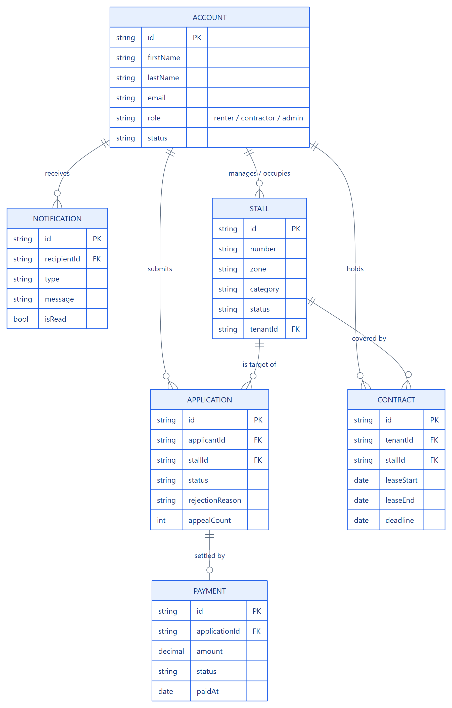
Figure 1 — Entity-Relationship Diagram

5. DFD Level 0 — Context Diagram
The context diagram shows the entire MyTalipapa system as a single process (0) and the data exchanged with each external entity. It fixes the system boundary before any internal detail is added.
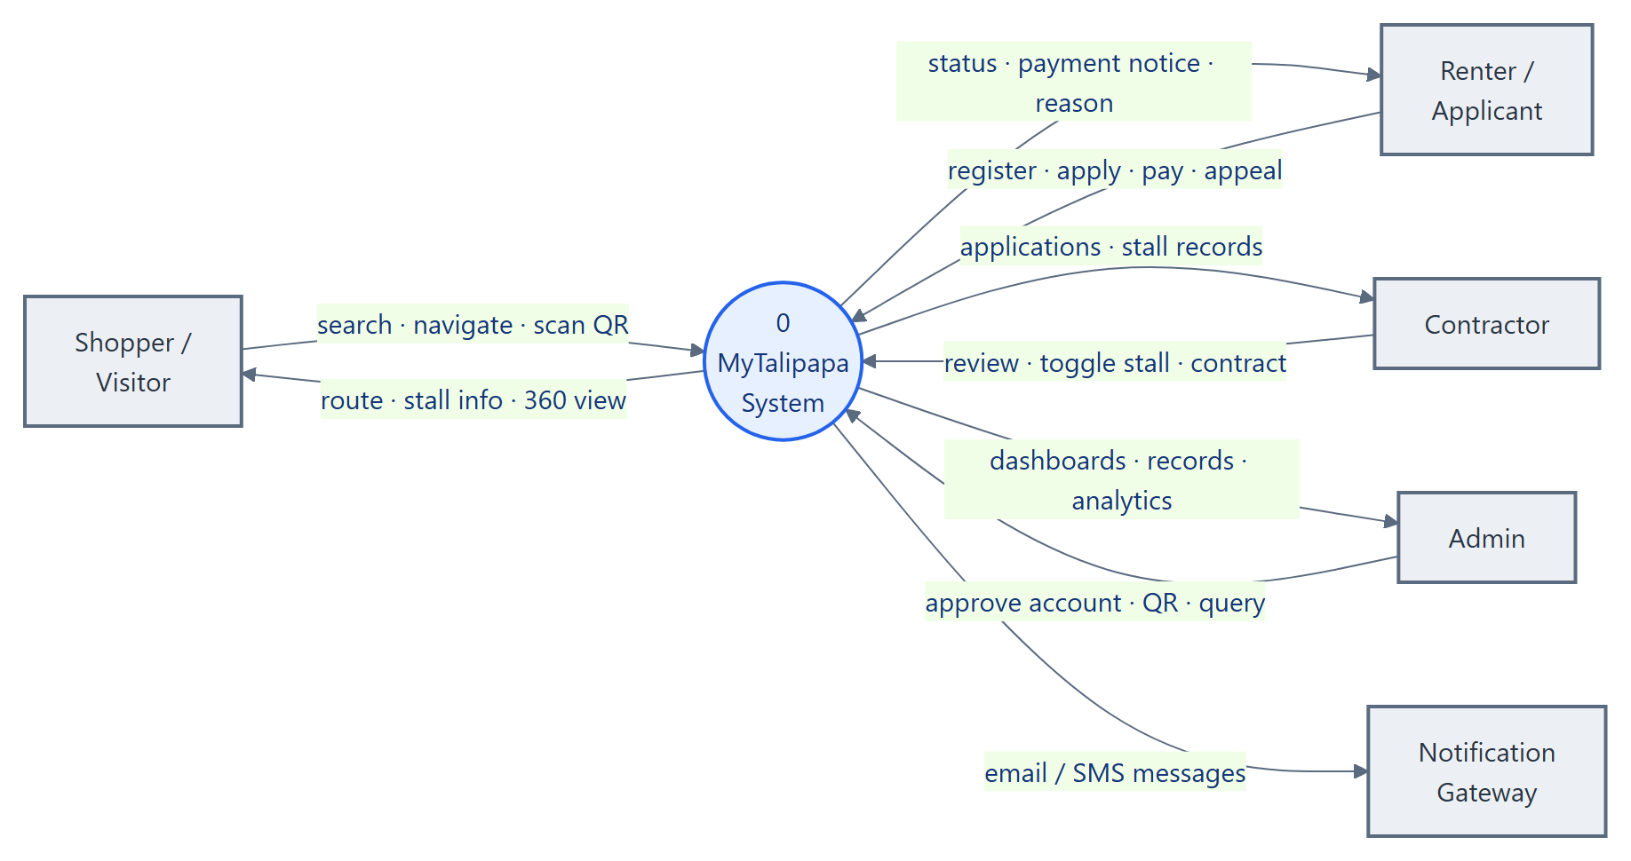
Figure 2 — Level 0 Context Diagram

6. DFD Level 1 — System Decomposition
Process 0 expands into six processes that exchange data with the entities and seven data stores.
- 1.0 Manage Accounts & Authentication — registration, login, role-based access, admin approval of contractor accounts.
- 2.0 Process Applications & Approval — submission, review, approve/reject with reason, appeal/resubmit, proceed-to-payment.
- 3.0 Manage Stalls & Contracts — enable/disable stalls, maintain stall details, lease dates and deadlines.
- 4.0 Navigate & Find Stalls — 360° panorama, search, route computation, panorama & AR guidance, QR recognition.
- 5.0 Process Payments — record and track stall-rental payments.
- 6.0 Send Notifications — dispatch email/SMS/in-app messages on key events.
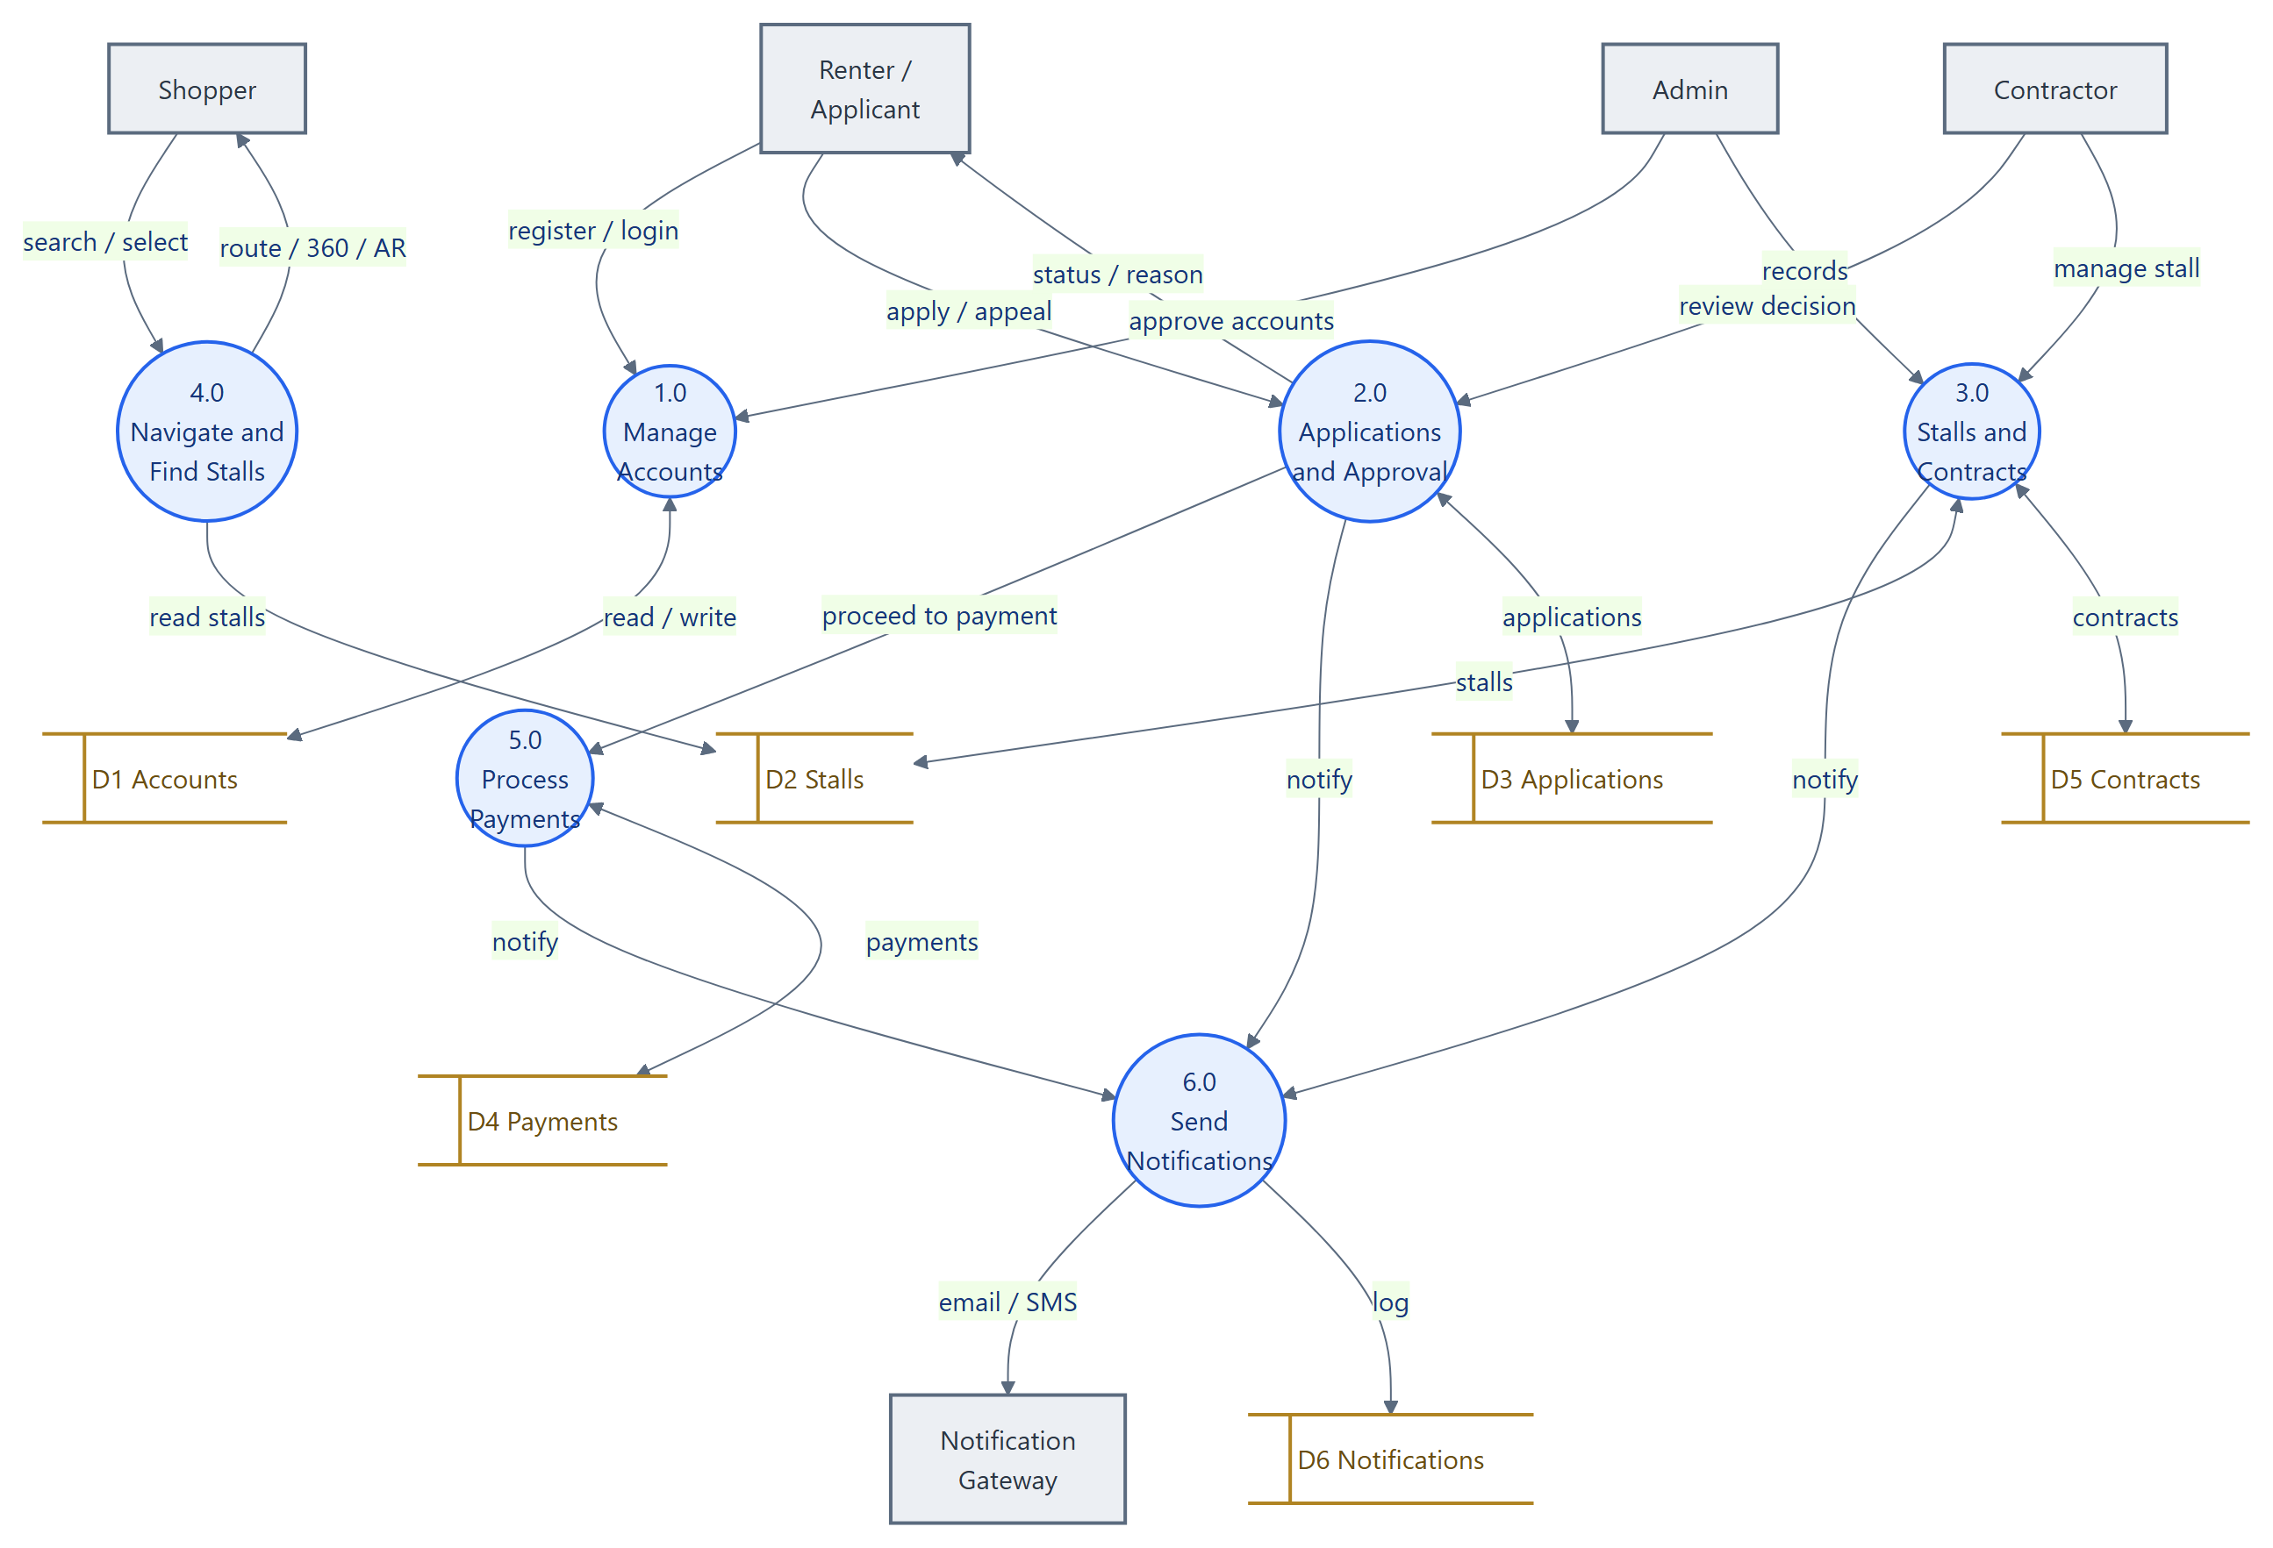
Figure 3 — Level 1 System Decomposition

7. DFD Level 2 — Process 2.0 Applications & Approval
Process 2.0 decomposes into the stall-application lifecycle: a renter submits, a reviewer validates and decides (with a reason), rejected renters may appeal, and approved applications proceed to payment and occupy the stall.
- 2.1 Submit / Resubmit Application.
- 2.2 Review & Validate (expanded at Level 3).
- 2.3 Record Decision — approve or reject, storing the reason.
- 2.4 Handle Appeal / Resubmission.
- 2.5 Initiate Payment & Occupy Stall.
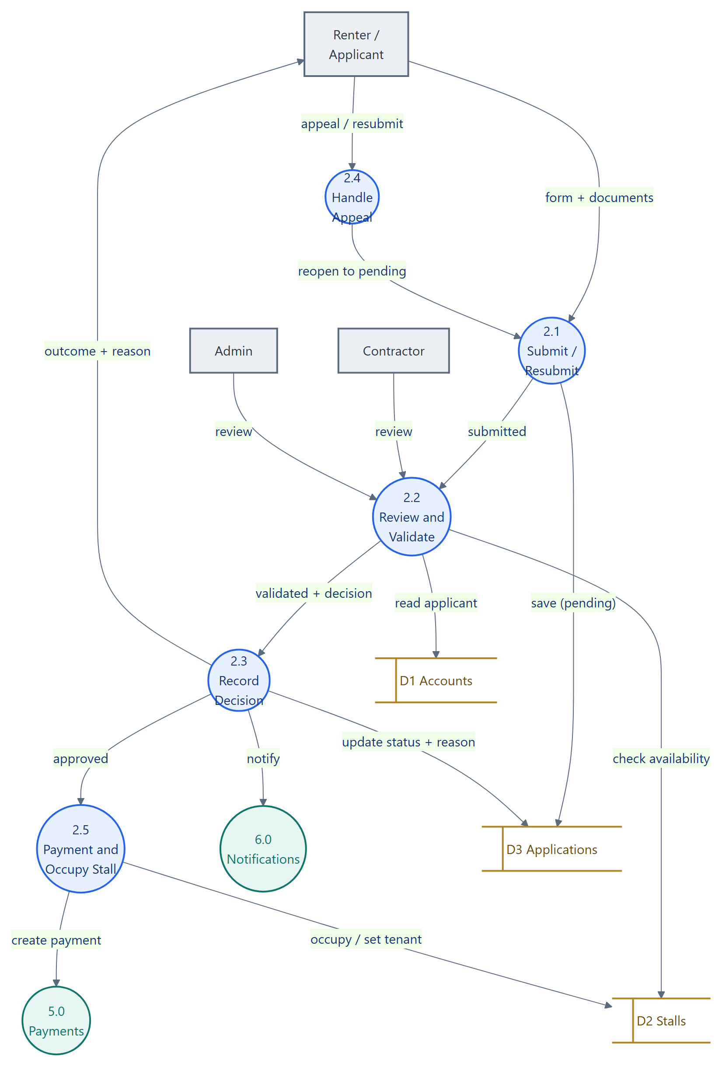
Figure 4 — Level 2: Applications & Approval

8. DFD Level 3 — Process 2.2 Review & Validate
The review process is broken into primitive steps: verifying the applicant, confirming the stall is available, presenting the case to the reviewer, and capturing the decision together with its reason.
- 2.2.1 Check Applicant Record & Documents.
- 2.2.2 Verify Stall Availability.
- 2.2.3 Present to Reviewer (contractor / admin).
- 2.2.4 Capture Decision & Reason.
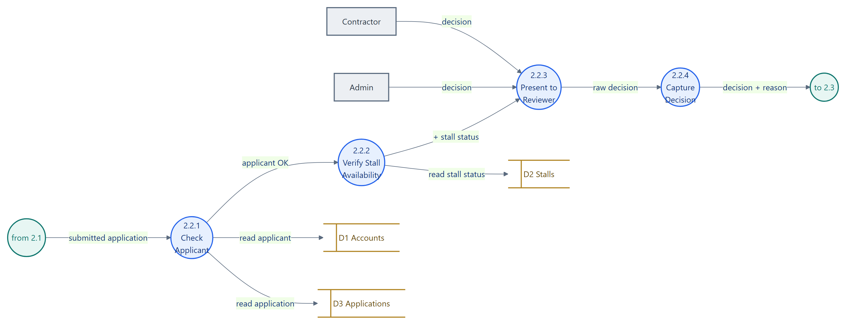
Figure 5 — Level 3: Review & Validate

9. DFD Level 2 — Process 4.0 Navigate & Find Stalls
Process 4.0 decomposes into the wayfinding pipeline: browse the panorama, choose a destination, compute a walking route, then guide the shopper either through the panorama or the AR camera.
- 4.1 Browse 360° Panorama.
- 4.2 Search / Select Destination.
- 4.3 Compute Walking Route (expanded at Level 3).
- 4.4 Guide via Panorama (arrows + mini-map).
- 4.5 Guide via AR (camera + QR + step detection).
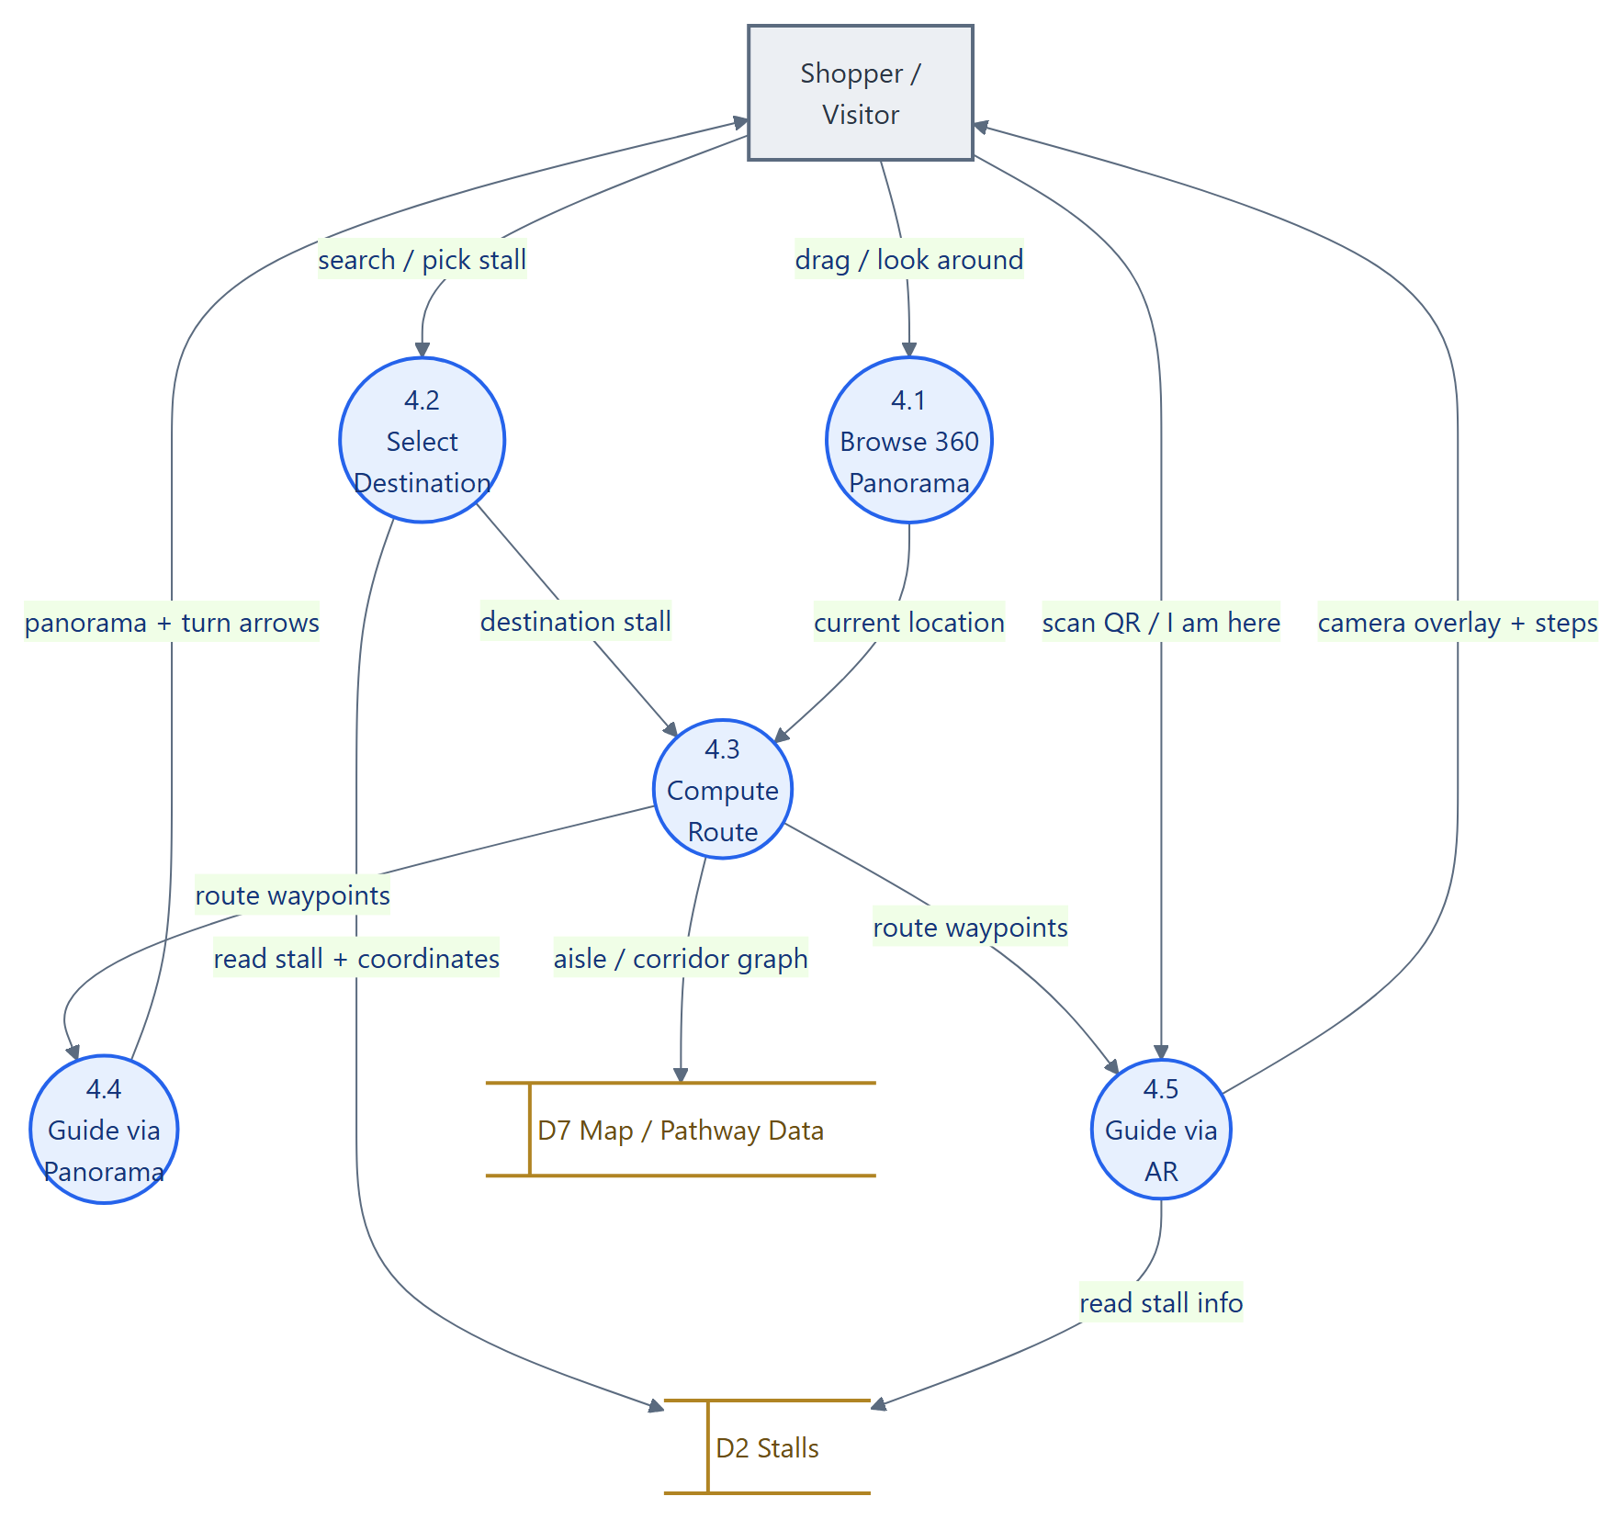
Figure 6 — Level 2: Navigation

10. DFD Level 3 — Process 4.3 Compute Walking Route
Route computation snaps the start and destination onto the nearest walkable aisles, builds an orthogonal aisle/corridor graph from the stored map geometry, runs Dijkstra's shortest-path algorithm, then simplifies the result to a minimal list of turn-by-turn waypoints. This guarantees routes follow real aisles and never cross a stall block.
- 4.3.1 Snap Endpoints onto Aisles.
- 4.3.2 Build Aisle / Corridor Graph.
- 4.3.3 Run Dijkstra Shortest Path.
- 4.3.4 Simplify to Turn-by-Turn Waypoints.
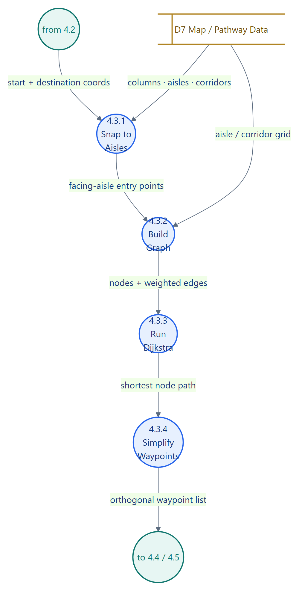
Figure 7 — Level 3: Compute Route (pathfinding)

11. Process Flowchart — Shopper Wayfinding
The flowchart traces a shopper's end-to-end journey from opening the 360° tour to arriving at a stall. After a route is computed the shopper may follow panorama arrows or switch to AR; in AR they may scan a QR code to fix their position, and step detection updates their location until they arrive.
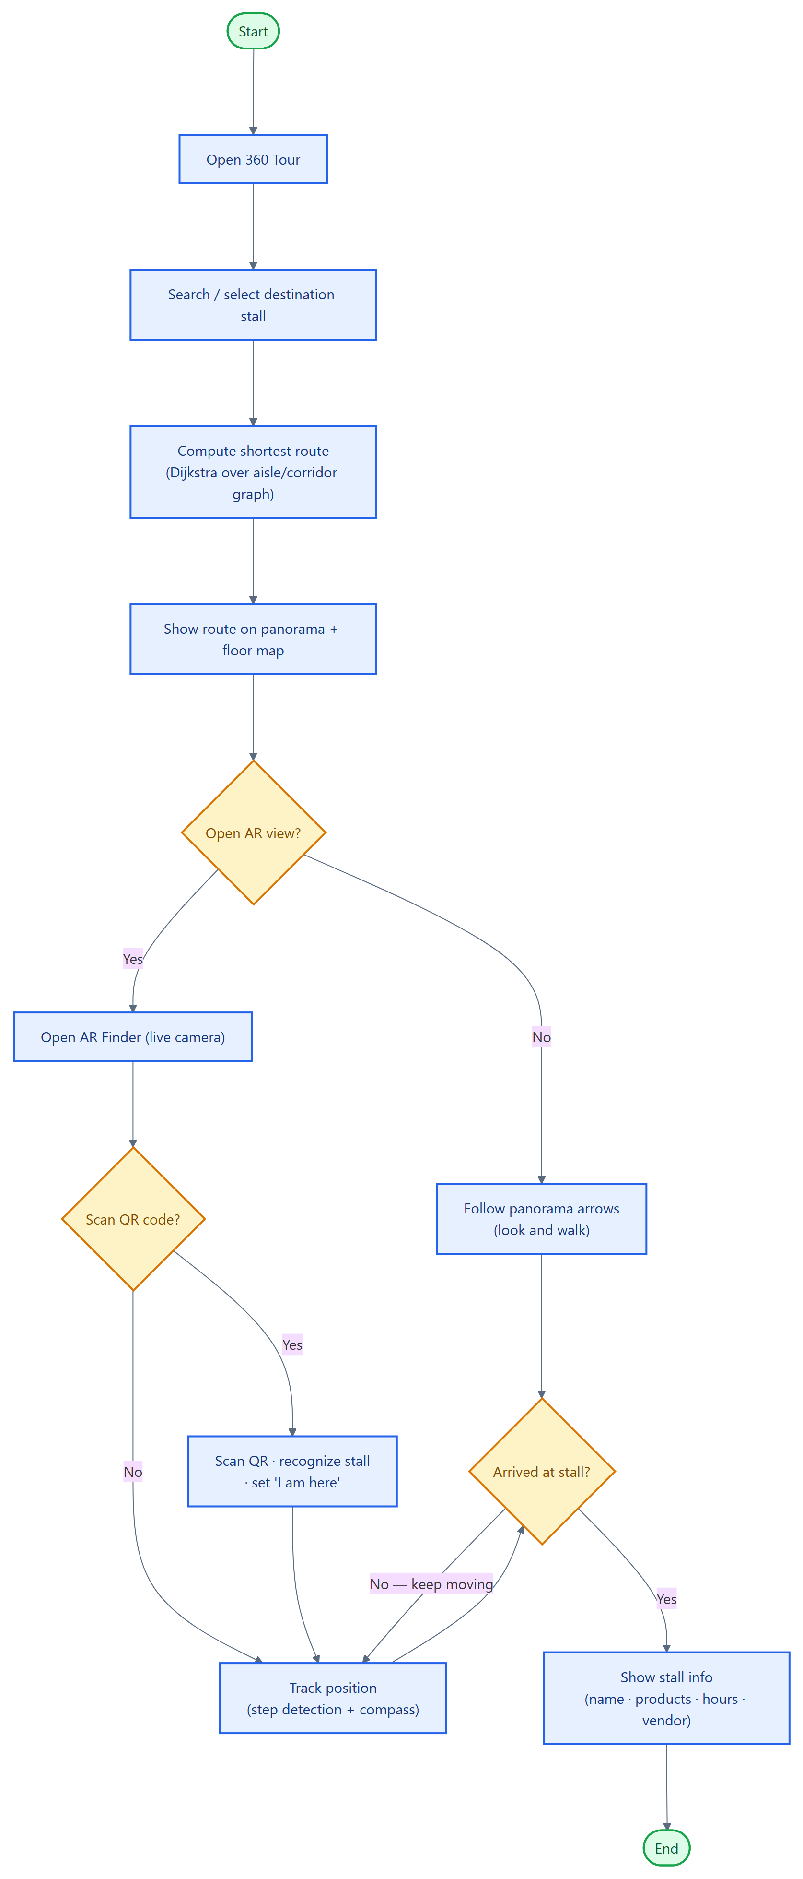
Figure 8 — Process Flowchart: Shopper Wayfinding

