MyTalipapa
Public-Market Navigation & Stall-Management System

Data Flow Diagrams (Level 0–3)
& Process Flowchart
System Design Documentation
June 2026

Contents
Contents 2
1. System Overview 3
Notation 3
2. External Entities 4
3. Data Stores (Data Dictionary) 5
4. DFD Level 0 — Context Diagram 6
5. DFD Level 1 — System Decomposition 7
6. DFD Level 2 — Process 2.0 Applications & Approval 8
7. DFD Level 3 — Process 2.2 Review & Validate 10
8. DFD Level 2 — Process 4.0 Navigate & Find Stalls 11
9. DFD Level 3 — Process 4.3 Compute Walking Route 12
10. Process Flowchart — Shopper Wayfinding 14

1. System Overview
MyTalipapa is a paperless public-market platform with two purposes. For visitors it provides wayfinding — a 360° panorama tour and an augmented-reality (AR) finder that route a shopper to a specific stall. For the market it provides management — renter/contractor/admin accounts, a stall-application and approval workflow, payments, lease contracts, and notifications.
This document models the system using Data Flow Diagrams (DFDs) at four levels of detail (the Level 0 context diagram down to Level 3 primitive processes) following Gane–Sarson notation, plus a process flowchart for the shopper wayfinding journey.

Notation
Symbol | Meaning
Rounded rectangle (blue) | Process — a transformation of data. Numbered (0, 1.0, 2.1, 2.2.1 …).
Rectangle (grey) | External entity — a person or system outside the boundary that supplies or receives data.
Cylinder (amber) | Data store — where data rests between processes (D1–D7).
Rounded rectangle (teal) | Link to a process detailed on another DFD level.
Labelled arrow | Data flow — the label names the data that moves.
Flowchart shapes | Stadium = start/end · rectangle = action · diamond = decision.

2. External Entities
Entity | Description | Principal exchanges with the system
Shopper / Visitor | Public market visitor using wayfinding; no account required. | In: search, navigation request, QR scan. Out: route, stall info, 360° view, turn guidance.
Renter / Applicant | Registers and applies to rent a stall. | In: registration, application, payment, appeal. Out: status, rejection reason, payment notice.
Contractor | Manages assigned stalls and reviews renter applications. | In: review decision, enable/disable stall, contract dates. Out: applications queue, stall & contract records.
Admin | Market administrator overseeing accounts and records. | In: account approvals, QR generation, record queries. Out: dashboards, records, analytics.
Notification Gateway | External email (Nodemailer) and SMS (Twilio) services. | Out: email / SMS messages dispatched by the system.

3. Data Stores (Data Dictionary)
ID | Store | Representative contents | Maintained by
D1 | Accounts | User records for renters, contractors, admins — credentials, role, status. | 1.0
D2 | Stalls | Stall number, zone, category, map coordinates, status, current tenant. | 3.0, 2.0
D3 | Applications | Applicant, target stall, status, rejection reason, appeal count. | 2.0
D4 | Payments | Application, amount, status, date of stall-rental payment. | 5.0
D5 | Contracts | Tenant, stall, lease start/end, contract deadline. | 3.0
D6 | Notifications | Email / SMS / in-app notification log. | 6.0
D7 | Map / Pathway Data | Stall coordinates, column/aisle/corridor geometry, navigation graph. | 4.0

4. DFD Level 0 — Context Diagram
The context diagram shows the entire MyTalipapa system as a single process (0) and the data exchanged with each external entity. It fixes the system boundary before any internal detail is added.
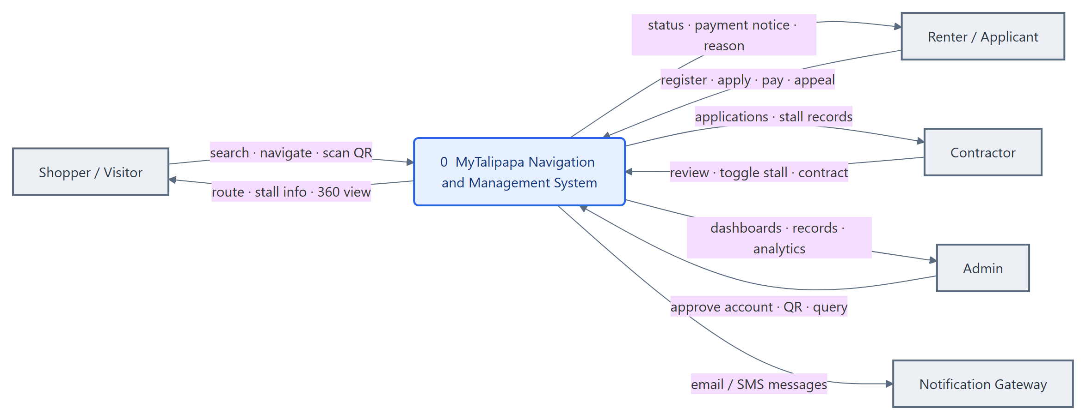
Figure 1 — Level 0 Context Diagram

5. DFD Level 1 — System Decomposition
Process 0 expands into six processes that exchange data with the entities and seven data stores.
- 1.0 Manage Accounts & Authentication — registration, login, role-based access, admin approval of contractor accounts.
- 2.0 Process Applications & Approval — submission, review, approve/reject with reason, appeal/resubmit, proceed-to-payment.
- 3.0 Manage Stalls & Contracts — enable/disable stalls, maintain stall details, lease dates and deadlines.
- 4.0 Navigate & Find Stalls — 360° panorama, search, route computation, panorama & AR guidance, QR recognition.
- 5.0 Process Payments — record and track stall-rental payments.
- 6.0 Send Notifications — dispatch email/SMS/in-app messages on key events.
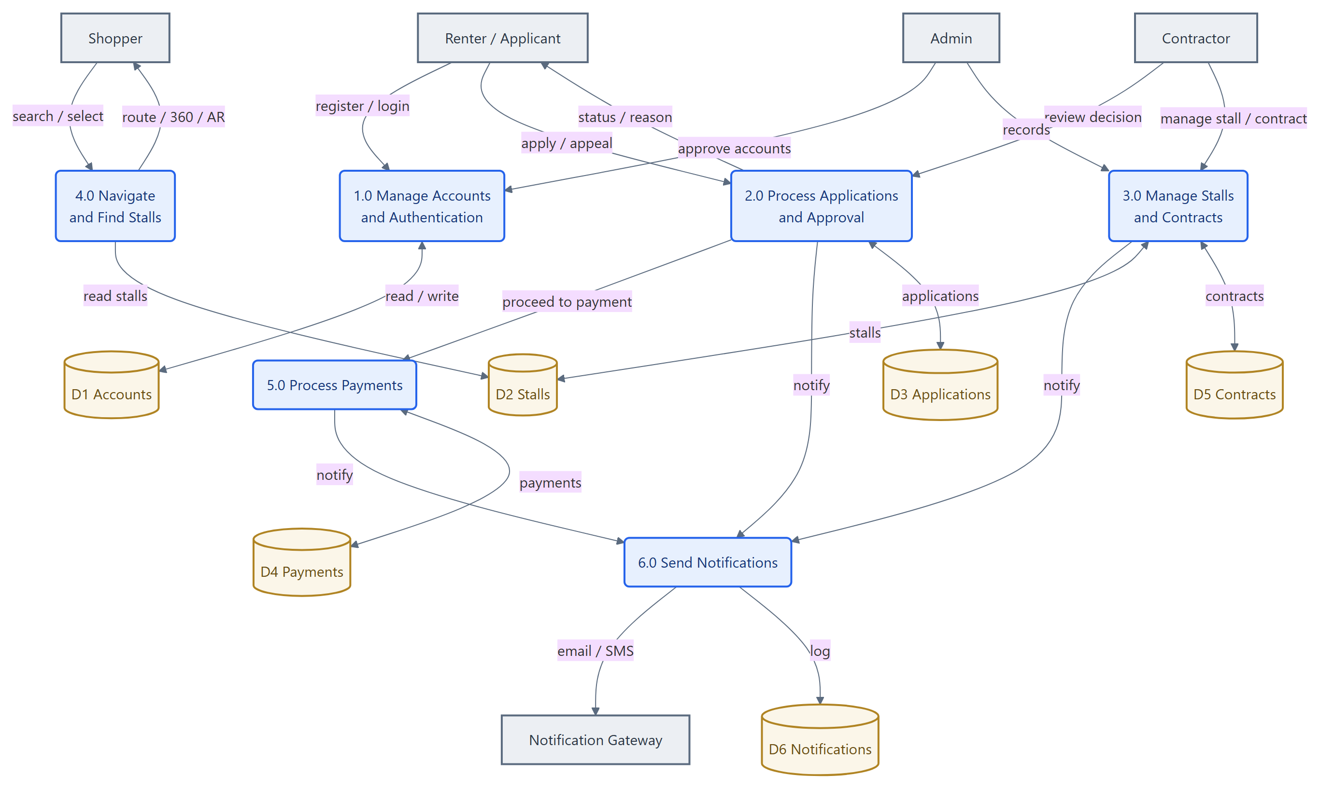
Figure 2 — Level 1 System Decomposition

6. DFD Level 2 — Process 2.0 Applications & Approval
Process 2.0 decomposes into the stall-application lifecycle: a renter submits, a reviewer validates and decides (with a reason), rejected renters may appeal, and approved applications proceed to payment and occupy the stall.
- 2.1 Submit / Resubmit Application — capture the application and supporting details.
- 2.2 Review & Validate — checked against applicant and stall records (expanded at Level 3).
- 2.3 Record Decision — approve or reject, storing the reason.
- 2.4 Handle Appeal / Resubmission — reopen a rejected application to pending.
- 2.5 Initiate Payment & Occupy Stall — create the payment and assign the tenant.
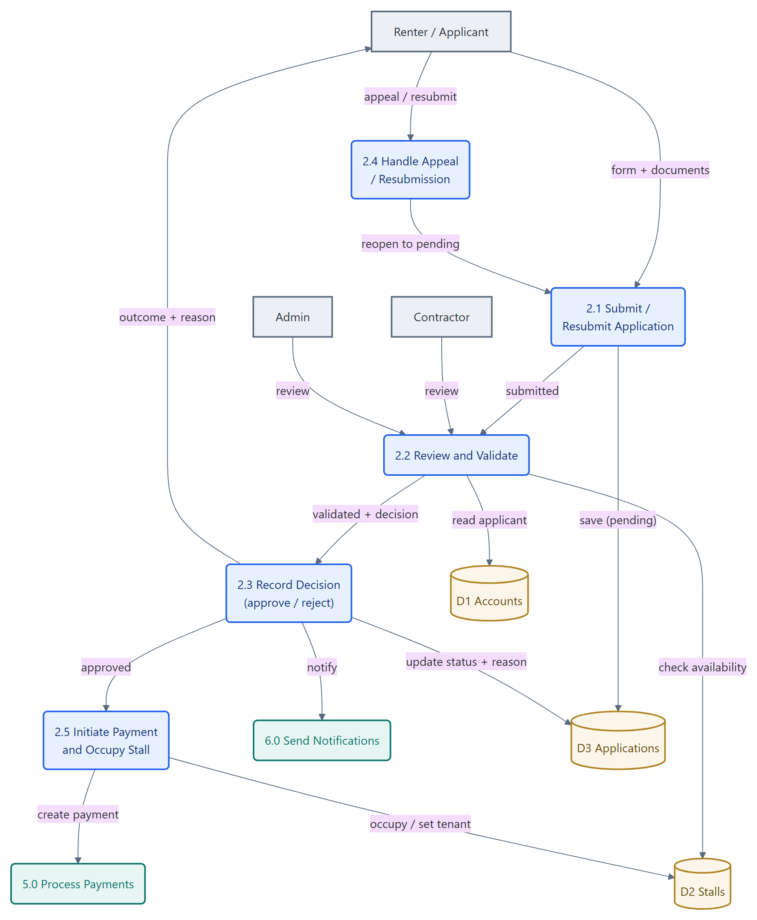
Figure 3 — Level 2: Applications & Approval

7. DFD Level 3 — Process 2.2 Review & Validate
The review process is broken into primitive steps: verifying the applicant, confirming the stall is available, presenting the case to the reviewer, and capturing the decision together with its reason.
- 2.2.1 Check Applicant Record & Documents.
- 2.2.2 Verify Stall Availability.
- 2.2.3 Present to Reviewer (contractor / admin).
- 2.2.4 Capture Decision & Reason.
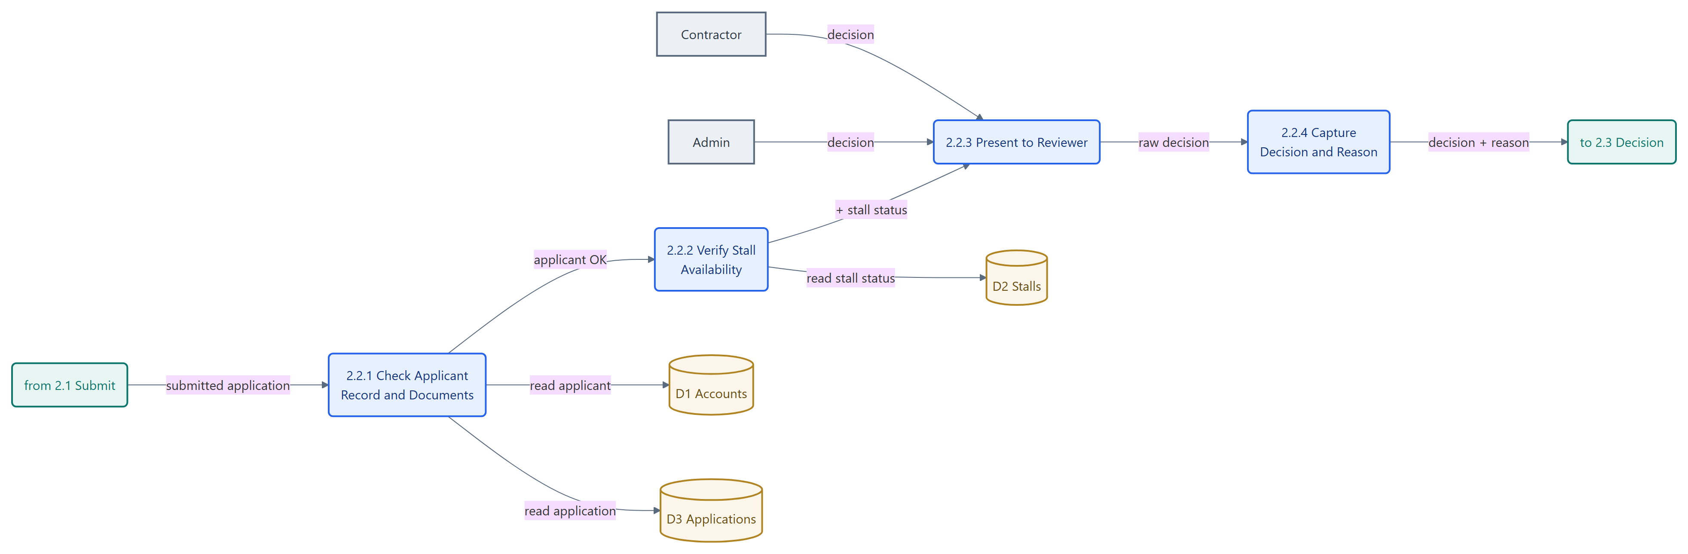
Figure 4 — Level 3: Review & Validate

8. DFD Level 2 — Process 4.0 Navigate & Find Stalls
Process 4.0 decomposes into the wayfinding pipeline: browse the panorama, choose a destination, compute a walking route, then guide the shopper either through the panorama or through the AR camera.
- 4.1 Browse 360° Panorama.
- 4.2 Search / Select Destination.
- 4.3 Compute Walking Route (expanded at Level 3).
- 4.4 Guide via Panorama (arrows + mini-map).
- 4.5 Guide via AR (camera + QR + step detection).
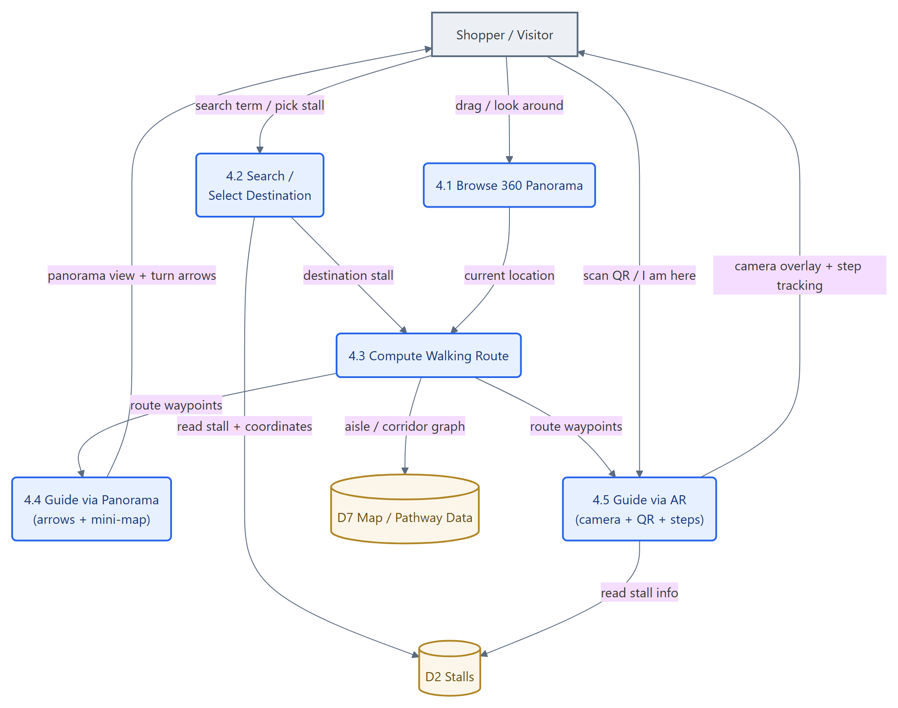
Figure 5 — Level 2: Navigation

9. DFD Level 3 — Process 4.3 Compute Walking Route
Route computation snaps the start and destination onto the nearest walkable aisles, builds an orthogonal aisle/corridor graph from the stored map geometry, runs Dijkstra's shortest-path algorithm, then simplifies the result to a minimal list of turn-by-turn waypoints. This guarantees routes follow real aisles and never cross a stall block.
- 4.3.1 Snap Endpoints onto Aisles.
- 4.3.2 Build Aisle / Corridor Graph.
- 4.3.3 Run Dijkstra Shortest Path.
- 4.3.4 Simplify to Turn-by-Turn Waypoints.
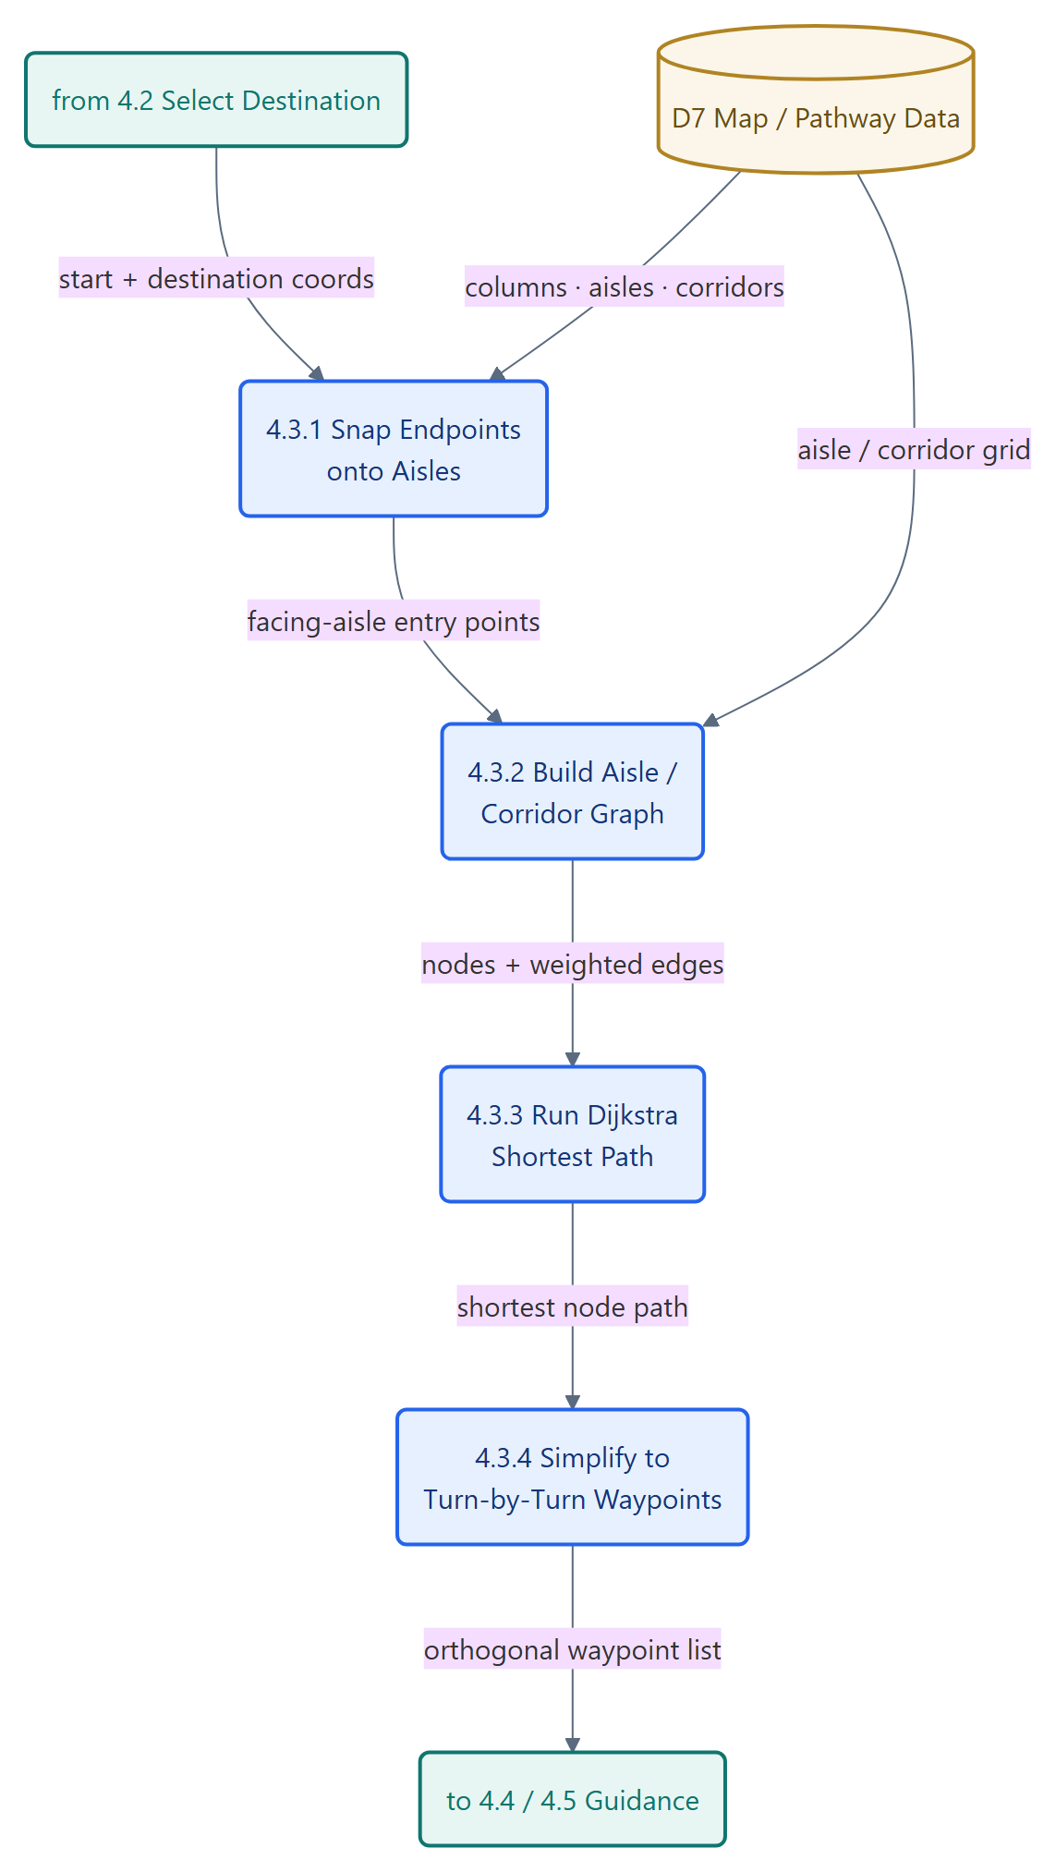
Figure 6 — Level 3: Compute Route (pathfinding)

10. Process Flowchart — Shopper Wayfinding
The flowchart traces a shopper's end-to-end journey from opening the 360° tour to arriving at a stall. After a route is computed the shopper may follow panorama arrows or switch to AR; in AR they may scan a QR code to fix their position, and step detection updates their location until they arrive.
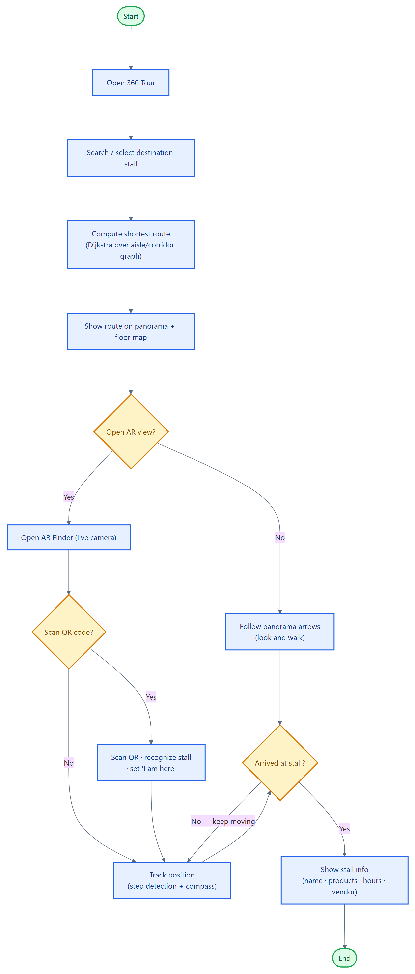
Figure 7 — Process Flowchart: Shopper Wayfinding

