BIOC 300D2
Lecture #2 - January 29th, 2007
Dr. Beauchemin

NOTE: This NTC is meant to be used as a study aid to supplement your own class notes. Hence, not all of the text or diagrams contained in the lecture slides will be reproduced here.
Induction of β-Galactosidase

This lecture is on the induction of β galactosidase, which is present in bacteria. It has many applications in molecular biology. The lab and lecture will cover and test the theory of induction and repression of the enzyme.

E. Coli:
- We focus on E. Coli because it is a gut bacteria and it is important in human metabolism.
- E. coli needs a supply of nutrients to live but it is very capricious, it has preferred substrates.
- Depending on its environment and the gut it colonizes it will need to be flexible in order to switch and adapt its metabolism depending on the sugar it receives.
- Because it can be flexible it can synthesize one substrate then switch to another.
- To survive, this bacterium depends on economizing energy. This requires tight regulation of use of the pathways to degrade the sugar to create energy.
- Bacteria have learned to avoid synthesizing enzymes they will not need and avoid activating a pathway that is unnecessary (need to shut off some pathways to turn others on).

The tight regulation is possible because genes encoding the enzymes are grouped in clusters of genes. All the enzymes involved in one pathway are clustered on one transcriptional unit that can be up-regulated or down-regulated together.

Sugar Metabolism in E. Coli:
- The important issue is to go from glucose to pyruvate to produce that the bacteria need to live. The most preferred substrate is glucose.
- There are two types of sugars that can be provided.
- Hexoses:
- Example: Galactose or Lactose
- Pentoses:
- Example: Arabinose (which comes from plant degradation)
- Therefore there are three pathways to degrade sugars, as seen in the figure on the next page.
- Lactose is a combination of glucose and galactose through an ether linkage (the β galactoside linkage).
- The position of hydroxyl residues change in glucose and galactose (one is cis and one is trans).
- To degrade these two sugars that are linked in β-galactoside linkage you need an enzyme called β-galactosidase.
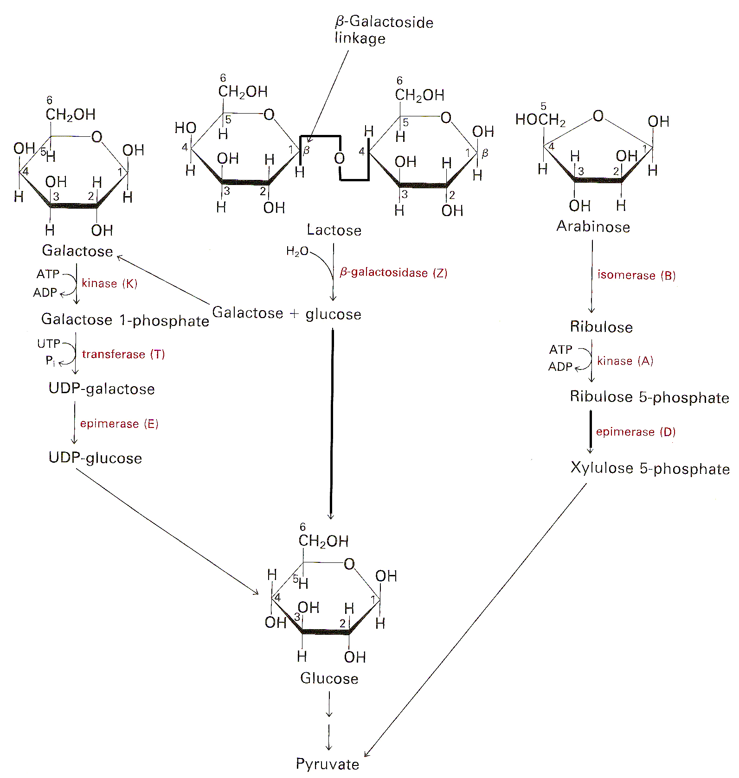
- The galactose produces glucose through enzymatic transformation. First a kinase will add a phosphate onto the galactose at the 1 position. Once this 1 has been phosphorylated, a transferase will add a UDP onto the galactose. Then an epimerase will switch the hydroxyl and produce UDP-glucose. Lastly, the UDP is cleaved and glucose is produced.
- Arabinose is a pentose, so we need to go from a 5-carbon sugar to a 6-carbon sugar. Arabinose is subjected to an isomerase and gives rise to a ribulose. Then through epimerization you will create ribulose-5’-phosphate which is degraded to pyruvate.

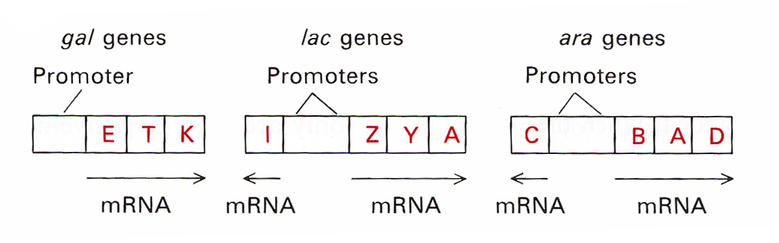
- The lactose genes have inducibility genes and a promoter. This transcriptional unit contains the β-galactosidase gene, a permease gene and a transacetylase gene.
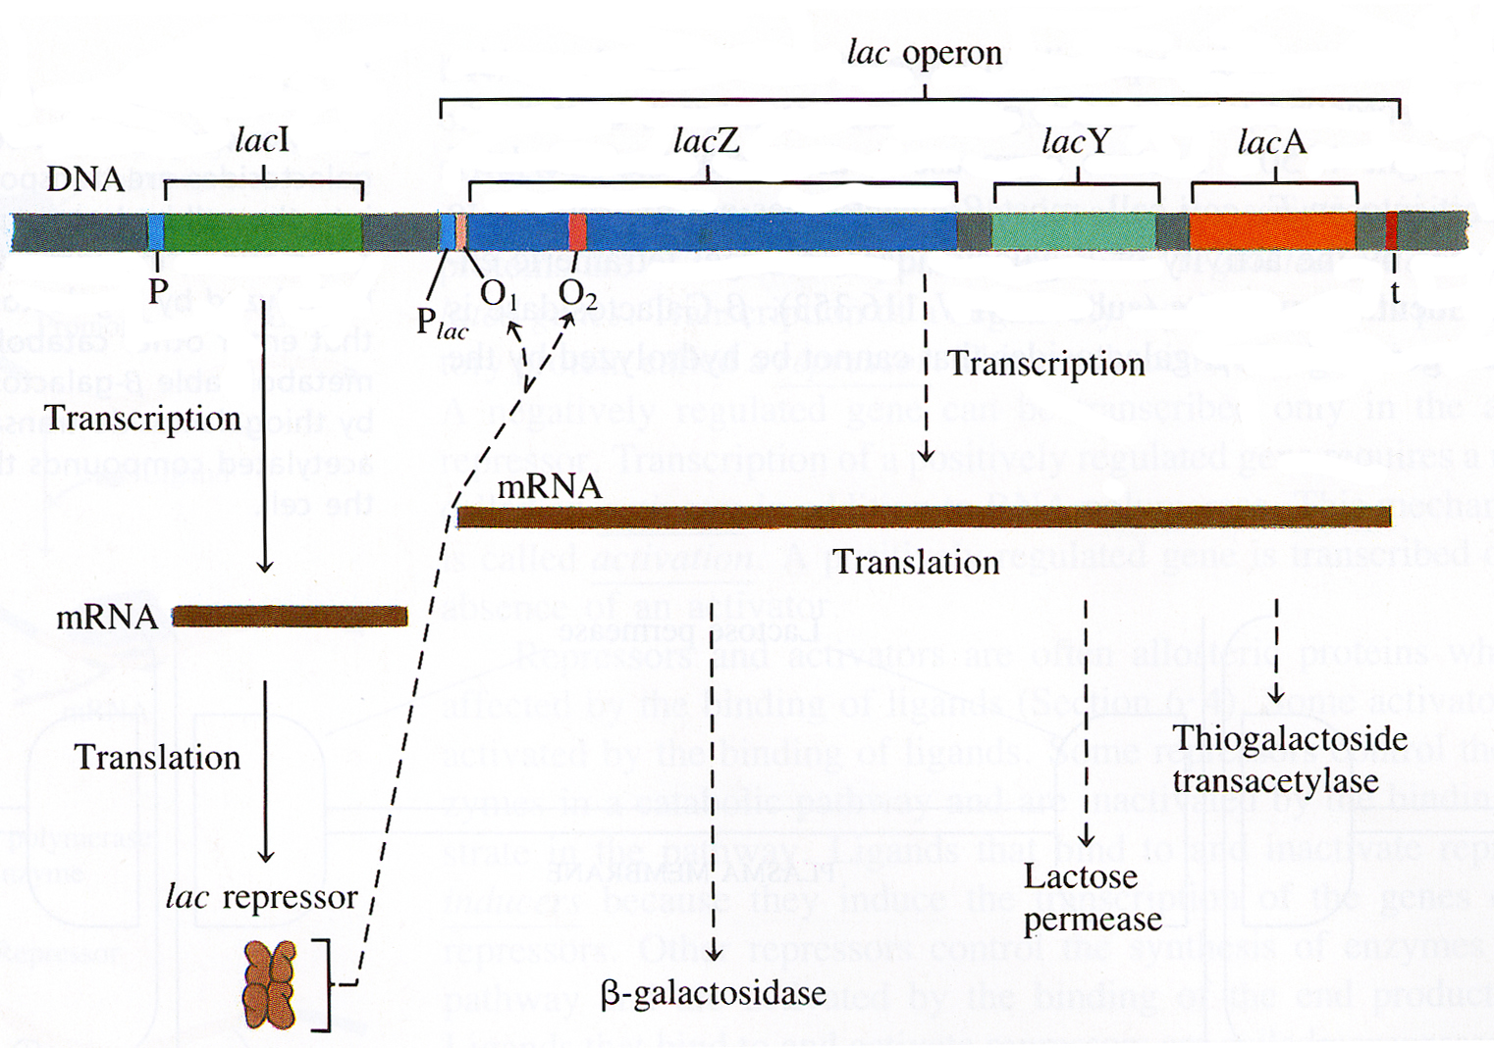

Lactose Operon:
- It encompasses the whole transcriptional unit and will transcribe a poly-cistronic mRNA. Meaning, there is more than one protein encoded by this mRNA, in the end it will produce three different enzymes.
- On the same operon we have another gene called the Lac I (inducibility gene) and the Lac repressor (which contains four individual, but identical subunits). The role of the repressor is to bind to the two operator regions which are upstream of the Lac Z gene.

Induction: if E. Coli is grown on the appropriate substrate, there will be synthesis of the enzyme, β-galactosidase. If the E. Coli is grown on glucose there will be no synthesis of β-galactosidase, since there is no need for it. If we switched the medium to lactose, then β-galactosidase should be produced so that it can cleave the lactose to glucose and galactose. Therefore there is an induction of the operon and rapid synthesis of the β-galactosidase enzyme.
- The opposite of induction is repression; this is when the system is shutoff when a repressor is present.
- Example: Tryptophan (Trp) Synthetase
In both induction and repression situations, small molecules trigger the change. These small molecules are either:
- The enzyme’s substrate (lactose)
- The reaction product (Trp)

The inducer is a small molecule that causes the synthesis of enzymes that are able to metabolize it. The co-repressor is a small molecule that prevents the synthesis of the enzyme

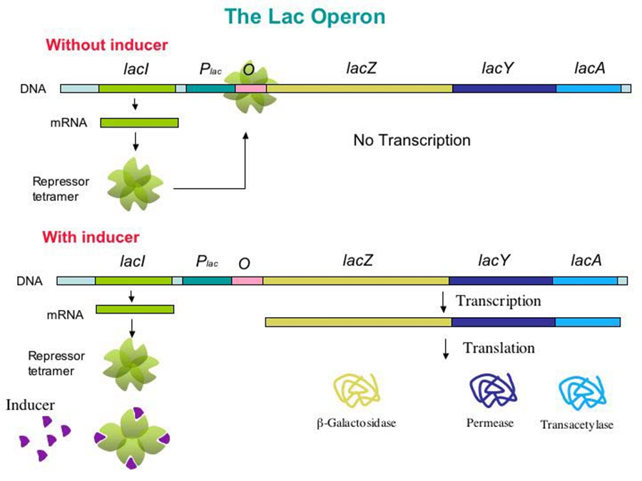
Inducer at the Molecular Level:
- The particular repressor has lots of affinity for the operator (in between the promoter and lac Z gene). When the repressor is bound to the operator, RNA polymerase II cannot bind and transcribe this gene.
- If we switch our bacteria from glucose to lactose, we introduce lactose as the inducer into the system. Lactose has lots of affinity for the repressor sequence (conformation change that reduces the repressors affinity for the operator region).
- The production of the enzymes occurs in the order of need. The enzyme that is needed first is produced first. β-galactosidase is translated first. The second one necessary is the permease and the last is the transacetylase.

Organization of the Promoter Region:
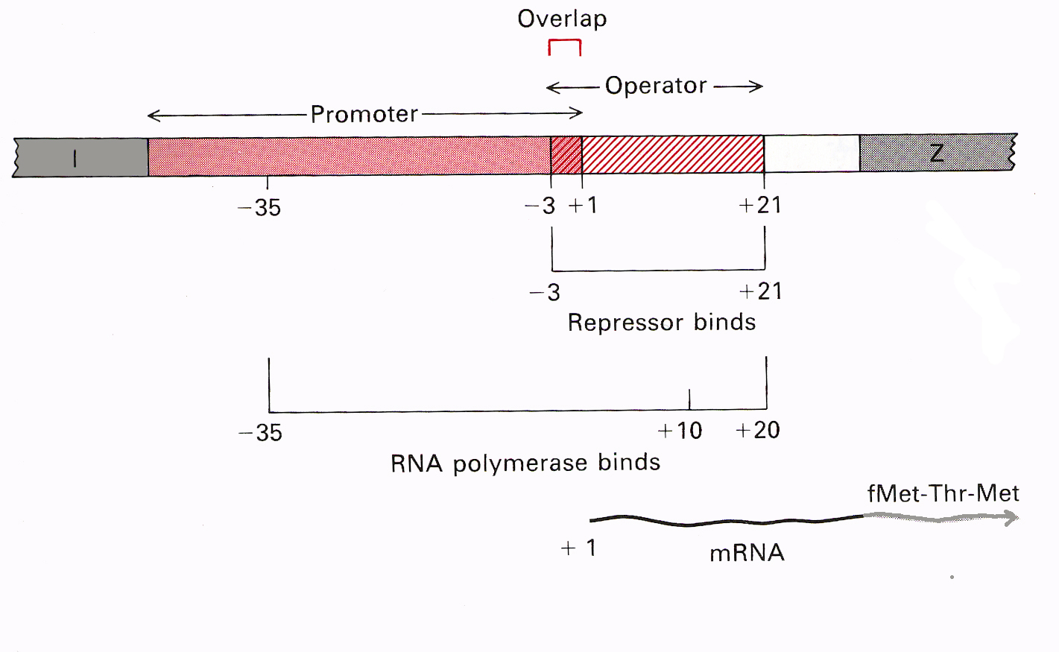
- This is constituted by two regions: the promoter and then the operator.
- There is a short overlap between the beginning of the promoter and the end of the operator.
- The -35 area is a GC rich area necessary to open up the promoter region. Before we get to the actual gene of interest we must go through the operator and repressor region.
- This is why when the repressor is bound the RNA polymerase II cannot not bind and transcribe.

Laboratory Experiment:
- We grew E. Coli with and without induction.
- We used IPTG (isopropylthiogalactoside) as the inducer. IPTG can induce β-galactosidase synthesis but β-galactosidase will not metabolize it, since β -galactosidase cannot cleave a -S- linkage.

- Growth Curve:
- Collected the samples at various time points
- Measure the OD₆₅₀ → a measure of turbidity (as the E. Coli gets denser the turbidity of solution is increasing and that is proportional to the number of bacteria).
- Then plot OD₆₅₀ versus time as a semi-log. The midpoint will correspond to the dividing time of bacteria.

- Viable Cell Counts:
- Count the number of cells to double check.
- We expect the number of colonies to increase with time and there should be a correlation in the increase OD650 (valid in between 0 and 1.2) and an increase of bacterial colonies.
- There should be no more than a 5% variation between the two plates. In between each sampling you need to vortex your tube to really mix the bacteria well.

- Determination of β-Galactosidase Activity:
- We took the E. Coli suspension and broke open the bacteria by subjecting them to chloroform and soap (SDS) treatment which burst the bacteria. What remains is the bacterial remnant pellet.
- The supernatant will contain the enzymes and the proteins of the cells.
- The activity is tested through a simple enzymatic test. We gave β-galactosidase a substrate (PNPG – which is normally colorless) and then when the bond is cleaved it gives rise to a yellow product (p-nitrophenol) and therefore you can measure the OD₄₀₅ and correlate the increase of OD₄₀₅ as an increase in enzyme concentration.

- Induction of β -Galactosidase Activity:
- To do this we added the inducer, IPTG. When we reached a point where the OD₆₅₀ = 0.5 we gave the system IPTG. Note that growth should continue and there should be a minimal lag in your growth curve. The viable cell counts should still increase.
- You should see a dramatic increase in the activity of the β-galactosidase, we have now given it a β-galactoside linkage and it needs to be cleaved to provide the E. Coli energy to grow.

The Importance of the Lac Operon in Modern Biology:

As an Indicator:
- β-galactosidase is a really good indicator gene in both prokaryotes and eukaryotes; it is used to differentiate between vectors in cloning.
- The blue script vector contains the lac-Z gene and in between contains a polylinker region (a series of nucleotides that correspond to number of restriction enzyme sites).
- If you have an insert that you want to clone and it has been produced by two different enzymes at different ends, it is easy enough to cleave the polylinker region with EcoR1 and H1, to recleave the small piece of DNA use the a ligase to make a single piece of DNA.
- If there is no insert we still get production of β-galactosidase, if we cleave then there is no longer any synthesis of the enzyme. When we want to differentiate which of the colonies are due to religation of the vector onto itself versus the recombinant bacteria that have added our gene of interest into their DNA.
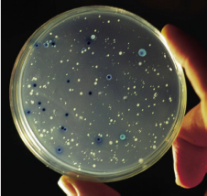
- To see this we add IPTG and X-gal. IPTG will be cleaved and will produce a blue color. If there is β-galactosidase activity it has to come from bacteria that have religated the vector onto itself and therefore the non-recombinant bacteria will be blue. This is known as the Blue/White Screen.
- Note: the larger the piece of DNA in the plasmid, the more time it will take to replicate. This means that the bacteria will be smaller, so it might be smart to pick the smaller colonies to clone.

Transgenic Mice:
- The Lac operon is used as a reporter in transgenic mice.
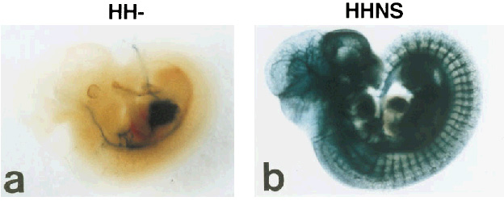
- Experiment: after the discovery of a new tyrosine kinase receptor (promoter is called Tie2) that we knew was involved in making blood vessels, a researcher made a construct in which he inserted the β-galactosidase gene downstream from the full promoter of this receptor, called HHNS. Then he cleaved half of the promoter, keeping only the HH part. To find out where this gene was actually expressed, he reinjected mice oocyte with these two constructs (one with the full promoter and the β-galactosidase gene and the second with the cleaved promoter and the β-galactosidase gene) and let the mice develop in vivo. He stopped embryonic development at 8.5 days. The mice which contained the full promoter have normal development for that stage, but the mice containing the HH construct are abnormal.
- The stain works through IPTG and X-gal. The researcher basically stained every blood vessel in the body. With a shorter promoter of Tie2, you see that the heart is still blue but certainly not as overwhelming as the full promoter HHNS.
- This is a good way to track viruses as well.

