
January 15, 2007
Lecture #5: January 15, 2007
Lecture #6: January 17, 2007
Lecture #7: January 19, 2007
Lecture #8: January 22, 2007

- Remember to validate your Athena account through the BUGS website link. (http://bugs.sus.mcgill.ca/)
- Check out our website for upcoming events this semester!
- Questions?! Comments?! Email us at: biochem.u1reps@gmail.com
SET # 2 :
January 15, 2007
Lecture #5: Cell Cycle II
Dr. Arnim Pause

NOTE: This NTC is meant to be used as a study aid to supplement your own class notes. Hence, not all of the text or diagrams contained in the lecture slides will be reproduced here.

Please send any comments or questions about NTCs to us through e-mail at biochem.u1reps@gmail.com.

Announcements:
- There are two TA’s for this course. Please email them with any questions you have. Their email addresses are on WebCT.

Questions addressed at the start of class:
  - Production of mutant yeasts and discovery of the gene responsible for the mutant phenotype:
    - Look for a cell with spontaneous, random point mutation among thousands of wild type cells over a duration of time. Isolate the mutant. Insert the wild type gene back into the mutant’s genome to rescue the mutation (i.e. make the mutant “normal”).
    - Mutations can be accelerated by treating the organism with carcinogens (compounds that damage/mutate DNA). This creates mutations at many different loci. It is hard to rescue these mutants since only one wild type gene is put back at a time. Usually this process does not work.
  - Studying cell-cycle progression in mammalian cells
    - Observe (count) the percentage of round cells. This will be the percentage of cells carrying out the cell cycle
    - Flat cells may be arrested in G1 or in S phase
    - Cells in the G1 or S phases can be made visible by 3 methods:
- Incorporate radioactive thymidine (nucleotides) into DNA of cells in S phase.
- Fluorescently label the nucleotides (Prof. Pause uses BrdU in his example). Cells in S phase are reddish-pink, while others are coloured blue.
- Use Flow cytometry, the most modern method. It measures the distribution of the cells in the different phases with the use of a FACS (fluorescence-activated cell sorter) machine that sorts cells according to their DNA content (eg. the normal amount or double the normal amount per cell). A graph of relative number of cells vs. relative amount of DNA per cell is produced from the data.

The control of the cell cycle:
The cell cycle can be stopped at any time due to the presence of checkpoints. These checkpoints are not required for the cell to cycle and their removal will not affect the cycle itself. They are only “add-on’s” to prevent the formation of mutant cells through negative feedback signals. Cancer cells do not have these checkpoints and as a result continue to grow uncontrollably and go on to form even more mutations. In contrast, frog oocytes do not have these checkpoints. Fertillization of the oocyte leads to thousands of S and M phases. Proliferation is controlled in the adult stages.
The checkpoints are:
- G1 checkpoint - Enter S: checks if the environment is favourable, if there are enough nutrients, if the cell has doubled in size.
- G2 checkpoint - Enter M: checks if the environment is favourable, if all the DNA has been replicated. Damaged DNA will cause the cell cycle to arrest in the G1 or G2 phase depending on which phase the cell is in when the problem is detected.
- Metaphase checkpoint - Exit M: Checks if all the chromosomes have attached to the spindle apparatus. If the chromosomes have attached improperly to the spindle, they will not separate; hence, forming one daughter cell with more than the normal number of chromosomes and another daughter cell with less.
These checkpoints will induce a cell cycle block if the checkpoint-specific criteria are not met.

Two key components of the cell cycle control system (Table 17-1):
- Cyclins
  - Act as on/off switches
  - Undergo a cycle of synthesis and degradation in each cell cycle (hence the name cyclin)
  - Regulate the activity of cyclin-dependent kinases (Cdk’s)
  - 4 types: S-cyclin (cyclin A), M-cyclin (cyclin B), G1-cyclin (cyclin D) and G1-S cyclin (cyclin E). The different types direct their respective Cdk partners to their substrates (the substrates are only present in the phase for which they are required OR the cyclin gives substrate specificity to the cyclin-Cdk complex – THIS IS NOT ENTIRELY FIGURED OUT)

- Cyclin-dependent kinases (Cdk)
  - Always present in cells
  - Inactive without cyclins
  - Need to be phosphorylated in order for the cell cycle to continue
  - There are several types – 5 types in vertebrates and only 1 kind in yeasts

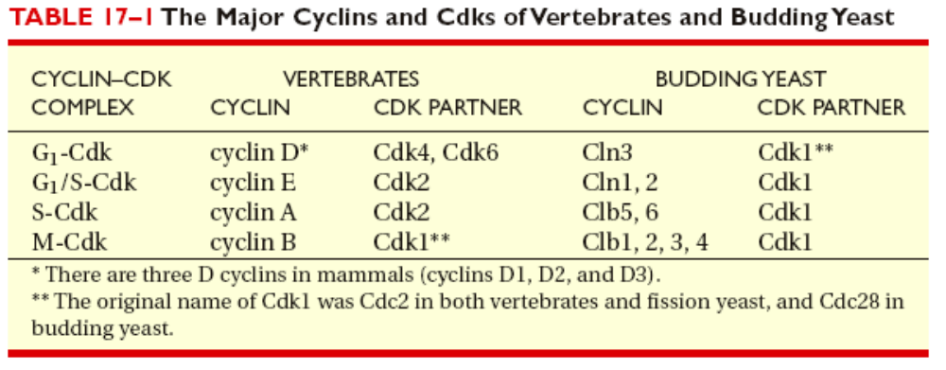

- Cdk’s bind to different cyclins to trigger different cell cycle events:
  - S-cyclins bind Cdk’s during S phase to trigger the DNA replication machinery. The S-cyclin is degraded at the end of the S phase
  - M-cyclins bind Cdk’s during M phase to trigger the mitosis machinery. The M-cyclin is degraded at the end of the M phase
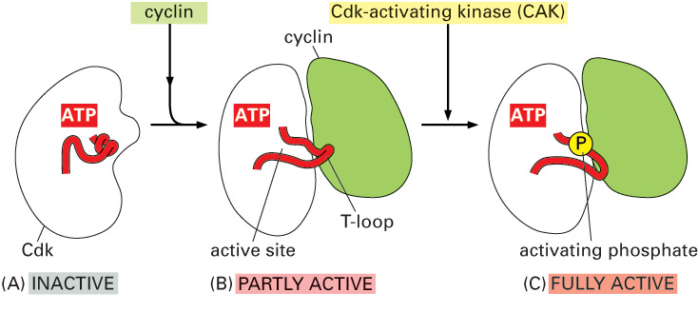
Cdk activation:
- The different structures of Cdk’s were determined by x-ray crystallography
- In the inactive state, the active site of the Cdk is sterically blocked by the T-loop. The binding of cyclin causes the T-loop to move out of the active site causing partial activation. Phosphorylation of Cdk2 by CAK (Cdk-activating kinase) at the T-loop completely activates the enzyme.

Regulation of Cdk activity by inhibitory phosphorylation:
- Wee1 kinase inactivates the cyclin-Cdk complex by adding an inhibitory phosphate to the Cdk. Note: the phosphate is not added to the active site
- Cdc25 phosphatase activates the cyclin-Cdk complex by removing the inhibitory phosphate

CAK, Wee1 kinase and Cdc25 phosphatase may act as oncogenes (promote cancer) or as tumour suppressors.

Inhibition of cyclin-Cdk complex by Cdk inhibitor proteins (CKI’s):
- 4 types of CKI’s: p21, p27 (degraded in S phase; represses G1 cyclin), p57, p16
- The CKI binds to both the cyclin and Cdk in the complex, distorting the active site of the Cdk and inhibiting it.

Cell cycle control by proteolysis:
SCF and APC are protein complexes that function as E3 ubiquitin ligases. With the aid of proteins E1 and E2, they attach a polyubiquitin chain to proteins to mark them for degradation by a proteasome. (E1 activates ubiquitin and E2 conjugates ubiquitin to E3.)

SCF :
- A multi-subunit complex of 7 proteins
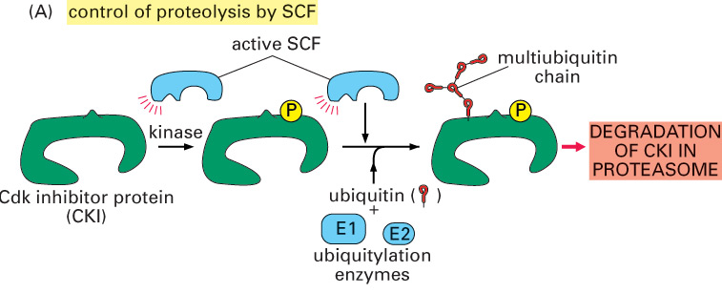
- Has two substrates: p27 (a CKI) and the G1/S-cyclin
- SCF will only bind to p27 when p27 is phosphorylated
- Transfers (with E1 and E2) multiple ubiquitin molecules onto the phosphorylated (via a kinase) CKI protein
NOTE: APC and SCF only tag the proteins for degradation; it is the proteosome that degrades the marked proteins to amino acids.
- Its activity is dependent on substrate phosphorylation

APC (anaphase promoting complex)
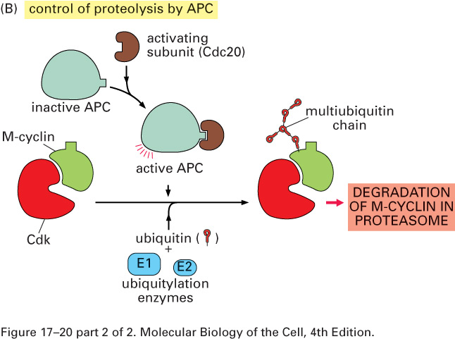
- First discovered in frog oocytes. The cytoplasm of the oocyte was fractionated and the different fractions were then put back into the extract one at a time to figure out which extract drives which phase in the cell cycle. Removal of APC from the cytoplasm blocks anaphase.
- Complex of 20 different proteins
- APC is always present in the cell in the inactive form. It is activated by the addition of an activating subunit; Cdc20. Active APC targets M-cyclin for degradation through polyubiquitination of the M-cyclin.
January 17, 2007
Lecture #6: Cell Cycle III
Dr. Arnim Pause

NOTE: This NTC is meant to be used as a study aid to supplement your own class notes. Hence, not all of the text or diagrams contained in the lecture slides will be reproduced here.

Please send any comments or questions about NTCs to us through e-mail at biochem.u1reps@gmail.com.

Announcements:
- The midterm exam will be on Tuesday, February 13th. Please let the professor know if you have any complaints. BUT this is “more or less” the final date.
- Details about how to contact the TA’s are on WebCT under “Announcements”. If you have any questions, either read the book or ask the TA’s. If the TA’s do not understand, they will ask Prof. Pause.

Cell fusion experiments for a rereplication block:
Two cells, each arrested at a different stage of the cell cycle with the use of drugs, are fused together. Polyethylene glycol (PEG) is used to fuse together the cell membranes.
- When an S-phase cell and a G1-phase cell are fused, the S phase cell continues with S-phase and the G1-phase cell goes immediately into S-phase. So, a cell in S-phase must contain factors in its cytoplasm that would drive a G1 nucleus immediately into S-phase.
- When an S-phase cell and a G2-phase cell are fused, the S-phase cell continues with S-phase and the G2-phase cell stays in G2. This shows that cells, having already replicated its DNA once, are refractory to these factors.
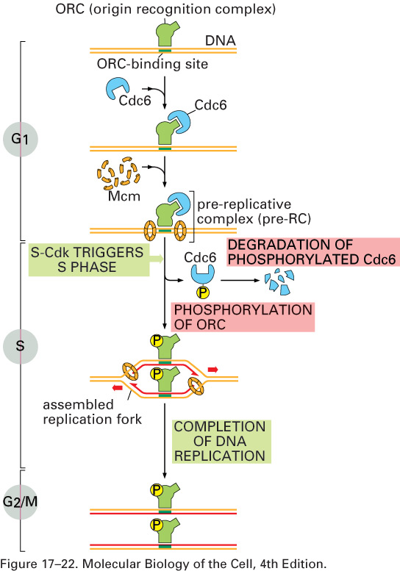
- When a G1-phase cell and a G2-phase cell are fused, the G1-phase cell continues with G1-and then moves on to S-phase (as it would normally) and the G2-phase cell stays in G2. Therefore, the cytoplasmic factors that promote DNA synthesis in S-phase disappear when the cell moves onto G2.

Regulation of DNA replication:
This regulation ensures that DNA is only duplicated once per cycle.
- DNA has several origins of replication where an origin recognition complex (ORC) can bind.
- In G1, transcription of Cdc6 is stimulated by G1-Cdk. Cdc6 binds to ORC and ORC-Cdc6 assembles Mcm proteins on the DNA. Mcm’s are composed of 10 different proteins that form a ring around the DNA on both sides of ORC-Cdc6 and function as a ATP-dependent DNA helicase. The Mcm ring complexes, ORC and Cdc6 form the pre-replicative complex (pre-RC).
- Then, S-Cdk triggers S-phase by phosphorylating ORC (Cdc6 can not bind to the phosphorylated ORC), signalling the Mcm proteins to move in opposite directions and unwind the DNA. S-Cdk and another kinase assemble DNA polymerase and other replication proteins to form the assembled replication fork.
- The replication complex moves along the DNA strand until it reaches another origin of replication. All the proteins except the phosphorylated ORC leave the DNA. The ORC remains phosphorylated (by M-Cdk) throughout G2, keeping it inactive.

M-Cdk and S-Cdk ensure that
- Cdc6 is phosphorylated continuously so that it gets destroyed.
- Mcm proteins are phosphorylated and then transported to the cytoplasm once DNA replication has started to prevent the formation of a second replication fork

Functions of M-Cdk:
Before M-phase, the production of inactive M-Cdk is increased. This can be detected by staining the cell with an antibody against M-Cdk. The following functions are regulated by substrates of M-Cdk:
- Chromosome condensation
- Assembly of the mitotic spindle
- Attachment of chromosomes to the mitotic spindle
- Breakdown of the nuclear envelope: lamin filaments form the nuclear membrane. Phosphorylation of these filaments by M-Cdk causes them to depolymerise and the dissolution of the nuclear membrane.

Cdc25 phosphatase acts as a signal to activate M-Cdk. Cdc25 is itself inactive and needs to be phosphorylated by another kinase to be activated. Active Cdc25 removes the inhibitory phosphate from M-Cdk to activate it. Active M-Cdk then potentiates this signal in two ways:
- In a positive feedback loop, where it phosphorylates more inactive Cdc25 (and the active Cdc25 in turn activates more M-Cdk).
- In a negative feedback loop, where it inhibits Wee1 (which is responsible for adding the inhibitory phosphate) – i.e. it inhibits the inhibitor.
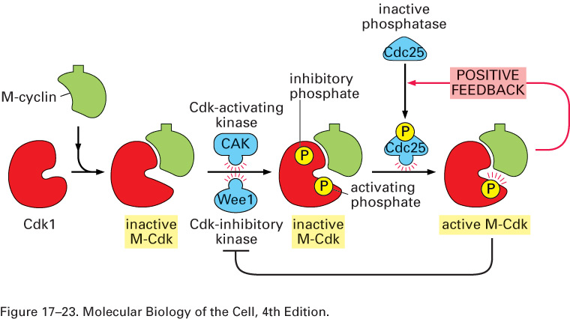

Experiments with the DNA replication checkpoint:
  - The control undergoes normal cell cycle (S, G2, then M)
  - In presence of hydroxyurea (no need to memorize the name), which is a DNA replication inhibitor, the DNA replication checkpoint detects that DNA has not been duplicated. The cell arrests at S/G2-phase (mistake in lecture slide) and waits for complete DNA replication.
  - Caffeine inactivates the DNA replication checkpoint when present in high levels. In presence of caffeine and hydroxyurea, incomplete DNA replication is not detected. Cells go through S-phase and continue on to mitosis. In normal cells, another checkpoint (present after mitosis) detects this and causes the cell to die (apoptosis).
Cancer cells do not have the second checkpoint, and as a result these cells do not go into apoptosis and cells with inappropriate numbers of DNA continue to grow and proliferate.

M-Cdk and chromosome condensation:
- Condensins and cohesins are substrates of M-Cdk. They were discovered in yeast cells.
- When phosphorylated by M-Cdk, condensins bind to DNA so that it condenses into coils
- Cohesins hold together sister chromatids from G2 to metaphase and are not present in the metaphase to anaphase transition when sister chromatids are pulled apart.
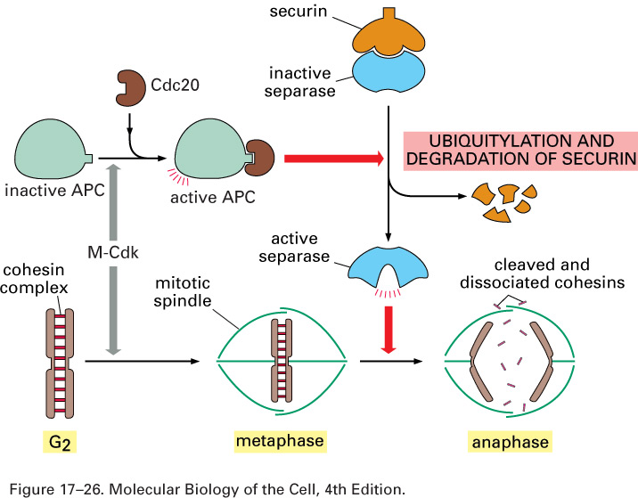
Triggering of sister chromatid separation by APC:
M-Cdk activates APC by adding Cdc20 (a cofactor) to it. Active APC ubiquitylates securin. The removal of securin activates separase (a protease). Separase cleaves cohesin so that sister chromatids can be pulled apart by spindle fibres at anaphase.

Experiments demonstrating the requirement for proteolysis in transitioning from metaphase to anaphase:
- Experiments were carried out in vitro using frog oocyte cytoplasm.
- In the presence of an APC inhibitor, the oocyte extract arrested at metaphase.
- APC targets M-cyclin for degradation by a proteosome by ubiquitylating M-cyclin. The ubiquitin proteins are attached to the M-cylin at a lysine residue. When the lysine is mutated to an alanine or arginine residue, ubiquitin cannot be attached and the M-cyclin is non-degradable. In presence of non-degradable M-cyclin, the extract goes through metaphase, the chromosomes are pulled apart and then the extract arrests at anaphase.
- Therefore, APC must destroy cohesin and M-cyclin. M-cyclin degradation is required to complete anaphase and enter cytokinesis.

Spindle attachment checkpoint in mammalian cells
This checkpoint ensures that all the chromatids are attached to the spindle before anaphase begins. Mad2 protein will bind to any chromatids that are not attached to the spindle and will signal to the cell to not go into anaphase. This binding can be observed by staining with an antibody against Mad2. When the chromatid attaches to the spindle, Mad2 is removed (the exact mechanism is not known). Improper chromosomal segregation can lead to diseases like Down syndrome.

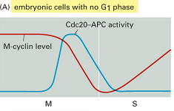Creation of G1 phase by Cdk inhibition
Cdk activity is high in S, G2 and M phases and must be lowered for the cell to go into G1 (or G0) phase. This is done by the removal of M-cyclin

- In embryos (no G1 and G2; M and S phases alternate
rapidly):
High levels of M-cylcin in the M phase stimulate Cdc20 production. Cdc20 binds to APC to activate it. Active APC targets M-cyclin for degradation. When M-cyclin levels go down, Cdc20 levels also go down as its production is no longer stimulated. APC is inactive and this leads to a rise in M-cyclin production
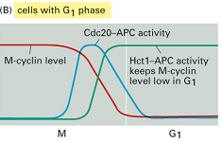
- In adult cells:
Hct-1 is the second activator of APC. Hct-1 binds to APC to activate it. Active APC targets M-cyclin for degradation. Since Hct-1 levels are not dependent on M-cyclin levels, M-cyclin levels remain low in G1.

January 19, 2007
Lecture #7: Cell Cycle IV
Dr. Arnim Pause
NOTE: This NTC is meant to be used as a study aid to supplement your own class notes. Hence, not all of the text or diagrams contained in the lecture slides will be reproduced here.

Please send any comments or questions about NTCs to us through e-mail at biochem.u1reps@gmail.com.

Announcements:
- Please make an appointment with Biochemistry department Chair, David Thomas, if you have a problem with the date of the midterm.

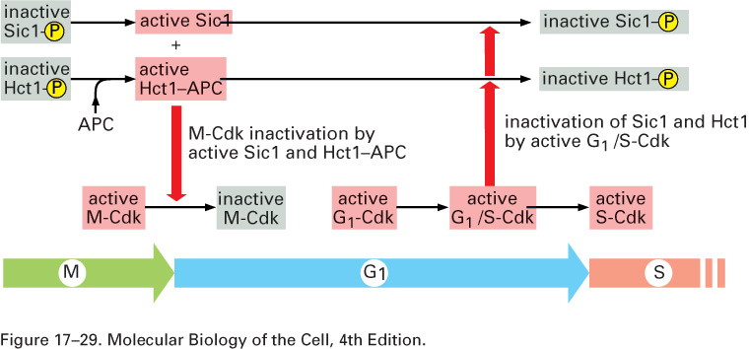
G1 regulation in yeasts:
Sic1 is a Cdk inhibitor (CKI) in yeasts (similar to p27 in mammals) that can inhibit M-Cdk by binding to it. Sic1 (inactivated) levels are controlled by SCF. In M-phase, Sic1 and Hct1 are kept phosphorylated by M-Cdk. Towards the end of the M-phase, Cdc20-APC triggers M-cyclin destruction. This leads to dephosphorylation and activation of Sic1 and Hct1. Although some cells stay in G1 forever (e.g. neurons in G0), others, like liver cells, remain in G1 until some damage occurs. Cells surrounding the damaged area will signal (via growth factors, proliferation factors, mitogens) cells in the damaged area to proliferate in order to replace dead cells. This signal activates G1-Cdk, which in turn activates G1/S-Cdk (here activation means phosphorylation, transcription and translation). G1/S-Cdk will phosphorylate Sic1 and Hct1, and S-phase will begin.

G1 regulation in mammalian cells:
- Rb (retinoblastoma) protein is a tumour suppressor with 3 homologues. Its absence in the cell causes eye tumours in children. This is a hereditary disease caused by the loss of the Rb protein gene. A phenomenon called loss of heterozygosity (LOH) is also responsible where the second, normal allele of the gene is also lost.
- G1-Cdk is activated by an external signal such as growth factors or nutrients.
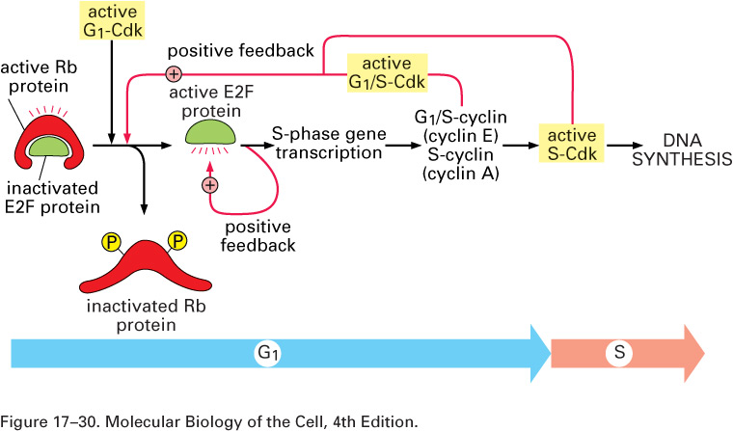
- E2F is a transcription factor involved in the transcription of many S-phase genes including G1/S-cyclin and S-cyclin. It has 6 to 7 homologues.
- G1-Cdk activity will phosphorylate Rb, freeing E2f to activate more S-phase genes.
- G1 regulation in mammals demonstrates a common theme in regulation of the cell cycle i.e. signal potentiation through a positive feedback loop.
- When the Rb gene is deficient or missing, the Rb protein is either absent or always inactive. E2F is then always active and cells are continually driven to S-phase resulting in the formation of eye tumours (due to the loss of only one homologue).
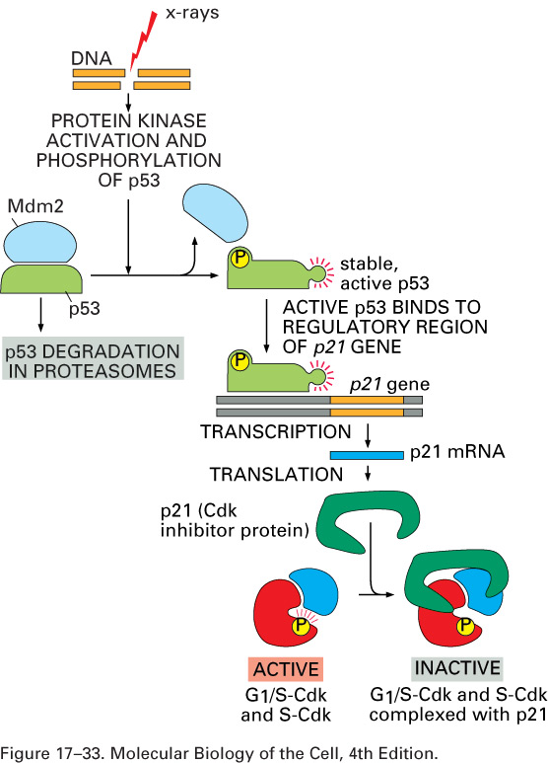
Proteins involved in the arrest of cell cycle in G1 due to DNA damage:
p53, a tumor suppressor, is a transcription factor for many genes including those important for DNA repair, as well as p21. It is also termed “the guardian of the genome”. p53 is never present in cells with normal DNA. When DNA is damaged in the cell (by X-rays, UV radiation, carcinogens, etc.), p53 is phosphorylated by ATM kinase so that Mdm2, an E3 ubiquitin ligase, cannot trigger its destruction. p53 is inactive in more than 50% of all tumors, causing cells to be unable to detect damaged DNA. As a result, these cells accumulate mutations and become more malignant.

p21 is a p27 and Sic1 homologue and a CKI for G1/S-Cdk and S-Cdk. The objective of this pathway is to ultimately arrest the cell in G1.

Overview of cell-cycle control system:
- Checkpoints are negative signals, i.e. they are not necessary for the cell cycle and the cell cycle will continue without them.
- Unfavourable extracellular environment: no growth factors, mitogens, nutrients, etc.
- Cell cycle arrest by p53 can also lead to cell death by initiating the transcription of proteins that are involved in cell death e.g. when there is too much DNA damage for the cell to repair.

Note: In slides 38 and 40 of Dr. Pause’s lecture slides for lectures 4-7, APC-Cdh1 is the same as APC-Hct1. There is no need to memorize slide 40, it is enough to just understand how the cell cycle can be arrested in different phases.

Cell death:
- Cell death can be signalled externally by survival factors and also internally due to problems within the cell.
- Necrosis: explosion of the cell and leakage of its contents (due to injury, etc). This causes inflammation and other problems.
- Apoptosis: naturally-programmed cell death. The cell condenses, the nuclear envelope disassembles, and the nuclear DNA breaks up into fragments. DNA or proteins contained inside vacuoles are degraded to nucleotides and amino acids, respectively. The dying cell is phagocytized by a macrophage. This allows the organic components of the dead cell to be recycled by the cell that ingests it.

Cell death, cell growth and cell proliferation need to be perfectly balanced in multicellular organisms:
- Cell division is regulated by mitogens (also known as growth or proliferation factors).
- Cell growth is regulated by growth factors
- Cell death is regulated by survival factors; cells die when they are absent.
- Some factors can regulate a combination of the three processes.
- There is a different growth factor for each type of cell: keratinocyte growth factor, hepatocyte growth factor, platelet-derived growth factor (PDGF).
- Platelet-derived growth factor:
- Identified by growing cells in serum (contains platelets) and plasma (doesn’t contains platelets). Cells grown in serum would grow while those in plasma would not. PDGF are contained in secretory vesicles within platelets
- PDGF (or any other growth factor or mitogen) will initiate growth and proliferation when added to cells in culture. When PDGF is removed, cells will arrest in G1.

How mitogens stimulate cell division:
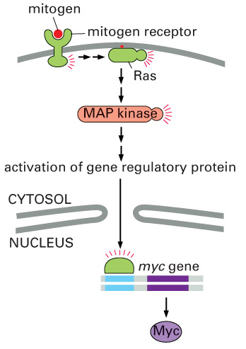
- Growth factor receptors (tyrosine kinases) span the cell membrane. When a mitogen binds to the receptor, the receptor is phosphorylated and transmits the signal through a cascade of other factors (Ras and MAP kinase, for example). In the nucleus, the production of Myc (a transcription factor and an oncogene) is induced. Mutant cells that over-express Myc will continue to proliferate even when the mitogen or growth factor has been removed, but they will decrease in size as they run out of nutrients (as seen in mutant yeast cells, slide 34).
- Each of these factors is involved in cancer. Some cancer cells over-express a particular mitogen, stimulating their own proliferation. In others, the growth factor receptor always stimulates the cascade regardless of the presence of mitogen. In others (about 30% of lung cancers), the Ras protein (a GTPase and an oncogene) is mutated.
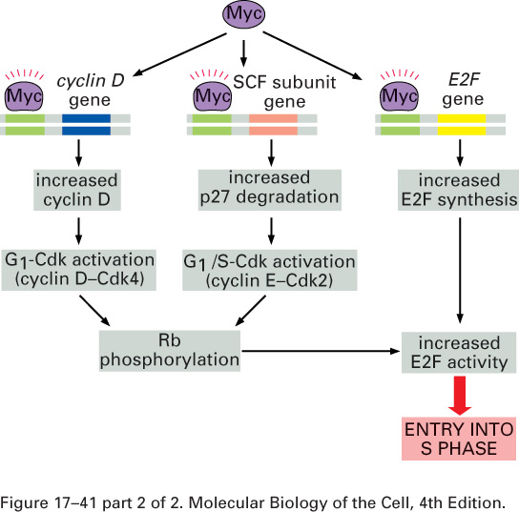
- The over-expression of oncogenes will drive cells into proliferation. Some growth factor receptors are oncogenes. EGFR is involved in most epithelial tumors. HER2 is involved in 30% of all breast cancers.
- Myc will stimulate cell division by enhancing transcription of three genes: cyclin D, SCF subunit and E2F. The downstream effects of the transcription of these genes will ultimately push the cell into S-phase.
- Remember that SCF is a ubiquitin ligase that targets the p27 protein (a CKI) for degradation by the proteasome.

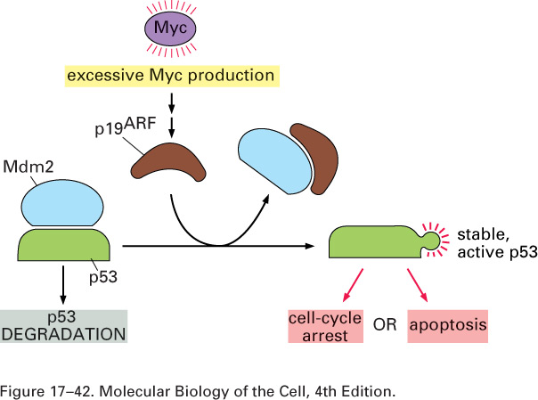
Excess mitogen induces p53:
The cell will either arrest in the cell cycle or die by apoptosis depending on the strength of the signal. The signal (Myc) may be external (e.g. from a neighbouring cell that died by necrosis causing the release of substances into the tissue fluid). Note that p19^{ARF} is only induced by Myc when there is excessive proliferation.

Cell senescence:
- A protein called telomerase adds short fragments of DNA or RNA to the ends of chromosomes, which protects the DNA from damage. If a cell contains telomerase, the end pieces will be resynthesized after each division. In normal human cells, telomerase is inactivated, so that after each cell division, the end pieces shrink little by little and eventually DNA is damaged. As a result, cell division ceases after about 50 divisions.
- Immortalized cells are capable of proliferating indefinitely because they express telomerase. Many cancer cells, as well as rodent cells also express telomerase (hence the use of rodent cells in most cell cultures).
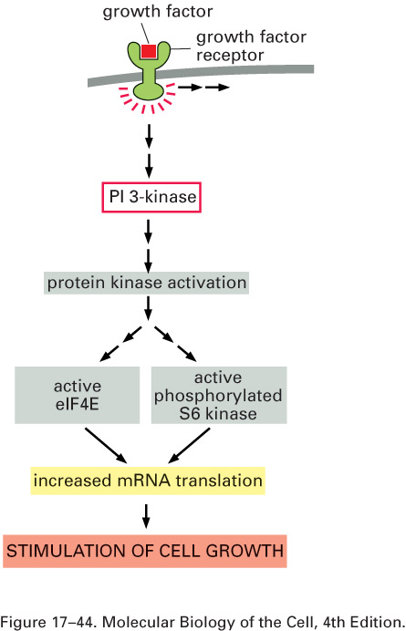
Growth factor receptors:
- Growth factors can stimulate cell growth as well as proliferation.
- Growth factors receptors can induce the MAP kinase pathway (results in proliferation) and the PI 3-kinase pathway (solely important for cell growth). The PI 3-kinase pathway goes through several kinases including Akt and mTOR.
- S6 is a ribosomal protein
- Note that the effects of the pathway occur on the level of protein synthesis.

Size difference in cells:
Neurons are arrested in G1/G0 and are terminally differentiated. This is controlled by a factor that has two roles: growth factor and survival factor. A similar process occurs in muscle and fat cells (they increase and decrease in size but do not divide).

How nerve cells locate their target cells:
The target cell produces a survival factor called nerve growth factor (NGF) in an amount that is sufficient for the survival of only one nerve cell. A target cell is matched to one neuron through the death of the extra neurons.

Growth of cell monolayer:
- Cells are provided with nutrients and growth factors. They divide until they produce a monolayer on the Petri dish due to:
- Contact inhibition: cells sense other cells “touching” them (as if in a tissue) and this produces an internal signal to stop dividing and the cells arrest in G1.
- Lack of growth factors and nutrients: when the medium is replaced, the cells begin to proliferate locally.
Note: this only happens in artificial culture
  - Individual cells are flattened and spread out so they seem large. In a monolayer, the cells are more cylindrical and thicker.

Attachment to substratum affects entry into S-phase:
  - Most cells (except free floating cells like lymphocytes and blood cells) need to be attached to an extracellular matrix.
  - Agar prevents cells from attaching to it. Even in the presence of growth factors and nutrients, cells will not go into S-phase since they cannot attach.
  - The adhesive patch contains extracellular matrix molecules (proteins) to which the cell can attach. Attachment signals to the cell to enter S-phase.

January 22, 2007
Lecture #8: Cancer I
Dr. Arnim Pause

NOTE: This NTC is meant to be used as a study aid to supplement your own class notes. Hence, not all of the text or diagrams contained in the lecture slides will be reproduced here.

Announcements:
- Anatomy clothing: bring your receipt to the MACSS office to obtain your clothing.

The relationship between the Cell Cycle and Cancer:
- It is a common misconception to associate cancer with a faster cell proliferation. This is not entirely true, in that both cycles take exactly the same time in a cell, whether it is cancerous or normal.
- The cell cycle includes processes such as DNA replication and mitosis, which take the same amount of time in both types of cells. However, this is often confused because cancer cells proliferate whereas normal cells generally do not.
- Normal cells are usually found in the G1 or G0 phase. Essentially, the difference is cell proliferation (cancer) versus non-proliferation (normal).
- By placing both cell types in a cell culture (with appropriate growth factors) and measuring the time it takes to complete a cell cycle, results would show that both cell types would take an equal amount of time to cycle.
- However, in the absence of growth factors, a normal cell would cease its proliferation (this would signal a checkpoint in the normal cell cycle), whereas a cancer cell would continue. This is why the term “uncontrolled cell cycle” applies to cancer cells; the control mechanisms are defective and, as mentioned before, the defect usually lies within the checkpoints of the cell cycle.
- There are a great number of cancers associated directly with defects in cell signalling pathways (the Ras / Map Kinase pathway for example). There can also be problems with programmed cell death (apoptosis) as well as tissue architecture (the extracellular matrix or ECM). Any number of problems in these categories can create uncontrolled cell proliferation.

Adenomas versus Adenocarninomas:
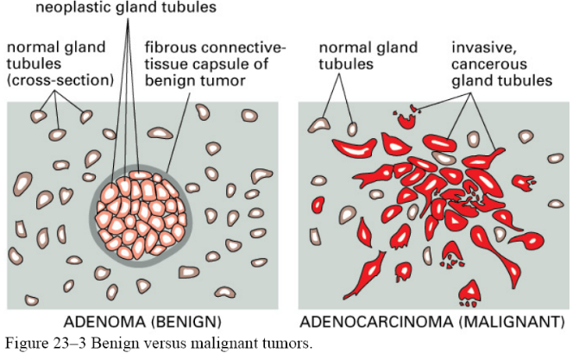
- As can be seen from Figure 23-3, a benign breast tumor is confined to a certain region, fenced in by epithelial cells (the tumor has not spread and the cells have not migrated; it is simply a result of the excessive proliferation of one cell).
- This barrier is formed by epithelial cells, which can be ECM molecules, and is also referred to as the basal lamina.
- In cancer cells, the basal lamina becomes digested and the invasive cancerous cells are free to spread throughout the body.
- In order for this to be possible, the cell must acquire more and more mutations in important genes that control cell proliferation. This can allow the benign tumor to remain unnoticed for a long time.
- Cancer is an accumulation of mutations in cell proliferation genes. Usually there are mechanisms to avoid the proliferation of a cell while DNA mutations are present (DNA repair mechanisms, the death of the cell under too many mutations in the genome).
- This is manifested as a checkpoint in the normal cell cycle, which is absent in cancer cells.
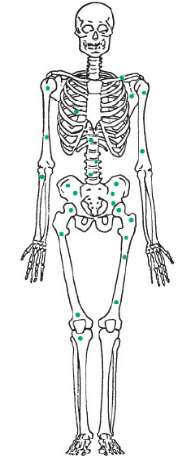
- In certain cancer cells, p53 is lost, causing the acquisition of more mutations in oncogenes, so that they proliferate uncontrollably. A cancerous cell can end up killing an entire population of cells.
- Benign tumor: a tumor that is locally confined and, if detected, can be removed surgically to avoid cancer. A tumor is clearly more easily detected in surface tissues (by sight, touch, pain, etc.) than in organs such as the liver or kidney (must be seen by x-ray, MRI, etc.).
- Once malignant and able to migrate (See Figure at right for Prostate cancer example), it becomes virtually impossible for a surgeon to locate and remove the cancerous cells.

Types of Cancers in Humans:
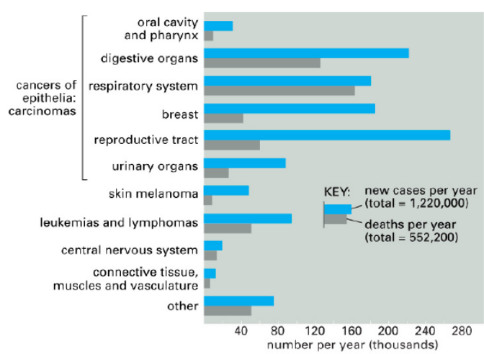
- There are three basic types of cancer in humans, found in three tissue types.
- The most common (90% of all cancers) are carcinomas, which are cancers of the epithelia (single layers of cells in certain organs or tubes, such as in the kidney).
- The second type is sarcomas, which are cancers of the muscles and connective tissues (these are highly rare in comparison to carcinomas).
- The third type is referred to as “liquid cancers” and is essentially cancer of the blood or immune system. These cells are not physically attached and are floating in certain liquids in the body.
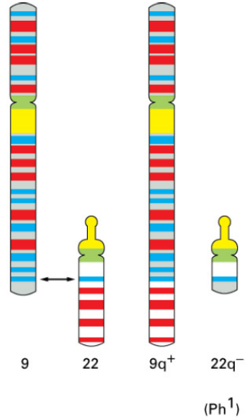
- In reference to the above figure, it can be seen that cancers which have high incidence (i.e. breast, reproductive tract and colon cancers) but are easily detected (i.e. on the surface etc.) have a lower proportion of deaths to new cases as opposed to cancers which are highly difficult to detect (i.e. lung cancer results in almost certain death because it basically cannot be felt and detected at early stages).
- A great many tumor cells are required for the tumor to be noticeable. The early stages are often undetectable until it reaches about 1 cm in diameter.
- One of the first genetic abnormalities causing cancer was in Chronic Myelogonous Leukemia (CML). In CML cases, the recurring genetic problem arose: a chromosomal segment translocation from chromosome 22 to chromosome 9 in many of these leukemia patients (because of the city of its discovery, the smaller chromosome 22 is referred to as the Philadelphia chromosome).
- It can be said that an oncogene becomes active once this translocation event has occurred, thus causing the uncontrolled cell proliferation seen in CML patients.
- A drug has been developed (20 years after the discovery) that can actually inactivate this oncogene and “cure” these patients, if only for a small period of time. This case is somewhat predictable (much easier to target with a drug) in that 90-95% of all cases of CML are caused by this translocation event; whereas in other cancers, predicting the cause becomes a much more difficult challenge.

Cancer as a Function of Age:
- An accumulation of mutations in cancer-causing genes is needed to initiate cancer, therefore it is obvious that as one ages, the accumulated amount of DNA mutations which can potentially cause cancer increases exponentially
- The rule of thumb: ~10 mutations in ~10 different cancer-causing genes are needed to cause cancer in a given cell (genes must be somehow linked to uncontrolled cell proliferation). These events are usually very rare, explaining the incidence at older ages.

Carcinogens and Carcinogenic Effects:
- Cancer can be accelerated by increased exposure to cancer-causing carcinogens (DNA-damaging chemical compounds, X-rays or UV-rays).
- The effects will usually appear at a later time because it takes time to accumulate mutations. However, theses effects can be sped up by increasing exposure (i.e. smoking to a great degree).

Stages of Cancer Development:
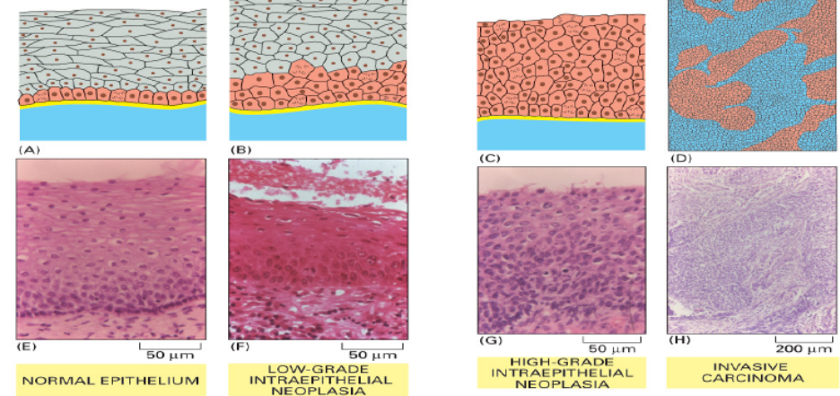
- The top and bottom portions of the figure at the right display the development of cancer in stages.
- In the first picture (A), the topmost cells are fibroblasts, and the next cells are epithelial cells that are bordered by the basal lamina, which limits their proliferation under normal circumstances.
- The uncontrolled cell proliferation begins from a single cell that acquired a sufficient amount of mutations.
- As the pictures progress from low- to high-grade neoplasia, it can be seen that the fibroblast layer is completely taken over by the uncontrolled proliferation of the epithelial cells.
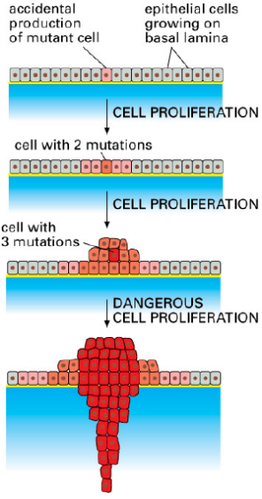
- Invasive carcinoma displays a mixture of cancer and normal cells. The cancer cells appear very small because of the lack of checkpoints in their cell cycle, causing them to divide without sufficient cell growth.

Clonal Evolution:
- This diagram illustrates the situation discussed above. A single cell acquires a mutation; it duplicates to create more cells with the mutation and can, itself, acquire more mutations. The accumulating effects of cell proliferation of mutant cells, as well as the increase in the number of mutations create a piling up of cells (abnormal event).
- Eventually, invasiveness results and becomes very dangerous because of metastasis, wherein the mutant cancerous cells can migrate to various regions of the body and proliferate (they become virtually impossible to locate by medical procedures).
Genetic Basis of Cancer:
- Firstly, there is a usual occurrence of an increased number of chromosomes in tumor cells. There is then an abnormal amount of DNA due to the greater number of chromosomes.
- Most of these chromosomes are disfigured and have experienced translocation events or breaks which can create more or less copies of certain genes in certain cells (Down syndrome / Trisomy 21, which is not a form of cancer, but rather, an example of what can occur with too much DNA).
- These translocation events can be detected by staining an individual chromosome with its own dye and observing the variety of colours on any single chromosome in tumor cells. This illustrates the hallmark of cancer cells: genetic instability (no cell cycle checkpoints to keep cell proliferation under control).

Cancer Theory: Selective Barriers
- The first theory: any cell must cross two selective barriers in order to become a cancer cell.
- These barriers can consist of hypoxia (i.e. low oxygen tension / a state of decreased oxygen).
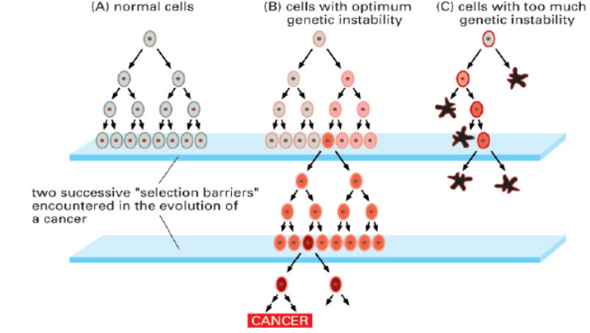
- A cancer cell, due to its high proliferative characteristics, quickly runs low on oxygen as it continuously divides in a certain area (many more cells than usual requiring oxygen from the original source). Thus it encounters the first barrier, hypoxia, which will signal to the cells to stop proliferating because there is not enough oxygen for more cells.
- However, if there is a mutation in any aspect of this signalling pathway, it is obvious that cells will proliferate continually, even in the absence of sufficient oxygen.
- The secretion of certain factors can also occur in the event that the cells are sufficiently mutated, which cause blood vessels to begin to grow towards the tumor, giving the tumor cells a greater access to oxygen and allowing them to proliferate abnormally.
- These factors are referred to as angiogenic factors. This process is referred to as the angiogenic switch and initiates the blood vessel proliferation into the tumor, allowing access to nutrients and oxygen contained within blood vessels.
- The second barrier encountered would be a lack of mitogens or growth factors that, under normal circumstances, would not be present.
- As can be seen from the diagram, if one cell contains a mutation in a certain gene that causes it to produce mitogens, it can stimulate its own proliferation, as well as the proliferation of its neighbours (as seen in the figure).
- The third case (C) portrayed in the figure, demonstrates cells that have acquired too many genetic abnormalities, and thus leads to cell death (either due to their own instability, to the failure of genome repair or to the cell death-triggering checkpoints which remain functional in the cell cycle).

Cancer Theory: Stem Cell Theory
- Stem cells can self-renew themselves (simple cell division into identical stem cell daughter cells), or can differentiate into daughter cells with less proliferation capacity (hepatocytes, etc.). These differentiated cells go through only a limited number of cell divisions (i.e. 10 cell divisions).
- These differentiated cells will eventually divide, and only then, will they be replaced by new cells.
- Theoretically, a stem cell is analogous to a tumor or cancer cell: it divides continuously.
- The basis behind this theory is: if there is a certain mutation which can cause the progeny of stem cell division to be all stem cells, this would allow a continuous cell proliferation (the daughter cells can still proliferate in an ongoing manner as opposed to a limited number of cell divisions).
- The third case illustrated below displays a stem cell that does not differentiate normally, and thus the daughter cells retain the ability to proliferate continuously, allowing the formation of a tumor. This can be due, for example, to the expression of the enzyme telomerase, which will allow a continual proliferation of cells.
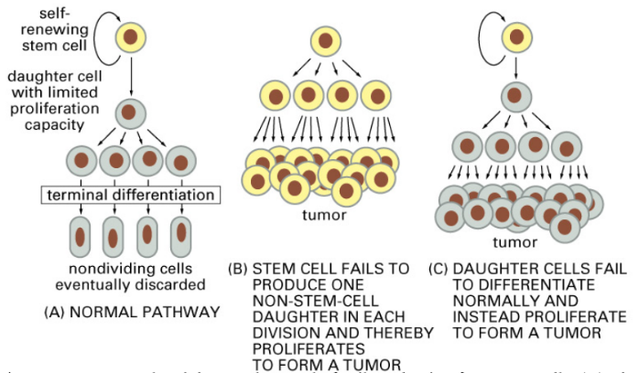
- Chemotherapy: DNA damaging agents or carcinogens that are given to patients with a tumor in order to cause cell cycle arrest in cells which are highly proliferating (i.e. tumor cells, which will die as a result).
- However, a relapse (the re-emergence of a tumor years later) can be caused by the lack of destruction of the slowly proliferating stem cells, which can sit dormant in the tissues, avoiding the effects of chemotherapy.
- Isolating cancer stem cells is thus an important aspect of research because it would allow the ultimate elimination of a tumor.

The process of Metastasis:
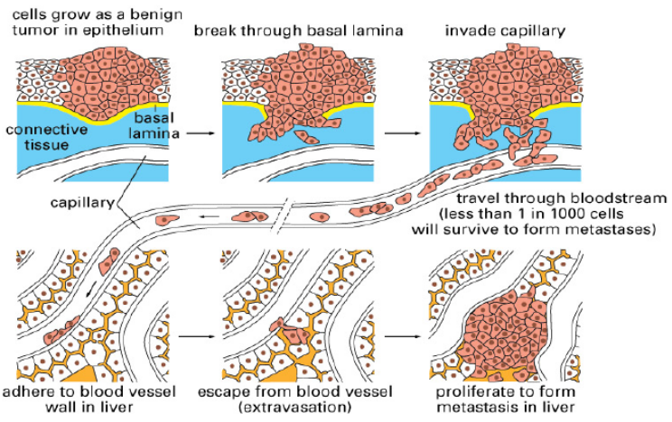
- As illustrated by the image at right, metastasis is preceded by a simple benign growth of epithelial cells that is contained by the basal lamina.
- As the cells acquire more and more mutations, the basal lamina can then be digested, and the cancerous cells are free to migrate through the connective tissue layer of fibroblasts to eventually reach the bloodstream, enabling them to travel throughout the body.
- Cells must have acquired mutations which allow them to digest the basal lamina, travel through fibroblasts as well as the blood vessel wall. Furthermore, they must also have acquired mutations that enable them to survive in liquid phase (i.e. the bloodstream) and grow without any attachment in this phase.
- The cells must then be able to attach to the blood vessel wall and infiltrate into the tissues (much like a white blood cell which migrates to a site of injury outside of the bloodstream; although clearly, the effects are significantly different).

Cancer Incidence among Populations:
- There are both high and low incidence populations for specific cancers (table 23-1 in the slides).
- Low incidence populations usually occur in under-developed countries (i.e. eat more natural food, smoking, genetic background etc.).
- It is easy to predict some sorts of cancers (i.e. melanoma incidences in sunny Australia, colon cancers due to increased intake of red meats etc.).
- However, some cancers are virtually impossible to explain.
- Both genetic backgrounds as well as environmental factors affect one’s risk of cancer.

Carcinogens:
- Aflatoxin, which comes from a mold (Aspergillus) that covers nuts, grains and beans, can cause significant DNA damage when metabolized.
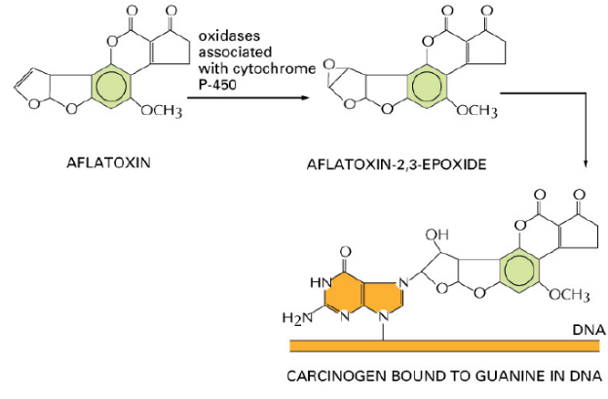
- Aflatoxin on its own is not a carcinogen. However, when it is metabolized in the liver by an enzyme called cytochrome p450, it would result in detoxification, and thus, be converted into the guanine-nucleotide-binding compound seen in the figure at the left. This bonds covalently with G in DNA, causing a DNA break during replication due to the inability of the polymerase to replicate properly.
- Toxins in cigarette smoke act very similarly to this mechanism: the metabolites are usually the more harmful compounds. Genetic variation among populations (variations in the types of cytochrome p450 for example) can result in the production or absence of certain metabolites of an ingested compound.
- Dr. Pause gave the example of alcohol tolerance amongst Caucasian and Asian populations, and explains the lower tolerance in Asian populations as a result of the lower concentration of alcohol-metabolizing enzymes in the liver.
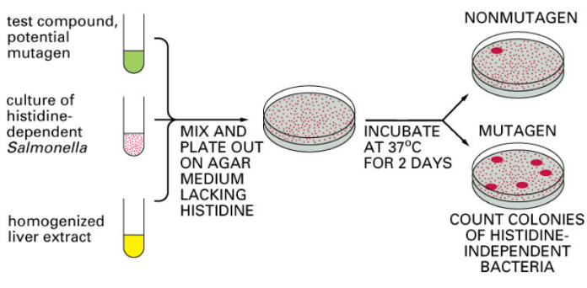
- Therefore, the genetic background of an individual greatly affects their contraction of specific cancers.
- The Ames Test (discovered by Bruce Ames in the 60’s): every compound that populations eat, use as cosmetics or intake as a drug must pass this test.
- The use of His- Salmonella tests mutagenic compounds and liver enzymes. The result on a His- agar plate will determine the mutagenic capacity of the compound.
- Many colonies result if the test compound is a mutagen because it indicates a change in the DNA that allows the Salmonella to grow on the His- plates.

Cancer-causing Viruses:
- Viruses can also cause cancer, for many different reasons.
- Direct causes of cancer: Papillomavirus or HPV causes benign warts in genital areas and carcinoma (uterine cervix) – interferes with the action of p53 and Rb, and thus the cell cycle machinery.
- Indirect causes: Hepatitis B and C viruses infect the liver and cause a continuous inflammation, which causes the cancer. The viruses themselves do not cause cancer, but the constant state of inflammation over long periods of time can cause cancer.
- HIV is also an indirect cause of cancer because it suppresses the immune system, increasing an individual’s susceptibility to bacteria
- Refer to table 23-2 in the lecture slides for more details concerning cancer-causing viruses.

