
SET # 8 :
Lecture #23: March 5, 2007
Lecture #24: March 7, 2007
Lecture #25: March 9, 2007

SET # 8 :
- Biochem clothing orders are in! Come by the BUGS office during our office hours to pick them up!
- Merck Frost Tours are taking place next Thursday. Sign up at the BUGS office ASAP (space is limited). Cost is $20.
- Sugar shack is next Friday (March 23, 2007). Sign up at the BUGS office!
March 5th, 2007
Lecture #23: Peripheral Membrane Proteins
Prof. Martin Latterich

NOTE: This NTC is meant to be used as a study aid to supplement your own class notes. Hence, not all of the text or diagrams contained in the lecture slides will be reproduced here.

Please send any comments or questions about NTCs to us through e-mail at biochem.u1reps@gmail.com.

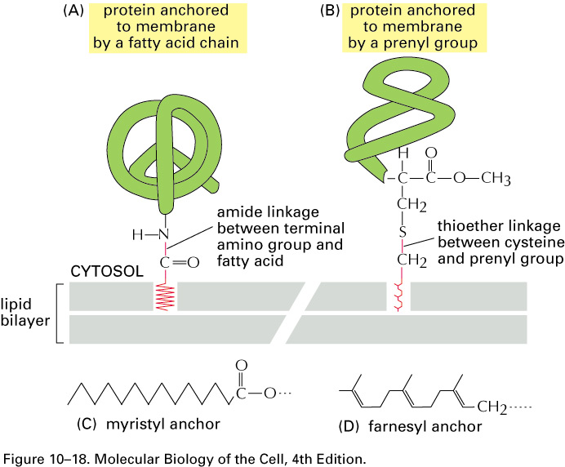
Fatty-Acyl/Prenyl Anchors:
- Fatty-acyl/prenyl anchors are proteins that use a lipid anchor, covalently linked to the protein, to stably insert themselves into the membrane of a cell.
- These proteins are facing the cytosol and are not exposed to the extracellular space (unlike GPI-anchored proteins).
- The two major classes of fatty-acylated/prenylated proteins are the myristylated proteins and the prenylated proteins.
- Myristylated proteins contain a myristyl anchor, a relatively long fatty acid chain, which is usually attached to the N-terminus of the protein.
- The presence of a consensus sequence near the N-terminus of the protein determines whether the protein will be myristylated.
- An enzyme called myristyl transferase is responsible for the attachment of the myristyl group.
- The biological function of the myristylation is to make soluble proteins more lipophillic so that they can associate with the membrane.
- Proteins, such as ARF proteins, can selectively expose or mask their myristyl group under certain conditions in order to determine whether the membrane-association will occur. If the group is folded backwards/masked, it can resolubilize the protein so that it is directed away from the membrane.
- There are two different categories of prenylated proteins: ones that use a farnesyl anchor and others that employ a geranylgeranyl anchor.
- The structure of a myristyl anchor is more hydrophobic than that of a farnesyl anchor.
- The farnesyl anchor is attached to a cysteine residue at the C-terminus of the protein via a sulfide linkage (all proteins that are farnesylated have a cysteine as the forth last amino acid from the C-terminus in their sequence). If a protein has a cysteine at the -4 position, it has a 100% chance of being farnesylated or geranylated.
- GPI-anchored proteins face the lumen (outside) of the secretory pathway whereas myristylated and prenylated proteins face the cytosol.

Membrane Protein-Associated Complexes:
- Membrane protein-associated complexes include peripheral proteins that bind to transmembrane proteins.
- Erythrocyte membranes have been intensely studied since the 1960s because the cells are easy to obtain in large quantities from the blood.
- An example of a sub-peripheral-associated class of proteins that bind through other transmembrane proteins is known as ankyrin. Actin is used to make up the actin cytoskeleton and ankyrin is an
actin binding protein.
- Ankyrin binds to Band 3 and links to actin as it acts as an intermediate protein to recruit a soluble and cytosolically-formed structure to the membrane, while Ankyrin and Band 4.1 can act to subdirectly bind and recruit cytoskeletal structures to the membrane.
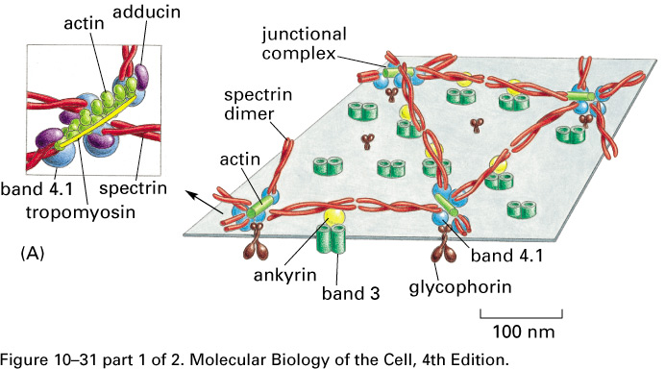
- Many membrane-associated proteins are associated via protein-protein interactions to integral membrane proteins.
- 1/3 of proteins are transmembrane proteins and so it is likely that many more are actually membrane-associated proteins.
- One possible explanation for having so many membrane-associated proteins is that proteins are recruited to other proteins that are present in the membrane mainly to enhance the effective local concentration and make certain biochemical reactions more kinetically favourable since reactions tend to happen in localized spaces inside the cell.

Lipid Signaling – the Phosphatidylinositol Lipid Signaling Pathway:
- Submembrane-localized signaling complexes use lipids and other proteins to determine whether cells should survive, proliferate or die. Lipid signaling is the result of collaboration between lipids, transmembrane proteins and peripheral proteins.
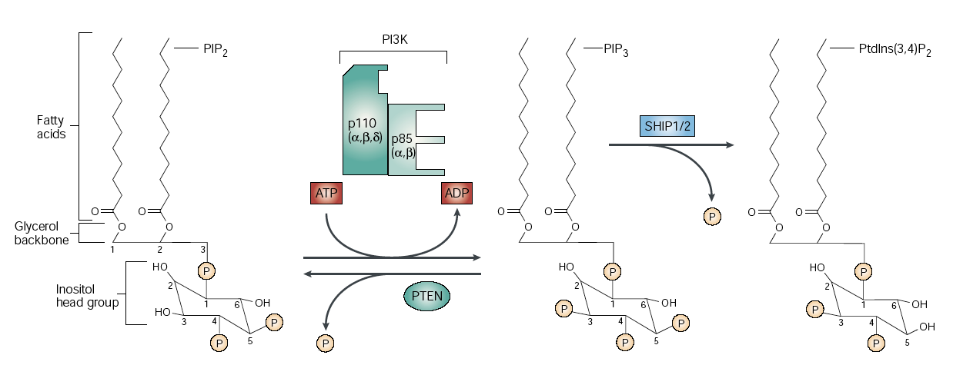
- The phosphatidylinositol lipid signaling pathway uses the conversion of one type of phosphatidylinositol into another type of phosphatidylinositol in order to send a signal to the cell to tell it whether to proliferate or induce apoptosis. This pathway is found in every mammalian cell.
- The pathway requires PIP2; a phosphatidylinositol lipid with two phosphate groups at the 4th and 5th positions of its inositol molecule, as well as two fatty acid chains at the SN1 and SN2 positions.
- Phosphatidylinositol makes up 1% of the total membrane-associated phospholipids.
- PI3 kinase is an enzyme that can attach an additional phosphate, through ATP hydrolysis, to the inositol of PIP2 at position 3 of the substrate to create PIP3 (phosphatidylinositol-triphosphate). The only difference between PIP2 and PIP3 is the presence of an additional phosphate on PIP3.
- PIP3 acts as a positive signal to induce a cell proliferation signal.
- Once the formation of PIP3 is induced, cells at rest are stimulated to undergo proliferation.
- Inhibition of the signal is carried out through a PI3-specific phosphatase called PTEN, which removes the phosphate to shut off the signal so that there is no uncontrolled cellular proliferation. PTEN is a tumor suppressor gene.
- PIP3 can also be selectively dephosphoraylated at the 5th position through the enzymes SHIP1 or SHIP2 to produce phosphatidylinositol-3,4-diphosphate which can act as a secondary messenger in other cell signaling events.
- The most prominent pathway is the one in which PIP2 is phosphorylated selectively to produce PIP3, which can be dephosphorylated back to PIP2 to remove effective concentrations of PIP3.
- PIP2 and PIP3 are used as a signal for cell proliferation and specifically used if a receptor tyrosine kinase (RTK) is activated by a specific ligand.
- The ligand binds to the receptor that induces a structural change so that the normally monomeric receptor protein becomes dimeric by associating with another RTK.
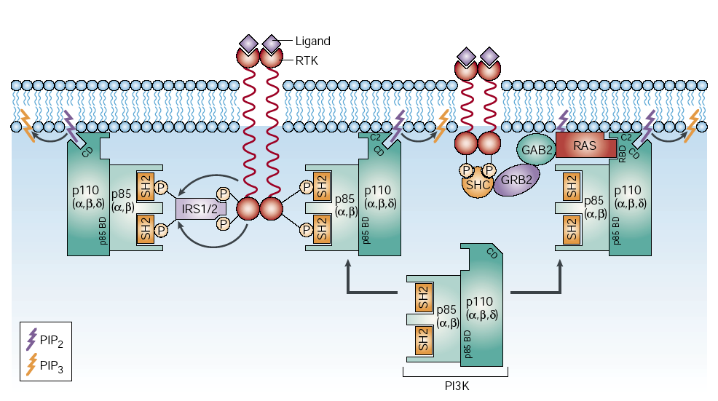
- This leads to an auto-phosphorylation cascade of a domain in the receptor tyrosine kinase. The receptor has a built-in kinase that can phosphorylate the opposite binding partner.
- The phosphorylated dimer is recognized by a subunit of PI3 kinase.
- When the receptor tyrosine kinase is phosphorylated, it can be directly recognized by the P85 subunit of the PI3 kinase, which contains two SH2 domains that bind to phosphotyrosine residues.
- In other circumstances, a spacer molecule known as IRS1/2 recognizes the phosphorylated receptor tyrosine kinase and becomes phosphorylated so that it can bind to the P85 subunit and recruit the whole subunit to the membrane.
- PI3 kinase is recruited to the RTK site only after auto-phosphorylation of the RTK’s has occurred, and only when PI3 is membrane associated, can it convert PIP2 to PIP3.
- There is another subcellular signaling pathway that leads to the activation and membrane- localization of the Ras protein. When Ras is bound and activated, it can recruit PI3 kinase to the membrane to allow the conversion of PIP2 to PIP3 to occur. Note that when the concentration of PIP3 is increased, an increase in the concentration of components that are specifically recruited and bound to PIP3 also occurs.

Induction of Cell Proliferation Through the Recruitment of AKT by PIP3:
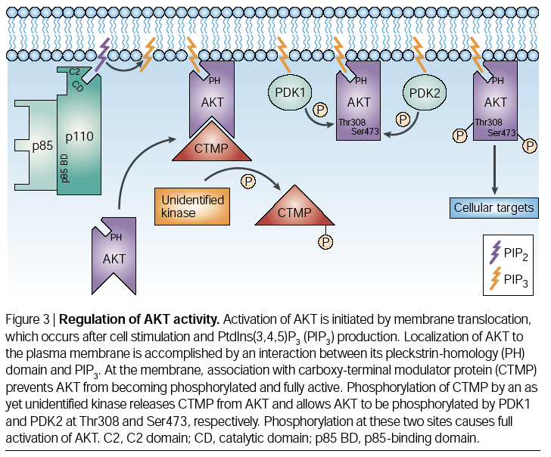
- AKT kinase is an enzyme that is normally found in the cytoplasm, and only with an increased concentration of PIP3, it will be recruited to the membrane via a specific domain in the AKT protein called the PH domain that specifically recognizes PIP3. The PH domain is also the domain that leads to membrane-association at a site where there is a high PIP3 concentration.
- Once the membrane association of AKT has occurred, other proteins, such as the carboxyterminal modulator protein (CTMP), can be recruited.
- CTMP normally is bound to AKT and prevents it from being functionally active, but once membrane-association of AKT has occurred, the CTMP is phosphorylated by an unknown kinase and can no longer bind to AKT. It is thus ejected from the complex.
- When CTMP is released from the complex, other kinases such as PKD1 and PDK2 perform the phosphorylation of specific AKT residues, such as threonine 308 and serine 473. Upon phosphorylation of AKT by these other kinases, AKT becomes activated so that it can interact and phosphorylate other substrate proteins.
- If there is an elevation or activation of PTEN, PIP3 concentration in the membrane will be reduced; the AKT kinase will be released from the membrane and the kinase will no longer be able to
perform its signaling function.
- The PTEN pathway counteracts the AKT activation pathway.
- Once AKT has been activated, several other pathways can be regulated – the NFкB pathway is a transcriptional regulator and when it is activated in high levels it prevents apoptosis and promotes cell proliferation.
- By activating AKT, mechanisms that promote growth and proliferation (which can possibly lead to cancer) are enhanced and certain apoptotic signals are counteracted.
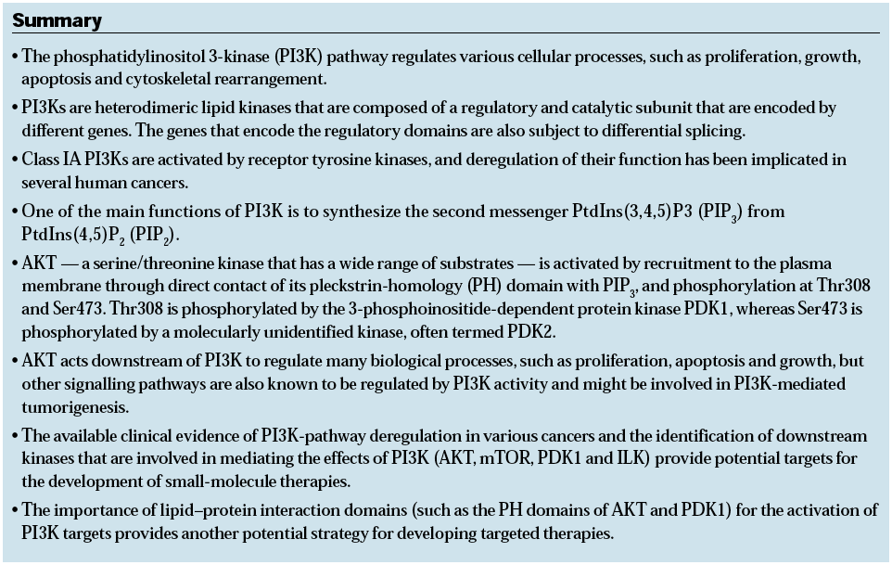

Peripheral Membrane Proteins and Membrane Binding Domains:
- PTEN is the second most common tumor suppressor gene that is defective in cancers (p53 being most common).
- PI3 kinase and PTEN are examples of peripheral membrane proteins with protein-protein interactions and protein-lipid interactions. PTEN binds to lipids, predominantly PIP3.
- It is a combination of external stimuli (receptor tyrosine kinase binding) and available substrates (PIP2) that direct the events that take place at the cell membrane.
- Peripheral protein-membrane interactions are important in signaling and can be controlled through conformational changes and modifications.
- Membrane binding proteins (type 9 in the slides) have a membrane-associated domain, which is a stretch of amino acids that binds to the bilayer. Examples of this category are the Pleckstrin Homology (PH) domain which is present in both AKT and PTEN and binds to PIP3, as well as the C2 domain which acts to localize lipases to the plasma membrane.

Sample Question:
PTEN is a specific lipid phosphatase. It removes a phosphate from
  - A channel protein
  - A cholesterol
  - PIP3
  - phosphatidylethanolamine

March 7th, 2007
Lecture #24: Liposomes and Detergent Extraction
Prof. Martin Latterich

NOTE: This NTC is meant to be used as a study aid to supplement your own class notes. Hence, not all of the text or diagrams contained in the lecture slides will be reproduced here.

Please send any comments or questions about NTCs to us through e-mail at biochem.u1reps@gmail.com.

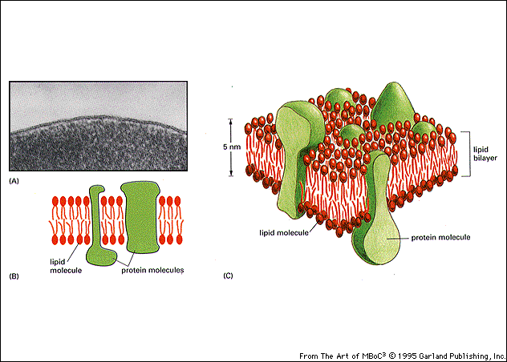
Membrane Purification and Artificial Assembly:
- It is difficult to study individual components in a biological context because biological membranes are a heavily contaminated, heterogeneous mixture of lipids, proteins, etc.
- Reductionism or reconstitution of a biochemical reaction is a mechanism in which the individual components of a membrane are isolated from other complex machinery and are put back together in order to analyze their individual functions.
- It is easy to spontaneously form membranes from individual lipids because the lipids have a property that allows them to self-assemble under proper conditions into bilayers, as their hydrophobic layers can form an aqueous exclusion zone.

Two Methods of Bilayer Formation:
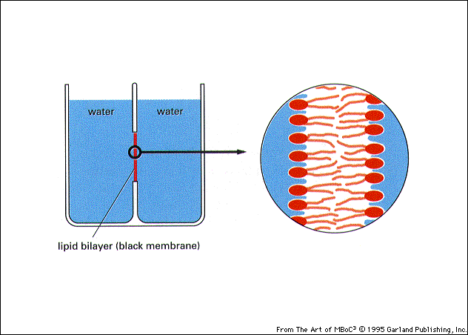
- If a pipette is used to place an organic solution of lipids into the orifice between a membrane reservoir and the reservoir is simultaneously filled with water, a single bilayer membrane will form. It will appear black to the eye and is thus referred to as a ‘black membrane’.
- There is no diffusion present from one side to the other across the artificial bilayer.
- If a specific channel protein is integrated into the artificial bilayer, the properties of the channel protein can be studied.
- An easier way to assemble an artificial membrane is by assembling small artificial lipid vesicles known as liposomes.
- When lipids are in solution and assemble into a sheet, it is not a very energetically stable conformation. Thus, they tend to self-assemble into a spherical object by getting rid of the exposed hydrophobic zones to form a more energetically favourable state.
- A lot of research has been done over the past 50-60 years to generate vesicles with slightly different properties.
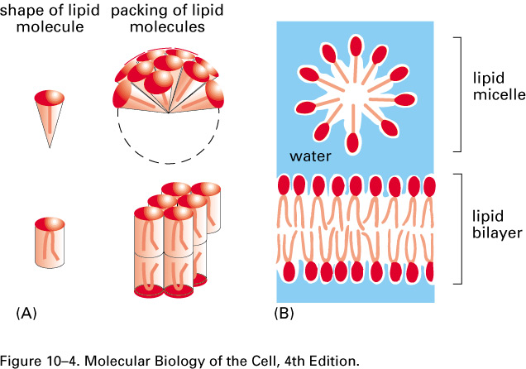
- The type of vesicle that forms in solution depends on the type of solution (i.e. whether the solution is aqueous, polar, hydrophobic, a solvent, etc.), as well as the type of lipid (i.e. phospholipid, cone shaped, inverted cone, etc…).
- Lipids with a large head group and small tail region that are in aqueous solution form micelles because this is the most favourable conformation.
- In a hydrophobic solution, they form an inside-out arrangement.
- If the right detergent or solvent is provided, lipid nanotubes can even form.
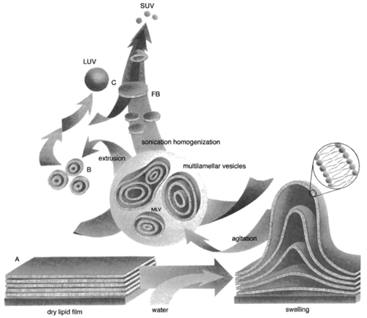
- The most common liposome is formed by taking lipids that are dried to a surface and adding water so that the hydration of the polar head regions causes the lipid layer to swell. If the mixture is then agitated slowly over time, some of the structures will break away and self-assemble into completely enclosed structures.
- Usually, an arrangement forms in which there is a small liposome inside of a larger one
- Sonication is a technique that is used to break open structures and allow the spontaneous releasing of individual membranes into smaller liposomes
- High-pressure extrusion through a porous membrane filter can also be used to open structures and produce a more homogeneous type of single lamellar liposome.
- Multilamellar liposomes enclose different types/numbers of bilayers, while unilamellar ones have a single bilayer. SUV stands for small unilamellar vesicle and LUV stands for large unilamellar vesicle.
- An organic solvent (such as ether, chloroform, methanol), as well as a mixture of choice can be added to lipids. The solvent can be evaporated so that the lipids from the mixture dry on the side of a flask. The mixture of choice usually contains water, buffer (to maintain a desired pH range), and small molecule drugs (if the liposomes are for cancer treatment, for example). By agitating the flask, which now contains an aqueous solution, the lipid cake is hydrated and large multilamellar vesicles will form.
- To make a homogeneous mixture of liposomes, the solution/mixture could be washed with different types of buffers and extruded through a filter to generate SUV’s.
- It is relatively easy to make liposomes because they spontaneously self-assemble.
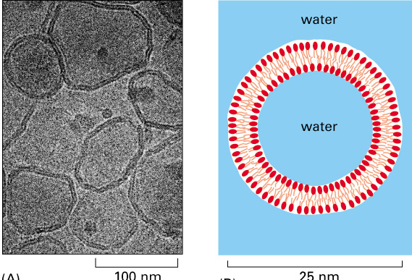
- However, they can be inconvenient to produce because if the lipids are unsaturated, they can be readily oxidized, which destroys their function. Thus liposomes are usually made under inert conditions (argon or hydrogen gas).
- The diagram to the right shows an electron microscopy image of a LUV and shows the lipid bilayer, membrane, and the buffer that is enclosed in the membrane.

Purification of Membrane Proteins Using Detergents:
- To get proteins into the liposomes in order to study protein function within membranes, the protein must first be solubilized from the original membrane and fractionation procedures must be employed to separate the protein from other proteins.
- The membrane is carefully destroyed in order to solubilize the component of interest using a detergent, which is basically small molecules that, like lipids, are amphipathic as they usually have a hydrophilic head and a hydrophobic tail region.
- Detergents are usually much smaller than the average lipid molecule and are more soluble so that they can exist freely in an aqueous solution as monomers. Conversely, when in high concentration, these detergents form structures that are called detergent micelles.
- Most detergents exist in a kinetic equilibrium so they can readily go between the monomeric and the multimeric micellar form.
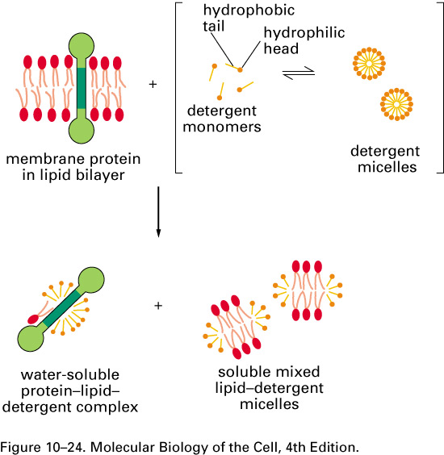
- Based on their properties, when detergents are added to membranes, they will disrupt the membrane and solubilize small portions of the lipid bilayer. Furthermore, added detergents can also disrupt/solubilize the membrane proteins by hydrophobically masking their transmembrane domain regions by generating a hydrophobic exclusion zone.
- Two of the most commonly used detergents are Sodium Dodecyl Sulfate (SDS) and Triton X-100.
- SDS disrupts and solubilizes protein complexes as well as membranes since it is so strong. Its use also leads to the denaturation of proteins and so it cannot be used if a functional reconstitution of proteins is required.
- Triton X-100 is highly hydrophobic and has a very small hydrophilic alcohol head group.
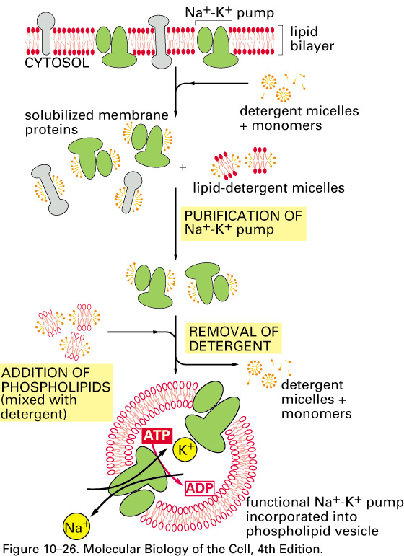
Isolation of the Sodium-Potassium Pump:
- To study a protein, such as the sodium-potassium (Na⁺-K⁺) pump, the protein present in the plasma membrane is isolated and its enzymatic properties are studied.
- A specific detergent must be selected that is optimal for maintaining the activity of the channel, since not all detergents are equally suitable for different types of proteins.
- Detergents solubilize the membrane to form a heterogeneous mixture of solubilized membrane proteins, so a purification scheme must be employed to separate the protein of interest (the Na⁺-K⁺ pump in this situation) from the rest of the proteins.
- The addition of liposomes that have been solubilized with detergent to the purified solubilized membrane protein (Na⁺-K⁺ pump), as well as the subsequent, slow removal of the detergent favours the self-assembly of the membranes into liposomes.
- Since there is a mixture of proteins, the hydrophobic regions can interact with the hydrophobic exclusion zones from the membrane fragments.
- The simultaneous removal of detergent and addition of lipids will allow the insertion of proteins into a lipid environment and the formation of proteolipisomes.
- After the detergent molecules are removed, functional liposomes that now include the Na⁺-K⁺ channel will be left.
- Membrane proteins can be detergent solubilized and purified by chromatography.
- Unlike the natural translocation process where there is a targeted way of depositing proteins into membranes, a random arrangement often results, where some of the Na⁺-K⁺ channels will have inserted themselves in the opposite direction.
- It is impossible to study the enzymology of channels in a complex system, but by having a pure Na⁺-K⁺ channel in a pure liposome, the biochemical properties performed by the Na⁺-K⁺ channel can be examined.
- The reconstitution of a different type of channel (H⁺,K⁺-ATPase) is illustrated in the diagram below.
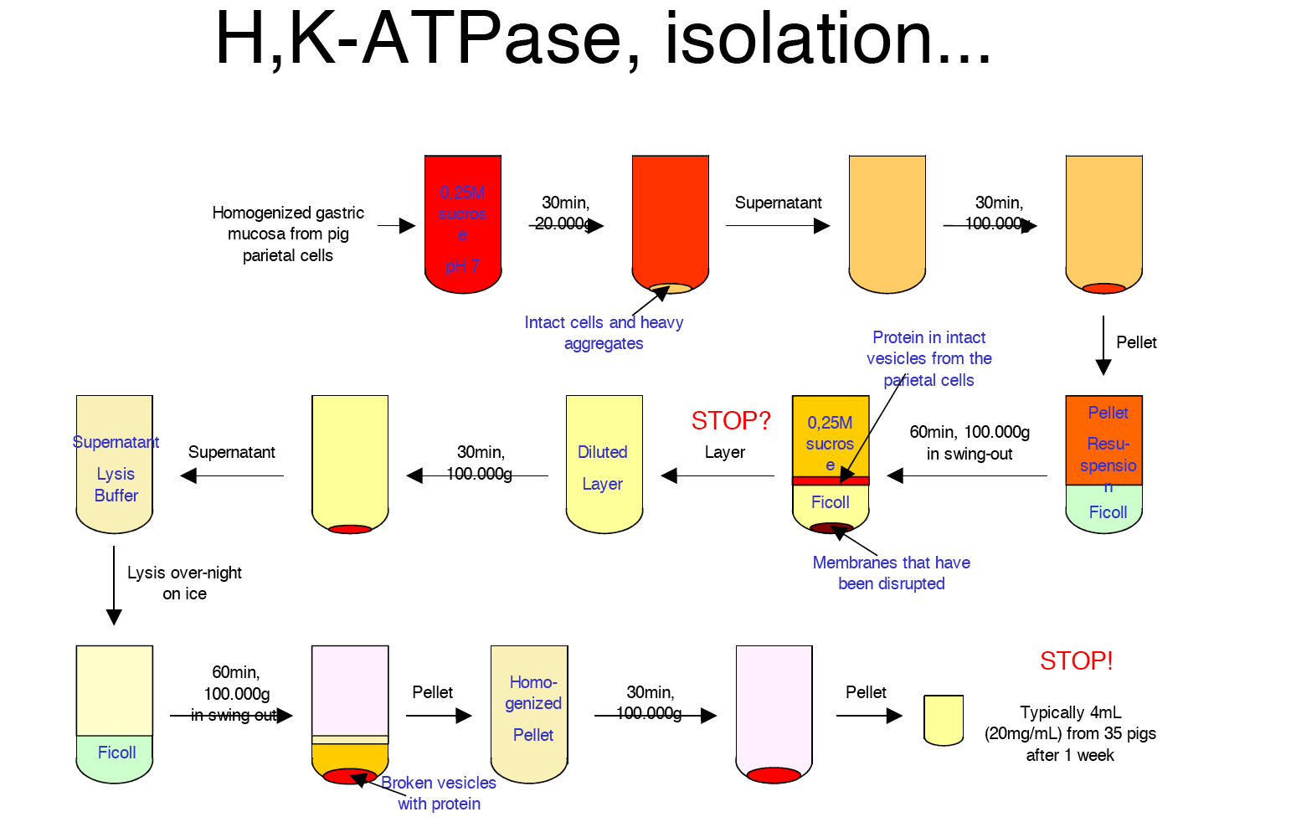
- To isolate this H⁺,K⁺-ATPase channel, 35 pigs were sacrificed. Their mucosa was isolated from the parietal cells in their stomachs, and also from the rest of the stomach with the cells discarded. This generated a supernatant that was spun down to separate out the mucosal layer.
- A further purification was performed in order to purify the plasma membrane. The fraction obtained consisted of relatively pure membrane. The membrane was then lysed to get rid of the debris in the sample by isolating broken vesicles. High speed centrifugation was then used to homogenize the mixture
- The end result after 1 week was 80 mg of the protein extracted from the 35 pigs.
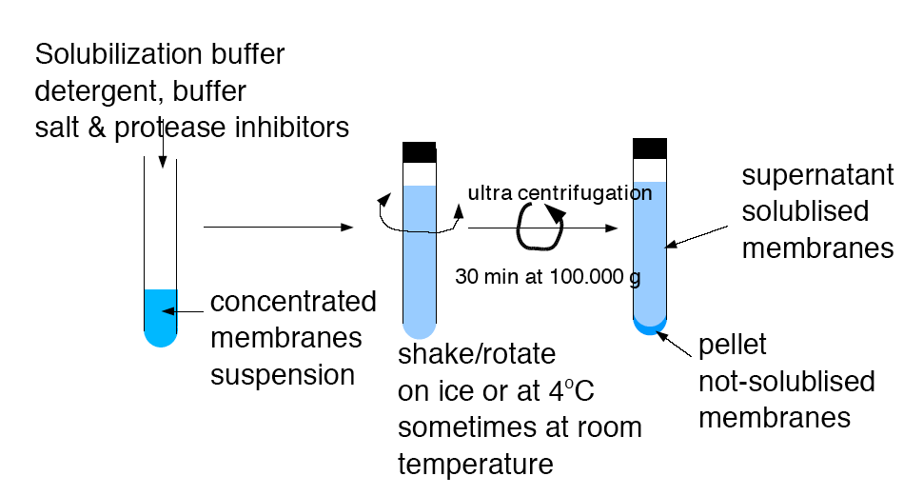
- Once a relatively pure fraction, containing the protein of interest, had been obtained, further purification was done by performing a detergent solubilization. The purified protein (containing membrane fragments) was then concentrated by centrifugation.
- Next, the protein was incubated further in the presence of a detergent, which acted to solubilize the proteins. This process also ridded the mixture of non-solubilized membranes, and very often membrane rafts will form in the pellet produced because they are detergent insoluble.
- The resulting supernatant then contained the solubilized membranes.
- Finally, the purified protein was incorporated into liposomes.

Critical Micellar Concentration:
- Detergents are surface-active and act to reduce surface tension.
- Most detergents are shaped as reversed cones with a large head and a small tail, and it is this structure that allows them to interact with and destroy membranes and attach to membrane proteins.
- They are usually soluble as monomers, but aggregate when present above a critical micellar concentration (CMC).
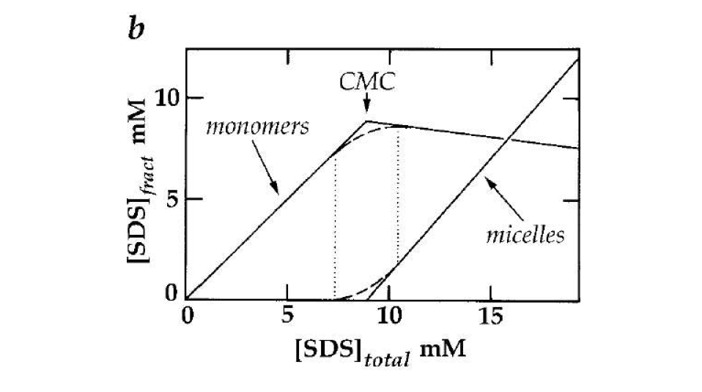
- The CMC is important because once a detergent has exceeded certain concentration levels in aqueous solution, the detergent will exist as micelles that are difficult to destroy.
- To do reconstitution experiments, the detergent concentration must be maintained below the CMC because otherwise it would be difficult to remove the detergent from the sub-membrane and liposome mixtures.
- Detergents are mostly active and effective as monomers.
- Above the CMC, detergents exist as micelles; whereas below the CMC, individual detergent monomers exist in solution. Different types of detergents have different equilibrium concentrations. When the concentration is lowered, some readily go from micelles to monomers, whereas others are more reluctant to make this transformation.

Use of Reconstitution Experiments to Analyze Release of Cytochrome C During Apoptosis:
- There are machineries in mitochondria which cause the leakage of certain components (cytochrome C) from the mitochondrial membrane to the outside of the cell.
- If cytochrome C is released into the cytoplasm, it generates a signal that causes the cell to die by apoptosis.
- There was then a need to determine which of the many different types of proteins in the mitochondrial membrane was responsible for the release of cytochrome C.
- In order to do this, researchers had to break the mitochondria into individual fractions and add the individual components to artificial liposomes to reconstitute the cytochrome C released from the mitochondrial inner space into the cytoplasm.
- Using this reconstitution approach, it was determined that there are in fact two proteins that were found in the cytoplasm and on the mitochondria (Bid and Bax) that interacted with the mitochondrial membrane.
- Bid and Bax were found to form pores in the artificial membranes of the liposomes to allow for the free passage of cytochrome C.
- When individual components were added to the artificial liposomes, there was not any visible export as it was determined that the presence of a specific lipid, cardiolipin, is also required for pore formation to occur.

March 9th, 2007
Lecture #25: Bacteriorhodopsin
Prof. Martin Latterich

NOTE: This NTC is meant to be used as a study aid to supplement your own class notes. Hence, not all of the text or diagrams contained in the lecture slides will be reproduced here.

Please send any comments or questions about NTCs to us through e-mail at biochem.u1reps@gmail.com.

Bacteriorhodopsin Basics:
- Researchers have been working on determining the function of Bacteriorhodopsin for over 40 years, and only recently, was a Nobel Prize given out for this research.
- Bacteriorhodopsin (BR) is a membrane protein found in blue-green algae. It can convert photon energy into chemical energy in order to produce ATP in the bacterium.
- Unlike photosynthesis, which requires highly complicated machinery, BR is a single protein that alone drives a whole chain of events to create a proton gradient used for energy production.
- BR is a protein that gives the coloured pigment to blue green-algae production plants as they are watered to make salt. Salt lakes contain bacteriorhodopsin, and BR in the membrane gives the lakes their characteristic purple colour.
- Halobacterium salinarm uses BR (found in its membrane) instead of chloroform to generate a chemiosmotic proton pump, used for energy production in salt-rich environments.

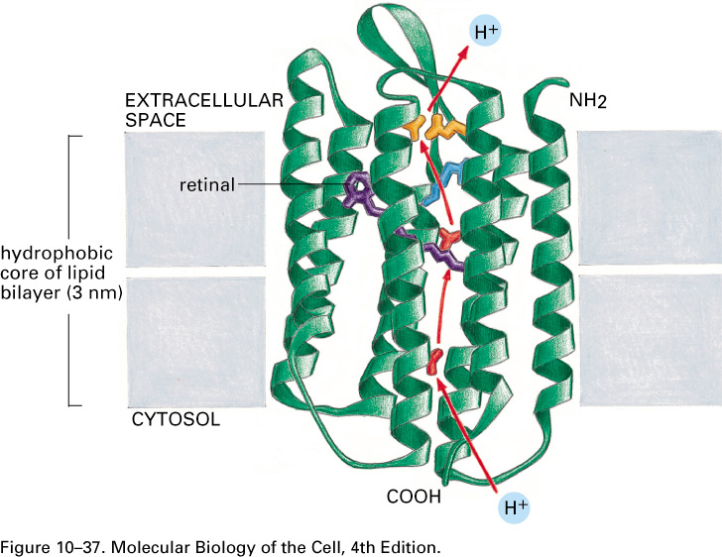
Structural Features of Bacteriorhodopsin:
- BR is a multi-spanning membrane protein that contains 7 transmembrane domains.
- BR acts as a channel that allows the directional passage of protons from inside the bacterium into the extracellular space. Having a large number of protons on the outside of the membrane creates a proton gradient, and there exists another membrane channel that is coupled to an ATP synthase in order to form ATP using this gradient.
- BR does not only consist of amino acids. It also has a vitamin A analog, retinal, which is covalently linked to a lysine located inside the channel. Retinal is a chromophore (light-absorbing molecule), and undergoes a conformational change (isomerization) once it absorbs a photon. This structural change allows the passage of protons along the inside of the membrane channel.
- Bacteriorhodopsin differs from other ionic channels because the proton that enters the channel is not the same as the proton that ends up on the other side, as the release of the exiting proton from an amino acid residue on the channel’s extracellular side is the result of a “proton chain reaction” caused by the isomerization of retinal.
- The chromophore of BR is different in sequence but identical in function to the chromophore contained in Rhodopsin, which is in the active component of the photoreceptor cells of the vertebrate eye. Bacteriorhodopsin is only found in bacteria whereas Rhodopsin is only found in photoreceptor cells.

Analysis of Proton Transport by Bacteriorhodopsin:
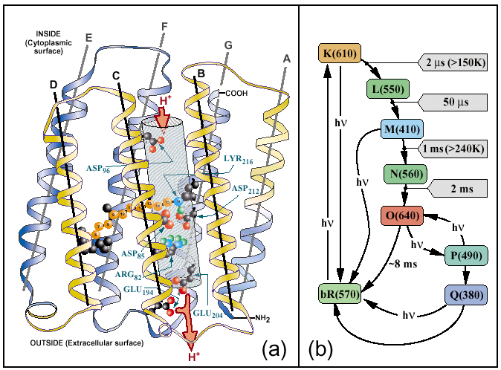
- The retinal molecule is localized in the channel and sits in the middle (purple structure in the diagram).
- The absorbance of light leads to the isomerization of retinal, causing a conformational change in the transmembrane domains of BR. These changes relay different protons from one position to the next along the channel.
- BR plays a large role among ion-transporting membrane proteins.
- Spectroscopy can be used to determine the amount of time each transition state takes to transfer a proton from one amino acid residue to the next.
- On the right hand side of the diagram are the specific amino acid residues that are used for the transport of protons by association and disassociation.

Experimental Procedures:
- It was observed that, in vivo, BR molecules aggregate into patches on the membrane.
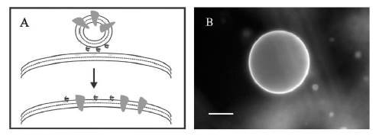
- A reconstitution experiment was done in which radiolabelled BR molecules were packed into artificial liposomes and fused together under artificial conditions into a large unilamellar vesicle (LUV).
- These LUV’s were fused to generate a giant unilamellar vesicle (GUV), a vesicle so large that it can be seen with light microscopy.
- It was observed that there was an even, homogeneous distribution of BR across the GUV as opposed to the formation of patches.
- It was then thought that maybe light could drive the localization of patches.
- Two types of vesicles with BR were created: one type had a low BR concentration and the other type had a high BR concentration. Both types of vesicles were either kept in the dark or exposed to light for prolonged periods of time.
- It was determined that in the dark, low concentration BR showed an even distribution. However, when exposed to light, these vesicles contained concentrated patches of BR in the membrane.
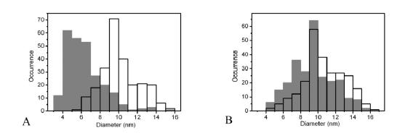
- Vesicles with a higher concentration of BR were observed to form patches in both light and dark conditions. It was therefore concluded that the actual concentration and light conditions could in fact drive the aggregation of BR molecules into more defined patches.
- The diameter of BR distribution in the vesicles was measured and the findings are shown in the graphs above.
- Graph A shows that when BR was present in low concentrations, the weighted average size
distribution was much smaller under dark conditions than in the light-adapted state, proving that very few BR were in contact with each other in the dark. When exposed to light, there was a dramatic shift in size distribution.
- Graph B shows that there were fairly similar size distributions in both light and dark conditions when BR was present in high concentrations. At higher concentrations, it was concluded that BR forms larger aggregates/crystals in the membrane with very minor increases in size distribution when exposed to light.
- The final conclusion was that BR associates in clusters upon photoactivation, and this behavior might reflect the tendency of BR to increase self-association during proton pumping to increase the stability and efficiency. This light-induced, self-association of BR may be a feature common to many other cell membrane receptors involved in signal pathways that make cellular events function more efficiently.

Structure of the Chromophore and Similarity to Rhodopsin:
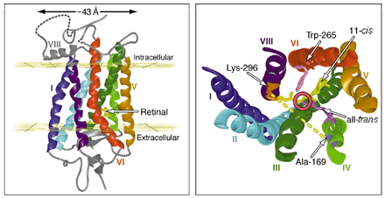
- In summary, BR contains a chromophore that is identical to the one found in the photoreceptors of the vertebrate eye.
- Retinal is purple and the location of bacteriorhodopsin in the bacterial membrane is visible as purple patches.
- Rhodopsin is very similar in structure to BR, including a retinal molecule that is covalently linked to a lysine residue (#296 in rhodopsin), as well as 7 alpha-helical transmembrane domains.
- Rhodopsin and BR are dissimilar in their primary amino acid sequence, which is an example of convergent evolution, where two separate events result in proteins with the same structure serving very similar functions.
- In photoreceptors, there are three types of rhodopsins (one for each colour – red, blue, and green) that can absorb as little as 5 photons in order to be activated. Unlike BR, rhodopsin is coupled to a signal transduction pathway that generates a nerve impulse that self-propagates along the visual nerve. This G-coupled signal transduction pathway allows cells to generate an electric nerve impulse.
- There are two forms of retinal chromophores: the 11-cis-retinal and the all-trans-retinal. Upon absorption of a photon, 11-cis-retinal can undergo isomerization and the molecule can turn around a carbon atom to form all-trans-retinal. This transition from the cis- to the trans-form pushes away some of the transmembrane regions, as it forms a longer retinal molecule.
- 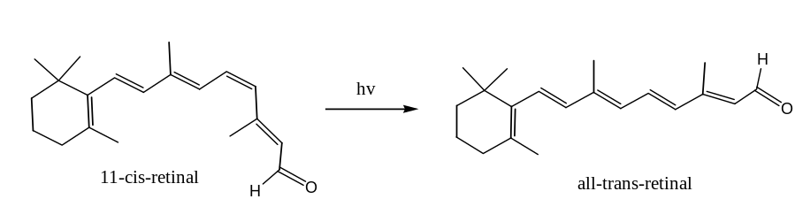Once the transition from cis- to trans- has occurred, the overall molecular conformation has been changed and this drives the rest of the conformational changes in BR and in rhodopsin.
- It is not known why there are not different chromophores in rhodopsin (vertebrate eyes), as there are 3 different rhodopsins that are used to sense energy of different wavelengths. One assumption that has yet to be proven is that the same chromophore is included in different types of molecules which differ in their amino acid sequences, and so it is probably the immediate surroundings of the chromophore that changes the optic properties that allows it to absorb different wavelengths.

