
Lecture #26: March 12, 2007
Lecture #27: March 14, 2007

SET # 9 :
- BUGS election is happening right now! Come out to the BUGS wine & cheese on April 2, 2007 to meet the candidates. Voting period will run from April 3 to April 5, 2007.

- Biochem clothing orders are in! Come by the BUGS office during our office hours to pick them up!

March 12th 2007
Lecture #26: Secretory Pathway
Dr. David Y. Thomas

NOTE: This NTC is meant to be used as a study aid to supplement your own class notes. Hence, not all of the text or diagrams contained in the lecture slides will be reproduced here.

Please send any comments or questions about NTCs to us through e-mail at biochem.u1reps@gmail.com.

Announcements
- The BUGS Symposium is happening tomorrow from 4 to 6:30, and includes professors, chairs and advisors from many different departments; all great sources of academic advice.
- The Biochemistry Post-Midterm Party is happening Wednesday night, at Benelux (on Sherbrooke). Everybody is welcome; tickets are $5 and can be bought from Adam, Shirley or the BUGS office.
- The McGill Soccer Team is hosting a Comedy Night this Thursday. Tickets can be bought for $10 from a team member or for $15 at the door. Steve Patterson, who was featured at Just for Laughs last year, will be performing.

Dr. Thomas will be giving the next three lectures on the secretory pathway, vesicle budding and vesicle fusion. Podcasts of the lectures should be available as mp4 files on COOL sometime soon.

Endoplasmic Reticulum – Entry Point into the Secretory Pathway:
- Eukaryotic cells compartmentalize their biochemical reactions in many membrane-bound organelles, including endosomes (for endocytosis), lysosomes, the Golgi apparatus, etc.
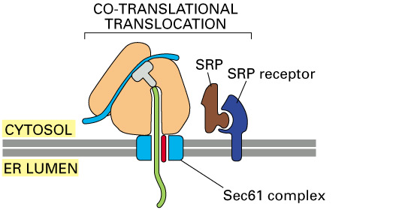
- Also included among these compartments is the endoplasmic reticulum (ER), which serves as the point of entry for all the proteins that will eventually be secreted by the cell, as well as others that will end up within different organelles.
- Polypeptide chains enter the ER lumen (space within the ER) through co-translational translocation. In this mechanism, the mRNA recruits ribosomal subunits in the cytosol and translation begins. Early in the nascent polypeptide chain’s sequence, a hydrophobic, signal sequence of about 20 to 25 amino acids long is exposed.
- This sequence is then recognized by SRP, which brings the entire ribosomal complex to the ER membrane by binding to the SRP receptor.
- The SRP-SRP receptor binding docks the ribosome at a very nearby hydrophilic channel in the membrane, known as the translocon. The translocon is composed of three proteins, which make up the Sec61 complex.
- Once the polypeptide chain has been completely translocated, it is cleaved from the signal peptide and becomes free in the lumen.
- A similar mechanism is used in all bacteria, archea and eukaryotes. In bacteria, though, polypeptides are translocated to the outside of the cell, since bacteria do not contain any organellar structures.

Protein Folding and Post-Translational Modifications:
- Correct protein folding is absolutely required for the protein to achieve the correct tertiary structure, as well as for the fulfillment of the correct biochemical function.
- Aside from a very small minority, most proteins cannot fold on their own and require the help of molecular chaperones to aid the folding process. Primarily, these chaperones inhibit the interaction between multiple misfolded proteins, since improperly folded proteins have a tendency to aggregate together, which can be detrimental to the cell.
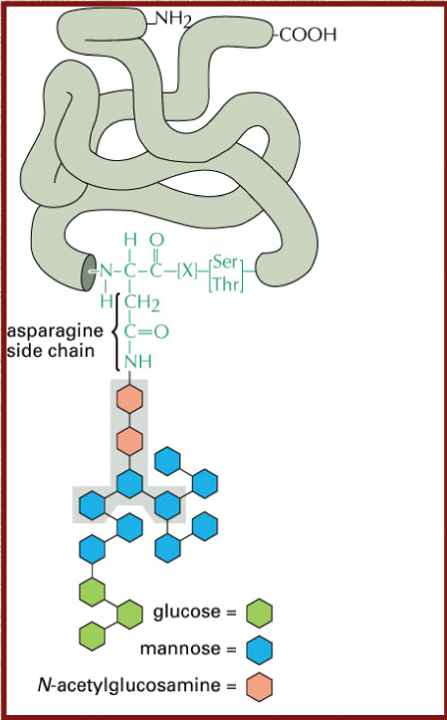
- The removal of peptides via proteolytic cleavage is another way in which proteins are modified post-translationally. For example, the signal sequence discussed on the previous page is cleaved by signal peptidase.
- The activation of a zymogen (inactive protein precursor) can also be done through proteolytic cleavage. For example, a lysosome contains many proteases used to digest viruses, old proteins, etc. To avoid serious damage to the ER, these proteases contain a propeptide sequence that maintains their inactivation while in the ER lumen. This propeptide is cleaved later on when the activation of the protease is required in the lysosome.

Post-Translational Covalent/Chemical Modifications:
- The modifications discussed are N-glycosylation, disulfide bond formation and prolyl cis/trans isomerization.
- N-glycosylation involves the addition of a sugar moiety to a protein. The oligosaccharide’s structure is very specific, consisting of 3 glucose, 9 mannose and 2 glucosamine molecules, moving from the outer structure towards attached protein.
- The linkage between the moiety and the protein is covalent, and only occurs at a specific sequence: Asn-X-Ser/Thr. The oligosaccharide is linked to an asparagine residue, the X can be any amino acid except proline, and the third residue in the sequence can either be serine or threonine.
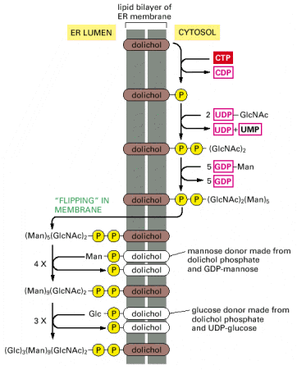
- Glycosylation serves multiple purposes. Not only does it aid in protein folding, but it also acts as a barrier that protects against proteases (when the glycoprotein is secreted into the bloodstream, for example). Also, cell-cell interactions are mediated by glycoproteins (i.e. cadherins).
- In contrast to proteins present in the cytosol, most membrane-bound and soluble proteins are glycoproteins. One key exception is serum albumin, which is present in large amounts in the bloodstream. Its fetal equivalent, though, alpha-fetoprotein, is glycosylated.
- Synthesis of a glycoprotein is a three-step process. Firstly, on the cytosolic side of the ER membrane, the precursor oligosaccharide is assembled on dolichol, a carrier lipid (shown at left). Dolichol is connected to the growing saccharide chain via a pyrophosphate linkage. The precursor is then flipped to the inside of the membrane. The gene responsible for this flipping process was just recently discovered.
- After undergoing further modification in the lumen, the oligosaccharide is then attached to the correct asparagine residue on the growing polypeptide chain. This attachment is mediated by oligosaccharyltransferase, which is membrane-bound, next to the translocon.
- Disulfide bond formation readily occurs in the ER’s oxidative environment. These S-S bonds form between cysteine residues, and their formation is catalyzed by protein disulfide isomerases (PDI), a group of many different proteins within the ER.
- PDI’s exist in two forms. Oxidized PDI mediates the formation of disulfide bonds by acting as an oxidizing agent and is reduced in the process. Reduced PDI facilitates the formation of the correct disulfide bonds within the substrate but does not change its oxidation state in the process.
- Note that disulfide bond formation is a reversible reaction.
- An early observation in protein folding involved ribonuclease A (the glycosylated form is called RNase B), which contains several disulfide bonds. It was known that it only takes seconds for the protein to fold in the ER, but it took much, much longer in the lab. This emphasized the important assistance that chaperones give to nascent polypeptide chains.
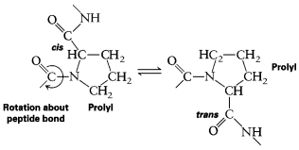
- Prolyl cis/trans isomerization is mediated by several different types of proteins, collectively called protein prolyl cis-trans isomerases (PPI).
- PPI catalyzes the rotation about the prolyl peptide bond, a step thought to be rate-limiting in protein folding.
- Cyclosporin, an immunosupressant used in transplantation surgeries, targets PPI’s.

ER Quality Control Mechanism:
- N-glycosylation and molecular chaperones, which affect folding pathways and inhibit the aggregation of misfolded proteins, respectively, were already discussed.
- Ultimately, the mechanism serves to recognize improper folding.
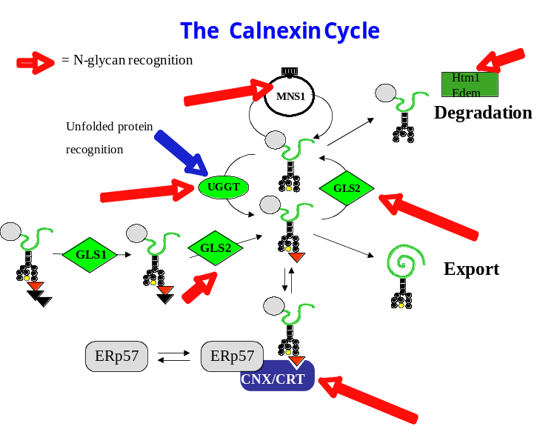
- Calnexin (discovered in Dr. Thomas’ lab) and calreticulin are calcium-binding, chaperone-like proteins that recognize a single terminal glucose (instead of three) at the end of an N-linked oligosaccharide, instead of the overall protein shape. Shown at the right is the entire cycle.
- Two glycosidases, GLS1 and GLS2, recognize and remove a glucose molecule from the end of the glycoprotein’s sugar moiety in sequence (the triangles represent glucose molecules in the diagram).
- Calnexin (CNX) and calreticulin (CRT) can only recognize the monoglucose form of the moiety. ERp57, a PDI, is recruited by CNX to reshuffle the protein’s disulfide bonds.
- GLS2, in addition to cleaving the Glu₁-Glu₂ bond, also cleaves the Glu₁-Man bond, but at a much slower rate.
- UDP-glucose glycoprotein glucosyltransferase (UGGT) recognizes if a mannose-9 glycoprotein is properly folded (note that the three glucose molecules have already been removed by GLS1, GLS2 and GLS 2 again, respectively). If improperly folded, UGGT will transfer a glucose molecule to the glycoprotein so that it can be recognized by CNX and refolded.
- Mannosidase 1 (MNS1, discovered in Dr. Herscovics’ lab) removes a mannose molecule from a misfolded protein, which will then enter a degradation pathway.
- Export of a properly folded protein is mediated by the vesicular system.
- Cystic Fibrosis results from a small mutation in a protein, which causes it to slightly misfold yet still keep its function. The quality control system, though, functions too efficiently by targetting this functional protein for degradation.

ER Degradation System:
- Misfolded proteins are retrotranslocated back into the cytosol and are targeted for degradation by the proteasome. Before that can happen, though, all the post-translational modifications and tertiary structure must be undone.
- ERdj5, the strongest-reducing PDI, reduces all the protein’s disulfide bonds so that it can fit back into the pore. Using ATP, heavy chain binding protein (BiP, a non-glycoprotein-type chaperone) unfolds the protein completely.
- Ubiquitin ligases 6 and 7 (UB6, UB7), which sit on the ER membrane, pull the protein into the cytosol. N-glycanase cleaves off the glycan at the site of the amide bond on asparagine. The misfolded protein is then fed into the proteasome and degraded.
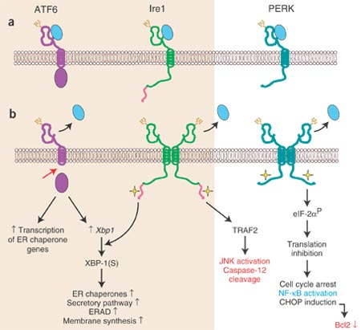
- Lactacystin, a proteasome inhibitor, keeps the protein in the ER in order to avoid its degradation. This is useful in Cystic Fibrosis.
- Ubiquitin is a short polypeptide that is attached to the epsilon amino group of lysine residues of a target protein. Monoubiquitylation usually results in a transportation signal, while polyubiquitylation targets a protein for degradation.

Mammalian Unfolded Protein Response:
- A problem within the ER is a lack of fine control (via phosphorylation, etc). Therefore, other signals, such as protein aggregation, can be used to induce control pathways. ATF6, Ire1 and PERK specifically recognize unfolded proteins in the ER.
- Ire1 is a transmembrane protein with a kinase domain facing the cytosol. It has a sensor on the lumenal side that, when activated by an aggregation of unfolded proteins, causes its kinase domain to activate ribonuclease L (RNase L).
- RNase L, through a tRNA-like splicing mechanism, splices the XBP-1 pre-mRNA. Translation of the mature mRNA results in a transcription factor that activates transcription of ER chaperones, which should reduce the initial aggregation.

March 14th 2007
Lecture #27: Vesicle Budding
Dr. David Y. Thomas

NOTE: This NTC is meant to be used as a study aid to supplement your own class notes. Hence, not all of the text or diagrams contained in the lecture slides will be reproduced here.

Please send any comments or questions about NTCs to us through e-mail at biochem.u1reps@gmail.com.

Announcements
- Tickets for the Post Midterm Party tonight at Benelux are still available for $5 from Shirley, Adam or the BUGS office. The party starts at 8 PM.
- Problems with accessing lecture slides online should be addressed to Christine Laberge, the course coordinator.

Review of the Secretory Pathway:
  - Cells compartmentalize many biochemical reactions in different organelles that are surrounded by lipid bilayers. These biological membranes are embedded with proteins, and each organelle has its own proper function. Organelles communicate with eachother via vesicles.
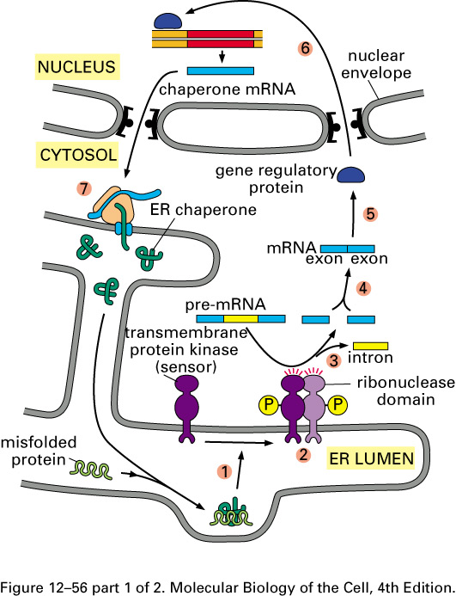
  - The endoplasmic reticulum (ER) is an organelle that serves as an entry point into the secretory pathway. Proteins are translocated into its lumen and the hydrophobic signal peptide is then cleaved. Proteins are folded, and then oligosaccharyltransferase glycosylates a target protein by transferring a sugar moiety (from a dolichol phosphate 2-glucosamine 9-mannose 3-glucose) to a specific asparagine (Asn-X-Ser/Thr, where X ≠ proline).
  - N-glycosylation links both folding and the quality control mechanism. It is also frequently used in cell-cell recognition (not Man-9 glycans, though) and even confers resistance to many proteases.
  - Folding in the ER is also aided by PDI’s (form S-S bonds found in extracellular proteins) and PPI’s (catalyze isomerization of prolines).
  - The ER’s quality control machinery is mediated by chaperones, and enlists glycosylation to serve as a flag (calnexin/calreticulin recognize a glycan moiety – Glu-1 Man-9).
  - In the unfolded protein response, Ire1 has a lumenal sensor domain that recognizes aggregations of unfolded proteins, which causes its cytosolic serine/threonine kinase domain to dimerize and self-activate via trans-phosphorylation. The ribonuclease domain, now activated, splices the XBP-1 mRNA (HAC1 in yeast) in a manner similar to that of a tRNA. A tRNA ligase then ligates the ends of the mRNA together. Translation of the processed mRNA yields a stable transcription factor that activates the transcription of more ER chaperones.

Vesicles – from the ER to the Golgi Apparatus and Back Again:
- Vesicular transport involves budding (formation) and fusion (merging/integration into another membrane).
- Unidirectional vesicle budding from the ER and subsequent transport to the Golgi presents a logistical problem: a serious increase of the membrane size of the Golgi coupled with a membrane decrease of the ER.
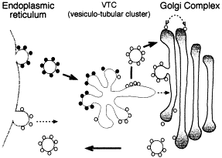
- This problem is solved with a retrograde system of transport that brings vesicles from the Golgi back to the ER. Note: anterograde transport is directed forwards, retrograde transport is directed backwards.
- There are three different types of vesicles, which can all be identified biochemically and microscopically:
- Clathrin-coated vesicles: these will be discussed further in the next lecture.
- COP I-coated vesicles: movement is retrograde.
- COP II-coated vesicles: movement is anterograde.
- All three types of vesicles contain different types of coat proteins, and it is the collection of coat proteins that determines a vesicle’s properties.
- COP II vesicles merge into the vesiculo-tubular cluster (VTC) before their contents are transported to the Golgi.
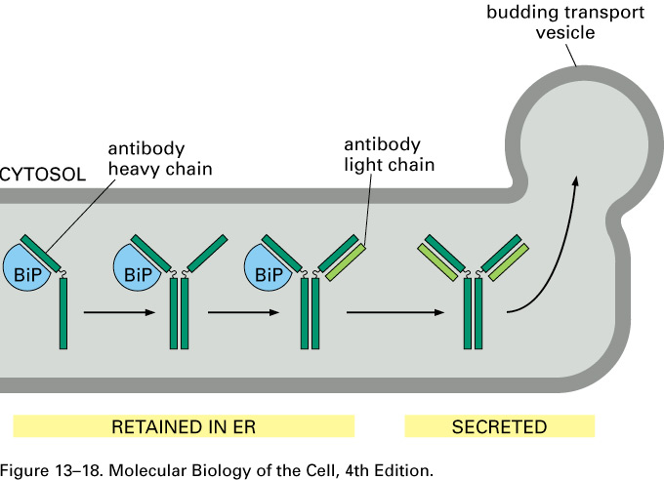
- The Golgi itself is a collection of membranes, named cis-, medial and trans-, in order of increasing maturation. It is unknown whether proteins are trafficked between sections by vesicles, or whether vesicles initially form the cis-Golgi, which then matures into the medial and then finally the trans-Golgi.
- Whatever the mechanism of maturation, each type of Golgi contains different types of proteins. For example, the trans-Golgi contains furins, which are proteases that process proteins such as insulin. Insulin requires that a C chain be processed out by furins at dilysines so that PDI’s can connect the A and B chains to form active insulin. The inactive precursor (A, B and C chains) is present in other sections of the Golgi. Today, pharmaceutical companies mimic this process.
- Only mature proteins are packaged and exported by COP II vesicles. For example, the heavy chain binding protein (BiP) binds to the heavy chain of immunoglobulins (IG’s, which contain disulfide bonds) and is only released when the IG is fully assembled. BiP itself contains a sequence tag that will cause it to be kept in the ER and NOT exported along with the IG. This is the case for many ER proteins.

ER – Protein Degradation:
- The ER acts as a quality control center, in which proteins are folded, disulfide bonds are formed, and glycosylation occurs. This quality control mechanism is regulated by protein interactions with chaperones, such as BiP and calnexin, where an extended interaction acts as a signal for degradation.
- Proteins to be degraded are first unfolded, and then sent back out through the translocon to be degraded by the proteasome.
- Less than 10% of proteins are actually exported from the ER, possibly because these are protein complexes where all the proteins of the entire complex must be folded correctly (increasing the chance of misfolded proteins).

Bulk-Flow Hypothesis and Protein Transit:
- Jim Rothman found positive evidence for the bulk-flow hypothesis when he labelled a tetrapeptide (Tyr-Asn-Gly-Thr) with radioactive iodine (¹²⁵I). He also modified its N- and C- termini to remove the amino group and the carboxyl group, respectively, so that the tetrapeptide could enter cells. Since it contained a glycosylation signal, the tetrapeptide was glycosylated in the ER, as well as exported. Rothman observed the rate of flow of the radioactive molecule and concluded that the peptide always moved at the same rate.
- The fact that ER proteins themselves have very different transit times provided evidence against bulk-flow. This was observed by doing a pulse-chase experiment. The experiment involved observing protein synthesis after feeding a cell radioactive amino acids. After a certain period of time, the radioactive (hot) amino acids were replaced with normal (cold) ones. The proteins secreted by the cell were run on an acrylamide gel and an audioradiograph was done to observe radioactive proteins on the gel. Numerous gels were done, and the presence of radioactive proteins could be observed over time. By doing this type of experiment, it was observed that the flow rate was determined by the time spent associated with ER chaperones.
- It is thought that there is some sort of positive selection mechanism in the ER to ensure that the right proteins are secreted. COP II vesicles contain a type I membrane protein called p24 that is thought to positively select proteins that are properly folded, properly glycosylated and that do not contain a retention signal. Supporting observations included the facts that secretory proteins are concentrated at p24 sites, and that these proteins are almost always secreted, whereas chaperones (BiP, PDI, etc) are not.

Retention of Proteins in the ER:
- Proteins that are permanently retained in the ER (such as the α, β and γ subunits of the Sec61 complex) must contain signals that cause them not to be exported.
- A transmembrane protein called a KDEL receptor binds specifically to KDEL (lysine-aspartate-glutamate-leucine) or sometimes HDEL (histidine-aspartate-glutamate-leucine) sequences at the C-terminus of lumenal ER proteins to retain them within the ER.
- The names of Yeast genes always consist of three letters followed by a number.
Ex: Cdc25 is the normal name of this yeast gene, the lowercase form represent the mutant form (cdc25) and Cdc25p is the protein.
- The retrograde transport of COP I vesicles brings ER membrane proteins back from the VTC and cis-Golgi. COP I coat proteins recognize ER membrane proteins by binding to their dilysine and diarginine motifs. Type I ER membrane proteins contain a KKXX (lysine-lysine-X-X) sequence at their C-terminus while type II ER membrane proteins contain an MXXRR (methionine-X-X-arginine-arginine) sequence at their N-terminal end. Note that both these motifs are on the cytoplasmic side of the membrane.

Role of Small G Proteins in COP II Vesicle Budding:
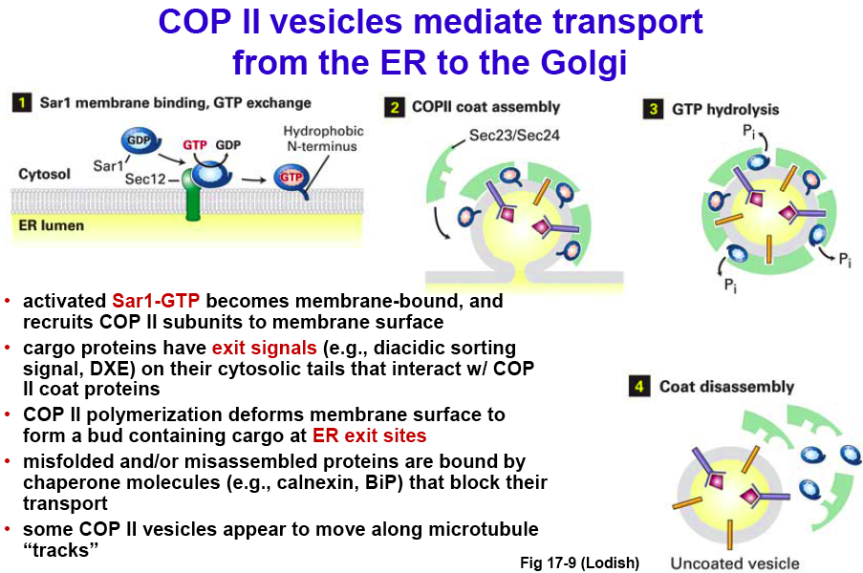
- G proteins contain an intrinsic GTP that is self-cleaved to form GDP. As a rule, these proteins (such as cdc42 and Ras) are active in the GTP state and inactive in the GDP state. When they are activated, G proteins can specify switches in cell polarity, catalyze actin formation, activate kinases, etc.
- Guanine exchange factors (GEF’s) activate G proteins by catalyzing the GDP to GTP exchange.
- GTPase activating proteins (GAP’s) inactivate G proteins by enhancing the intrinsic GTPase activity of the G protein, which hydrolizes GTP to GDP.
- Sar1 is a small GTP-binding protein that is stimulated by Sec12, a GEF, at exporting sites. In the GTP-bound state (active), Sar1 binds to the ER membrane via a now-exposed hydrophobic sequence and then recruits COP II coat proteins, which contain GAP’s that stimulate GTP hydrolysis (inactivation).
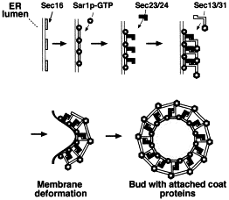
- These COP II coat molecules (type I and II membrane proteins) interact with cargo proteins through exit signals (such as a diacidic signal, among other) found in the cargo protein’s sequence. In other words, GTP-bound Sar1 recruits many proteins, such as Sec23 and Sec24, which then polymerize to form the coat. Single Sec23 and Sec24 molecules are slightly curved; therefore polymerization yields a curved vesicle that buds off the membrane.
- The “pinching off” mechanism is not well understood, but it is thought that after the vesicle has budded off, Sar1 hydrolyzes GTP to GDP, causing its inactivation and dissociation of the coat. After this step, the vesicle is left uncoated.
- Vesicle formation occurs in a very specific area of the ER, opposite the Golgi, which is defined by the presence of Sec16 (one of the largest proteins in yeast). Sec16, through indirect interaction, recruits Sar1. Sar1 recruits Sec23 and 24, which in turn recruit Sec13 and Sec31 (both GAP’s). This recruitment leads to a membrane deformation that finally results in the budding off of a vesicle.

