
Lecture #28: March 16, 2007
Lecture #29: March 19, 2007
Lecture #30: March 21, 2007

SET # 10 :
- BUGS Wine & Cheese is this coming Monday, April the 2nd! Come out to meet the BUGS election candidates.

- BUGS Elections are happening right now! Remember to vote from April 3-5th, 2007 after class!!!

March 16th 2007
Lecture #28: Membrane Fusion
Dr. David Y. Thomas

NOTE: This NTC is meant to be used as a study aid to supplement your own class notes. Hence, not all of the text or diagrams contained in the lecture slides will be reproduced here.

Please send any comments or questions about NTCs to us through e-mail at biochem.u1reps@gmail.com.

Announcements
- BUGS is organizing a tour of Merck Frost on March 29th. The cost is $20, the tour is from 1 PM to 3 PM and there will be bus service there and back. There are a limited number of spots, so sign up quickly at the BUGS office.
- BUGS elections are coming up. The nomination period begins next week, and more information can be found on the BUGS website at bugs.sus.mcgill.ca.
- Dr. Thomas reminds those of you who can to VOTE in the PROVINCIAL ELECTION on March 26th.
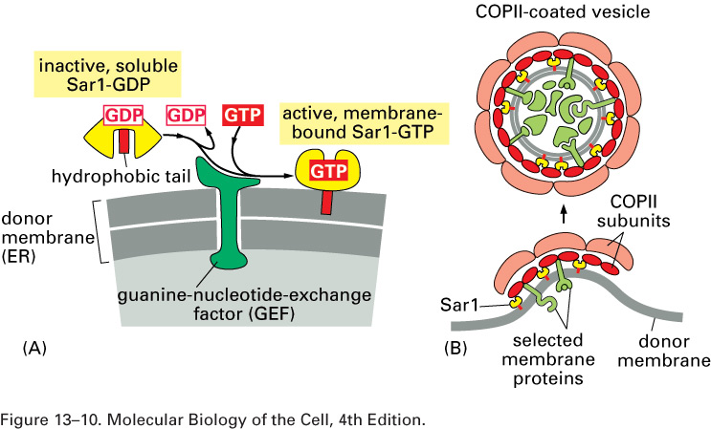

Review of Vesicle Budding:
- In the case of anterograde vesicular transport, the G protein Sar1 (GDP-bound, inactive) is activated by a GEF (guanine-nucleotide exchange factor) anchored in the membrane. In the active, GTP-bound state, Sar1 recruits Sec 23 and 24, which in turn power the assembly of Sec 13 and 31 proteins to form the COP II vesicular coat.
- While COP II vesicles are for anterograde transport and are regulated primarily by Sar1, COP I vesicles take part in retrograde transport and their assembly is regulated mainly by Arf1.
- ER membrane proteins contain a dilysine motif, while ER lumenal proteins contain a KDEL sequence that is recognized by a KDEL receptor. These mechanisms ensure a steady state of ER proteins within the ER.

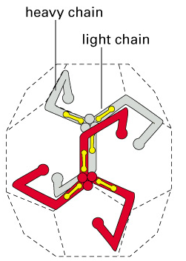
Clathrin-Coated Vesicles:
- Another method of vesicle formation is mediated by the clathrin molecule. Clathrin itself is made up of three heavy chains and three light chains, which come together to form a triskelion-shaped molecule (three protrusions with a rotational symmetry – see diagram). These molecules then assemble into an ordered-lattice structure (which looks like a ball) to form the vesicular coat.
- An example of clathrin-coated vesicular transport involves the transferrin receptor, which is responsible for the cellular uptake of iron. The binding of extracellular iron to the receptor on the cell surface causes the recruitment of a protein called adaptin. Clathrin recognizes the C-terminus of adaptin, and clathrin subunits will begin to be recruited to the activated receptor. The final budding off is powered by dynamin, a GTPase.
- This clathrin-mediated mechanism is not the main source of cellular uptake. More salient uptake mechanisms include endocytosis (clathrin-independent) and phagocytosis (i.e. in a macrophage).
Basics of Membrane Fusion:
- Vesicular trafficking must remain faithful and specific, in the sense that vesicles containing proteins destined for the vesicular tubular cluster (VTC) do not end up fusing with the plasma membrane. If this were the case, the proteins would skip the numerous modifications that they undergo in the Golgi (proteolytic cleavage, etc) that ensure their proper function.
- In terms of the membranes themselves, polarity and composition must remain constant, since different leaflets contain different lipids, etc. Protein orientation must also be conserved (i.e. extracellular transmembrane proteins must be secreted so that they face the outside of the cell).
- There are two types of vesicular fusion that Dr. Thomas discussed:
- Fuse-and-collapse is the most common mechanism. The vesicle docks at the membrane, fuses and then becomes part of the target membrane.
- Kiss-and-run is very fast (ideal for neurotransmitters), and involves the opening of a pore between the vesicular and the target membrane to allow quick diffusion of the vesicle’s contents, and then the closing of the pore.
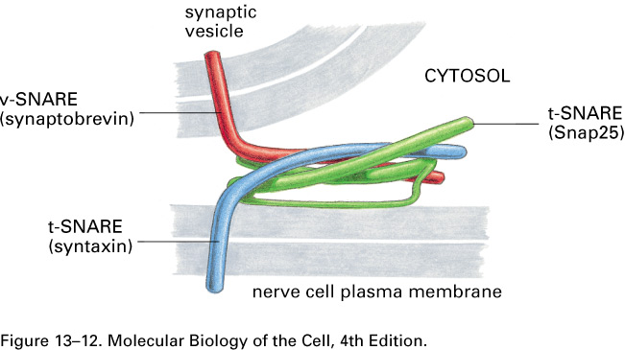
- Not only do these mechanisms preserve protein orientation, but lipid orientation is also conserved as well. This is, of course, after the protein coat has dissolved (in anterograde transport, this dissolution is mediated by an intrinsic timer in Sar1 and possibly other GTPases).
- NOTE: Even though it is shown on the slides, membranes will not fuse in an aqueous environment without proteins which are needed to mediate the fusion.

SNARE Hypothesis:
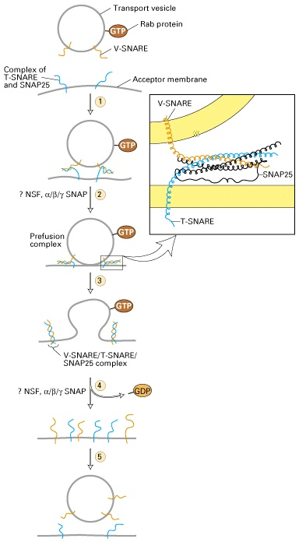
- Complementary sets of v-SNAREs (vesicle) and t-SNAREs (target) mediate and give specificity to the targeting mechanism and the attachment process. The general structure of SNAREs was determined by Axel Brunger.
- This process occurs through the recognition of the t-SNARE complex on the target membrane by the v-SNARE on the vesicle.
- An example of this association in nerve cells is shown above. Dr. Thomas warned us that the nomenclature might get very confusing, since synaptobrevin in one organism may refer to a v-SNARE, but in Drosophila, for example, it can refer to something completely different (the textbook, he assured us, keeps the names constant).
- SNAREs interact through long, coiled-coil domains. The great amount of surface area on which the interaction occurs allows for a strong association and a large amount of specificity. Also, the fact that there are 40 t-SNAREs in human cells allows for combinatorial specificity.
- Initial experiments (figure at the left) showed that a GTPase was present, so it was concluded that energy was needed for fusion to occur. Later biochemical assays that found the minimal protein component needed for association proved this to be wrong. The Rab protein (shown bound to GTP in the figure) is probably involved in quality control rather than in fusion.
- It was found that SNAREs are type II membrane proteins that act as a tetramer (one v-SNARE and three t-SNAREs) to assist fusion and provide target specificity. These proteins show structural similarity to viral fusogens.
- Frank Parlati, a grad student in Dr. Thomas’ lab, studied v- and t-SNARE associations. He recreated the 22 v- and t-SNAREs found in yeast using E. coli and, by mixing and matching, tested the relative amount of vesicular fusion. After solubilizing the SNARE complexes, he then purified the t-SNARE Sed5 in a column by tagging it with a glutathione ligand. It was found that, along with Sed5, other SNAREs were also purified (Bos1, Sec22 and Bet1). This showed that the complex had a very strong association. The complex could even resist protein denaturants such as SDS, etc.

Fusion Mediated by SNAREs:
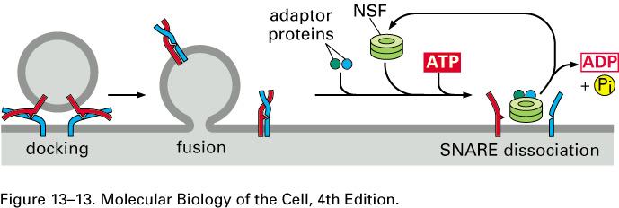
- V- and t-SNAREs associate through long, hydrophobic, coiled-coil regions. Once these regions first associate, they then tend to undergo conformational changes causing them to twist, creating an increasingly tighter binding effect. ATP or GTP hydrolysis does not drive this process.
- In some situations, inhibitory proteins (possibly Rab) must be removed from the SNARE before docking can occur. Rab may also play a role in recognizing a proper v-SNARE/t-SNARE association.
- After fusion has occurred, N-ethylmaleimide sensitivity factor (NSF), mediated by adaptor proteins and ATP hydrolysis, interacts with the complex to cause its dissolution.

Homotypic Membrane Fusion:
- Just like when organelles are partitioned during cell division, they must also fuse during cell fusion (i.e. spermatogenesis). This fusion, referred to as homotypic or organelle fusion, is achieved via a similar mechanism to that of vesicular fusion and has similar players.
- First of all, GTP and ATP hydrolyses are required (determined by Jacques Paiement at U de M), as well as multiple kinases and actin molecules.
- T-SNAREs are also involved, although this may be through a t-SNARE/t-SNARE interaction (i.e. no v-SNARE required).
- Finally, p97, a AAA protease, is needed. Its location is specified through the help of adaptor proteins. Note that p97 is also used in ER-associated degradation (ERAD), to pull misfolded proteins out of the ER.

March 19th, 2007
Lecture #29: Ligands and Receptors – Signalling by G-Protein-Linked
Dr. Morag Park

NOTE: This NTC is meant to be used as a study aid to supplement your own class notes. Hence, not all of the text or diagrams contained in the lecture slides will be reproduced here.

Announcements:
- Due to the provincial election on March 26th, 2007, there will be no BIOC/ANAT 212 lecture. Dr. Park will teach her previously assigned 4 lectures in the span of 3.
- Dr. Park will also post the PowerPoint file of her notes on WebCT. All the information is contained within her notes, with most diagrams coming from Molecular Biology of the Cell, 4th edition, by Alberts et al.

Dr. Park’s lectures will be highly concerned with the signal transduction process. In particular, a strong focus will be placed on the mechanism of action of an extracellular signal leading to changes in gene expression. Dr. Park expects a deeper understanding to be acquired by students, rather than have them simply memorize tables of information.

Ligands and Receptors – Cell Communication:
- It is of fundamental importance to understand the biological and physiological processes that are governed by cellular communication. The mechanistic as well as regulatory stages of this signal transduction process will be focused on.
- Cell communication is a fundamental biological process that is essential more specifically to multicellular organisms. A unicellular organism (i.e. a bacterium) may not require a significant degree of cell-cell communication (i.e. they are single-celled, thus cell-cell communication in this context consists of communication with another bacterium for instance). However, many unicellular organisms still deem it a fundamental biological property.
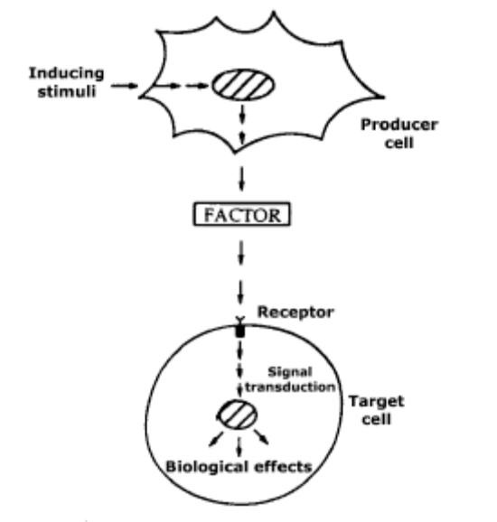
- Cell communication is required for embryonic processes such as growth, cell migration and cellular differentiation. It is also of fundamental importance in the aspect of tissue organization and thus organ and limb development.
- Cell communication in adults is also required to coordinate normal cell behaviour (i.e. apoptosis, cell cycling, etc.), as well as responses to wounding and infection.
- Insufficient cell signalling results can result in severe disease, such as cancer and diabetes, as well as cardiovascular and immune diseases. The normal regulation of an organism’s cell signalling processes is absolutely essential to maintain normal homeostasis and proper functioning.
- Essentially, the basic cellular communication process depends on the ability of one cell-type to produce a soluble molecule in response to a stimulus. This soluble molecule can be a variety of things: growth factors, cytokines, peptide factors, etc.
- The soluble factor, once released to the extracellular milieu, can have a variety of effects on neighbouring cells (or the same cell, i.e. autocrine signalling). This depends on the presence of a cell-surface protein (i.e. a receptor, however there may be intracellular receptors such as nuclear or cytoplasmic receptors).
- This cell-surface protein will ultimately lead to signal transduction by transmitting the signal to other effectors. This can result in changes to cellular physiology due to proteins binding in the nucleus or the cytoplasm.
- One of the critical processes which cell communication governs is that of cell proliferation.
- Most cells of the adult human body are not actively cycling and are in a resting, very early G1 or G0 (this is still debated) phase.
- This is not true of all of the body’s cells however. Consider endothelial cells of the gut as well as the colon, which are continuously changed every three to four days.
- It is important to note that it is the presence of specific growth factors binding to receptors that allows cells to progress through G1 and arrive at the G1/S checkpoint. At this checkpoint, the growth factor is no longer required. If the cells go through that checkpoint, the cells are committed to the remainder of the cell cycle (there are other checkpoints present in the cell cycle, however, Dr. Park emphasized that most cells that cross the G1/S checkpoint typically complete the remainder of the cell cycle).
- This decision-making process at the checkpoint is referred to as a restriction point, in that without the previous influence of growth factors, many cells will be restricted from entering the S phase.
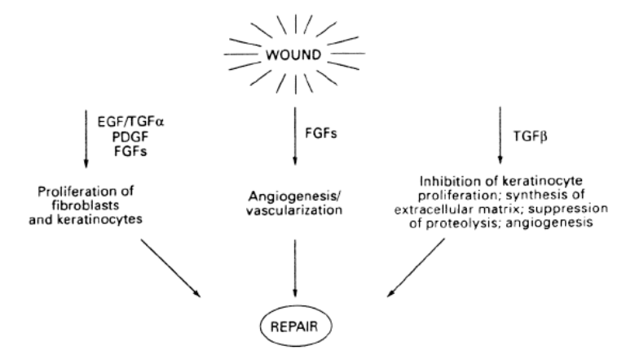
- Oncogenes often mimic the action of growth factors, in that they can drive the cells through the G1 phase of the cell cycle.

Wound Healing and Tissue Repair:
- In response to a wound, cells will produce many different types of factors.
- One category of growth factors includes…
EGF: Epidermal Growth Factor
TGFα: Transforming Growth Factor α
PDGF: Platelet-Derived Growth Factor
FGF: Fibroblast Growth Factor
- This category stimulates the recruitment as well as the migration of fibroblasts and the proliferation of fibroblasts and keratinocytes. These cells will serve to “fill up” the wound.
- Due to the fact that this category of factors begins to reform a new tissue, a new blood supply is needed to replace that which was damaged in the wounding.
- FGF is one factor that is also needed to promote angiogenesis as well as vascularisation of the new tissue to allow a proper blood supply to the newly formed cells. It does this by stimulating the recruitment and migration of endothelial cells that will ultimately form the needed blood vessels.
- This process clearly needs to be arrested (or else tumours and perhaps cancer would result from over-proliferation and increased angiogenesis). Other factors such as TGFβ are produced, which have a number of roles. TGFβ promotes the formation of matrix so that the cells will properly reconstitute a functional tissue and opposes the proliferative signals discussed previously, in order to avoid uncontrolled proliferation.

Wound Healing and Tumour Development:
- The diagram shown on the next page illustrates the similarities between tumour development and wound healing. The top left portion of the figure demonstrates wound repair, wherein it can be seen that the presence of factors (i.e. FGF, etc.) promotes the recruitment of fibroblasts into the beige-coloured wounded area, as well as platelets (from the action of PDGF). These factors are driving the proliferation of these cell types and their migration into the desired area.
- Matrix can also be seen to form in the lower portion of the diagram. This important structural process allows the blood vessels to form correctly, and promotes cell organization.
- The TGFβ pathway will suppress this process, eventually leading to an arrest of the proliferation.
- 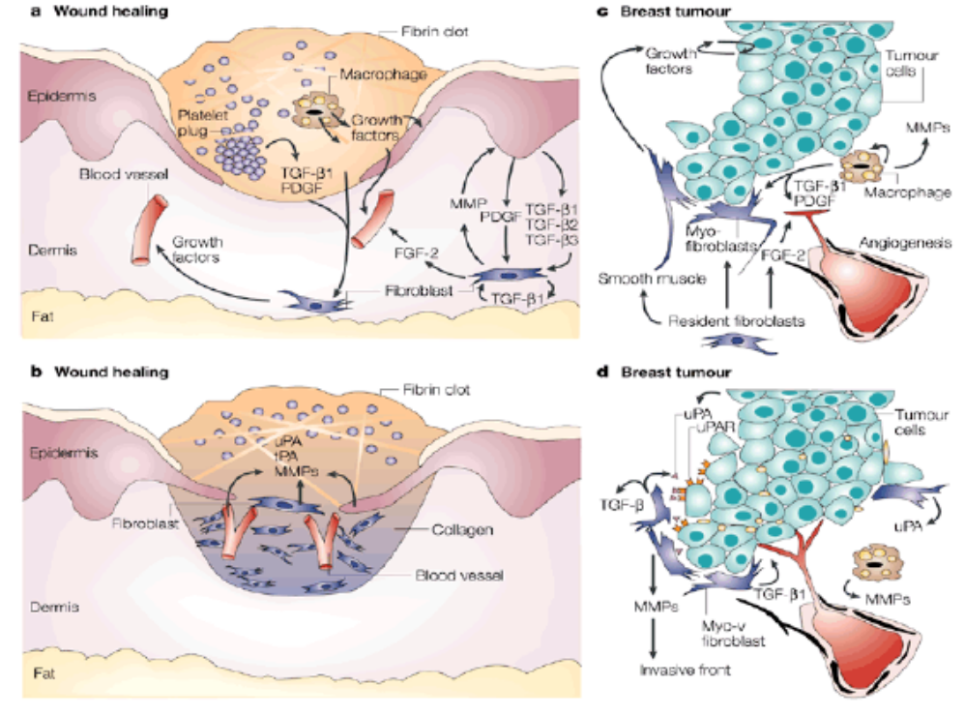Cancer in itself is a highly similar process. Cell proliferation, migration and invasiveness are all characteristics of cancer.
- Carcinomas (as well as fibrosarcomas), for example, exemplify cancer in that they are stimulated by a certain signal and, through various dysfunctional mechanisms, are allowed to over-proliferate.
- This increased cell population requires a higher degree of vascularisation and thus, angiogenesis is also stimulated in cancers.
- This illustrates the importance of studying normal cellular physiology and responses, which can actually serve as a cancer model, due to these similarities.
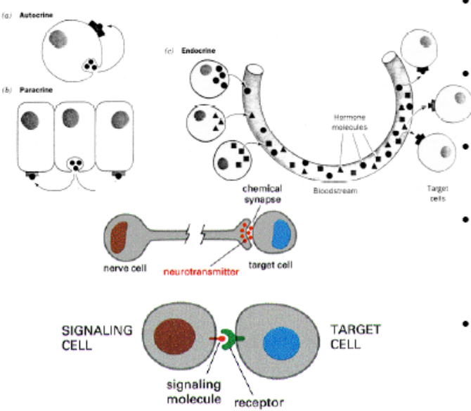
- In patients, usually a surgical removal of the primary tumour will cure the patient if the cancer has not metastasized. However, if metastasis has occurred, very little can be done to save the patient from the dangerous, uncontrolled cell proliferation and invasiveness characteristic of a metastasized tumour.

Growth Factor (Ligand) Action Mechanisms:
- Growth factors (ligands) can act in various ways.
- The first of which illustrated in the diagram at the right is that of autocrine signalling, wherein the same cell that produces the factor has a receptor that binds it. This is not a very common process, but often occurs in cancer and can perhaps explain increased cell proliferation.
- The more common mechanism is that of paracrine signalling. A given cell will secrete a factor that will bind to the receptor of a neighbouring cell. This is very important during embryonic development as well as during adulthood. A good example of this process in adults occurs in fibroblasts that secrete factors that will stimulate epithelial cells.
- Endocrine signalling refers to the release of factors that are secreted and circulate to various regions of the body. This is very common for steroid hormones. Upon their release from circulation, the hormones can act on cells by binding to receptors (i.e. cell-surface, cytoplasmic or nuclear).
- Synaptic signalling is a highly specialized type of signalling mechanism that occurs in nerve cells. The presynaptic cell will release a neurotransmitter into the synaptic cleft in response to a stimulus (i.e. an action potential). This neurotransmitter binds to receptors located on the postsynaptic cell to induce the signal transduction process. It is clear that this structure (the synaptic cleft) is highly specialized in that it releases specific neurotransmitters that bind to receptors elsewhere in the synaptic cleft.
- Juxtacrine signalling refers to the fact that the factor protein is embedded in the membrane, thus signalling requires direct contact between cells. This is important during embryonic development in cell migration, where the migratory process is often regulated by juxtacrine signalling.

Specific Signals and Cell Responses:
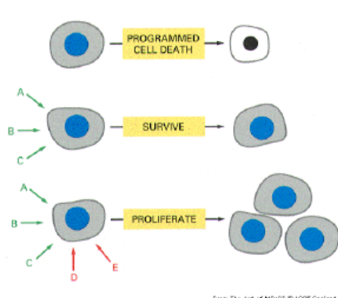
- Usually, cells do not respond to any one single ligand. More commonly, a combination of several ligands is needed to elicit a response.
- This is important because by requiring a combination of signals, the risk of large fluctuations, in the case of dependence on a single molecule, is eliminated. In other words, if one molecule is missing (i.e. due to a mutation), a smaller effect is seen because a combination of factors is needed.
- In the absence of certain signals, cells usually engage in apoptosis (programmed cell death). Thus it can be said that the default “program” of a cell is to die, and that certain factors are needed to inhibit this function.
- Simple survival (diagram at the left) requires a certain threshold amount of factors (A, B and C).
- Proliferation, a more complicated process, requires even more factors (D and E). Migration, on top of all this, would perhaps require another specific amount of factors, although it is possible that given factors can stimulate both cell proliferation and cell migration in the same cell.
- The same ligand can bind to different receptors in different cell types.
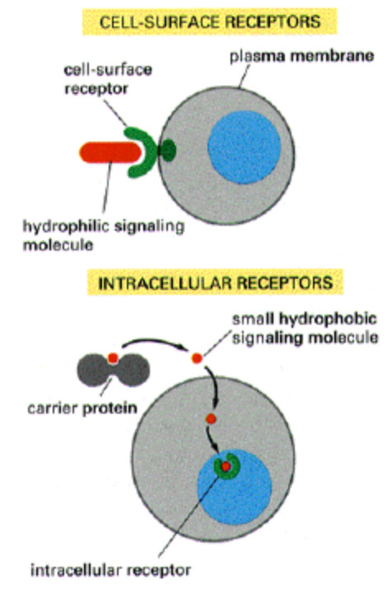
- Take acetylcholine (Ach) for example, which in skeletal muscle cells binds to nicotinic Ach receptors to induce contraction of that muscle cell. Ach binds to a different type of receptor (a G-protein coupled receptor) in secretory cells to induce secretion. In cardiac muscle cells, Ach binds to the same G-protein coupled receptor, however it induces a completely different response (i.e. relaxation of the cardiac muscle cell).
- The effect ultimately depends on the nature of the signalling cascade as well as the receptor identity.

Classes of Ligands:
- There are two broad classes of ligands: hydrophilic and hydrophobic (lipid-soluble) ligands.
- Hydrophilic ligands cannot cross the lipid bilayer, thus they must bind to receptors on the cell-surface.
- Hydrophobic ligands can pass directly through the plasma membrane and can bind to receptors present inside the cell (i.e. steroid hormone receptors, which are also referred to as ligand-regulated transcription factors).
- If the steroid hormone passes freely through cells, it will only be retained by cells that contain a binding protein for the ligand. Oftentimes, the steroid hormone (or any lipid-soluble signalling molecule) is carried through the circulatory system by a carrier protein, which thus offers a certain degree of regulation through which cell types it passes. However once released, the steroid hormone can freely cross the plasma membrane due to its hydrophobic nature.
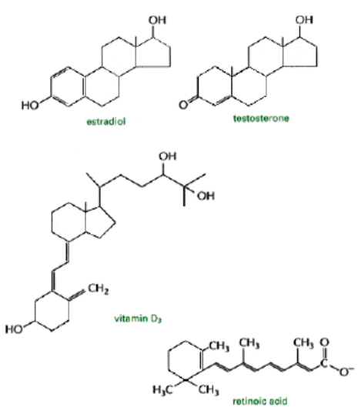
- The diagram at the right illustrates an important scientific point concerning the initial discovery of the structure and function of steroid hormones. For instance, if an animal were given steroid hormones, only certain tissues in certain animals would demonstrate any response to the administration of steroid hormone.
- This allowed the development of the hypothesis that only these particular cell types contained receptors for these steroid hormones.
- Experimentally, this was analyzed by the injection of radio-labelled steroid hormones. Tissue concentrations of steroid hormone can then be analyzed after a given time period to assess the regions of the animal in which an accumulation of steroid hormone has occurred. At the same time, this would indicate which cell types contained receptors (binding proteins) for these steroid hormones and which did not.
- One of the classic mechanisms of a steroid hormone receptor is that it is initially located in the cytoplasm and then translocates to the nucleus upon binding of the ligand, to subsequently induce changes in gene expression.
- All steroid hormone receptors are proteins that can bind to DNA to change transcription of specific genes (hence why they are referred to as ligand-regulated transcription factors).
- The binding of the ligand to the cytoplasmic receptor can be seen to elicit changes in the conformation of this steroid hormone receptor, which can expose a nuclear localization signal in its amino acid sequence. This would thus allow its translocation into the nucleus. For those steroid hormone receptors already present in the nucleus, a binding of the ligand can be shown to elicit conformational changes in the receptor that allows it to become active and able to induce changes in gene expression.
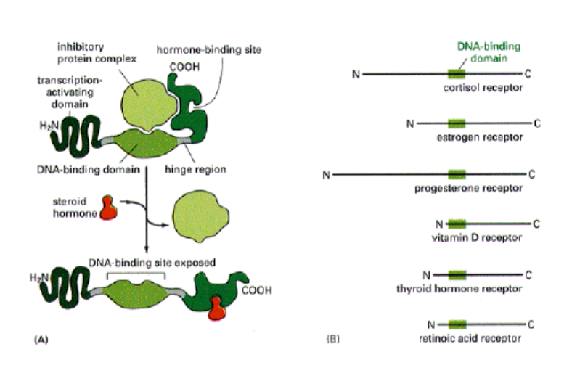
- Illustrated in the figure at the left is the structure and mechanism of the cortisol receptor (this is shown as a general mechanism and is a generic model of what occurs during the binding of a steroid hormone).
- The DNA-binding domain is common to all the receptors illustrated, but will recognize a different sequence on the DNA and thus will lead to the change in expression of different genes.
- The N-terminus of each of these receptors contains the transcription-activating domain, whereas the C-terminus contains the hormone-binding site.
- In the absence of hormone, the cortisol receptor is shown to be coiled up and actually bound to an inhibitory protein complex (in this particular case this is a Heat-Shock Protein). In this state, it cannot bind DNA.
- The binding of the ligand allows the DNA binding site to be exposed and the receptor to become active.
- This illustrates the concept of modular protein structure (i.e. specific regions of a protein which are folded in a certain way to yield a certain function). Usually these modules can be swapped between proteins of the same family and functionality still results. However, supposing hormone binding sites were swapped, a different hormone would now induce the expression of different genes (i.e. cortisol binding site + retinoic acid DNA binding domain → changes in gene expression of retinoic acid regulated genes)

Hydrophillic Ligands and their Receptors:
- These types of ligands must bind cell-surface receptors because they cannot cross the lipid bilayer of the plasma membrane like steroid hormone receptors.
- The range in size of these molecules is enormous. The molecules can range from the small molecule acetylcholine to small growth factors like EGF, and up to 90kDa proteins such as Hepatocyte growth factor (HGF).
- The size of these molecules clearly has an influence on their diffusion (i.e. HGF will obviously have a slower rate of diffusion due to its large size in comparison to that of Ach).
- Ion-channel-linked receptors (which will not be focused on) are able to bind a ligand and, in doing so, experience a conformational change to open an ion pore specific to certain ions.
- G-Protein coupled receptors do not have intrinsic enzymatic activity. A transmembrane protein, once bound to an extracellular ligand, promotes an interaction with an intracellular G-protein (through conformational changes). This association allows activation of the G-protein, which then induces other downstream changes.
- Enzyme-linked receptors include receptors such as Receptor Tyrosine Kinases (RTKs) and others that have intrinsic enzymatic activity. In the absence of ligand they are inactive, but become activated once ligand binding occurs.

G-Protein Coupled Receptor (GPCR) Family:
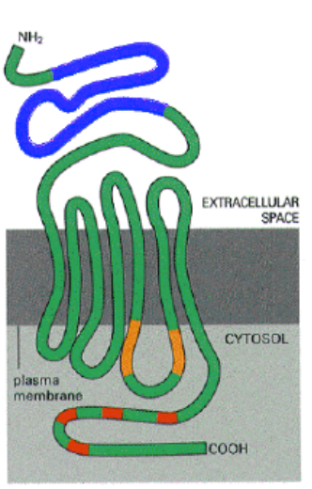
- This is the largest family of cell-surface receptors (i.e. largest diversity).
- An example of this diversity lies in their mediation of all tastes and smells we experience. These tastes and smells originate from the binding of certain molecules to G-protein coupled receptors.
- The seven-transmembrane domain is common to all GPCRs. Also, the extracellular region is present in all GPCRs although it is variable in structure in order to give it specificity for the ligand that it binds.
- There is also some variability within the C-terminal region (which interacts with the G-protein). This allows interaction with different G-proteins.
- The basic structure however, is common to all GPCRs.
- Many GPCRs were cloned according to homology with the first GPCRs isolated and sequenced.
- Due to the fact that these proteins were quite rare on the cell-surface (less than 0.01% of the total cellular protein mass), purification by biochemical methods were initially quite difficult. Today, GPCRs are usually identified by bioinformatics techniques (i.e. through homology searches).

Enzyme-Linked Receptors:
- There are 4 major classes of enzyme-linked receptors: RTKs, RTK-associated receptors, Receptor Serine/Threonine Kinases and Receptor Tyrosine Phosphatases (remove phosphates added by tyrosine and serine/threonine kinases).
- All of these receptors contain a single transmembrane domain, leading to their classification as single-pass transmembrane receptors.
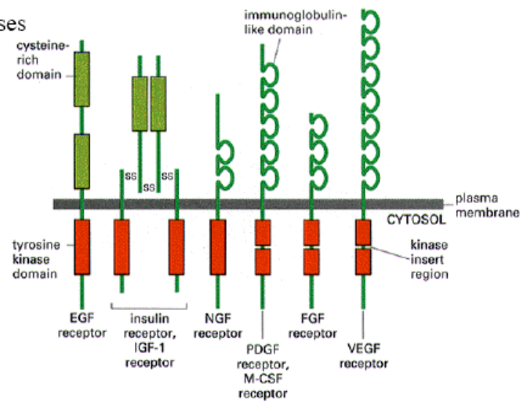
- The red region illustrated in the figure at the right is the tyrosine kinase domain and can be seen to be present in all receptors of this type. This domain may be split up into two regions. However, they all contain significant homology, and protein crystallization would most probably even allow them to be superimposed.
- It is important to note the differences in the lengths of the extracellular domains. Unlike GPCRs, enzyme-linked receptors have very large extracellular domains.
- In breast cancer, a receptor of the EGF family, EGF-2 (also called HER2) is amplified. Herceptin, a therapeutic drug that binds particularly to the extracellular domain (cysteine-rich domain) of HER2, illustrates the specificity given by this extracellular domain.
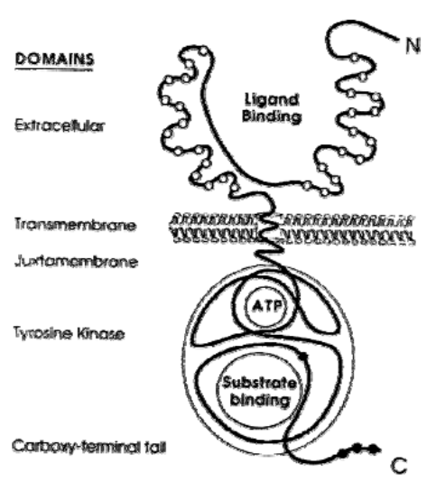
- The immunoglobulin-like domains, which contain loop structures formed by disulfide bonds between cysteine residues, give specific structure to the extracellular domain to dictate specificity of ligand binding.
- The extracellular domain has a specific 3-dimensional structure that forms a binding pocket for the specific ligand to be bound. In the absence of this ligand, the receptors are catalytically inactive.
- The binding of the ligand promotes dimerization of the receptor and allows transmission of the signal to the catalytic domain. This catalytic domain is further broken down to two sub-domains: an ATP-binding domain and a substrate-binding domain (which usually binds the tyrosine to be phosphorylated). This combination promotes the transfer of a γ-phosphate from ATP onto a substrate molecule. It is common for the receptors to phosphorylate themselves, allowing a rapid initiation of the signal transduction pathway.
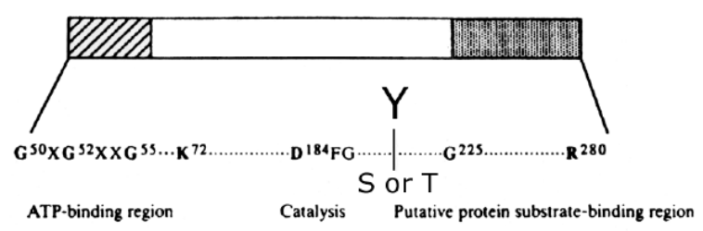
- The Src protein is not a transmembrane protein, but rather associates with the plasma membrane through the addition of a lipid moiety. The protein has a myristic acid at the amino terminus, which allows it to insert into the plasma membrane. Thus, this protein has different properties than other receptors of this family: it cannot interact with extracellular ligands because it lacks a transmembrane domain.
- Serine/Threonine kinases have homologous kinase regions, although these phosphorylate serine/threonine residues rather than tyrosine residues. Some of the serine/threonine kinases can have transmembrane domains (i.e. the TGFβ receptor in the wound response).
- The catalytic domain is represented in the figure above, and much like steroid hormone receptor, is modular and can function if removed from the protein when replaced in another protein.
- Usually they are 250 amino acids in length (although 280 are shown).
- There are usually very well conserved structural motifs that can be seen at the level of the sequence.
- Many specific amino acids, namely the lysine (K) residue downstream of the ATP-binding site is essential to the functioning of the proper phosphate transfer from ATP. One can thus go into the genome and subsequently identify the nucleotide sequence responsible for a given tyrosine kinase domain sequence of amino acids.
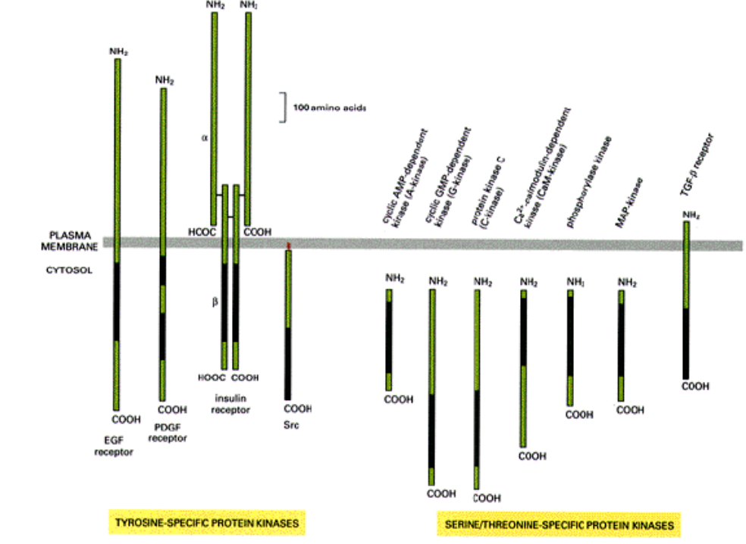

March 21st, 2007
Lecture #30: Cell Communication
Dr. Morag Park

NOTE: This NTC is meant to be used as a study aid to supplement your own class notes. Hence, not all of the text or diagrams contained in the lecture slides will be reproduced here.

Please send any comments or questions about NTCs to us through e-mail at biochem.u1reps@gmail.com.

Announcements:
- Elections are happening for both MACSS and SUS. Polls are open from March 22 to 24th.
- There are new instructions for enrolling in Anatomy, please check them out.

Kinase Specificity for Tyrosine or Serine and Threonine Residues:
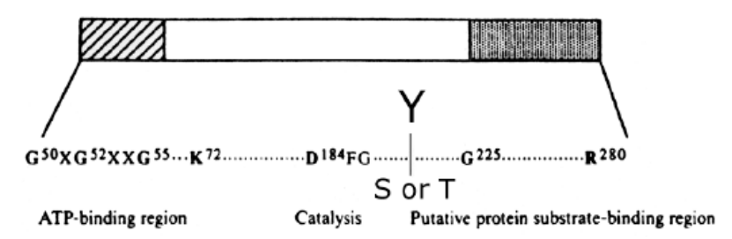
      - All tyrosine, serine and threonine kinases can be identified by the sequence in the catalytic domain, depending on the residue at a specific point. There is also sequence conservation in the ATP-binding domain with an invariant downstream lysine that is required for the transfer of phosphate groups, as well as a substrate-binding region. All kinases have these three domains.
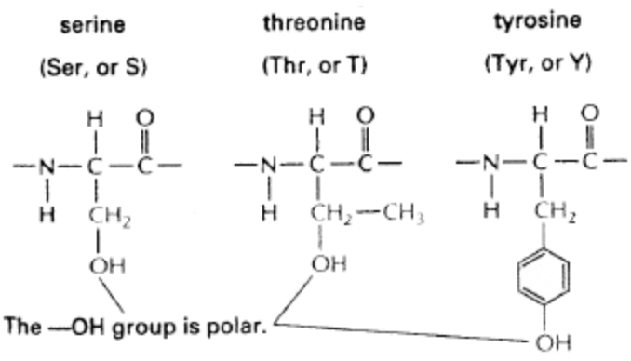
      - 10% of cellular proteins are phosphorylated at any one time. Most of these phosphorylations are on serine residues, 9% are phosphothreonines and 0.5% are phosphotyrosines. The small number of phosphotyrosines suggest that phosphorylation of tyrosine is a key regulatory process, or a key switch in a signalling pathway.
      - When speaking of kinases that catalyze the transfer of phosphates, these are proteins that bind ATP, i.e. the transfer the γ-phosphate of ATP to the hydroxyl group on either serine, threonine or tyrosine residues, releasing ADP.
      - Although the structures of serine and threonine are similar, that of tyrosine contains a phenolic ring. This structural variation affects the distance from the peptide backbone to where the phosphate group attaches (discussed later). The transfer of phosphate to the hydroxyls also increases negative charge, inducing a number of steric hindrances or switches in the conformation of the protein.

Signal Transduction from the Outside to the Inside of a Cell:
      - Receptor tyrosine kinases (RTKs) are single transmembrane proteins with large extracellular domains. They contain a kinase domain that is about 250 amino acids long; the receptors are present in the plasma membrane and remain inactive in the absence of ligands.
      - Ligand binding promotes the dimerization of the receptor proteins. Some receptors are already dimers in the membrane; this is considered an exception (i.e. the insulin receptor).
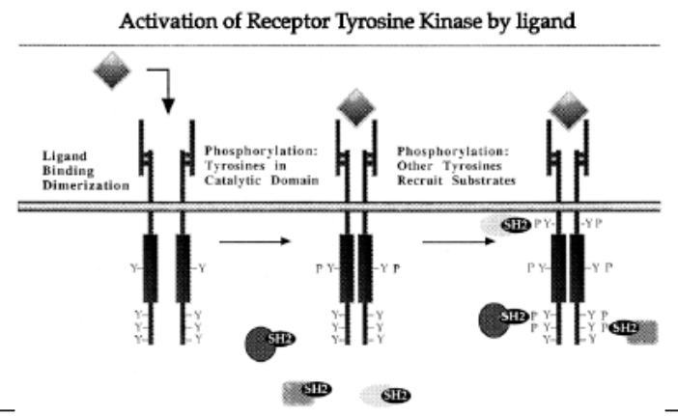
      - This dimerization creates a change in conformation of the kinase domain. In the absence of ligand, the receptor cannot bind ATP, hence it cannot catalyze the transfer of the γ-phosphate. When the ligand is bound, it induces a conformational change in the kinase domain that will then be able to bind ATP.
      - The first tyrosine to be phosphorylated is the tyrosine in the kinase domain. This is specific, because in a serine or threonine kinase, the first residue to be phosphorylated is a serine or threonine residue, respectively. After the first tyrosine is phosphorylated, other tyrosines outside the kinase domain are phosphorylated. This acts like a cascade: the first tyrosine releases ADP and binds more ATP, then more ATP causes phosphorylation of more tyrosines, etc. For example, in the diagram on the right, there are 4 tyrosine residues on each receptor molecule. Therefore, 8 ATP molecules will be needed to phosphorylate each dimer.
      - Although the kinase domain of one receptor will phosphorylate the tyrosine residues on the other and vice-versa, each dimer is only self-phosphorylating (i.e. the dimer is its own substrate). It is important to note that although there might be 16 tyrosine residues (for example) on each receptor, only 4 or 5 will get phosphorylated and it will always be the same 4 or 5. This is thought to be determined by the sequence around the tyrosines or the steric shape that will enable those specific tyrosines to fit into the pocket of the substrate-binding domain of the enzyme.
      - These specific phosphorylated tyrosines will provide specific binding sites for proteins that contain SH2 domains, and these domains will recognize phosphorylated tyrosines in the context of their surrounding amino acids. Therefore, we get direct protein-protein interaction between the recruited proteins and the receptor. The tyrosine in the kinase domain does not bind to downstream signalling proteins (via SH2 domains) and the role of that phosphorylated tyrosine residue is solely to maintain the kinase in a conformation that will bind ATP.

SH2 and SH3 Domains:
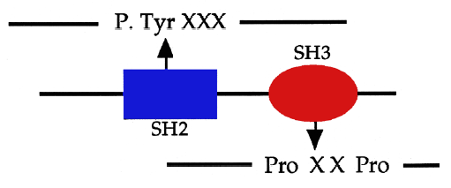
      - SH2 domains are protein domains that will bind to phosphotyrosine residues. Just like the kinase domain, SH2 domains show structural conservation, and thus, they can be predicted from a protein’s amino acid sequence.
      - SH2 domains recognize the phosphotyrosine residue in the context of the downstream amino acids; therefore, this is sequence- specific binding. Many proteins containing SH2 domains also contain other specific domains such as SH3 domains. SH3 domains bind to a different type of amino acid motif that contains proline residues (which are also in a context of other amino acids). Therefore, these two domains interact in a protein-protein network with the receptor. Hence, the RTK can bind to proteins with different combinations of SH2 and SH3 domains, creating a different pattern of activation within those three proteins.
      - Protein domains, when inserted into another protein, still retain their function. Hence, SH2 and SH3 function in the same way. When SH2 domains are taken out of their proteins and incorporated into a small fusion protein (in bacteria for example), it will still bind to the same phosphotyrosine residue that the full length SH2 domain binded to. For example, when a specific domain of a steroid hormone receptor is taken out and introduced in another receptor, that domain will act in the same way it did in the first receptor. Thus, these proteins fold and function in the same way independent of whatever protein they are present in.
      - SH2 domains usually contain around 100 amino acids, whereas SH3 domains contain 50 amino acids. Historically, they were named after the Src tyrosine kinase protein because they showed a lot of homology (SH actually stands for Src Homology). Src was one of the first tyrosine kinases to be discovered. It is neither a receptor nor a transmembrane protein: it is a cytosolic kinase that can bind to the inside of the plasma membrane. Src contains domains such as SH1 (the tyrosine kinase domain), SH2 and SH3. Most proteins recruited to tyrosine kinases contain a SH2 domain that binds to phosphotyrosines.
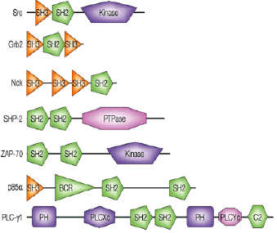
Protein Domains such as SH2 and SH3 are Modular:
      - The diagram on the right depicts different proteins and their constitutive domains. The SH2 domain is presented as a pentagon, the SH3 domain is depicted as a triangle and other domains are represented as various other shapes.
      - An interesting fact is that some proteins that contain SH2 and SH3 domains have no enzymatic activity. For example, Grb2 has an SH2 between two SH3 domains and no enzymatic domain. This protein can bind to phosphotyrosine residues and can bind to other proteins containing proline motifs, acting as a bridge. Therefore, it is called an adaptor protein.
      - Nck and p85 also have no enzymatic activity and are adaptor proteins. p85 recruits a lipid kinase to the receptor complex and will phosphorylate lipid residues within the plasma membrane. The SHP-2 protein has two SH2 domains and a phosphatase domain that will remove phosphates from tyrosine residues. Therefore, this protein acts as a regulating protein for phosphorylation activity. It is important to remember that SH2 domains will not bind to inactive receptors (with unphosphorylated tyrosines). Thus, in the absence of ligand, the receptor is not activated and there is no phosphorylation of tyrosine residues or protein-protein binding through SH2 domains.

Structure of SH2 and SH3 Domains:
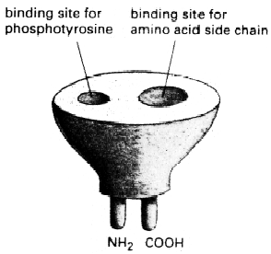
      - The diagram on the left shows a schematic of the structure of an SH2 domain. There is a binding pocket for phosphotyrosine residues, as well as another groove for binding residues that are downstream of the phosphorylated peptide. Therefore, differences in structure can dictate which amino acids fit into the grooves. SH2 domains will bind phosphopeptides in addition to binding to a phosphorylated receptor.
      - Synthesis of a 10 amino acid-long peptide with a phosphorylated tyrosine in the middle of its sequence can help demonstrate binding specificity of the SH2 domain because the domain will bind with relatively high affinity (not too high, so that the peptide can also be released).
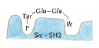
      - In the cell, the SH2 domain gets recruited and, instead of binding directly to a phosphotyrosine, thereby being completely fixed to the protein, it goes through different types of interactions where it will bind, then release, then rebind, and so on and so forth. It is not a static process. Binding of SH2 domains randomly to phosphopeptides proceeds with 1000 times less affinity, demonstrating a large amount of specificity.
      - SH2 domains will never bind to unphosphorylated peptides.
      - To determine specificity of the SH2 domain, observations of the structure and its interactions must be performed. The diagram on the right shows the phosphotyrosine binding in the first pocket and the downstream sequence of amino acids binding in the second pocket, specifically an isoleusine residue.
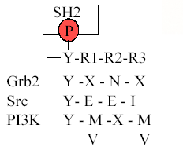
      - To perform a test of specificity, a random phosphotyrosine library can be made with every combination of downstream amino acids. This library can be interacted with an SH2 domain to see what sequences will yield a strong binding association. This is done by introducing the SH2 domain into a column, passing random phosphopeptides over in the column and recording which phosphopeptides end up being bound. Finally, the phosphopeptides are released, sequenced on a gel and, using mass spectrophotometry, their sequence/structure is determined.
      - When referring to the Src-SH2 domain, certain specificities remain with each combination. There is always a phosphotyrosine and an isoleucine residue, although the two glutamine residues can be replaced by other (but not all) residues, like alanine. Other examples of specificity and non-specificity in SH2 domains are in the diagram on the right. Grb2 adaptor protein binds a phosphotyrosine (pY), followed by an asparagine (N) two residues after (the X denotes any amino acid). Thus, by taking all the SH2 domains and using these types of phosphopeptide screening processes, prediction of binding patterns can be obtained.
      - The same thing can be said for SH3 domains, except that the major difference is that they are not regulated by enzymatic activation. SH3 domains bind proline-rich motifs and, since they do not need to be activated, are usually already bound to the proteins containing the proline-rich domains.
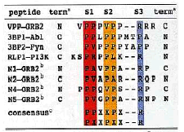
      - The presence of proline in the structure induces a bend in the peptide such that the aromatic ring of the proline sticks into the folded sheets of the SH3 domain. The same process for SH2 domain specificity is used for SH3, which is to say that the phosphopeptide screening processes can help determine specificity in the domain. To be completely sure of specificity, mutations and changes in the sequence can be made to both non-essential and essential parts of the binding sequence. For example, changing a proline to an arginine and observing if binding differences occur.
      - Many proteins have both SH3 and SH2 domains; SH2 binds to phosphorylated receptors and SH3 recruits other proteins that contain proline-rich motifs.

Different Phosphorylation Sites Determine Different Binding Partners:
      - Mapping domains is made possible by phosphopeptide screenings, and different observations can be made when different domains are activated. Prof. Park uses the “Christmas tree” analogy to show how a whole sequence of events begins by a small event, i.e. the activation of the receptor, to the huge recruitment of proteins inside the membrane.
      - The question, then, is how does the cell or receptor create those specific results of proliferation and migration? The epidermal growth factor receptor is an important receptor that will stimulate the proliferation and migration of epithelial cells. The platelet-derived growth factor is also important because it binds to a receptor tyrosine kinase frequently expressed in fibroblasts. When this receptor is activated, it stimulates the proliferation and migration of fibroblasts into the wound.
      - Both receptors mentioned above are tyrosine kinases and both are ligand activated. Remember that, although the EGF receptor has one kinase domain, the PDGF receptor’s kinase domain is split in two: an ATP binding region and a substrate-binding region. The tyrosine kinase is present in the second region (but this is the tyrosine that does NOT bind the SH2 domain).
      - After ligand binding and receptor dimerization occur, the activated kinase domain will phosphorylate specific tyrosines. These other phosphorylated tyrosines provide binding sites for the SH2 domains.
      - The Grb2 domain, for example, is an absolute requirement for the EGF receptor at a specific binding site. Recall that the domain can bind a phosphotyrosine, any amino acid, asparagine, then any amino acid again; Y-X-N-X. Therefore, that particular tyrosine in the EGF receptor will bind the SH2 domain in Grb2, while other tyrosines will bind other SH2 domains.
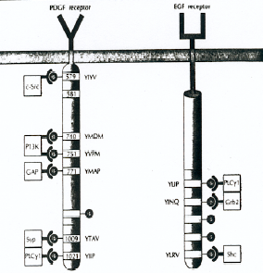
      - The PDGF receptor has more phosphorylated tyrosine residues than EGF, but it will also bind the downstream signalling proteins in a sequence specific manner. For example, the P13K domain binds to two phosphotyrosines.
      - In summary, the diagram at the right depicts two receptors, which bind to proteins in a sequence specific manner. Furthermore, a protein can bind to another tyrosine close to it and share an SH2 domain with its nearest phosphotyrosine neighbour (i.e. PI3K). Note also that the tyrosines are not always in the same positions, and once the receptors are activated, it is the primary sequence of the receptors that will dictate what proteins are recruited to the receptor.

RTKs and Protein Recruitment:
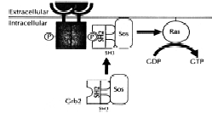
      - Usually, many proteins are already present in the vicinity of the receptor, but do not bind. Recruitment of these proteins can occur in three different ways:
      - Translocation – Grb2-SOS-RAS. This mechanism, depicted below, begins with a phosphorylated tyrosine residue (on the black box, which represents the dimerized receptor) and a Grb2 protein (which has no enzymatic activity in the vicinity of the phosphorylated tyrosine). The SH2 domain will bind to phosphotyrosine residue in the receptor, and an increased concentration in Grb2 will occur at the plasma membrane. Grb2, through its two SH3 domains, then binds the proline-rich motifs in the SOS protein, which is a guanine nucleotide exchange factor (GEF) that will activate RAS. The RAS protein itself is present on the inside of the plasma membrane, associated through a lipid moiety. RAS is inactive in the GDP-bound state. To activate RAS, an induced conformational change must be done to release GDP and bind GTP (by chance, because GTP is 10 times more abundant in cell than GDP). When SOS is recruited to the membrane, it will interact with RAS, and as it binds to RAS, it will change its conformation such that its affinity for GDP decreases, causing GDP’s release and its exchange for GTP. RAS is now active, and will have numerous downstream effects. One a side note, Grb2-SOS is present as a complex in cytosol.
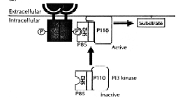
      - Conformational change – p85. PI3 kinase is a lipid kinase and it will phosphorylate the 3rd position in lipids (these lipids can be phosphorylated or unphosphorylated on the 4th and 5th positions). PI3 is an enzyme and it will bind to the p85 adaptor protein that contains an SH2 domain. PI3-p85 is an inactive complex. When the SH2 domain of p85 binds to the phosphorylated residue on the RTK, it induces a conformational change in the p85 adaptor, which is transferred to the PI3 kinase enzyme (the P110 subunit). It converts the subunit from an inactive to an active enzyme. For example, in the Grb2-SOS-RAS pathway, an enzyme was brought up to the membrane and increased in concentration. In this case, the enzyme is being brought to the membrane and its activation is ensued.
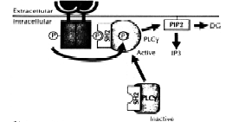
      - Tyrosine Phosphorylation – PLCγ. Active PLCγ hydrolyses PIP2, another phospholipid, to generate second messengers (i.e. inositol trisphosphate) that promote the release of calcium and diacylglycerol, which go on to activate a number of serine and threonine kinases. PLCγ is an enzyme which contains an SH2 domain and is inactive in the cytosol. It is then recruited to the activated RTK, where the SH2 binds to the specific phosphorylated tyrosine residue. In this case, the tyrosine kinase (TK) directly phosphorylates PLCγ on its tyrosine residues. In the other pathways, p85 and P110 do not get phosphorylated directly – they are activated by a conformational change. PLCγ is unique in this process of being phosphorylated directly on its tyrosine residues. This phosphorylation event converts PLCγ from its inactive conformation to its active state. Again, this enzyme is concentrated at the plasma membrane where it is activated in the presence of its substrate.
      - By activation of the receptor, the recruitment of many sequence-specific proteins occurs. Each of those proteins now interacts with their own specific substrates present at the plasma membrane. The downstream substrates of these pathways usually go on to the nucleus to activate transcription of specific proteins and complete the signalling pathway.

The Src Protein – an In-Depth Look at Conformational Change:
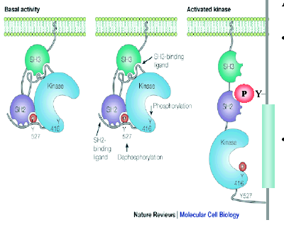
      - The Src protein is a tyrosine kinase, and has an SH1, SH2 and SH3 domain. It has also a myristyl tag at its N-terminus that is added post-translationally. The myristyl tag causes the protein to insert itself into the plasma membrane. It is neither a transmembrane protein nor a receptor tyrosine kinase. The activation of Src occurs through the activation of an RTK. When Src is inactive, it is already phosphorylated on a tyrosine outside its kinase domain. This phosphotyrosine binds Src’s SH2 domain. The region between the kinase and SH2 domains is proline-rich, so Src’s SH3 domain will also bind to that stretch. In this conformation, the kinase domain is inactive and cannot bind ATP.
      - If an RTK is activated and in the SH2 context of the Src protein, the SH2 domain of Src will bind to phosphotyrosine residues in the RTK with a higher affinity than it will with the phosphotyrosine residue in its C-terminal tail.
      - Therefore, the phosphotyrosine from the RTK will destabilize the folded structure, with the kinase domain being released in the process. Phosphatases will be able to dephosphorylate the tyrosine residue (in the second diagram in the above picture). The kinase can finally bind ATP, and will phosphorylate the tyrosine residue within the kinase domain, in order to keep the kinase in the open conformation. Src will recruit other proteins through its SH3 domain and will phosphorylate other substrates that the RTK does not interact with.

Downstream Fate of RAS:
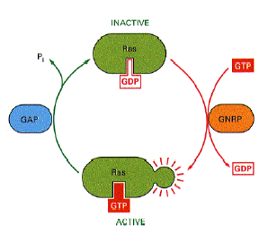
      - Short (fast) signals usually stimulate cell proliferation, whereas longer (more complex, slower) signals usually stimulate cell migration. Both these signal types can be accomplished through the same receptor.
      - The RAS protein, for example, illustrates this fact. Once RAS is activated (in the GTP-bound state), it will slowly hydrolyze GTP back to GDP, since it contains an inefficient, intrinsic GTPase. This process, though, is accelerated by GAP proteins (GTPase activating protein). GAPs contain an SH2 domain and get recruited up to RTKs, so they too are recruited (in addition to the SOS protein) to the plasma membrane.
      - This acts as a stop mechanism for the RAS protein, since the GAP will bring it back to its inactive state more efficiently.
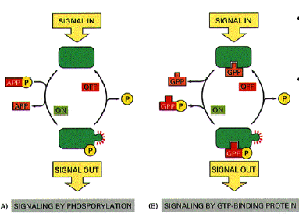
        - Note that the receptor does not dephosphorylate or release ADP. It must enlist the help of a phosphatase, which will remove a phosphate from the receptor to switch off the signal at two levels: 1) dephosphorylation of the tyrosine residue in the kinase domain (so it cannot bind ATP anymore) and 2) dephosphorylation of the tyrosine residue that binds to the SH2 domain, to inhibit recruitment of other proteins.
        - Therefore, both the activation and recruitment ability of RTKs can be inhibited by phosphatases.

