
phar303
set #11
lecture #: | date: | professor:
22-23 | April 7, 2007 | Dr. Robaire

Announcements:
- Last Set of the semester, good luck to all of you on the finals!

PHAR 303 Dr. Hale - Lecture 22 April 3

Environmental and Occupational Toxicology
There are a lot of interactions between environmental and occupational toxicology.
Environmental/Ecotoxicology - Chapter: 29
Occupational Tpxocology – Chapter 33

Toxic Chemicals: the environmental/Ecotoxicology
What we are interested in is the interaction between some of the toxicants what is called product in this picture means toxicants. What we are saying is that there are obviously interactions between these areas.
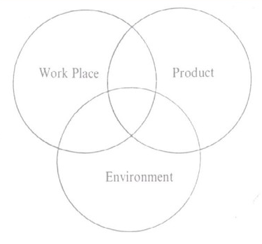

Enironmental/Ecotoxicology
What are we interested in and why?
We are interested in fate of toxic substances in the ecosystem
- Chemodynamics
  - Where are they?
  - Air, soil, water, biological systems
- What happens to them in terms of the Biological availability
- How persistent are they and where did they go?
- Lots of chemicals that we know about are pollutants

Major Environmental Pollutants
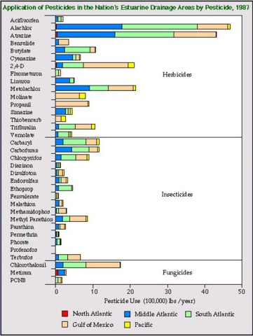
Instead of covering everything in environmental toxicology, we will talk about classes of chemicals:
- Pesticides as environmental toxicants
- Metals
- Polycyclic aromatic hydrocarbons
The stuff we learned from other lectures might be pulled into the contents of environment.

Pesticides
One illustration of why there is concern and the kinds of variety of chemicals that we actually talking about. So you can see along this list of chemicals used as Herbicides, insecticides or Fungicides. They are used intensively, what is amazing is that the bottom axis is the 100,000lbs/year, used in the US. That is a huge amount.

Agricultural Pesticide Use in Estuarine Drainage
They get into the water and then get into different drain areas an spread

Annual pesticide use in California
It is just one state. Although it is a large garden state, the consumption is about 100,000 lbs per year. The data has been classified into different toxic groups such as class B carcinogens, class C carcinogens, Methyl bromide, and Metam sodium.

Pesticide use density in California.
For other states in the US, there is not as much agriculture, and therefore the used is less. A lot of fruit that was coming from California on the Canadian market.

Use trends of pesticides with known reproductive toxicity.
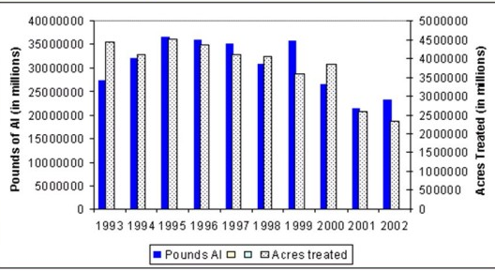
We know there are all kinds of pesticides that are in use, what kind of toxicity do they have, are there really general kinds of toxicity? We have already talked about reproductive toxicity, with Dr. Robaire. So when you look at use trends, just for pesticides that we know are toxic- the use has gone down in the past 10 years. There is a trend to decrease use but that doesn’t means they are gone, there are still tons of these chemicals that are in use now.

Estimated Pesticide Exposure by Occupation
The pesticides are heavily concentrated in the farm place, therefore, the greatest exposure goes to the people that apply or use them.
Here we are looking at the human exposure illness associated with the pesticides.
- People that are using them the most: ground applicators, the gardeners and nurserymen,
- People that are preparing the pesticides, mixing them up and involved in preparation.
- People that are working in the fields, which have been treated with these pesticides.

This is as predicted. Then there are the Firemen, policeman, and people that are doing area applications. There are obviously occupational risks associated with the pesticide application.

Direct Exposure:

Dermal absorption of pesticides
Lots of variable absorption from many body areas- scalp, forehead, jaw, abdomen, hands, feet, lots of vascularization in the scrotum, armpit. Any unprotected area of the body could be exposed, and the level of absorption depends on the skin area.

Q: if you wash your hands immediately are you decreasing the exposure?
A: If you already exposed to the chemical the chance is you get some absorption, but you decrease absorption if you wash it off immediately, so you can have an impact on it. It depends on the lipid solubility and the absorption rate of the chemical.

Indirect Exposure:

Ground Water
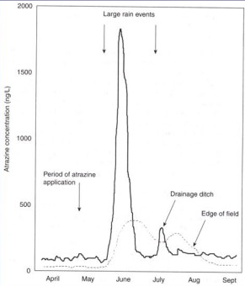
Looking at pesticides products, we are looking at those that we detect in our ground water. There are a lot different kinds of herbicides and insecticides that are detected in the ground water near the agricultural area.

Drinking water
Rain enhances the spread of atrazine (one kind of herbicides) from the field to adjacent water. Most of the pesticides are highly seasonal, especially in Canada, they are been applied in a few weeks, before the grains be planted (about April, May). And after that, if there is rain, the atrazine concentration will be high in the adjacent water. You could even detect them at the edge of the field in September even it was applied during spring.

In food
Most of the fruit we eat was treated with pesticides. Unless you know the food is really organic, pesticides are normally used. To look and compare, children who consumed organic fruits, vegetables, and juices had significantly lower pesticide exposures.

Classification of the pesticides
We can classify pesticides in different ways. We talked about classifying chemicals according to how toxic they are. The same thing applies to the pesticides:
WHO classification of pesticide toxicity: 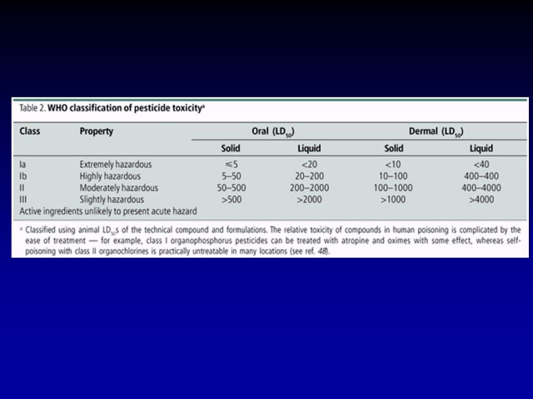
Pesticides have been classed into Class 1a, 1b, II, and III. The extremely hazardous ones in Ia have an oral LD₅₀ of less than 5. Some of the pesticide exposures can be treated afterwards, others do not have antidotes. Some of the pesticides have been banned, others are used more nowadays according to the banning of others.

DDT: an Organochlorine Insecticide
A relatively simple chlorine molecule, we know it affects the nerve system.
DDT acts on the axon sodium channels in the nervous system so it can disrupt the action potentials. As a consequence of that, it causes uncontrolled repetitive spontaneous discharges along the nerves.
- Nobel prize awarded to Dr. Muller in 1948
- Use banned in the U.S. in 1972.
- Found out it had extensive effects on the ecosystem, and was threatening a number of organisms.
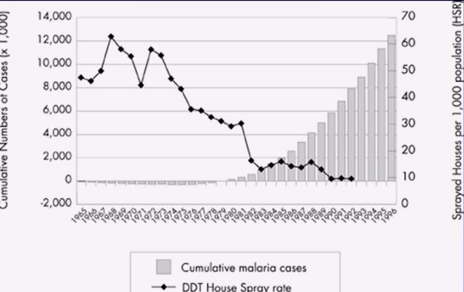
- It was very effective as an insecticide.

Risk vs. benefit?
They used to spray houses inside with DDT and this decreased the consequence of malaria. With the ban of DDT, the incidence of malaria increased dramatically. There is a risk associated with the use of DDT- especially bad for the birds and other organisms in the ecosystem. But there was a benefit aswell.

Cyclodienes
Pesticide mixtures are a number of active gradients. They are not single compound or pure. The mixture in the pesticides is different every year. Cyclodiene is a group of compounds in pesticides and Chordane, Aldrin, Mirex are examples from this group that are still using today. Cyclodienes prevent chloride ions from entering the neurons, and thereby antagonize the “calming” effects of GABA.

Organophosphate Insecticides
They have different structure rather than multiple ring structure. They have organophosphate type of structure. One of the examples is Parathion, they are used particularly as insecticides and what they do is they target the nerve system. Some of them have a low LD₅₀, so they are quiet toxic. They irreversibly inhibit AChE. When ACh is released in the nerve system, there is an enzyme that breaks it down (ACh esterase, which breaks down ACh in the nerve junction). If there is no break down, there will be excess ACh across these junctions.

Accumulation of ACh at junctions or synapses causes rapid twitching of voluntary muscles and finally paralysis. Sounds like a very toxic compound use as a pesticide, but they are still used today. There are researchers in Asia trying to figure out the treatment for acute organophosphate poisoning includes clearing airways, improving tissue oxygen, and IV administration of the anticholinergic agent atropine. Pralidoximine may also be indicated. They are doing clinical trials and try to find out how to clear out the toxic. Basically using antagonist block the effects to the receptor so that there is not over stimulates.

Paraquat: a bipytidyl herbicide
The problem with paraquat is that you can form a free radical when in contact with this herbicide. As a consequence, you will develop a reactive oxygen species and cause a variety of damage to the body.
Fungicides: Organotins (talked about in Dr. Robaire’s class)
Inhibit oxidative phosphorylation at the site of dinitrophenol uncoupling the metabolism. It is an endocrine disruptor.

Some of the other compound used as Herbicides:
- Atrazine – the one shown that spread out in the rain and got into ground water.
- Alachlor
- There are numbers of mechanism of toxicity has been worked out.
- These are broad leaf herbicides
- 100s of million pounds used annually in the U.S.
- There is a whole area across in the middle US where atrazine is used extensively
- They are used a lot in the cornfields.

Atrazine toxicity: (3ppb)
Short-term: congestion of heart, lungs, and kidneys, low blood pressure, muscle spasms, weight loss, damage to adrenal glands, also evidence there is some reproductive toxicity.
Long-term (lifetime exposure): weight loss, cardiovascular damage, retinal and some muscle degeneration, cancer. There is a spectrum of different toxic effects that are result of atrazine exposure.

“Alarming” Atrazine studies
Number of studies looking at the effect on reproductive and endocrine activity of these chemicals was done. African clawed frog tadpoles exposed to 0.1ppb atrazine develop into hermaphrodites. Instead of having just ovaries or testes, they have some of both.

Are these herbicides human reproductive toxicants?
We talked a bit of this in Dr. Robaire’s class, which he was talking about dibutal 10 as reproductive toxicants. Here we are shown one studies and we are looking at Missouri which is the states at the middle of the belt where you have a lot of exposure to pesticides including atropine.
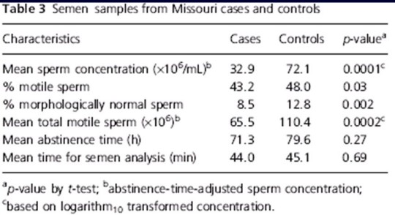
They are looking at whether the sperm is present, as well as whether it is functional. Some parameters suggest that there might be an affect on fertility, specifically on sperm concentrations. The motility of the sperm could be affected due to abnormal structure, this affect could be independent from prostaglandin.

Are these herbicides human reproductive toxicants?
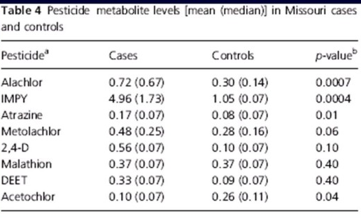
Pesticide metabolite levels [mean (median)] in Missouri cases and controls.
These are the same Missouri farmers, and we are looking at the controls, cases and there relationships. As mentioned before, there is an effect on sperm, we can look and see which of these pesticides (such as Alachlor and atrazine) has significant differences in concentration. Some of them are not significant, such as Malathion and DEET, but others are highly significant, such as Alachlor and IMPY. The chances are that farmers were exposed to mixtures of several chemicals. This piece of information may show there is a cause- response relationship, between reproductive problems and some of these pesticides. Then you have to figure out whether there is a cause response relationship. Whether it involve one specific chemical here or not. Still require a lot of research.

Chlorophenoxy Herbicides: examples are the 2,4-D and 2,4,5-T. TCDD has a variety of toxic effects. It has very serious skin effects. The Dioxin depresses immune function and is an extreme carcinogen. Dioxins causes black heads, cysts, inflammatory lesions, chloracne blackheads and other specific skin effects.

Environmental persistence
So, the pesticides are used intensively and there is geographical distribution. There are variety different mechanisms of action, so they are targeting different processes. They have consequence in terms of toxicity so that we can classify them whether they are extremely toxic or not. Exposure has been shown to produce effects.

There is a rational reason to use the pesticides for making more food for the world, and there is another rational reason to use them in terms of the malaria story. So some of these chemicals benefit the society and there are reasons that they should be used. So we can try to find a mixture with the least toxic components and decrease the overall toxicity of the mixture that is used. But what’s happening years later? Are these compound persistent? Is there bioaccumulation associated with them? If we use them in one season where are they the next season? Are they spread?

First problem: Environmental persistency
When we look at the half-life of the chemicals, they are very persistent. The half-life of DDT, TCDD, and Atrazine is 10years, 9 years and 25 months respectively. That means that 10 years from now, 50% of the DDT will still be in the soil if we spray the houses. Some of the other compounds require less time, but not a lot less.
Second problem: Bioaccumulation
In biological organisms there is often a high lipid content. If the compounds are lipophilic, they will accumulate in these organisms to a much greater extent than the environmental water, soil or air. We could expect that organisms with high lipid content would concentrate the chemical.
Bioaccumulation: along the food chain
When you test the water sample for DDT, you will find out that the concentration is extremely low, and if you were just considering this, you would predict the concentration would not cause any problems to the animals. However, the chemicals accumulate as you go up the food chain, in terms of lipid content. This might be the reason that they didn’t predict the problem for the organisms in the ecosystem.

Bioaccumulation in fish: dependent on bioaccumulation factors.
Why are they different in terms of bioaccumulation? One of the reason is that they are metabolized to a different extent. For example, Chlordane susceptibility to biotransformation is low, so that its accumulation factor is very high. Some of the compounds are metabolized to a greater extent and we are going to have less accumulation. Therefore we should make sure the chemical compounds we use can be broken down biologically by organisms in the environment.

Persistent Organic Pollutants (POPs):
The Arctic is considered a clean environment, we can look for and ask about the kinds of organic chemicals that are found in this environment. Complex mixtures of POPs such as HCB, HCHs, PCBs, Chlordanes (Herbicide), Nonachlor, Dieldrin (Herbicide), Mirex, Toxaphene (Herbicide), DDT (insecticide), DDE (metabolites of DDT) are present in the Arctic environment. So where do these compounds came from?

In order to answer this question, we have to study the water and the wind cycle around the world, there are several studies going on, but we haven’t figured it out yet. What we do know is that POPs in the Arctic accumulate as you go up the food chain.

PCBs in mothers and infants in Nunavik: Nunavik is north of Montreal.
Humans are near the top of the food chain, because people there eat polar bears and seals which contain high concentrations of PCB. People in Montreal may have much lower levels of PCBs in their body, because we have a broader diet.

Metals

Lead
All measured effects of lead are adverse. Lead reaches the aquatic environment through industrial and municipal discharges, atmospheric deposition, weathering processes and highway runoff. It inhibits the formation of heme, and adversely affects blood chemistry. It way also cause neurological effects such as degenerative lesions present in the myelin of brachial nerves.

There are different effects of lead. Basically in both children and adults you have effects in heme synthesis, but these are relatively higher concentrations. The lowest concentrations that have effects on children are developmental toxicity, such as effect IQ, hearing, and growth.
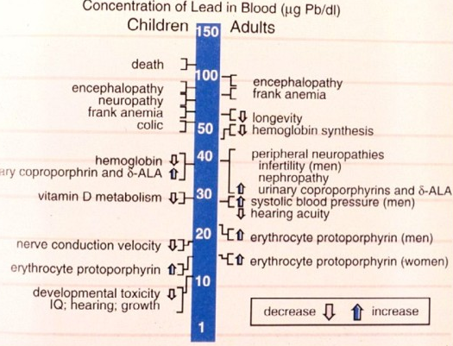.

Lead interferes with Heme synthesis
This is not the most sensitive effect, the most sensitive is the developmental effects. The general mechanism here is the inhibition of Heme synthesis from Protoporphyrin IX and inhibition of enzyme δ-aminolevulinate dehydratase.

Cadmium
It is present in batteries. Recycling batteries is an important thing, because Cadmium has a long half-life, because it is a persistent metal. It is a heavy metal released into the environment in a variety of ways such as smelting, burning coal and oils, and from the wear of vehicle tires. Effects of cadmium poisoning include bone damage, suppressed egg production, eggshell thinning in birds and kidney damage. Yellow paint has cadmium in it, so artists may be exposed to cadmium. As shown in the Mutagenicity test, cadmium is a very good mutagen.

Mercury
- Present in fish and lot of different things
- A mutagen, teratogen, and carcinogen
- In aquatic organisms, adversely affects reproduction, growth, behavior, osmoregulation, and oxygen exchange
- In marine birds, it causes kidney lesions, neurological damage, and reduces food intake leading to weight loss, progressive weakness in wings and legs.

Where do we get it from?
Mercury exists in a range of organic and inorganic forms. It enters the environment through industrial and domestic coal combustion, waste incineration, gold mining, and the dumping of sewage sludge. There’s a lot of gold mining in northern Quebec. Power Plants, Boiler and Municipal Waste Incineration are the huge source of Mercury.

Mercury Emissions in Canada
From 1970 to 2007 the mercury emissions have gone down dramatically. Again, identifying something as an environmental pollutant and toxicant has impact to replace the mercury from industrial use.

There is bioaccumulation of Mercury in our fishes in organic forms. So the methylation of Hg is important in terms of accumulation. In the case of distribution, way to the north, there are less Hg in the ground water. As we look at the size of the fish as part of the bioaccumulation, Hg level goes up.
Hg is also a developmental toxicant, we know a lot about Hg in developmental toxicity. Therefore, most pregnant women in Canada are told not to eat fish more than once a week. People that have diets high in fish, have more potential risk with Mercury.

How much mercury is too much?
From 1969 to 2000, just in the US, it has been decreased. There is an opposing pressure because in many ways fish are healthy to eat, and there are good reasons to eat fish. Therefore, if you know there is Hg in the water supply, you should increase the amount so people can eat it and it is a good food of nutrition, but you also have to decrease the amount because it does have a toxic effect. There’s a lot of political pressures going on.

Polycyclic aromatic hydrocarbons (PAH)
We have learned a lot about them already. They are produced by cars, and the classical sample is P[B]P. They are metabolically activated and the products are carcinogenic metabolites.

PAH Emission Profiles
PAH emission from trucks is much higher than the car.

St. Lawrence River Industry
The emission in terms of smokes contains compounds such as PAH. When we look at the PAH concentrations in sediments in the Saguenay river, the concentration is really high downstream of the factories.

Many SLE beluga have been found dead on the shoreline. We compare the data with whales dead in Alaska, what you can see is that when we look at the reason for the death, some of the whales especially the aged one had digestive system cancer.
Primary causes of death in SLE beluga is then compared to deaths of roe deer in Sweden. They find that the cancer is a low cause of death for Roe Deer but highly associated with this strain of whales. So maybe the cancer incidence is very high.

Then they compared the SLE beluga to humans, since we have a lot of data on humans. The study looked at different kinds of cancer in different animals in the same geographical region and looked at different types of cancer. They found that mammary gland and stomach cancer was particularly high. Some of the other animals such as humans, cats and dogs had this cancer also, but not sheep and cattle.

If you look at the distribution of beluga in St. Laurence Estuary and digestive system cancer in Quebec, You see that there is a high incidence in this region, in both men and women. Therefore there is a geographical relationship.

Basically by studying chemicals in the environment can have a huge impact on study for what these chemicals are doing to the environment and the story can turn around because by study of the beluga we learned something for the human, because we are in the same ecosystem. So you can learn something from one for the other.

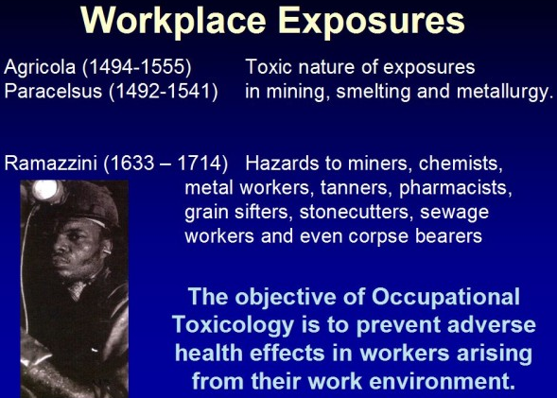
Toxic Chemicals in the work place
We have touched about work place when we talked about pesticides, because we said there was a work place exposure that is higher than the general public.

A lot of people were exposed to the metal toxic, but by only knowing this is not enough, we have to find a solution for this toxicity.

USA-Labor market
67.5% of the population over 16 work
18.9% are involved in manufacturing, construction and agriculture
Farmers are at high risk for fatal and nonfatal injuries, work-related lung diseases, noise-induced hearing loss, skin diseases, and certain cancers associated with chemical use and prolonged sun exposure (skin cancer). Construction workers are risk. Each day, construction workers face trench cave-ins, falls, machinery accidents, electrocutions, and motor vehicle incidents.

Occupational illnesses by category of illness and industry
Look at different kinds of industries, and trying to figure out what is the highest risk is. If you look at agriculture, we have lots of different incidence such as skin diseases. For constructions, skin diseases are high as well. Manufacturing causes lots of skin disease and respiratory disease. But there are still some disease associates with finance, insurance, and real estate.

Occupational illnesses by category: from 1982 to 1998
If we work out the categories and the years, there are different kinds of disorders and disease that could be occupational hazards.

Determinants of Dose: The dose is important.
Dose – the amount of toxicant that reaches the target tissue over a defined time span.
Exposure – used as a surrogate for dose; dose is a function of exposure cocnetration, duration and frequency.
Routes of exposure – the main occupational exposure are inhalation and dermal.

Determinates of toxicant dose
There are a lot of ways to measure the exposure by inhalation, and dermal. We have talked about the dermal exposure to pesticides, so we know that the skin has to be intact and depends on a lot of different factors.

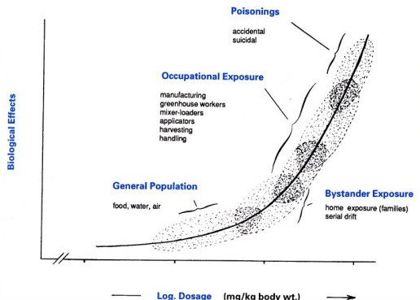
Theoretical dose-effect relationships
If you are going to work with a toxicant, and you know it is occupationally related, then this group will be a good group to study, because you know they have a high level of exposure and higher effects than the general population. The general population is only exposed to food, water and air. Therefore, research and data is required to find the effect.

Exposure Monitoring
Environmental monitoring – air sampling, dermal (measure skin exposure)
Biological monitoring – internal dose; body burden time of sampling versus half-life may include non-occupational exposure. Even the drug has been excreted, the consequence may be still there.

Skin disease:
From farmers to dentists to hairdressers;
From contact dermatitis to chloracne

Respiratory conditions due to toxic agents
Lung and airways: coal worker’s lung disease, asbestosis, occupational asthma, hypersensitivity pneumonitis
Causative agents: coal dust, silica, asbestos, bacteria, fungi, pollen, foreign proteins, CO, arsenic, cotton dust, barn environment, and cigarette smoke, including the insulation of some of the McGill buildings.

Work-related asthma (Lung disease)
- Chemical industry: plastic, rubber polymer precursors, disocyanates, reactive dyes
- Metal fabrication, lawn and turf, agriculture: biocides and fungicides, metals
- Shellfish processors
- Bakery workers: alpha amylase
- Laundry workers: subtilisin
- Animal handlers, lab technicians: animal urine, salivary proteins
- Sawmill workers, wood chips: fungi
- Health care workers – rubber latex in gloves
There is huge difference in different occupations, these workers can have different triggers for increasing the risk of asthma.
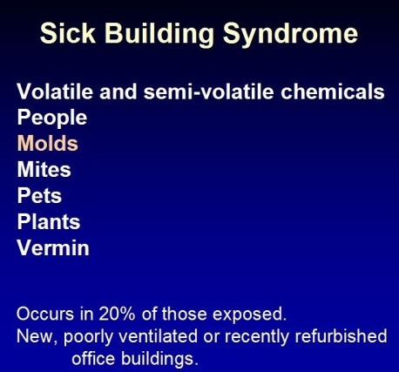
Challenges in Occupational and environmental toxicology
It’s difficult to establish a causal link between illness and exposure or job:
- Equivalence of occupationally-induced vs. non-occupational disease (ex: headaches and other non-specific symptoms)
- Protracted latent interval between exposure and expression of disease (seen with belugas getting cancer in old age)
- Multi-factorial nature of diseases of occupational origin.
- Some of the symptoms are very nonspecific.
- They could be a long adapt of impact, the disease might generate 10 years after the exposure in case of cancer.

Occupational Exposure Limits
ACGIH – American Conference of Governmental Industrial Hygienists
OSHA – Occupational Saftety and health administration
TLVs – threshold limit values
TLV-TWA – avg. for 8h day, 5-days/week
TLV-STEL – 15min
TLV-C – ceiling
Depends on how they calculate these numbers
PELs – permissible exposure limits
RELs – recommended exposure limits
BEIs – biological exposure indices

Control Approaches for occupational inhalation hazards
Basically what we can do is study them, and use exposure limits as much as possible to limit it. To some extent, you can change the process, these kinds of reasons for Hg limits that falling substantially as a substitution.
On the other hand, we should use special protection to isolate the toxicants such as using special protection clothes.
- Change the process to use or produce less hazardous compounds
- Automate and enclose the process to isolate the compounds
- Incorporate administrative and work practice controls to reduce duration or intensity of exposure
- Install or upgrade local exhaust systems and dilution exhaust
- Institute a comprehensive program for personal protective equipment use where necessary.

Thursday, April 5th 2007
Responsibilities for regulatory agencies: Risk assessment, validation of tests, risk management

- Can validate a test but not have it accepted
- Not such a thing as living in a risk-free world; must manage the risks

High Production Volume Chemicals
- a chemical that is produced or imported in amounts equal to or greater than one million pounds per year
- 3,300 out of 70,000 (between 60-100 000) chemicals qualify as HPVs (produced at a million pounds per year)- this is at “low end”, many chemicals are produced at hundreds of millions of pounds per year
- In the U.S., 4.4 to 7.1 trillion pounds of HPV chemicals are produced/imported annually
- proportion of chemicals for systems we know nothing about is huge; between 60-90%; staggering!  - At least 50% have never been tested on any of these systems  - Very few chemicals have been tested on all the systems  - Most of the ones tested are the drugs and food additives, many of the others are not tested of these various systems | 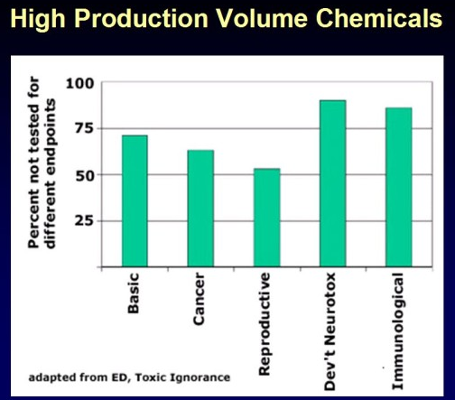

- Phase I: assess that chemical is not toxic to healthy individuals  - Phase II: see if drug works on patients  - Phase III: a large number of people, looking for side effects  - Chemicals are made and as we learn more about the toxicity, the numbers decrease (toxicity; main factor that seems to decrease the number of chemicals- diagram on right) | 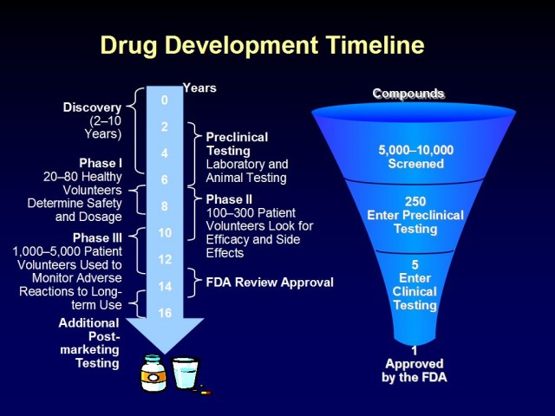

What is risk?
- can assess risk in a scientific way
- the way you communicate the risk and how public perceives the risk are very different (e.g. studies done on Saccharin; many people think this will cause cancer vs. actual scientific information; the press usually is “out for a story”, misinterprets or over-represents scientific assessments)
- should not leave it to the press or for people to figure out our their own; scientists must fill in “vacuum” and inform people

Scientific assessment ←→ information vacuum ←→public perception of risk

Science investigates and attempts to explain natural phenomena
- cautious (and often hard to understand for people not in the field)
- incremental (develop ideas based on what we read and what others have done; usually huge group of people responsible for a concept)
- truth seeking (the objective is to figure out how things work)

Industry strives to develop novel compounds that will:
- result in the greatest efficacy and safety (and rapid)
- but also provide the largest profit margins (vs. scientists: knowledge is their currency)

Government, as the regulator, attempts to affect human behaviour and resolve disputes
Governments want to resolve issues.
- episodic
- peremptory (not challengeable, cannot appeal… if for example a chemical is shown to be toxic, company must stop making it, no appeal)
- pursues resolution rather than truth

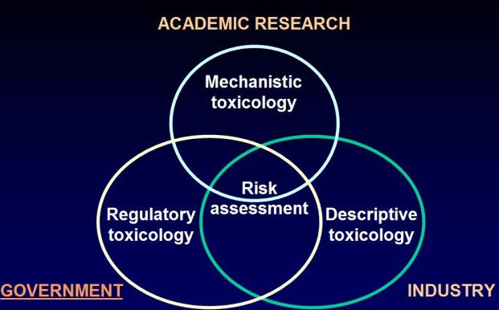

Government, academic research and industry intersect in risk assessment.

In Canada:
→Health Products and Food Branch
(Gives sense of how complex the system is; see a slide with a huge list of agencies that just cover health products and food, not even talking about environment)
e.g. Veterinary Drugs Directorate: looking at safety of drugs simply on animals
→Environment Canada
→National Centre for Occupational Health and Safety (what you are exposed to when you are working)
→Canadian Council on Animal Care (voluntary organization, 4th major arm of enforcement of risk management of Canadian system)

U.S.:
→Food and Drug Administration (also look at other bioproducts; e.g. growth hormone given to cows→ get bigger cows… before this was not regulated, now it is- same thing with GMOs)
→Environmental Protection Agency-EPA (effects of chemicals on environment and effects of environmental chemicals on humans and animals)
→Occupational Safety and Health Administration (similar to one in Canada)
→ Consumer Product Safety Commission (for consumers, e.g.: you think the shampoo is harmful for your eyes… in Canada, you go to Health Canada (more broad in Canada))
→Animal Welfare Act (Government has passed legislation- not how it is in Canada)

Necessary conditions that must be established for government to act in regulating a toxicant
- The substances must be capable of harming persons who are exposed
- Humans are likely to be exposed to the substances in a way that could be harmful (some things can cause harm but are unlikely to be exposed to it- government “will not care” if it is harmful but you will not be exposed to it)

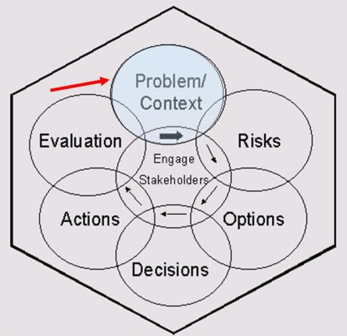
Problem/Context
Problem formulation
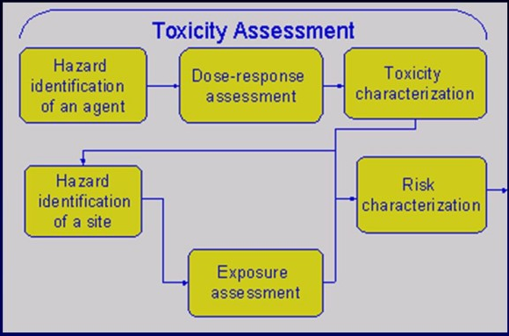
- dose-response: what is level of exposure required to get a response?

Burden of proof is very different depending on what you are looking at:

Requirement to prove that new substances will have no hazard on humans prior to approval (Food Additives Amendment); e.g. want to add a red dye to a cake
Requirement that regulators show that a substance is hazardous before exposure can be restricted (Occupational Safety and Health Act) e.g.: whenever I work with this new kind of computer, it makes rays that affect my eyesight

“Safety” of a chemical
- Absolute safety: NO risk (nothing that is absolutely safe).To prove a negative in science is extremely difficult. Not a question if there is no risk, more a question of how big the risk is. For example, replace a plastic with a biodegradable one… cannot say new one does not have any risk- has maybe LESS of a risk.
- Relative safety: negligible risk

Is there a “safe” dose for a carcinogen?
Any chemical that is shown convincingly in animal studies to be a carcinogen must be assumed to be a potential carcinogen in humans.
For these compounds (about 500), no finite level of human exposure is considered “risk free”
(Can use cell lines to do experiments but this will not solve all issues; also need to do tests on multiple species, assess extrapolation, etc.)

- Carcinogen: has to be below homeostatic effect  - Any chemical (or food additive, drug, etc.)that has potential to lead to cancer: government excludes it (if found to lead to cancer in ANY animal model, will not be allowed for human use)  - BUT has been challenged recently because it might be a drug that could help a lot of people and will only cause cancer at extremely large doses in test animals; must be proven beneficial to humans | 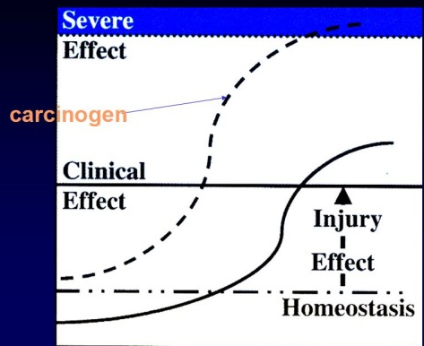
The Delaney Proviso: A Categorical Risk-Benefit Judgment
“Any food additive must be found safe before the FDA can approve its use”
No compound can be found “safe” as a food additive if it has been shown to cause cancer in animals or in man.
Assessing Risk for Changed Industrial Emissions
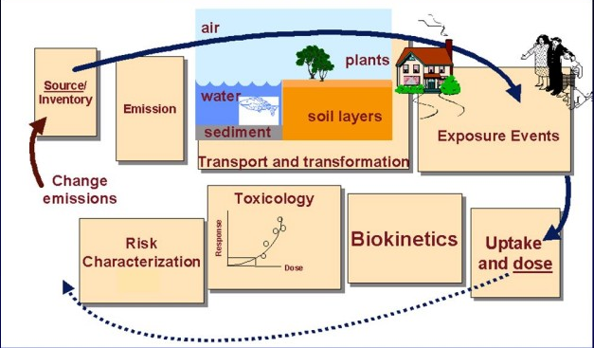
- change emissions; e.g.: notice there is a new smell in the environment → look how change is occurring (why occurring? Circulation system not working? New industry?) → assess relative risk and target (animals? Environment? Humans?)→ will change in level be sufficient to cause an effect?
- E.g. Hydro Quebec; passes higher and higher voltage through its lines; change to exposure in electromagnetic waves. Will this increase have an effect on animals and people around lines? Big debate, some people say yes, some people say no. Must have a way to see if these alterations cause changes in animals, humans, etc.
- From there, how do you act? Tell company to go back to level it was at before? Tell Hydro Quebec to only pass lines over areas where no people are living? Etc…

Dose-Response Assessment (Hazard characterization)
- quantitatively relates the impact of an exposure on the host
- means by which the public health impact of the hazard is established

Risks
Risk characterization
- integration of exposure and dose-response assessments
- also includes:
- uncertainty vs. variability (difference between both- “I’m not sure there is a danger associated with exposure to this chemical” vs. “everyone that is exposed will have a risk but the damage is variable”)
- sensitivity analysis (will always have some people who will be very sensitive for example; recall bell-shaped curve)
- severity analysis (nature of the response will vary)
- interpretation (key is interpretation; how you interpret data but in most cases, as seen before, do not even have data!
Hard for government to “go back” and reconsider levels that have already been decided (e.g. accepting a chemical that was once proved to be dangerous or another e.g.: lowering the accepted dose, thereby saying that the initial accepted dose was too high)
Risk characterization
Variability:
- inherent characteristic of system
- reduce through control programs (better assays for example)
Uncertainty:
- lack of knowledge
- reduce through conducting research (i.e. increase knowledge by doing more research)

Hazard assessment: What toxicities occur?
→Single chemical (traditional approach, want to simplify things, look at one chemical): select the most important effect of ALL toxicities observed of a chemical
→Cumulative (e.g. all chemicals in the same family respond in the same way): select the common effect shared by a group of chemicals (although most chemicals work on various receptors, some will activate certain receptors and others in the same family will affect others- thus this dogma has been challenged)
E.g.: Many PCBs but will all work by many different mechanisms
- Also, could have mixtures also that work by synergism.

Steps for conducting a cumulative risk assessment (set of logical steps-look over quickly)
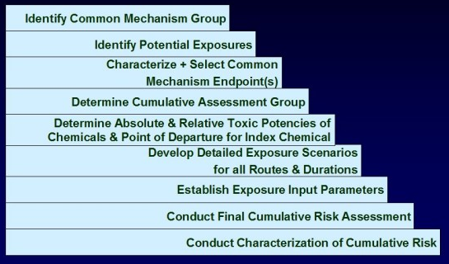

Cumulative hazard assessment
Pesticides: almost always mixtures (must “hit” different bugs)- very broad spectrum approach and as a consequence, the farmers are exposed to all these chemicals.
-1st step: identify group of chemicals that share a common toxicity that arises via a common mechanism

Relative Potency
- Although the chemicals produce the same effect via a common mechanism, they will have different toxic strengths or potencies (as discussed just above with affecting different receptors for example)
- How assess multiple chemicals working on multiple genes in multiple families; look at with toxicogenomics- causing a lot of trouble for chemical companies (governments could or could not require them to do toxicogenomics)

Cumulative Dose-Response Assessment
- determine relative potency
- estimate the point of departure for the index chemical
Cumulative risk assessment:
- select the studies and endpoints
- determine relative potency using index chemical
- determine the index chemical’s point of departure or the “endpoint”

Hazard (index chemicals PoD for group)+ Exposure (index chemical exposure equivalents)= RISK
Hazard and exposure has to be sufficiently high (cannot just have high hazard and low exposure or vice versa, must have both to have a risk)

DART guideline studies
- Different regulations all over the world, but must come together and set guidelines for everyone
-There are consensus meetings for every system (e.g. cardiovascular) to come up with international guidelines
→ICH Guideline on Detection of Toxicity to Reproduction for Medicinal Products-1994
→Developmental and Reproductive Toxicology studies are designed to cover all stages of development.
- Premating to conception (particularly drug companies wanted to exclude that- Japanese government insisted on having two generations of gametes exposed; had to reach consensus)
- Conception to implantation
- Implantation to closure of hard palate (when all organs are defined in the body e.g.: “this will become the heart, that will be the lungs”)
- Closure of palate to end of pregnancy
- Birth to weaning
- Weaning to sexual maturity (F1)

1) Female Rat Fertility Study
- dosed 2 weeks, mated
(Japanese had 60 days, Americans 4 days, etc… come to a consensus, now it is 14 days)
Parameters measured:
- estrous cycle length
- mating times
- conceptus viability (litter size)
- histology of reproductive organs

2) Male Rat Fertility Study
- dosed 4 weeks, mated, up to 63 days (only end point before was progeny outcome, now there are other requirements as seen below)
Parameters measured:
- mating times
- conceptus viability (litter size)
- sperm counts and motility
- histology of reproductive organs
Problem: exposure times are limited to about 40 days, whereas the Japanese required a 6month exposure (argument: could effect multiple generations of stem cells)

3) Embryo-fetal Development Study
- Look at organogenesis
Parameters measured:
- gross
- visceral (e.g. heart right size and in right place)
- skeletal

4) Peri-Postnatal Development Study
- through lactation; organogenesis, peri-postnatal development
Parameters measured
- viability
- sexual maturation (external)
- learning and memory (Europeans were opposed to this type of testing, e.g.: put in a maze, may do poorly)
- reflexes (another end point in nervous system)

Validation (have a risk, know how to assess it, must do tests… how do we validate whether that is a new test we want to use or not? Very tricky process.)
The process by which the credibility of a candidate test is established for a specific purpose. – Frazier, ‘89

Stages in the development of new toxicological testing methods
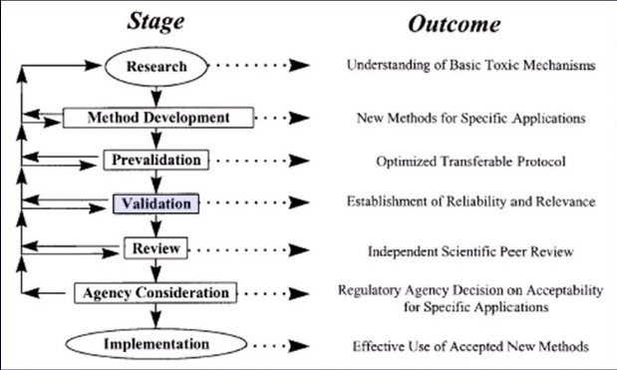

(Review: review of validation (whether it was done properly of not))
In the last 11 years, there has been five new methods that have been put forward to be used in reproductive toxicology- 4/5 have already been rejected at agency level and one that is being considered now.

Validation
- the scientific and regulatory rationale for the test method should be available
- The relationship of the test method’s endpoint(s) to the biologic effect of interest must be described. The relationship may be mechanistic or correlative.

A detailed protocol for the test method must be available and should include:
- a description of the materials needed
- a description of what is measured and how it is measured
- acceptable test performance criteria
- a description of how data will be analyzed
- a list of the species for which the test results are applicable
- a description of the known limitations of the test (pros and cons must be stated)

The extent of test variability must be demonstrated by: (did not read through in class)
- the level of intra- and inter-laboratory reproducibility
- how these values vary overt time
- the degree to which biological variability affects the test reproducibility
Must prove that the new test is better than any other existing test.

The test method’s performance must have been demonstrated using:
- reference chemicals or test agents representative of the types of substances to which the test method will be applied
- both known positive and known negative agents

Sufficient data should be provided to permit a comparison of the performance of a proposed substitute test with that of the test it is designed to replace.
Performance should be evaluated in relation to existing relevant toxicity testing data, and relevant toxicity information from the species of concern.

Realize that validation process is the most difficult process to get anything accepted.

Key points to remember:
1- Any test must follow good laboratory practices:
All data supporting the validity of a test method should be obtained and reported in accordance with Good Laboratory Practices (GLPs) (most university labs do not do this)

2- All data supporting the assessment of the validity of the test method must be available for review.

3- Detailed protocols should be readily available and in the public domain.

4- The method(s) and results should be published or submitted for publication in an independent, peer-reviewed publication.

Evaluation
- Incredibly complex interactions  Regulations on Animal Use: The present situation  - under the laws of Canada and the United States, animals cannot be said to possess “rights” (and yet we have a responsibility towards the animals to protect them)  - it would be more accurate to say that, in some circumstances, animals enjoy certain “protections”, especially from pain and distress in biomedical research | 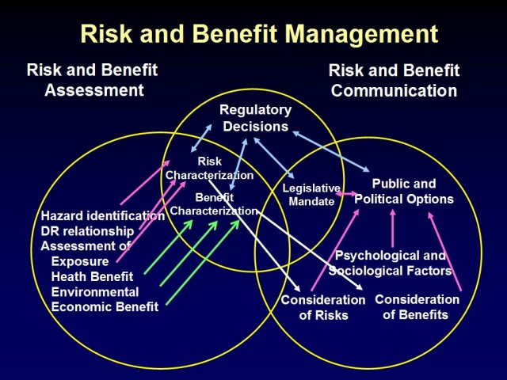

The Animal Welfare Act (US 1985)
Governments pass regulations at regular intervals (e.g. holes in boxes for animals→ animals less stressed→ better experiments→ better extrapolation, etc.)
- the major piece of federal legislation that defines the relationship between biomedical researches and animals in research settings
- strives to balance welfare of animals with necessity of biomedical research
- regulates humane handling, care, treatment, and transportation of animals;
BUT;
- cannot regulate design, outlines, guidelines of actual research or
experimentation

The Canadian Council on Animal Care-CCAC (volunteer organization but “weird”; we are all volunteers and we must do what they tell us to do- as if passed a legislation)
The Animal Welfare Act (US 1985)
- prevention of pain and distress; better care and treatment mandated
- anesthetics, analgesics, tranquilizers
- consideration of alternatives, if procedure involves pain and/or distress
- consult veterinarian in planning research
- IACUCs
- intent is to “represent society’s concerns regarding the welfare of animals use…”
e.g.: concept of pain- now have to for example, maintain painkillers for 24hours after a small surgery on an animal and administer antibiotics for possible infections (even though highly unlikely)- every year becomes more stringent
- IACUC to inspect all animal study areas and review practices to ensure compliance
with the provisions to minimize pain and distress to animals

