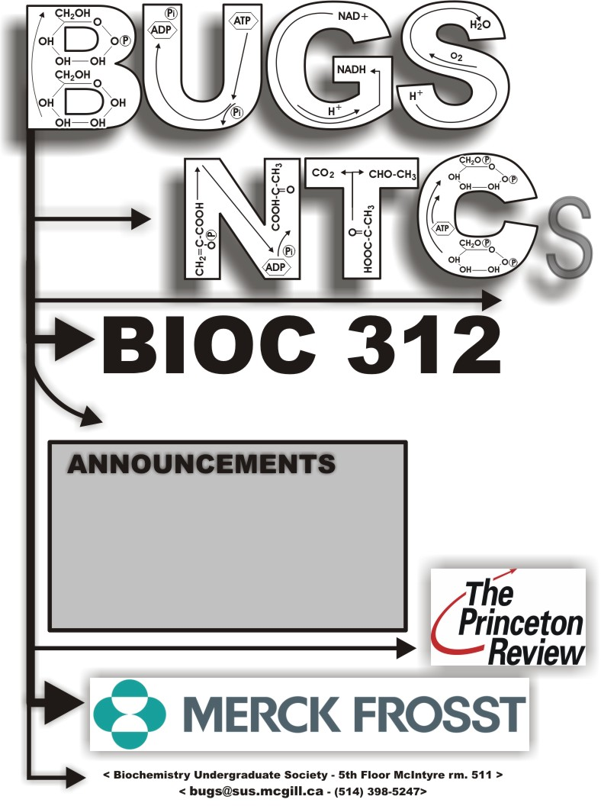
SET # 6 Lectures 19-22 (02/26/07 –03/05/07 )
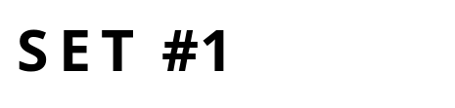

02/26/2007

Lecture #19– Introduction to RNA Polymerases
NOTE: This NTC is meant to be used as a study aid to supplement your own class notes. Hence, not all of the text or diagrams contained in the lecture slides will be reproduced here.
Please send any comments or questions about NTCs to either Misha or James through e-mail at bugs_u2reps@yahoo.ca

There are 4 different RNA polymerases in Eukaryotes: 3 nuclear, 1 mitochondrial.
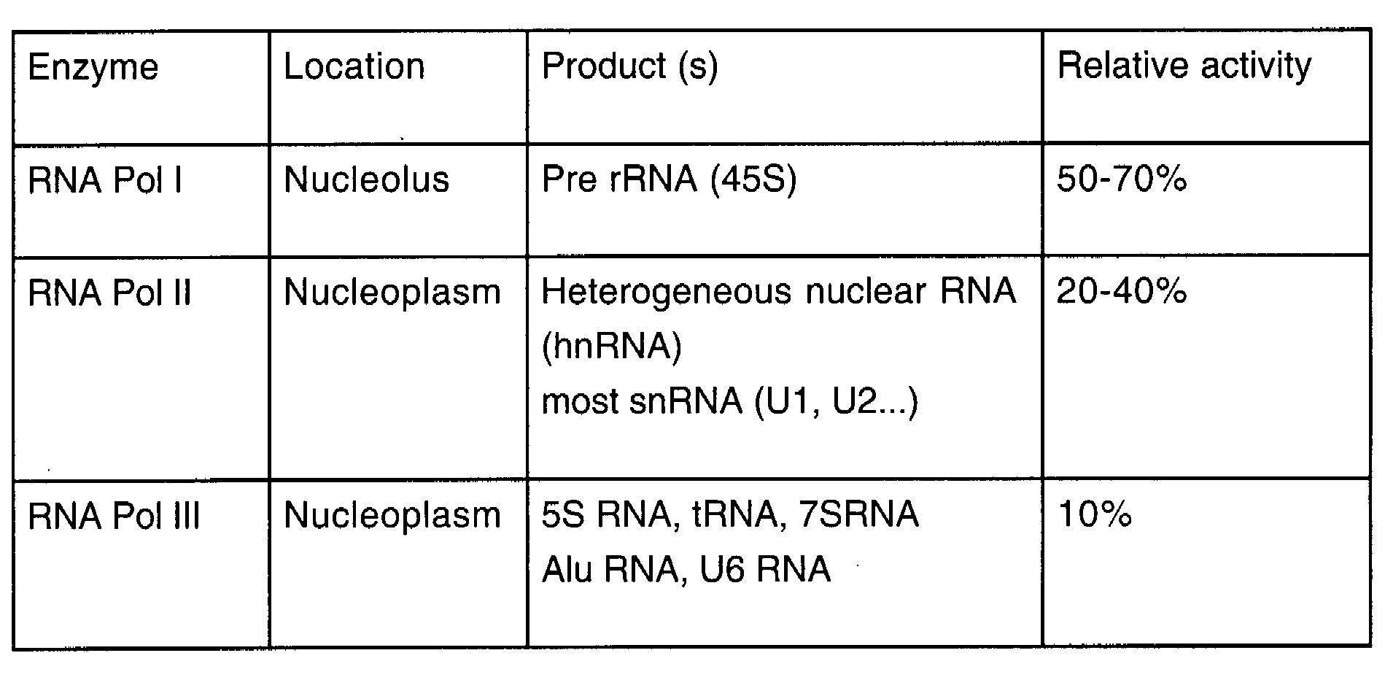
- The mitochondrial polymerase is involved in transcribing mitochondrial DNA, its composition is primitive, similar to bacterial phage T7 RNA pol.
- 3 nuclear polymerases: General properties overviewed in Table 1 (left).
Transcription by RNA Pol I and III accounts for most transcription in eukaryotic cells: both under less regulation than Pol II.

Pol I: in nucleolus, transcribes 45S, a smaller pre- rRNA which will form the ribosome. Its relative activity is very important and accounts for 50-70% in Euk. Cells. Because this rRNA is not translated, poly ribosomal complex cannot be amplify its translation, therefore it requires high activity since a single rRNA is needed for each ribosomal unit.
Pol II: in nucleoplasm, transcribes hnRNA, which matures into mRNA, it also transcribes snRNA; depending on the cell type it accounts for 20-40% of activity in the cell.
Pol III: in nucleoplasm, transcribes remaining rRNA and the tRNAs, and 7SRNA is for translocation in the ER. It is responsible for transcription of regulative sequences (i.e. ALU) and a small nuclear RNA U6. Accounts for 10% of transcription in euk cell.

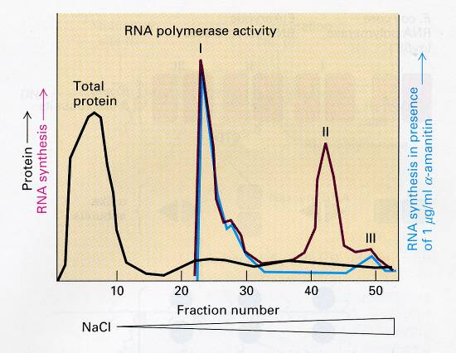
Two related experiments to show that the 3 polymerases exist and function separately:
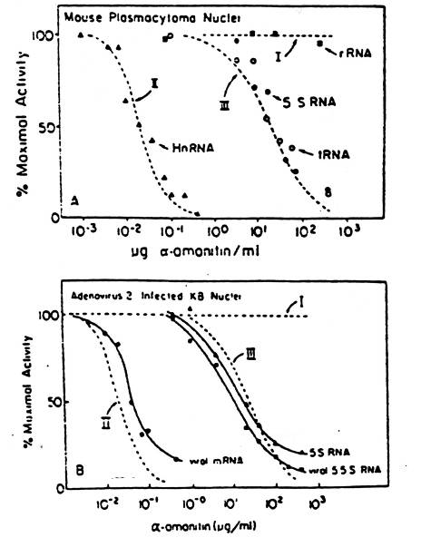
Nuclei were isolated and nuclear extract was obtained, which was loaded into a column (DEAE Sephadex). Protein was eluted by increasing salt (NaCl) concentration. This expermient used an in vitro transcription system, a non specific DNA template, and included labelled ribonucleotides. The experiment’s goal was to measure the incorporation of these labelled ribonucleotides into RNA.
- Total protein: most protein eluted in the first fraction.
- The 3 peaks provides evidence for 3 distinct activities for transcription from DNA into RNA.
2nd experiment (Blue line): used a drug (α-amanitin) from mushroom. This is a polymerase inhibitor. One can see that this drug affects pol II significantly while the other 2 polymerases (I & III) were not affected. This again is evidence that there are 3 RNA pols; each with distinct activities.

Response curve:
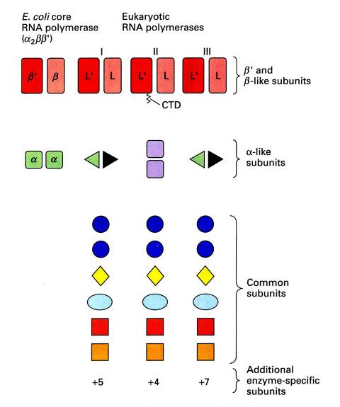
- Top curve: These curves show that pol II is extremely sensitive to the drug α-amanitin; pol III has moderate sensitivity, while pol I is not sensitive at all (except at high concentrations of drug ~1mg/ml).
- Bottom curve: same experiment, but the cells are infected by adeno virus, to see if the viral mRNA shows similar sensitivity to the drug: Yes it does, because it is transcribed by pol II, it is also seen that rRNA transcription is effected moderately.
- This method allows inference of which pol is responsible for the transcription to the gene.

The cartoon (right) shows the subunits of the RNA pols (top: largest and bottom: smallest) showing that the two largest subunits (β units) are related, some subunits are identical, whereas some show specificity for the different RNA pols. The findings are not surprising since all these enzymes perform the same function (use ribonucleotides & DNA as template, etc)

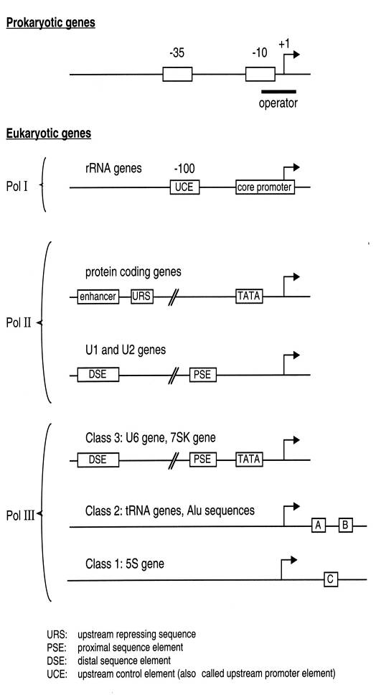
Overview of promoters:
Prokaryotes:
- 2 important elements in -35 and -10 sites: sequences are recognized by the σ (sigma) unit of RNA pol.
Eukaryotes:
- Pol I: 2 important elements: core promoter (located around the start site) and -100 (the Upstream Control Element) which can modulate activity at the core promoter
- Pol II: TATA box binds TBP (TFIID) allows for the assembly of initiation complex. It has little activity on its own, activity can be modulated by enhancer sequences URS: upstream repressing sequences. DSE= distal sequence element.
- Pol III: 3 major classes of genes.
- U6 gene = similar to u1 and u2, and contains TATA box.
- tRNA and Alu, has A and B (both downstream of the start site).
- 5S gene: also downstream of start site.

Initiation and transcription at the proper site also need other factors: called transcription factors. 100 L of human cells was grown, the extract was centrifuged at 1000 G; proteins are eluted at different salt concentrations (0.1M KCl) and the different protein fractions were collected. Using this assay, results show that TFIIA is needed for transcription by pol 2.
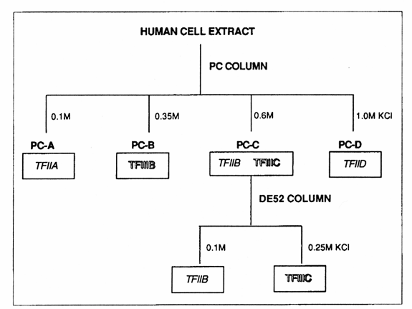
Note: TFIID (transcription factor for pol 2 in fraction D) contains TBP.

The RNA Pol 3 model: 5s gene and tRNA models.
In the experiment, TFs were added to DNA of gene 1 (present in large excess), pol 3 was added followed by gene 2. (see diagram for clarification)
Two different results were hypothesized:
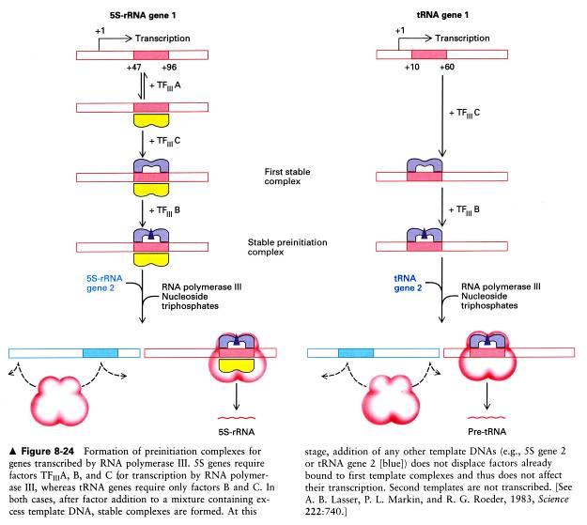
1) Stable preinitiation complex: after one round of transcription, the complex will remain attached to the DNA and thus the next round of transcription will take place on the same template. Only gene 1 will be transcribed NOT gene 2, which was added after the transcription complex.
2) Unstable preinitiation complex: After one round of transcription, the factors will disassociate and then re-associate for another round of transcription. In this case both genes 1 & 2 will be transcribed.

The experimental results from 5s rRNA revealed that case 1 was the correct model. Only gene 1 is transcribed, concurring with theory 1 that a stable preinitiation complex is formed by the RNA pol III transcription mechanism.
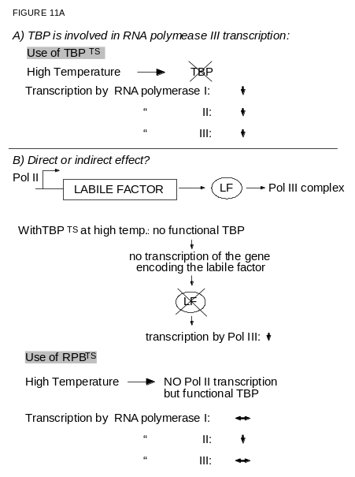
For the tRNA, the experiment is slightly different, in this case transcription doesn’t require TFIII; the stable preinitiation complex is formed just as well.

TBP: necessary for transcription by pol II.
Scientists were surprised when they discovered that it is also needed for transcription of I and III.

In Vivo Experiment:
Yeast cells are used, of which there are two TS mutants (mutated TBP gene). At low temperatures (30 ºC) the TBP is functional, when the temperature is raised (i.e. to 37ºC) TBP becomes non-functional. For the experiment, RNA with very sort half life is used allowing the amount of RNA to remain proportional to the rate of transcription.
Mutant TS shows a lower transcription level, since TBP is required for pol II transcription. However the transcription by pol III is also affected so it seems that TBP is also required for function of pol III. The effect could be indirect: i.e. via a Labile Factor (LF): for example pol II transcribes a LF that is necessary for transcription by pol III. When TBP is knocked out, it produces a domino effect. Even though it is not directly involved in transcription by pol III, it is affected due to the absence of LF (transcribed by pol II). The existence of this model is tested with a subsequent experiment; again temperature is raised, in this case TBP is still functional. By decreasing his3 gene transcription, a decrease in pol II transcription is seen but pol III activity remains unaffected. Therefore the effect of TBP on pol III is direct. Similar experiment also shows the same observation for pol 1’s relationship with TBP.

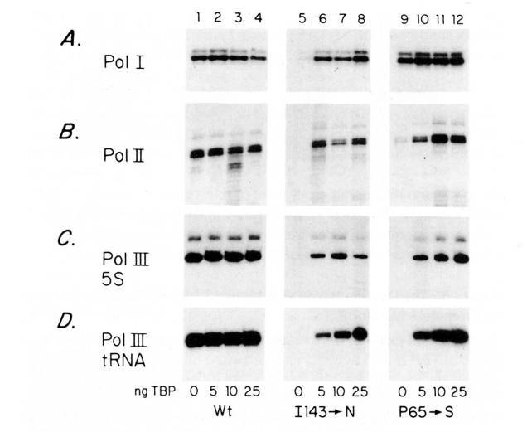
In vitro experiment:
This in vitro experiment agrees with previous data.
Use mutant strain of TBP allele, which is thermo sensitive (TS). Take wild type (Wt) or mutant, raise temp and prepare extract for transcription.
If we focus on lane 1 and lane 5. With TS mutant of TBP, there is a loss of transcription at all genes tested, due to a lack of functional TBP. As seen in lane 6, if we add recombinant TBP, transcription was restored to TS mutant. This provides strong evidence that TBP is the missing component and is required by all 3 pols.

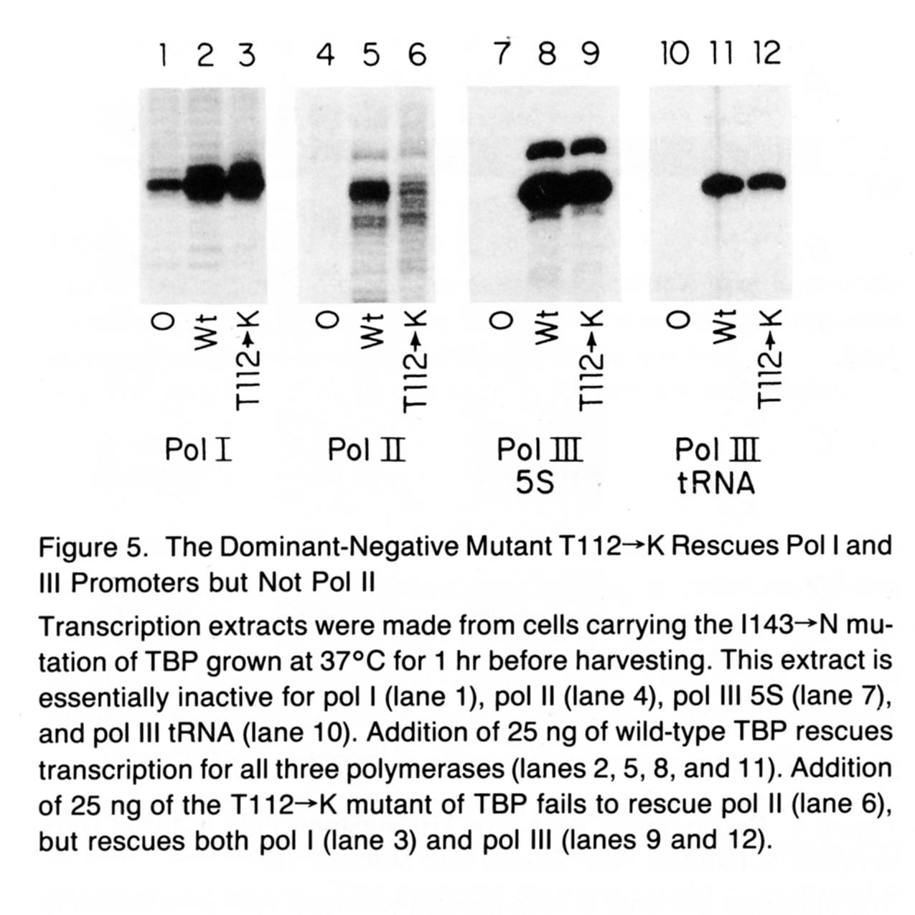
Do we need DNA binding of TBP for all 3 polymerases?
Take a mutant that has problems with DNA binding. In lane 0 = no TBP, Lane wt= regular TBP, lane T112-K = mutated TBP with poor DNA binding. Pol II shows no transcription with no TBP and full transcription with wtTBP, but the mutant TBP has poor transcription abilities. This is because TBP DNA binding is involved in transcription by pol II. In pol I and III, it can be seen that with the mutant TBP, the transcription is fully restored, this is because DNA binding activity of TBP is not in the transcription mechanism for these two polymerases (I and III). Not surprising since most genes transcribed by pol I and III have no TATA box.

Summary:
In vitro transcription with extract from mutant TBP strain:
Pol I ↓
Pol II ↓
Pol III ↓
Add recombinant TBP:
Pol I ↑
Pol II ↑
Pol III ↑
Add mutant TBP (with reduced DNA binding):
Pol I ↑
Pol II ↓
Pol III ↑

Study using Xenopus Oocyte:
In 5S genes: the important region of transcription control is downstream of start site.
The Oocyte needs to make ribosomes in order to develop, therefore it needs to transcribe the 5S rRNA gene. Transcription of this gene is at high levels in the early phases of development. At this point mutated plasmids are injected into these Oocytes. The experiments show that if a truncation is done ~+65 and on (downstream of start site), then the 5s gene is not transcribed (nothing on the gel for +65 and +125 truncation mutants).
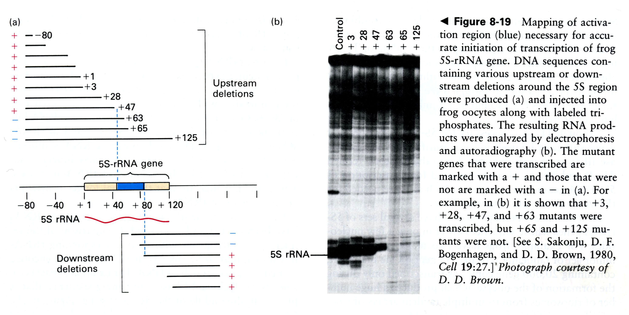

02/28/2007

Lecture #20– RNA Pol III & Pol I Transcription
NOTE: This NTC is meant to be used as a study aid to supplement your own class notes. Hence, not all of the text or diagrams contained in the lecture slides will be reproduced here.
Please send any comments or questions about NTCs to either Misha or James through e-mail at bugs_u2reps@yahoo.ca

As we saw in Monday’s class, there are three different classes of pol III promoters. We will see in more detail today what are the transcription factors involved in transcription of each class’ promoters. We will also focus on U1 and U6 genes; one is transcribed by pol II, the other by pol VI (target for RNA pol III), although they are very similar. We will also see some examples of the mechanism of regulation of RNA pol III activity.

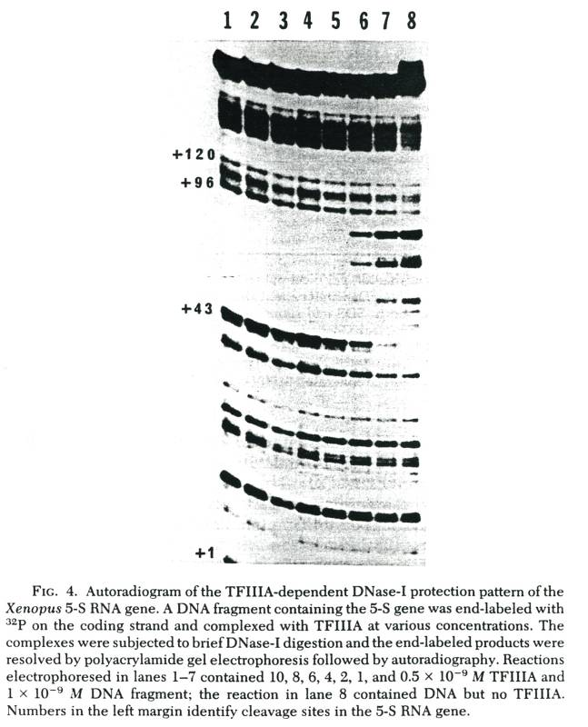
Review
- 5S gene has an internal promoter – shown through use of deletion mapping analysis. Then experimenters looked in more detail at this region and found that this internal region is actually a binding site for a transcription factor called TFIIIA.
- Purification of this factor was relatively easy because TFIIIA accounts for around 10% (large amount!) of the protein in Xenopus oocytes. This is in contrast to most transcription factors that are only present in very low concentrations (0.001 – 0.01%). We then perform DNase I footprinting, in which you have a DNA fragment of interest (in this case the 5S gene); the fragment is labelled at one end (on only one strand). The fragment will then be incubated with purified transcription factor and partially digested. On average, you want one cut per DNA molecule. In the absence of protein, DNase I will cleave DNA more or less randomly. Following DNase I digestion, DNA is purified and run on a denaturing gel.

If we look at lane number 8, in this case the DNA fragment was treated with DNase I in the absence of protein and we see that it is cleaved more or less randomly. If we look at lanes 1-7, the samples were incubated with decreasing concentrations of TFIIIA.
- TFIIIA will bind to the internal region of the 5S gene and protecting this region from the action of DNase I; leaving a protected region or footprint. This protected region roughly maps to the region that was identified in vivo using the deletion analysis.
- TFIIIA was the first transcription factor to be isolated with its gene cloned.
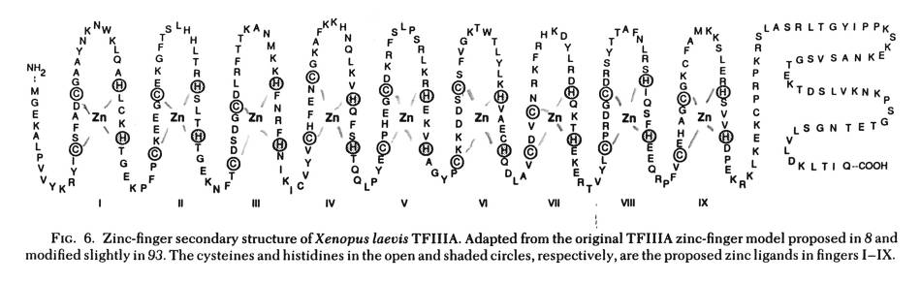
Once you have the DNA sequence it’s easy to predict the amino acid sequence. What is really striking is that we have a repeating pattern. For example, looking at the amino acid sequence of TFIIIA, we have two cysteines followed by two histidine residues, followed again by two cysteines and two histidines, and so on. Researchers speculated that zinc will bind to both cysteine and histidine, allowing formation of a secondary structure in order to allow this factor to bind DNA. The model turned out to be right!
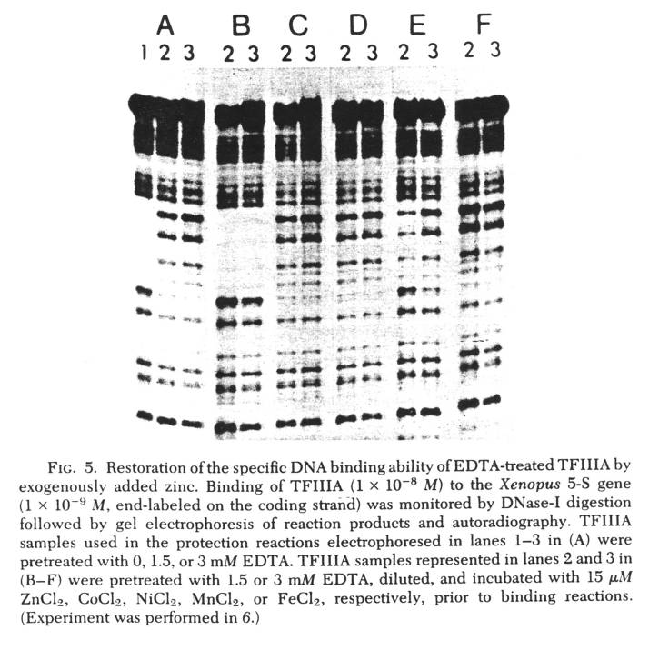
- TFIIIA is called a zinc finger protein because it requires zinc for proper function.
- This was shown by DNase I footprint analysis. In this case, before doing the DNase I digestion, TFIIIA was incubated with small molecules called EDTA, which is a very strong chelator of metal ions, therefore removing zinc from TFIIIA. As result you lose binding activity as shown in lanes number 2 and 3. Therefore, zinc is required for DNA binding activity of TFIIIA.
- In panel B, you simply add back extra zinc and as a consequence, you restore DNA binding of TFIIIA (use of any other metal ions (besides the case of cadmium, which is not shown), as is the case in panels C-F, does NOT work).
Conclusion: Zinc is required for proper secondary structure of TFIIIA and as a result DNA binding activity.
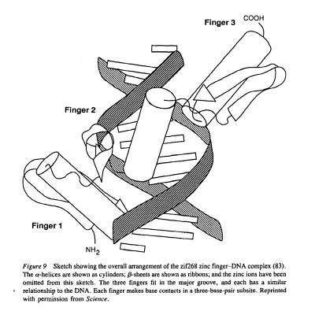
Another line of evidence: If you mutate some cysteine and histidine residues, you will lose the DNA binding activity for this transcription factor.
- Initially people tried to obtain a 3D structure of TFIIIA – it turned out to be extremely difficult because it is not possible to get high quality results.
- People focused on another protein – Zif268 – this is a mouse protein expressed early during development. It contains domains similar to those of TFIIIA; three zinc fingers. If we look at the portion containing the cysteine residues, its configuration is that of anti-parallel β-sheets, followed by regions containing histidine residues, corresponding to an α-helix. The zinc atom is located between the anti-parallel β-sheets and the α-helix.
- In addition, we can see that these zinc fingers contact the major groove of DNA.

3-D structure of the factor TFIIIA:
- It is only possible to crystallize the first six zinc fingers.
- It has a very similar structure to Zif268. Once again we have the anti-parallel β-sheets followed by the α-helix.
- The zinc fingers contact the major groove of DNA.
- The first three zinc fingers contact the region of +80. Zinc fingers 4-6 contact the middle region, whereas zinc finger 7-9 contact the region around +55 base pairs of the 5S gene.

Binding Order
- We have binding of TFIIIA to Box C. This allows recruitment of a second factor, TFIIIC (a big transcription factor, about the size of RNA polymerase III itself – containing five subunits). Binding of TFIIIC results in extended footprint around the start site of the 5S gene.
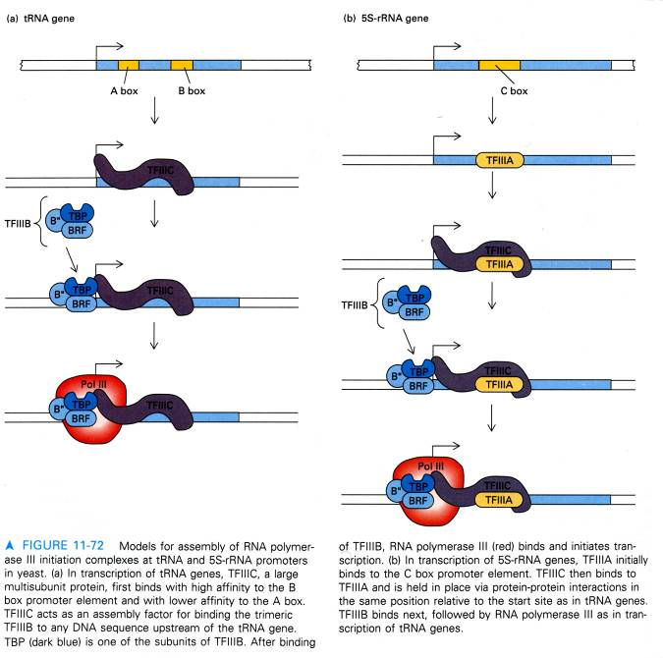
- This will allow recruitment of another factor, TFIIIB. It is composed of three different subunits: TBP, BRF (B Related Factor – highly related to the transcription factor TFIIB which is responsible for transcription by RNA polymerase II) and B’’.
- TFIIIB will interact with the region around the start site of the 5S gene and then it will allow the recruitment of RNA polymerase III for proper initiation of transcription.
- Once TFIIIB is recruited to the promoter, TFIIIA and TFIIIC are no longer required (tested in vitro). From this observation, we can state that TFIIA and TFIIIC are assembly factors, whereas TFIIIB can be compared to σ factor (allows proper positioning of RNA polymerase III).
- If we look at the tRNA gene, we see that there are two important DNA elements: Box A and Box B.
  - In this case, we don’t need TFIIIA – TFIIIC will bind with high affinity to Box B and with weaker affinity to Box A.
  - Once TFIIIC is bound to the internal region, it will allow recruitment of TFIIIB and then RNA polymerase III.
  - Major difference (as compared to 5S gene) is that we don’t need TFIIIA for transcription of tRNA genes.

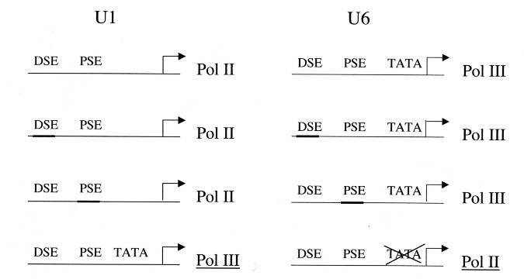
Class III genes (quite different)
One example of this is U6 (encoding a small nuclear RNA).
- They are more similar to polymerase II genes.
  - Both U1 (transcribed by pol II) and U6 (pol III) have a distal sequence element and a proximal sequence element.
If we make hybrid genes:
- For example, we have an U1 hybrid gene carrying the DSE from the U6 gene – however, there is no change in the use of RNA polymerase (still uses RNA pol II).
  - DSE turns out to be an unanswered sequence – there are eight nucleotides that are very well conserved – they are recognized by the OCTI transcription factor.
  - In addition, the DSE contains a binding site for the transcription factor SPI (another zinc finger protein related to TFIIIA).
  - The distance between the DSE and the start site is not critical.
  - In addition, you can flip the sequence and it has no major effect. This is characteristic of an unanswered sequence.
- If we swap the elements of the PSE, again there is no difference.
  - This is not so surprising – if we compare the nucleotide sequence of PSE U1 and U6, they share around fourteen out of eighteen homologous nucleotides. The PSE is not involved in specifying RNA polymerase use.
- If we add a TATA box to the U1 gene, then it will be transcribed by RNA polymerase III.
- If you delete the TATA box of the U6 gene, then it will be transcribed by RNA polymerase II.
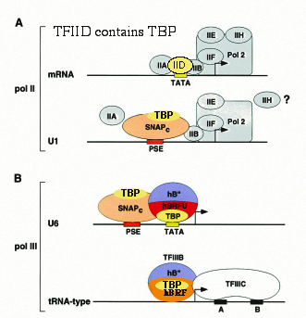
  - Hence, it is clear that the TATA box is the dominant element in determining if the gene is transcribed by RNA pol II or III (we are talking only about small nuclear RNA genes).

Summary:
- Classical pol II promoter: TFIID binds to TATA box, which will then interact with a number of different factors like TFIIA and B, allowing recruitment of RNA polymerase II.
- tRNA gene: Have TFIIIC, and then have TFIIIB located around the start site, allowing recruitment of RNA polymerase III.
- With U1 and U6 – new factor involved in transcription of both – SNAPc. This complex contains TBP protein.
- At U1, the SNAPc complex interacts with the PSE element, and other pol II transcription factors such as TFIIA or TFIIB, recruiting RNA polymerase II.
- If we look at U6, we have a PSE interacting with the same SNAPc complex, and in addition we have a TFIIIB like-factor containing TBP, BRFU and B’’. There is an interaction between the SNAPc complex and the TFIIIB complex, resulting in the recruitment of RNA polymerase III.

Experiment that provided evidence for the SNAPc complex:
- Use nuclear extract for in vitro transcription.
- We have two different templates: 1) U1 gene and 2) a classical pol II gene.
- With total nuclear extract we observe transcription at both templates
- If we use an antibody against TBP in order to deplete TBP from the extract – we will lose transcription at both U1 and classical pol II promoters.
- If we use the same TBP depleted extract but we add recombinant TBP, we can restore transcription at both U1 and classical pol II promoters.
- If we add back purified TFIID, we see only transcription at the classical pol II promoter (remember that TBP is tightly associated with the TFIID complex).
- This means that we are missing TBP in a different form.
- This suggests that there must be another complex involved in U1 transcription and this complex does not require TFIID.
- Fractionate nuclear extract, to look for U1 transcriptional activity. This allowed purification of a new complex – SNAPc (small nuclear activating protein complex). When this complex was characterized, it turned out that it contains TBP as well as TBP associated factors (ex. SNAP19 – named after molecular weight – don’t need to memorize the molecular weights!!).

Questions:
- Is the SNAPc really involved in U1 transcription?
- Is it required also for transcription at U6?
Isolate cDNA encoding SNAP43, it is possible to deduce the primary amino acid sequence of the SNAP43 polypeptide. A short peptide was synthesized in vitro and was used to culture antibodies (injected into rabbits). The idea here is to deplete the SNAPc and look at the effect on transcription at various templates.
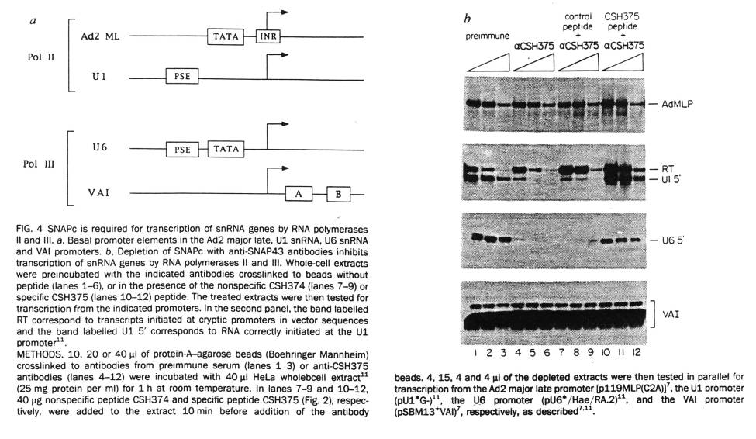
- Four different templates, two are transcribed by RNA polymerase II.
- VAI (last template) is a cRNA like gene with regulatory elements found downstream of the start site.
We see the results of the in vitro transcription assay:
- Pre-immune (just a control) – see transcription of templates tested
  - Get transcription of the ADMLP promoter
- For U1, RT = read through (non-specific) – see figure above
- If we deplete the extract from SNAPc, there is no effect at ADML promoter or tRNA like gene
- However, we see a significant reduction in the transcription at U1 and U6 – this means that the SNAPc complex is required for transcription of small nuclear RNA genes

Another factor is specific for U6 – hBRFU (h= human).
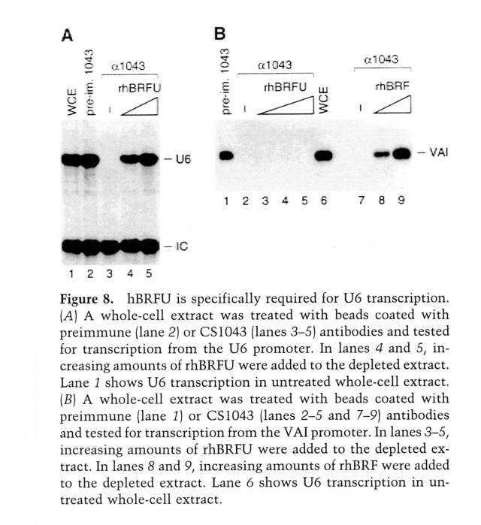
- There are two different BRF factors :
- BRF
- BRFU
- They are highly related, but BRFU is specific for transcription at U6, while as BRF is involved in transcription at tRNA genes.

Experiment:
Antibody was raised against a BRF (can react with BRFU too). Therefore can deplete the extract for both BRF and BRFU.
If we use U6 as a template for in vitro transcription, we can see that we don’t have any signal because we are lacking a BRFU factor; however, if we add recombinant BRFU, we can restore transcription at U6.

VAI → no transcription for extract lacking BRF and BRFU.
- If we add back BRFU, no effect.
- If we add back recombinant BRF, then we observe transcription.
The assembly model we have just seen is known as the Stepwise Assembly Model. This model has been challenged in recent years:
- If we look at pol III transcription, there is very good evidence that there is also a complex found in cells, a pre-formed complex called holoenzyme – this contains all subunits for RNA polymerase II as well as other transcription factors. This huge complex can be recruited directly to specific promoters following transcription of these target genes (similar phenomenon for RNA pol III).

Experiment to find out if there is an RNA polymerase III holoenzyme:
- Tag subunits specific for RNA polymerase III.
- Have a very small epitope that is recognized with an antibody called FLAG.
- Antibody used for immunoprecipitation
- Proteins were eluted and run on a gel
- Can see all the subunits of RNA polymerase III (16 different subunits)
- If perform Western blot analysis, it is possible to detect TBP and components of TFIIIB and TFIIIC
- Using this assay it is possible to recover 60% of the subunits of TFIIIB and TFIIIC
- If use Pol III holoenzyme, this is sufficient to get transcription as assayed in vitro, providing evidence for pol III holoenzyme.

At this point, we don’t know whether holoenzyme model or stepwise assembly model is right.

We will look at the mechanism that allows regulation of RNA polymerase III activity.
- If we look at some pol II genes, can have a huge variation in gene expression (100-1000X) following a given signal.
- For pol III it is not on or off because pol III transcribes genes that are essential for all cells (ex. components of the ribosome).
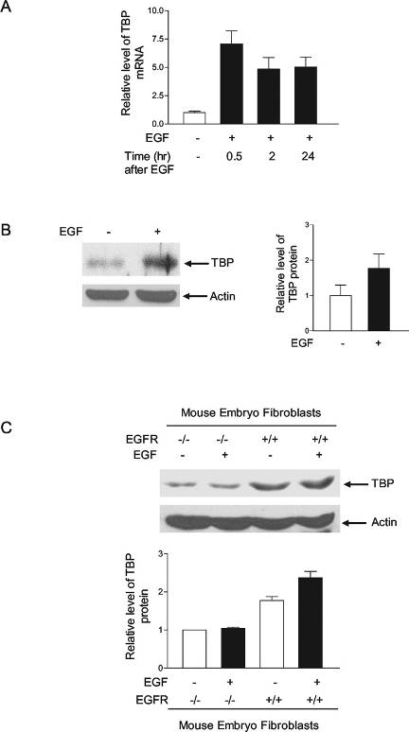
Did some modulation of pol III activity :
- the sustained cell proliferation depends on the duplication of all components of a cell (not just the chromosome).
- If we look at bacteria or yeast, the chromosome duplication is dependent on biosynthesis. If look at yeast cells, they must reach a critical size before they enter the S phase of the cell cycle.
- In yeast cells, if you force expression of the cyclin, then the cell will enter the S phase but they will be smaller.
- Clearly there is a relationship between chromosome duplication and synthesis of the cell components.
- If we look at animal cells this relationship is less clear but we still must have regulation of pol I and III transcription.
- For example, serum stimulation will increase RNA polymerase III activity
- In cancer cells, we see increase pol III transcription.

Three major mechanisms that allow regulation of RNA polymerase III activity:
  - Overexpression of some pol III factors
  - Release from repressors
  - Direct activation by oncogene products

We will focus on the first mechanism.
- Quite often in a cancer cell we will see the overexpression of TFIIIB and TFIIIC components.
- Mechanism not well understood.
- Another mechanism is to increase TBP expression

Example on left: Growth factor EGF stimulates cell proliferation through the receptor EGFR. If we treat human cells with EGF, we see increase levels for the mRNA encoding TBP.
In addition, if we treat the cells with EGF, we see that at the protein level we see increase expression of TBP.
- With wild type mouse embryo fibroblast cells, treatment with EGF increases TBP levels.
- However, if we use fibroblasts that lack both alleles encoding the EGF receptor, we don’t see this effect!
- If you forced the expression of TBP (for example, by introducing an expression vector for TBP) this will result in increase pol III transcription.

Mechanism - Release from repressors:
- A key regulator of pol III transcription is the Rb protein.
- Rb is involved in controlling the expression of a number of genes (ex. involved in DNA replication or control of cell growth).
- RB controls the transition from G1 to S. It will bind to a transcription factor called E2F and inhibit its activity.
- Following phosphorylation of Rb, it will dissociate from E2F, allowing this transcription factor to possibly control expression of a DNA replication gene and other genes involved in the cell cycle progression.
- Loss of Rb may lead to cancer – mice missing both Rb alleles have a very high incidence of cancer.

Rb controls activity of RNA polymerase III – two set of experiments that provided evidence for this: one set done in vivo and the other in vitro.
- Look at the expression of VAI gene (tRNA like gene) –we over express Rb (under the control of a strong promoter, CMV)
- If we introduce the over-expression vector, we get decreased level of the VAI mRNA
- As a control, if you express a mutated form of Rb, there is no effect on the expression of this gene.
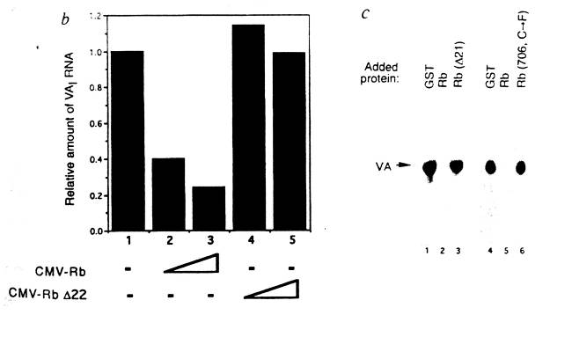
- If we look at the cells that lack Rb, we see increased RNA pol III activity.

In vitro: we add a classical in vitro transcription system; we look again at this tRNA like gene. Have GST as a control, or GST fused to the Rb protein. There is a drastic loss in transcription if you add the GST/Rb fused protein. If we express a non-functional form of Rb fused to GST (control), there is no effect on transcription.

03/02/2007

Lecture #21– RNA Polymerase III & I Transcription
NOTE: This NTC is meant to be used as a study aid to supplement your own class notes. Hence, not all of the text or diagrams contained in the lecture slides will be reproduced here.
Please send any comments or questions about NTCs to either Misha or James through e-mail at bugs_u2reps@yahoo.ca

Today is the third and last lecture about RNA Pol I and III, this will not be part of the midterm material, only the final exam.

Review:
- There were different methods to regulate RNA polymerase III activity.
- One way to up-regulate the RNA polymerase III activity is to increase the expression of the components of the transcriptional machinery of RNA polyermase III.
- Also, there are negative regulators such as Rb, which negatively regulates E2F (involved in cell proliferation).
- In addition, Rb can regulate RNA polymerase III activity; the mechanism: Rb blocks the interaction between TFIIIB and TFIIIC, and the interaction between them and RNA polymerase III. T his will result in lower RNA polymerase III transcription.
- A similar mechanism has been described for p53,which also results in lowered expression of RNA polymerase III gene (such as the tRNA gene).

Continued Mechanism of Regulation of RNA Polymerase III Transcription:
Direct Activation by Oncogene Products:
- CK2 (casein kinase) phosphorylates TFIIIB, and subsequently will phosphorylate TBP. This results in increased assembly of the transcription complex on the DNA.
- ERK kinase phosphorylates BRF1, which also results in stimulation of assembly of the complex.

Transcription by RNA Polymerase I:
- The yeast ribosomal RNA (rRNA) gene is 30S, the human gene is much longer and is called 45S.
- Some sequences can be cleaved by RNase and that will give rise to a major transcript: 18s and 5.8S and so on. The sequences between the major RNA are degraded.
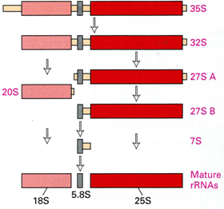
- There is no poly-adenylation or capping which are seen with mRNAs.
- Transcription of rRNA genes, by RNA Polymerase I, occur in the nucleolus. Chromosomes that are found in the nucleus will loop into the nucleolus; these loops correspond to rRNA genes and will be transcribed by RNA Polymerase I.
- After transcription the pre-ribosomal RNA will be associated with a number of ribonucleoproteins to form the ribonucleoprotein complex, which allows for maturation to occur. The ribonucleoproteins are imported from the cytoplasm. Once the rRNA is mature, assembly of the small and large subunits of the ribosome will occur.
- These subunits will then be exported to the cytoplasm, where final maturation will occur, giving rise to the 40S and the 60S particle.

Ribosomal RNA accounts for ~80% of the RNA content in a cell. In the case of rRNA, amplification is not possible. If you have on mRNA molecule it can be translated many times to give many copies of a polypeptide, but in the case of rRNA only one molecule can be perforated into a ribosome (no amplification); as a result, the cell must produce lots of rRNA.

If you look at HeLa cells in vitro, the cells double every 24 hours, and the cells contain about 5-10 million ribosomes; meaning that this much rRNA must be produced daily.

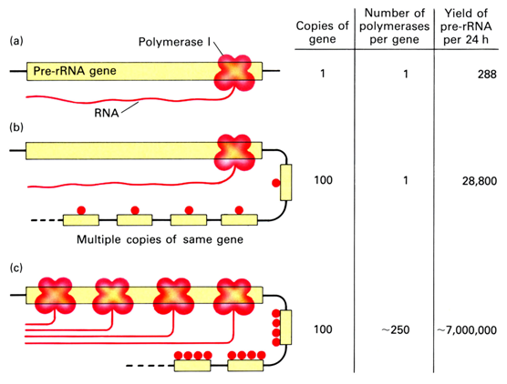
This can be calculated, as seen in the diagram to the right. We need many copies of the rRNA genes to achieve a million copies and therefore it must be transcribed by many RNA Polymerases. Lastly, we need a high rate of transcription.
The time of transcription of the 45S rRNA is ~5 minutes. Let’s say there is only one copy of that rRNA gene, and it can only be transcribed by one RNA Polymerase I at a time, then you can only synthesize 12 rRNAs in one hour (288 rRNA in 24 hours). Therefore this is not plausible, we need to increase the number of rRNA genes (100 copies), but if there is only one RNA polymerase I transcribing it, we can only achieve ~28,800 rRNA.
Therefore, to achieve ~7,000,000 rRNAs, we need 100 copies of the gene and ~250 RNA polymerase I enzymes to transcribe.

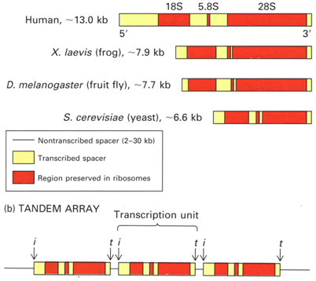
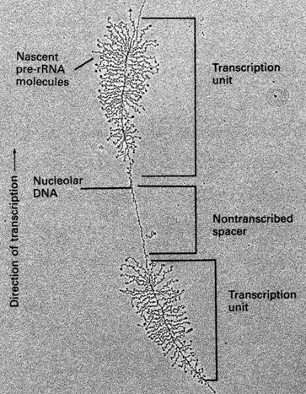
The organization of the transcription units is important. There are some differences within species. The major rRNA, however, show very good conservation; the genes are conserved, but the length of the spacer sequences is not (these sequences are degraded during maturation). These sequences are found as tandem repeats or tandem organization, for instance, we have one ribosomal gene with an initiation site and terminator site, which is followed by another transcription unit (with an initiator site and terminator site). This type of tandem organization is observed in all species.

The second criteria to achieving the optimal number of ribosomal subunits is the number of RNA polymerase I transcribing a given gene. We can see in frog oocytes, which have been photographed by electron microscopy, that there are many nascent pre-rRNA molecules coming off any given RNA gene. This means that there is a high number of RNA polymerase I transcribing the gene. From this picture one can also determine the direction of transcription, since closer to the bottom we have short RNA molecules and closer to the top we have longer RNA molecules; therefore, RNA polymerase I transcribes from the bottom of the slide to the top of the slide.

Organization of Promoter:
The third criteria of achieving the optimal number of rRNA transcripts in a given cell is the rate of transcription (which must be high).
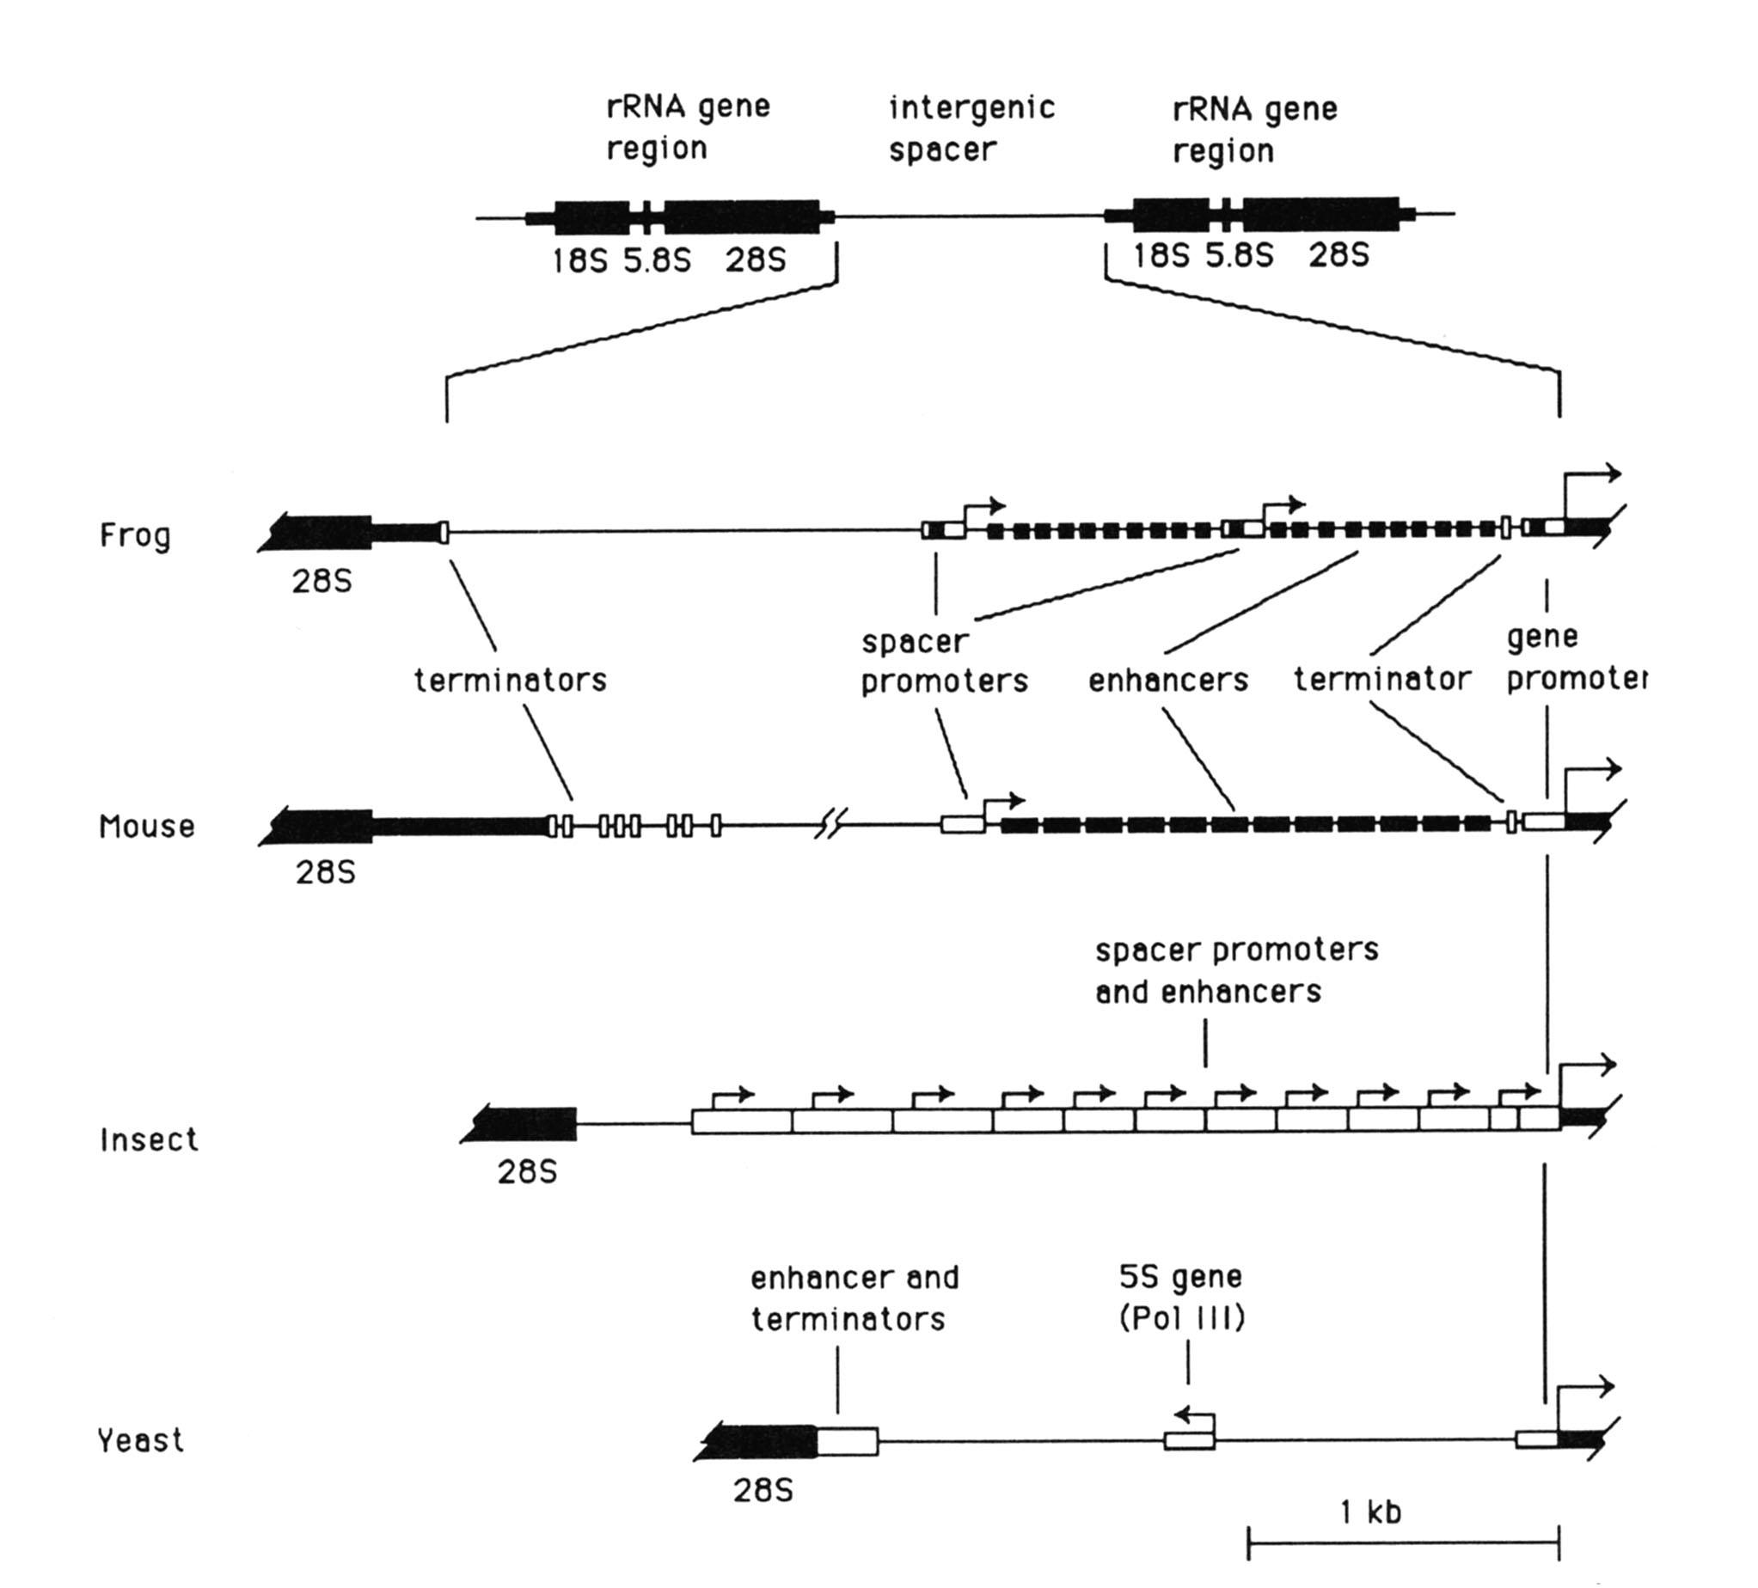
This diagram focuses on the intergenic spacer from different species. Example, the frog and mouse have a similar organization: starting from the 3i end we have a ribosomal gene, followed by a terminator, which is followed by a region that is not transcribed. After which, comes the intergenic spacer, which contains a spacer promoter, this region is transcribed by RNA polymerase I; the reason for these spacer promoters is unknown. These promoters will allow the transcription of certain enhancer sequences (length varies). These enhancer sequences will increase transcription of the rRNA gene, and they control the activity of the spacer promoter.
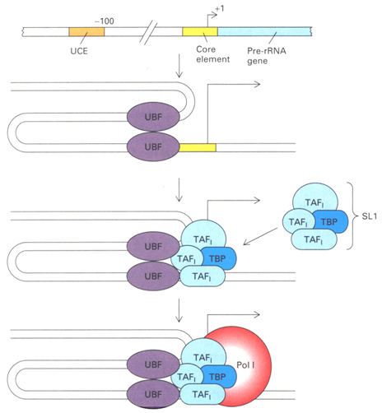
Focusing on the rRNA promoter and the region on the start site we notice that there are two main elements; the core promoter which appears around the start site and extends 4-5 base pairs downstream of the start site. The second element is located at ~ -100 base pairs, which is known as the upstream control element (UCE). These two DNA elements are bound by a dimerized transcription factor called UBF (upstream binding factor). The binding of UBF will result in the formation of a DNA loop. SL1 is a selectivity factor which is composed of TBP and TAFs; therefore SL1 is required for transcription and RNA polymerase I binding. The TAFs are distinct from those in other RNA polymerase complexes (such as TFIIIB or TFIID).

Once SL1 is bound to the promoter then RNA polymerase I is recruited and transcription is induced. UBF is also found in the coding region of rRNA (core promoter), not only at the UCE. The bridge between SL1 and RNA polymerase I is mediated by a protein called Rrn3 (TIF-1A).

SL1 is named selectivity factor, because researchers noticed that if you take a human transcription system and supply SL1 from a different source, the SL1 will not work, though they are related, they are different enough such that the SL1 from different species will not complement each other.

UBF → Upstream Binding Factor has two isoforms. This protein has a few different domains: the N-terminus contains the dimerization domain (the formation of dimers allows the DNA to loop), there are a number of localization signals (nuclear localization signals), finally there are number of HMG (high mobility group) domains, which is involved in DNA recognition.

Regulation of RNA Polymerase I Activity:
Fast growing cells need to make more ribosomes through the increased synthesis of rRNA. This is the case during organ regeneration, if we look at the size of nucleolus; it’s a good measure of the growth rate of the cell. This is seen in cancer cells, they tend to have a large nucleolus, which can be used to determine the proliferation of the cell (lots of transcription of the rRNA genes). If we have high rate of Cro, ribosomal protein, we simply increase translation of the mRNA, for ribosomal RNA, we have 4 or 5-fold increase in RNA Polymerase I activity; the increase will allow the cell to increase the growth rate when required.
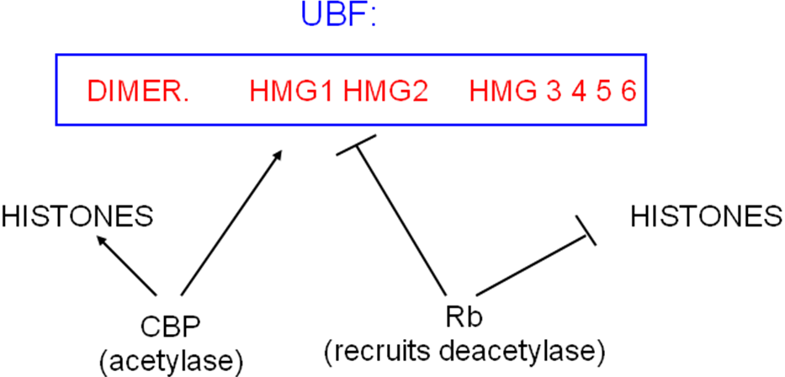
One limiting factor for transcription by RNA polymerase I, is UBF. Studies have shown that if you over express UBF in animal cells you will increase transcription by RNA polymerase I. UBF is subject to post-translational modification and is regulated by a number of factors. CBP is a histone acetyl transferase which can also acetylate UBF, through the HMG1 dn HMG2 domain. This results in increased activity of UBF. Rb decreases the activity of UBF by recruiting histone deacetylases and therefore deacetylate the same residues found in HMG1 and HMG2. Both CBP and Rb compete for binding to HMG1 and HMG2.

**NOTE: There is a mistake on slide 50, it says “Rb prevents interaction between UBF and SL1” it should say “p53 prevents interaction between UBF and SL1”.

Therefore, p53 is a negative regulator, it binds to SL1 resulting in a decreased transcription.

Epidermal Growth Factor:
Epidermal Growth Factor (EGF) is another regulator of transcription. EGF will result in an active ERK1/ERK2 Kinase, which will phosphorylate UBF at threonine residue 117 and threonine residue 201; these residues are well conserved in species. The phosphorylation of these residues results in reduced affinity of UBF for DNA which results in a increase in transcription by RNA polymerase I. If you mutate these threonine residues to alanine, phosphorylation is blocked, and transcription is reduced. UBF is dynamic, you need phosphorylation and dephosphorylation, you need to dephosphorylate UBF to achieve promoter clearance and some recent data suggests that major regulation by RNA polymerase I occurs at the elongation step.

Termination of Transcription:
RNA Polymerase I:
- Termination signal is 18 basepairs and are called Sal Boxes, because this short signal contains a site for the restriction enzyme SalI.
- Therefore are 8 or more Sal boxes found in the terminator gene.
- There is one transcription factor necessary for this activity it is called TTF1 (terminator transcription factor 1).
- The orientation is important; unlike enhancer sequences, here you cannot flip the sequence and still get termination.

RNA Polymerase III:
- Contains a stretch of 4 or 5 thymine residues, surrounding by guanine rich sequences.
- The RNA transcripts will a short stretch of uridine residues at the 3’ end.
- There is no evidence for another factor which favors termination.

03/05/2007

Lecture #22– Proteolytic modification of Proteins & Protein Targeting
NOTE: This NTC is meant to be used as a study aid to supplement your own class notes. Hence, not all of the text or diagrams contained in the lecture slides will be reproduced here.
Please send any comments or questions about NTCs to either Misha or James through e-mail at bugs_u2reps@yahoo.ca

Outline:
Reference material: Molecular Cell Biology, Chapter 12
Description of proteins from their transcription through to maturation, synthesis, degradation, etc
- Previously discussed earlier aspects of gene expression and protein synthesis
- Today and Wednesday: protein targeting
  - principles involved in protein targeting
  - applicable to a variety of situations where they’re targeted to the different organelles
- Friday: protein degradation
  - proteins are at a steady state; protein levels determined by rate of synthesis and degradation
  - we typically think of protein levels as effects of transcription and translation but there’s an enormous amount of regulation that occurs at the level of degradation
- Next week: forms of proteolytic cleavage that results in cell death, apoptosis is a very important process

Protein targeting:
- hallmark of the eukaryotic cell is its complexity and degree of organization
- many proteins and metabolic pathways are concentrated at specific sites in the cell, e.g. transcription in the nucleus, energy synthesis in the mitochondria, lipid metabolism in peroxisome; yet all proteins are synthesized in 80S ribosomes which are only present in the cytoplasm
- Therefore, an enzyme involved in energy metabolism in the mitochondria must have a mechanism of reaching its target
  - characteristics that target the protein but also determine its final destination within that site; e.g. the matrix of the mitochondria
  - these characteristics include topology and organization, who it interacts with, etc
- not all organelles are competent to take up newly synthesized proteins; only five organelles are able to do this
  - in animal and plant cells:
  - nucleus: all nuclear proteins involved in transcription & RNA splicing are targeted here
  - peroxisome: lipid metabolism
  - mitochondria: energy synthesis
  - endoplasmic reticulum: continuous with the outer membrane of nuclear envelope but has a very different function
  - in plant cells, the chloroplast, where photosynthesis takes place, also takes up newly synthesized proteins
Biological problems that must be overcome have formed the principles of protein targeting:
- evolutionary drive for these principles
  - specificity: i.e. a protein is only targeted to one location;
  - thermodynamics: proteins are synthesized in an aqueous solution but they must be targeted across non-polar membranes
- this energy consuming step drives the process uni-directionally
- protein targeting typically doesn’t occur de novo; i.e. it doesn’t occur in the absence of organelles
- organelles aren’t made from scratch
  - they proliferate during cell growth and partition to daughter cells during division
  - very seldom are organelles made that didn’t previously exist in cell

All the information for protein targeting is found in the primary sequence of the protein
- protein function is derived from primary sequence
- targeted proteins typically have a signal sequence “zip code” at the C terminus of its chain
- the 5 organelles have different signal sequences. See table below (taken from p. 1 of the handout)

Organelle | Location of signal | Signal generally removed? | Nature of signal
ER | Usu. N terminal | usually | short sequence of hydrophobic amino acids and often preceded by one or more basic amino acids, e.g. lysine or arginine; flanked by amino acids with small side chains  it’s not sequence specific but it has this special pattern
Mitochondria | Usu. N terminal | Usually | net positive charge, enriched in lysine and arginine, no acidic amino acids (Glu or Asp); some amino acids with small side chains
Chloroplast | Usu. N terminal | usually | No common sequence motifs; generally rich in Ser, Thr, and small hydrophobic amino acids; poor in Glu and Asp
Peroxisome | Usu. C terminal | No | Many sequence specific zip codes; usually  Ser-Lys-Leu at extreme C-terminus
Nucleus | Usually internal | No | cluster of basic amino acids; one cluster of 5 basic aa or 2 smaller clusters of basic residues separated by ~10aa

General steps of targeting
- pg. 2 of the hand out has a list of steps
- they will be explained in the context of specificity and thermodynamics
- pg. 3 contains a schematic of generic membrane representing a generic organelle

- Targeting information resides in primary amino acid sequence.
These sequences are referred to as topogenic sequences and determine final topology of protein within the cell, not only which organelle it gets to but whether it’s a soluble protein or a membrane protein, and where it’s located within the organelle. e.g. mitochondria have four compartments. A protein addressed to mitochondria must be targeted to one of these compartments.

  - Signal sequences direct the proteins after synthesis by the 80S ribosome to its target organelle.
  - Membrane anchor sequences specifically address a protein to integrate into the membrane lipid bilayer, as opposed to becoming a soluble protein
  - Sorting sequences get proteins to their final destination. e.g. in the ER, the signal sequence get the protein to the ER membrane but it is the sorting sequence which determines the next step in the secretory pathway, be it the Golgi apparatus, secretory vesicles, plasma membrane, or outside of the cell
Two classical experimental methods to determine to identify the signal sequence
- Deletion of the signal sequence: the protein stays in the cytosol instead of going to an organelle.
- Recombinant manipulation: fuse the specific sequence to a cytoplasmic protein and see if the cytoplasmic sequence is delivered to specific organelles; typically that’s the case
These experiments are used to identify and confirm that a specific sequence functions as a signal sequence.

- As proteins leave the 80S ribosome, they must be conformationally competent for targeting and translocation across boundary membranes of a particular organelle.
The proteins can be synthesized co-translationally; as is the case for proteins targeted to ER, resulting in eukaryotic ER studded with 80S ribosomes in electron micrographs. The ribosomes bound to the surface are either sending protein to or across the membrane.
All other organelles take up proteins post-translationally, after the protein has left cytoplasmic 80S ribosome. Chaperone proteins keep these proteins in a conformation that’s competent for translocation and targeting, e.g. ensuring that the zip code is well exposed. Chaperones are very important in preventing non-specific protein-protein aggregation that may interfere with its function.
- Cytosolic movement of membranes is driven by diffusion.
When a protein is synthesized by 80S (cytoplasmic ribosome differs from mitochondrial & prokaryotic 70S ribosome); it isn’t recognized at this step. The movement of protein is completely random once it leaves the free 80S ribosome. This protein must be selectively captured by organelle. There should only be one organelle that’s competent in taking up the protein. Delivery of the nascent protein is a random event and selectively comes from how the protein is recognized by the organelle.
Examination of live cells under the microscope shows a very dynamic continually streaming cytoplasm. This constant motion aids with diffusion.
- Correct membrane recognition is determined by receptor proteins on the surface of an organelle.
Each organelle that is competent for translocation across their membrane has distinct receptors to recognize proteins destined for the organelle. The recognition by the organelle is specific but the movement of the protein is random. e.g. An ER protein makes contact with mitochondrial receptor but nothing happens because it doesn’t have a sequence recognized by the mitochondrial receptor.

General methods for dissection of targeting pathway:
Biochemical
- Reconstituting the entire pathway in vitro in a test tube.
- Isolate organelles
- Translate specific proteins with intact zip codes and reconstituting the movement of proteins into organelles.
- As the components ARE identified, the entire pathway can be reconstituted from purified components. e.g. reconstitute a synthetic lipid bilayer using purified receptors and purified components of the pathway.
- Introduce biochemical blocks in the pathway that forces accumulation of translocation intermediates, e.g. at the receptor or another point in the pathway.
- these accumulations help us to understand which proteins it’s interacting with, the environment it’s in, etc

Genetic
typically applies to intact cells in eukaryotes, yeast is often used
- e.g. to identify receptor, protein accumulates at the receptor, the complex is identified by protein sequencing, e.g. for mitochondria, the signal sequence has enrichment of basic charges
- how do receptors recognize substrate? i.e. how does receptor recognize the zip code?
  - Hydrophobic interactions, Van der Waals, hydrogen bonds and ionic interactions determine a tight and specific fit between the lock and key of enzyme-substrate reactions
  - In this situation, one would predict that the binding site of the mitochondrial receptor has negative charges since the signal sequence has many basic positive charges
- if we convert the signal sequence or the zip code to have a negative charge e.g. aspartate or glutamate, the protein is no longer targeted to mitochondria
- Suppressor mutations (aka second site mutations) can be engineered, e.g. mutations in the genome that overcome the first defect
  - One would predict that the second mutation would involve the receptor having a positive charge.
  - If the second mutation restored translocation into mitochondria, we’ve probably suppressed a mutation in a key recognition protein that’s required for protein uptake by the organelle, e.g. mutation in a receptor
- these tests are used in ER and mitochondria to identify a receptor
- Protein insertion or translocation across a membrane is usually mediated by a pore complex.
A pore complex has an aqueous environment that is similar to the one a protein encounters when it leaves the cytoplasmic ribosome. There was biophysical evidence that suggested newly synthesized proteins could translocate across the hydrophobic component of the lipid bilayer. Recall that most globular proteins have polar amino acids on the surface and hydrophobic amino acids on the interior. There were theories proteins inverted during translocation across the membrane and traveled across the lipid bilayer.
Through biochemical reconstitution, it was shown that the pore complex provided a continuous aqueous environment. The pore complex appears as black blobs across the lipid bilayer of an organelle. (pg. 3) A protein binds selectively to its receptor with high affinity binding. Low affinity binding wouldn’t be specific. Therefore, high affinity binding confers specificity but for protein to be released, a biochemical change must happen to change the binding to low affinity.
There must be mechanism to ensure that the delivery of the protein is unidirectional and that it doesn’t diffuse back into cytoplasm. This could be explained by having a series of binding sites going from the receptor into the translocation pore complex.
Pore complexes were identified using biochemical tricks that allowed proteins to accumulate at a translocation intermediate in the pore complexes
- These complexes with embedded nascent chain were purified
- Proteins associated with the translocation intermediate were identified using chemical crosslinking
- Genetic tricks: suppressor mutations that were used in the same manner as receptor to identify components of complex
Bottom line: from a thermodynamic perspective, a protein is retained in an aqueous environment during its journey across the lipid bilayer
- Protein transport across the hydrophobic bilayer consumes energy.
- this confers uni-directionality.
- ATP hydrolysis can maintain unidirectionality
- separation of charge, i.e. a charge difference between one side of membrane and the other side allows movement in only one direction
- proton gradients can drive protein translocation in one direction
- protein folding: proteins are typically partially unfolded as they translocate across membrane
- proteins acquire final conformation on the other side of the membrane, this folding reaction leads to lower protein free energy
- there’s a gain in energy through folding of polypeptide chain that contributes to uni-directionality
- Protein folding contributes to uni-directional translocation
- all proteins assume their final conformations when they cross the membrane barrier of an organelle
- just as chaperones are involved in keeping proteins translocation-competent in the cytoplasm, they are also involved in folding to final conformation through protein-protein interactions
- Signal sequence is typically cleaved
- contributes to uni-directional movement, as the protein no longer has its targeting sequence
- once signal sequence is cleaved, the protein is able to fold to its final conformation

Steps 1 - 8 describe how the protein travels from the cytoplasm, across the boundary membrane of an organelle and arrives at the aqueous environment on the other side of the membrane. Proteins embedded in the bilayer arrive there by a membrane anchor sequence and zip code that’s recognized by the receptor.
A membrane anchor sequence is typically a stretch of 20 uniformly hydrophobic amino acids that form an alpha helix within a non-aqueous, non-polar environment. If this hydrophobic sequence is located downstream of the N terminal zip code, this signal drives the protein into the lipid bilayer. This occurs during translocation so the protein doesn’t turn back. The membrane anchor acts as a topogenic sequence that causes translocation of the protein to be arrested as the protein engages the translocation pore.
Since the 20 hydrophobic amino acid sequence is in a thermodynamically unfavourable aqueous environment, it causes partial opening of the translocation pore which allows the sequence to slide out of the pore and into the lipid bilayer. We seldom see proteins that partially insert into the bi-layer, probably driven by underlying thermodynamics of how proteins get inserted in the bilayer

Proteins that span the membrane once, i.e. have a single membrane anchor sequence, are referred to as
bi-topic proteins. Bi-topic because if they have a one transmembrane section, part of it exists on one side as one topology and the other part must be on the other side and have a topology there.
- Proteins can acquire very complex forms within membranes.
- Proteins can have from 1-16 transmembrane sequences
- The protein threads back and forth across the membrane
- Protein entry into the membrane is determined by the first membrane anchor sequence that engages the translocation pore. This signal releases the protein in the surrounding bi-layer.
- The orientation of the first insertion event will determine the subsequent insertion orientations
- Proteins with an even number of transmembrane anchors will have N-terminus on the same side of the membrane as C-terminus
- Protein with odd number of protein anchor sequences will have N-terminus and C-terminus on opposite sides
- It’s very important whether the protein is inserted into bilayer with its amino terminus on the cytoplasmic side or on the other side of the membrane

- Important principle related to bio-tendencies of membrane proteins is that protein insertion into membranes is coupled to translocation of the protein across the membrane.

- Following translocation, protein is sorted to final destination
Sorting sequences are located within the polypeptide that’s being translocated into the organelle. Sorting can be complex in that it occurs through positive, negative or no signals. The protein engages in a default pathway when it crosses the boundary membrane of its target organelle if it has no additional topogenic information.
- The default pathway of a protein targeted to the mitochondria is the inner matrix; i.e. it will go someplace else if there’s a second topogenic sequence.
- default pathway for proteins that have entered the ER lumen is to the outside of the cell.
  - in order for protein to get to lysosome, Golgi, resident protein of ER, or insertion into the membrane, the protein must have sorting signals that gets them to their subsequent locations within the soma

