Applied Statistical Modeling (SoSe 2021) – Homework, Week 2

Marc Blauert

4/22/2021

Tasks: McElreath chapter 2.6, exercises 2M(1-7), extra: 2H(1-4)

### Task 2M1 – Grid Approximation with Globe Tossing Model

# Step 1: Define grid  
p_grid <- seq(from = 0, to = 1, length.out = 100)  
# Step 2: Define prior (Assumption: Uniform distribution)  
prior <- rep(1 ,100)

First set of observations: W W W (3/3)

# Step 3: Compute likelihood at each value in grid  
likelihood <- dbinom(3, size=3, prob=p_grid)  
# Step 4: Multiply prior with likelihood to get unstandardized posterior  
unstd.posterior <- likelihood * prior  
# Step 5: Standardize the posterior  
posterior <- unstd.posterior / sum(unstd.posterior)  
  
plot(p_grid, posterior, type="b" ,  
 xlab="probability of water", ylab="posterior probability")

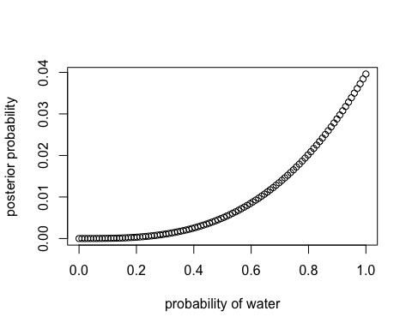

Second set of observations: W W W L (3/4)

# Step 3: Compute likelihood at each value in grid  
likelihood <- dbinom(3, size=4, prob=p_grid)  
# Step 4: Multiply prior with likelihood to get unstandardized posterior  
unstd.posterior <- likelihood * prior  
# Step 5: Standardize the posterior  
posterior <- unstd.posterior / sum(unstd.posterior)  
  
plot(p_grid, posterior, type="b" ,  
 xlab="probability of water", ylab="posterior probability")

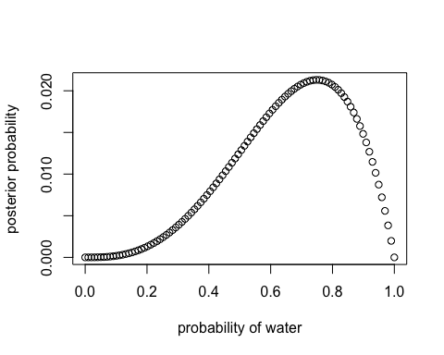

Thrid set of observations: L W W L W W W (5/7)

# Step 3: Compute likelihood at each value in grid  
likelihood <- dbinom(5, size=7, prob=p_grid)  
# Step 4: Multiply prior with likelihood to get unstandardized posterior  
unstd.posterior <- likelihood * prior  
# Step 5: Standardize the posterior  
posterior <- unstd.posterior / sum(unstd.posterior)  
  
plot(p_grid, posterior, type="b" ,  
 xlab="probability of water", ylab="posterior probability")

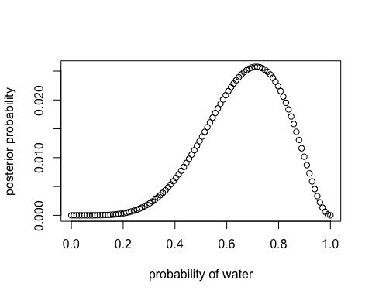

### Task 2M2 – Adjust Globe Tossing Model with binary prior shifting at the value of 0.5

First, adjust the prior:

# Step 2: Define prior (Assumption: Uniform distribution)  
prior <- ifelse(p_grid < 0.5, 0, 1)

Now, re-run with adjusted prior:

First set of observations: W W W (3/3)

# Step 3: Compute likelihood at each value in grid  
likelihood <- dbinom(3, size=3, prob=p_grid)  
# Step 4: Multiply prior with likelihood to get unstandardized posterior  
unstd.posterior <- likelihood * prior  
# Step 5: Standardize the posterior  
posterior <- unstd.posterior / sum(unstd.posterior)  
  
plot(p_grid, posterior, type="b" ,  
 xlab="probability of water", ylab="posterior probability")

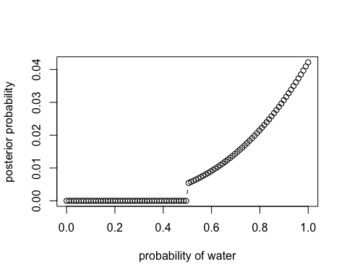

Second set of observations: W W W L (3/4)

# Step 3: Compute likelihood at each value in grid  
likelihood <- dbinom(3, size=4, prob=p_grid)  
# Step 4: Multiply prior with likelihood to get unstandardized posterior  
unstd.posterior <- likelihood * prior  
# Step 5: Standardize the posterior  
posterior <- unstd.posterior / sum(unstd.posterior)  
  
plot(p_grid, posterior, type="b" ,  
 xlab="probability of water", ylab="posterior probability")

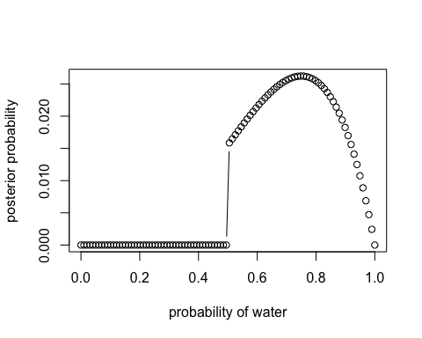

Thrid set of observations: L W W L W W W (5/7)

# Step 3: Compute likelihood at each value in grid  
likelihood <- dbinom(5, size=7, prob=p_grid)  
# Step 4: Multiply prior with likelihood to get unstandardized posterior  
unstd.posterior <- likelihood * prior  
# Step 5: Standardize the posterior  
posterior <- unstd.posterior / sum(unstd.posterior)  
  
plot(p_grid, posterior, type="b" ,  
 xlab="probability of water", ylab="posterior probability")

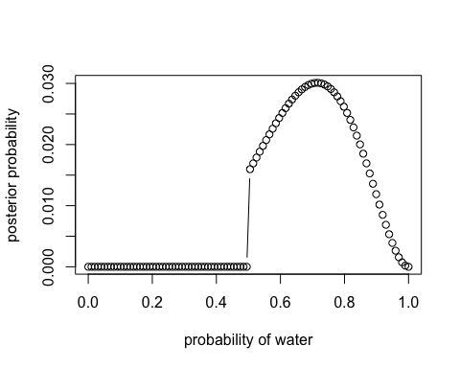

### Task 2M3 – Tossing of Earth and Mars

First, the information from the text is stored in probabilities:

prob_earth_water <- 0.7 # Earth covered with 70% water  
prob_earth_land <- 1-prob_earth_water # Land conditional on water  
  
prob_mars_land <- 1 # Not much water on Mars  
  
prob_earth <- 0.5 # Both planets equally likely to be tossed  
prob_mars <- 1-prob_earth

Now, this information can be used to compute the posterior probability that the globe was the Earth, conditional on seeing land (Pr(Earth|land)) and that it is equal to 0.23:

prob_land <- prob_earth_land*prob_earth + prob_mars_land*prob_mars; prob_land

## [1] 0.65

prob_land_earth <- (prob_earth_land*prob_earth)/prob_land; prob_land_earth

## [1] 0.2307692

### Task 2M4 – Three black and white cards

A deck involves three cards with the following properties: Card 1: Black/Black Card 2: Black/White Card 3: White/White

One card is randomly chosen and put on the table. The upper side is black, now show that the probability that the other side is also black is 2/3:

d <- tibble(front = c(0, 0, 1),  
 back = c(0, 1, 1))  
  
d %>% mutate(first_black= front+back) %>%   
 mutate(prob = first_black/(sum(first_black)))

## # A tibble: 3 x 4  
## front back first_black prob  
## <dbl> <dbl> <dbl> <dbl>  
## 1 0 0 0 0   
## 2 0 1 1 0.333  
## 3 1 1 2 0.667

### Task 2M5 – Now four cards

The deck from the previous task is supplemented by another Black/Black card. Therefore the overall deck is:

Card 1: Black/Black Card 2: Black/White Card 3: White/White Card 4: Black/Black

d <- tibble(front = c(0, 0, 1, 1),  
 back = c(0, 1, 1, 1))  
  
d %>% mutate(first_black= front+back) %>%   
 mutate(prob = first_black/(sum(first_black)))

## # A tibble: 4 x 4  
## front back first_black prob  
## <dbl> <dbl> <dbl> <dbl>  
## 1 0 0 0 0   
## 2 0 1 1 0.2  
## 3 1 1 2 0.4  
## 4 1 1 2 0.4

When adding up the probabilities where the first side is black (lines 3 and 4) we arrive at a probability of 0.8 (0.4 + 0.4) that the other side is black as well.

### Task 2M6 – Unequal probabilities to draw black

Now, the deck from task 2M4 is used again but this time the probabilities to draw a card depend on the color since the ink makes the cards with black sides heavier:

Card 1: Black/Black Card 2: Black/White Card 3: White/White

For every way to pull the Black/Black card from the bag, there are 2 ways to pull the Black/White card and 3 ways to pull the White/White card.

d <- tibble(front = c(0, 0, 1),  
 back = c(0, 1, 1),  
 weight = c(3, 2, 1))  
  
d %>% mutate(first_black= front+back) %>%   
 mutate(prob = first_black*weight/(sum(first_black*weight)))

## # A tibble: 3 x 5  
## front back weight first_black prob  
## <dbl> <dbl> <dbl> <dbl> <dbl>  
## 1 0 0 3 0 0   
## 2 0 1 2 1 0.5  
## 3 1 1 1 2 0.5

From the table it can be seen that if the front is black, then the probability with the adjusted weight of also having black on the back drops to 0.5.

### Task 2M7 – Three black and white cards, again, but different setting

Deck: Card 1: Black/Black Card 2: Black/White Card 3: White/White

Setting: A first card is drawn from the deck and is black in the front. Now a second card is drawn and the front is white. In this setting, what is the probability that the backside of the first card is also black?

card <- c("Black/Black", "Black/White", "White/White")  
prior <- 1  
ways <- c(6, 2, 0)  
likelihood <- ways * prior  
prob <- likelihood / sum(likelihood); prob

## [1] 0.75 0.25 0.00

Note: The code above doesn’t automatically produces the results but builds on the logically derived, hard-coded “ways” vector.

First card: Black/Black (2) –> Second card: Black/White or White/White (3) –> there are 6 (2 * 3) possible ways to produce the observed outcome First card: Black/White (1) –> Second card: Black/Black or White/White (2) –> there are 2 (1 * 2) possible ways to produce the observed outcome First card: White/White (0) –> No way to produce the observed outcome