–

Exective Summary:

What TFO is.

A two-for-one tactic is s
In basketball, a two-for-one tactic is when teams try to get two shots at the ends of quarters and force their opponent to only get one shot, essentially getting a one-shot advantage over the opponent.
A team can generally secure a two-for-one advantage by timing their shots, so that if they shoot with around 35 seconds remaining in the quarter, they can get the ball back for another shot which will be the last shot in the quarter, with only a few seconds remaining.

In this study, we look to see if and how, by trying to maximize the number of shots attempted, teams negatively impact the quality of those shots.

Overall, compared to baseline shooting, during a Two-for-One window, teams both attempt more 3 point shots, and shoot 3 point shots less efficiently (down 4 percentage points). Overall field goal efficiency for all shots (2 pt and 3 pt attempts combined) drops from 51% to 48%.

On a more fine-grained scale, from 40-seconds to 27 seconds remaining, shooting percentage drops from about 57% to about 47%, indicating that teams may be forcing shots towards the end of this two-for-one window.

Distance of shots was steady between the two periods, from XX ft and YY ft for 2pt and 3pt shots respectively.

–

Intro:

-

Figures...

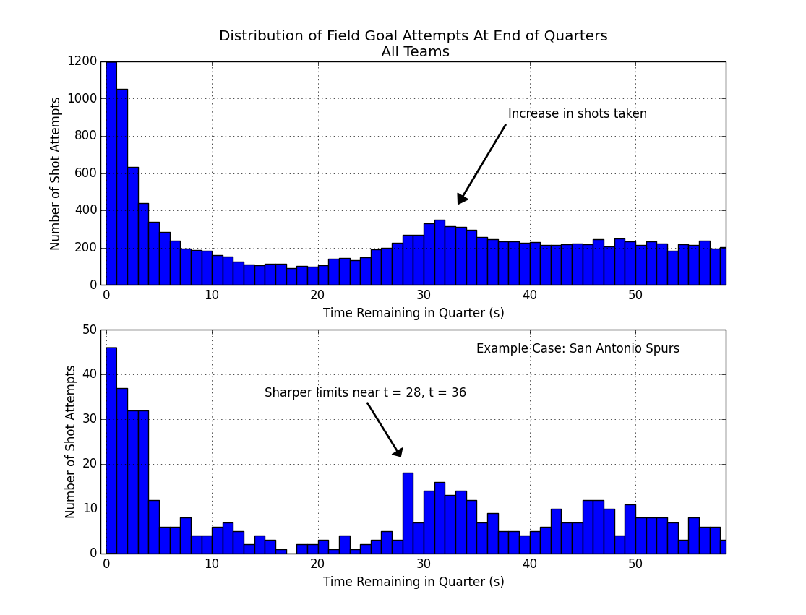

First off we need to identify and define this Two-For-One window.

Above figure. Top panel, shows an increase in shot attempts around 30-35 seconds remaining in the quarter. We also notice a decrease in shots taken between 10-25 seconds, and a lot of buzzer-beat type shots taken with 3 seconds or less left on the clock.

So 30-35 seconds gives us a general timeframe of a 2-for-1 window, but let's get more specific. If we look at an example case like the San Antonio Spurs, a league-leading team known for smart basketball, (figure, lower panel) we see a similar increase in the number of shots attempted, with slightly different cutoff points, near 28 seconds, and 36 seconds. And these cutoffs have sharp drop-offs before and after, so this gives us further indication that we're basically in the right window of time.

In the end, we're going to define our 2-for-1 window from 27-35 seconds (inclusive) remaining in the quarter. This is a bit conservative on the upper end, but to the extent we can, we want to make sure most of these shots in this window are indeed 2-for-1 type of shots and not just a team's normal behavior. For comparison, we define a baseline timerange from 65 to 180 second remaining in the quarter. (* Due to an issue with the data near time = 60, we make some adjustments here to compensate.) Shooting statistics in this baseline timerange are very close to overall season mean shooting numbers. Additionally, this baseline may be a better comparison since it is closer in time, and may partially control for players on the court, fatigue, and other factors.

(end)

What's in the figure: the figure shows the total number of shot attempts taken during the entire season in the league, with X many seconds left on the game clock in the quarter.

Example: there were around 200 total shots taken with about 50 seconds left on the clock.

General;
While the tactic is about maximizing the number of shot attempts, we're going to look and see if and how that's impacting the quality of those attempts.

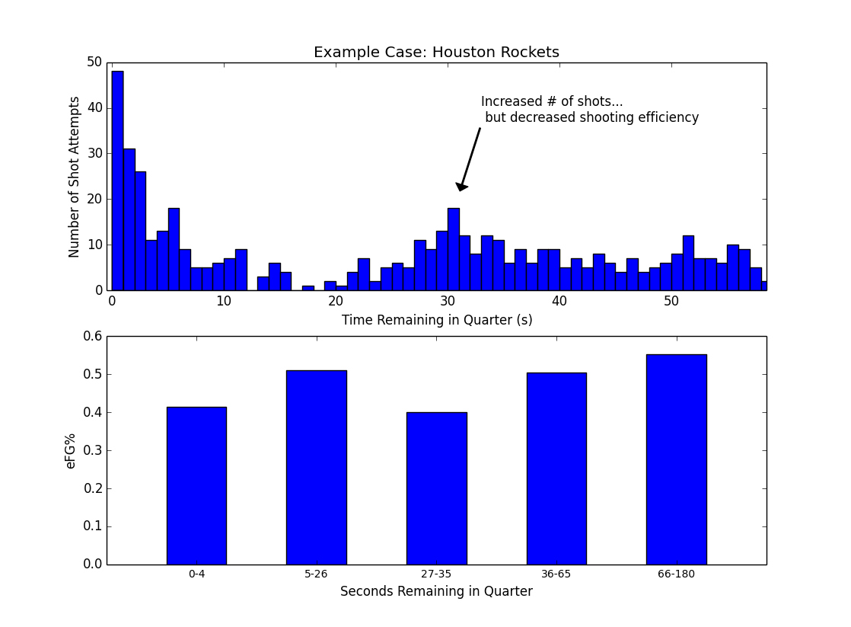

–
Example case Houston.

So, in the second figure, we're seeing an example of what may be happening for some teams: a team shoots more during this two-for-one window (near 30 seconds remaining on the clock), and there's a resulting dip in shooting efficiency (figure, lower panel) between 27-35 seconds remaining in the quarter. The drop in efficiency for Houton is substantial, from 0.55 to 0.40, a drop of 15 percentage points, or roughly 0.3 points per shot. That size of difference is enough to take an offense from first to lat in the NBA. For comparison, the difference between the first ranked and the last ranked offense in the league in points per shot was 0.17. Houston's drop-off is almost double.

The main question we're asking here is whether Houston is an outlier case, or whether this happens for all or most teams, and how big of a drop-off there may normally be.

--

Middle -

Proportion of shots that are 3pt attempts, epoch 3: 0.33
Proportion of shots that are 3pt attempts, epoch 5: 0.26

3pt fg %, epoch 3: 0.33
3pt fg %, epoch 5: 0.37
Change in 3pt fg %: -0.04

Overall eFG %, epoch 3: 0.48
Overall eFG %, epoch 5: 0.51
Change in Overall eFG %: -0.02

Table 1: Overall Comparison of Two-for-One shooting vs Baseline Shooting.

 | Proportion of 3pt Attempts (2s vs 3s) | 3pt Effectiveness | Overall Shot Efficiency (eFG%)
Baseline (Epoch 5) | 0.26 | 37 % | 0.51
Two-for-One (Epoch 3) | 0.33 | 33 % | 0.38
Change | + 0.07 | - 0.04 % pts | - 0.02 *

* may not add up due to rounding.
** Transpose table?

Grouping teams by shot , TFO aggressiveness:

Tripiles …

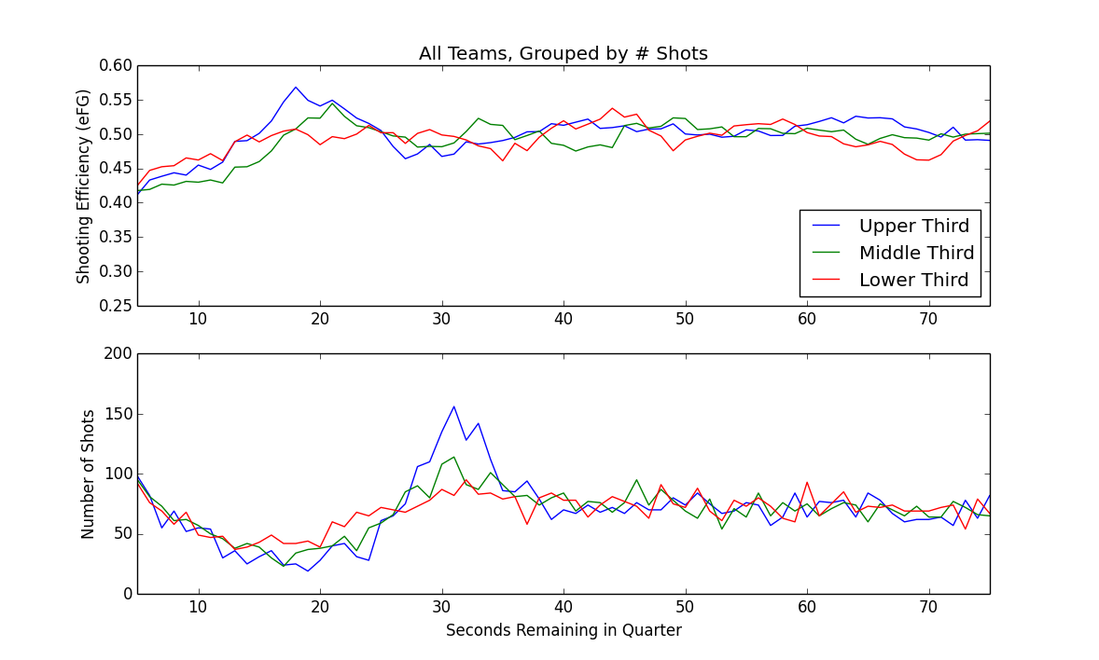

(Add vertical bars to highlight two-for-one window?)

We grouped teams into three groups, based on number of shots taken during the 2-for-1 window, as a simple way of seeing which teams were attempting a 2-for-1 tactic the most often.

Overall, for the top one-third of teams in terms of number of shots taken in the 2-for-1 window, we can see an increase in shots around 30 seconds remaining (lower panel, blue), along with a slight dip in shooting efficiency (upper panel, blue).

The other thing we see in this series is that the middle group, and the lower group, really aren't that much more aggressive in terms of taking extra shots in this 2-for-1 window.

Final answers.

Main figure / main result:

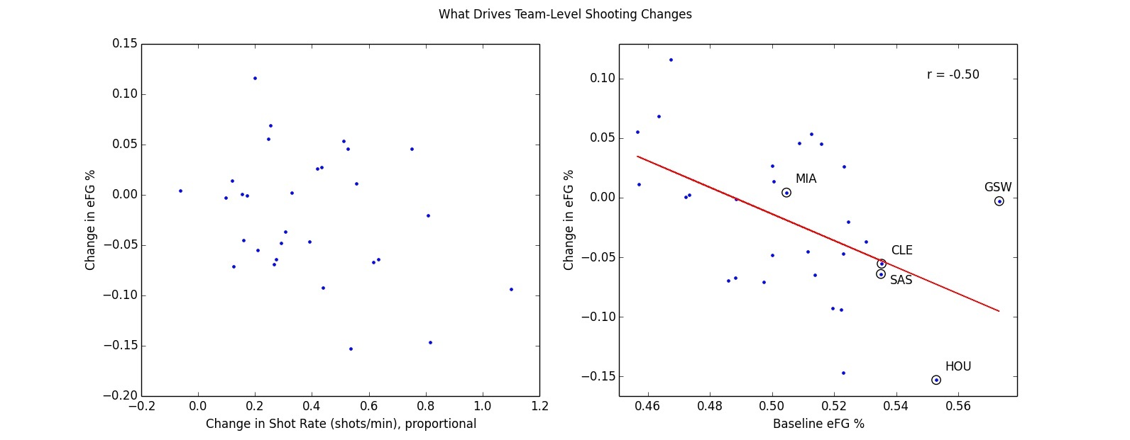

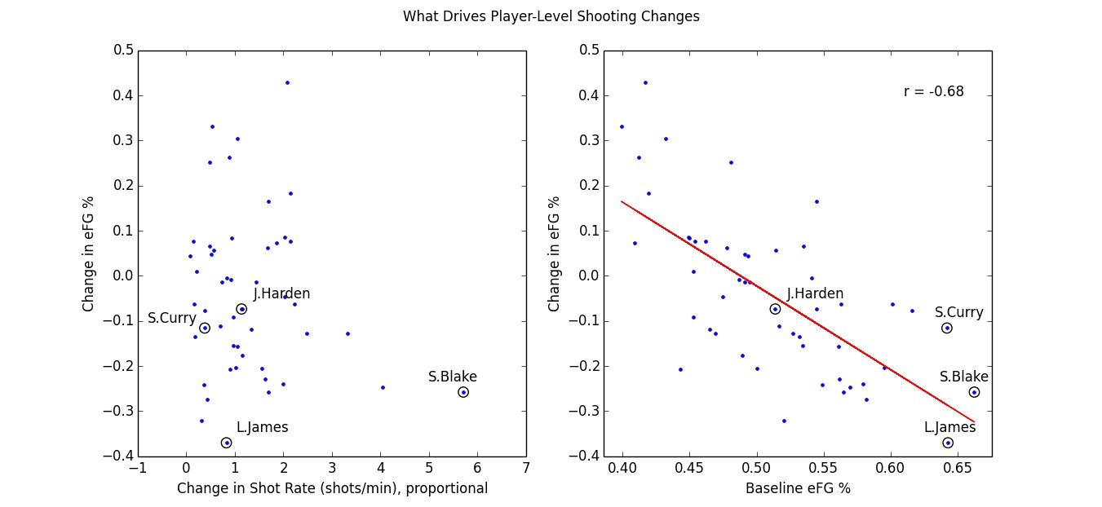

# Breakdown –

.. small driver vs bigger driver.

So, at the team level, there's some indication that taking more shots during the TFO window leads to less efficient shooting, // it's weakly correlated.
At the individual level this breaks down. It may be true for some extreme cases like Steve Blake (circled, left panel).

Overall, the spread in shooting efficiency is pretty random.
On the right, we can see that most of the change in shooting efficiency is actually related to how well teams and individuals shot to begin with (right panels).

Teams that shoot worse in general tend to shoot better during this two-for-one window; conversely, teams that normally shoot well, saw a decrease in their efficiency during this window.

That same relationship tends to hold when looking at the individual level: bad players shot better and the good players shot worse. For example, Lebron James, who shot an adjusted 64% during the baseline window, ends up shooting about 33 % points worse when shooting in the two-for-one window.

This is a type of “regression to the mean” effect, …

The other way to look at this is more simple: it's harder for a poor shooting team to shoot worse, so they can only improve in the two-for-one window. Conversely, a good-shooting team would find it difficult to shoot better than a league-leading offense, so the only way they can move is down toward the middle of the pack.

–

Smoothed data / per-second analysis:

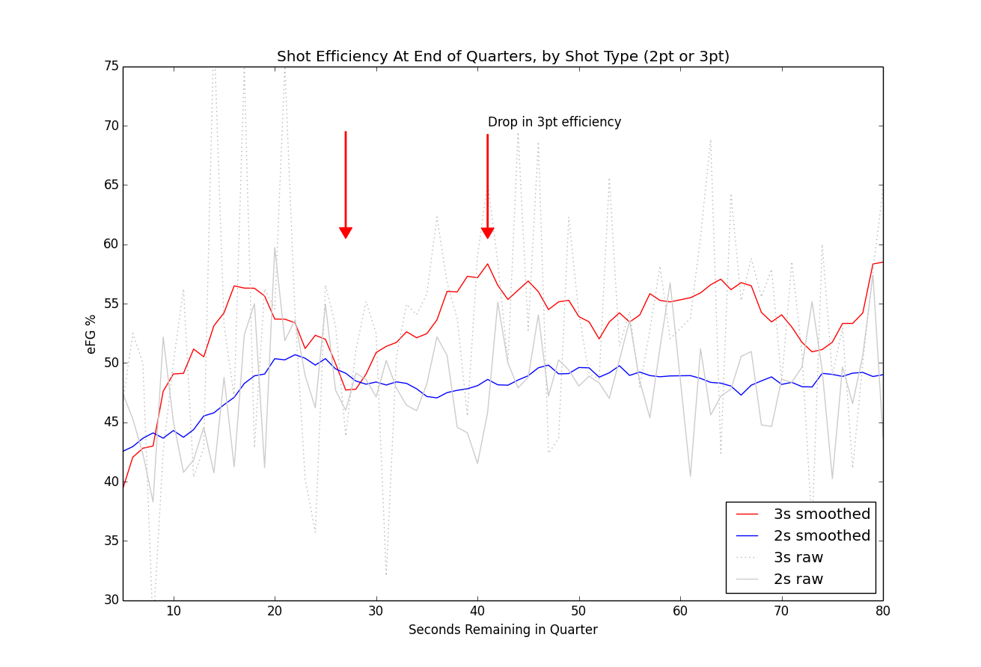

–
Furthermore, during a smoothed per-second analysis during and around the two-for-one window (from 40 to 27 seconds), we can see a decrease of in 3pt shooting efficiency (Figure X, red line) of about 10 percentage points, from about 57% to around 47%.

Interpretation: during the two-for-one window, three-point shots get worse as you approach the 27 second mark, as players get more antsy just to get off any shot.

Additional finding:
pearsonr(team_report['shotrate_diff'], team_report['prop_threes_diff'])
# (0.48164911393624316, 0.0070403594139744228)
# Higher TFO Shotrate -> Higher Proportion of 3s Attempted.

# **

# add in somewhere fitting.

On a per-team basis, the more a team goes for a TFO advantage, the higher proportion of 3s a team attempts.

# The fact that Proportion of Threes is marginally associated with 3pt eFG, means we'd want to keep an eye on this going forward. – It may become more relevant in the future.

.. blah blah.

–
Control:
(file: tfo_team_report.py)

Figures 1010 1011, 1012.

e3 vs e5, ok – a reg.
diff(e3, e5) vs control – no diff ?

E5 vs diff(e3,e5) –

econtrol vs diff(e3,ec) – still a regression to mean... so regression to mean still mainly in effect.

E5 vs diff(e3, ec) – flat. & e5 corr with ec. Therefore: Regression to mean effect between e5, and e3, probalby not due to chance.).

efg EC vs diff(e3, EC) – still reg to mean type neg correlation. // if we use an alternate control instead of E5, we still see regression to mean.

# ---

What does this mean? :

pearsonr(df_espn['AFG%'], df_espn['AFG%'] - team_report['team_efg_e3'])
Out[262]: (-0.36302758790579298, 0.048638443311019963)

means:
1) what we saw with e3-e5, should still hold. It's basically the same thing. (Especially considering e5 corr with espn_afg.

# Fig 1021 ** – with increasing shotrate, you see teams taking proportionally more 3pt attempts.

# –

Correlation between efg in epochs 4 and 5 – are correlated (r .40, p = .028).

So upshot: normally, efg from differenct time periods *should* be correlated.
What's telling us something about e3 is that this relationship broke down.
That it is not correlated between the TFO window and normally, in epoch 5 (baseline).
That's our interpretation.

– So what we see between epochs 3 and 5 (between the TFO window and baseline shooting), is not correlated, it's just random. – So what this means is that efg is different from what it normally is.

–
more – alt.
Do Shot Quality based on Expected Value of the shooter taking the shot.
Then it's just an EV calc between epochs.

–
HOU Followup section -

So, what's going on with Houston?

The overall story at the team-level doesn't hold for Houston when we look at individuals. Harden, an above average player, takes a slight dip in efficiency, but his teammates face a steeper fall-off.

Here's the splits between Harden and the rest of the team:
(Table)

(Table not shown. TODO)

–

Technical Skills shown:

- Used data to address specific questions related to performance.
- Data preparation, pre-processing: smoothing data, re-mapping time into alternate time periods; parsing the descriptive text to extract player, shot type, distance information.
- Data quality / anomaly check (spike in data at time = 60 seconds)
- Data smoothing
- Data re-shaping, reconstructing shot-logs for end of quarter scenarios.
- Analysis at different levels of aggregation: by team, by individual, by quarter.

