Two-for-one shooting in the NBA

Marc Velasco

# tl;dr In the two-for-one window, there's a slight dip (~2%) in overall eFG%. Teams shoot more 3s, and shoot them at a worse percentage (33% instead of 37%). The decrease is not uniform for all teams however, some shoot better and some shoot worse.

Intro:

At the end of the 2014 NBA season, Zach Lowe (link, item 19) suggested that some teams, in an attempt to get off a first shot in a two-for-one situation end up with “godawful looks.” That may be because in short clock situations like a two-for-one situation, generating quality looks is not easy.

The logic of going for a two-for-one is essentially this: “A smart team would’ve taken two bad shots instead of one good one” - Jonah White. As long as the bad shots aren’t “too bad” then 2 shots > 1 shot. But the question Lowe raises is “do teams shoot worse when going for a two-for-one? And if so, how bad are the bad shots?”

Part 1: The Two-for-One Window

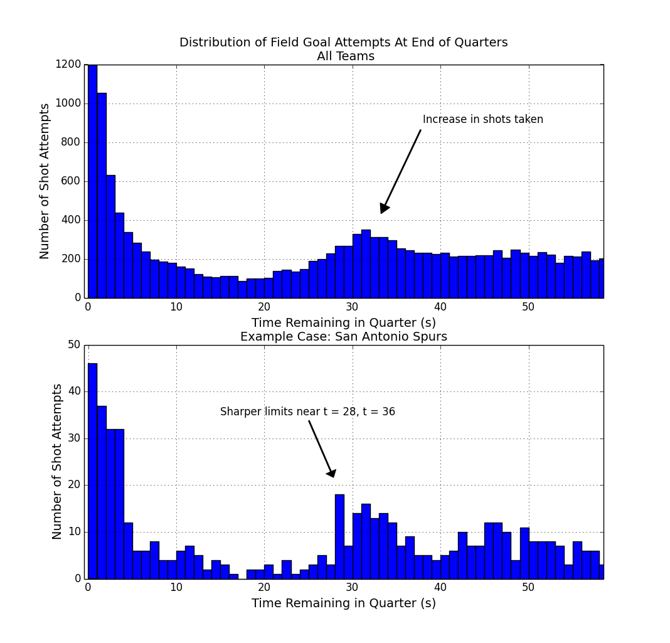
First off we need to identify and define this Two-For-One window.

We look at the shots taken at the end of quarters in the 2014-2015 season in the NBA, focusing on the first three quarters only, dropping the fourth quarter due to end-of-game complications. The top panel shows an increase in shot attempts in the number of shots taken around 30-35 seconds remaining in the quarter. We also notice a lot of buzzer-beat type shots taken with 3 seconds or less left on the clock. Looking at the Spurs specifically (bottom panel), they show an in shots around 28-36 seconds remaining.

In the end, we're going to define our 2-for-1 window from 27-35 seconds (inclusive) remaining in the quarter. For comparison, we define a baseline time-range from 66 to 180 second remaining in the quarter. In general, shooting statistics in this baseline time-range are close to overall season shooting numbers. Additionally, this baseline may be a better comparison since it is closer in time, and may partially control for players on the court, fatigue, and other factors.
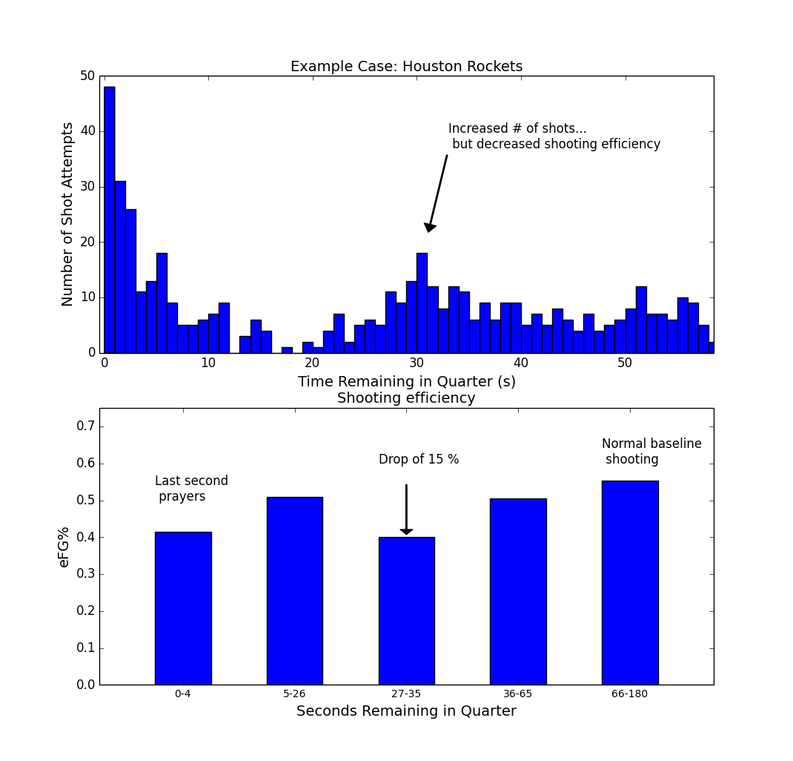
Example case Houston

With Houston, we're seeing an example of what may be happening for some teams: a team shoots more during this two-for-one window (near 30 seconds remaining on the clock), and there's a resulting dip in shooting efficiency (figure, lower panel) between 27-35 seconds remaining in the quarter. The drop in efficiency for Houston is substantial, from 0.55 to 0.40, a drop of 15 percentage points, or roughly 0.3 points per shot. For comparison, that size of difference is enough to take an offense from first to last in the NBA. Last year, the difference between the first ranked and the last ranked offense in the league in points per shot was 0.17. Houston's drop-off is almost double this.

Part 2: The Impact of Two-for-One Shooting on Shooting Efficiency

Approach:

The approach we're going to take is to compare a Baseline period and use it to compare against the shooting in the Two-For-One window. The baseline period is from 66-180 seconds remaining in the quarter, and the two-for-one window is from 27-35 seconds remaining in the quarter. (Dataset: shots dataset from basketball-reference.com for the 2014-2015 season. Further details on the dataset are at the end under Technical Notes.)

Results:

Here's the basic differences in shooting behavior between the Baseline period and the Two-for-One window. Overall eFG% (2s and 3s combined) takes a slight dip of 2% in the Two-for-One window. The main story is around 3-pt shots.

There's a change in shot selection as teams attempt more 3-pt shots, with the share of 3-pt shots increasing from 0.26 of all shots to 0.33 of all shots. While teams shoot more 3s, the accuracy on 3-pt shots decreases, from 37% to 33%.

Table 1: Overall Comparison of Two-for-One shooting vs Baseline Shooting

 | Proportion of 3pt Attempts (2s vs 3s) | 3-pt Accuracy | Overall Shot Efficiency (eFG%)
Baseline (65-180 seconds) | 0.26 | 37 % | 51 %
Two-for-One (27-35 seconds) | 0.33 | 33 % | 48 %
Change | + 0.07 | - 04 % pts | - 02 % *

* may not add up due to rounding.

Which teams and individual players are affected the most

The overall impact was a modest drop-off in shooting efficiency of about 0.02%, this does not affect all teams equally, some teams and individuals performed relatively better and worse.

First, the teams. Here are the 10 teams that shot saw the biggest declines in the Two-for-One window.

Table 2: Team Changes

Houston saw the biggest drop-off at 15%, but Houston is not alone, as Utah also dropped off nearly as much. Portland and Washington each saw declines of about 9%. The main curiosity here is that Houston is as driven by analytics as any organization (link), so you wouldn't expect them to pursue a tactic like this and get sub-par results.
Table 3: Individual Players

At the individual player level, shooting in the Two-for-One window more often may lead to a decrease in shooting efficiency. Of the players on this table who saw a change in shooting efficiency of more than 10 percentage points either up or down, 2 saw an increase, and 8 saw a decrease. And for this group of twenty players, the average change in shooting efficiency was -5.6%, which is slightly worse than the -2.2% change we saw at the overall league-wide comparison. 1.

(For full tables of Teams and Players, see the two excel files attached to this project.)

Predictors of shooting efficiency during the two-for-one window

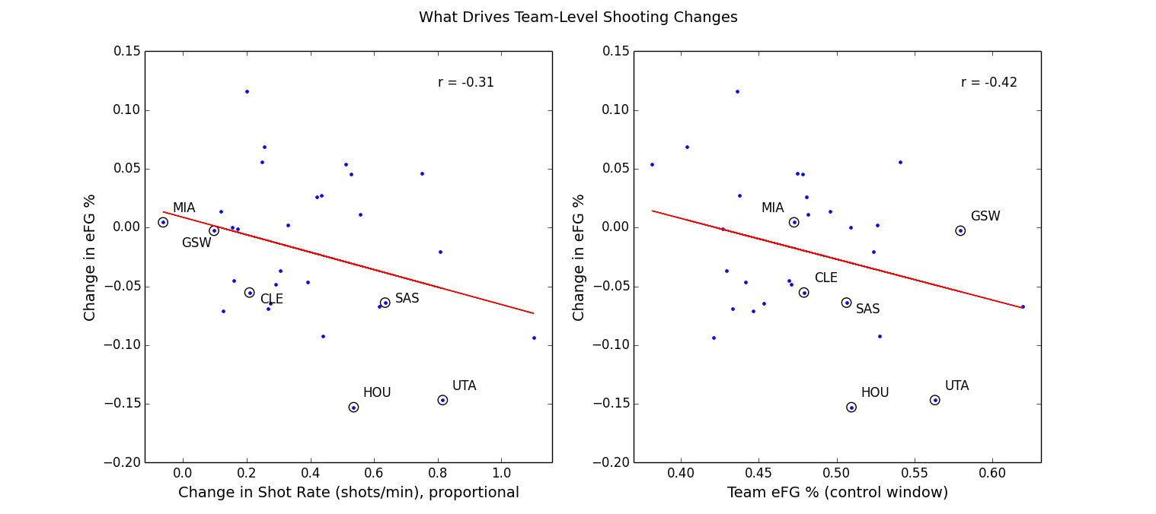

Here we look at two possible drivers to explain what happens to changes in shooting efficiency.

In the left panel above there's some indication that taking more shots during the Two-for-One window leads to less efficient shooting (r = -0.31). The change in shooting efficiency is also related to how well teams shoot to begin with (right panel). (Here, shooting efficiency (Team eFG%) is measured in a control window from time between 5 and 26 seconds remaining in the quarter.) Teams that shoot worse in general tend to shoot better during this two-for-one window; conversely, teams that normally shoot well end up shooting worse. This is a type of “regression to the mean” effect. One way to look at it is like this: it's harder for a poor shooting team to shoot worse, so they can only improve in the two-for-one window. Overall, these two predictors don't offer the tightest fit (r-values are modest, but not great). So, likely there additional factors at play.

3-point Efficiency Decreasing Over Time

Here we are looking at a per-second analysis of eFG%. Because it's noisy, we smooth the time series and plot the results, in red for 3-point attempts and in blue for 2-point attempts. (Raw data in grayscale.)

There's no major change for 2-point shots. For 3-point shots (solid red line) efficiency drops off between 40 and 27 seconds, with a decrease in efficiency of about 10 percentage points, from about 57% to 47%.

Earlier, we saw a difference in shooting efficiency between these our two time windows. Here, it appears 3-point shooting percentage decreases within this Two-for-One window as well. As time approaches roughly 27 seconds remaining, and players become antsy to get off any shot, overall shot quality diminishes.
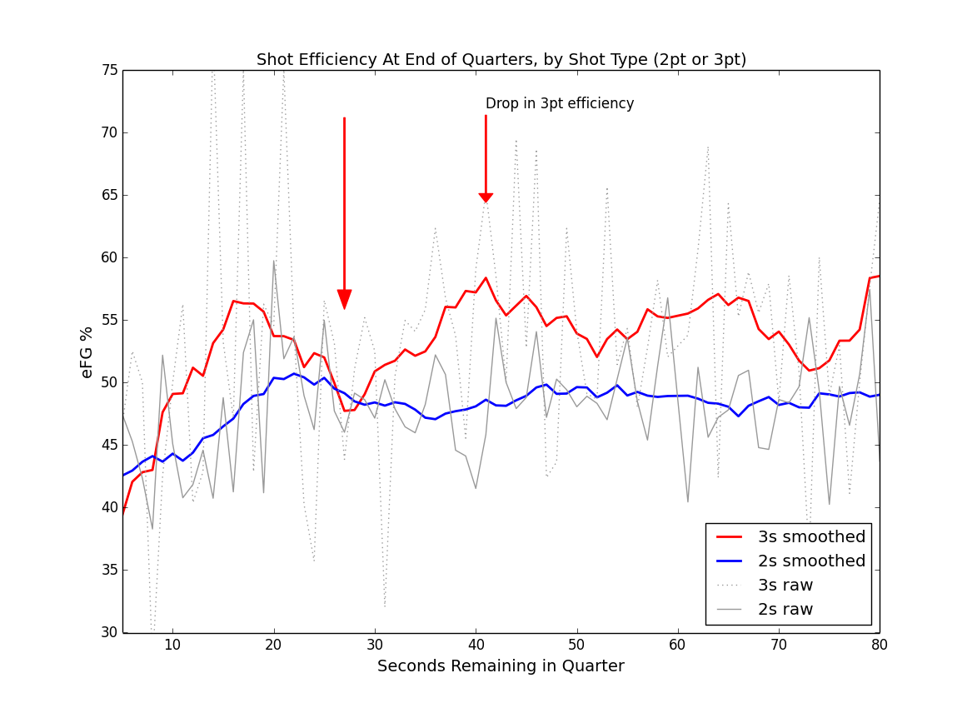

Following up with Houston

So, what's going on with Houston?

While Harden takes a slight dip in efficiency, his teammates face a much steeper fall-off, dropping 20 percentage points from 0.57 to 0.37 in adjusted efficiency. Here's the splits between Harden and the rest of the team:

Table 4: Houston Splits.

A closer look at game film or SportsVu data on these plays could also help evaluate how bad these shots were, how close any defenders were, or if the players had poor mechanics on those shots, etc. Houston was one of the teams that saw the highest increase in shot volume during the two-for-one window, and they seem to be one of the teams whose shooting efficiency suffered the most.

Conclusion:

The logic of the Two-for-One tactic is premised on the idea that one team will end up with an extra shot, and on average that extra shot will be worth roughly one point. When we look at the expected value of the extra shot generated that shot value is only 0.70 points and that there is also a negative impact of about 0.05 points on the shot taken during the Two-for-One window, on which teams compromise on quality in order to secure the extra shot. So pursuing this tactic may not yield as high returns as teams hope for.

Teams do change their shooting behavior during the Two-for-One window, and Lowe's observation that some teams end up with bad looks during the Two-for-One window may reflect three things: 1) the general increase in 3-point attempts 2) the concurrent decrease in 3-point accuracy and, 3) the fact that the biggest drop-offs in shooting efficiency tend to be happening to normally high-powered offenses like Houston's.

Technical Notes:

Data source: basketball-reference.com. End of quarters only, for quarters one through three. Fourth quarter discarded because of end-of-game complications. Only shots occurring in the last three minutes of the quarter were included. A ceiling on distance was placed on 3-point shots, allowing only those of less than 40 ft, so that low-percentage, full-court shots would not be included. We’re not tracking full play-by-play data, so turnovers, rebounds, second chances, free throws, etc aren’t in the picture. We’re just looking at shot data, time of shot, distance, player, 2-point vs 3-point attempt.

1. Note: Here and elsewhere in this report, changes in shooting efficiency are denoted as a % even though the numbers are strictly flat percentage point changes. So a change from 50% to 40% is simply referred to as a 10% drop (and not a relative 20% drop).

