Two-for-one shooting in the NBA

–

Exective Summary:

In basketball, a two-for-one tactic is when teams try to get two shots at the end of quarters and force their opponent to only get one shot, essentially getting an extra shot over the opponent.
A team can generally secure a two-for-one advantage by timing their shots, so that if they shoot with around 35 seconds remaining in the quarter, they can get the ball back for another shot which will be the last shot in the quarter.

In this study, we look to see if and how, by trying to maximize the number of shots attempted, teams negatively impact the quality of those shots. The data used is a set of all field goal attempts from all games in the 2014-2015 NBA regular season.

Overall, compared to normal, baseline shooting behavior, during a Two-for-One window, teams both attempt more 3 point shots, and shoot 3 point shots less efficiently (down 4 percentage points). Overall field goal efficiency (conversion of shots to points) for all shots (2-point and 3-point attempts combined) drops from 51% to 48%. // At the team level, the decrease in shooting efficiency is not uniform, as some teams improve during the two-for-one window, and some teams decrease.

Distance of shots was steady between the two periods, with shots from 8.0 ft and 24.9 ft for 2-point and 3-point attempts respectively.

On a more fine-grained scale, per-second analysis, from 40 seconds to 27 seconds remaining, shooting efficiency for 3-point shots drops steadily from about 57% at 40 seconds to about 47% at 27 seconds, indicating that teams may be forcing shots towards the end of this two-for-one window.

Overall, the rate at which teams increase the number of shots taken in the Two-for-One window moderately correlates with a decrease in shooting efficiency. Poor shooting teams improved their shooting efficiency during the Two-for-One window, and normally good-shooting teams saw their shooting efficiency decrease. This is in line with the general belief that most teams end up with only “average” shots during this Two-for-One window.

While the two-for-one tactic may not yield as high returns as teams hope for, this tactic is still worth pursuing as it prevents the other team from securing that advantage. Over the first three quarters of an NBA game, the cumulative advantage can be 3.9 points.

–

Intro:

Recently Zach Lowe (http://grantland.com/the-triangle/the-supersize-nba-season-ending-things-i-like-and-dont-like/, item 19) suggested that some teams, in an attempt to get off a first shot in a two-for-one end up with “godawful looks.” What follows is a preliminary analysis of shooting efficiency in the two-for-one scenario.

What is a two-for-one scenario? It’s a situation at the end of quarters where a team tries to get two shots and limit their opponent to only one shot. The logic of going for a two-for-one is essentially this: “A smart team would’ve taken two bad shots instead of one good one” - Jonah White.

As long as the bad shots aren’t “too bad” then 2 shots > 1 shot. But the question Lowe raises is “do teams shoot worse when going for a two-for-one? And if so, how bad are the bad shots?”

In Part 1, we will use the shot occurrence data to help define when this two-for-one window occurs, and in Part 2, we will examine the impact that two-for-one shooting has on shot quality (ie, shooting accuracy).

Part 1: The Two-for-One Window

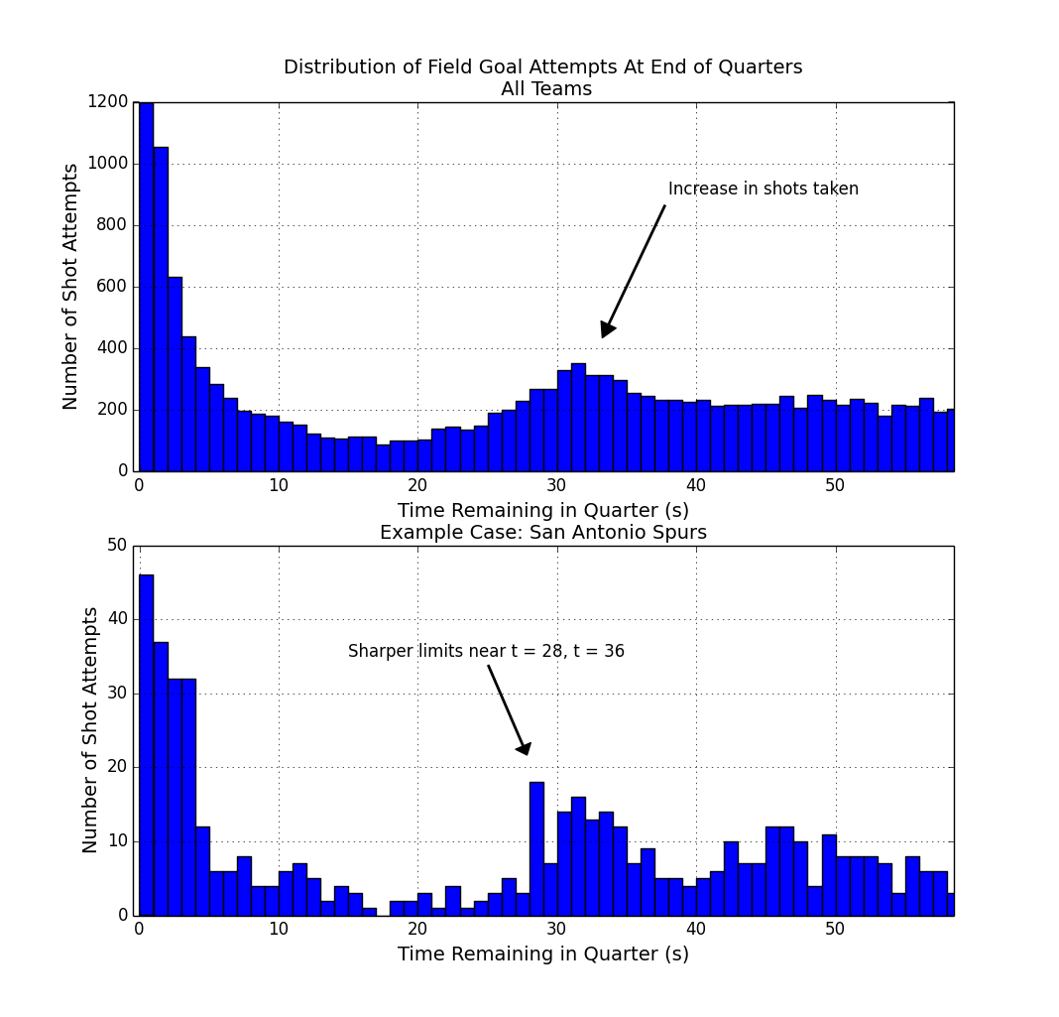
First off we need to identify and define this Two-For-One window.

Context: In basketball, there's a shot clock of 24 seconds. This means that once a team gets the ball, in the simplest case, they have 24 seconds in which to shoot the ball, or else they forfeit possession, and the ball goes to the other team. So a savvy team, if they shoot the ball with about 30 seconds remaining, even if the other team uses all 24 seconds to shoot the ball, will still get it back with about 6 seconds left. That's enough time for a shot, not a great shot, but just a decent one.

So we look at all the shots taken in the 2014-2015 season in the NBA, focusing on the first three quarters only, dropping the fourth quarter due to end-of-game complications. In the figure above (top panel), for the last minute in the quarter, we can see when the shots were taken, e.g., with 23 seconds remaining in the quarter there were about 200 shots taken during the season.

The top panel shows an increase in shot attempts in the number of shots taken around 30-35 seconds remaining in the quarter. We also notice a decrease in shots taken between 10-25 seconds, and a lot of buzzer-beat type shots taken with 3 seconds or less left on the clock.

So 30-35 seconds gives us a general timeframe of a 2-for-1 window, but let's get more specific. If we look at an example case like the San Antonio Spurs, a league-leading team known for smart basketball, (figure, lower panel) we see a similar increase in the number of shots attempted, with slightly different cutoff points, near 28 seconds, and 36 seconds. And these cutoffs have sharp drop-offs before and after, so this provides further indication that we're in the right window of time.

In the end, we're going to define our 2-for-1 window from 27-35 seconds (inclusive) remaining in the quarter. This is a bit conservative on the upper end, but to the extent we can, we want to make sure most of these shots in this window are indeed 2-for-1 type of shots and not just a team's normal behavior. For comparison, we define a baseline time-range from 65 to 180 second remaining in the quarter. (* Due to an issue with the data near time = 60, we make some adjustments here to compensate.) Shooting statistics in this baseline time-range are very close to overall season mean shooting numbers. Additionally, this baseline may be a better comparison since it is closer in time, and may partially control for players on the court, fatigue, and other factors.

–
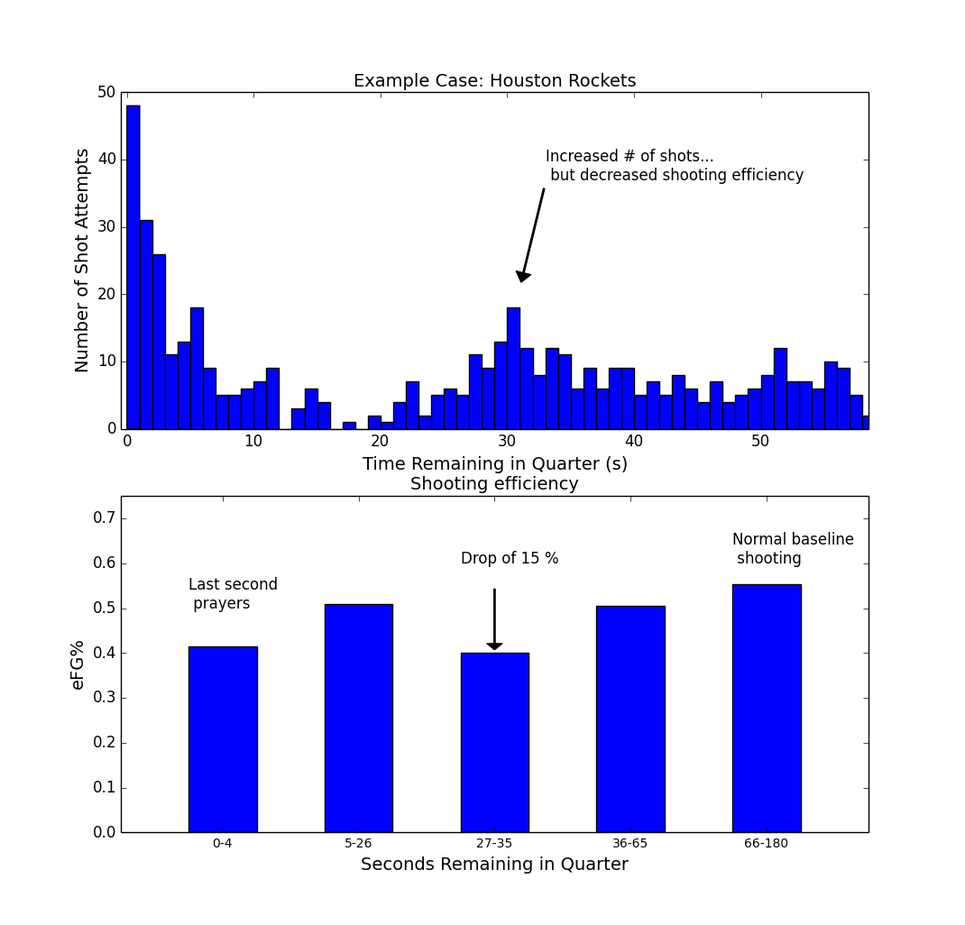

Example case Houston.

So, in the second figure, we're seeing an example of what may be happening for some teams: a team shoots more during this two-for-one window (near 30 seconds remaining on the clock), and there's a resulting dip in shooting efficiency (figure, lower panel) between 27-35 seconds remaining in the quarter. The drop in efficiency for Houston is substantial, from 0.55 to 0.40, a drop of 15 percentage points, or roughly 0.3 points per shot. That size of difference is enough to take an offense from first to last in the NBA. For comparison, the difference between the first ranked and the last ranked offense in the league in points per shot was 0.17. Houston's drop-off is almost double this.

The main question we're asking here is whether Houston is an outlier case, or whether this happens for all or most teams, and how big of a drop-off there may normally be.

–

Part 2: The Impact of Two-for-One Shooting on Shooting Efficiency

In part 2 we look at …

Approach (Methods):

As the Houston example suggests, the approach we're going to take is to compare a Baseline period and use it to compare against the shooting in the Two-For-One window. The baseline period is from 65-180 seconds remaining in the quarter, and the two-for-one window is from 27-35 seconds remaining in the quarter.

The main measure we're going to be using is effective field goal percentage (eFG%), which is the # of shots made / # shots attempted, weighted by point value. So shooting 33% on 3 point shots is equivalent to shooting 50% on 2-point shots. It's measuring how efficiently a team (or player) converts shots into points.

While eFG% is useful for combining two- and three-point shots together, we're also going to look at field goal percentage, broken down by 2-point and 3-point shots separately. We are going to look at this first at the team level, then at the player level. Furthermore, we will inspect this on a second-by-second basis. And lastly, we will look again at Houston and see what is driving their dip in shooting efficiency. (Shooting efficiency, eFG%, is an advanced measure within basketball circles that has recently become more broadly accepted into standard practice.)

Another thing we're going to do is look at Shot Rate and the change in Shot Rate. Shot Rate is basically how often a team shoots (shots per second). We're going to look at this to see if and when teams shoot more often during the two-for-one window than during the baseline period. This is an indicator of how often a team is pursuing this two-for-one tactic, as opposed to playing their regular style of offense.

Dataset: shots dataset from basketball-reference.com (field goal attempts from the 2014-15 season).

Dataset characteristics include: number of shots: 40,379, number of games: 1230. Other data conditioning and filtering: Included only quarters one through three; fourth quarter was dropped due to end-of-game complications. Only shots occurring in the last three minutes of the quarter were included. A ceiling on distance was placed on 3-point shots, allowing only those of less than 40 ft, so that low-percentage, full-court shots would not be included. (Further details on the dataset are at the end under Technical Notes.)

Results:

Here's the basic difference in shooting behavior between the Baseline period and the Two-for-One window. Teams tend to attempt more 3 point shots, while shooting both worse on those 3 point attempts and worse overall (2's and 3's combined).

(add Sentence describing the table)

Table 1: Overall Comparison of Two-for-One shooting vs Baseline Shooting.

 | Proportion of 3pt Attempts (2s vs 3s) | 3-pt Accuracy | Overall Shot Efficiency (eFG%)
Baseline (65-180 seconds) | 0.26 | 37 % | 51 %
Two-for-One (27-35 seconds) | 0.33 | 33 % | 48 %
Change | + 0.07 | - 04 % pts | - 02 % *

* may not add up due to rounding.

The distance of shots taken during the two-for-one window did not really change compared to the baseline period. For two point shots, average shot distance was 7.85 ft compared to 8.0 ft, two-for-one window and baseline period respectively. For three-point shots average shot distance was 25.1 ft compared to 24.9 ft.

Predictors of shooting efficiency during the two-for-one window.

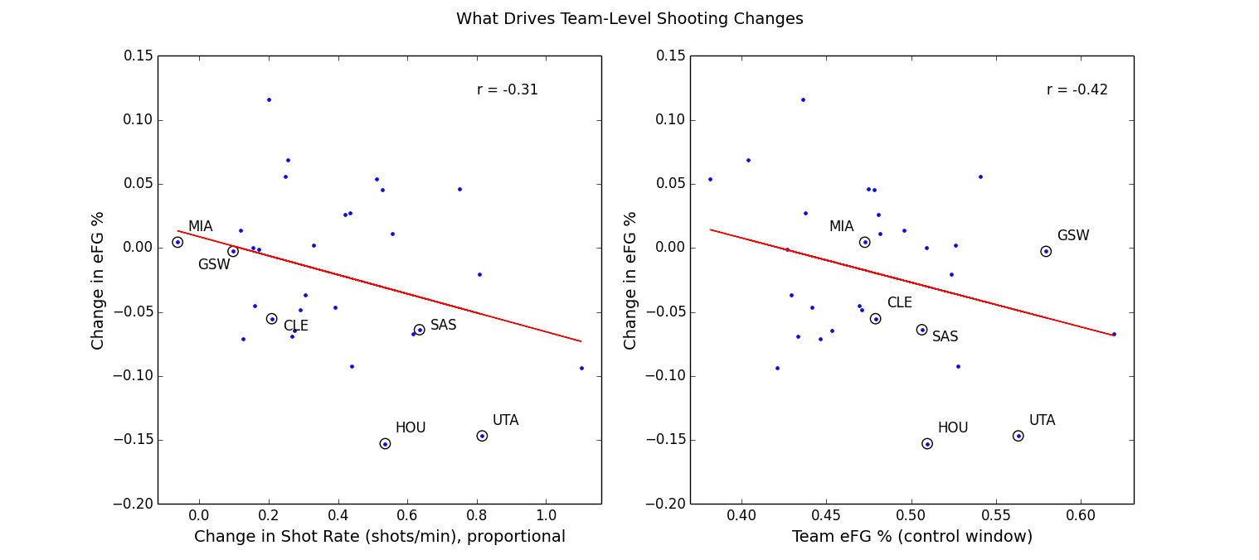

Here we look at two possible drivers to explain what happens to changes in shooting efficiency.
The first measure we look at is Shot Rate (how often a team shoots, the volume of shots a team takes), specifically looking at the Change in Shot Rate, so how much more a team shoots in the Two-for-One window than normal. The second explanatory measure we will look at it is how well the team shoots normally.

In the left panel above there's some indication that taking more shots during the Two-for-One window leads to less efficient shooting (r = -0.31). So here, the simplest explanation is that taking more shots to take advantage of the Two-for-One window negatively impacts the quality of shots taken.

The change in shooting efficiency is also related to how well teams shoot to begin with (right panel). Here, shooting efficiency (Team eFG%) is measured in a control window from time between 5 and 26 seconds remaining in the quarter. (This avoids a potential issue with measuring a variable against a change in itself).

Teams that shoot worse in general tend to shoot better during this two-for-one window; conversely, teams that normally shoot well, saw a decrease in their efficiency during this window. This is a type of “regression to the mean” effect. One way to look at it is as follows: it's harder for a poor shooting team to shoot worse, so they can only improve in the two-for-one window. Conversely, a good-shooting team would find it difficult to shoot even better than a league-leading offense, so the only way they can move is down toward the middle of the pack.

Normally, how well a team shoots tends to tell you how well they'll shoot later. Full-season shooting averages from ESPN's website correlate strongly with the Baseline period used here (shooting at r = 0.8). And for three alternate time window (0-4 seconds, 5-26 seconds, and 36-64 seconds remaining), result in correlations of 0.46, 0.37, and 0.42 respectively. Those values are modest, but they still indicate there's a relationship there; the teams that shoot well during one time window are the same ones that shoot well in a different time window. When looking at the Two-for-One window the correlation drops to 0.13 (basically nothing). So, knowing how well a team shoots in general tells you little about how well they'll shoot in the Two-for-One window. Overall, that's an indicator that something fundamentally different is going on in the Two-for-One window when it comes to shooting.

(So upshot: normally, eFG from differenct time periods *should* be correlated. What this is telling us is that in the Two-for-One window, this relationship broke down. )

Shooting from different windows in time tends to correlate with itself; in other words, how a team shoots tends to stay the same. What happens here, in the Two-for-One window is that this correlation breaks down, so instead of a modest r-value around 0.4 (Baseline period vs other time windows), the correlation drops to 0.13.

But this regression to the mean effect isn't happening in a vacuum. The broader context is the other changes in shooting behavior in the Two-for-One window (see Table 1, above): the increase in 3-point shots attempted, and the decrease in 3-point accuracy. In context, this is what NBA discussion of journalists and analysts seem to be saying, teams settle for quick, decent shots by design. So this should be reflected in shooting percentages that are close to average. And that may be resulting in the regression to the mean effect we see here.

In addition to thea team-level analysis, we also looked at the effect of Two-for-One shooting on individual players. We pulled the top 30 players in terms of shot volume during the Two-for-One window (see Appendix Table A). While this pool of players experienced changes in shooting efficiency in both directions, the overall changes tended toward net negative effect, with 4 players experiencing an increase of 10 percentage points or more, and 13 players experiencing a decrease of 10 percentage points or more. Some of these players, such as Josh Smith of Houston, or Gordon Haywood of Utah saw large drops in efficiency that likely pull their team ratings during this window down as well.

–

3-point Efficiency Decreasing Over Time

Here we are looking at a per-second analysis of effective field goal percentage (eFG%). We're looking at all the shots on a second-by-second basis (gray dots). Because it's noisy, we smooth the time series with a 9-second window, and plot the results, in red for 3-point attempts and in blue for 2-point attempts.

The blue line stays fairly level, showing no real change for 2-point shots. For 3-point shots (solid red line) efficiency drops off between 40 and 27 seconds, with a decrease in efficiency of about 10 percentage points, from about 57% to 47%.

So not only do we see a drop from baseline time period compared to two-for-one window, a second-by-second breakdown, it appears 3-point shooting percentage decreases within this window as well. As time approaches roughly 27 seconds remaining, and players become antsy to get off any shot, overall shot quality diminishes.
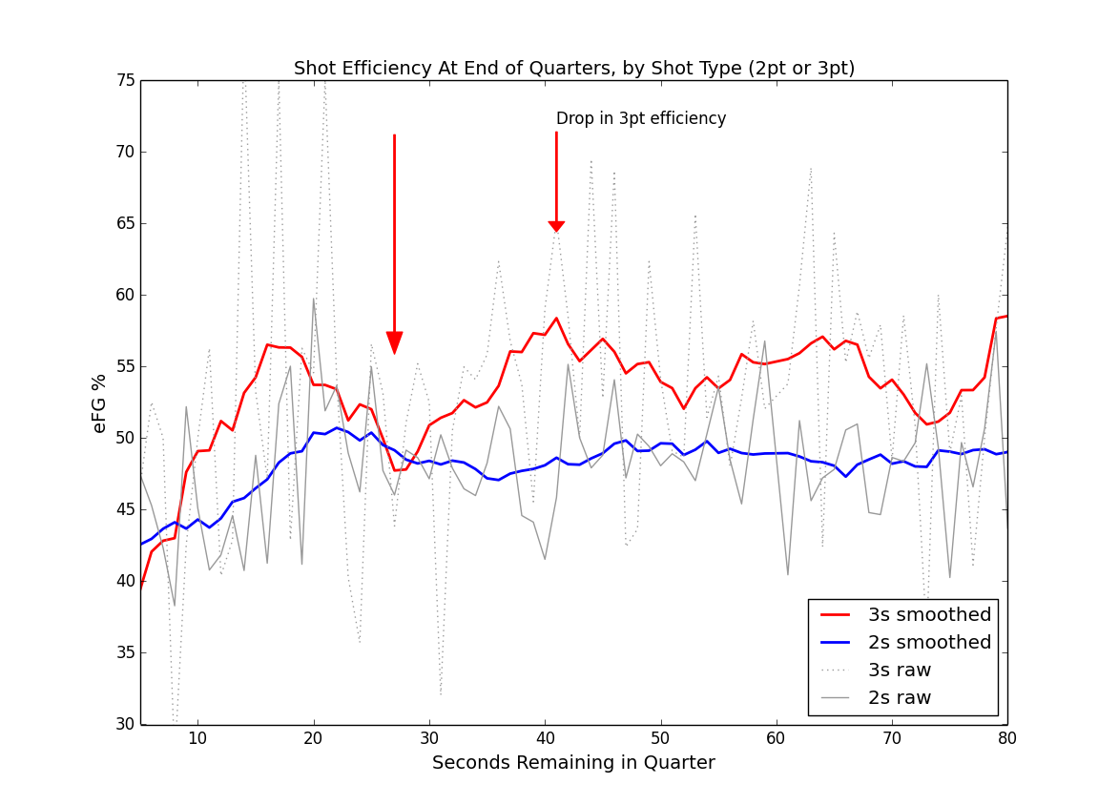

Following up with Houston

So, what's going on with Houston?

The overall story at the team-level doesn't hold for Houston when we look at individuals. While Harden, an above average player, takes a slight dip in efficiency, his teammates face a much steeper fall-off, dropping 20 percentage points from 0.57 to 0.37 in adjusted efficiency. With a typical regression to the mean effect, you'd expect Harden to suffer the biggest fall-off and his teammates to shoot the same or better.

Here's the splits between Harden and the rest of the team:

Table 2: Houston Splits

Advice for Houston: Basically, there's an opportunity for Houston to improve here. Have all the players besides Harden be more selective with their shots during the two-for-one window. It looks like they're just taking any shot and many of those shots aren't falling. A closer look at game film or SportsVu data on these plays could also help evaluate how bad these shots were, how close any defenders were, or if the players had poor mechanics on those shots, etc. Houston was one of the teams that saw the highest increase in shot volume during the two-for-one window, and they seem to be one of the teams whose shooting efficiency suffered the most.

Conclusion:

The logic of the Two-for-One tactic is premised on the idea that one team will end up with an extra shot, and on average that extra shot will be worth roughly one point. In this report, when we look at the expected value of the extra shot generated that shot value is only 0.70 points and that there is also a negative impact of about 0.05 points on the shot taken during the Two-for-One window, on which teams compromise on quality in order to secure the extra shot.

So pursuing this tactic may not yield as high returns as teams hope for. In the end, this tactic is still worth pursuing because it prevents the other team from securing that advantage. Over the first three quarters of an NBA game, the cumulative advantage can be 3.9 points (0.65 per quarter * 3 quarters * 2 competition-effect) can be achieved.

Teams do change their shooting behavior during the Two-for-One window, and Lowe's observation that some teams end up with bad looks during the Two-for-One window may reflect three things: 1) the general increase in 3-point attempts 2) the concurrent decrease in 3-point accuracy and, 3) the fact that the biggest drop-offs in shooting efficiency tend to be happening to normally high-powered offenses like Houston's.

–

Technical Notes:

Below are some technical notes on how the project was implemented in Python.

Data and Methods

Data source: basketball-reference.com; used the Event Finder query tool for Field Goal Attempts. Games used: all regular season NBA games from 2014-15. Data collected on a per-team basis. Filters: End of quarters only, for quarters one through three. Fourth quarter discarded because of end-of-game complications. We’re not tracking full play-by-play data, so turnovers, rebounds, second chances, free throws, etc aren’t in the picture. We’re just looking at shot data, time of shot, distance, player, 2-point vs 3-point attempt.

Python packages used: Analysis was completed using Python and the Pandas toolkit. Figures created via Matplotlib library. Data persistence was done using Python/Pickle (file-based object serialization). Python environment was the Enthought/Canopy distribution.

Data Notes

Data parsing: Some of the data input processing simply involved extracting time information from time fields formatted as strings, or other straightforward conversions, or re-codings. Player and shot information (shot type, make/miss status, and shot distance) were parsed out of the Description text field and added as new variables (aka, columns). A few examples of that Description text are below:

“D. Wade makes 3-pt shot from 25 ft”
“C. Bosh misses 2-pt shot from 14 ft”
“C. Bosh makes 2-pt shot at rim (assist by D. Wade)”

Data Quality:
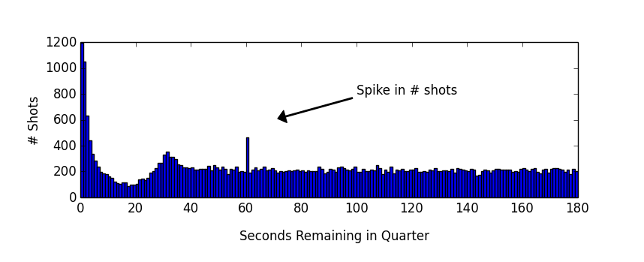
One issue regarding data quality came up during analysis. It looks like there's a spike in shots when there's 60 seconds remaining in the quarter. There is no apparent local increase in shot quantity at nearby timepoints like 58, 59, or 61 seconds. This may reflect a bias in hand-coding towards a round number like “one minute left” when the data is originally tracked during the game. There is perhaps a slight dip in volume of shots around this timepoint, which may reflect this bias. There was no obvious relation of this increase in shots with any team or player, or anything else which may reflect other data corruption issues.

Workarounds for this were either dropping the 60 bin of shots entirely (for per-second analysis), or re-drawing the boundaries of different time periods. The baseline time period was set from 65 to 180 seconds to avoid any effect of this data spike on Shot Rate (and Change in Shot Rate) which was sensitive to this anomaly.

Technical Skills Shown:

- Used data to address specific questions related to performance.
- Data preparation, pre-processing: re-mapping time into alternate time periods; parsing the descriptive text to extract player, shot type, distance information.
- Data smoothing
- Data re-shaping, reconstructing shot-logs for end of quarter scenarios.
- Data quality / anomaly check (spike in data at time = 60 seconds)
- Analysis at different levels of aggregation: by team, by individual, by quarter.

Additional Analysis:

A few additional analyses were performed, summarized below.

- The increase in volume of shots is related to the types of shots teams take. On a per-team basis, the more a team shoots in the two-for-one window, the higher the proportion of 3s a team attempts (r = 0.48, p = 0.007).

- End-of-quarter shot logs were reconstructed for every quarter in every game. – Basically, teams that end up taking the only shot in the two-for-one window end up securing the final shot of the quarter about 3 out of 5 times. So there's a slight advantage to winning it, but it's not as high as one would expect (closer to 8 or 9 out of ten times, or something much higher.) Main caveat: this analysis is limited by lack of free throw information or turnovers or other information available from a full play-by-play dataset.

