Summary Results:

Proportion of shots that are 3pt attempts, epoch 3: 0.33
Proportion of shots that are 3pt attempts, epoch 5: 0.26

3pt fg %, epoch 3: 0.33
3pt fg %, epoch 5: 0.37
Change in 3pt fg %: -0.04

Overall eFG %, epoch 3: 0.48
Overall eFG %, epoch 5: 0.51
Change in Overall eFG %: -0.02

–

Exective Summary:

–

Intro:

-

Figures...

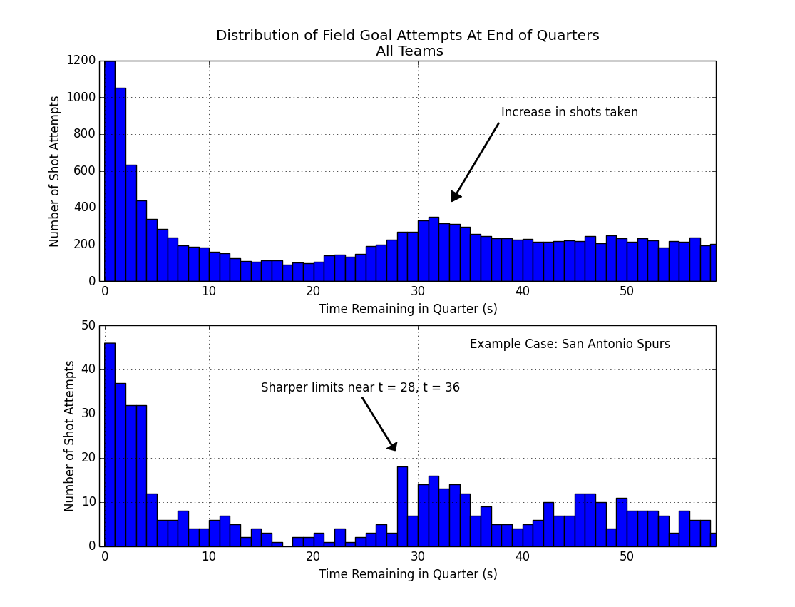

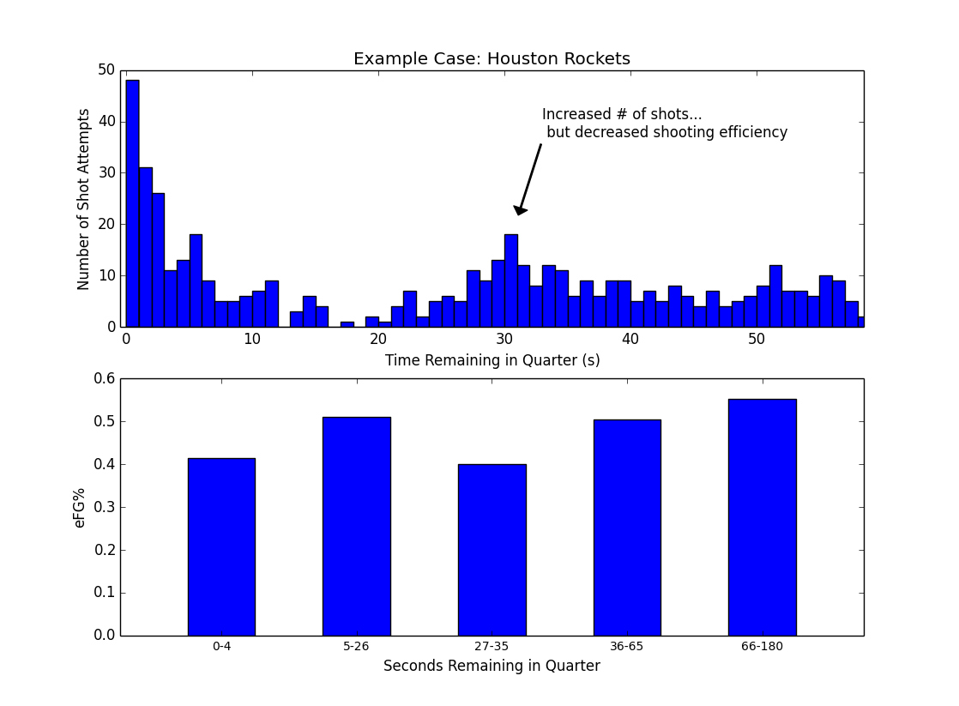

Middle -

Proportion of shots that are 3pt attempts, epoch 3: 0.33
Proportion of shots that are 3pt attempts, epoch 5: 0.26

3pt fg %, epoch 3: 0.33
3pt fg %, epoch 5: 0.37
Change in 3pt fg %: -0.04

Overall eFG %, epoch 3: 0.48
Overall eFG %, epoch 5: 0.51
Change in Overall eFG %: -0.02

Overall Table:

 | Proportion of 3pt Attempts | 3pt Effectiveness | Overall Shot Efficiency (eFG%)
Baseline (Epoch 5) | 0.33 | 33 % | 0.48
Two-for-one (Epoch 3) | 0.37 | 37 % | 0.51
Change | + 0.07 | - 0.04 | - 0.02 *

* may not add up due to rounding.

Shots per second, split by shot type...

.. decrease in 3pg eFG %.

...
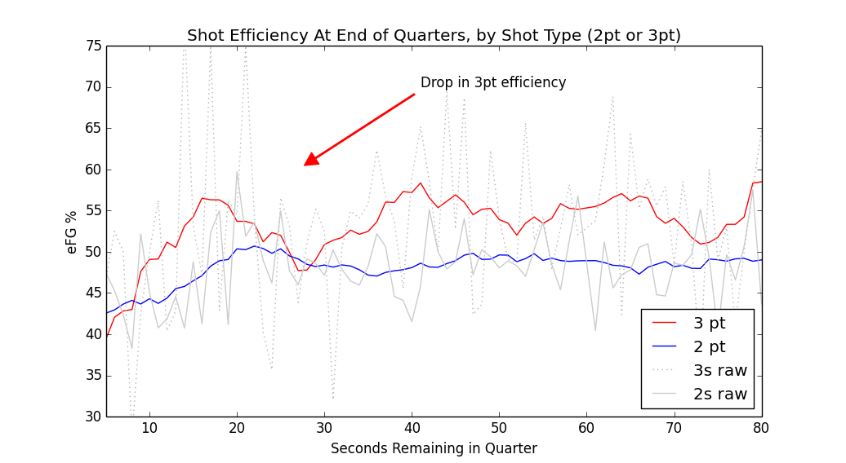
Overall, looking at the smoothed line of 3 pt efficiency in red

Tripiles …
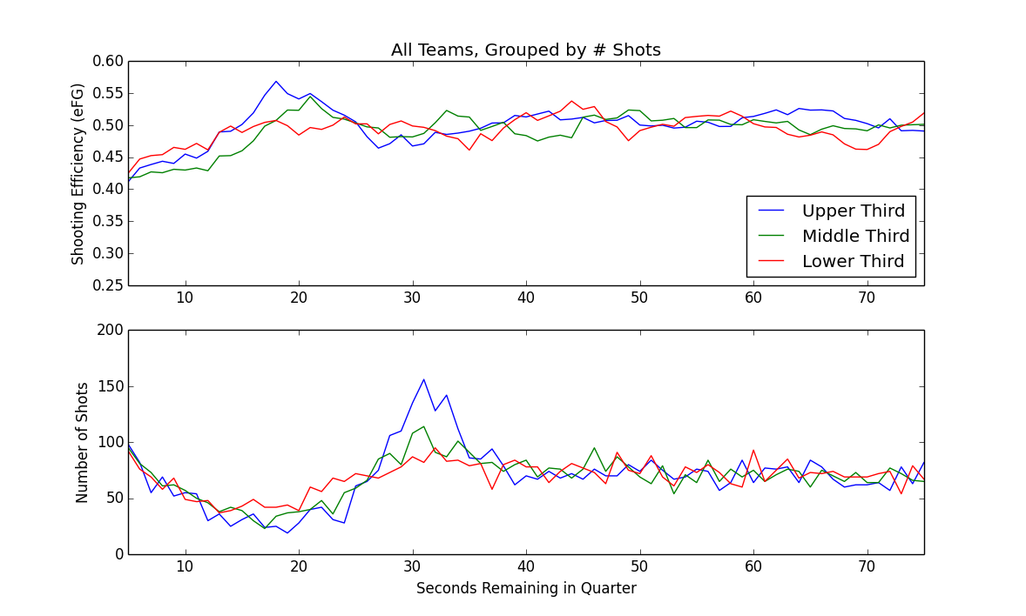

We grouped teams into three groups, based on number of shots taken during the 2-for-1 window, as a simple way of measuring two-for-one agressiveness,
which teams were attempting a 2-for-1 tactic the most often. …
Overall, for this top one-third of teams, we can see...
Overall, for the top one-third of teams in terms of number of shots taken in the 2-for-1 window, we can see an increase in shots around 30 seconds remaining (lower panel, blue), along with a slight dip in shooting efficiency (upper panel, blue).

The other thing we see in this series is that the middle group, and the lower group, really aren't that much more agresive in terms of taking extra shots in this 2-for-1 window.

Final answers.

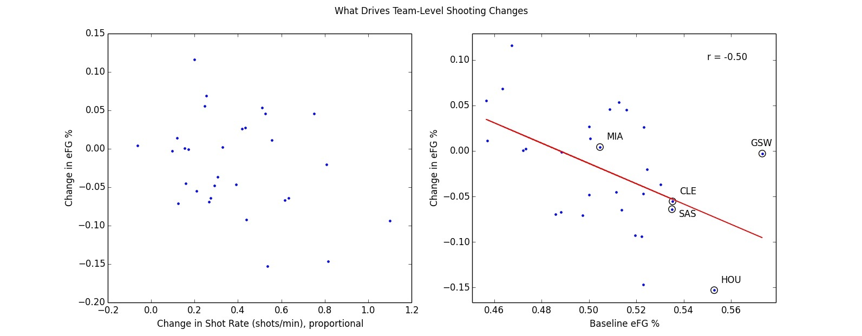

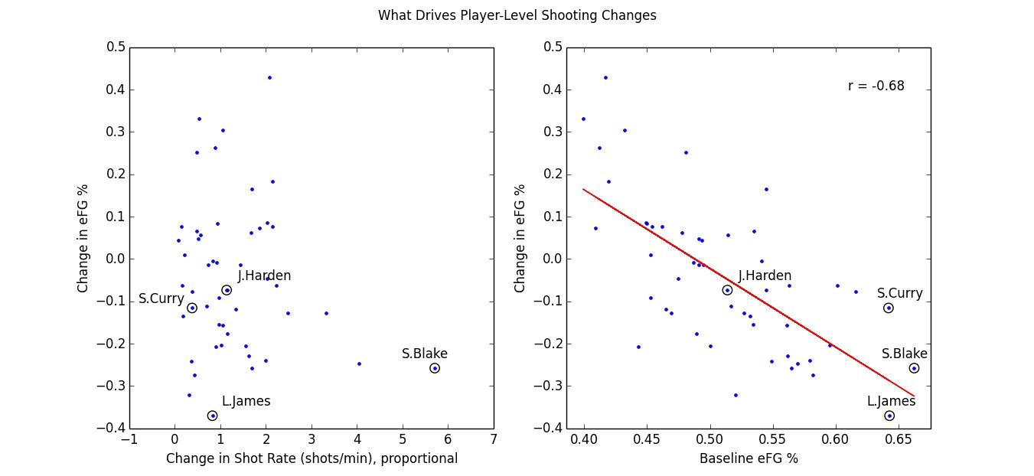

# Breakdown –

.. small driver vs bigger driver.

Notes:

– smoothing

– notes, comparison --- regression to mean, control group, comparisons, etc.

– data spike

Additional finding:
pearsonr(team_report['shotrate_diff'], team_report['prop_threes_diff'])
# (0.48164911393624316, 0.0070403594139744228)
# Higher TFO Shotrate -> Higher Proportion of 3s Attempted.

# **

# add in somewhere fitting.

On a per-team basis, the more a team goes for a TFO advantage, the higher proportion of 3s a team attempts.

# The fact that Proportion of Threes is marginally associated with 3pt eFG, means we'd want to keep an eye on this going forward. – It may become more relevant in the future.

.. blah blah.

–
Control:
(file: tfo_team_report.py)

Figures 1010 1011, 1012.

e3 vs e5, ok – a reg.
diff(e3, e5) vs control – no diff ?

E5 vs diff(e3,e5) –

econtrol vs diff(e3,ec) – still a regression to mean... so regression to mean still mainly in effect.

E5 vs diff(e3, ec) – flat. & e5 corr with ec. Therefore: Regression to mean effect between e5, and e3, probalby not due to chance.).

efg EC vs diff(e3, EC) – still reg to mean type neg correlation. // if we use an alternate control instead of E5, we still see regression to mean.

# ---

What does this mean? :

pearsonr(df_espn['AFG%'], df_espn['AFG%'] - team_report['team_efg_e3'])
Out[262]: (-0.36302758790579298, 0.048638443311019963)

means:
1) what we saw with e3-e5, should still hold. It's basically the same thing. (Especially considering e5 corr with espn_afg.

# Fig 1021 ** – with increasing shotrate, you see teams taking proportionally more 3pt attempts.

