Two-for-one shooting in the NBA

–

Exective Summary:

In basketball, a two-for-one tactic is when teams try to get two shots at the ends of quarters and force their opponent to only get one shot, essentially getting a one-shot advantage over the opponent.
A team can generally secure a two-for-one advantage by timing their shots, so that if they shoot with around 35 seconds remaining in the quarter, they can get the ball back for another shot which will be the last shot in the quarter.

In this study, we look to see if and how, by trying to maximize the number of shots attempted, teams negatively impact the quality of those shots. The data used is a subset of all field goal attempts from all games in the 2014-2015 NBA regular season.

Overall, compared to normal, baseline shooting behavior, during a Two-for-One window, teams both attempt more 3 point shots, and shoot 3 point shots less efficiently (down 4 percentage points). Overall field goal efficiency (conversion of shots to points) for all shots (2 point and 3 point attempts combined) drops from 51% to 48%.

Distance of shots was steady between the two periods, from 8.0 ft and 24.9 ft for 2pt and 3pt shots respectively.

On a more fine-grained scale, per-second analysis, from 40-seconds to 27 seconds remaining, shooting percentage for 3-point shots drops steadily from about 57% at 40 second to about 47% at 27 seconds, indicating that teams may be forcing shots towards the end of this two-for-one window.

(regression to the mean snippet?)

–

Intro:

Recently Zach Lowe (http://grantland.com/the-triangle/the-supersize-nba-season-ending-things-i-like-and-dont-like/, item 19) suggested that some teams, in an attempt to get off a first shot in a two-for-one end up with “godawful looks.” – (replace with “godawful looks”.) What follows is a preliminary analysis of shooting efficiency in the two-for-one scenario.
What is a two-for-one scenario? It’s a situation at the end of quarters where a team tries to get two shots and limit their opponent to only one shot.
The logic of going for a two for one is essentially this: “A smart team would’ve taken two bad shots instead of one good one“ - Jonah White.
As long as the bad shots aren’t “too bad” then 2 shots > 1 shot. But the question Lowe raises is “do teams shoot worse when going for a two-for-one? And if so, how bad are the bad shots?”

(end intro)

The Two-for-One Window

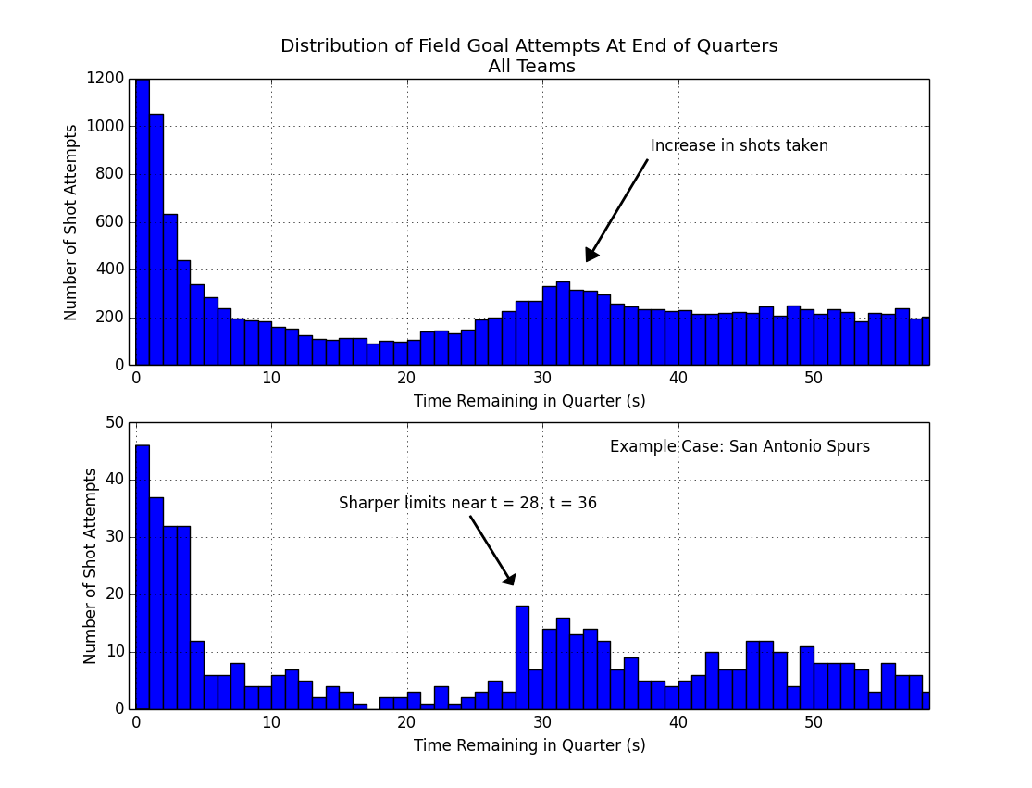
Example Case: San Antonio Spurs should be moved to top of graph to parallel All Teams

First off we need to identify and define this Two-For-One window. (does this section need an explanatory figure? – like a diagram showing the different shooting epochs?)

I am not sure how the preceding fits with the rest. There is a reference to Epoch 3 on page 9 without a definition anywhere what Epoch 3 is. So the answer might be “yes”.

Context: In basketball, there's a shot clock of 24 seconds. This means that once a team gets the ball, in the simplest case, they have 24 seconds in which to shoot the ball, or else they forfeit possession, and the ball goes to the other team. So a savvy team, if they shoot the ball with about 30 seconds remaining, even if the other team uses all 24 seconds to shoot the ball, will still get it back with about 6 seconds left. That's enough time for a shot, not a great shot, but just a decent one.

So we look at all the shots taken in the 2014-2015 season in the NBA, focusing on the first three quarters only, dropping the fourth quarter due to end-of-game complications. In the figure above (top panel), for the last minute in the quarter, we can see when the shots were taken, e.g., with 23 seconds remaining in the quarter. Should 25 seconds be 35 seconds? Yeah.

Top panel, shows an increase in shot attempts around 30-35 seconds remaining in the quarter. We also notice a decrease in shots taken between 10-25 seconds, and a lot of buzzer-beat type shots taken with 3 seconds or less left on the clock.

So 30-35 seconds gives us a general timeframe of a 2-for-1 window, but let's get more specific. If we look at an example case like the San Antonio Spurs, a league-leading team known for smart basketball, (figure, lower panel) we see a similar increase in the number of shots attempted, with slightly different cutoff points, near 28 seconds, and 36 seconds. And these cutoffs have sharp drop-offs before and after, so this provides further indication that we're in the right window of time.

In the end, we're going to define our 2-for-1 window from 27-35 seconds (inclusive) remaining in the quarter. This is a bit conservative on the upper end, but to the extent we can, we want to make sure most of these shots in this window are indeed 2-for-1 type of shots and not just a team's normal behavior. For comparison, we define a baseline timerange from 65 to 180 second remaining in the quarter. (* Due to an issue with the data near time = 60, we make some adjustments here to compensate.) Shooting statistics in this baseline timerange are very close to overall season mean shooting numbers. Additionally, this baseline may be a better comparison since it is closer in time, and may partially control for players on the court, fatigue, and other factors.

(end)

..
(( Define effectiveness as efficiency. Quality vs quantity tradeoff as short version of whole thing.
General;
While the tactic is about maximizing the number of shot attempts, we're going to look and see if and how that's impacting the quality of those attempts. ))
The above needs to be clarified.

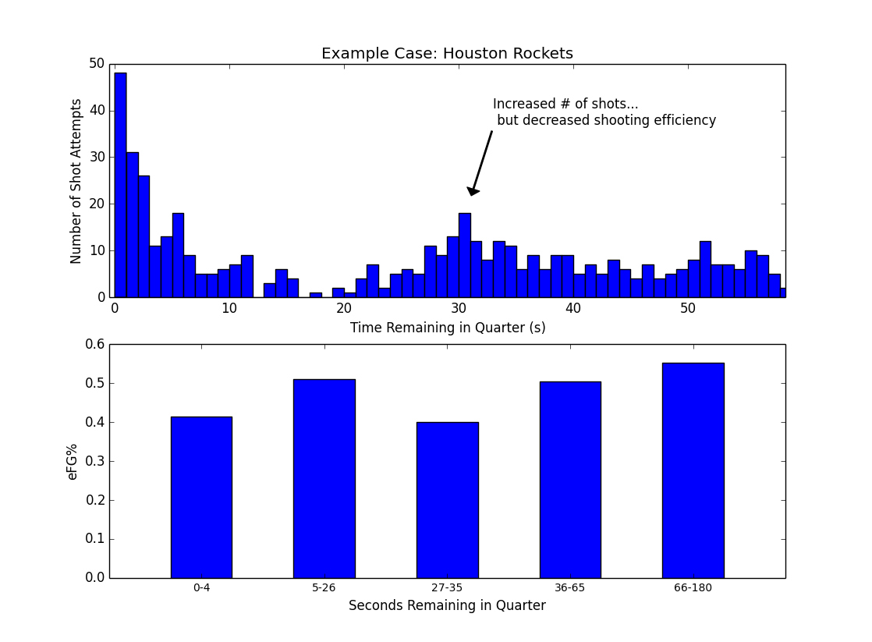
Font of heading of second graph needs to equal font of first graph

–
Example case Houston.

So, in the second figure, we're seeing an example of what may be happening for some teams: a team shoots more during this two-for-one window (near 30 seconds remaining on the clock), and there's a resulting dip in shooting efficiency (figure, lower panel) between 27-35 seconds remaining in the quarter. The drop in efficiency for Houston is substantial, from 0.55 to 0.40, a drop of 15 percentage points, or roughly 0.3 points per shot. That size of difference is enough to take an offense from first to last in the NBA. For comparison, the difference between the first ranked and the last ranked offense in the league in points per shot was 0.17. Houston's drop-off is almost double this.

The main question we're asking here is whether Houston is an outlier case, or whether this happens for all or most teams, and how big of a drop-off there may normally be.

--

Approach (Methods):

As the Houston example suggests, the approach we're going to take is to compare a Baseline period and us it to compare against the shooting in the Two-For-One window. The baseline period is from 65-180 seconds remaining in the quarter, and the two-for-one window is from 27-35 seconds remaining in the quarter.

The main measure we're going to be using is effective field goal percentage (eFG%), which is the # of shots made / # shots attempted, weighted by point value. So shooting 33% on 3 point shots is equivalent to shooting 50% on 2-point shots. It's measuring how efficiently a team (or player) converts shots into points.

While eFG% is useful for combining two- and three-point shots together, we're also going to look at field goal percentage, broken down by 2-point and 3-point shots separately. We are going to look at this first at the team level, then at the player level. Furthermore, we will inspect this on a second-by-second basis. And lastly, we will look again at Houston and see what is driving their dip in shooting efficiency. (Shooting efficiency, eFG%, is an advanced measure within basketball circles that has recently become more broadly accepted into standard practice.)

Another thing we're going to do is look at Shot Rate and the change in Shot Rate. Shot Rate is basically how often a team shoots (shots per second). We're going to look at this to see if and when teams shoot more often during the two-for-one window than during the baseline period. This is an indicator of how often a team is pursuing this two-for-one tactic, as opposed to playing their regular style of offense.

Dataset: shots dataset from basketball-reference.com (field goal attempts from the 2014-15 season).

Dataset we're using is: …
# of shots: 40,379.
# of games. 1230

Other data conditioning filtering. Included only quarters one through three; fourth quarter was dropped due to end-of-game complications. A ceiling on distance was placed on 3-point shots, allowing only those of less than 40 ft, so that low-percentage, full-court shots would not be included.

Results:

Here's the basic difference between baseline shooting and shooting efficiency in the two-for-one window. Teams tend to shoot more 3 point attempts, while shooting worse on those 3 point attempts, and worse overall. // Second part of sentence needs to be rewritten.

Table 1: Overall Comparison of Two-for-One shooting vs Baseline Shooting.

 | Proportion of 3pt Attempts (2s vs 3s) | 3pt Effectiveness | Overall Shot Efficiency (eFG%)
Baseline (65-180 seconds) | 0.26 | 37 % | 0.51
Two-for-One (27-36 seconds) | 0.33 | 33 % | 0.48
Change | + 0.07 | - 0.04 % pts | - 0.02 *

* may not add up due to rounding.

The distance of shots taken during the two-for-one window did not really change compared to the baseline period. For two point shots, average shot distance was 7.85 ft compared to 8.0 ft, two-for-one window and baseline period respectively. For three-point shots average shot distance was 25.1 ft compared to 24.9 ft.

Drivers of shooting efficiency during the two-for-one window:
(Main figure / main result:)

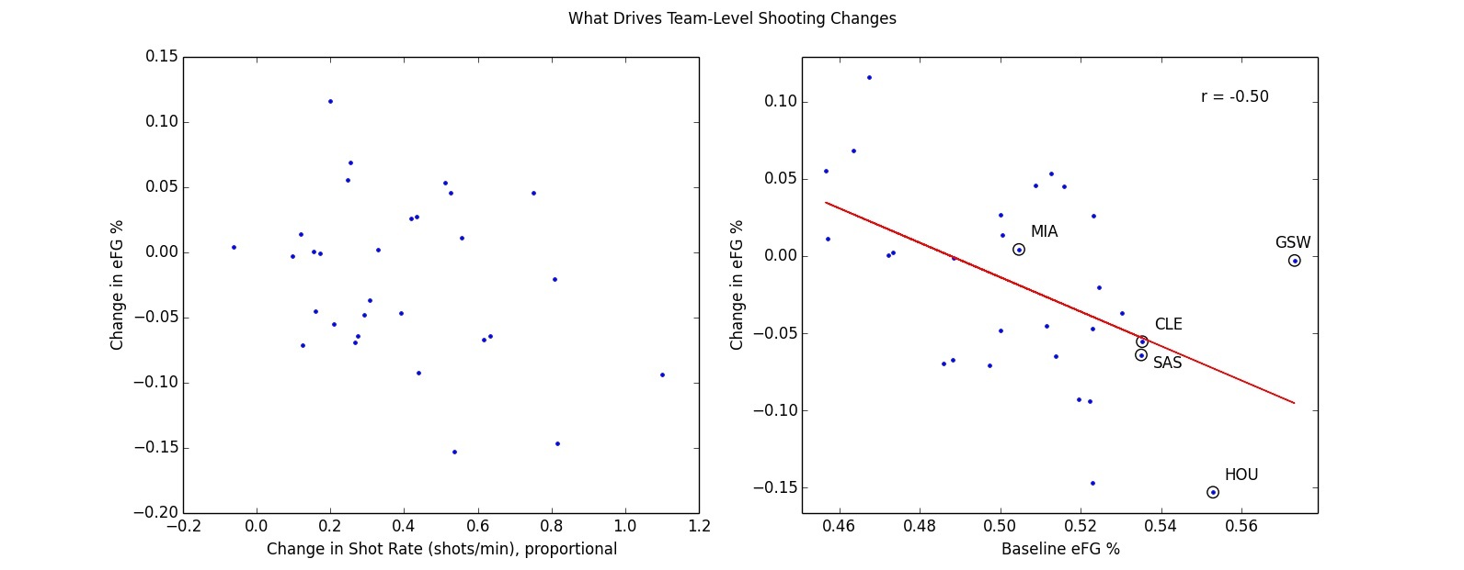

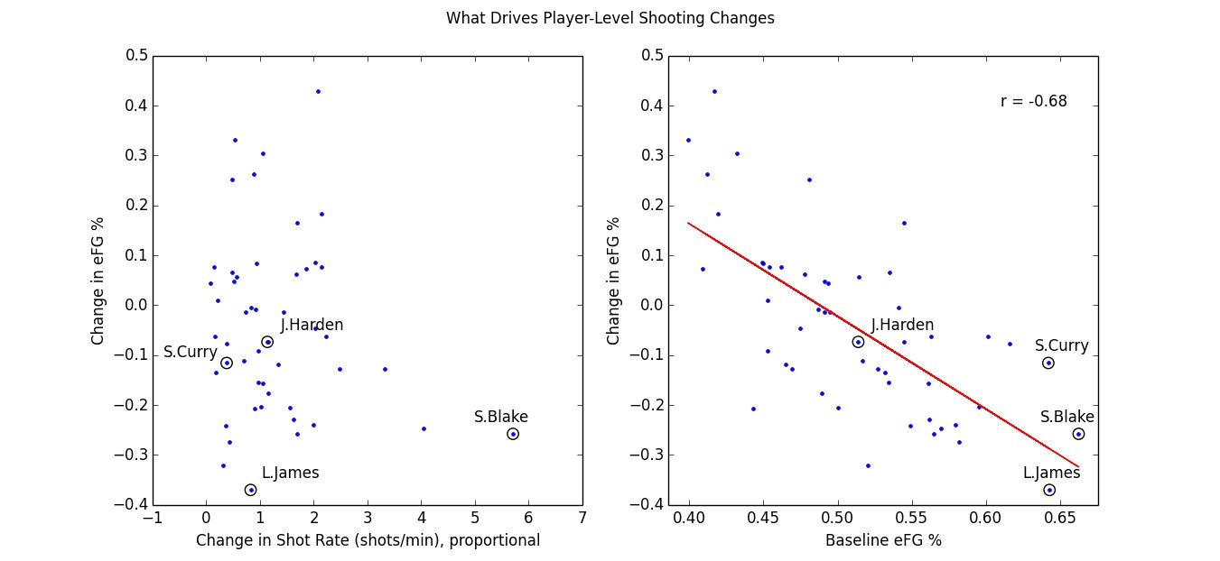

# Breakdown –

.. small driver vs bigger driver.

So, at the team level, there's some indication that taking more shots during the TFO window leads to less efficient shooting, // it's weakly correlated.
At the individual level this breaks down. It may be true for some extreme cases like Steve Blake (circled, left panel).

– explain what Shot Rate change is measuring....

Overall, the spread in shooting efficiency is pretty random.
On the right, we can see that most of the change in shooting efficiency is actually related to how well teams and individuals shot to begin with (right panels).

Teams that shoot worse in general tend to shoot better during this two-for-one window; conversely, teams that normally shoot well, saw a decrease in their efficiency during this window.

That same relationship tends to hold when looking at the individual level: bad players shot better and the good players shot worse. For example, Lebron James, who shot an adjusted 64% during the baseline window, ends up shooting about 33 percentage points worse when shooting in the two-for-one window.

This is a type of “regression to the mean” effect, …

The other way to look at this is more simple: it's harder for a poor shooting team to shoot worse, so they can only improve in the two-for-one window. Conversely, a good-shooting team would find it difficult to shoot better than a league-leading offense, so the only way they can move is down toward the middle of the pack.

–
A word about this regression to the mean effect we see here. Normally, regression to the mean involves two samples, both of them fairly random. Example, someone scores a 70% on their first test and 80% on their second test. The 10% “improvement” has as much to do with the first score being low as any extra studying done by the student prior to the second test.

Here, in this case, our first baseline measure of offensive shooting efficiency seems to be on the mark. Golden State had a leading offense that helped it win a championship. Houston had a near-top offense that propelled it deep into the playoffs as well. Philadelphia, scoring low in the baseline condition here, was one of the worst teams in the league. Additionally, the baseline offensive measures here are only off by (x.x %) from the season long offensive numbers as per data from ESPN's website (..). So in our case, the first measure seems a true measure. It's the deviation from that in the two-for-one window that seems to indicate that something different is going on.

Correlation between efg in epochs 4 and 5 – are correlated (r .40, p = .028).

So upshot: normally, efg from differenct time periods *should* be correlated.
What's telling us something about e3 is that this relationship broke down.

So this regression to the mean looks like
1) the Baseline period correlates with another period (36-65 seconds), so the fact that this relationship breaks down in the two-for-one window tells us that something different is going on there.
2) It's related to other changes in shooting behavior: the increase in 3-point shots attempted, and the decrease in 3-point accuracy.
3) in context, this is what NBA discussion in general seems to be saying, teams settle for quick, decent shots by design. So this should be reflected in shooting percentages that are close to average.

–

3-point Efficiency Decreasing Over Time

Here we are looking at a per-second analysis of effective field goal percentage (eFG%). We're looking at all the shots on a second-by-second basis (gray dots). Because it's noisy, we smooth it with a 9-second window, and plot the results, in red for 3-point attempts and in blue for 2-point attempts.
The blue line stays fairly level, showing no real change for 2-point shots. For 3-point shots (solid red line) efficiency drops off between 40 and 27 seconds, with a decrease in efficiency of about 10 percentage points, from about 57% to 47%.

So not only do we see a drop from baseline time period compared to two-for-one window, a second-by-second breakdown, it appears 3-point shooting percentage decreases within this window as well. As time approaches roughly 27 seconds remaining, and players become antsy to get off any shot, overall shot quality diminishes.
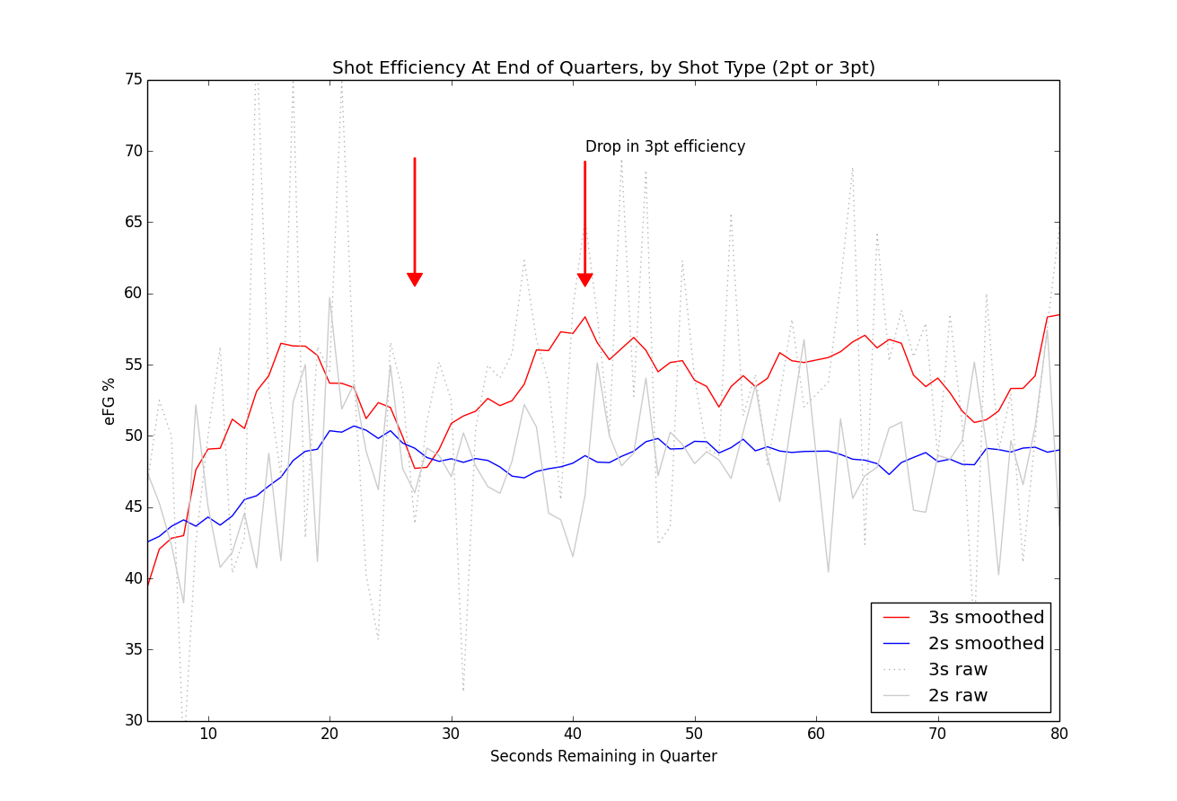

Following up with Houston

So, what's going on with Houston?

The overall story at the team-level doesn't hold for Houston when we look at individuals. Harden, an above average player, takes a slight dip in efficiency, but his teammates face a steeper fall-off. If anything you'd expect Harden to suffer the biggest fall-off and his teammates to shoot the same or better.

Here's the splits between Harden and the rest of the team:

Table: Houston Splits

Advice for Houston:

Basically, there's an opportunity for Houston to improve here. Have all the players besides Harden be more selective with their shots during the two-for-one window. It looks like they're just taking any shot and many of those shots aren't falling. A closer look at game film or SportsVu data on these plays could also help evaluate how bad these shots were, how close any defenders were, or if the players had poor mechanics on those shots, etc. Houston was one of the teams that saw the highest increase in shot volume during the two-for-one, and they seem to be one of the teams whose shooting efficiency suffered the most.

–

– end

Conclusion:

(some concluding remarks)

Technical Skills shown:

- Used data to address specific questions related to performance.
- Data preparation, pre-processing: smoothing data, re-mapping time into alternate time periods; parsing the descriptive text to extract player, shot type, distance information.
- Data quality / anomaly check (spike in data at time = 60 seconds)
- Data smoothing
- Data re-shaping, reconstructing shot-logs for end of quarter scenarios.
- Analysis at different levels of aggregation: by team, by individual, by quarter.

Data and Methods

Mini-methods: data source: basketball-reference.com; used the Event Finder for Field Goal Attempts. Games used: All regular season NBA games from 2014-15. Data collected on a per-team basis. Filters: End of quarters only, for quarters one through three. Fourth quarter discarded because of end-of-game complications. We’re not tracking full play-by-play data, so turnovers, rebounds, second chances, free throws, etc aren’t in the picture. We’re just looking at shot data, time of shot, distance, player, 2-point vs 3-point attempt.

Analysis was completed using Python and the Pandas toolkit. Figures created via Matplotlib library. Python environment was the Enthought/Canopy distribution.

Data

Data parsing:

Some of the data input processing simply involved extracting time information from time fields formatted as strings, or other straightforward conversions, or re-codings. Player and shot information (shot type, make/miss status, and shot distance) were parsed out of the Description text field and added as new variables (aka, columns). A few examples of that Description text are below:

D. Wade makes 3-pt shot from 25 ft
C. Bosh misses 2-pt shot from 14 ft
C. Bosh makes 2-pt shot at rim (assist by D. Wade)
Data Quality:
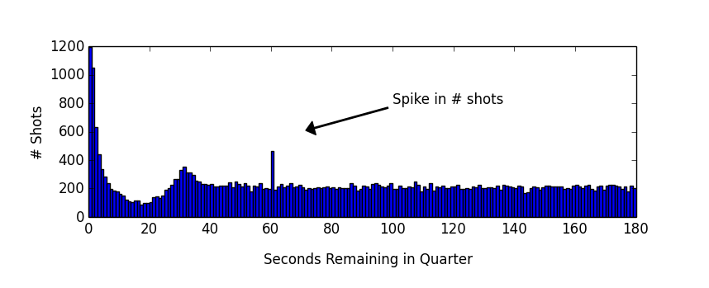
One issue regarding data quality came up during analysis. It looks like there's a spike in shots when there's 60 seconds remaining in the quarter. There is no apparent local increase in shot quantity at nearby timepoints like 58, 59, or 61 seconds. This may reflect a bias in hand-coding towards a round number like “one minute left” when the data is originally tracked during the game. There is perhaps a slight dip in volume of shots around this timepoint, which may reflect this bias. There was no obvious relation of this increase in shots with any team or player, or anything else which may reflect other data corruption issues.

Workarounds for this were either dropping the 60 bin of shots entirely (for per-second analysis), or re-drawing the boundaries of different time periods. The baseline time period was set from 65 to 180 seconds to avoid any effect of this data spike on Shot Rate (and Change in Shot Rate) which was sensitive to this anomalie.

Additional Analyses:

A few additional analyses were performed, summarized below.

- End-of-quarter shot logs were reconstructed for every quarter in every game. – Basically, teams that end up taking the only two-for-one window end up taking the final shot of the quarter about 3 out of 5 times. So there's a slight advantage to winning it, but it's not as high as one would expect (closer to 9 out of ten times, or something much higher.)

- So the increase in volume of shots is related to the types of shots teams take.
On a per-team basis, the more a team shoots in the two-for-one window, the higher proportion of 3s a team attempts. (# Fig 1021 ** )

- Aggregating teams by shot-aggressiveness.

Teams were grouped into thirds, depending on how often they shot in the two-for-one window (rankings based on simple shot counts).

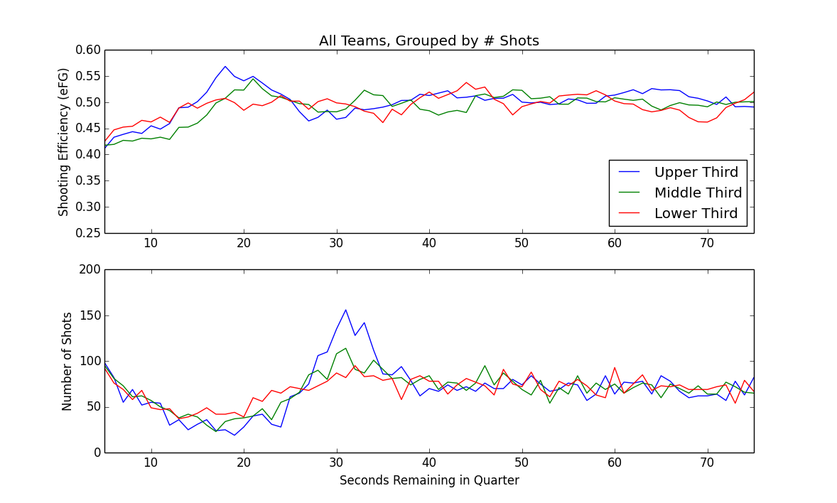

We grouped teams into three groups, based on number of shots taken during the 2-for-1 window, as a simple way of seeing which teams were attempting a 2-for-1 tactic the most often.

Overall, for the top one-third of teams in terms of number of shots taken in the 2-for-1 window, we can see nearly a 100% increase in shots around 30 seconds remaining (lower panel, blue), along with a slight dip in shooting efficiency (upper panel, blue).

The other thing we see in this series is that the middle group, and the lower group, really aren't that much more aggressive in terms of taking extra shots in this 2-for-1 window. They are likely playing more of their regular, conventional offense.

Basically, most of the change in shooting behavior (in terms of shot volume) during this two-for-one window is coming from about ten teams, with about half the teams shooting with roughly the same frequency.

– data spike issue here? // histogram of shot count by second.

– insert table of Top 10 Players (by TFO shot volume? It's already computed, just not in the doc.)

End.

# ---------------------------

–
Extra verbage, data points, re regression to the mean.

# add in somewhere fitting.

( --------- For Now... this is just some Notes -----------------)

Additional finding:
pearsonr(team_report['shotrate_diff'], team_report['prop_threes_diff'])
# (0.48164911393624316, 0.0070403594139744228)
# Higher TFO Shotrate -> Higher Proportion of 3s Attempted.

# **

# The fact that Proportion of Threes is marginally associated with 3pt eFG, means we'd want to keep an eye on this going forward. – It may become more relevant in the future.

.. blah blah.

–
Control:
(file: tfo_team_report.py)

Figures 1010 1011, 1012.

e3 vs e5, ok – a reg.
diff(e3, e5) vs control – no diff ?

E5 vs diff(e3,e5) –

econtrol vs diff(e3,ec) – still a regression to mean... so regression to mean still mainly in effect.

E5 vs diff(e3, ec) – flat. & e5 corr with ec. Therefore: Regression to mean effect between e5, and e3, probalby probably not due to chance.).

efg EC vs diff(e3, EC) – still reg to mean type neg correlation. // if we use an alternate control instead of E5, we still see regression to mean.

# ---

What does this mean? :

pearsonr(df_espn['AFG%'], df_espn['AFG%'] - team_report['team_efg_e3'])
Out[262]: (-0.36302758790579298, 0.048638443311019963)

means:
1) what we saw with e3-e5, should still hold. It's basically the same thing. (Especially considering e5 corr with espn_afg.

# –

Correlation between efg in epochs 4 and 5 – are correlated (r .40, p = .028).

So upshot: normally, efg from differenct time periods *should* be correlated.
What's telling us something about e3 is that this relationship broke down.
That it is not correlated between the TFO window and normally, in epoch 5 (baseline).
That's our interpretation.

– So what we see between epochs 3 and 5 (between the TFO window and baseline shooting), is not correlated, it's just random. – So what this means is that efg is different from what it normally is.

