Two-for-one shooting in the NBA

–

Exective Summary:

In basketball, a two-for-one tactic is when teams try to get two shots at the end of quarters and force their opponent to only get one shot, essentially getting an of an extra shot over the opponent.
A team can generally secure a two-for-one advantage by timing their shots, so that if they shoot with around 35 seconds remaining in the quarter, they can get the ball back for another shot which will be the last shot in the quarter.

In this study, we look to see if and how, by trying to maximize the number of shots attempted, teams negatively impact the quality of those shots. The data used is a set of all field goal attempts from all games in the 2014-2015 NBA regular season.

Overall, compared to normal, baseline shooting behavior, during a Two-for-One window, teams both attempt more 3 point shots, and shoot 3 point shots less efficiently (down 4 percentage points). Overall field goal efficiency (conversion of shots to points) for all shots (2-point and 3-point attempts combined) drops from 51% to 48%.

Distance of shots was steady between the two periods, with shots from 8.0 ft and 24.9 ft for 2-point and 3-point attempts respectively.

On a more fine-grained scale, per-second analysis, from 40 seconds to 27 seconds remaining, shooting efficiency for 3-point shots drops steadily from about 57% at 40 seconds to about 47% at 27 seconds, indicating that teams may be forcing shots towards the end of this two-for-one window.

Overall, the rate at which teams increase the number of shots taken in the Two-for-One window only weakly correlates with a decrease in shooting efficiency. Poor shooting teams improved their shooting efficiency during the Two-for-One window, and normally good-shooting teams saw their shooting efficiency decrease. This is in line with the general belief that most teams end up with only “average” shots during this Two-for-One window.

–

Intro:

Recently Zach Lowe (http://grantland.com/the-triangle/the-supersize-nba-season-ending-things-i-like-and-dont-like/, item 19) suggested that some teams, in an attempt to get off a first shot in a two-for-one end up with “godawful looks.” What follows is a preliminary analysis of shooting efficiency in the two-for-one scenario.
What is a two-for-one scenario? It’s a situation at the end of quarters where a team tries to get two shots and limit their opponent to only one shot.
The logic of going for a two for one is essentially this: “A smart team would’ve taken two bad shots instead of one good one“ - Jonah White.
As long as the bad shots aren’t “too bad” then 2 shots > 1 shot. But the question Lowe raises is “do teams shoot worse when going for a two-for-one? And if so, how bad are the bad shots?”

In Part 1, we will use the shot occurrence data to help define when this two-for-one window occurs, and in Part 2, we will examine the impact that two-for-one shooting has on shot quality (ie, shooting accuracy).

Part 1: The Two-for-One Window

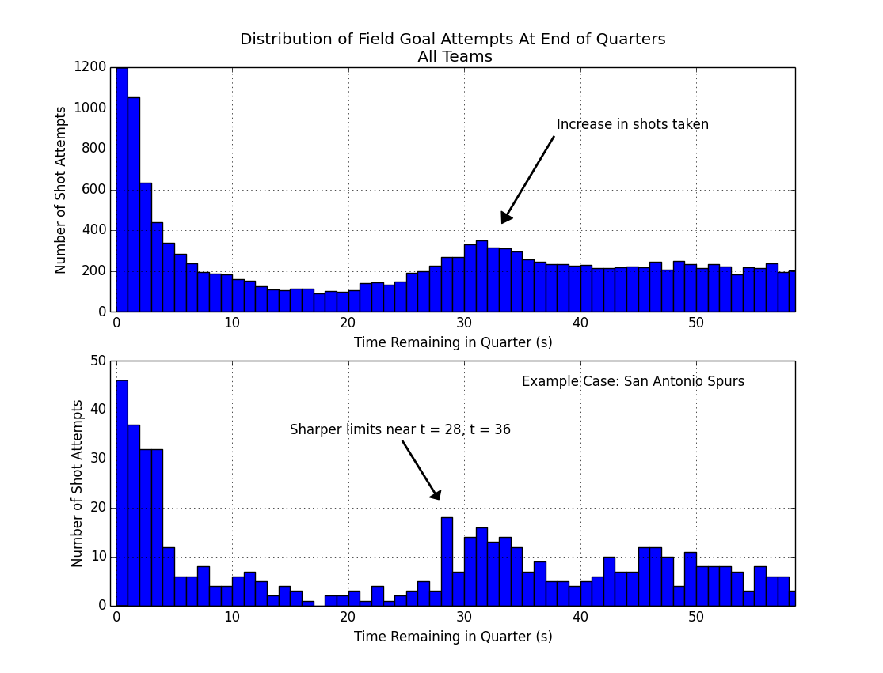
Example Case: San Antonio Spurs should be moved to top of graph to parallel All Teams

First off we need to identify and define this Two-For-One window.

Context: In basketball, there's a shot clock of 24 seconds. This means that once a team gets the ball, in the simplest case, they have 24 seconds in which to shoot the ball, or else they forfeit possession, and the ball goes to the other team. So a savvy team, if they shoot the ball with about 30 seconds remaining, even if the other team uses all 24 seconds to shoot the ball, will still get it back with about 6 seconds left. That's enough time for a shot, not a great shot, but just a decent one.

So we look at all the shots taken in the 2014-2015 season in the NBA, focusing on the first three quarters only, dropping the fourth quarter due to end-of-game complications. In the figure above (top panel), for the last minute in the quarter, we can see when the shots were taken, e.g., with 23 seconds remaining in the quarter there were about 200 shots taken during the season.

The top panel shows an increase in shot attempts in the number of shots taken around 30-35 seconds remaining in the quarter. We also notice a decrease in shots taken between 10-25 seconds, and a lot of buzzer-beat type shots taken with 3 seconds or less left on the clock.

So 30-35 seconds gives us a general timeframe of a 2-for-1 window, but let's get more specific. If we look at an example case like the San Antonio Spurs, a league-leading team known for smart basketball, (figure, lower panel) we see a similar increase in the number of shots attempted, with slightly different cutoff points, near 28 seconds, and 36 seconds. And these cutoffs have sharp drop-offs before and after, so this provides further indication that we're in the right window of time.

In the end, we're going to define our 2-for-1 window from 27-35 seconds (inclusive) remaining in the quarter. This is a bit conservative on the upper end, but to the extent we can, we want to make sure most of these shots in this window are indeed 2-for-1 type of shots and not just a team's normal behavior. For comparison, we define a baseline timerange from 65 to 180 second remaining in the quarter. (* Due to an issue with the data near time = 60, we make some adjustments here to compensate.) Shooting statistics in this baseline timerange are very close to overall season mean shooting numbers. Additionally, this baseline may be a better comparison since it is closer in time, and may partially control for players on the court, fatigue, and other factors.

(end)

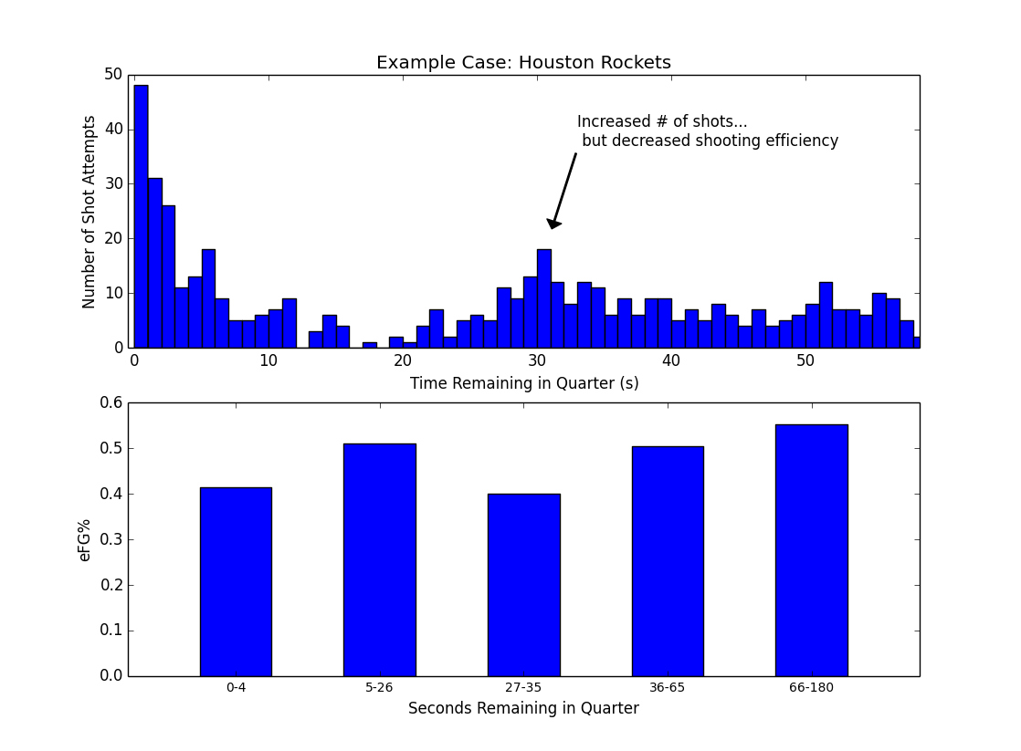

–
Example case Houston.

So, in the second figure, we're seeing an example of what may be happening for some teams: a team shoots more during this two-for-one window (near 30 seconds remaining on the clock), and there's a resulting dip in shooting efficiency (figure, lower panel) between 27-35 seconds remaining in the quarter. The drop in efficiency for Houston is substantial, from 0.55 to 0.40, a drop of 15 percentage points, or roughly 0.3 points per shot. That size of difference is enough to take an offense from first to last in the NBA. For comparison, the difference between the first ranked and the last ranked offense in the league in points per shot was 0.17. Houston's drop-off is almost double this.

The main question we're asking here is whether Houston is an outlier case, or whether this happens for all or most teams, and how big of a drop-off there may normally be.

--

Approach (Methods):

As the Houston example suggests, the approach we're going to take is to compare a Baseline period and use it to compare against the shooting in the Two-For-One window. The baseline period is from 65-180 seconds remaining in the quarter, and the two-for-one window is from 27-35 seconds remaining in the quarter.

The main measure we're going to be using is effective field goal percentage (eFG%), which is the # of shots made / # shots attempted, weighted by point value. So shooting 33% on 3 point shots is equivalent to shooting 50% on 2-point shots. It's measuring how efficiently a team (or player) converts shots into points.

While eFG% is useful for combining two- and three-point shots together, we're also going to look at field goal percentage, broken down by 2-point and 3-point shots separately. We are going to look at this first at the team level, then at the player level. Furthermore, we will inspect this on a second-by-second basis. And lastly, we will look again at Houston and see what is driving their dip in shooting efficiency. (Shooting efficiency, eFG%, is an advanced measure within basketball circles that has recently become more broadly accepted into standard practice.)

Another thing we're going to do is look at Shot Rate and the change in Shot Rate. Shot Rate is basically how often a team shoots (shots per second). We're going to look at this to see if and when teams shoot more often during the two-for-one window than during the baseline period. This is an indicator of how often a team is pursuing this two-for-one tactic, as opposed to playing their regular style of offense.

Dataset: shots dataset from basketball-reference.com (field goal attempts from the 2014-15 season).

Dataset characteristics include: number of shots: 40,379, number of games: 1230. Other data conditioning and filtering: Included only quarters one through three; fourth quarter was dropped due to end-of-game complications. Only shots occurring in the last three minutes of the quarter were included. A ceiling on distance was placed on 3-point shots, allowing only those of less than 40 ft, so that low-percentage, full-court shots would not be included. (Further details on the dataset are at the end under Technical Notes.)

Results:

Here's the basic difference in shooting behavior between the Baseline period and the Two-for-One window. Teams tend to attempt more 3 point shots, while shooting both worse on those 3 point attempts and worse overall (2's and 3's combined).

Table 1: Overall Comparison of Two-for-One shooting vs Baseline Shooting.

 | Proportion of 3pt Attempts (2s vs 3s) | 3pt Effectiveness | Overall Shot Efficiency (eFG%)
Baseline (65-180 seconds) | 0.26 | 37 % | 0.51
Two-for-One (27-36 seconds) | 0.33 | 33 % | 0.48
Change | + 0.07 | - 0.04 % pts | - 0.02 *

* may not add up due to rounding.

The distance of shots taken during the two-for-one window did not really change compared to the baseline period. For two point shots, average shot distance was 7.85 ft compared to 8.0 ft, two-for-one window and baseline period respectively. For three-point shots average shot distance was 25.1 ft compared to 24.9 ft.

Drivers of shooting efficiency during the two-for-one window:
(Main figure / main result:)

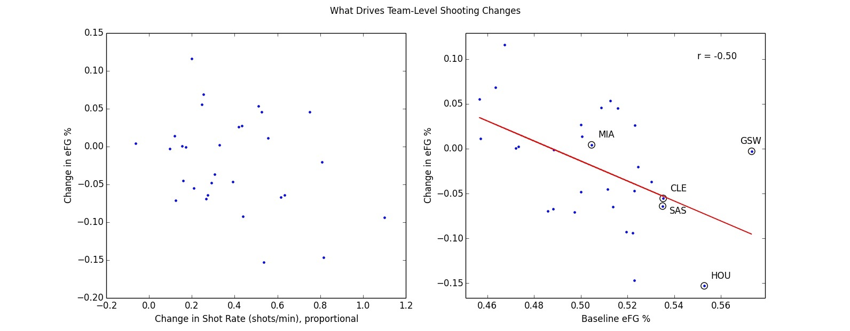

# Breakdown –

What's the question, what are we doing.

Here we look at two possible drivers to explain what happens to changes in shooting efficiency.
The first measure we look at is Shot Rate (how often a team shoots, the volume of shots a team takes, and whether this increases in the Two-for-One window).
The second explanatory measure we will look at it is how well the team shoots normally.

And again, the dependent variable we're interested in here is the Change in Effective Field Goal Percentage, an indicator of shot quality.

.. small driver vs bigger driver.

So, at the team level, there's some indication that taking more shots during the Two-for-One window leads to less efficient shooting, // it's weakly correlated.
At the individual level this breaks down. It may be true for some extreme cases like Steve Blake (circled, left panel).

– explain what Shot Rate change is measuring....

Overall, the spread in shooting efficiency is pretty random.
On the right, we can see that most of the change in shooting efficiency is actually related to how well teams and individuals shot to begin with (right panels).

Teams that shoot worse in general tend to shoot better during this two-for-one window; conversely, teams that normally shoot well, saw a decrease in their efficiency during this window.

That same relationship tends to hold when looking at the individual level: bad players shot better and the good players shot worse. For example, Lebron James, who shot an adjusted 64% during the baseline window, ends up shooting about 33 percentage points worse when shooting in the two-for-one window.

This is a type of “regression to the mean” effect, …

The other way to look at this is more simple: it's harder for a poor shooting team to shoot worse, so they can only improve in the two-for-one window. Conversely, a good-shooting team would find it difficult to shoot better than a league-leading offense, so the only way they can move is down toward the middle of the pack.

–
A word about this regression to the mean effect we see here. Normally, regression to the mean involves two samples, both of them fairly random. Example, someone scores a 70% on their first test and 80% on their second test. The 10% “improvement” has as much to do with the first score being low as any extra studying done by the student prior to the second test.

Here, in this case, our first baseline measure of offensive shooting efficiency seems to be on the mark. Golden State had a leading offense that helped it win a championship. Houston had a near-top offense that propelled it deep into the playoffs as well. Philadelphia, scoring low in the baseline condition here, was one of the worst teams in the league. Additionally, the baseline offensive measures here are only off by (x.x %) from the season long offensive numbers as per data from ESPN's website (..). So in our case, the first measure seems a true measure. It's the deviation from that in the two-for-one window that seems to indicate that something different is going on.

Correlation between efg in epochs 4 and 5 – are correlated (r .40, p = .028).

So upshot: normally, efg from differenct time periods *should* be correlated.
What's telling us something about e3 is that this relationship broke down.

So this regression to the mean looks like
1) the Baseline period correlates with another period (36-65 seconds), so the fact that this relationship breaks down in the two-for-one window tells us that something different is going on there.
2) It's related to other changes in shooting behavior: the increase in 3-point shots attempted, and the decrease in 3-point accuracy.
3) in context, this is what NBA discussion in general seems to be saying, teams settle for quick, decent shots by design. So this should be reflected in shooting percentages that are close to average.

If we look at these two potential drivers at the player-level (top X players who shot most often in the two-for-one window), we see a similar pattern holds. On the left panel (figure below), we see that shooting more often in the Two-for-One window (x-axis) doesn't really associate with a change in shooting efficiency (eFG%, y-axis)

–
# (0.41091272199690065, 0.024088814569956266)
# (0.25616472653484323, 0.17181989037121467)
# (-0.059337020660216747, 0.75544567941622742)
# (0.3086740898764998, 0.096985273305257927)

# So in general, shooting correlates, except for in epoch 3 vs epoch 5.
# Because something is diff in epoch 3.

Shooting from different windows in time tends to correlate with itself; in other words, how a team shoots tends to stay the same. What happens here, in the Two-for-One window is that this correlation breaks down, so instead of a modest r-value around 0.4 (Baseline period vs other time windows), the correlation drops to -0.05.

* It's the data plus what we hear from teams about this. This isn't just the data speaking only from itself, but some data analyis taken together with evaluative judgments from teams, players, journalists, and people in the field.

–

So, knowing how well a team shoots normally tells you nothing about how well they'll shoot in the Two-for-One window.

Time Window (seconds) r-value
Baseline
Time Window (seconds) | r-value
65-180 (Baseline) | 0.81
36-64 | 0.42
27-35 (Two-for-One) | 0.13 *
5-26 | 0.37
0-4 | 0.46

–
if we look at a control comparison (e4 – efg-diff), then we see another weak correlation r = -0.30 and p near 0.10. So it looks like there's probably a small regression to the mean effect in EFG as before, although the effect size is more modest.

--

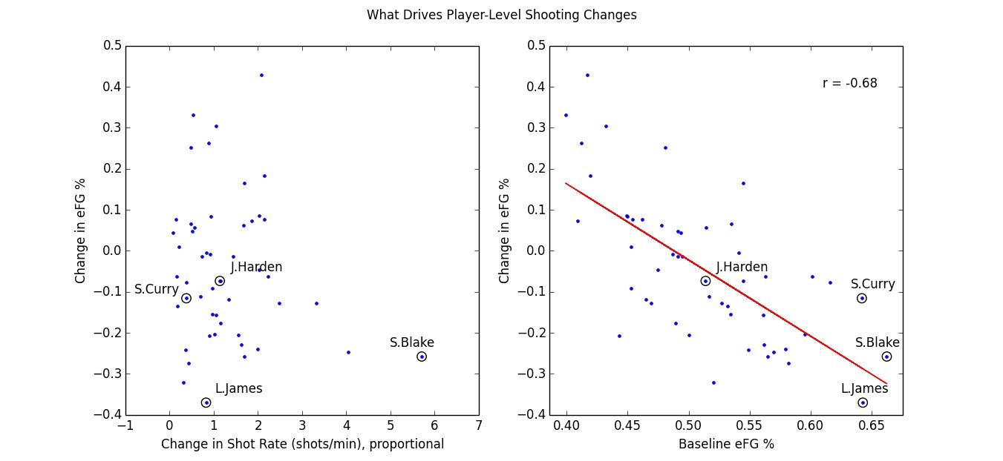
Also: regression towards the mean – or over-correction? It's not just that it's less extreme, it's that bad players shoot better than league average? That LBJ shoots worse than league average?

–

3-point Efficiency Decreasing Over Time

Here we are looking at a per-second analysis of effective field goal percentage (eFG%). We're looking at all the shots on a second-by-second basis (gray dots). Because it's noisy, we smooth the time series with a 9-second window, and plot the results, in red for 3-point attempts and in blue for 2-point attempts.
The blue line stays fairly level, showing no real change for 2-point shots. For 3-point shots (solid red line) efficiency drops off between 40 and 27 seconds, with a decrease in efficiency of about 10 percentage points, from about 57% to 47%.

So not only do we see a drop from baseline time period compared to two-for-one window, a second-by-second breakdown, it appears 3-point shooting percentage decreases within this window as well. As time approaches roughly 27 seconds remaining, and players become antsy to get off any shot, overall shot quality diminishes.
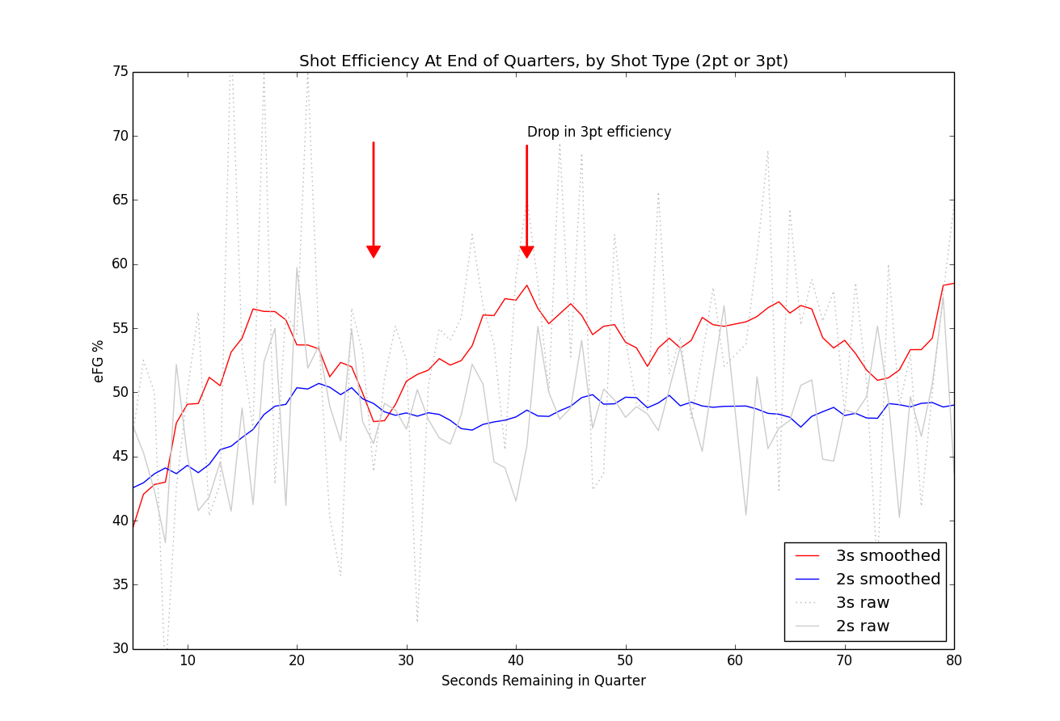

Following up with Houston

So, what's going on with Houston?

The overall story at the team-level doesn't hold for Houston when we look at individuals. While Harden, an above average player, takes a slight dip in efficiency, his teammates face a much steeper fall-off, dropping 20 percentage points from 0.57 to 0.37 adjusted efficiency. With a typical regression to the mean effect, you'd expect Harden to suffer the biggest fall-off and his teammates to shoot the same or better.

Here's the splits between Harden and the rest of the team:

Table: Houston Splits

Advice for Houston:

Basically, there's an opportunity for Houston to improve here. Have all the players besides Harden be more selective with their shots during the two-for-one window. It looks like they're just taking any shot and many of those shots aren't falling. A closer look at game film or SportsVu data on these plays could also help evaluate how bad these shots were, how close any defenders were, or if the players had poor mechanics on those shots, etc. Houston was one of the teams that saw the highest increase in shot volume during the two-for-one, and they seem to be one of the teams whose shooting efficiency suffered the most.

–

– end

Conclusion:

(some concluding remarks)
– context = Zach Lowe.

So Lowe's observation that some teams end up with bad looks during the Two-for-One window may reflect three things: 1) the general increase in 3-point attempts 2) the concurrent decrease in the rate at which teams make those 3-point shots, 3) the fact that the biggest drop-offs in shooting efficiency tend to be happening to normally high-powered offenses like Houston's.

–

Technical Notes:

Below are some technical notes on how the project was implemented in Python.

Data and Methods

Data source: basketball-reference.com; used the Event Finder query tool for Field Goal Attempts. Games used: all regular season NBA games from 2014-15. Data collected on a per-team basis. Filters: End of quarters only, for quarters one through three. Fourth quarter discarded because of end-of-game complications. We’re not tracking full play-by-play data, so turnovers, rebounds, second chances, free throws, etc aren’t in the picture. We’re just looking at shot data, time of shot, distance, player, 2-point vs 3-point attempt.

Python packages used: Analysis was completed using Python and the Pandas toolkit. Figures created via Matplotlib library. Data persistence was done using Python/Pickle (file-based object serialization). Python environment was the Enthought/Canopy distribution.

Data Notes

Data parsing: Some of the data input processing simply involved extracting time information from time fields formatted as strings, or other straightforward conversions, or re-codings. Player and shot information (shot type, make/miss status, and shot distance) were parsed out of the Description text field and added as new variables (aka, columns). A few examples of that Description text are below:

“D. Wade makes 3-pt shot from 25 ft”
“C. Bosh misses 2-pt shot from 14 ft”
“C. Bosh makes 2-pt shot at rim (assist by D. Wade)”

Data Quality:
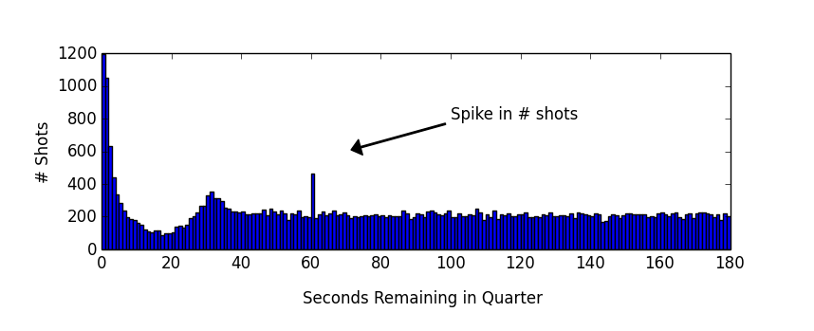
One issue regarding data quality came up during analysis. It looks like there's a spike in shots when there's 60 seconds remaining in the quarter. There is no apparent local increase in shot quantity at nearby timepoints like 58, 59, or 61 seconds. This may reflect a bias in hand-coding towards a round number like “one minute left” when the data is originally tracked during the game. There is perhaps a slight dip in volume of shots around this timepoint, which may reflect this bias. There was no obvious relation of this increase in shots with any team or player, or anything else which may reflect other data corruption issues.

Workarounds for this were either dropping the 60 bin of shots entirely (for per-second analysis), or re-drawing the boundaries of different time periods. The baseline time period was set from 65 to 180 seconds to avoid any effect of this data spike on Shot Rate (and Change in Shot Rate) which was sensitive to this anomaly.

Technical Skills Shown:

- Used data to address specific questions related to performance.
- Data preparation, pre-processing: re-mapping time into alternate time periods; parsing the descriptive text to extract player, shot type, distance information.
- Data smoothing
- Data re-shaping, reconstructing shot-logs for end of quarter scenarios.
- Data quality / anomaly check (spike in data at time = 60 seconds)
- Analysis at different levels of aggregation: by team, by individual, by quarter.

Additional Analysis:

A few additional analyses were performed, summarized below.

- The increase in volume of shots is related to the types of shots teams take. On a per-team basis, the more a team shoots in the two-for-one window, the higher proportion of 3s a team attempts (r = 0.48, p = 0.007). (# Fig 1021 ** )

- End-of-quarter shot logs were reconstructed for every quarter in every game. – Basically, teams that end up taking the only shot in the two-for-one window end up securing the final shot of the quarter about 3 out of 5 times. So there's a slight advantage to winning it, but it's not as high as one would expect (closer to 8 or 9 out of ten times, or something much higher.) Main caveat: this analysis is limited by lack of free throw information or other information available from a full play-by-play dataset.

