Summary Results:

Proportion of shots that are 3pt attempts, epoch 3: 0.33
Proportion of shots that are 3pt attempts, epoch 5: 0.26

3pt fg %, epoch 3: 0.33
3pt fg %, epoch 5: 0.37
Change in 3pt fg %: -0.04

Overall eFG %, epoch 3: 0.48
Overall eFG %, epoch 5: 0.51
Change in Overall eFG %: -0.02

–

Exective Summary:

–

Intro:

-

Figures...

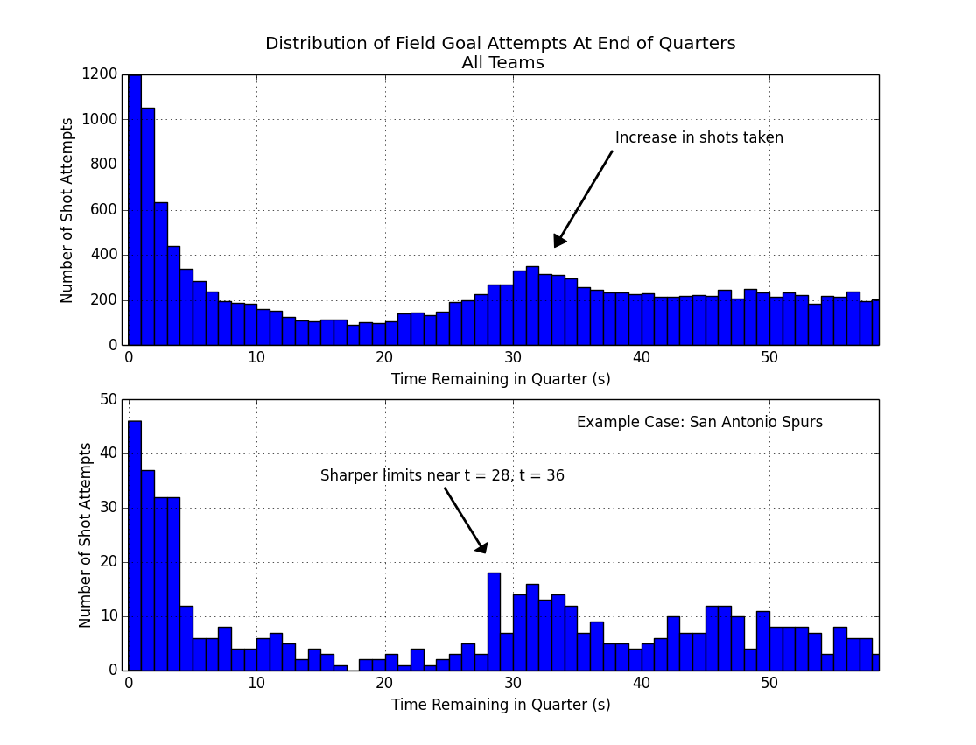

First off we need to identify and define this Two-For-One window.

Above figure. Top panel, shows an increase in shot attempts around 30-35 seconds remaining in the quarter. We also notice a decrease in shots taken between 10-25 seconds, and a lot of buzzer-beat type shots taken with 3 seconds or less left on the clock.

So 30-35 seconds gives us a general timeframe of a 2-for-1 window, but let's get more specific. If we look at an example case like the San Antonio Spurs, a league-leading team known for smart basketball, (figure, lower panel) we see a similar increase in the number of shots attempted, with slightly different cutoff points, near 28 seconds, and 36 seconds. And these cutoffs have sharp drop-offs before and after, so this gives us further indication that we're basically in the right window of time.

In the end, we're going to define our 2-for-1 window from 27-35 seconds (inclusive) remaining in the quarter. This is a bit conservative on the upper end, but to the extent we can, we want to make sure most of these shots in this window are indeed 2-for-1 type of shots and not just a team's normal behavior.

(end)

What's in the figure: the figure shows the total number of shot attempts taken during the entire season in the league, with X many seconds left on the game clock in the quarter.

Example: there were around 200 total shots taken with about 50 seconds left on the clock.

General;
While the tactic is about maximizing the number of shot attempts, we're going to look and see if and how that's impacting the quality of those attempts.

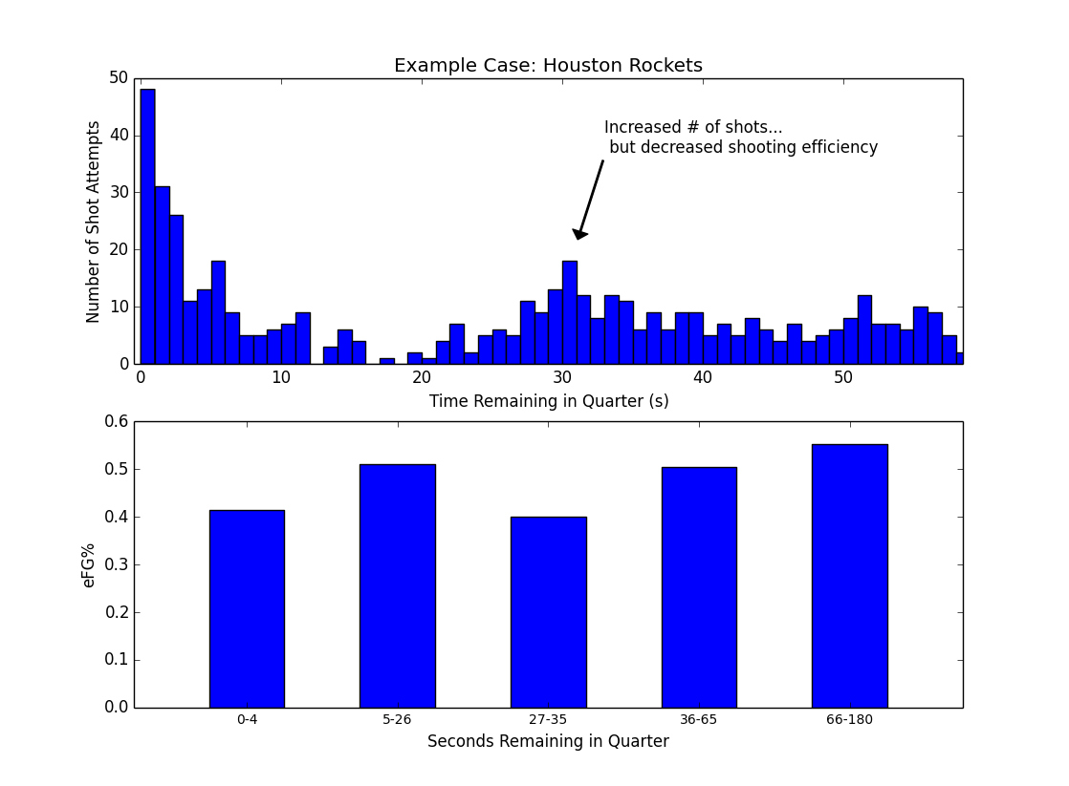

Middle -

Proportion of shots that are 3pt attempts, epoch 3: 0.33
Proportion of shots that are 3pt attempts, epoch 5: 0.26

3pt fg %, epoch 3: 0.33
3pt fg %, epoch 5: 0.37
Change in 3pt fg %: -0.04

Overall eFG %, epoch 3: 0.48
Overall eFG %, epoch 5: 0.51
Change in Overall eFG %: -0.02

Table 1: Overall Comparison of Two-for-One shooting vs Baseline Shooting.

 | Proportion of 3pt Attempts (2s vs 3s) | 3pt Effectiveness | Overall Shot Efficiency (eFG%)
Baseline (Epoch 5) | 0.26 | 37 % | 0.51
Two-for-One (Epoch 3) | 0.33 | 33 % | 0.38
Change | + 0.07 | - 0.04 % pts | - 0.02 *

* may not add up due to rounding.

Shots per second, split by shot type...

.. decrease in 3pg eFG %.

...
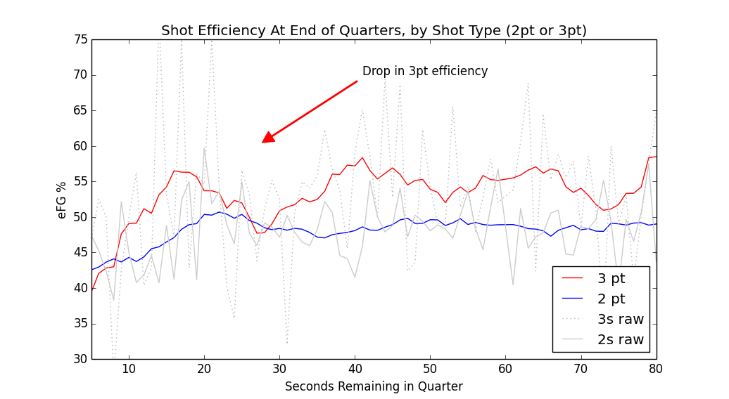
Overall, looking at the smoothed line of 3 pt efficiency in red

Tripiles …
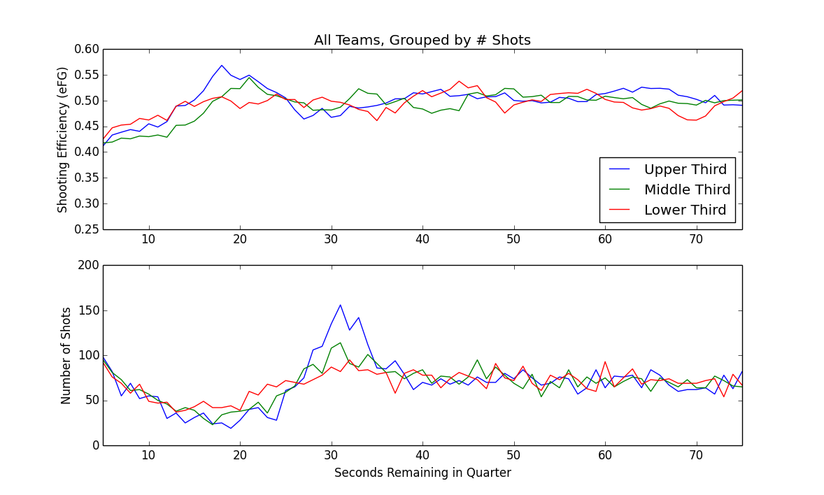

We grouped teams into three groups, based on number of shots taken during the 2-for-1 window, as a simple way of measuring two-for-one agressiveness,
which teams were attempting a 2-for-1 tactic the most often. …
Overall, for this top one-third of teams, we can see...
Overall, for the top one-third of teams in terms of number of shots taken in the 2-for-1 window, we can see an increase in shots around 30 seconds remaining (lower panel, blue), along with a slight dip in shooting efficiency (upper panel, blue).

The other thing we see in this series is that the middle group, and the lower group, really aren't that much more agresive in terms of taking extra shots in this 2-for-1 window.

Final answers.

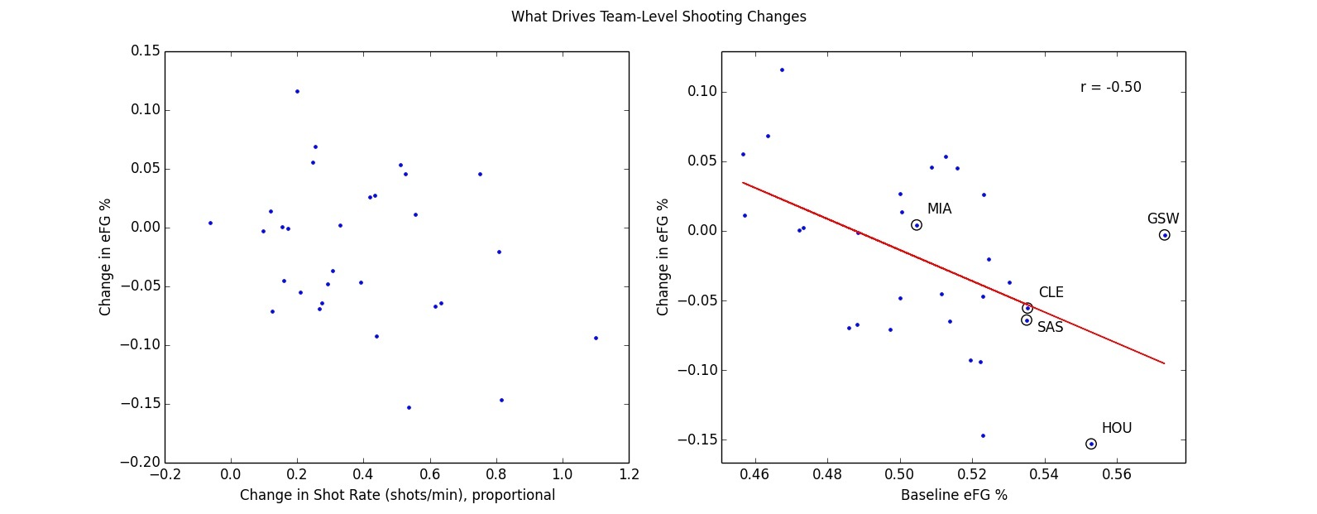

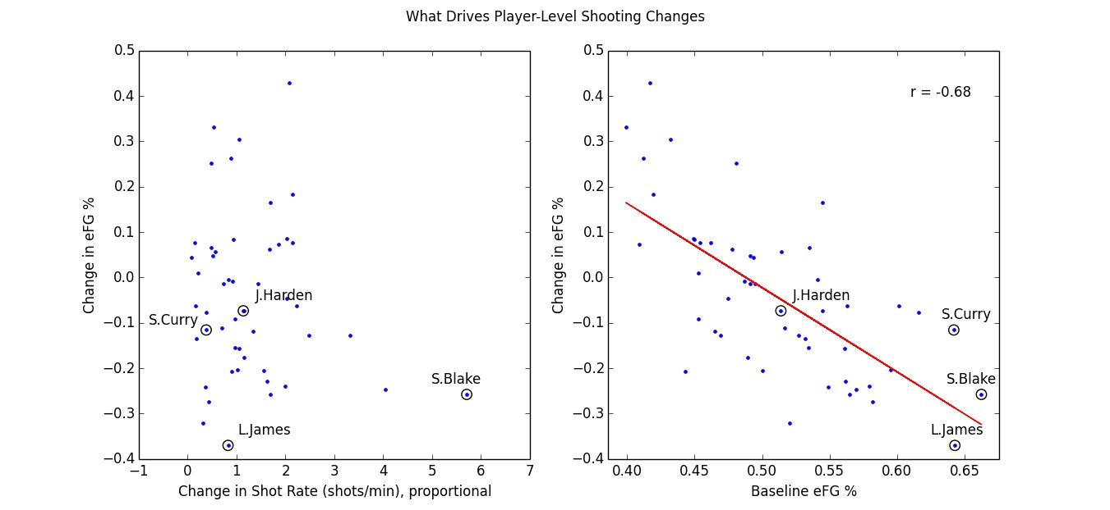

# Breakdown –

.. small driver vs bigger driver.

Notes:

– smoothing

– notes, comparison --- regression to mean, control group, comparisons, etc.

– data spike

Additional finding:
pearsonr(team_report['shotrate_diff'], team_report['prop_threes_diff'])
# (0.48164911393624316, 0.0070403594139744228)
# Higher TFO Shotrate -> Higher Proportion of 3s Attempted.

# **

# add in somewhere fitting.

On a per-team basis, the more a team goes for a TFO advantage, the higher proportion of 3s a team attempts.

# The fact that Proportion of Threes is marginally associated with 3pt eFG, means we'd want to keep an eye on this going forward. – It may become more relevant in the future.

.. blah blah.

–
Control:
(file: tfo_team_report.py)

Figures 1010 1011, 1012.

e3 vs e5, ok – a reg.
diff(e3, e5) vs control – no diff ?

E5 vs diff(e3,e5) –

econtrol vs diff(e3,ec) – still a regression to mean... so regression to mean still mainly in effect.

E5 vs diff(e3, ec) – flat. & e5 corr with ec. Therefore: Regression to mean effect between e5, and e3, probalby not due to chance.).

efg EC vs diff(e3, EC) – still reg to mean type neg correlation. // if we use an alternate control instead of E5, we still see regression to mean.

# ---

What does this mean? :

pearsonr(df_espn['AFG%'], df_espn['AFG%'] - team_report['team_efg_e3'])
Out[262]: (-0.36302758790579298, 0.048638443311019963)

means:
1) what we saw with e3-e5, should still hold. It's basically the same thing. (Especially considering e5 corr with espn_afg.

# Fig 1021 ** – with increasing shotrate, you see teams taking proportionally more 3pt attempts.

# –

Correlation between efg in epochs 4 and 5 – are correlated (r .40, p = .028).

So upshot: normally, efg from differenct time periods *should* be correlated.
What's telling us something about e3 is that this relationship broke down.
That it is not correlated between the TFO window and normally, in epoch 5 (baseline).
That's our interpretation.

– So what we see between epochs 3 and 5 (between the TFO window and baseline shooting), is not correlated, it's just random. – So what this means is that efg is different from what it normally is.

