xCelerator CISSynchronous Installation and User Guide
Version 1.0

Preface

Purpose
This document provides step-by-step instructions on how to install and configure the xCP CIS
Synchronous xCelerator. It details how to configure and use the delivered java module
in xCp Designer and provides information about the xCP CIS Synchronous xCelerator
source code to implement the template.

Intended audience
The information in this guide is intended for process designers and developers using Documentum
xCP Designer software. The objective of this xCelerator is to provide reusable java extension
to resolve common business problems.

Support information
The xCP CIS Synchronous xCelerator is not supported by EMC.

Related documentation
The EMC Documentum xCelerator home page (https://community.emc.com/docs/DOC-6143) provides access to xCP xCelerators.

Revision history
Date | Version | Change
Nov. 2010 | 1.0 | Initial publication
Nov. 2012 | 2.0 | Migration to xCP 2.0

Contents
Preface 2
Purpose 2
Intended audience 2
Support information 2
Related documentation 2
Revision history 2
Contents 3
Overview 4
What is an xCelerator? 4
xCP CIS Synchronous xCelerator 4
Bill of Materials 4
Installing xCP CIS Synchronous xCelerator 6
Prerequisites 6
Install the CIS Synchronous xCelerator file 6
Installation troubleshooting 8
Using the CIS Synchronous xCelerator 9
Configuration 9
Method 12
Considerations 12

Overview

What is an xCelerator?
An xCelerator is one or more artifacts that can be used to accelerate the creation, adoption, and/or implementation of an EMC Documentum xCelerated Composition Platform (xCP) solution. An xCelerator is not necessarily a running application; instead, it is intended to hasten application development by providing key pieces of functionality out-of-the-box. Examples of this include:
- A sample business process flow created by Process Builder
- A sample high fidelity form using Forms Builder
- A sample Business Activity Monitor (BAM) dashboard
- A sample bit of code or configuration that connects the workflow with a third-party product
- Documentation that focuses on best practices and troubleshooting when developing and implementing an xCP solution
- A sample application
xCelerators are:
- Technology focused and can be samples, examples, starting points, or guides that accelerate the creation of an xCP solution
- Free and are not EMC-supported products, yet they do go through a formal release cycle, including quality assurance and documentation
- EMC intellectual property
- Sharable with multiple partners or anyone who wants to download them from the xCP community site

xCP CIS Synchronous xCelerator
Documentum Content Intelligence Services (CIS) allows you to classify documents based on the analysis of their content and metadata. Using a predefined or a custom taxonomy, you can automatically classify new or modified documents. A taxonomy is a hierarchy of categories. When a document matches a category definition, it is assigned to this category.
Refer to the Documentum Content Intelligence Services Administration Guide for more information on CIS classification.
This xCelerator integrates the classification function of CIS with xCP by adding an java extension:
• Classify and Categorize

Bill of Materials
The xCP CIS Synchronous xCelerator is accessible through the Community xCelerator xChange home page (https://community.emc.com/docs/DOC-7597) by selecting the xCP CIS Synchronous xCelerator download link.
The CIS Synchronous contains:
Artifact | Path / File Name
Overview guide (this document) | Documentation/xcelerator-cissynchronous.pdf
Installation files | Package/xcp2_cissynchronous.jar
Source code | Source

Installing xCP CIS Synchronous xCelerator

Prerequisites
In addition to Documentum Content Server 7, the following must also be installed prior to installation of this xCelerator:
- Documentum Content Intelligence Services 7
- Documentum XCP Designer 2.0

Install the CIS Synchronous xCelerator file
Download the xcp2_cissynchronous xCelerator.zip file which is accessible through the EMC Documentum xCelerator community home page by selecting the CISSynchronous xCelerator link.
Unzip the xcp2_cissynchronous xCelerator.zip file and locate the xcp2_cissynchronous.jar at the following path: <Install folder>/xcp2_cissynchronous xCelerator/Package/xcp2_cissynchronous.jar
Open your application in xCP Designer and select “Model” in the “Application” tab
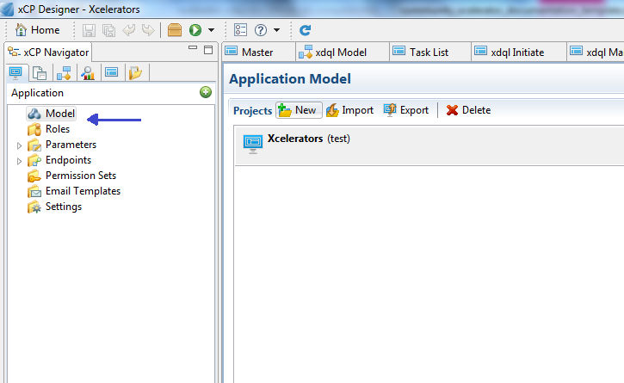

In the Libraries part, click on the “ADD” button. A pop-up will open. Click the “Browse” button and navigate to the folder <Installed folder>/xcp2_cissynchronous xCelerator/Package and select xcelerator in “Libraries to copy”. Click on the Next Button
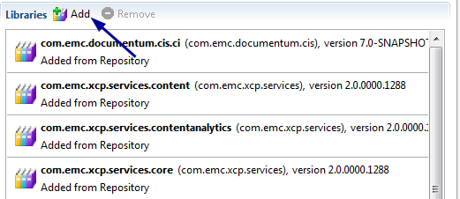

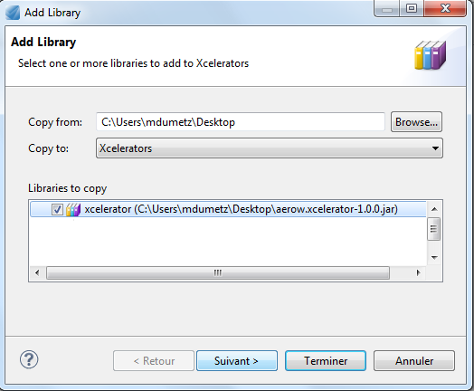
Check if the same name and the Namespace are well filled and click on the “Finish” Button
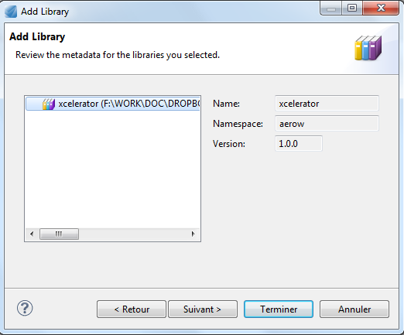

Installation troubleshooting

Using the CIS Synchronous xCelerator
The CIS Synchronous xCelerator enables a process to request CIS to analyze a document and configure what to do with the resulting categories.

Configuration
CIS must be installed and configured as described in the Content Intelligence Services documentation. At least one taxonomy synchronized in production mode is required.
- When designing your process in xCP Designer, drag and drop the Execute Java Service activity onto the process template.
- Double-click the activity to open the Activity Inspector, and navigate to the Execute Java Service Configuration tab to configure the activity.
You can choose between three methods for the CISSynchronousActivity module:
- ICategoryMetadata[] suggestMetadataById(String) returns an array of category names of applicable categories suggested by CIS for the document in question.
- String[] suggestFolderPathsById (String) returns an array of category paths of the applicable categories suggested by CIS for the document in question.
- MetadataAndFolders suggestMetadataAndFoldersById(String) returns a MetadataAndFolders object holding both the applicable categories and their paths for the document in question.
The three methods take the same argument, described in the following table:

Argument | Type | Description
arg0 | String | The r_object_id of the document you want to analyze.
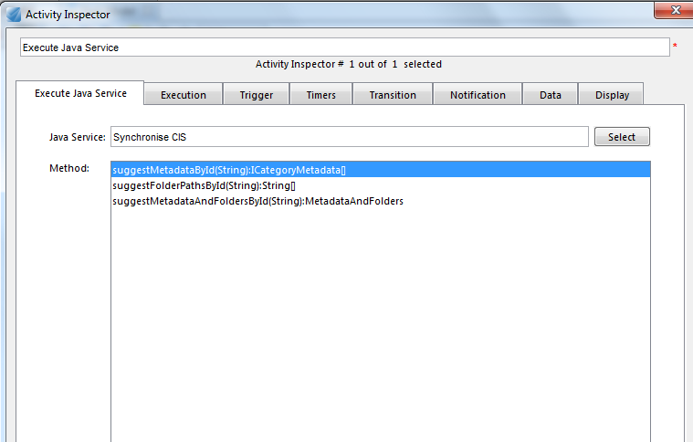

- Click Next to start the wizard. On the Input Message Mapping screen, indicate the mapping for the r_object_id of the document you wish to analyze into the argument arg0.

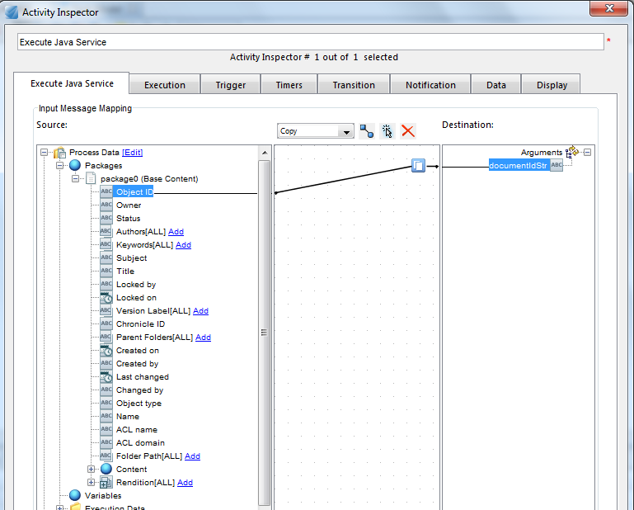

- Click Next. On the Output Message Mapping screen, indicate the mapping for the resulting categories into a process variable for further processing.

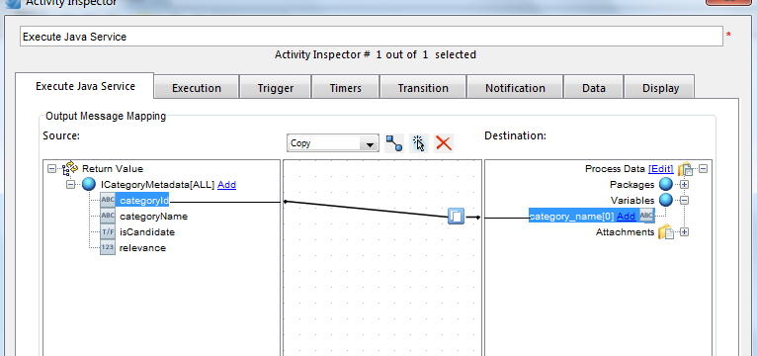

Method
The three methods available suggestMetadataById, suggestFolderPathsById , or suggestMetadataAndFoldersById, return the applicable categories suggested by CIS for the document in question. It can either be the category names, the category paths, or both.

Considerations

