Comparing Different Sorting Algorithms
Marcelo Camba
CSCI 212
December 2025
Abstract
Sorting algorithms help us organize data, and one way to compare them is by looking at how many element-to-element comparisons they make. In this study, I looked at five algorithms—heapsort, quicksort, merge sort, tree sort, and insertion sort—by sorting arrays of 20,000 random integers. Each algorithm was run ten times to get an average number of comparisons. A one-way ANOVA showed a significant difference between the algorithms (F(4, 20.5) = 6.86×10⁶, p < 0.001). Merge sort and quicksort made the fewest comparisons, while insertion sort made the most, showing how inefficient it is for large random lists. Overall, the results match what we expect based on time complexity and show why choosing the right algorithm matters.
Introduction
Sorting algorithms are algorithms that help us put elements into a specific order, usually numerical order, which can be ascending or descending. This is helpful whenever we need to process data that comes in random arrangements and we need it to be ordered in a specific way. In class, we have discussed different qualities of sorting algorithms. The first one is the time complexity, or the time that the algorithm takes depending on its input. There is also stability, which basically tells us if the algorithm maintains the relative order of the elements with equal sort keys (e.g., age, class, weight) or not (Harrison, 2018). We can also look at their auxiliary space, which is just the extra space taken by the algorithm temporarily to do the job. In this paper, I will be discussing five different sorting algorithms and will do an experiment that is looking into their efficiency when it comes to doing element to element comparisons.
Heapsort
Invented by J. W. J. Williams in 1964, this sorting algorithm organizes an array of elements into a max heap, and then repeatedly moves the max element of the heap, placing it at the end of the array (Wikipedia, 2025b). This process continues until the max heap has only one element left. Because it is a binary heap, this sorting algorithm has an efficient time complexity of O(n log n) which makes it good for large data sets, and it also does not need much more auxiliary space (GeeksforGeeks, 2025).
This process is visually represented in Fig. 1. Starting from the initial array of integers [8, 6, 7, 5, 3, 0, 9], we build a binary heap from that. Then, we convert it into a max heap, where the maximum value is the root and both its children are smaller. Then the largest element swaps with the last child and then the largest element is dequeued to the last index of the array. Afterwards we apply the bubbleDown method to recreate the max heap and repeat the whole process until we get the sorted array [0, 3, 5, 6, 7, 8, 9].

Figure 1. Visualization of Heapsort
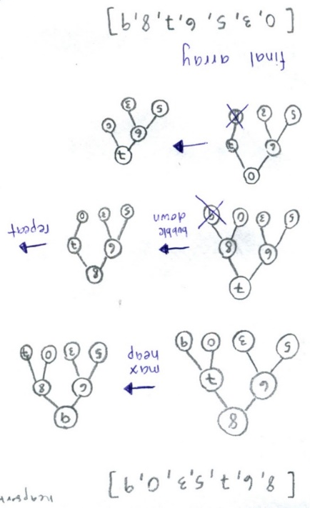
Quicksort
Developed in 1959 by Tony Hoare and published in 1961 (Wikipedia, 2025c). It is one of the divide-and-conquer algorithms, where they take a problem and divide it into tinier subproblems, recursively solves them and then combines the solutions (Khan Academy, 2025). However, it does have a time complexity of Θ(n²). This can be exemplified on Fig. 2. Using the same array as previous examples, we first pick the first element as the pivot. In the code, there are two pointers, the start which is after the pivot, and the end that is at the end of the array. The start pointer moves forward until it sees an element that is larger than the pivot and the end moves backwards until it sees an element that is smaller than the pivot. When this happens the start and end pointers swap values. Ultimately, the pointers will cross each other, and here we swap with the pivot, so all elements smaller or equal than the pivot are to the left and all the larger ones are to the right. We repeat the process with the left and right parts, choosing a pivot and arranging the elements, until we have a subarray with less than two elements, which would mean that our array is sorted.
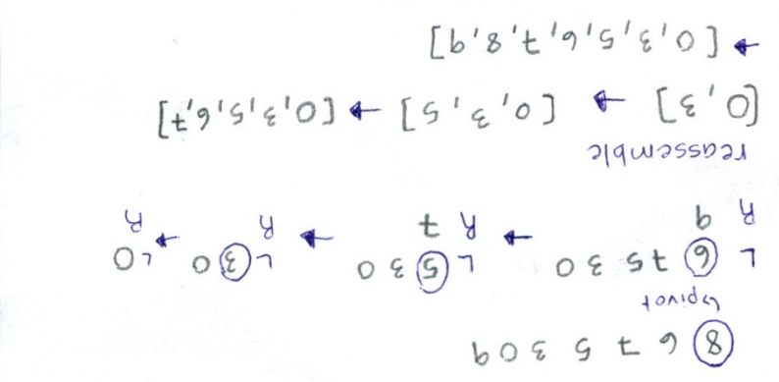
Figure 2. Visualization of Quicksort
Merge sort
It was developed by John von Neumann in 1945, merge sort is another of the divide-and-conquer type of sorting algorithms (Alake, 2023). It works by recursively splitting the array in halves until we have subarrays of less than two elements and then merges these subarrays together making sure that they are sorted (Alake, 2023). It has a time complexity of Θ(n log n).
In Fig. 3 there is a visual representation of the merge sort algorithm. We are using the same array as before. We start by splitting the array in half and then we keep doing that recursively on the left and right halves until we reach subarrays of less than two elements. Then we have pointers in each sorted subarray that compare each element and put the smaller one into a new array. Repeat the process until all elements from the subarrays are in the sorted array.
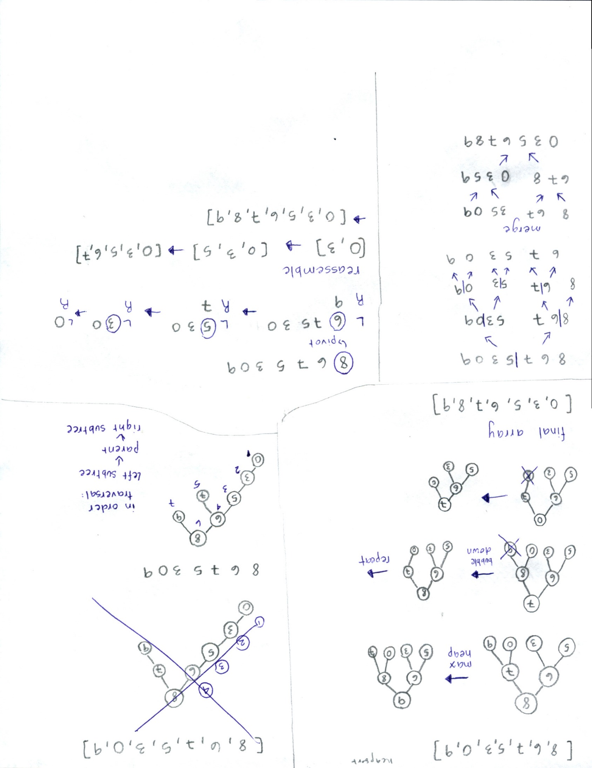
Figure 3. Visualization of Merge sort
Tree sort
Tree sort is a sort algorithm that organizes the array into a binary search tree and then traverses the tree in order so that the elements become sorted (Wikipedia, 2025a). The average performance is O(n log n). However, this can go to O(n²) if our binary search tree is unbalanced (Wikipedia, 2025a). In the visualization (Fig. 4) we have the same array we have been using for previous examples sorted into the binary search tree. It follows the invariant that the left children are smaller than or equal to the parent, and the right children are greater than the parent. The figure shows an unbalanced binary search tree. To look at the sorted array, we do an in order traversal, that is going from the left subtree, then the parent and then the right subtree.

Figure 4. Visualization of Tree sort
Insertion sort
Insertion sort is the fifth sorting algorithm that I chose for this paper. My reason for choosing it is because it is a simple but famous algorithm, so I wanted to compare it to the other sorting algorithms that we have seen in class. It has an average time complexity of O(n²) (GeeksforGeeks, 2025). It starts by picking the second element from the unsorted array (referred to as the key) and then compares it to the previous element. If the key is smaller than the previous element, it swaps the positions. Then it moves to the third element and compares it to the first two elements to do the same. It keeps repeating the same process until it reaches the last element and sorts the full array (GeeksforGeeks, 2025).
Figure 4. Visualization of Insertion sort
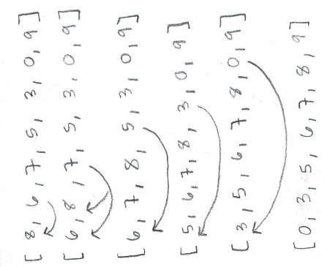

Methodology
The purpose of this experiment is to compare the efficiency of five common sorting algorithms (heapsort, quicksort, merge sort, tree sort, insertion sort) by tracking the number of comparisons between elements that they make when sorting arrays of integers. Inspired by the assignment we had in H6, I decided to do a similar task of generating arrays of 20,000 random integers and sorting them with the different sorting algorithms that we have. However, in order to try to take into account the possible cases in which some algorithms might do better than others depending on how the integers are arranged in the arrays, I decided to run the code for 10 times and then compare the average comparisons between elements that each sorting algorithm has made.
Results
A one-way ANOVA was carried out to determine if the number of element-to-element comparisons varied by type of sorting algorithm (quicksort, heapsort, merge sort, tree sort, insertion sort). There was a main effect F(4, 20.5) = 6.86x10⁶, p < 0.001. The averages of the comparisons between sorting algorithms are in Table 1.
Table 1. Results of Average Number of Element Comparisons
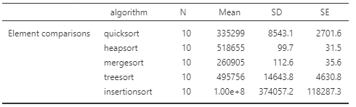

Conclusion
Overall, this experiment showed that there are clear differences in how efficient the five sorting algorithms are when it comes to doing element-to-element comparisons. Merge sort and quicksort made the fewest comparisons on average, which fits with what we know about their time complexity. Heapsort and tree sort were in the middle, and insertion sort required by far the most comparisons, going over a million for a list of 20,000 integers. This lines up with the theoretical expectations that O(n log n) algorithms perform much better than O(n²) algorithms for large, randomly arranged data.
Even though these results make sense based on the theory, this experiment only focused on the number of comparisons. A next step could be to look at other factors that also matter for efficiency, such as actual running time, memory usage, or how the algorithms behave when the data is already partially sorted. It might also be interesting to run the experiment with different types of input distributions or bigger lists to see if the patterns stay the same. This could give an even better idea of when each sorting algorithm is most useful.

References
Alake, R. (2023, June 12). Merge sort explained: A data scientist’s algorithm guide. NVIDIA Technical Blog. https://developer.nvidia.com/blog/merge-sort-explained-a-data-scientists-algorithm-guide/
Harrison, O. (2018, December 28). Stability in sorting algorithms - a treatment of equality. freeCodeCamp.org. https://www.freecodecamp.org/news/stability-in-sorting-algorithms-a-treatment-of-equality-fa3140a5a539/
Heap sort. GeeksforGeeks. (2025a, October 18). https://www.geeksforgeeks.org/dsa/heap-sort/
Insertion sort algorithm. GeeksforGeeks. (2025b, July 23). https://www.geeksforgeeks.org/dsa/insertion-sort-algorithm/
Khan Academy. (n.d.). Overview of quicksort. Khan Academy. https://www.khanacademy.org/computing/computer-science/algorithms/quick-sort/a/overview-of-quicksort
Wikimedia Foundation. (2025a, April 5). Tree sort. Wikipedia. https://en.wikipedia.org/wiki/Tree_sort
Wikimedia Foundation. (2025b, October 23). Heapsort. Wikipedia. https://en.wikipedia.org/wiki/Heapsort
Wikimedia Foundation. (2025c, November 6). Quicksort. Wikipedia. https://en.wikipedia.org/wiki/Quicksort

Appendix

