Marcel Galliker

marcel@radex-net.com

A short introduction to the radex RX-LabelComposer tool.

RX-LabelComposer

Documentation

Version 0.0.0.1

Contents

1 Introduction 3

1.1 Numeric Fields 3

2 Main Compoments 4

2.1 Menu 4

2.1.1 Menu File 4

2.1.2 Menu DATA 5

2.1.3 Menu Help 5

2.2 Tab Selector 5

2.3 Record Selector 5

3 Label View 6

3.1 General Concepts 6

3.2 Label Preview 7

3.3 Toolbar 7

3.4 Label Settings 7

3.4.1 Dialog Fields: 7

3.5 Boxes Table 9

3.5.1 Toolbar 9

3.5.2 Selecting a box 9

3.6 Data Table 10

3.7 Counter 11

3.7.1 Counter field 11

3.7.2 Counter Definition 11

3.7.3 Elements Definition 11

3.8 Box Properties 12

3.8.1 General Properties 12

3.8.2 Text Properties 13

3.8.3 Barcode Properties 13

4 Data Definition 15

4.1 Data Preview 16

4.2 File Properties 16

4.2.1 Field Properties 16

5 Samples 17

5.1 Counter.xml 17

5.2 Color labels 17

5.2.1 Label-Black.xml 17

5.2.2 Label-Color-1.xml 17

5.2.3 Label-Color-2.xml 18

5.2.4 Label-Color-3.xml 18

# Introduction

The RX-LabelComposer is a software out of the radex printer control system. It is used to personalize printed documents (like labels) using texts and barcodes. The RX-LabelComposer runs stand alone on any windows x64 based PC. It creates XML formatted documents that can be printed on the radix printers.

This document describes how the RX-LabelComposer is used.

## Numeric Fields

All numeric fields can be changed by keys.

#### Function keys

|  |  |
| --- | --- |
| Key | Function |
| [+] | adds 1 |
| [-] | subtracts 1 |
| [shift][+] | adds 0.1 |
| [shift][-] | subtracts 0.1 |
| [ctrl][+] | adds 0.01 |
| [ctrl][-] | subtracts 0.01 |

# Main Compoments

❹

❸

❷

❶

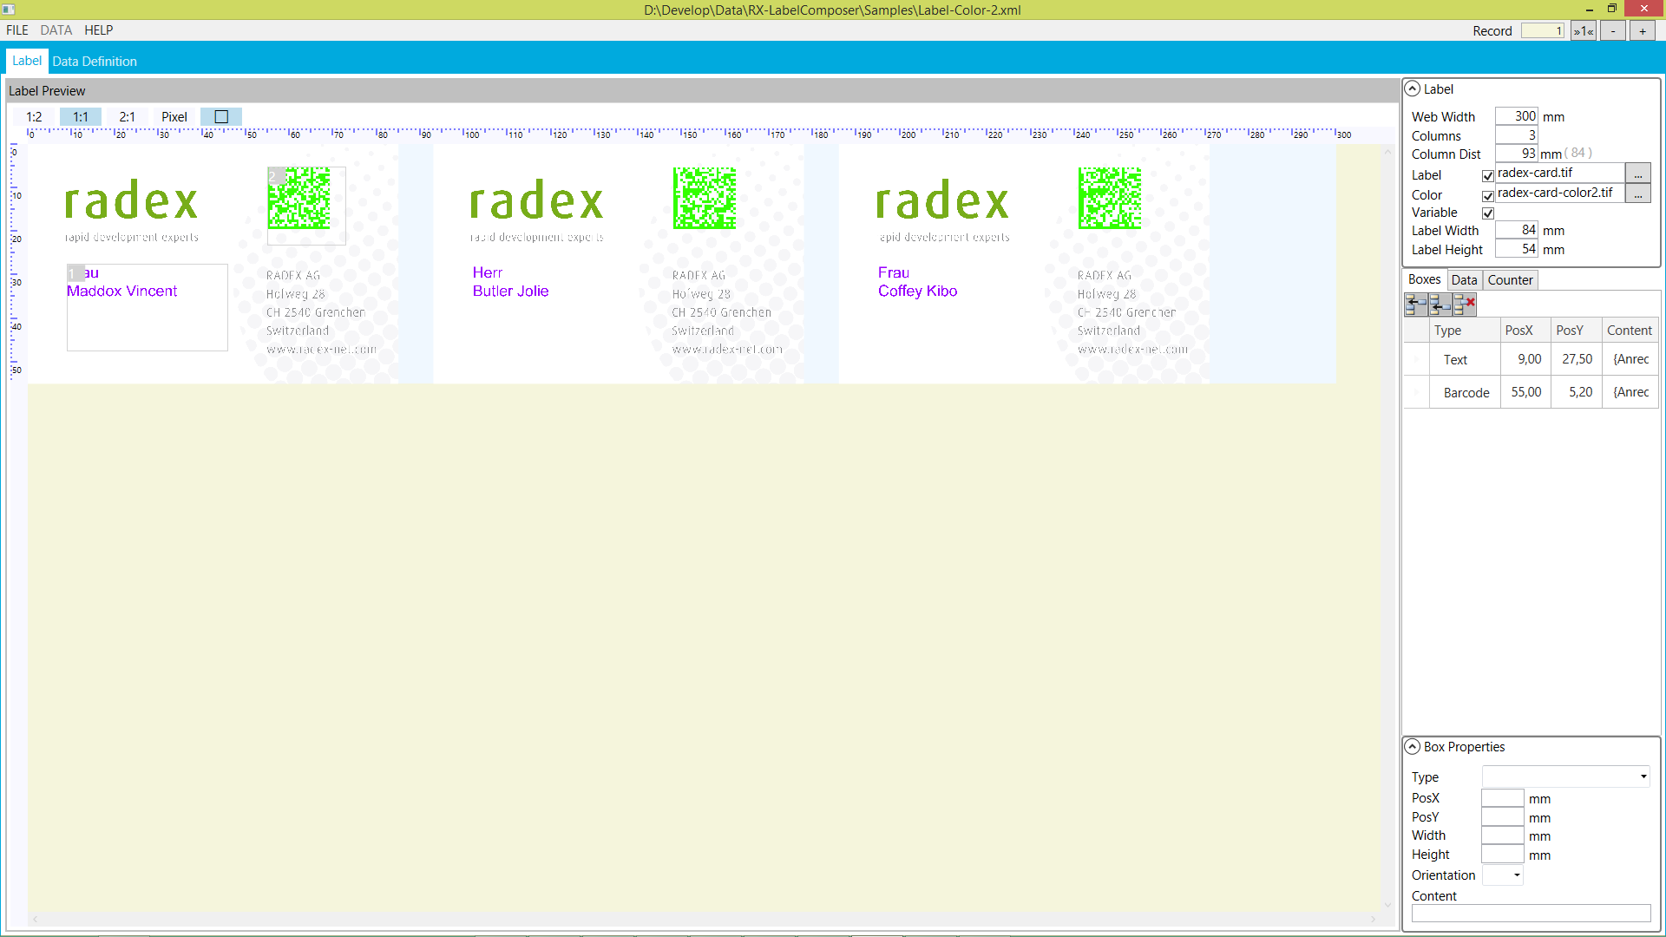

|  |  |
| --- | --- |
|  | Element |
| ❶ | Menu |
| ❷ | Tab selector (selects between Label and Data Definition) |
| ❸ | Actual file (the path of the actual file) |
| ❹ | Record selector |

## Menu

This is the menu of the application.

### Menu File

This is the main file menu. When settings have changed and one of this commands is selected RX-LabelComposer asks to save the changes.

#### **F**ile/New

Asks for the name of the file and setts all settings to default values.

#### File/Open

Asks for a file to open.

#### File/Save

Saves all settings in the actual file.

#### File/Save As

Asks for a new filename and saves all settings into this file. The selected file is now the actual file.

#### File/Exit

Closes the application.

### Menu DATA

The menu data is only enabled when the “Data Definition” tab is active.

#### Data/Analyse

Menu/Analyse works through the active DataFile and tries to find the correct settings. As this function overwrites the actual settings the user has to confirm this action first.

#### Data/First Record as Fieldnames

This function takes the values of the first data record as field names. The first record is then skipped. As this function overwrites the actual settings the user has to confirm this action first.

### Menu Help

#### Check for update

Checks the radix server for a newer version.

#### About

Shows information about the application.

## Tab Selector

Here the user can change between the Label and DataDefinition tab.

## Record Selector



❹

❶❸

❷

❸

|  |  |
| --- | --- |
|  | Element |
| ❶ | Actual record |
| ❷ | Go to first record |
| ❸ | Go to previous record |
| ❹ | Go to next record |

# Label View

## General Concepts

A label is a rectangular area that holds boxes with variable data. The label may have a background image and color defining image.

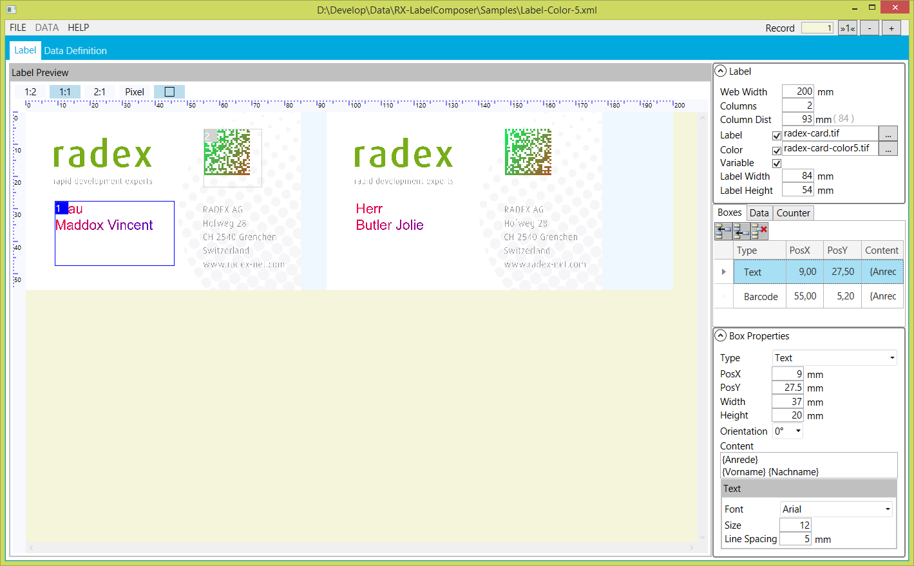

❶

❷

❸

❹

❺

|  |  |
| --- | --- |
|  | Element |
| ❶ | Label Preview |
| ❷ | Toolbar |
| ❸ | Label settings |
| ❹ | Boxes / Data / Counter Table |
| ❺ | Box Properties |

## Label Preview

The label preview shows one row of labels on the web. The ruler is set according to the web and label dimensions. Use this view also to select a box of variable data or move it around.

## Toolbar



❶

❷

❸

❹

❺

|  |  |
| --- | --- |
|  |  |
| ❶ | Set preview zoom to 1:2 (size on screen is half the real size) |
| ❷ | Set preview zoom to real size (size on screen exactly as printed) |
| ❸ | Set preview zoom to 2:1 (size on screen is twice the real size) |
| ❹ | Set preview zoom to pixel (each display pixel corresponds to one printer dot) |
| ❺ | Show / hide the border of the boxes with variable data |

## Label Settings

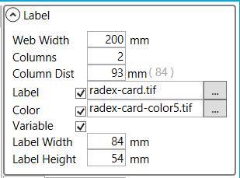

❶

❷

❸

❹

|  |  |
| --- | --- |
|  | Element |
| ❶ | Expander for the settings dialog |
| ❷ | Visibility check boxes for **Label** background, **Color** definition and **Variable** data |
| ❸ | Width of the label |
| ❹ | Button to open explorer to select the file |

### Dialog Fields:

#### Web Width

Defines the width of the paper in the web. It is measured in millimeters where after comma digits are possible. To change the value type in the number or use the keys as defined in chapter 1.1.

#### Columns

Defines how many columns of the label are printed in one row.

#### Column Distance

Defines the distance of the columns in mm. The value in brackets shows the width of one label. Make sure that the Column Distance is wider than this.

It is measured in millimeters where after comma digits are possible. To change the value type in the number or use the keys as defined in chapter 1.1.

#### Label

The when a filename is defined this is the background of the label. Use the […] button to open the explorer to select the file. The file is an unripped source file, usually in TIFF format.

When a file is selected the checkbox is used to show/hide the image in the preview.

#### Color

The when a filename is defined this defines the color of the variable data. Use the […] button to open the explorer to select the file. The file is an unripped source file, usually in TIFF format.

When a file is selected the variable data is colored according to this file. The checkbox is used to show/hide the image in the preview.

When NO file is selected the variable data is in black.

#### Variable

The checkbox shows/hides the variable boxes in the preview.

Depending in the files selected these combination of the colors can be checked by the preview:

|  |  |  |  |  |
| --- | --- | --- | --- | --- |
| Label | Color | Variable | Preview | Comment |
|  |  | ✓ |  | The variable data in black. |
| ✓ |  | ✓ |  | The variable data in black on the label.  Use this to verify the variable data is ripped correct and at the correct place. |
|  | ✓ |  |  | The color definition.  Use this to check that the areas of the variable data are colored. |
|  | ✓ | ✓ |  | Colored variable data.  Use this to check that all variable data is colored. |
| ✓ | ✓ | ✓ |  | Final preview.  The labels will be printed like this. |

## Boxes Table

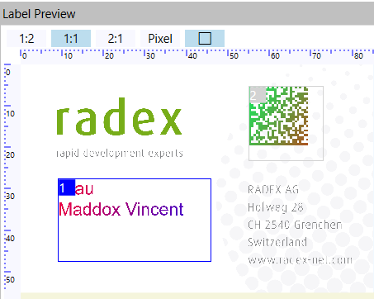 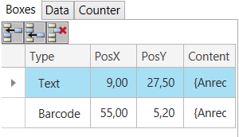

❶

❷

❸

❺

❻

❹

|  |  |
| --- | --- |
|  | Element |
| ❶ | Toolbar |
| ❷ | Boxes list showing the most important settings of the box |
| ❸ | Active box (highlighted) |
| ❹ | Active box (highlighted border) |
| ❺ | Box number and active positioning area |
| ❻ | Inactive Box |

### Toolbar

|  |  |
| --- | --- |
| Button | Function |
|  | Inserts new box before active box |
|  | Inserts new box after active box |
|  | Deletes the active box |

### Selecting a box

The active box is selected by clicking on the row in the boxes list or by clicking into the box in the preview.

## Data Table

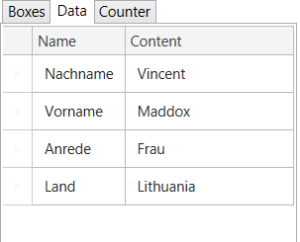

❶

|  |  |
| --- | --- |
|  | Element |
| ❶ | List of data fields |

This table shows the available data field names and their values at the actual record.

By double clicking on a field row the field is inserted into the content of the actual box.

## Counter

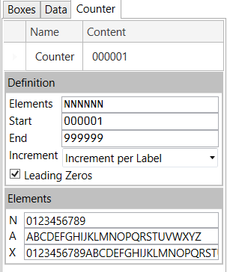

❶

❷

❸

|  |  |
| --- | --- |
|  | Element |
| ❶ | Counter field |
| ❷ | Counter definition |
| ❸ | Elements definition |

### Counter field

This corresponds to the field list of the data table. It shows the value of the counter at the active record. Double clicking on this row inserts the counter into the content of the active box.

### Counter Definition

#### Elements

Defines the length of the counter and the elements (N, A, X) of the digit.

#### Start

Defines the counter value corresponding to data record 1.

#### End

Defines the counter value corresponding to the last data record.

#### Increment

Defines whether the counter is incremented by each data record or each printed row of labels. This property is used when the label columns is set.

#### Leading Zeros

Defines whether leading zeros of the counter are printed.

### Elements Definition

Defines the strings of digits for the three element types.

## Box Properties

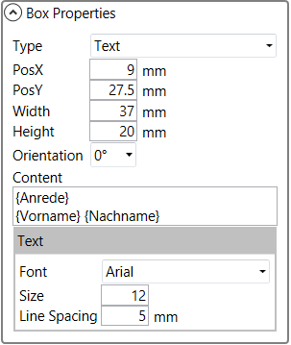 

❶

❷

❸

❹

|  |  |
| --- | --- |
|  | Element |
| ❶ | Expander for the settings dialog |
| ❷ | Move area |
| ❸ | General box properties |
| ❹ | Properties for a Text box |

### General Properties

These properties are available for all types of variable data boxes.

#### Type

Selects between a text box and a barcode box.

#### PosX / PosY / Width / Height

Defines position and size of the active box in mm.

It is measured in millimeters where after comma digits are possible. To change the value type in the number or use the keys as defined in chapter 1.1.

The position can also be changed by moving the mouse pointer into the Move area of the box in the preview, holding the left mouse button down and moving the mouse.

#### Orientation

Select one of the proposed orientations of the box.

#### Content

This is the content of the box. Fixed text or variable fields are accepted as well as multiple lines.

To select a DATA FIELD open the DATA tab and double click on the desired row.

To select the COUNTER open the COUNTER tab and double click on the counter row.

### Text Properties

These properties are available for text boxes.

#### Font

Defines the font in which the text is printed. Listed are all true type fonts installed on the system.

#### Size

Size of the text in POINTS. All numbers are allowed but no comma.

#### Line Spacing

Defines the distance between lines in multiline boxes. Value in mm, comma allowed.

### Barcode Properties

The barcodes are generated using the libraries of TEC-IT ([www.tec-it.com](http://www.tec-it.com)). You find detailed information on their web site at: <http://www.tec-it.com/de/support/knowbase/Default.aspx>.

In case the box type is set to barcode like box 2 of the example the following screens are displayed.

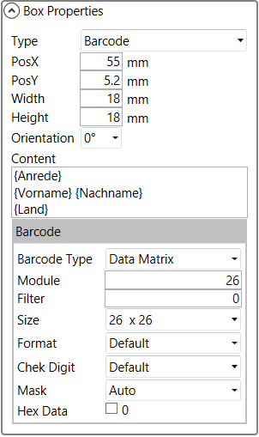 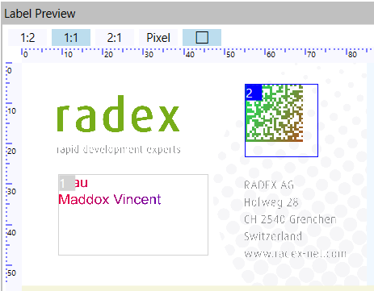

❶

❷

|  |  |
| --- | --- |
|  | Element |
| ❶ | Barcode properties |
| ❷ | Active box |

The available properties vary by barcode type.

#### Barcode Type

Select one of the barcode types available on the list.

#### Bars / Spaces

Defines the width of each bar/space size. It is measured in dots (1200 dpi).

To des default values: define the first bar size and click on the [default] button.

#### Long Bar / Short Bar

Defines the length of short and long bars in dots. This is most used for US Postal codes.

#### Module

Module used in 2D barcodes. This defines the size of one module. Defined in dots.

#### Filter

This is used together with the Module property. It is used to reduce dot growth due to ink flow on the substrate. The value is measured in dots and defines how many black dots of a module are removed to compensate the ink flow.

#### Size

This property is mostly used in 2D barcodes. It defines the barcode dimension in modules.

#### Format

Defines the format of the code.

#### Check Digit

Defines the method for check digit generation from a drop down list.

#### Mask

Select the barcode mask from a drop down list.

#### Hex Data

If selected the data is expected to be in “ASCII-HEX” format and will be translated to binary code before generating the barcode. In ASCII-HEX each byte of data is represented by two characters. The range of characters is from “00” to “FF” representing the values 0x00 to 0xff. Spaces are omitted.

#### Rows / Columns

Define rows and columns for some 2D barcodes.

#### Segments / Row

Define the segments per row on special 2D barcodes.

#### Font

Defines the font for human readable text corresponding to the barcode.

#### Size

Defines the size of the font in Points.

#### Above

If available defines whether the human readable is above or below the barcode.

#### Distance

Defines the distance between the barcode and the human readable text. It is measured in mm.

# Data Definition

It is possible to run a job without data file when the layout uses only a counter or fixed data.

When a data file is used almost any ASCII file can be included in the job.

❼

❻

❺

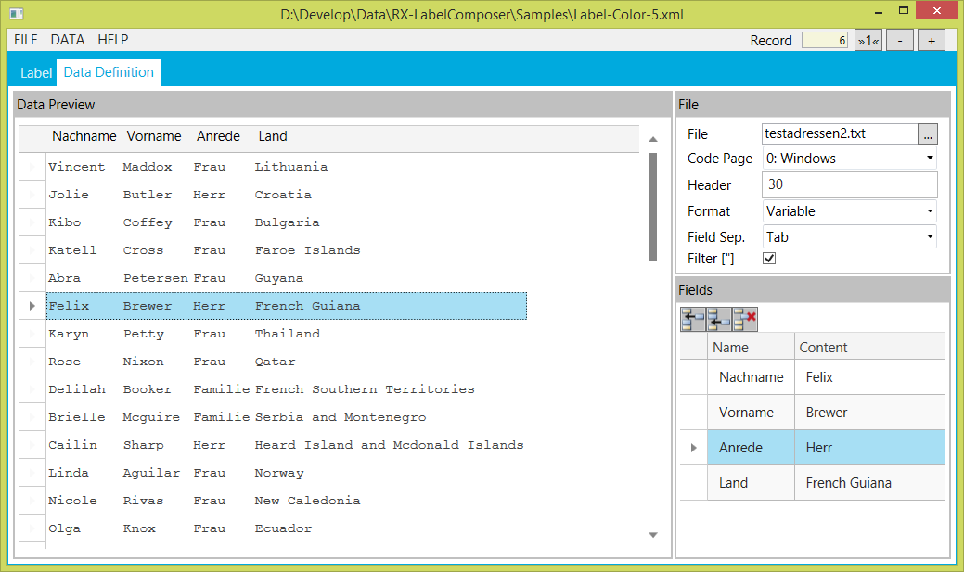

❷

❸

❶

❹

|  |  |
| --- | --- |
|  | Element |
| ❶ | Data definition menu (see 2.1.2) |
| ❷ | Data file preview |
| ❸ | File properties |
| ❹ | Field properties |
| ❺ | Record selector |
| ❻ | Active record |
| ❼ | Active field |

## Data Preview

This table shows one data record per row separated into the defined data fields.

The record is selected by clicking on its row or by the Record Selector.

## File Properties

#### File

Defines the data file. Use the […] button to open the explorer for selection.

The data file is included into the XML file. When the label file is reopened the data file path is not shown any more. This means that the embedded file is used.

#### Code page

Defines the code page of the data file. It can be selected from a drop down list.

#### Header

Defines how many bytes of the data file are a file are set before the first data record. To change it type the value or use the [+] and [-] keys.

#### Format

Defines whether the file uses fixed length fields and records or variable sized fields.

#### Length

Defines the record length in fixed length formatted files. To change it type the value or use the [+] and [-] keys.

In variable formatted files the >CR< character defines the end of the record.

#### Field Separator

Used in variable file formats. Select among the available separators.

#### Filter [“]

In some variable data files the Field Separator Character can be used in the data fields and therefore the field data is packed in quotation marks. This is often the case in CSV formatted files.

Use this option to remove quotation marks.

### Field Properties

The field properties shows the list of all defined fields. In a variable formatted file the fieldnames and its contents of the active record are displayed. The field name can be changed.

In fixed formatted files also the field position and the field length are displayed and can be changed. To change it type the value or use the [+] and [-] keys.

#### Toolbar

|  |  |
| --- | --- |
| Button | Function |
|  | Inserts new box before active field |
|  | Inserts new box after active field |
|  | Deletes the active field |

# Samples

## Counter.xml

This sample shows the use with only one counter defined and no data file and no label file.

## Color labels

For the color labels the following label file is used:

### Label-Black.xml

Shows the label with variable data but without a color definition file.

### Label-Color-1.xml

Is the same as Label-Black.xml but using the following tiff as Color Definition.

Size and all color settings are identical to the label tiff.

### Label-Color-2.xml

Is the same as Label-Black.xml but using the following tiff as Color Definition.

Size and all color settings are identical to the label tiff.

### Label-Color-3.xml

Is the same as Label-Black.xml but using the following tiff as Color Definition.

Size and all color settings are identical to the label tiff.