Version 1.2 Solothurn, 21.01.19

Service Technik Installer

1. Setup.exe  
   Copy the Mouvent_Service_Techniker_Installer.exe to your Desktop, open it  
   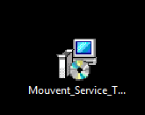
   1. press “Install”  
      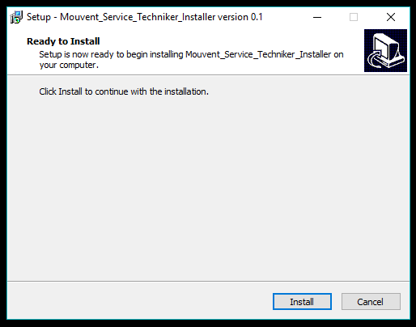

1. TeamViewer Setup  
   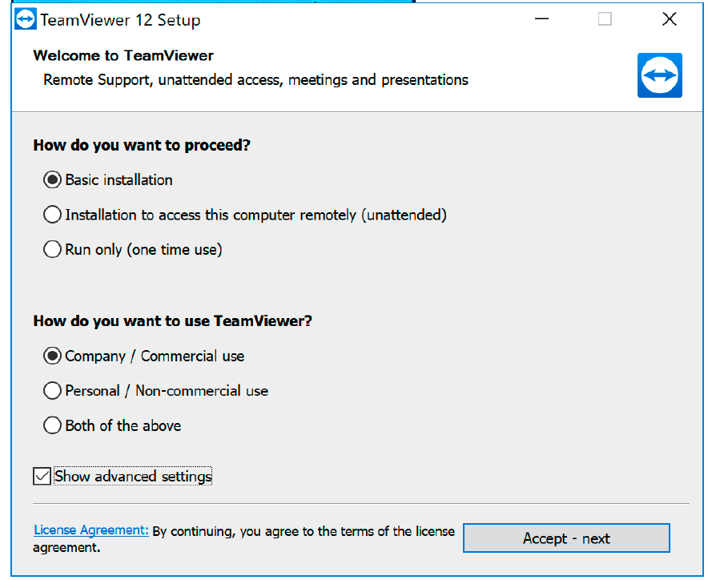  
   -> Select “Basic Installation”  
   -> Select “Company / Commercial use”  
   -> Check “Show advanced settings”  
   -> press “Accept –next”
   1. 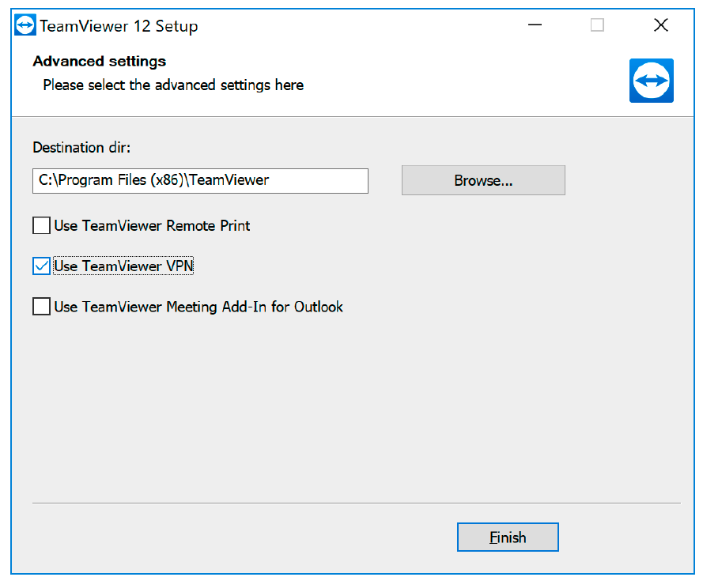  
      -> Check: “Use TeamViewer VPN”  
      -> press “Finish”
   2. Close all now opened Teamviewer Windows  
      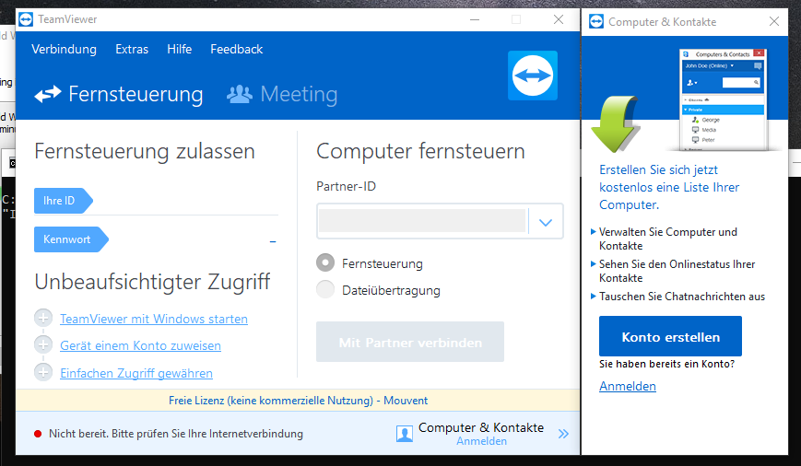
2. **Set-up WinpkFilter**  
   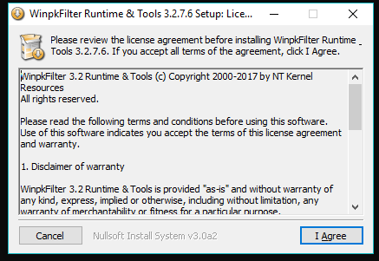  
   -> press “I Agree”
3. -> press “Next >”  
   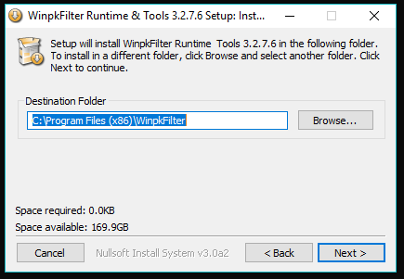
4. 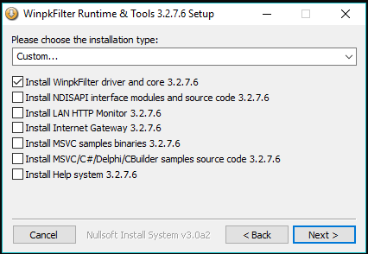
5. 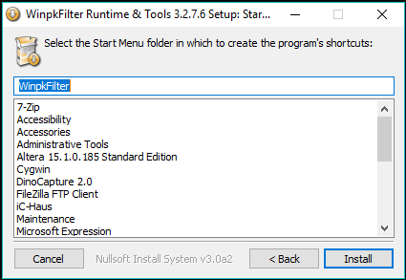
6. -> press “Close”  
   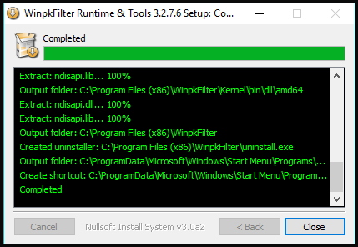
7. Restart  
   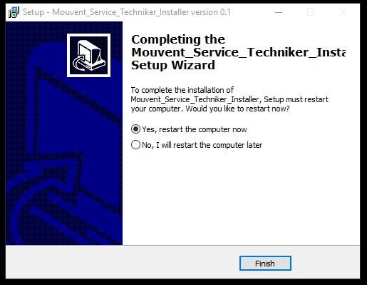
8. After the Restart, there is new “Putty” Icon on your Desktop, open it, it should look like this:  
   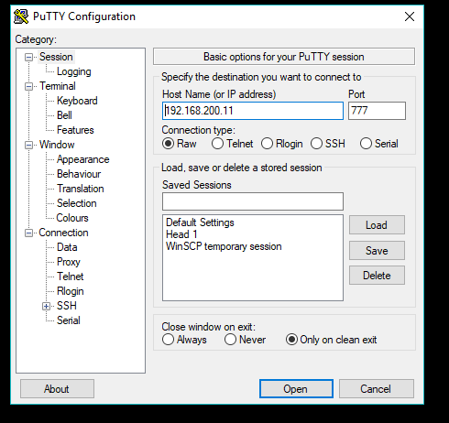
9. There is a new “WinScp” Icon on your Desktop, open it,  
    it should look like this:  
   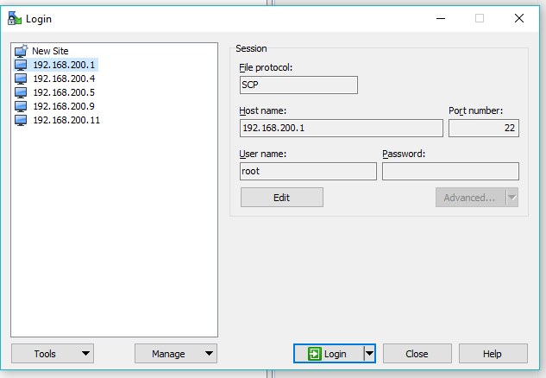
10. Remote Connect to Mouvent Machine  
      
    Once the “Service Technik Installer” is installed you might want to Test to connect from Remote to the Mouvent Machine.  
      
    For this purpose let’s introduce a naming convention:  
      
    **“PC”** => Laptop, netbook, Tablet or whatever, but Windows 10 (Win7 might work as well, but it’s not tested) should be installed.

**“PClocal”** = a PC physically connected to your Mouvent Machine over an Ethernet Cable

**“PCremote”** = remote PC (not physically connected to the Mouvent Machine over an Ethernet Cable)

Both PC’s have to be connected to the Internet. The easiest way might be over WLAN/WIFI/Mobile Phone Hotspot.

* 1. First of all, make sure on both PC’s the “Mouvent Service Technik Installer” is installed
  2. PClocal: start Teamviewer
  3. PCremote: start Teamviewer, connect to PClocal
  4. PClocal(via teamviewer): set a fixed ip in the range 192.168.200.xxx for your ethernet adapter
  5. PClocal(via teamviewer): open cmd, ping one Electronic Board in your machine (for example: “ping 192.168.200.4”)
  6. 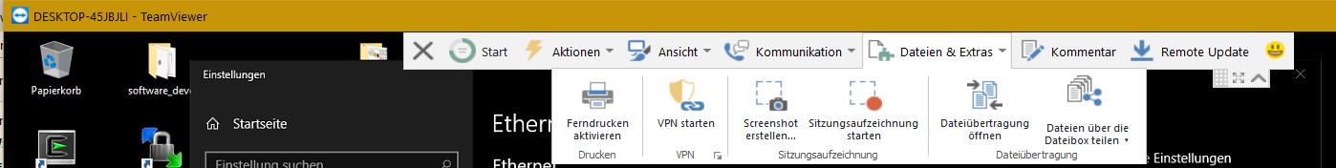PCremote: open teamviewer vpn
  7. 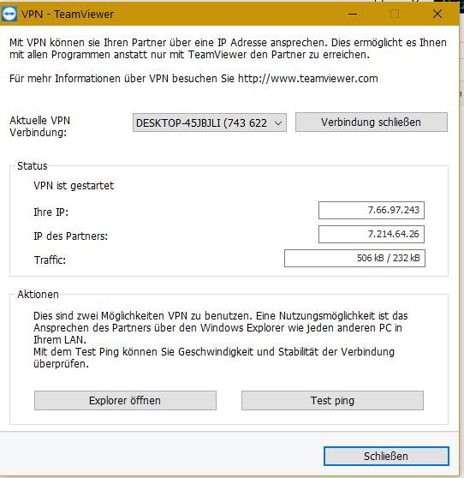Test ping

* 1. 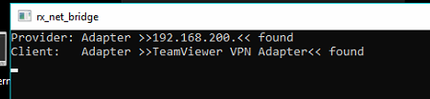PClocal(via teamviewer): open rx_net_bridge (shortcut on the PClocal desktop)
  2. PCremote: open rx_route as Admin (located in C:\Program Files (x86)\Mouvent\rx_route.exe)  
     => this only open shortly a cmd windows, which then is closed immediately
  3. PCremote: open cmd, ping one Electronic Board in your machine (for example: “ping 192.168.200.4”)

Now you can connect to your Mouvent Machine from your Remote PC via Teamviewer.

1. Notes for Mouvent Employees:  
     
   As we selected “Company / Commercial use” on the Teamviewer installation you will need sooner or later a valid Teamviewer Licence.  
   For Mouvent Employees we do have Teamviewer Licences available. To get a Licence send an email to David Jauslin, Head of Customer Service [david.jauslin@mouvent.com](mailto:david.jauslin@mouvent.com)

Revision History:

|  |  |  |  |
| --- | --- | --- | --- |
| Rev. | Author | Date | Description |
| 1.0 | Stefan Weber | 17.12.18 | Tool v1.0 |
| 1.1 | Stefan Weber | 16.01.19 | Tool v1.0 added Note about how to connect to Mouvent Machine from a Remote PC over Teamviewer |
| 1.2 | Stefan Weber | 21.01.19 | Tool v1.0 add Note about Teamviewer Licence |