

EasyBase-Time | Android Installation

Open installation email on your Android Device

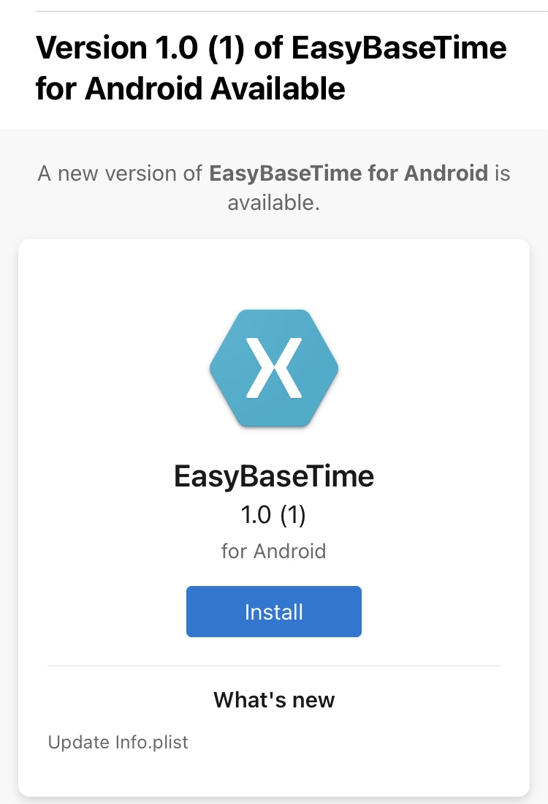

Click on “Install”

Click on “Download”

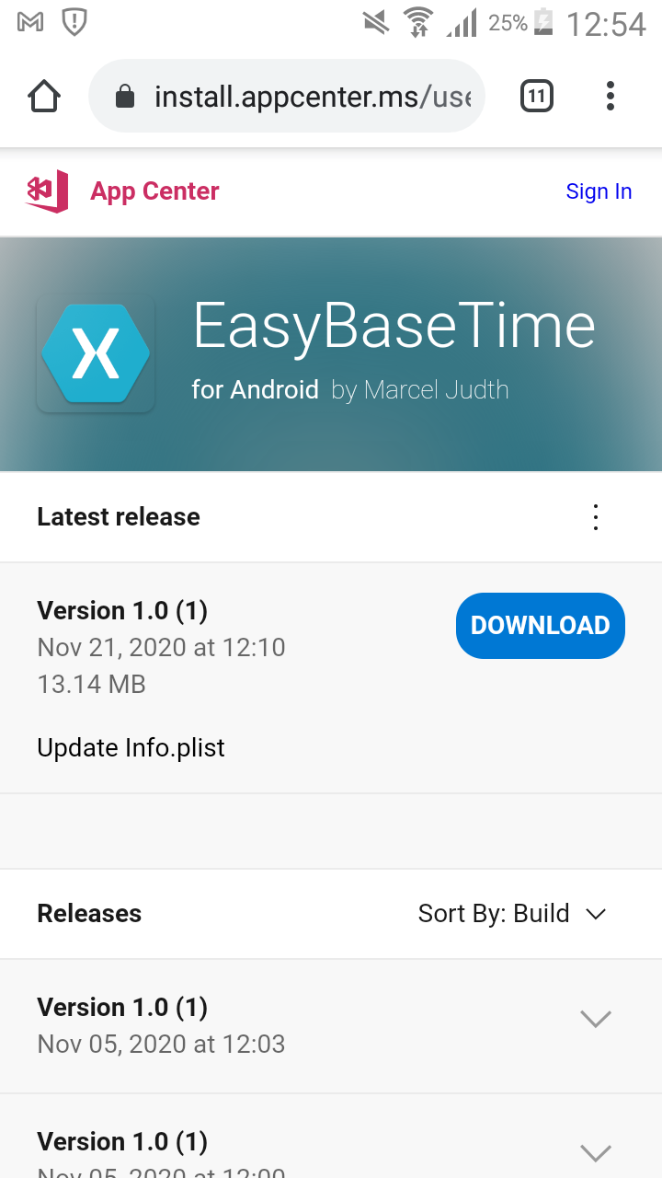

Click on “Download”/”Herunterladen” again
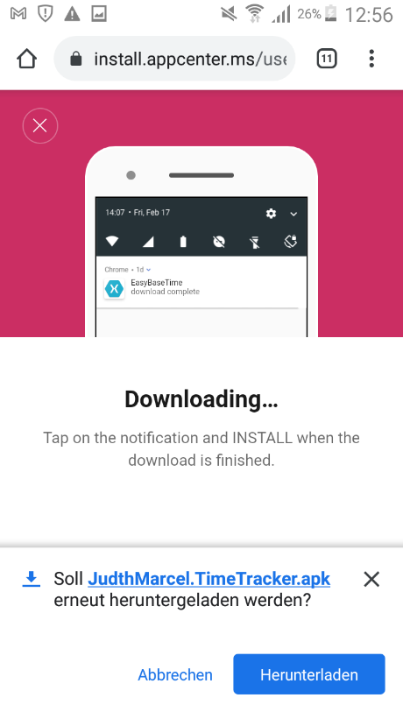

After downloading click “open”/”öffnen” on the bottom of the screen

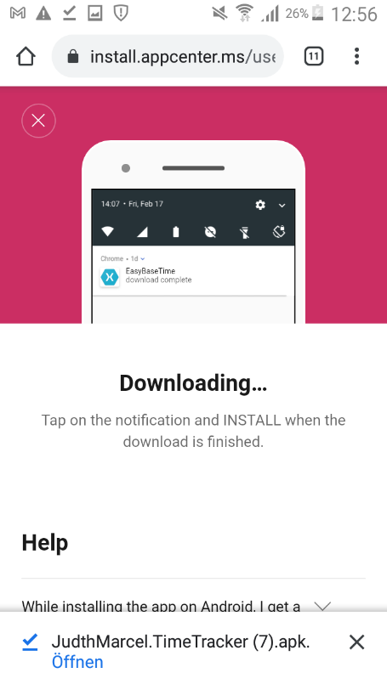

Click on “Install”/”Installieren” again

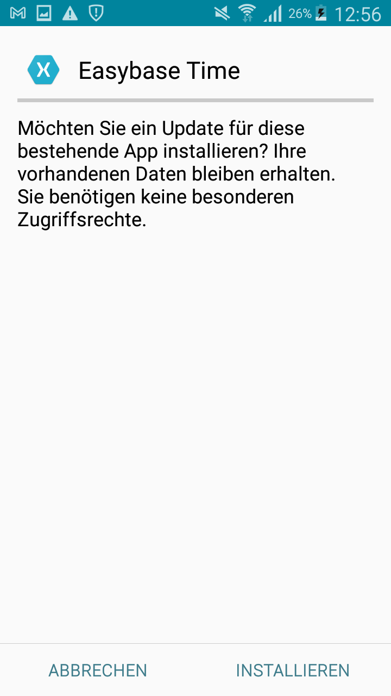

The App successfully installed. Click “open”/”öffnen”, to enter your server-key and your employee number.

