**Software Requirements Specification**

For

CMBooks

Prepared by : Moțiu Marcela Daiana

Morar Ana Carla

05.03.2019

Table of Contents

Table of Contents ii

Revision History ii

1. Introduction 1

1.1 Purpose 1

1.2 Document Conventions 1

1.3 Intended Audience and Reading Suggestions 1

1.4 Project Scope 1

1.5 References 1

2. Overall Description 2

2.1 Product Perspective 2

2.2 Product Functions 2

2.3 User Classes and Characteristics 2

2.4 Operating Environment 2

2.5 Design and Implementation Constraints 2

2.6 User Documentation 2

2.7 Assumptions and Dependencies 3

3. External Interface Requirements 3

3.1 User Interfaces 3

3.2 Hardware Interfaces 3

3.3 Software Interfaces 3

3.4 Communications Interfaces 3

4. System Features 4

4.1 System Feature 1 4

4.2 System Feature 2 (and so on) 4

5. Other Nonfunctional Requirements 4

5.1 Performance Requirements 4

5.2 Safety Requirements 5

5.3 Security Requirements 5

5.4 Software Quality Attributes 5

5.5 Business Rules 5

6. Other Requirements 5

Appendix A: Glossary 5

Appendix B: Analysis Models 5

Appendix C: To Be Determined List 6

Revision History

|  |  |  |  |
| --- | --- | --- | --- |
| **Name** | **Date** | **Reason For Changes** | **Version** |
|  |  |  |  |
|  |  |  |  |

# Introduction

## Purpose

The purpose of this product is to provide information about some of the most popular books in order to help people find the right book to read next.

## Document Conventions

This document uses the following conventions:

## Intended Audience and Reading Suggestions

This project is a website and it is restricted within the college premises. This has been implemented under the guidance of a college professor. This project is useful for anyone who is interested in reading or wants to find information or reviews of certain books.

## Project Scope

Our project is an interactive website which provides a relevant gallery of books. The most important features that the website offers to its users are to rate the books and express their opinion by writing comments. The system is based on a relational database that keeps information about users and books. Above all, we hope to provide a comfortable user experience.

# Overall description

## Product Perspective

A local database system stores the following information:

* Users:

It includes the user id, first name and last name, email address, birthdate, password and a boolean field which determines the user’s role within the application (admin or simple user).

* Books

This table stores the id of the book, its title, author, genre, year of publication, number of pages and a short description.

* Comments

It includes an id, the id of the user who added the comment, the id of the book in question, the date when the comment was posted and the text representing the actual comment.

* Rates

It includes an id, the id of the user who rated the book, the id of the book in question and the actual rate.

## Product Functions

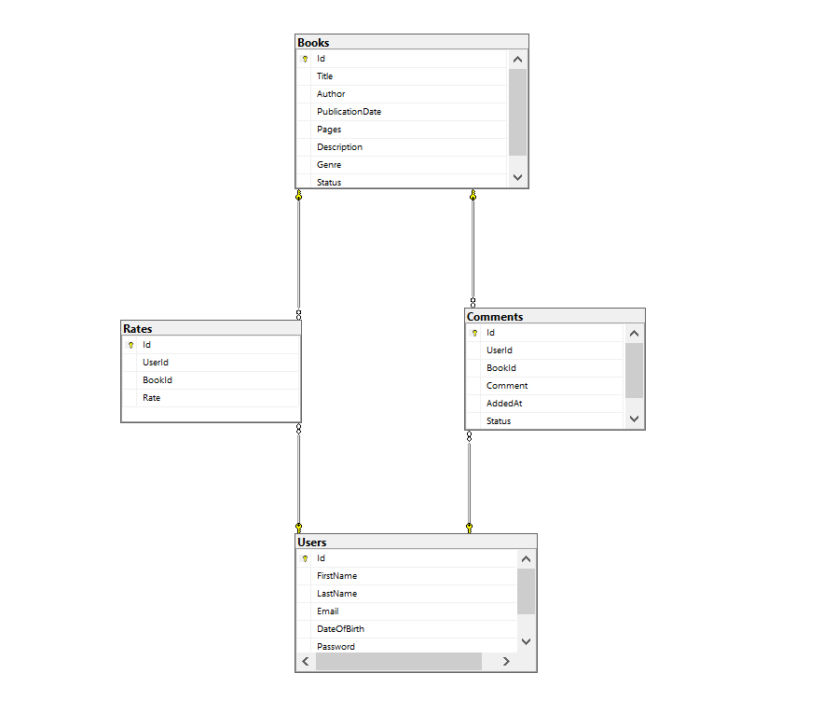

## User Classes and Characteristics

The users should have access to the following functions:

SIMPLE USER

* Register
* Login
* View books gallery
* Filter books by multiple criteria
* Search a certain book
* Rate a book
* Add comments to books
* Logout

ADMINISTRATIVE

* All simple user rights
* Add books
* Remove books
* Remove comments

## Operating Environment

* Local database
* Operating System: Windows
* Database: SQL Server

## Design and Implementation Constraints

# External Interface Requirements

## User Interfaces

Front-end software: HTML, CSS, JavaScript

Back-end software: C#

## Hardware Interfaces

Windows

A browser which supports HTML & JavaScript

## Software Interfaces

|  |  |
| --- | --- |
| Software Used | Description |
| Operating System | We have chosen Windows operating system for its best support and user-friendliness. |
| Database | To save the users, books, comments and rates we have chosen an SQL database. |

## Communication Interfaces

This project supports all types of browsers. . The communication standard that will be used is HTTP.