1. Create a Project
   1. Ñl
   2. Cs
   3. As
2. Open s

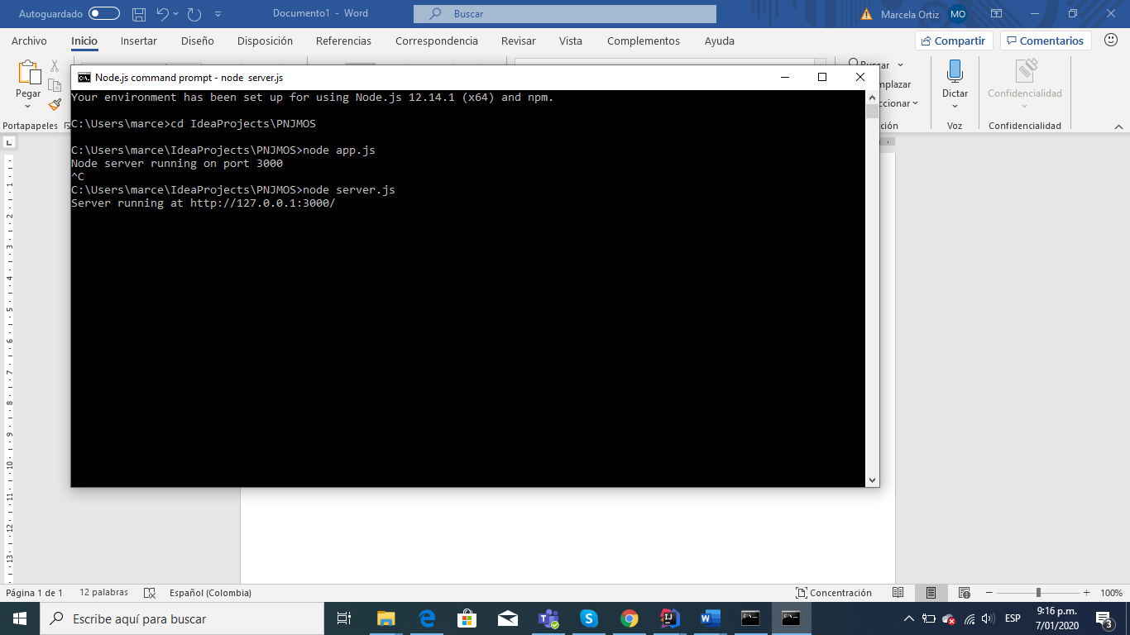

1. lsx