Group evaluation
Day 17/02 meeting to discuss about the two of us to work in a synchronized way to build the front and back-end and documentation together. This way we both will learn how to build the system from test to production, one will not have to wait for the other to complete a phase to be able to move on to the next level once we will both being working on parallel tasks, also we can follow up on each other’s accomplishments.
We decided to start studying together once in a week, watching the same tutorial videos and online classes so we can reach the same level of understanding about the tools will be using for this project.
Marcelina working: add, delete and update rooms, events and staff page. Login and logout post methods
Deisiane working: search option on index.php for rooms, events and staff/lecturer
both working on working prototype report

25/02/2021 – watched together php get and post learning videos for 2 hours. Udemi

This report as soon as finished will be incorporated to the final group report

Prototype report
Visual Studio code, Xampp with Mysql database server and Apache web server were already previously installed in the local computer and ready to be used. Bootstrap templates were taken into consideration at the beginning, but during the implementation there were loads of files in the library that we were not being using, then we preferred to start the admin panel from scratch.
Building the first admin page “index.php”, the page is separated into header, side bar, data and footer.
The header is a fixed block where the admin user information appears right after the log in. This header stays the same even when the user is changing pages during updates for the room or any other event.
Side bar is where the main options reside such as Dashboard for a preview review of the panel; Schedule where all the data about an event can be updated, created or deleted; Room where all the data about a room can be updated, deleted or created; QRCode where a unique code will be generated for each room and where the script should be implemented to link the last updated version of the specific room to its unique QR code.
The Data is a space in the middle right side of the admin page where it brings results and response about a function. For instance, the search bar on the top when used to find a room, the data about this room will be displayed at this Data space. Or when a room is updated, after click on the submit button, the message saying this room was successfully updated will be displayed in the same Data space. Also any information concern to upcoming events should be presented at this data space.

Database Management
phpMyAdmin is a free software tool written in PHP, intended to handle the administration of MySQL over the Web.
Storage engine: InnoDB
Database was created called “actsystem” where four tables were created:
rooms, admin_login, events, staff
For rooms main basic columns were created:
roomID (A.I), roomname, floor
For events main basic columns were created:
eventID, event,datetime,staffID (relatioship to staff table), roomID (relationship to rooms table)
For staff main basic columns were created:
StaffID, name, phone, email
For login page its just the option to login with an existing adm user and not for register.
For the register page for a new adm user, concern about security where anyone with access to the admin panel link address could add themselves as admin user.
Database there is a table called admin_login which is not related to any other table. It has 3 columns for ID, Admin_Name, Admin_Password.
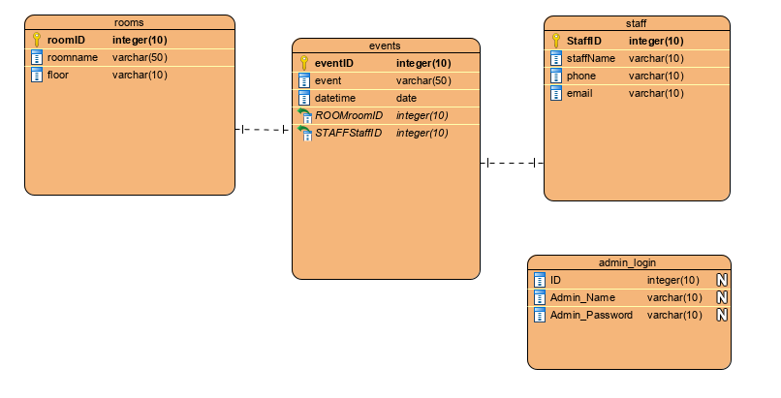

The review public files repository structure.
GitHub structure is under the path marcelateo/ACTSystem with files:
index.php, connection.php, adminLogin.php, schedule.php, room.php, staff.php and server.php

issue : date and time works for database, but it has to be done manually.. check code schedule.php
using get for search
CRUD = create, update and delete
datepicker -> jqueryui.com
formatos code para data select types

room tables create one just for events
inside room table create event_id = INT

Ajax lets web browsers load content without reloading the entire page
Implementation for features such as calendar (datapicker), search buttons

Testing

Testing database local connection (admin users and room data). Through Xampp using adminphp console for database we were able to test admin user connection when logging in to ACT admin panel system.

Testing AWS Amazon services connections
Reference
https://www.phpmyadmin.net/

