# Using a title with AWS ServiceX

*Author, role, team*

First paragraph introducing the problem to be solved or opportunity to improve.

Second paragraph as appropriate. The calls to action can include related content.

This post shows…

## Overview of solution

Paragraph

Diagram as appropriate, centered

Light background

File size: 250 KB or smaller

Dimensions: 800x400px (no wider than 1000px)

## Walkthrough

Brief intro to the walkthrough.

Sentence about the steps:

* Step
* Step
* Step

Link to CloudFormation stack or GitHub repo:

[Launch stack button]

### Prerequisites

For this walkthrough, you should have the following prerequisites:

* An [AWS account](https://signin.aws.amazon.com/signin?redirect_uri=https%3A%2F%2Fportal.aws.amazon.com%2Fbilling%2Fsignup%2Fresume&client_id=signup)
* AWS resources
* Any third-party software or hardware
* Any specialized knowledge

### Create step section

Paragraph with link to [service documentation topics](https://docs.aws.amazon.com/#lang/en_us) for basic procedures or more information.

#### To take action with a procedure

1. Log in to the [ServiceX console]().
2. Take action A.
3. Take action B.
4. Run the following command:

aws ecs create-cluster --cluster-name example --region us-east-1

1. Finish.

The following screenshot shows the best practices for images:

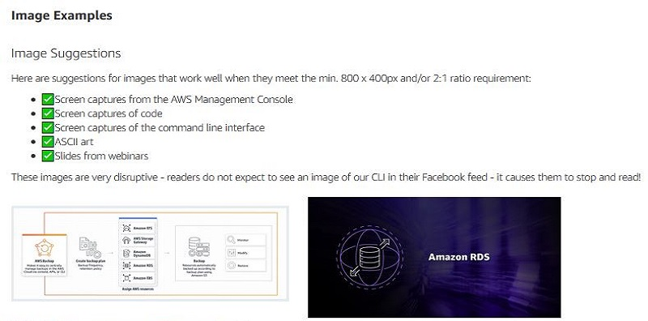

The following screenshot shows what not to do with images:

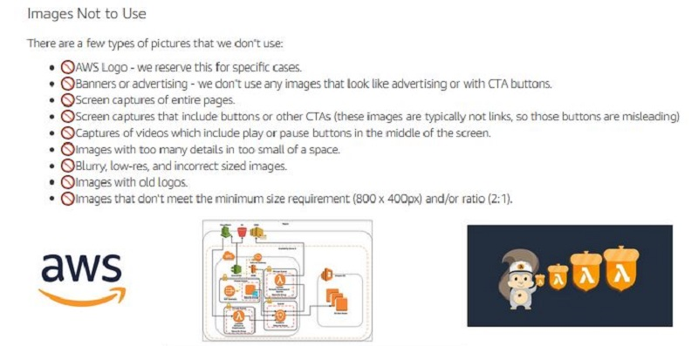

Code sample introduction

#include <stdio.h>

int main()

{

// printf() displays the string inside quotation

printf("Hello, World!");

return 0;

}

### Cleaning up

To avoid incurring future charges, delete the resources.

## Conclusion

Restate the post purpose and add next steps. The calls to action can include related content.

### [Optional] Author bio

|  |  |
| --- | --- |
| Photo | *Three sentences introducing the author’s AWS role, experience and interests, and a lighthearted personal note.* |

**Suggested tags:** [match these to the channel SEO strategy]