Wireshark Lab: TCP v7.0  Supplement to Computer Networking: A Top-Down Approach, 7th ed., J.F. Kurose and K.W. Ross  “Tell me and I forget. Show me and I remember. Involve me and I understand.” Chinese proverb  © 2005-2016, J.F Kurose and K.W. Ross, All Rights Reserved | 

In this lab, we’ll investigate the behavior of the celebrated TCP protocol in detail. We’ll do so by analyzing a trace of the TCP segments sent and received in transferring a 150KB file (containing the text of Lewis Carrol’s Alice’s Adventures in Wonderland) from your computer to a remote server. We’ll study TCP’s use of sequence and acknowledgement numbers for providing reliable data transfer; we’ll see TCP’s congestion control algorithm – slow start and congestion avoidance – in action; and we’ll look at TCP’s receiver-advertised flow control mechanism. We’ll also briefly consider TCP connection setup and we’ll investigate the performance (throughput and round-trip time) of the TCP connection between your computer and the server.

Before beginning this lab, you’ll probably want to review sections 3.5 and 3.7 in the text.

1. Capturing a bulk TCP transfer from your computer to a remote server

Before beginning our exploration of TCP, we’ll need to use Wireshark to obtain a packet trace of the TCP transfer of a file from your computer to a remote server. You’ll do so by accessing a Web page that will allow you to enter the name of a file stored on your computer (which contains the ASCII text of Alice in Wonderland), and then transfer the file to a Web server using the HTTP POST method (see section 2.2.3 in the text). We’re using the POST method rather than the GET method as we’d like to transfer a large amount of data from your computer to another computer. Of course, we’ll be running Wireshark during this time to obtain the trace of the TCP segments sent and received from your computer.

Do the following:
- Start up your web browser. Go the http://gaia.cs.umass.edu/wireshark-labs/alice.txt and retrieve an ASCII copy of Alice in Wonderland. Store this file somewhere on your computer.
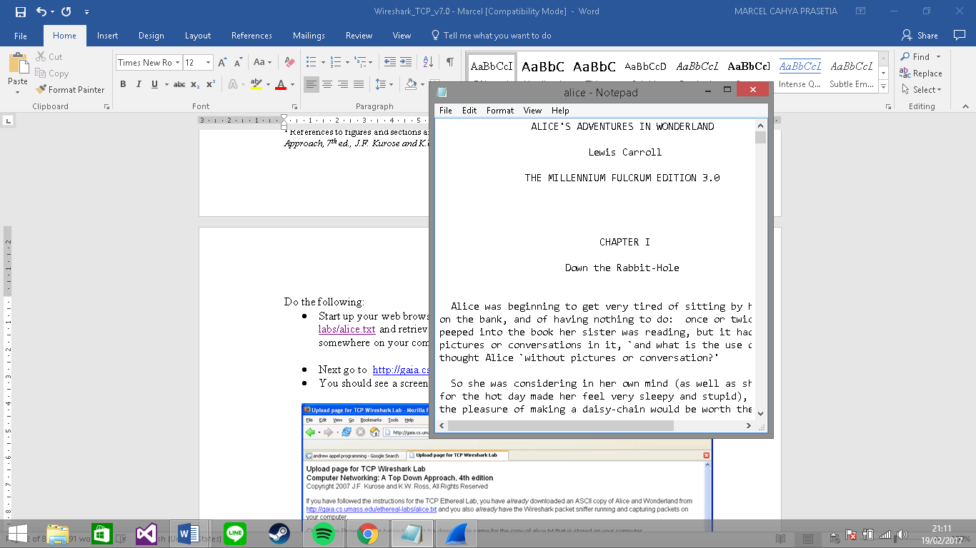
- Next go to http://gaia.cs.umass.edu/wireshark-labs/TCP-wireshark-file1.html.

- You should see a screen that looks like:

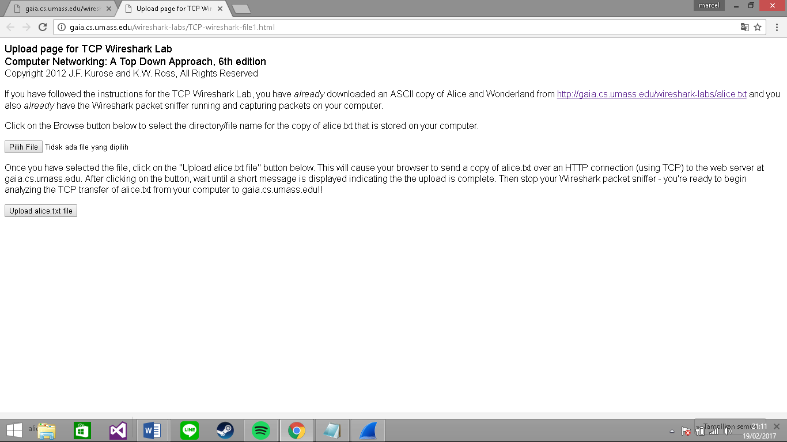

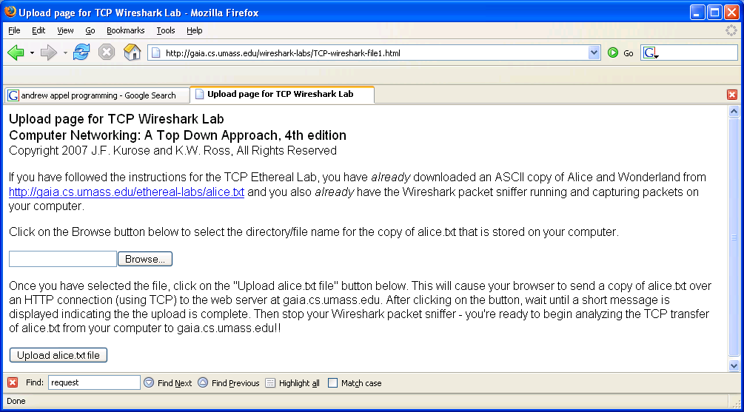

- Use the Browse button in this form to enter the name of the file (full path name) on your computer containing Alice in Wonderland (or do so manually). Don’t yet press the “Upload alice.txt file” button.
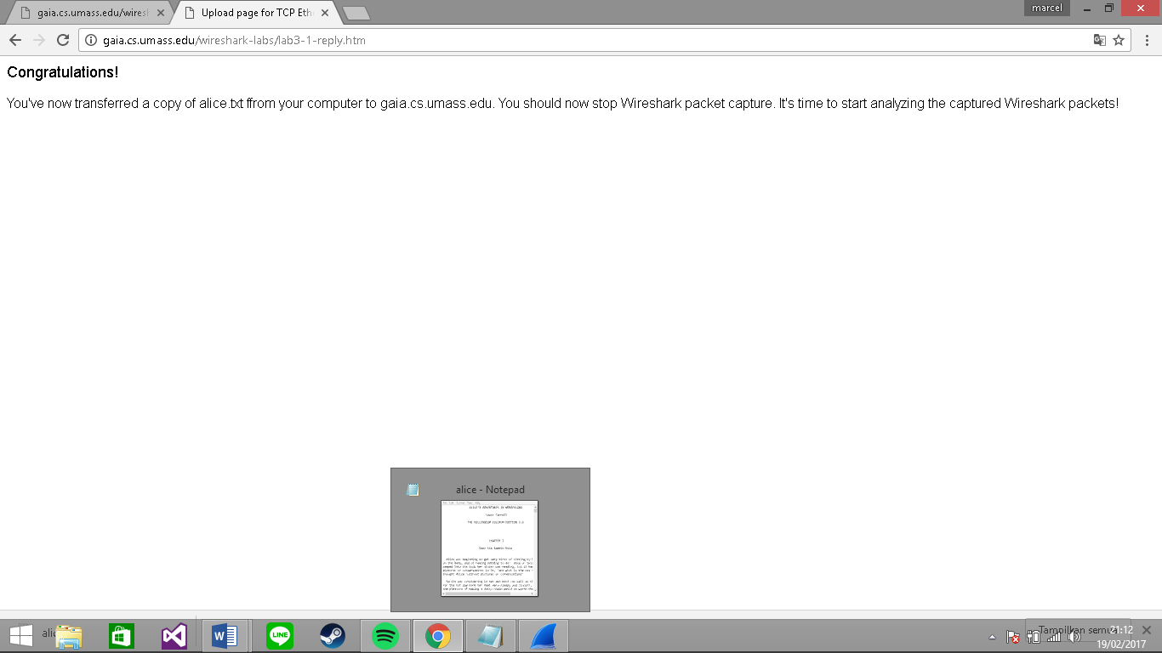
- Now start up Wireshark and begin packet capture (Capture->Start) and then press OK on the Wireshark Packet Capture Options screen (we’ll not need to select any options here).

- Returning to your browser, press the “Upload alice.txt file” button to upload the file to the gaia.cs.umass.edu server. Once the file has been uploaded, a short congratulations message will be displayed in your browser window.
- Stop Wireshark packet capture. Your Wireshark window should look similar to the window shown below.

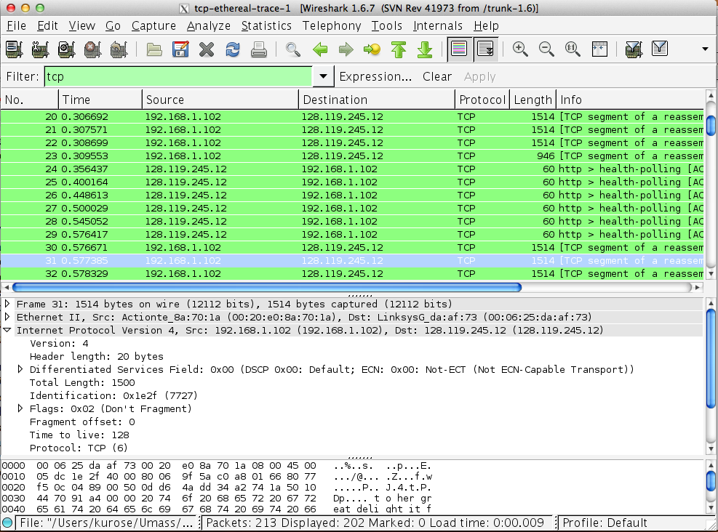

If you are unable to run Wireshark on a live network connection, you can download a packet trace file that was captured while following the steps above on one of the author’s computers. You may well find it valuable to download this trace even if you’ve captured your own trace and use it, as well as your own trace, when you explore the questions below.

2. A first look at the captured trace

Before analyzing the behavior of the TCP connection in detail, let’s take a high level view of the trace.
- First, filter the packets displayed in the Wireshark window by entering “tcp” (lowercase, no quotes, and don’t forget to press return after entering!) into the display filter specification window towards the top of the Wireshark window.
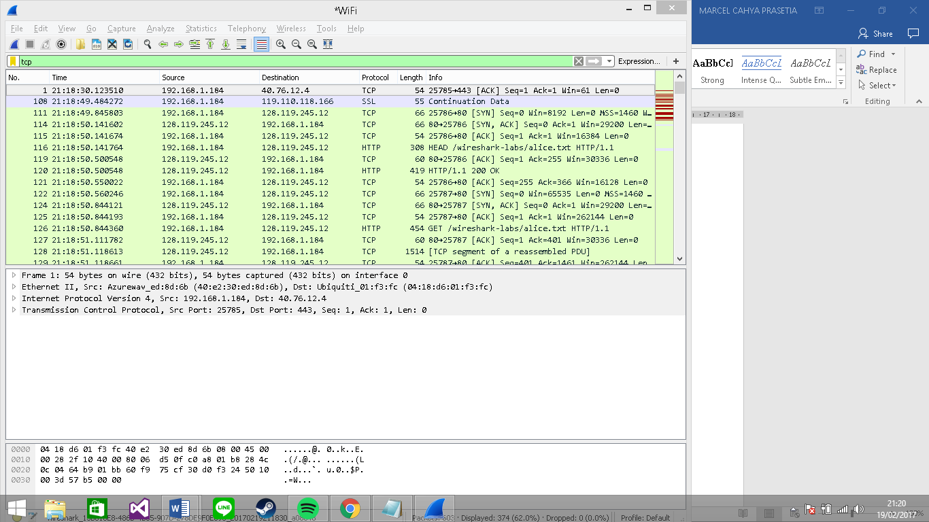

What you should see is series of TCP and HTTP messages between your computer and gaia.cs.umass.edu. You should see the initial three-way handshake containing a SYN message. You should see an HTTP POST message. Depending on the version of Wireshark you are using, you might see a series of “HTTP Continuation” messages being sent from your computer to gaia.cs.umass.edu. Recall from our discussion in the earlier HTTP Wireshark lab, that is no such thing as an HTTP Continuation message – this is Wireshark’s way of indicating that there are multiple TCP segments being used to carry a single HTTP message. In more recent versions of Wireshark, you’ll see “[TCP segment of a reassembled PDU]” in the Info column of the Wireshark display to indicate that this TCP segment contained data that belonged to an upper layer protocol message (in our case here, HTTP). You should also see TCP ACK segments being returned from gaia.cs.umass.edu to your computer.

Answer the following questions, by opening the Wireshark captured packet file tcp-ethereal-trace-1 in http://gaia.cs.umass.edu/wireshark-labs/wireshark-traces.zip (that is download the trace and open that trace in Wireshark; see footnote 2). Whenever possible, when answering a question you should hand in a printout of the packet(s) within the trace that you used to answer the question asked. Annotate the printout to explain your answer. To print a packet, use File->Print, choose Selected packet only, choose Packet summary line, and select the minimum amount of packet detail that you need to answer the question.
- What is the IP address and TCP port number used by the client computer (source) that is transferring the file to gaia.cs.umass.edu? To answer this question, it’s probably easiest to select an HTTP message and explore the details of the TCP packet used to carry this HTTP message, using the “details of the selected packet header window” (refer to Figure 2 in the “Getting Started with Wireshark” Lab if you’re uncertain about the Wireshark windows.
IP address: 192.168.1.184
Source port: 25791

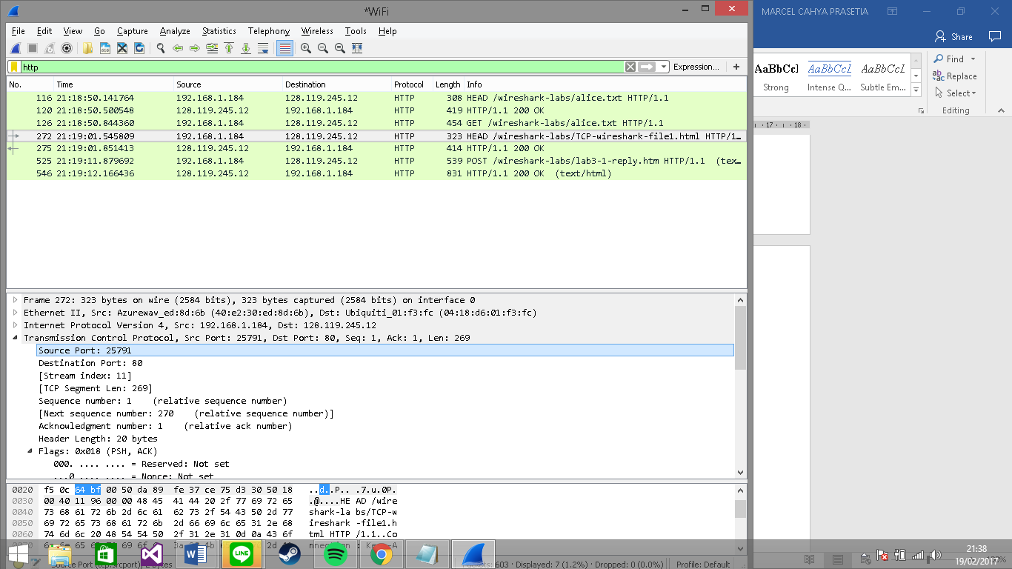
- What is the IP address of gaia.cs.umass.edu? On what port number is it sending and receiving TCP segments for this connection?
IP address of gaia.cs.umass.edu : 128.119.245.12
Source port: 80
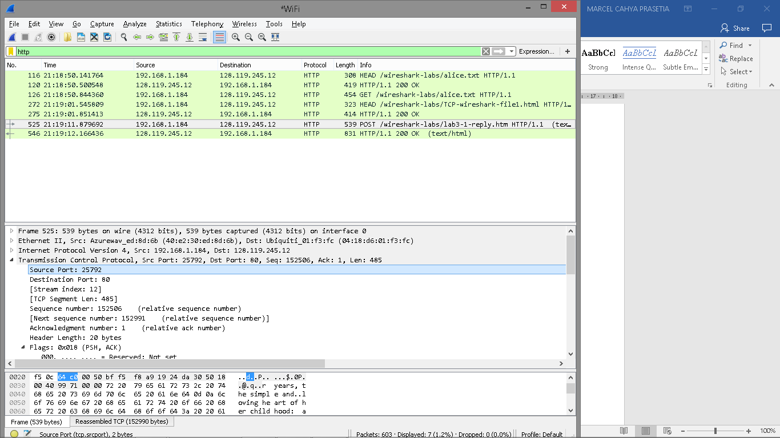
If you have been able to create your own trace, answer the following question:

- What is the IP address and TCP port number used by your client computer (source) to transfer the file to gaia.cs.umass.edu?
IP address: 192.168.1.184
Source port: 25792

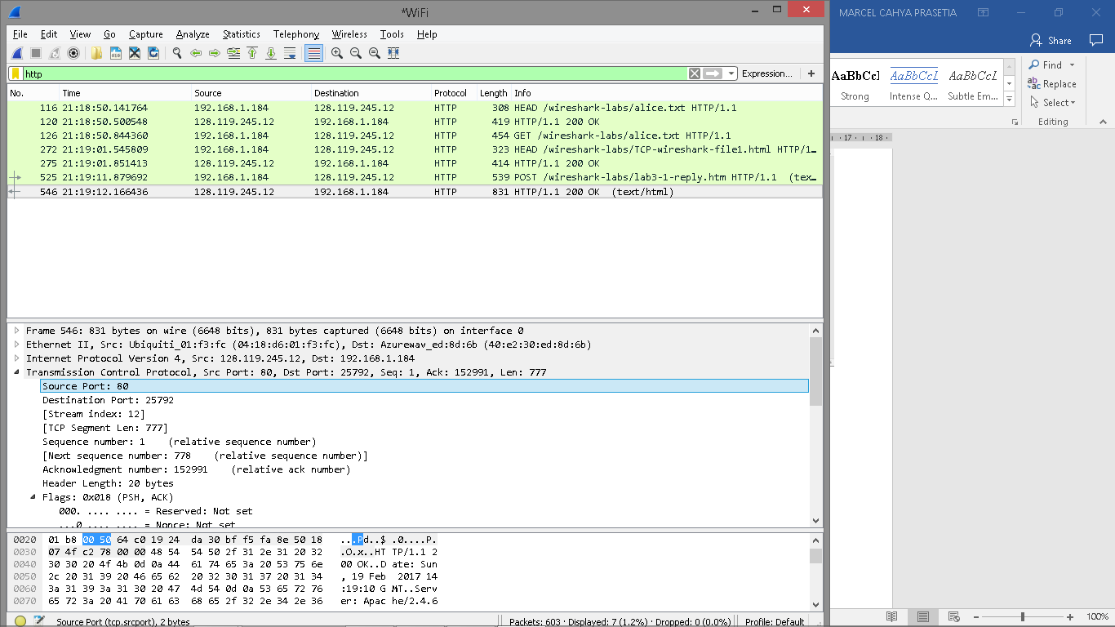
Since this lab is about TCP rather than HTTP, let’s change Wireshark’s “listing of captured packets” window so that it shows information about the TCP segments containing the HTTP messages, rather than about the HTTP messages. To have Wireshark do this, select Analyze->Enabled Protocols. Then uncheck the HTTP box and select OK. You should now see a Wireshark window that looks like:

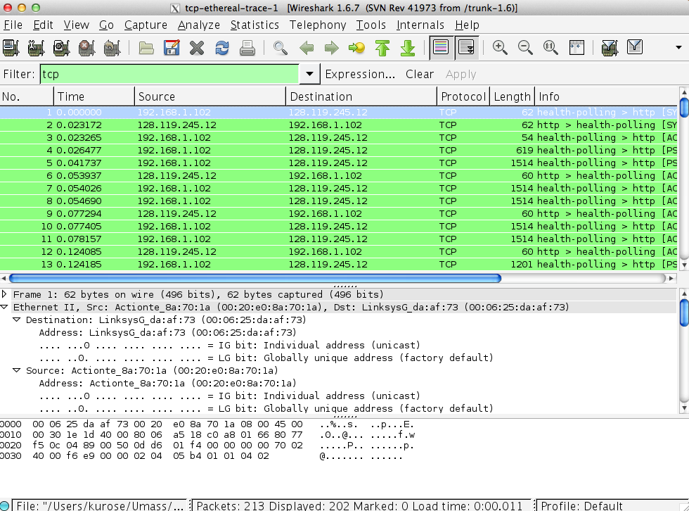

This is what we’re looking for - a series of TCP segments sent between your computer and gaia.cs.umass.edu. We will use the packet trace that you have captured (and/or the packet trace tcp-ethereal-trace-1 in http://gaia.cs.umass.edu/wireshark-labs/wireshark-traces.zip; see earlier footnote) to study TCP behavior in the rest of this lab.

3. TCP Basics

Answer the following questions for the TCP segments:

- What is the sequence number of the TCP SYN segment that is used to initiate the TCP connection between the client computer and gaia.cs.umass.edu? What is it in the segment that identifies the segment as a SYN segment?
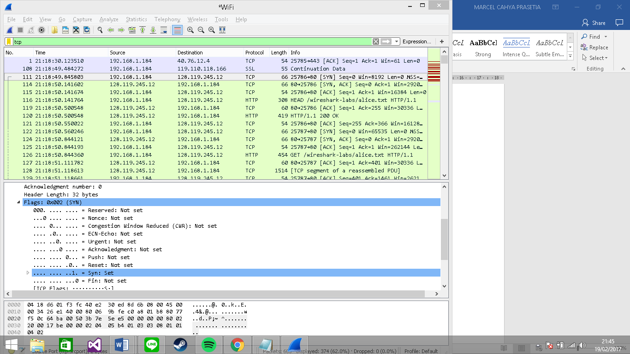
- What is the sequence number of the SYNACK segment sent by gaia.cs.umass.edu to the client computer in reply to the SYN? What is the value of the Acknowledgement field in the SYNACK segment? How did gaia.cs.umass.edu determine that value? What is it in the segment that identifies the segment as a SYNACK segment?
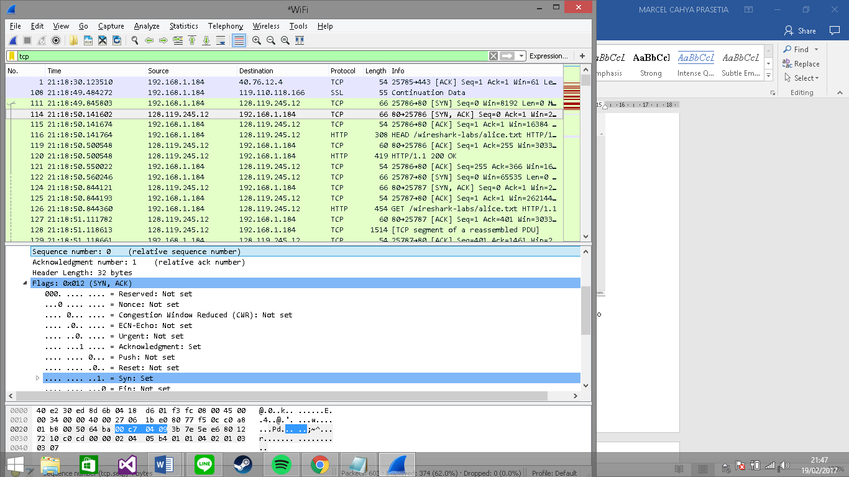
According to the above figure, the sequence number of the SYNACK segment sent by gaia.cs.umass.edu to the client computer in reply to the SYN is 0. The value of the acknowledgement field in the SYNACK segment is 1. The value of the ACKnowledgement field in the SYNACK segment is determined by the server gaia.cs.umass.edu. The server adds 1 to the initial sequence number of SYN segment form the client computer. For this case, the initial sequence number of SYN segment from the client computer is 0, thus the value of the ACKnowledgement field in the SYNACK segment is 1. A segment will be identified as a SYNACK segment if both SYN flag and Acknowledgement in the segment are set to 1.

- What is the sequence number of the TCP segment containing the HTTP POST command? Note that in order to find the POST command, you’ll need to dig into the packet content field at the bottom of the Wireshark window, looking for a segment with a “POST” within its DATA field.
Sequence number: 152268
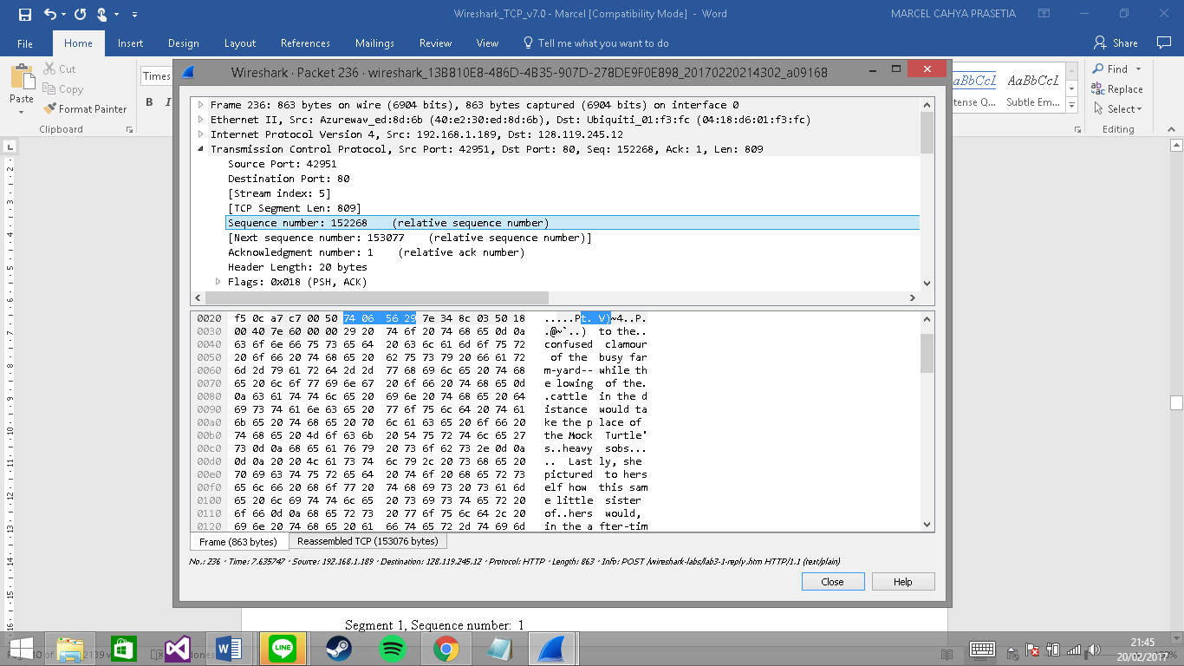
- Consider the TCP segment containing the HTTP POST as the first segment in the TCP connection. What are the sequence numbers of the first six segments in the TCP connection (including the segment containing the HTTP POST)? At what time was each segment sent? When was the ACK for each segment received? Given the difference between when each TCP segment was sent, and when its acknowledgement was received, what is the RTT value for each of the six segments? What is the EstimatedRTT value (see Section 3.5.3, page 242 in text) after the receipt of each ACK? Assume that the value of the EstimatedRTT is equal to the measured RTT for the first segment, and then is computed using the EstimatedRTT equation on page 242 for all subsequent segments.

Note: Wireshark has a nice feature that allows you to plot the RTT for each of the TCP segments sent. Select a TCP segment in the “listing of captured packets” window that is being sent from the client to the gaia.cs.umass.edu server. Then select: Statistics->TCP Stream Graph->Round Trip Time Graph.

The HTTP POST segment is considered as the first segment. Segments 1 – 6 are No. 4, 5, 7, 8, 10, and 11 in this trace respectively. The ACKs of segments 1 – 6 are No. 6, 9, 12, 14, 15, and 16 in this trace.

Segment 1, Sequence number: 1
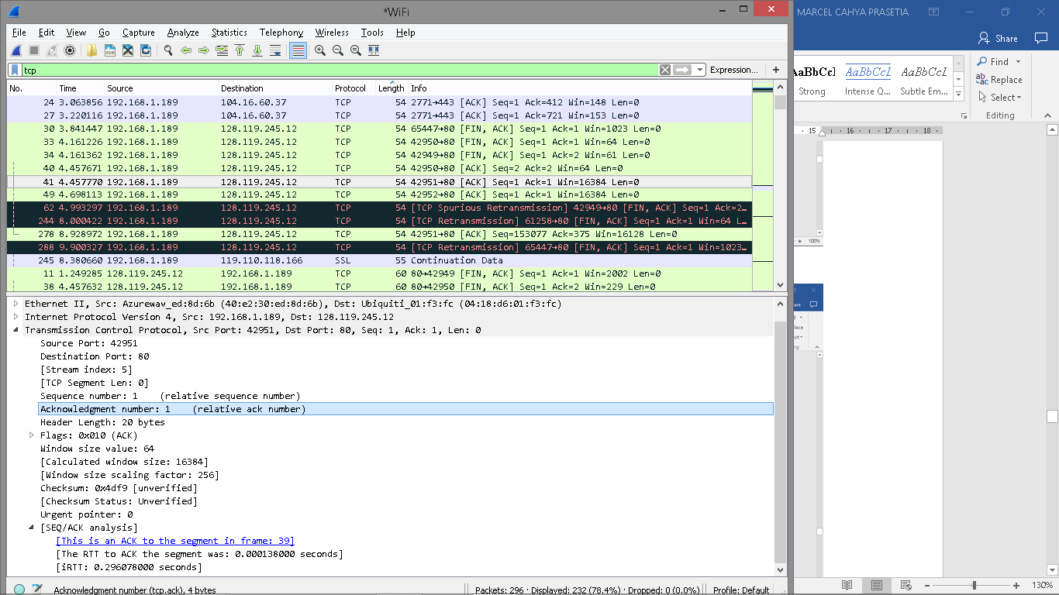

Segment 2, Sequence number: 756
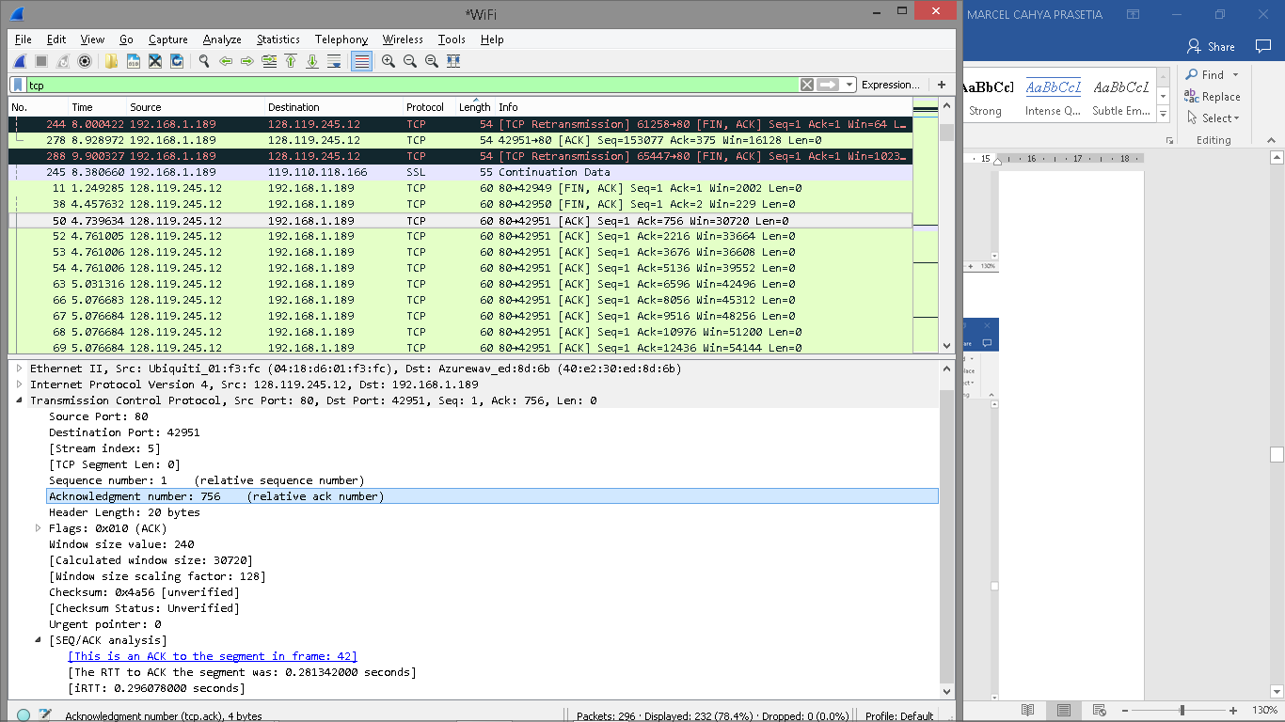

Segment 3, Sequence number: 2216
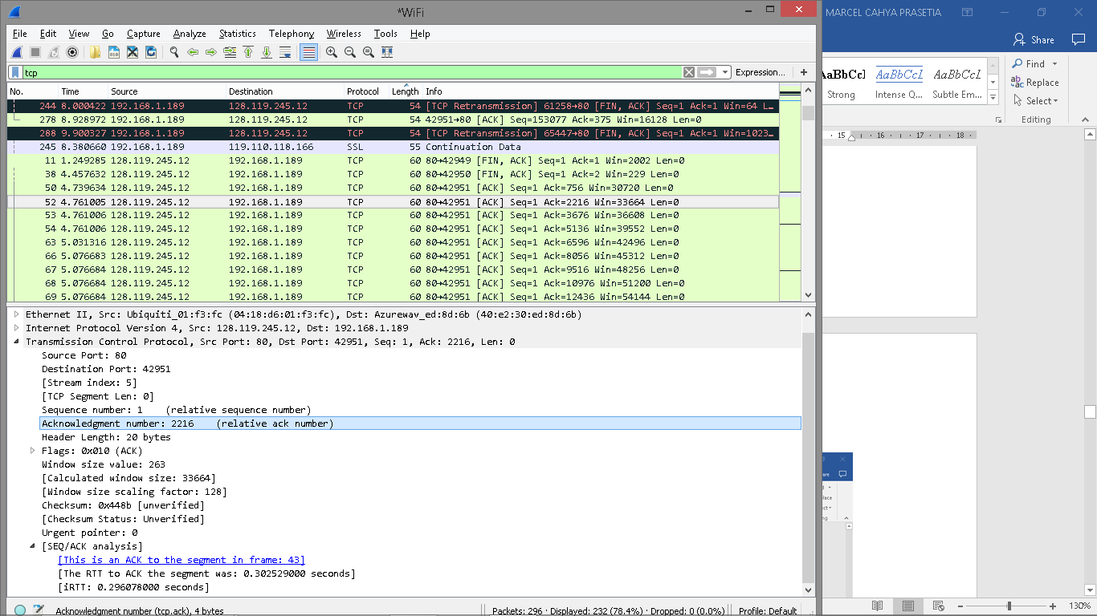

Segment 4, Sequence number: 3676
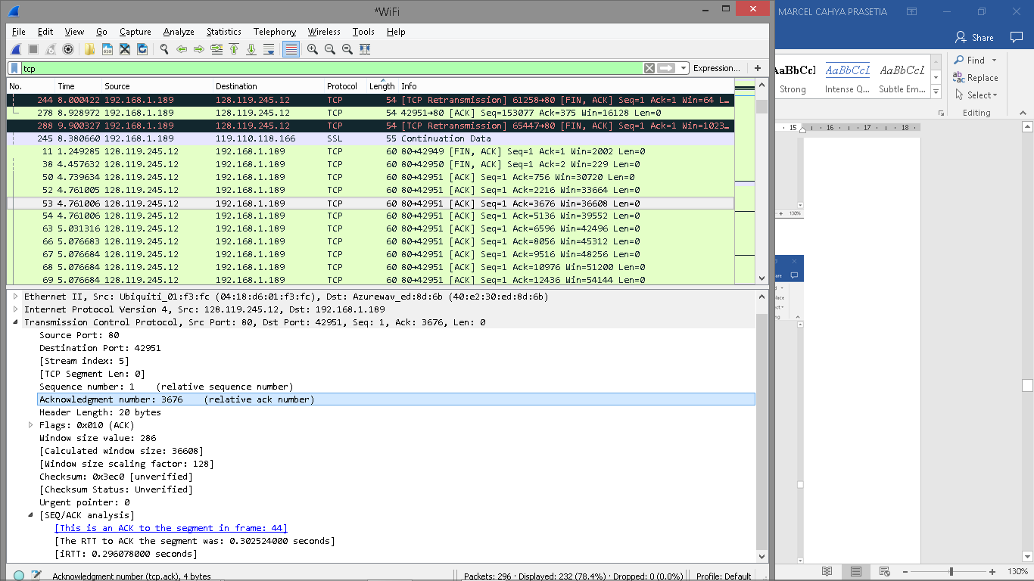

Segment 5, Sequence number: 5136
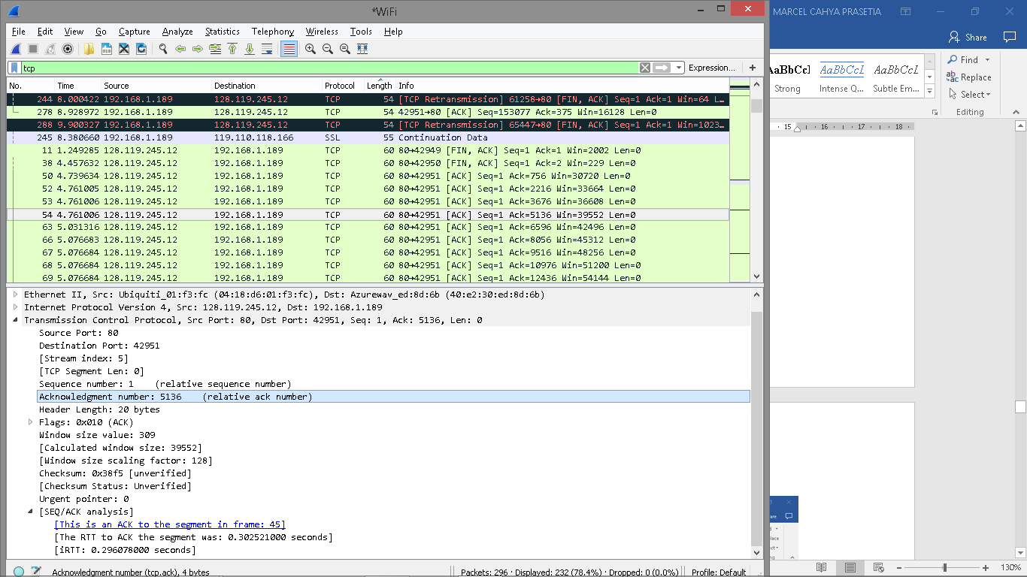

Segment 6, Sequence number: 6596
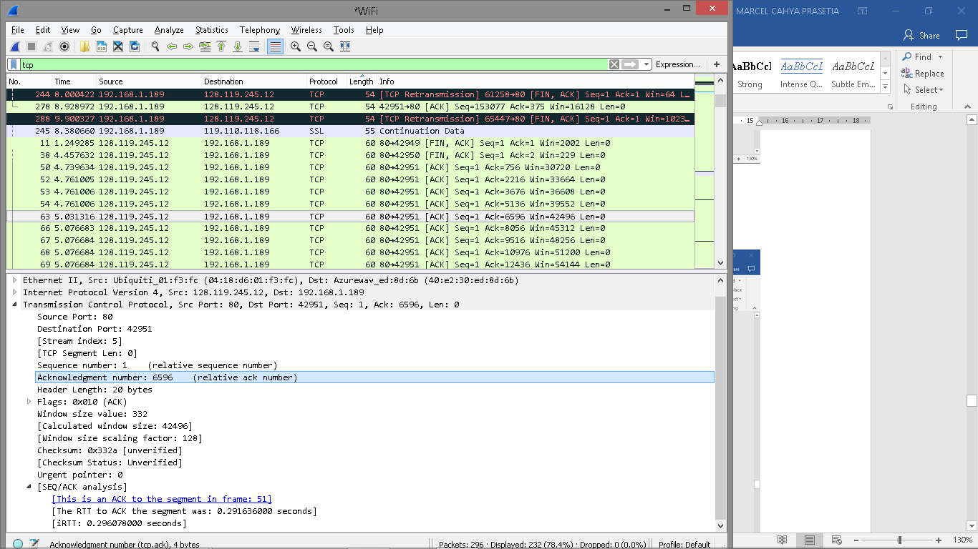

Round Trip Time:
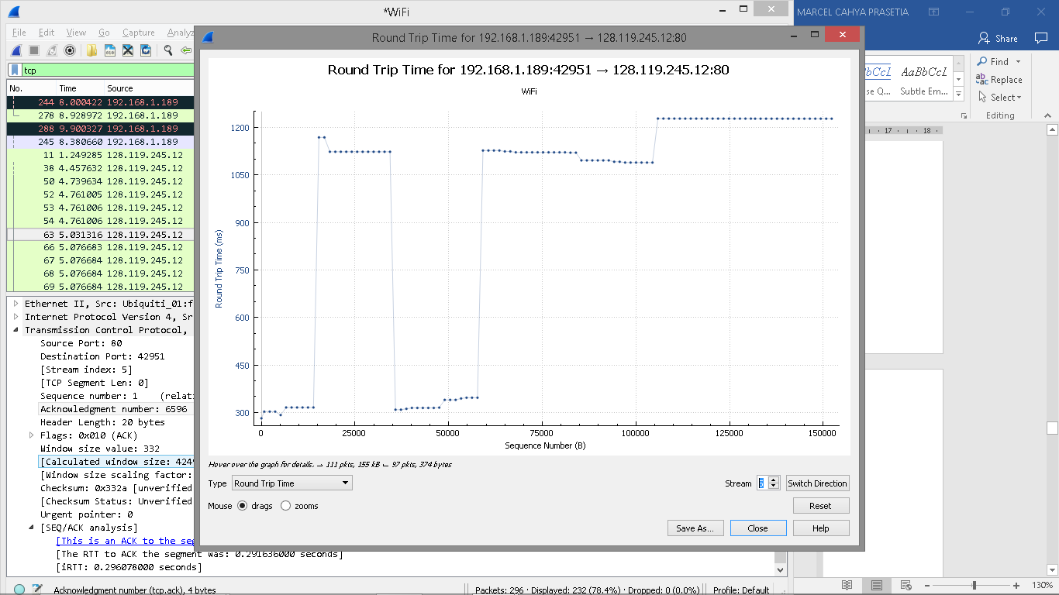
Sending time and the received time of ACKs in table

Segment | Sent time | ACK received time | RTT (seconds)
1 | 0.026477 | 0.053937 | 0.02746
2 | 0.041737 | 0.077294 | 0.035557
3 | 0.054026 | 0.124085 | 0.070059
4 | 0.054690 | 0.169118 | 0.11443
5 | 0.077405 | 0.217299 | 0.13989
6 | 0.078157 | 0.267802 | 0.18964
EstimatedRTT = 0.875 * EstimatedRTT + 0.125 * SampleRTT

EstimatedRTT after the receipt of the ACK of segment 1: EstimatedRTT = RTT for Segment 1 = 0.02746 second

EstimatedRTT after the receipt of the ACK of segment 2: EstimatedRTT = 0.875 * 0.02746 + 0.125 * 0.035557 = 0.0285

EstimatedRTT after the receipt of the ACK of segment 3: EstimatedRTT = 0.875 * 0.0285 + 0.125 * 0.070059 = 0.0337

EstimatedRTT after the receipt of the ACK of segment 4: EstimatedRTT = 0.875 * 0.0337+ 0.125 * 0.11443 = 0.0438

EstimatedRTT after the receipt of the ACK of segment 5: EstimatedRTT = 0.875 * 0.0438 + 0.125 * 0.13989 = 0.0558

EstimatedRTT after the receipt of the ACK of segment 6: EstimatedRTT = 0.875 * 0.0558 + 0.125 * 0.18964 = 0.0725 second

- What is the length of each of the first six TCP segments?
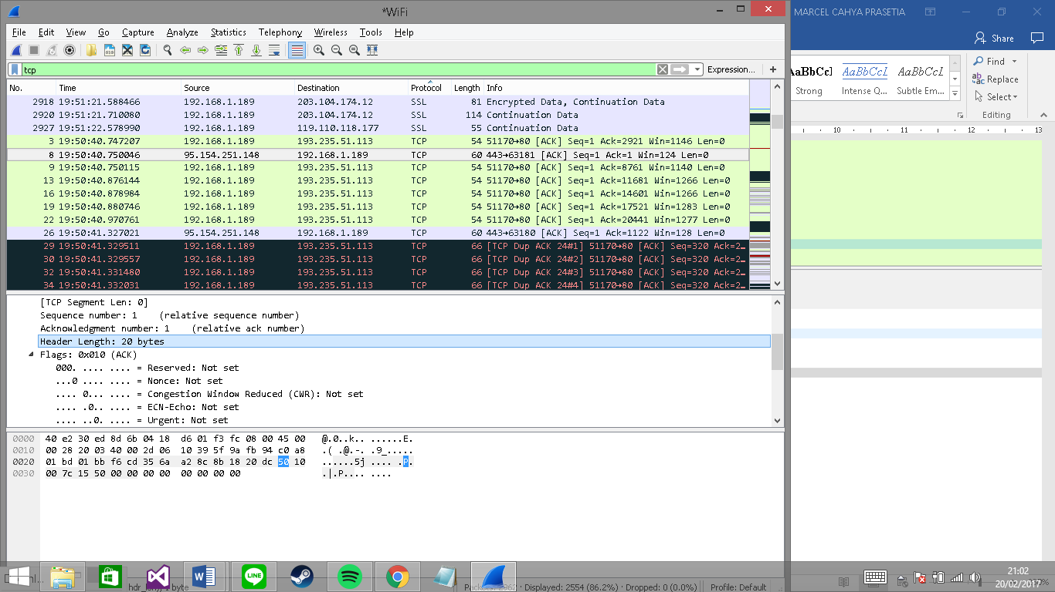
- What is the minimum amount of available buffer space advertised at the received for the entire trace? Does the lack of receiver buffer space ever throttle the sender?
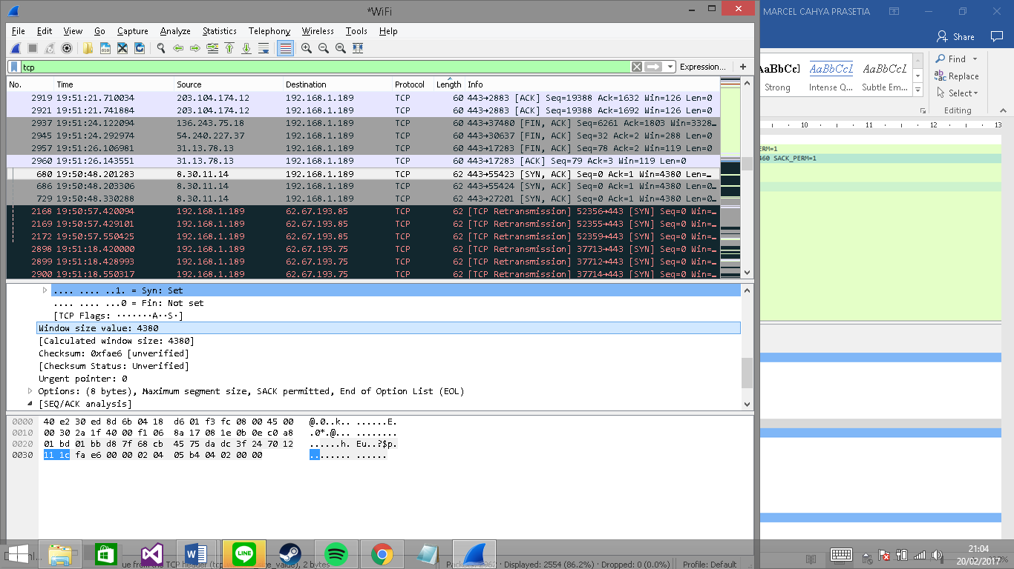
The minimum amount of available buffer space advertised at the received for the entire trace is indicated first ACK from the server, its value is 4380 bytes (shown in above figure). This reviver window grows until it reaches the maximum receiver buffer size of 8192 bytes. According to the trace, the sender is never throttled due to lacking of receiver buffer space.

- Are there any retransmitted segments in the trace file? What did you check for (in the trace) in order to answer this question?
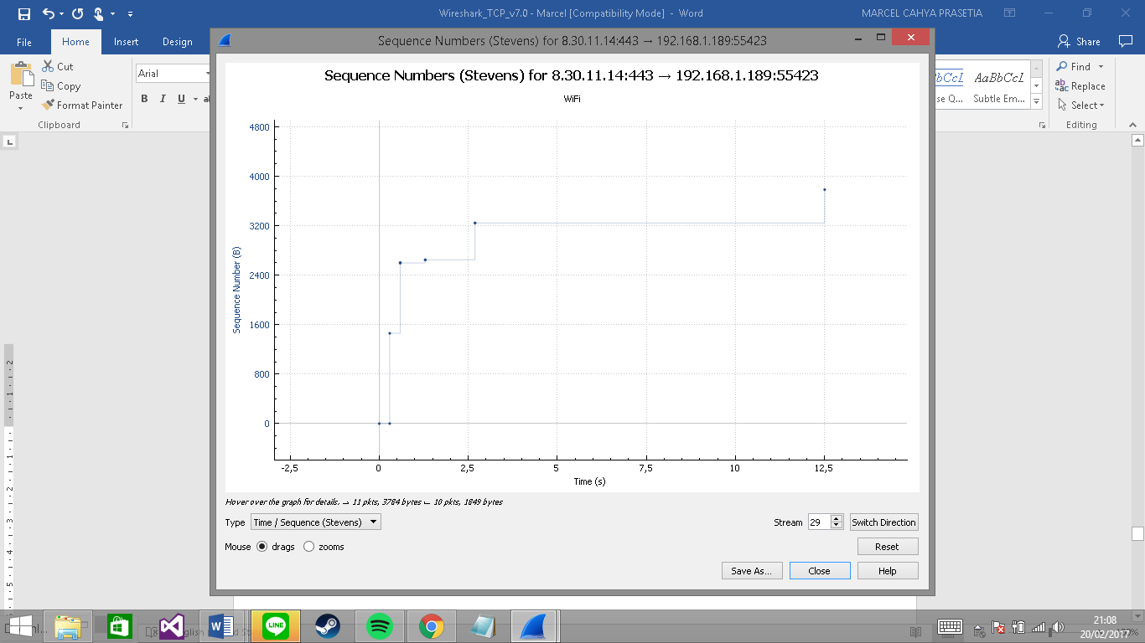
There is no retransmitted segments in the trace file since in the time sequence graph (stevens), all sequence numbers are monotonically increasing.

- How much data does the receiver typically acknowledge in an ACK? Can you identify cases where the receiver is ACKing every other received segment (see Table 3.2 on page 250 in the text).
ACK number: 412 , ACK data: 266
ACK number: 1 , ACK data: 755
ACK number: 756 , ACK data: 1460
ACK number: 130696 , ACK data: 1132

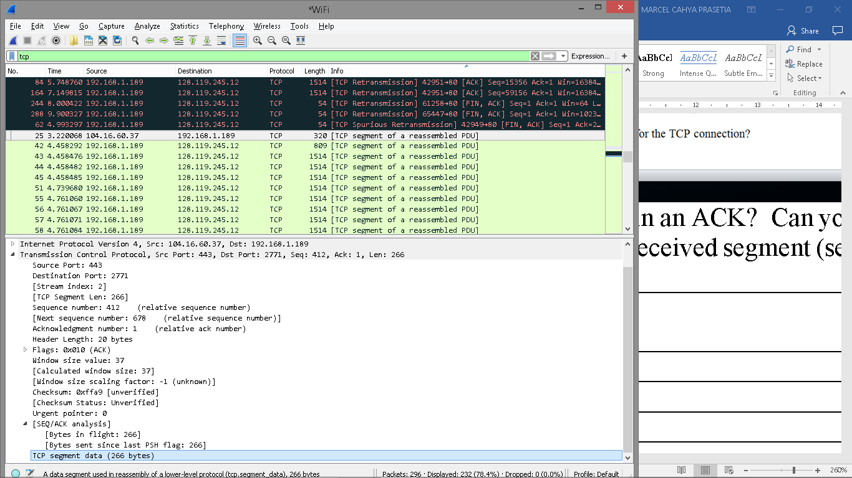
Cumulative ACKs (No. 62, 84, 164, 200, 244, 288) where the receiver is ACKing every other received segment

- What is the throughput (bytes transferred per unit time) for the TCP connection? Explain how you calculated this value.

The alice.txt on the hard drive is 152,138 bytes, and the download time is 1.578736000 (First TCP segment) ‐ 0.271257000 (last ACK) = 1.307479 second. Therefore, the throughput for the TCP connection is computed as 152,138/1.307479=116359.803867 bytes/second.

4. TCP congestion control in action

Let’s now examine the amount of data sent per unit time from the client to the server. Rather than (tediously!) calculating this from the raw data in the Wireshark window, we’ll use one of Wireshark’s TCP graphing utilities - Time-Sequence-Graph(Stevens) - to plot out data.
- Select a TCP segment in the Wireshark’s “listing of captured-packets” window. Then select the menu : Statistics->TCP Stream Graph-> Time-Sequence-Graph(Stevens). You should see a plot that looks similar to the following plot, which was created from the captured packets in the packet trace tcp-ethereal-trace-1 in http://gaia.cs.umass.edu/wireshark-labs/wireshark-traces.zip (see earlier footnote ):

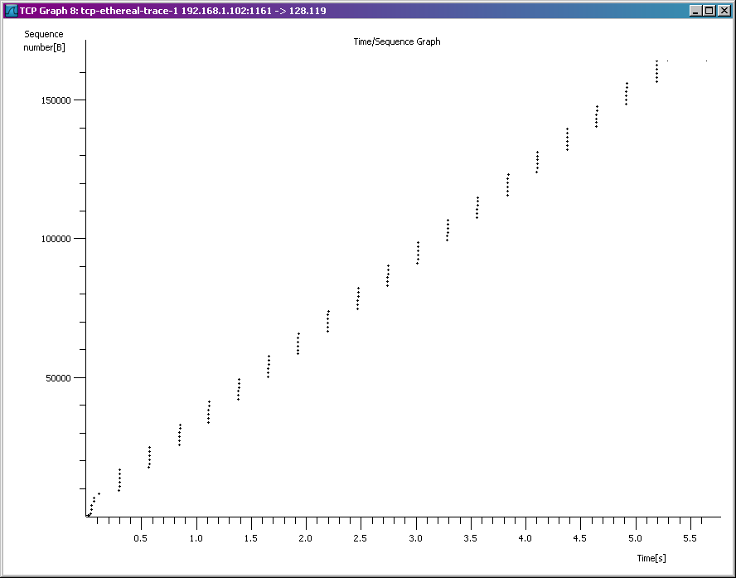

Here, each dot represents a TCP segment sent, plotting the sequence number of the segment versus the time at which it was sent. Note that a set of dots stacked above each other represents a series of packets that were sent back-to-back by the sender.

Answer the following questions for the TCP segments the packet trace tcp-ethereal-trace-1 in http://gaia.cs.umass.edu/wireshark-labs/wireshark-traces.zip
- Use the Time-Sequence-Graph(Stevens) plotting tool to view the sequence number versus time plot of segments being sent from the client to the gaia.cs.umass.edu server. Can you identify where TCP’s slowstart phase begins and ends, and where congestion avoidance takes over? Comment on ways in which the measured data differs from the idealized behavior of TCP that we’ve studied in the text.

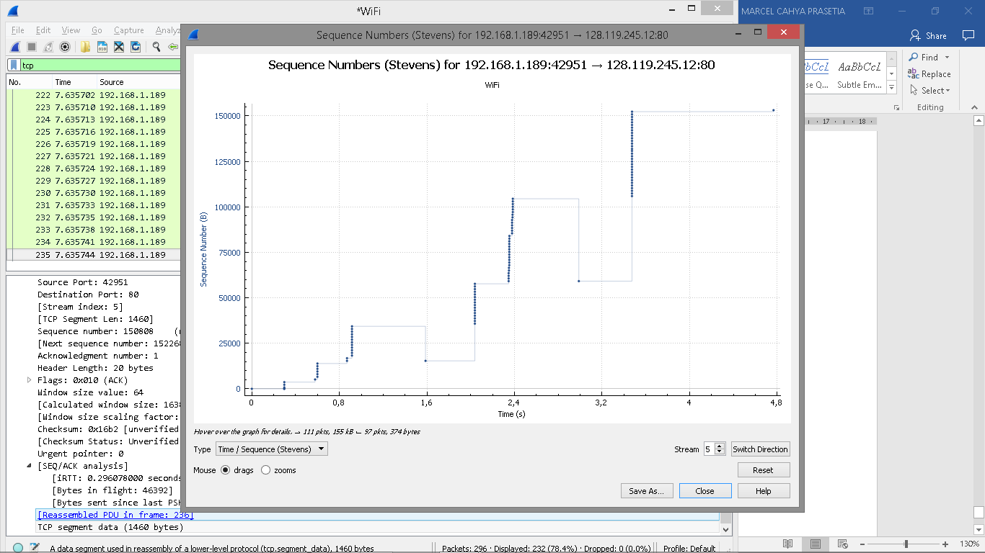
The slow start of the TCP seems to begin at about 0.3 seconds and then ends at about 0.56 seconds. Congestion avoidance takes over at about 3.0 seconds because it cut down the amount being sent.

- Answer each of two questions above for the trace that you have gathered when you transferred a file from your computer to gaia.cs.umass.edu
Type | No. | Seq. | ACKed seq. | Outstanding data
Data | 4 | 1 |  | 565
Data | 5 | 566 |  | 2025
ACK | 6 |  | 566 | 1460
Data | 7 | 2026 |  | 2920
Data | 8 | 3486 |  | 4380
ACK | 9 |  | 2026 | 2920
Data | 10 | 4946 |  | 4380
Data | 11 | 6406 |  | 5840
ACK | 12 |  | 3486 | 4380
Data | 13 | 7866 |  | 5527
ACK | 14 |  | 4096 | 4917
ACK | 15 |  | 6006 | 3007
ACK | 16 |  | 7866 | 1147
ACK | 17 |  | 9013 | 0
Data | 18 | 9013 |  | 1460
Data | 19 | 10473 |  | 2920
Data | 20 | 11933 |  | 4380
Data | 21 | 13393 |  | 5840
Data | 22 | 14853 |  | 7300
Data | 23 | 16313 |  | 8192
ACK | 24 |  | 10473 | 6732
ACK | 25 |  | 11933 | 5272
ACK | 26 |  | 13393 | 3812
ACK | 27 |  | 14853 | 2352
ACK | 28 |  | 16313 | 892
ACK | 29 |  | 17205 | 0
Data | 30 | 17205 |  | 1460
Data | 31 | 18665 |  | 2920
Data | 32 | 20125 |  | 4380
Data | 33 | 21585 |  | 5840
Data | 34 | 23045 |  | 7300
Data | 35 | 24505 |  | 8192
ACK | 36 |  | 18665 | 6732
ACK | 37 |  | 20125 | 5272
ACK | 38 |  | 21585 | 3812
ACK | 39 |  | 23045 | 2352
ACK | 40 |  | 24505 | 892
ACK | 41 |  | 25397 | 0
Data | 42 | 25397 |  | 1460
Data | 43 | 26857 |  | 2920
Data | 44 | 28317 |  | 4380
Data | 45 | 29777 |  | 5840
Data | 46 | 31237 |  | 7300
Data | 47 | 32697 |  | 8192
ACK | 48 |  | 26857
ACK | 49 |  | 28317
ACK | 50 |  | 29777
ACK | 51 |  | 31237
ACK | 52 |  | 33589
Data | 53 | 33589 |  | 6732
Data | 54 | 35049 |  | 5272
Data | 55 | 36509 |  | 3812
Data | 56 | 37969 |  | 2352
Data | 57 | 39429 |  | 892
Data | 58 | 40889 |  | 0
ACK | 59 |  | 35049 | 6732
ACK | 60 |  | 37969 | 3812
ACK | 61 |  | 40889 | 892
ACK | 62 |  | 41781 | 0
Data | 63 | 41781 |  | 1460
Data | 64 | 43241 |  | 2920
Data | 65 | 44701 |  | 4380
Data | 66 | 46161 |  | 5840
Data | 67 | 47621 |  | 7300
Data | 68 | 49081 |  | 8192
ACK | 69 |  | 44701 | 5272
ACK | 70 |  | 47621 | 2352
ACK | 71 |  | 49973 | 0
Data | 72 | 49973 |  | 1460
Data | 73 | 51433 |  | 2920
Data | 74 | 52893 |  | 4380
Data | 75 | 54353 |  | 5840
Data | 76 | 55813 |  | 7300
Data | 77 | 57273 |  | 8192
ACK | 78 |  | 52893 | 5272
ACK | 79 |  | 55813 | 2652
ACK | 80 |  | 58165 | 0
Data | 81 | 58165

The idealized behavior of TCP in text assumes that TCP senders are aggresive in sending data. TCP senders should follow aimd algorithm because too much traffic may congest the network. So, when they detect network congestion, their sending window size should drop down. TCP behavior is largely depends on application. Before the end of slow start phase, the transmission is over, the transmission of these small web objects suffers from the unnecessary long delay because of the slor start phase of TCP.

References to figures and sections are for the 7th edition of our text, Computer Networks, A Top-down Approach, 7th ed., J.F. Kurose and K.W. Ross, Addison-Wesley/Pearson, 2016.
Download the zip file http://gaia.cs.umass.edu/wireshark-labs/wireshark-traces.zip and extract the file tcp-ethereal-trace-1. The traces in this zip file were collected by Wireshark running on one of the author’s computers, while performing the steps indicated in the Wireshark lab. Once you have downloaded the trace, you can load it into Wireshark and view the trace using the File pull down menu, choosing Open, and then selecting the tcp-ethereal-trace-1 trace file.
What do we mean by “annotate”? If you hand in a paper copy, please highlight where in the printout you’ve found the answer and add some text (preferably with a colored pen) noting what you found in what you ‘ve highlight. If you hand in an electronic copy, it would be great if you could also highlight and annotate.
The TCP segments in the tcp-ethereal-trace-1 trace file are all less that 1460 bytes. This is because the computer on which the trace was gathered has an Ethernet card that limits the length of the maximum IP packet to 1500 bytes (40 bytes of TCP/IP header data and 1460 bytes of TCP payload). This 1500 byte value is the standard maximum length allowed by Ethernet. If your trace indicates a TCP length greater than 1500 bytes, and your computer is using an Ethernet connection, then Wireshark is reporting the wrong TCP segment length; it will likely also show only one large TCP segment rather than multiple smaller segments. Your computer is indeed probably sending multiple smaller segments, as indicated by the ACKs it receives. This inconsistency in reported segment lengths is due to the interaction between the Ethernet driver and the Wireshark software. We recommend that if you have this inconsistency, that you perform this lab using the provided trace file.

