Documentation for the plugin

PostGIS Queries

Installation
Extract the zip file available in https://github.com/marcelgaucho/PostGISQueries/releases to the QGIS plugins folder. This folder can be accessed as follows:

In the Menu Toolbar, Settings → User Profiles → Open Active Profile Folder.

A folder will open. Then navigate to python/plugins.

It is also possible to install from the QGIS Plugin Manager.

Plugin Behaviour
Each layer passed to the plugin represents a table or a view in the database. This table is passed, along with other parameters of the script, to perform the SQL query through the script gdal:executesql, which returns the result in a spatial layer.

Usage
It is recommended to leave the script dialog box open after execution to find out about possible problems. First go to Settings → Options… . Then, in the Processing → General tab, check the option Keep the dialog open after running an algorithm.
In case the script uses more than one layer, the layers must be in the same Coordinate Reference System (CRS).
The usage will be illustrated with a script, and the information given also applies to the other scripts. The example will be from the Figure 1 , used to find overlap between two layers.
- Input Layer (connection): first input layer for the script. It is also used to identify the database that will perform the query.
- Second layer: second layer passed to the script. There are cases where more than one layer needs to be passed, as is the case in the example, which detects the overlap between two layers.
- Minimum Squared Distance: parameter passed to the query, which is in the unit (degree or meter) of the input layer’s CRS.
- Filter layer (selected features) [optional]: layer of polygon type used as a filter for the input layers. It works by selecting, in the input layer, only those features that intersect the features selected in the current layer. Note that you need to select features in this layer for the script to work, otherwise it returns an error. Furthermore, the use of this layer is optional, so it is possible to leave it empty in order that no filter is applied.
- Filter Primary Key [optional]: primary key field of the filter layer which, therefore, has a unique value for each feature. The default value is “id”, so it will be automatically selected if the layer contains this field. The field is marked as optional, but if the filter layer is selected, selecting the primary key field becomes mandatory. This field will be used in the query together with its selected values and, therefore, if it does not contain unique values, the results will not be as intended.
- Output Layer: output layer. Often, it is possible to leave it empty to save to a temporary file, but is also possible to save the result to a specific file to be stored. If the script fails to save the result, try to resolve it by saving the output in a shapefile (*.shp) or geopackage (*.gpkg). In the three dots next to it, choose Save in file…, change the Type to SHP or GPKG files (*.shp or *.gpkg), create a name for the file and press to save.

In some scripts, the Input Primary Key is also requested, which is the primary key of the input layer, with information similar to the Filter Primary Key.

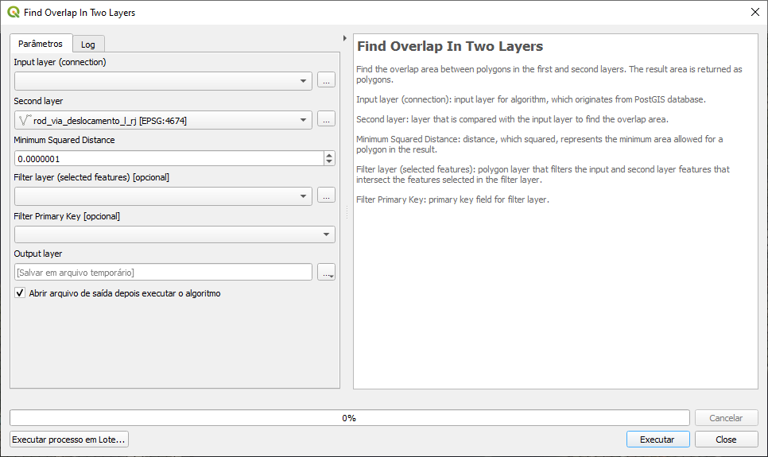Figure 1: Script to find the overlap between two layers

Available scripts

Find Dangles
Finds dangles for a line layer. Dangles are line nodes not connected to another line.

Input layer (connection): input line layer for algorithm, which originates from PostGIS database.
Input Primary Key: primary key field for input layer.
Node Join Tolerance: distance of a node to another line that considers the node connected to it.
Filter layer (selected features): polygon layer that filters the input features that intersect the features selected in the filter layer.
Filter Primary Key: primary key field for filter layer.

Find Empty or NULL Geometries
Find layer geometries that are Empty geometries or NULL.

Input layer (connection): input layer for algorithm, which originates from PostGIS database.
Input Primary Key: primary key field for input layer.

Find Endpoints that don’t touch polygon
Find endpoints of a line that don't touch a polygon boundary. A possible application of the script is to find bridges that don’t touch the boundary of a water body.

Input layer (connection): input line layer for algorithm, which originates from PostGIS database.
Polygon layer: polygon layer that relates to the input layer.
Node Join Tolerance: distance of a node or endpoint to a polygon boundary that considers the node intersects this boundary.
Filter layer (selected features): polygon layer that filters the input and polygon features that intersect the features selected in the filter layer.
Filter Primary Key: primary key field for filter layer.

Find Gaps
For a polygon layer that should have adjacent features, the gaps between polygons are returned as polygons.
This algorithm has the option of selecting features in the input layer, for the sake of operation ease. Sometimes we would like to find the gap between just two adjacent features, rather than using the entire layer, so this options serves that purpose. In addition to this option, filtering by selected features in a filter layer of polygon type continues to be valid, as in the other algorithms.

Input layer (connection) (use selection if exists): input polygon layer for algorithm, which originates from PostGIS database. If features are selected in this layer, the algorithm is applied only to these features.
Input Primary Key: primary key field for input layer. If there are features selected in the input layer, the input primary key must be selected.
Minimum Squared Distance: distance, which squared, represents the minimum area allowed for a polygon in the result. For example, taking the default value of the field, which is 0.0000001. Assuming that the layer CRS is in degrees, this value is equivalent to approximately 11 mm at the Equator, and therefore the minimum area of a polygon in the result is near to 11 mm².
Filter layer (selected features): polygon layer that filters the input features that intersect the features selected in the filter layer.
Filter Primary Key: primary key field for filter layer.

Find Geometries Different From Other Layer
Find geometries of input layer that are different from geometries in the second layer.

Input layer (connection): input layer for algorithm, which originates from PostGIS database.
Second layer: layer that is compared with the input layer.
Input Primary Key: primary key field for input layer.
Filter layer (selected features): polygon layer that filters the input and second layer features that intersect the features selected in the filter layer.
Filter Primary Key: primary key field for filter layer.

Find Geometries With Repeated Vertices
Find geometries that have duplicated vertices.

Input layer (connection): input layer for algorithm, which originates from PostGIS database.
Filter layer (selected features): polygon layer that filters the input features that intersect the features selected in the filter layer.
Filter Primary Key: primary key field for filter layer.

Find Invalid Polygons
Find invalid polygons for a polygon layer, according to Open Geospatial Consortium (OGC) rules, described by OGC Simple Features Implementation Specification for SQL 1.1. Briefly, invalid polygons are those that contain self-intersection or that have overlapping rings. Rings must be contained in the exterior ring and may touch each other, but only as tangents. The polygon interior must not be splitted, by rings, in more than one part. For a multipolygon, there are similar rules: the respective polygons must be valid, there must not be overlap and they may touch, but only as tangents. For more detail, refer to PostGIS documentation in
https://postgis.net/docs/using_postgis_dbmanagement.html#OGC_Validity .

Input layer (connection): input polygon layer for algorithm, which originates from PostGIS database.
Filter layer (selected features): polygon layer that filters the input features that intersect the features selected in the filter layer.
Filter Primary Key: primary key field for filter layer.

Find K Nearest Neighbors Within Distance
Find the K Nearest Neighbors within certain distance of the features. It takes 2 layers. The first is the input layer and the second is the neighbors layer. The features returned are from the neighbors layer. For each feature of the input layer, the K nearest features from the neighbors layer that are within the threshold distance are returned.

Input layer (connection): input layer for algorithm, which originates from PostGIS database.
Input Primary Key: primary key field for input layer.
Second layer: neighbors layer, from which features are returned.
Second Layer Primary Key: primary key field for second layer.
Threshold Distance: limit distance from the input layer at which features from the second layer are returned. Neighbors that do not intersect the search radius designated by the threshold distance will not be returned.
Number of neighbors: maximum number of neighbors, for each feature and located within the threshold distance, that can be returned.
Filter layer (selected features): polygon layer that filters the input and second layer features that intersect the features selected in the filter layer.
Filter Primary Key: primary key field for filter layer.

Find Not Simple Lines (Self-Intersection)
Find lines that are not simple. A not simple line is a line that has a self-intersection. A not simple multiline is a multiline in which at least one of the lines that form it is not simple or in which the lines that form it touch at points other than its boundaries.

Input layer (connection): input line layer for algorithm, which originates from PostGIS database.
Filter layer (selected features): polygon layer that filters the input features that intersect the features selected in the filter layer.
Filter Primary Key: primary key field for filter layer.

Find Overlap In One Layer
Find the overlap area of distinct polygons in a layer. The result area is returned as polygons.

Input layer (connection) (use selection if exists): input polygon layer for algorithm, which originates from PostGIS database. If features are selected in this layer, the algorithm is applied only to these features.
Input Primary Key: primary key field for input layer. If there are features selected in the input layer, the input primary key must be selected.
Minimum Squared Distance: distance, which squared, represents the minimum area allowed for a polygon in the result. For example, taking the default value of the field, which is 0.0000001. Assuming that the layer CRS is in degrees, this value is equivalent to approximately 11 mm at the Equator, and therefore the minimum area of a polygon in the result is near to 11 mm².
Filter layer (selected features): polygon layer that filters the input features that intersect the features selected in the filter layer.
Filter Primary Key: primary key field for filter layer.

Find Overlap In Two Layers
Find the overlap area between polygons in the first and second layers. The result area is returned as polygons.

Input layer (connection): input polygon layer for algorithm, which originates from PostGIS database.
Second layer: layer that is compared with the input layer to find the overlap area.
Minimum Squared Distance: distance, which squared, represents the minimum area allowed for a polygon in the result. For example, taking the default value of the field, which is 0.0000001. Assuming that the layer CRS is in degrees, this value is equivalent to approximately 11 mm at the Equator, and therefore the minimum area of a polygon in the result is near to 11 mm².
Filter layer (selected features): polygon layer that filters the input and second layer features that intersect the features selected in the filter layer.
Filter Primary Key: primary key field for filter layer.

Find polygons that aren’t filled by polygons from other layer

Find parts of polygons of an outer polygon layer that aren't filled by polygons from an inner polygon layer.

Input layer (connection) (Outer Polygon): input polygon layer for algorithm, which originates from PostGIS database, and consists of an external polygon layer.
Input Primary Key: primary key field for input layer.
Inner Polygon: polygon layer that is compared with the input layer and that should fill it.
Minimum Squared Distance: distance, which squared, represents the minimum area allowed for a polygon in the result. For example, taking the default value of the field, which is 0.0000001. Assuming that the layer CRS is in degrees, this value is equivalent to approximately 11 mm at the Equator, and therefore the minimum area of a polygon in the result is near to 11 mm².
Filter layer (selected features): polygon layer that filters the input and inner polygon layer features that intersect the features selected in the filter layer.
Filter Primary Key: primary key field for filter layer.

Find Polygons that don’t contain 1 point
Find polygons that don't contain 1 point. That is, they contain more than one point or no point.

Input layer (connection): input polygon layer for algorithm, which originates from PostGIS database.
Point layer: point layer that is compared with the input layer.
Filter layer (selected features): polygon layer that filters the input features that intersect the features selected in the filter layer.
Filter Primary Key: primary key field for filter layer.

Find Polygons with Holes
Find polygons that contain holes.

Input layer (connection): input polygon layer for algorithm, which originates from PostGIS database.
Filter layer (selected features): polygon layer that filters the input features that intersect the features selected in the filter layer.
Filter Primary Key: primary key field for filter layer.

Find Pseudonodes
Find pseudonodes for a line layer. Pseudonodes are nodes that form a break in the geometry, but without intersecting lines.

Input layer (connection): input line layer for algorithm, which originates from PostGIS database.
Input Primary Key: primary key field for input layer.
Excluded Field(s): if fields are selected, adjacent features with a change in these fields don't generate pseudonodes.
Node Join Tolerance: distance of a node to another line that considers the node connected to it.
Filter layer (selected features): polygon layer that filters the input features that intersect the features selected in the filter layer.
Filter Primary Key: primary key field for filter layer.

Find Repeated Geometries
Find duplicated geometries in a layer.

Input layer (connection): input layer for algorithm, which originates from PostGIS database.
Input Primary Key: primary key field for input layer.
Filter layer (selected features): polygon layer that filters the input features that intersect the features selected in the filter layer.
Filter Primary Key: primary key field for filter layer.

Find Undershoot and Overshoot
Find undershoot and overshoot for a line layer. Undershoot and overshoot are dangles that don't snap to another line: they go beyond or fall short of the connection.

Input layer (connection): input line layer for algorithm, which originates from PostGIS database.
Node Join Tolerance: distance of a node to another line that considers the node connected to it.
Threshold Distance: maximum distance to another line for the dangle to be returned in the result. A large value may include unexpected dangles in the results. Assuming that the layer CRS is in degrees, this value is equivalent to approximately 55 m at the Equator, and therefore dangles that are up to nearly 55 m from a line will be included in the result.
Filter layer (selected features): polygon layer that filters the input features that intersect the features selected in the filter layer.
Filter Primary Key: primary key field for filter layer.

Return Geometry Without Holes
Return geometry of a polygon layer without any holes.

Input layer (connection): input polygon layer for algorithm, which originates from PostGIS database.
Input Primary Key: primary key field for input layer.
Filter layer (selected features): polygon layer that filters the input features that intersect the features selected in the filter layer.
Filter Primary Key: primary key field for filter layer.

