The construction of patient-based bivariate reference models from trivariate arterial acid-base data distributions
Marcel Hekking, Edzard S. Gelsema, Jan Lindemans
Parts are published in: Clinical Biochemistry 1995; 6:581–585

Introduction
A central question in clinical chemistry is ‘Is the observed laboratory value for this person acceptable or not?’. The standard procedure for answering this question is to compare the observed laboratory value with a relevant univariate reference interval for that particular analyte [1-3]. The univariate reference interval has served for years as a standard for the judgement of ‘normalcy’ of laboratory values [4]. Many different approaches exist to determine a univariate reference interval [5-7]. In general, a reference interval is constructed by taking a random sample from a specific (often healthy) reference population. New observed values are then compared with the values of the sample. Obviously, if the observed value is clearly not within the range of the sample values then one can safely assume the observed value to be abnormal with respect to the chosen reference population. However, with observed values coming closer to the range of values in the sample, there has to be some decision point as whether to consider the observed value to be typical for the reference population or not. This decision point has been arbitrarily set at 5%; when a decision is made one accepts a 5% probability of erroneously classifying an observed value as not typical for the chosen reference population (in hypothesis testing known as a type I error) [8]. It has been shown that, in case the values of the sample follow a normal (or Gaussian) distribution, a parametric reference interval may be constructed by taking 2 standard deviations around the mean of the sample.
With respect to the statistical determination and the application of 95% univariate reference intervals for arterial pH, PaCO₂, a[] and BE on an intensive care department, the following problems exist.
First, there is no clear consensus about how to define a useful reference population. If a population of healthy persons is taken as a reference population, reference intervals may be too narrow to be of practical use in clinical situations. Moreover, for quantities that are obtained by invasive procedures, the use of healthy volunteers may be ethically unsound [9].
A second problem stems from the intrinsic two-dimensionality of a trivariate arterial acid-base data set. The relationship between pH, logarithmic PaCO₂ and logarithmic a[], as described by the Henderson-Hasselbalch equation, is linear and even the relationship between pH, PaCO₂ and BE is a nearly linear one (see preceding chapters). Accordingly, it is unnecessary and illogical to use reference intervals for all three acid-base variables, since only two of the three can change independently [10].
Thirdly, there are problems concerning the selection of the proper statistical model. The use of the parametric univariate 95% reference interval as the statistical model for evaluating laboratory values is well established in clinical chemistry [2]. However, already in 1969, Schoen and Brooks [11] reported a statistical dilemma resulting from the use of multiple 95% reference intervals. A person, evaluated with a single 95% reference interval has an a priori probability of 5% of being incorrectly diagnosed as abnormal. The same person evaluated with 10 such 95% reference intervals for 10 independent analytes will have an a priori probability of 40% (1-0.95¹⁰ = 0.4) for being incorrectly diagnosed as abnormal for one or more intervals. Hence, in situations of a simultaneous interpretation of multiple variables, the use of single 95% reference intervals results in an increase in the number of false positive observations by chance alone [12]. One way to deal with this dilemma is to automatically adjust the reference intervals in case of multiple variables in such a way that the probability of falling within all univariate reference intervals remains 95% (Bonferroni adjustment) [13, 14]. Another option is the use of the multivariate reference model [7, 14-19].
The essence of a multivariate reference model is that it treats two or more univariate distributions as one joint multivariate distribution rather than separate distributions. Figure 4–1 displays such a joint distribution for two hypothetical standard univariate distributions. Both univariate distributions are Gaussian, as illustrated by their bell-shaped curves. The joint distribution of both marginal distributions is the bell-shaped ‘mountain’ in the middle. Univariate reference intervals are obtained by making horizontal cross-section of the marginal distributions at the 5% probability density level. At the bottom the resultant squared reference region can be found. A cross-section of the multivariate distribution at the 5% probability level, however, results in an elliptical reference region. In analogy to the univariate case, an observation falling outside this ellipse has an a priori probability of 5% of being incorrectly diagnosed as abnormal.
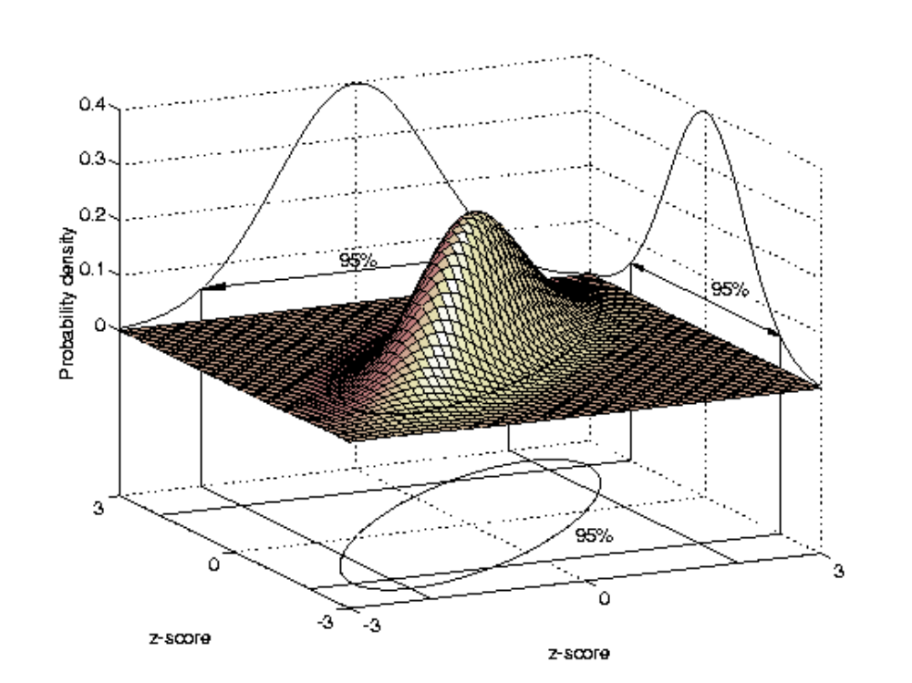
Figure 4–1. The joint distribution of two hypothetical standard normal univariate distributions. The correlation coefficient r between both variables has been set to 0.8. Projections of horizontal cross-sections at the 5% probability density level yield two types of reference regions: the square and the ellipse. Differences between these regions are explained further in Figure 4–2.
The major advantage of using a multivariate reference region as the true reference region rather than the region enclosed by the two univariate reference intervals is that it takes into account possible correlations between the variables. This is illustrated in Figure 4–2. The rectangle represents the reference region when using both univariate reference intervals. If the ellipse is taken as the standard, false positive and false negative observations may occur. For instance, observation 1 falls within both univariate intervals and is therefore normal for both variables separately. The combination of the two, however, is far from normal due to the positive correlation between the variables. On the other hand, observation 2 is abnormal for both univariate variables but is indeed normal if the correlation between the variables is taken into account. These effects become stronger as the correlation between the variables increases but are present even if the variates involved are uncorrelated [20].
In this chapter, a method for deriving reference models for arterial acid-base data is presented that addresses all of the problems discussed above. A method is proposed that calculates multivariate reference models from laboratory values of intensive care patients themselves. Intensive care patients rather than healthy individuals are therefore the reference population. Moreover, in concordance with the observed linearity between the arterial acid-base parameters, multivariate models are built on the first two rotated principal component values as calculated with the techniques described in the preceding chapters.
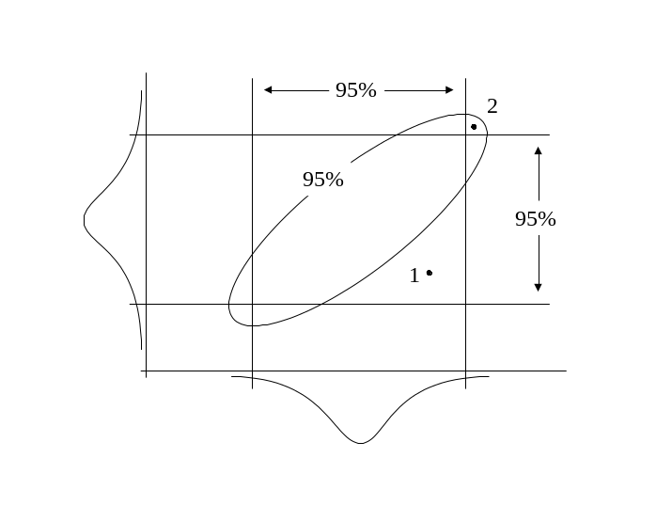
Figure 4–2. Discrepancy between a multiple univariate reference region and a single multivariate reference region. Plotted horizontally and vertically are the probability densities of analyte 1 and 2 of Figure 4–1, respectively. Using the region enclosed by the two univariate reference intervals as a reference region, observations 1 and 2 are a false negative and a false positive observation, respectively when the 95% reference ellipse is taken as the standard [7, 20].

Materials and methods

Patient data
For the analyses, the data sets presented in Chapter Error: Reference source not found were used; AZRbe, OLVGbe, OLVGab, SKZbe, ELIbe and ELIab. For each data set, the transformation matrix T was determined according to the descriptions in the preceding chapter. Each case in the original data set was then transformed with the transformation matrix T yielding new data sets of rotated principal component values PC1', PC2' and PC3'. The bivariate distributions of PC1' and PC2' are the input for the calculations presented below.

The multivariate reference model
The multivariate reference model is defined as follows. Assuming a theoretical multivariate Gaussian distribution with a known mean vector and variance-covariance matrix (μ,Σ) the squared Mahalanobis distances between a vector x and the mean μ:
d² = (x - μ)^{t} Σ⁻¹ (x - μ) (4–1)
are χ²(k)-distributed where k is the dimensionality of the multivariate model [21]. The superscript t stands for the transposition of a column-vector to a row-vector, x is the observation vector and Σ⁻¹ is the inverse of the variance-covariance matrix. The mean vector μ and the variance-covariance matrix Σ are called the model parameters. The 95% multivariate reference region includes all cases x with a d²smaller than or equal to the 0.95 fractile of a χ²(k)-distribution [22]. In practice, the model parameters are unknown and replaced by the sample estimates m and S, respectively.
To correct for the uncertainty in the sample estimates of the mean vector m and the variance-covariance matrix S when evaluating single multivariate observations, Chew and Albert proposed to use a 0.95 cut-off fractile that is based on the F-distribution [17, 23];
C = k(N2 − 1) F(0.95;k,N − k) / N(N − k) (4–2)
where k is the number of variables in the analysis, N is the number of cases and F(0.95;k,N - k) is the 0.95 fractile of the F-distribution for k and N - k degrees of freedom. In geometrical terms, 0.95 fractiles delimit specific regions in k-dimensional space and are known as 95% equal probability ellipses (for k = 2) or 95% equal probability ellipsoids (for k > 2). The region delimited by C is also known as the 95% prediction region [17].

Finding the Gaussian distributed core in a multivariate patient data set
In this section, an iterative trimming procedure is described for the determination of a valid acid-base bivariate 95% prediction region from the PC1' and PC2' values of an ICU patient data distribution. The method assumes that the patient data distribution is composed of two sorts of data; 1) a bivariate Gaussian distributed part of observations at the centre of the distribution (hereafter called the background model distribution) and 2) a contaminating part of outliers in the outer regions of the distribution. The method aims at finding the background model distribution by subsequently removing aberrant observations from the outer regions of the bivariate distribution until the remaining trimmed distribution is found to be bivariate Gaussian.
Under the assumption that the remaining observations of a trimmed bivariate distribution belong to a wider bivariate Gaussian distribution, the standard deviations of the marginal distributions of this wider bivariate Gaussian distribution can be approximated by the standard deviations of the trimmed distributions. However, clearly, these approximations are underestimates. Therefore, prior to the construction of the variance-covariance matrix from estimated marginal standard deviations, a correction must be performed. A table with standard deviation correction factors was constructed empirically beforehand as follows. A standard bivariate Gaussian distribution of 6000 cases was generated from two standard univariate Gaussian distributions (mean = 0 and standard deviation = 1) with the use of the SPSS statistical software package (SPSS for Windows release 6.0, Chicago). The resultant bivariate distribution was then trimmed at specific χ²(2) fractiles. At each χ² cut-off fractile, the correction factor was determined by dividing the standard deviation of the original marginal distribution by the standard deviation of the trimmed distribution. In Figure 4–3, correction factors (CF) are plotted for 24 fixed χ² cut-off fractiles.
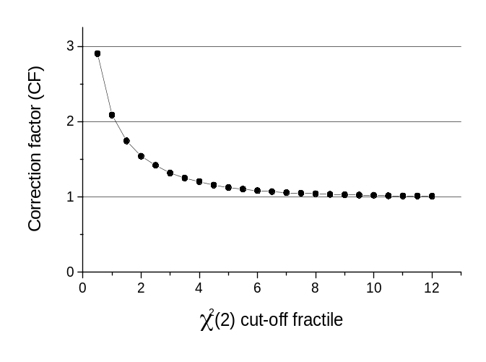
Figure 4–3. The standard deviation correction factor (CF) at 24 specific χ² cut-off fractiles for a bivariate Gaussian distribution.
Trimming the bivariate distribution now proceeds as follows (see also Figure 4–4).
1) In the first iteration on the untrimmed bivariate distribution, no cases are removed and the correction factor (CF) is therefore set to 1.
2) The model parameters (mean vector and variance-covariance matrix) are constructed from the estimated means, corrected standard deviations and estimated correlation coefficient.
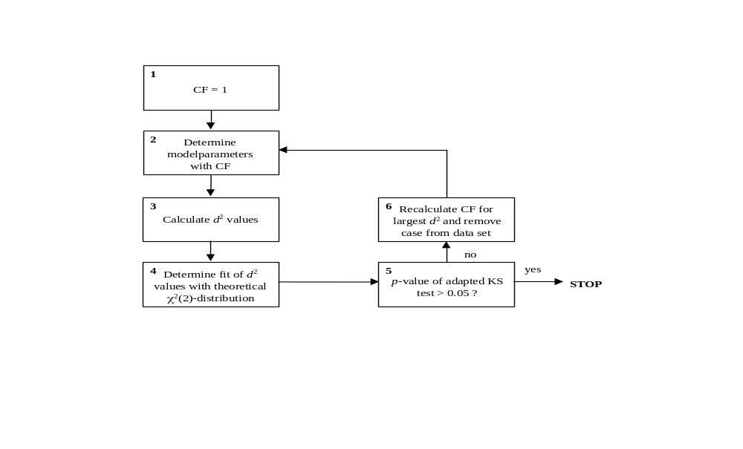
Figure 4–4. Flow-chart of trimming procedure to determine the background model parameters in a bivariate distribution of patient data. CF is the correction factor for the estimated standard deviations and KS stands for the size-adjusted Kolmogorov-Smirnov test. See text for further explanation.
3) With the estimated model parameters, a d²value (Equation 4–1) is calculated for each case in the data set.
4) The goodness-of-fit of the observed cumulative probability distribution of d²values with the theoretical cumulative χ²(2) probability distribution is now determined. In a bivariate Gaussian distribution, the d²values are distributed according to a χ²-distribution with 2 degrees of freedom [17, 18, 24, 25]. This observation is used to verify the bivariate Gaussian assumption. With a 1-dimensional goodness-of-fit test like the Kolmogorov-Smirnov (KS) test it can be tested whether the calculated d² values indeed follow a χ²(2)-distribution [24]. The test statistic of the KS test is the largest difference in probability between an observed cumulative probability distribution and a specific theoretical cumulative probability distribution [25]. If the KS test statistic is small enough, the hypothesis of the bivariate distribution being Gaussian is assumed to be verified.
However, the KS test is designed to be used in non-trimmed distributions only and an adaptation of the test was necessary. Under the assumption that the remaining cases of a trimmed bivariate distribution are part of a wider bivariate Gaussian distribution, the number of cases in this wider bivariate Gaussian distribution can be reconstructed for a given d²trimming value. Thus, for a ranked array of d²values (d₁,..., d_{N}) of a trimmed distribution, the adapted KS test statistic D_{max} is defined as:
D⁺ = max(i/(N/Pd_{N}) − Pd_{i}), (i = 1,..., N), (4–3)
D⁻= max(Pd_{i} − (i − 1)/(N/Pd_{N})), (i = 1,..., N),
D_{max} = max(D⁺, D⁻),
where Pd_{i} is the theoretical cumulative χ²(2) probability for d_{i}, Pd_{N} is the cumulative theoretical χ²(2) probability for d_{N} and consequently N/Pd_{N} is the estimated number of cases in the wider untrimmed bivariate Gaussian distribution. The p-value for a size-adjusted KS test statistic *D_{max} (D_{max} × (√N − 0.01 + 0.85/√N)) in the range of 0.01-0.15 can be calculated as [26]:
p-value = 6.18 − 17.53 × *D_{max} + 16.75 × *D_{max} ² − 5.39 × *D_{max}³ (4–4)
5) If the adapted KS test yields a p-value larger than α = 0.05, there is not enough evidence to reject the H_{o}-hypothesis of fit. It may then be concluded that the trimmed distribution is indeed part of a wider bivariate Gaussian distribution and the procedure is stopped. The estimated model parameters (mean vector m and variance-covariance matrix S as built from the corrected standard deviations and the estimated correlation coefficient) are now the background model parameters and can be used to define bivariate reference regions.
6) If the adapted KS test yields a p-value smaller than or equal to α = 0.05, the H_{o}-hypothesis of fit is rejected and the H_{a}-hypothesis (lack of fit) is accepted. This means that the trimmed bivariate distribution is not part of a wider bivariate Gaussian distribution and the case with the largest d²value is removed from the data set. A correction factor (CF) corresponding to this d²value is calculated and a new iteration starts with the trimmed distribution and the new correction factor.

Results
For each data set, the trimming procedure described in the preceding section succeeded in establishing the background model parameters. Results can be found in Table 4–1. In Figure 4–5, the cumulative probability plot of the d²-values of the ELIbe data set can be found as an example of the trimming procedure. Note that the remaining cases of the trimmed data set (thick line) follow the theoretical cumulative χ²(2) probability distribution (thin line). The corresponding adapted size-adjusted KS test-statistic is 0.855 with an associated p-value of 0.072. Hence, the conclusion can be drawn that the cases of this trimmed data set are part of a wider bivariate Gaussian distribution.
From the means (m), standard deviations (s) and correlation coefficients (r) presented in Table 4–1, the final background model parameters for each data set can be constructed. With the background model parameters, 95% and 30% equal probability ellipses were constructed for each data set and displayed in their respective tri-axial charts (Figure 4–6 to Figure 4–11). The differences between the corrected 0.95 and 0.30 fractiles (Equation 4–2) for the ELIbe data set (respectively 6.01 and 0.714) and the actual 0.95 and 0.30 χ²(2) fractiles (respectively 5.99 and 0.713) are only small. Since the number of trimmed cases in this data set is the largest of all data sets (382 cases), differences between corrected and actual fractiles will be even smaller for other data sets. Therefore, equal probability ellipses for each data set are based on the true χ²(2) fractiles rather than on their corrections.
Compared to the standard univariate reference region (the hexagon shaped figure) the 95% equal probability ellipses (outer ellipses) are relatively large. The location and orientation of the ellipses for the data sets ELIbe (Figure 4–6) and OLVGbe (Figure 4–7) are comparable. Their 30% equal probability ellipses both cover almost the entire standard univariate reference region. Both data sets come from a general ICU of a non-academic hospital. However, the ellipses of the AZRbe data set (Figure 4–8) are shifted towards a region with higher pH values and lower PaCO₂ values. The correlation coefficient r between PC1' and PC2' is -0.20 (see Table 4–1). Location and shape of the ellipses of the AZRbe data set indicate that a large portion of the acid-base data from this data set is indicative for a respiratory alkalosis. The AZRbe data set comes from the respiratory ICU of the academic hospital Dijkzigt. In Figure 4–9, the ellipses of the neonatal ICU of the Sophia Children’s hospital can be found. With respect to the hexagon in this figure and other data sets, the ellipses are shifted towards lower pH values, higher PaCO₂ values and lower BE values. This area is associated with combined respiratory and metabolic acidoses. Moreover, most of the variation in the data set is caused by variation in PaCO₂ values rather than BE values. This can be easily appreciated by (mentally) projecting the ellipses onto the PaCO₂ and BE axis, respectively. The projected ellipses would cover a much larger area on the PaCO₂ axis than on the BE axis.
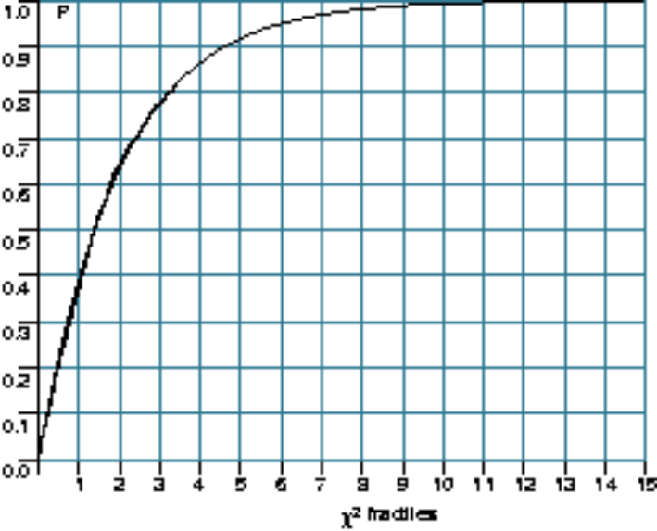
Figure 4–5. Fit of the observed cumulative probabilities of the remaining d²values of the trimmed ELIbe data set (thick line) with the theoretical cumulative χ²(2) probability distribution (thin line). P is the cumulative probability. *D_{max} is the test statistic of the adapted and size-adjusted Kolmogorov-Smirnov test, indicating the degree of fit of the d²values with the theoretical distribution. In this case there is not enough evidence (p > 0.05) to reject the H_{o}-hypothesis of fit.
Table 4–1. Distribution characteristics (m is mean, s is standard deviation and r is Pearson’s product correlation coefficient between PC1' and PC2') after trimming.
data set | N  total | trimmed | *D_{max} | m PC1' | m PC2' | s  PC1' | s  PC2' | r
AZRbe | 1500 | 264 | 0.891 (p = 0.050) | 1.93 | -1.41 | 2.46 | 2.99 | -0.20
OLVGbe | 1500 | 151 | 0.889 (p = 0.051) | 0.17 | 0.08 | 2.84 | 3.53 | 0.16
OLVGab | 1500 | 125 | 0.875 (p = 0.059) | 0.17 | 0.22 | 2.42 | 4.00 | -0.01
SKZbe | 1500 | 139 | 0.890 (p = 0.051) | -4.35 | -0.34 | 3.51 | 2.94 | -0.63
ELIbe | 1500 | 382 | 0.855 (p = 0.072) | 0.53 | -0.20 | 3.40 | 3.39 | 0.27
ELIab | 1500 | 307 | 0.882 (p = 0.055) | 0.31 | -0.15 | 3.16 | 3.63 | 0.18

*D_{max} = 0.855 (p-value = 0.072)
For the models based on the actual bicarbonate concentration (Figure 4–10 and Figure 4–11), it can be seen that the equal probability ellipses are also very wide but centred around the origin of the chart.

Discussion
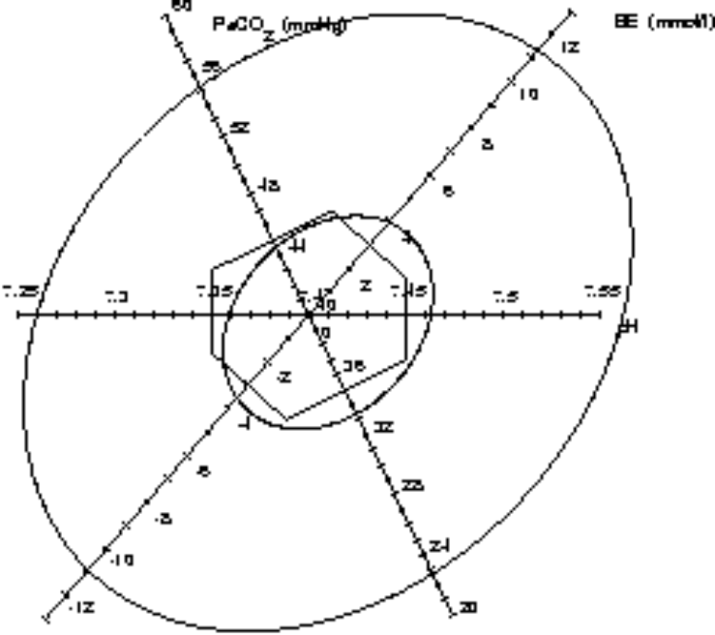
Figure 4–6. The 30% equal probability ellipse (inner ellipse) and the 95% equal probability ellipse (outer ellipse) for the ELIbe data set
In this chapter, an iterative method is described for the determination of bivariate reference models for acid-base variables, based on values coming from intensive care patients themselves. The proposed method closely resembles the iterative method described by Gelsema et al. for defining multivariate reference models from patient data [27]. In this method, the background model parameters are estimated by iteratively including an increasing number of observations from the centre of a multivariate distribution and verifying whether the included cases still belong to a multivariate Gaussian distribution. In general, however, there are fewer aberrant observations than normal observations in an unselected patient distribution and the method of Gelsema et al. may therefore be less efficient. Moreover, in the method of Gelsema the verification of the multivariate Gaussian assumption consists of a visual inspection of graphical output. In the method proposed in this chapter, the 1-dimensional Kolmogorov-Smirnov goodness-of-fit test is used to statistically verify the underlying multivariate Gaussian assumption. This makes the method suitable for an objective and fully automated process. Although the method was designed for the analysis of acid-base data, it can be used to define multivariate reference models for any combination of laboratory data or other measurements.
In clinical chemistry, the derivation of valid reference models from unselected patient data sets has always been attractive. No special sampling procedures are necessary, since routine daily measurements from the clinical chemical laboratory can be used. No extra costs for performing laboratory tests are involved and there is a direct relation of the reference model with the target population [28].
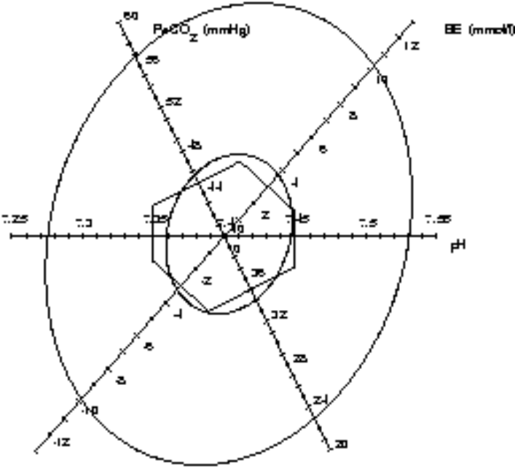
Figure 4–7. The 30% equal probability ellipse (inner ellipse) and the 95% equal probability ellipse (outer ellipse) for the OLVGbe data set
In his thesis, Naus [12] compared 5 different methods to define valid reference intervals from unselected univariate patient data distributions: the method of Hoffman, Neuman, Pryce, Becktel and Bhattacharya. It was shown that the Bhattacharya method was superior in terms of ease of use and reliability. The essence of the Bhattacharya method is that it determines the Gaussian component (if present) in an unselected univariate reference distribution of patient data. The method starts by dividing a frequency distribution into a number of equally spaced classes. If a Gaussian component is present, plotting the logarithm of the ratio of the frequencies in two subsequent classes against the midpoint of the first class results in a straight line (y = ax + b) somewhere in the graph. The estimated mean (m) and variance (s²) of the Gaussian component are then calculated respectively as -b/a+0.5h and -h/a-h²/12 (with h being the width of classes) [29]. For a detailed description of the Bhattacharya method the reader is referred to the thesis of Naus.
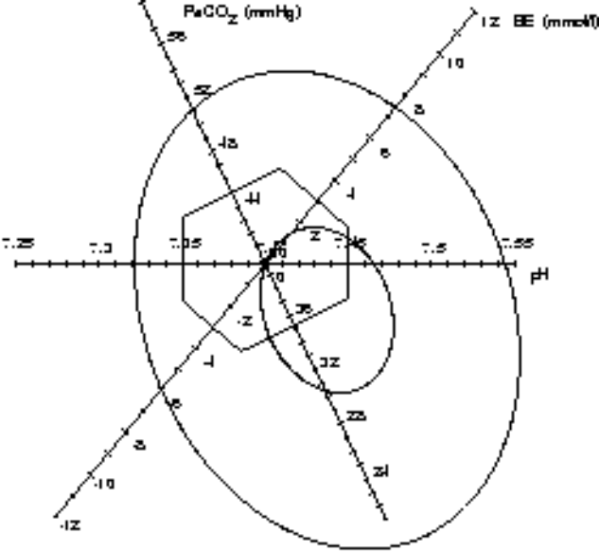
Figure 4–8. The 30% equal probability ellipse (inner ellipse) and the 95% equal probability ellipse (outer ellipse) for the AZRbe data set.
Baadenhuisen and Smit [28] used a modified Bhattacharya procedure to determine reference intervals for univariate unselected and skewed distributions. Oosterhuis [29] compared the Bhattacharya method for defining univariate reference intervals with the method proposed by the IFCC, which involves the evaluation of data from blood donor populations. Naus et al. [30] used the Bhattacharya method for the determination of reference intervals for a number of haematological parameters.
Naus also used the Bhattacharya method for the determination of a normal bivariate reference region from patient data for the combination of total protein and albumin [31]. His approach starts with calculating the means and variances for the two marginal distributions using the Bhattacharya method. Then, the covariance between both variables (hereafter called x and y) are determined as (s²sum – s²dif) / 4. The term s²sum is the variance of the distribution of the sums of x and y, determined with the Bhattacharya method. The term s²dif is the variance of the distribution of the differences of x and y, determined with the Bhattacharya method. The resulting variance-covariance matrix (constructed with the aid of the Bhattacharya method) and the mean values are then used as the background model parameters to calculate bivariate reference regions.
Major shortcomings of Naus’ method for defining multivariate normal reference regions from patient data are: 1) it cannot be used in situations where the Bhattacharya method fails to detect a Gaussian component in one or more marginal distributions; 2) the marginal distributions being Gaussian does not automatically imply that the joint distribution is also Gaussian; 3) computation time increases dramatically when the number of included variables increases; 4) the Bhattacharya method generally requires a substantial number of cases to be reliable [12].
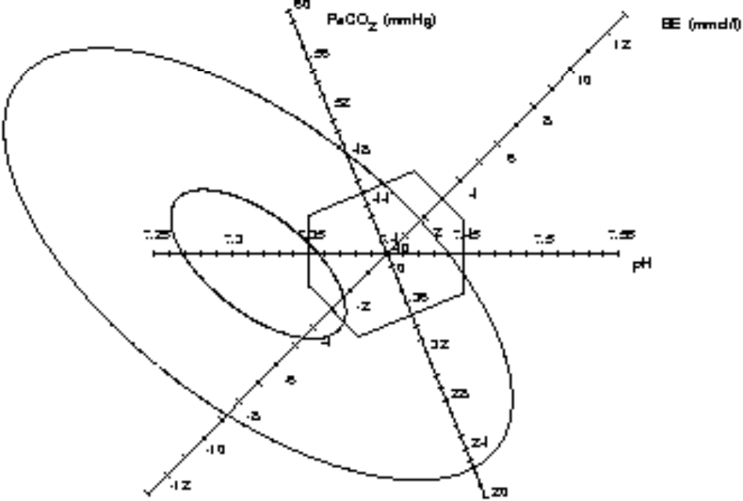
Figure 4–9. The 30% equal probability ellipse (inner ellipse) and the 95% equal probability ellipse (outer ellipse) for the SKZbe data set.
For the iterative method described in this chapter, the prerequisite of the marginal distributions being Gaussian no longer holds, since the trimming of aberrant observations and the verification of the multivariate Gaussian assumption is performed directly on the joint distribution rather than on the marginal distributions. Furthermore, the proposed method can automatically and straightforwardly be applied to both the univariate and the multivariate case. A special computer program for defining and testing multivariate normal reference models derived from patient data sets as described in this chapter can be found in [32].
In the discussion about the usefulness of the proposed bivariate reference models for arterial acid-base data in an intensive care setting, two central questions arise. First, what is the clinical value of reference models that are based on patient data rather than on healthy reference populations? Second, what is the clinical value of using a multivariate reference model as compared to using the classical univariate reference intervals?
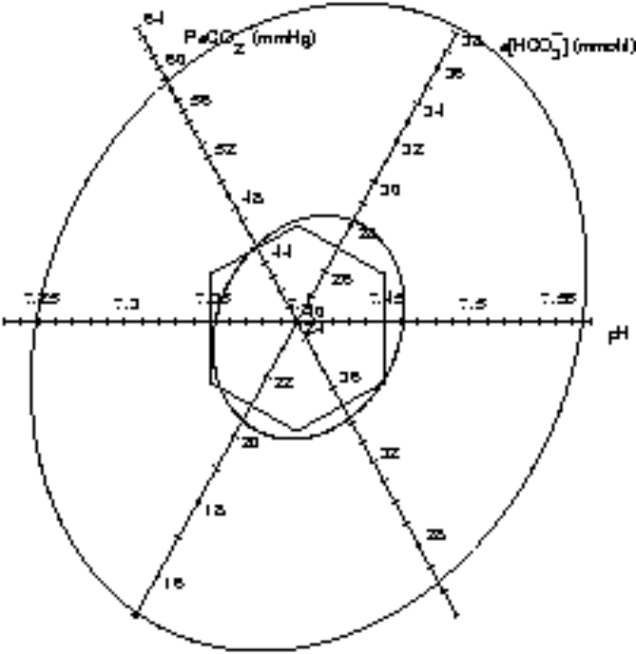
Figure 4–10. The 30% equal probability ellipse (inner ellipse) and the 95% equal probability ellipse (outer ellipse) for the ELIab data set.
Ad 1. What is the clinical value of patient-based reference models? The selection of the reference population is considered the most crucial part in the process of building reference models. In general, reference populations consist of ambulant, subjectively healthy students, laboratory staff, blood donors, etcetera. But are these reference models valid? What is the value of health-associated reference models for specific groups of patients? Much confusion arises about the fact that health is relative [33]. A patient can be regarded ill in one respect and healthy in another. Laboratory values found in a person at a young age could indicate health but the same values determined on the same patient at an older age could be indicative of disease. Moreover, the diagnosis of health cannot be based on excluding pathology only [7]. If no signs of disease are present, uncertainty remains because these signs could possibly be found on closer examination. As Gräsback defines: Health is characterised by a minimum of subjective feelings and objective signs of disease, assessed in relation to the social situation of the subject and the purpose of the medical activity, and it is in the absolute sense an unattainable ideal state [33]. In the light of this definition of health it seems appropriate that reference models should not only be derived from healthy people but from a diversity of populations to suit a diversity of purposes.
In order to answer the question whether the patient-based bivariate reference region as defined in this chapter could be useful in an intensive care setting, one should first consider the mechanisms that may shape a reference population. One of those mechanisms is the nature of the ICU from which the patient reference population is taken. Arterial acid-base data from a neonatal ICU will be quite different from acid-base data coming from a respiratory ICU for adults. This is illustrated by the reference ellipses that are based on the neonatal ICU data set (Figure 4–9). The ellipses are shifted towards the area of combined respiratory and metabolic acidoses. This is not the case for the adult respiratory intensive care units. This shift towards the combined acidosis area for the neonatal ICU is not surprising, since the majority of neonatal patients are premature new-borns with an insufficient respiratory and metabolic system, leading to an inadequate clearance of both volatile and non-volatile acids.
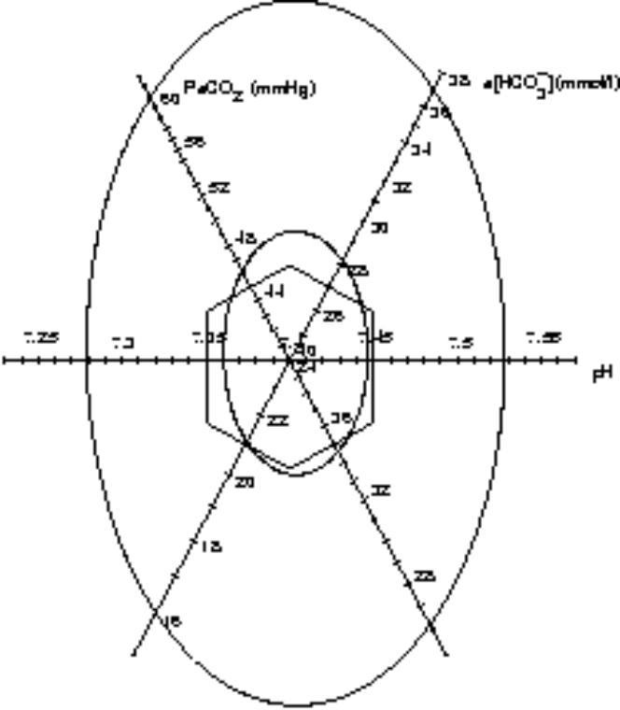
Figure 4–11. The 30% equal probability ellipse (inner ellipse) and the 95% equal probability ellipse (outer ellipse) for the OLVGab data set.
Another mechanism that might influence the shape and position of a patient-based reference region is the difference in protocols used on an ICU and the preferences of the clinicians working at that ICU. For instance, from discussions with clinicians at the respiratory ICU of the academic hospital Dijkzigt (data set AZRbe) it became clear that there was a tendency to keep ventilated patients in a moderate state of hyperventilation [19]. This explains the shift of the ellipses of the AZRbe data set (Figure 4–8) towards the area of respiratory alkaloses.
In conclusion, a multivariate reference region based on an ICU population is not only patient-based but also clinic-dependent. It gives an indication as to which of the patients in one particular ICU are most in need of care.
Ad 2. What is the clinical value of a multivariate reference model compared to the use of classical univariate reference intervals? The Mahalanobis distance (Equation 4–1) enables the monitoring of the original three laboratory values with only one single parameter. Monitoring the acid-base status with this single multivariate index may well be advantageous for ICU personnel because of its ease of interpretation. In a future acid-base monitoring system, one single threshold needs to be set instead of three separate thresholds for all laboratory acid-base variables. Also, using the Mahalanobis distance as a monitoring parameter for arterial acid-base values could substantially reduce the number of false-positive alarms as described in the introduction. It should be noted here that the Mahalanobis distance does not add new concepts to the interpretation of acid-base data. Merely, another statistical tool is presented for the analysis of acid-base data that deals with the fundamental problems associated with the simultaneous analysis of more that one variable. The proposed technique does not deprive a clinician of his usual way of interpreting acid-base data of a patient, but patient outcome could be indirectly influenced because of the possible reduction in false positive alarms and the simplicity of analysing a single parameter, giving the clinician more time for other aspects of patient care.

References
1. Solberg HE, PetitClerc C. International Federation of Clinical Chemistry (IFCC), Scientific Committee, Clinical Section, Expert Panel on Theory of Reference Values. Approved recommendation (1988) on the theory of reference values. Part 3. Preparation of individuals and collection of specimens for the production of reference values. J Clin Chem Clin Biochem 1988; 26:593-598.
2. Solberg HE. International Federation of Clinical Chemistry (IFCC), Scientific Committee, Clinical Section, Expert Panel on Theory of Reference Values, and International Committee for Standardization in Haematology (ICSH), Standing Committee on Reference Values. Approved Recommendation (1986) on the theory of reference values. Part 1. The concept of reference values. J Clin Chem Clin Biochem 1987; 25:337-342.
3. Solberg HE. International Federation of Clinical Chemistry (IFCC), Scientific Committee, Clinical Section, Expert Panel on Theory of Reference Values. Approved recommendation (1988) on the theory of reference values. Part 5. Statistical treatment of collected reference values. Determination of reference limits. J Clin Chem Clin Biochem 1987; 25:645-656.
4. Boyd JC. Perspectives on the use of chemometrics in laboratory medicine. Clin Chem 1986; 32:1726-1733.
5. Bezemer PD. Referentiewaarden - een verkenning van methoden voor het bepalen van 'normale waarden'. Amsterdam: Vrije Universiteit Amsterdam, 1981; 180 pp.
6. Solberg HE, Gräsback R. Reference values. Adv Clin Chem 1994; 27:1 -79.
7. Solberg HE. Establishment and use of reference values. In: Burtis CA, Ashwood ER, eds. Tietz textbook of clinical chemistry. 2nd Edition, W.B. Saunders Company, 1994; 454-484.
8. Dixon WJ, Massey FJ. Introduction to statistical analysis. Student Edition, Singapore: McGraw-Hill, Inc., 1983; 1-678.
9. Gelsema ES, Leijnse B, Wulkan RW. A multi-dimensional analysis of three chemical quantities in the blood. Med Inform 1991; 16:43-54.
10. Madias NE, Adroqué HJ, Horowitz GL, et al. A redefinition of normal acid-base equilibrium in man: Carbon dioxide tension as a key determinant of normal plasma bicarbonate concentration. Kidney Int 1979; 16:612-618.
11. Schoen I, Brooks SH. Judgment based on 95% confidence limits. Statistical Considerations 1969; 53:190-193.
12. Naus AJ. De berekening van referentiewaarden in de klinische chemie uit analyseresultaten van een patientenpopulatie. Maastricht: Rijksuniversiteit Maastricht, 1982; 154 pp.
13. Slotnick HB, Etzell P. Multivariate interpretation of laboratory tests used in monitoring patients. Clin Chem 1990; 36:748-751.
14. Winkel P. Multivariate analysis and expert systems. Scand J Clin Lab Invest 1994; 219:12-24.
15. Winkel P, Lyngbye J, Jörgensen K. The normal region - a multivariate problem. Scand J Clin Lab Invest 1972; 30:339-344.
16. Grams RR, Johnson EA, Benson ES. Laboratory data analysis system: section III-multivariate normality. Am J Clin Pathol 1972; 85:188-199.
17. Albert A, Harris EK. Multivariate interpretation of clinical laboratory data. New York: Marcel Dekker Inc, 1987, Owen DB, Cornell RG, eds., STATISTICS: Textbooks and Monographs; vol 75.
18. Harris EK. Statistical aspects of reference values in clinical pathology. Prog Clin Pathol 1981; 8:45-66.
19. Wulkan RW. Expert systems and multivariate analysis in clinical chemistry. Rotterdam: Erasmus University Rotterdam, 1992; 111 pp.
20. Stamhuis IH, Bezemer PD, Kuik D. Evaluation of univariate ranges with a multivariate standard. J Clin Epidemiol 1988; 41:359-366.
21. Mahalanobis PC. On the generalized distance in statistics. Proc Natl Inst Sci India 1936; 2:49-56.
22. Linnet K. Influence of sampling variation and analytical errors on the performance of the multivariate reference region. Meth Inform Med 1988; 27:37-42.
23. Chew V. Confidence, prediction, and tolerance regions for the multivariate normal distribution. J Am Stat Assoc 1966; 61:605-617.
24. Boyd JC, Lacher DA. The multivariate reference range: an alternative interpretation of multi-test profiles. Clin Chem 1982; 28:259-265.
25. Mardia KV. Tests of univariate and multivariate normality. In: Krishnaiah PR, ed. Handbook of Statistics. Amsterdam: North-Holland Publishing Co, 1980; 279-320; vol 1: Analyses of Variance.
26. Solberg HE. Statistical treatment of reference values in laboratory medicine: Testing the goodness-of-fit of an observed distribution to the Gaussian distribution. Scand J Clin Lab Invest Suppl 1986; 46:125-132.
27. Gelsema ES, Leijnse B, Wulkan RW. Detection of aberrant observations in a background of an unknown multidimensional gaussian distribution. Meth Inform Med 1990; 29:236-242.
28. Baadenhuijsen H, Smit JC. Indirect estimation of clinical chemical reference intervals from total hospital patient data: application of a modified Bhattacharya procedure. J Clin Chem Clin Biochem 1985; 23:829-839.
29. Oosterhuis WP. Application of statistics in the clinical laboratory with emphasis on multivariate analysis. Leiden: Rijksuniversiteit Leiden, 1994; 104 pp.
30. Naus AJ, Borst A, Kuppens PS. The use of patient data for the calculation of reference values for some haematological parameters. J Clin Chem Clin Biochem 1980; 18:621-625.
31. Naus AJ, Borst A, Kuppens PS. Determination of n-dimensional reference ellipsoids using patient data. J Clin Chem Clin Biochem 1982; 20:75-80.
32. Hekking M, Lindemans J, Gelsema ES. A computer program for constructing multivariate reference models. Comput Methods Programs Biomed 1997; 53:191-200.
33. Gräsbeck R. Reference values, why and how. Scand J Clin Lab Invest 1990; 201:45-53.

