A re-appraisal of the tri-axial chart for monitoring arterial acid-base values — three case reports

Published in shortened form in: Intensive Care Medicine 1998; 24:977–980
Marcel Hekking, Herman J.L.M. Ulenkate, Ben Speelberg, Marianne J.E. Van Puyenbroek, Henk M.J. Goldschmidt, Edzard S. Gelsema

Abstract
Objective: To demonstrate the practicability of a tri-axial chart for the graphical and quantitative monitoring of arterial pH, arterial carbon dioxide partial pressure (PaCO₂) and actual arterial bicarbonate-ion concentration (a[]) in intensive care patients.
Design: Case reports.
Setting: The general intensive care unit (ICU) of the St. Elisabeth hospital in Tilburg, The Netherlands.
Methods: Using a standard mathematical transformation, a data set of pH, log PaCO₂ and log a[] values can be transformed in such a way that a graphical display of all three variables is possible, while being faithful to their linear relationship. Remarkably, this graphical display closely resembles the plot on tri-axial coordinate paper that Hastings and Steinhaus described in 1931 for displaying changes in the acid-base balance during animal experiments. Two new monitoring parameters based on the chart and transformation are described. One of them monitors the abnormality of the acid-base status while the other monitors the rate of acid-base changes.
Conclusions: With the tri-axial acid-base chart, the complete acid-base status can be faithfully monitored. Moreover, the proposed monitoring parameters provide extra information about the arterial acid-base status that otherwise would remain hidden.

Introduction
The monitoring of laboratory values plays a central role in the intensive care unit (ICU). In general, monitoring involves the comparison of observed values with lower and upper limits for the variable in question. When monitoring the acid-base status using arterial pH, PaCO₂ and actual a[], however, the simultaneous use of lower and upper limits assumes these variables to be independent of each other which may lead to false positive and false negative observations [1]. Moreover, the linear relationship between the variables makes separate monitoring of all three variables illogical [2].
Recently, we developed a model that addresses both problems [3]. The model determines a bivariate reference region on the two dimensions as obtained after a mathematical data reduction of a pH, log PaCO₂ and log a[] distribution. After its development it was found that the associated graphical representation closely resembles the plot on tri-axial coordinate paper that Hastings and Steinhaus described in 1931 to study acid-base displacements (see Figure 6–1) [4].
In their coordinate paper, the three original acid-base axes are placed in the same typical tri-axial configuration. Original axes are not shown in Figure 6–1 but they can be reconstructed as follows. The pH axis is the hypothetical line through the origin, perpendicular to the Constant pH line. The CO₂ tension axis is the line through the origin, perpendicular to the Constant CO₂ tension line. Likewise, the BHCO₃ axis is the line through the origin, perpendicular to the Constant BHCO₃ line. The angle between the CO₂ tension axis and the BHCO₃ axis is 60°.
In the present paper, we confirm the tri-axial configuration of the coordinate paper of Hastings and Steinhaus with specific statistical methods. Furthermore, the practicability of the proposed tri-axial chart and model as a visual and quantitative monitoring tool is illustrated with three intensive care patient examples.
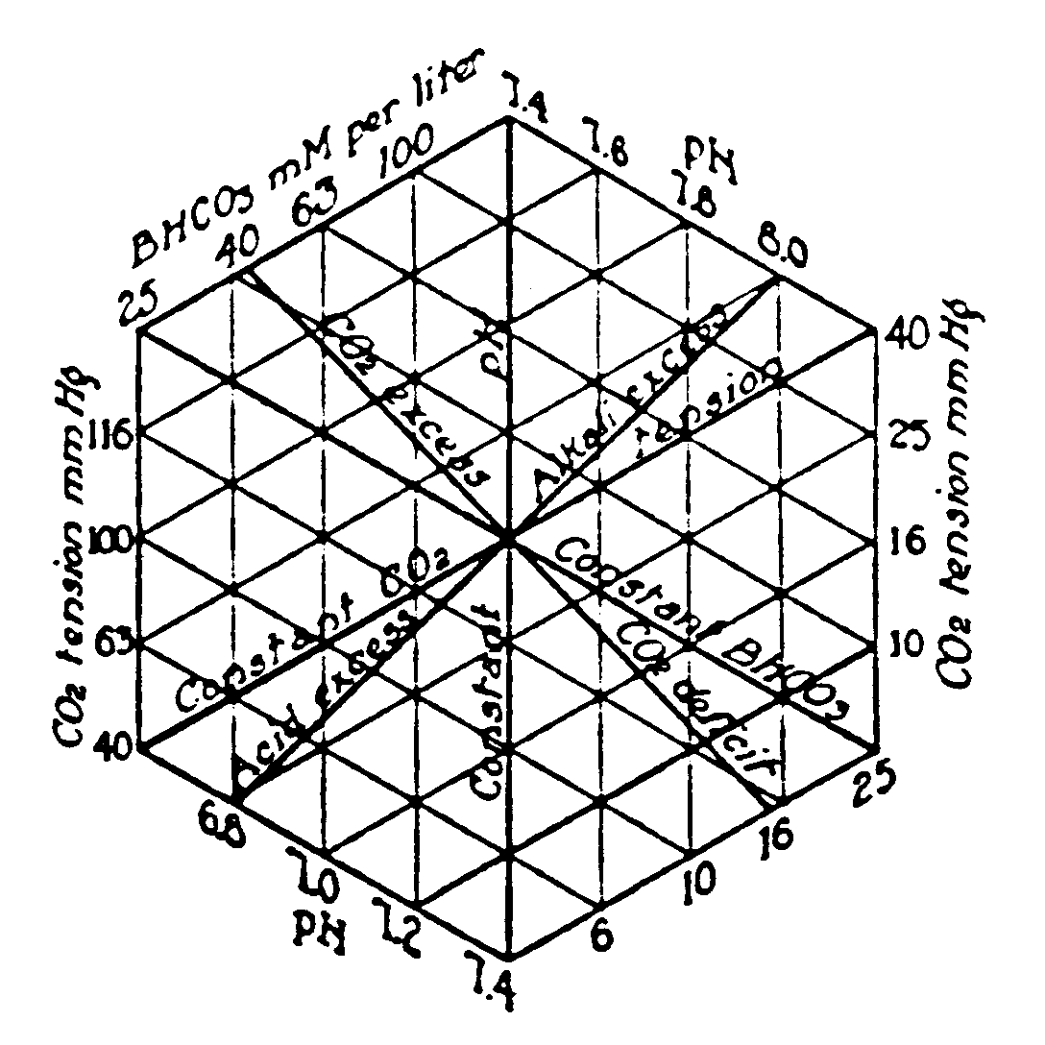
Figure 6–1. The tri-axial coordinate paper of Hastings and Steinhaus for representing pH, CO₂ tensions (PaCO₂) and BHCO₃ (a[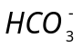]) values (reprinted with permission of The American Physiological Society) [4].

Materials and methods

Patient cases
Arterial acid-base measurements of three intensive care patients were recorded. The measurements included arterial pH, PaCO₂ in mmHg, PaO₂ in mmHg and actual a[] in mmol/l. Measurements were performed in duplicate on an OMNI-AVL-6 (E-Merck Nederland bv, The Netherlands) and an ABL-520 (Radiometer Nederland, The Netherlands) at the central clinical chemistry laboratory.

Construction of the chart
The tri-axial chart and the multivariate arterial acid-base reference model were constructed from a large patient acid-base data set consisting of 1500 cases (data set ELIab from Chapter Error: Reference source not found), according to the methods described in the preceding chapters. Figure 6–2 shows the resulting tri-axial chart. The angle between the original PaCO₂ and a[] axes is close to 60° as is the case in the coordinate paper of Hastings and Steinhaus. Note that original acid-base values of a point in the chart can be read from the original acid-base axes by projecting this point perpendicularly onto the respective acid-base axes. The hexagon figure in the chart represents the region defined by the three standard 95% reference intervals for pH, PaCO₂ and a[] (see Error: Reference source not found).
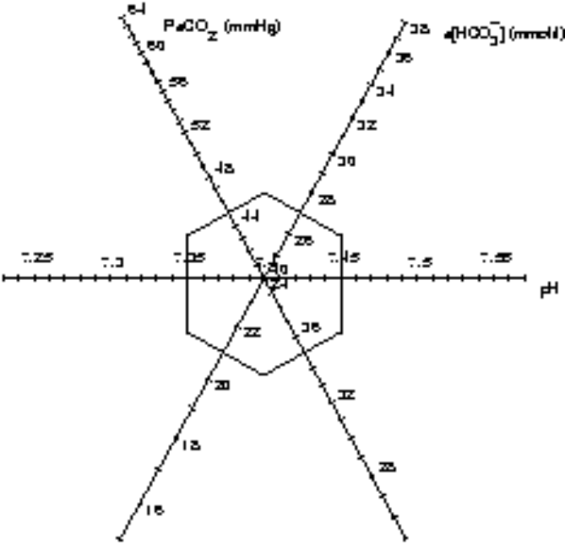
Figure 6–2. The tri-axial chart for the general ICU of the St. Elisabeth hospital.

Monitoring parameter 1: abnormality of acid-base status
In Chapter Error: Reference source not found, the rationale and the calculation of squared Mahalanobis distances for multivariate acid-base observations was described. In statistical terms, a squared Mahalanobis distance indicates the relative abnormality of an acid-base combination in reference to a specific distribution. Figure 6–3 shows the location of the reference distribution for the ICU of the St. Elisabeth hospital in its corresponding tri-axial chart. The definition of the squared Mahalanobis distance is such that observations on the same ellipse will have equal squared Mahalanobis distances. The Mahalanobis distance is in fact the distance between an observation and the mean of a multivariate distribution, weighed for possible interrelationships between the variables. Thus, the Mahalanobis distance for a single acid-base observation can be used as a multivariate index of its relative abnormality. By plotting these indices in time, the relative severity of the acid-base status of an intensive care patient may be monitored.
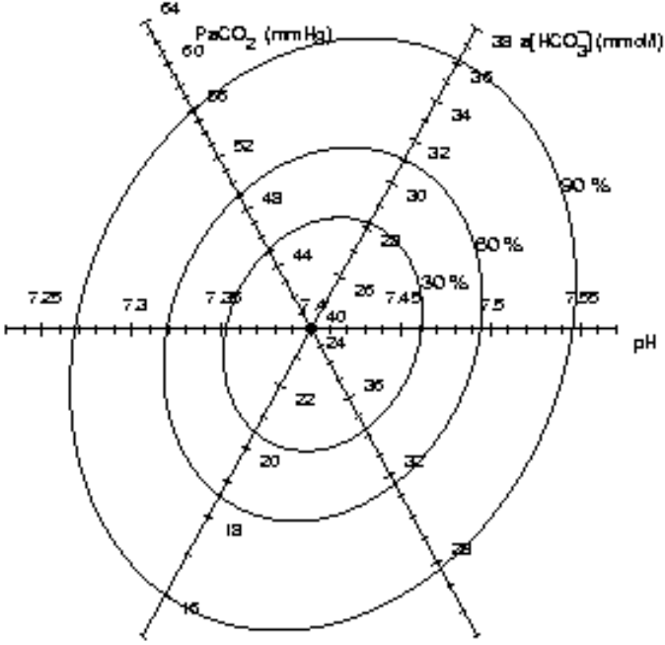
Figure 6–3. The multivariate patient-based reference model for the general ICU of the St. Elisabeth hospital. The 30%, 60% and 90% equal density ellipses each connect points of equal distribution densities.

Monitoring parameter 2: rate of acid-base change
Another monitoring parameter which can be derived from the tri-axial chart of Figure 6–2 is the rate of acid-base change. This is the distance between two points corresponding to two consecutive analyses as plotted in the chart, divided by the time elapsed between the two analyses. Values close to 0 mean slow acid-base changes, an indication for a stable acid-base status.

Patient reports
In this section, the clinical courses of three patients, as retrospectively reconstructed from their hospital records, of the general ICU of the St. Elisabeth hospital are presented to demonstrate the use and practicability of the tri-axial acid-base chart and the monitoring parameters. Where relevant in these narratives, the user is referred to the charts and trend plots.
The tri-axial charts and trend plots for the three patients are displayed in Figure 6–4 to Figure 6–6, respectively. The upper part of each figure is the tri-axial chart, while the lower part represents the trend plots of both monitoring parameters. Original data can be found in Table 6–1 to Table 6–3. The numbers in brackets in the narratives refer to the numbers in the tri-axial charts, the trend plots and the tables. They indicate the measurement sequence number of the blood gas analyses.

Patient 1 (Figure 6–4, Table 6–1)
Patient 1 is a 67-year-old male, who was hospitalised because of respiratory failure due to pneumonia. On arrival at the ICU, an arterial blood gas analysis showed severe hypoxia and also a combined respiratory alkalosis and metabolic acidosis (1). The hyperventilation (respiratory alkalosis) was triggered by hypoxia and the metabolic acidosis was also due to hypoxia. The patient was intubated and ventilated: volume controlled (VC) with a breathing frequency of 16/min and a tidal volume of 450 ml, FIO₂ 0.6 and positive end expiratory pressure (PEEP) of +5 cmH₂O.
Table 6–1. Data for patient 1.
measurement order | hours after first analysis | pH | PaCO₂  (mmHg) | EMBED Equation.2 EMBED Equation.2 a[ EMBED Equation.3 ]mmol/l | Abnormality index | Rate of acid-base change
1 | 0 | 7.424 | 28 | 17.9 | 2.07
2 | 3 | 7.335 | 38.3 | 19.9 | 1.18 | 2.118
3 | 6 | 7.399 | 31.3 | 18.9 | 1.47 | 1.396
4 | 12.5 | 7.367 | 33.8 | 18.7 | 1.31 | 0.273
5 | 26 | 7.241 | 46.3 | 19.3 | 2.51 | 0.528
6 | 34.08 | 7.187 | 51.4 | 18.3 | 3.42 | 0.352
7 | 36 | 7.214 | 46.5 | 18.2 | 2.91 | 0.995
8 | 49 | 7.282 | 39.5 | 18.1 | 1.95 | 0.289
9 | 63 | 7.243 | 44.6 | 18.6 | 2.47 | 0.180
10 | 74 | 7.237 | 39.4 | 16.2 | 2.68 | 0.269
11 | 98 | 7.129 | 54.7 | 17.5 | 4.27 | 0.287
12 | 104.27 | 7.135 | 51 | 16.6 | 4.11 | 0.226
13 | 122 | 7.108 | 45.4 | 13.8 | 4.54 | 0.205

Three hours after starting artificial ventilation, PaO₂ increased to 102.3 mmHg and the acid-base status (2) showed persistence of metabolic acidosis and less hyperventilation, resulting in a slight uncompensated metabolic acidosis. Three hours later (3), the arterial blood gas analysis showed a respiratory compensated metabolic acidosis. The compensating respiratory alkalosis was due to stimulation of central and peripheral chemoreceptors resulting in agitation of the patient on ventilator support, therefore sedation was increased. Twelve and a half hours after starting the ventilation (4), the hyperventilation diminished and the slight metabolic acidosis persisted.
The next day (5), the patient was quiet and PaCO₂ was 46.3 mmHg, indicative of a combined respiratory and metabolic acidosis. In the afternoon (6), the patient was again agitated and was fighting the ventilator in the volume-controlled mode. The combined respiratory and metabolic acidosis became more serious. After an initial decrease in the abnormality index of 2.07 (1) to 1.18 (2), the acid-base status became increasingly abnormal with an abnormality index of 3.42 (6). The rate of acid-base change decreased from 2.12 (2) to 0.27 (4). It is apparent that the lines in the tri-axial chart from (1) to (6) are all roughly perpendicular to the a[] axis, indicating that the change in arterial pH from 7.424 (1) to 7.187 (6) can predominantly be attributed to respiratory problems.
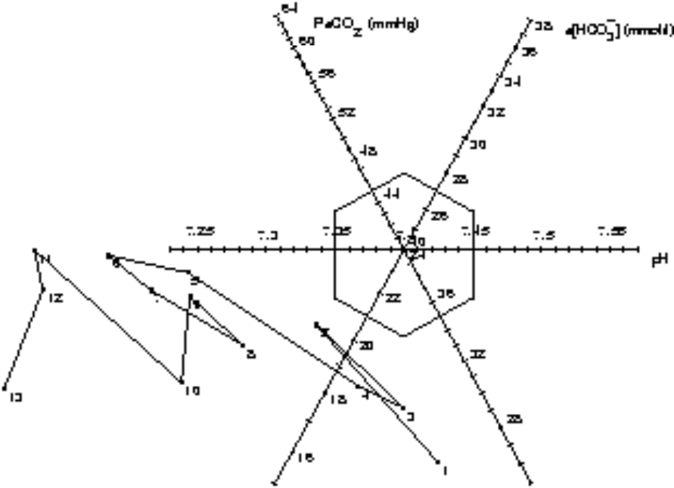

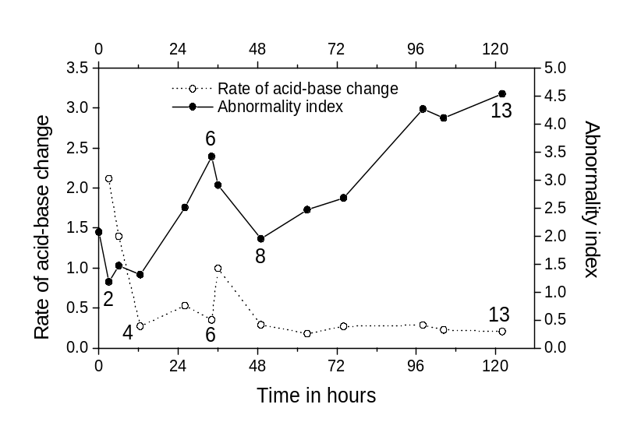
Figure 6–4. The tri-axial chart and the trend plots of the abnormality index (solid line, • , scale on the right) and the rate of acid-base change (dotted line, o , scale on the left) for patient 1.
The artificial ventilation was adjusted to the SIMV mode (Synchronised Intermittent Mandatory Ventilation) in combination with Pressure Support. The metabolic acidosis was assumed to be the result of hypotension and hypoxia. Therefore, dopamine was instituted in a dose of 5 μg/kg per minute. The patient was sedated and the VC mode of the ventilator was instituted again. After adjustment of the ventilation, the respiratory acidosis had improved (7) although the metabolic acidosis remained. The next two arterial blood gas analyses (8,9) showed normal PaCO₂ values but the metabolic acidosis remained. As a result of the ventilation adjustments and the dopamine therapy, the acid-base status became slightly more normal. Consequently, the abnormality index decreases from 3.4 (6) to 1.91 (8). Laboratory analysis showed a lactate level of 2.1 mmol/l, while chloride was 114.5 mmol/l, indicating the presence of a hyperchloraemic acidosis. The patient showed a severe uncompensated metabolic acidosis (10). Oxygenation problems developed again, showing a PaO₂ of 57.3 mmHg. The patient was ventilated with an increased inspiration time and increasing levels of PEEP.
Between (10) and (11), bicarbonate therapy was started because of a hyperchloraemic metabolic acidosis. CT scan of liver and thorax as well as liver biopsy showed metastasis of small cell anaplastic lung carcinoma. There were increasing respiratory problems (11) showing respiratory acidosis, as a result of CO₂ overproduction by infusion of bicarbonate, in combination with persistent metabolic acidosis. Institution of higher tidal volumes resulted in acid-base disorders with a small respiratory component and a large metabolic component (12, 13). No further therapy was instituted and the patient died. The trend plots of the monitoring parameters illustrate the gradual deterioration of the patient; the abnormality index increases from 1.91 (8) to 4.54 (13). However, the rates of acid-base change remain constantly low with a small peak at (7), indicating a stable though severely abnormal acid-base status.

Patient 2 (Figure 6–5, Table 6–2)
A 63-year-old female (height: 1.55 m, weight: 51 kg) was admitted to the ICU after resuscitation for cardiac arrest in the Emergency Ward. The patient had diabetes for which no medication was necessary. The medical history mentioned pneumonia and psychosis. On admission, she was hypotensive and had aspirated gastric contents. She was intubated and ventilated in pressure regulated volume-controlled mode (Siemens Servo 300) with an FIO₂ of 1.0, a breathing frequency of 14/min with tidal volumes of 550 ml and +6 cmH₂O of positive end-expiratory pressure (PEEP).
The first blood gas analysis (1) showed a severe uncompensated metabolic acidosis as a result of hypotension (blood pressure 70/40 mmHg). She was treated with dopamine i. v. in a dose of 15 μg/kg per min in combination with noradrenaline in a dose of 0.1 μg/kg per min and intravenous infusions of NaCl 0.9% in order to support circulation. The PaO₂ was 63.7 mmHg and the O₂ saturation was 93%. Metabolic acidosis (2, 3, 4) remained and respiratory compensation was initiated. An acute respiratory distress syndrome developed (Murray Score of 3.2), probably as a result of aspiration and the PEEP level was increased to +10 cmH₂O.

Table 6–2. Data for patient 2.
measurement order | hours after first analysis | pH | PaCO₂  (mmHg) | EMBED Equation.2 EMBED Equation.2 a[ EMBED Equation.3 ]mmol/l | Abnormality index | Rate of acid-base change
1 | 0 | 7.257 | 38.8 | 17.3 | 2.30
2 | 1 | 7.288 | 36.9 | 17.1 | 2.03 | 1.45
3 | 3.5 | 7.254 | 38 | 16.8 | 2.39 | 0.572
4 | 5 | 7.345 | 31.5 | 17.1 | 1.84 | 3.143
5 | 6.5 | 7.445 | 27 | 18.8 | 2.19 | 3.285
6 | 8.5 | 7.356 | 33.2 | 18.2 | 1.48 | 2.434
7 | 12.25 | 7.316 | 29.6 | 15.5 | 2.41 | 0.932
8 | 14.93 | 7.288 | 33.5 | 15.6 | 2.36 | 0.827
9 | 16.5 | 7.257 | 33.4 | 14.4 | 2.84 | 1.135
10 | 21.5 | 7.297 | 29.6 | 14.1 | 2.81 | 0.505
11 | 31.5 | 7.392 | 31.9 | 19 | 1.38 | 0.620
12 | 35.5 | 7.412 | 28.2 | 19 | 1.86 | 0.500
13 | 39.5 | 7.164 | 44 | 15.3 | 3.68 | 3.162
14 | 42.5 | 7.223 | 51.8 | 20.7 | 2.90 | 1.985
15 | 47.5 | 7.33 | 52.8 | 27.1 | 1.89 | 1.213
16 | 54.5 | 7.372 | 52.2 | 29.6 | 1.70 | 0.314
17 | 61.5 | 7.421 | 46.7 | 29.8 | 1.19 | 0.378
18 | 79.5 | 7.451 | 43 | 29.4 | 1.05 | 0.100
19 | 107.68 | 7.433 | 39.2 | 25.7 | 0.44 | 0.996

Arterial blood gas analysis (5) showed a respiratory alkalosis due to hyperventilation and metabolic acidosis. The lactate level was 0.9 mmol/l with an anion gap of 4 mmol/l, indicating that the metabolic acidosis was hyperchloraemic (6). The abnormality index remained relatively high from (1) to (6). Moreover, there was a high rate of acid-base change from (4) to (6), indicating an unstable acid-base status as a result of a progressive deterioration of her circulatory collapse. A thermodilution catheter was introduced in the left subclavian vein. Haemodynamic support was adjusted according to cardiac output and pulmonary capillary wedge pressure measurements, ultimately resulting in a blood pressure of 130/70 mmHg. The patient herself was unable to compensate, resulting in a partially compensated metabolic acidosis (7).
Thereafter, the tidal volume was reduced since the peak inspiratory pressure was 37 cmH₂O. The patient developed a serious metabolic acidosis (8, 9, 10) as a result of diminished respiratory compensation, resulting in an increase of the abnormality index to 2.81 (10). With higher blood pressure, metabolic acidosis recovered in the end (11, 12). The patient was becoming increasingly stable as evidenced by a rate of acid-base change decreasing from 3.29 (5) to 0.5 (12). A severe pure metabolic acidosis, combined with a slight respiratory acidosis (increase in PaCO₂ of 28.2 to 44.0 mmHg), suddenly appeared (13). This change in acid-base status can be clearly seen in both the tri-axial chart as well as in the trend plots of the monitoring parameters.
The lactate level was normal, but there was a hyperchloraemic acidosis (chloride 128.9 mmol/l). A 150-ml sodium-bicarbonate infusion (8.4%) was given at 39.5 hours, just after (13). The hyperchloraemic acidosis was probably due to renal loss or due to renal dysfunction as a result of inadequate renal perfusion. The metabolic acidosis decreased, but there was an accumulation of CO₂, resulting in a combined respiratory and metabolic acidosis (14). Ventilation was adjusted and bicarbonate supplementation was continued. Bicarbonate was discontinued (just after 15), since a pure respiratory acidosis developed and the ventilation was further adjusted.
The administration of bicarbonate leads to CO₂ and H₂O. Therefore, alveolar ventilation has to be increased when infusing bicarbonate, in order to eliminate the newly generated CO₂. In unconscious mechanically ventilated patients, the respiratory settings have to be increased accordingly. However, in this situation tidal volumes could not be adjusted sufficiently since there was already a high peak of inspiratory pressure. Minute volume can be increased by increasing the tidal volumes and, secondarily, the respiratory rate. In this case of severe ARDS there was no benefit from increasing the respiratory rate above 18/min. Finally, the respiratory acidosis was compensated (16) and pH returned to normal. After bronchial toilet, the PaCO₂ further decreased (17). A slight uncompensated metabolic alkalosis then occurred (18) that may have been the result of dehydration or the massive bicarbonate infusion.
The patient died with normal arterial blood gas values due to renal failure and hypoxic cerebral injury as a result of the cardiac arrest (19). Oxygen delivery was determined several times during hospitalisation and showed values above 700 ml/min. Note that the bicarbonate therapy and the subsequent adjustments to the ventilation after (13) resulted in an acid-base path in the tri-axial that is not the shortest route to the centre of the ICU reference distribution. From (13) to (19) the acid-base status of the patient gradually became more stable and normal, since the abnormality index decreased from 3.68 (13) to 0.44 (19), while the rate of acid-base change decreased from 3.16 (13) to 0.1 (19).
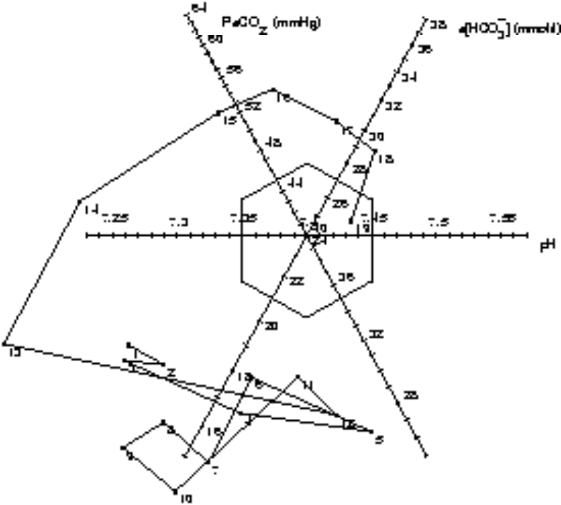

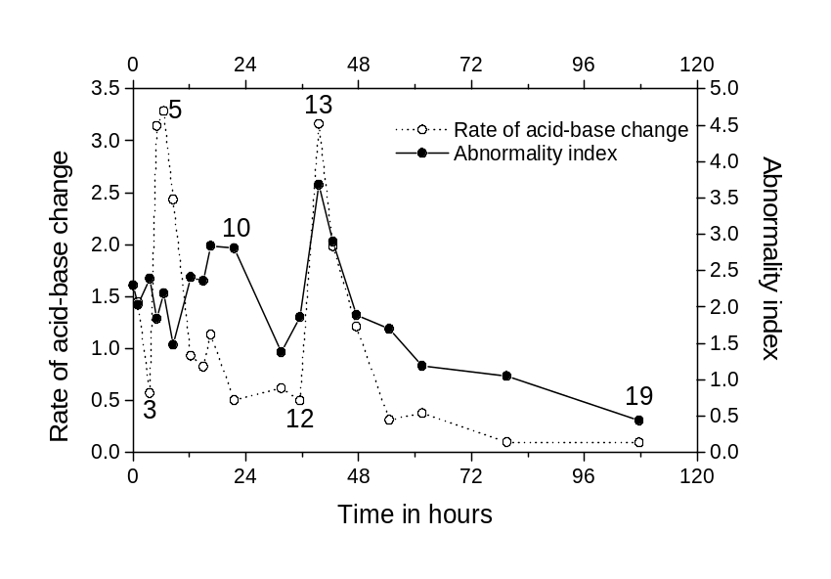
Figure 6–5. The tri-axial chart and the trend plots of the abnormality index and the rate of acid-base change for patient 2.

Patient 3 (Figure 6–6, Table 6–3)
A 50-year-old female was admitted to the ICU because of renal failure and respiratory insufficiency with scleroderma. The patient was ventilated in VC mode with 40% of oxygen, a breathing frequency of 16/min, a tidal volume of 550 ml and + 6 cm H₂O of PEEP. She received a Swan-Ganz catheter and inotropic support. The first arterial blood gas analysis showed a non-severe uncompensated metabolic acidosis due to renal failure (1) that deteriorated (2). Because renal failure was present, bicarbonate was given, resulting in a normal arterial blood gas analysis (3). Later (4), there was a slightly elevated PaCO₂ and tidal volume was increased. The patient developed an uncompensated metabolic acidosis (5) that became progressively severe (6). This can be seen in the trend plot as an increase of the abnormality index from 0.5 (3) to 2.5 (6).
Haemodiafiltration (HDF) was applied for 3 hours and resulted in a less severe metabolic acidosis (7, 8). The metabolic acidosis remained (9) and bicarbonate therapy was instituted again. Also, ventilation was increased with higher tidal volumes, resulting in a decreased PaCO₂ (10). Metabolic acidosis persisted and HDF was applied again for 4 hours. After HDF, the arterial acid-base status returned to normal (11). For 24 hours the arterial blood gas values remained normal (12). This is illustrated by a decrease of the abnormality index from 2.64 (6) to 0.24 (11). Six hours later, a respiratory acidosis occurred (13), possibly the result of air trapping because of high PEEP levels, due to ARDS. Increasing levels of PEEP were necessary with prolonged inspiration time. Ventilation was further adjusted and it was possible to treat the scleroderma and wean the patient from the ventilator.
Table 6–3. Data for patient 3.
measurement order | hours after first analysis | pH | PaCO₂  (mmHg) | EMBED Equation.2 EMBED Equation.2 a[ EMBED Equation.3 ]mmol/l | Abnormality index | Rate of acid-base change
1 | 0 | 7.344 | 38 | 20.2 | 1.05
2 | 15.75 | 7.289 | 38.8 | 17.6 | 1.95 | 0.198
3 | 48.83 | 7.375 | 38.5 | 22 | 0.53 | 0.149
4 | 62.75 | 7.351 | 42.8 | 23.1 | 0.87 | 0.150
5 | 87.75 | 7.293 | 42.4 | 19.9 | 1.71 | 0.133
6 | 111.75 | 7.233 | 42.4 | 17.3 | 2.64 | 0.136
7 | 124.75 | 7.32 | 43.2 | 21.7 | 1.31 | 0.386
8 | 135.75 | 7.279 | 44.9 | 20.4 | 1.94 | 0.183
9 | 138.75 | 7.29 | 41.7 | 19.5 | 1.76 | 0.482
10 | 140.75 | 7.326 | 39.1 | 20.4 | 1.20 | 0.947
11 | 144.08 | 7.393 | 38.7 | 23.1 | 0.24 | 0.998
12 | 169 | 7.417 | 35.6 | 22.3 | 0.61 | 0.069
13 | 175.72 | 7.338 | 46 | 24 | 1.22 | 0.788

The rate of acid-base change remained low from (2) to (8). The tri-axial chart shows two spikes; one at (2) and one at (6). The first spike (2) was caused by an uncompensated metabolic acidosis due to renal failure. The acidosis was treated with bicarbonate therapy resulting in normal acid-base values (3). The second spike (6) shows a recurrent metabolic acidosis. Subsequent HDF resulted in a slight amelioration of the acid-base values (7). From the tri-axial chart it can be deduced that all major acid-base changes are of metabolic origin since the projection of the complete acid-base path onto the PaCO₂ axis shows that all values fall within the standard 95% reference interval for PaCO₂.
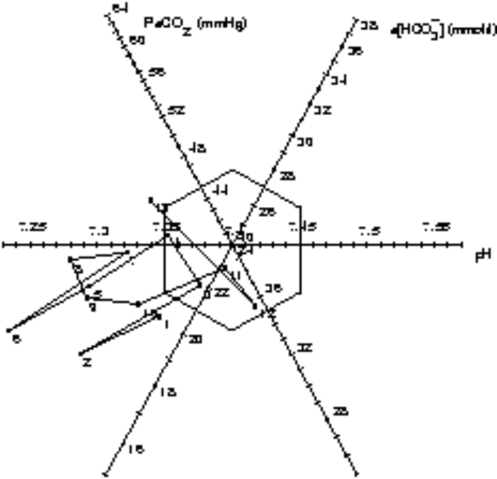

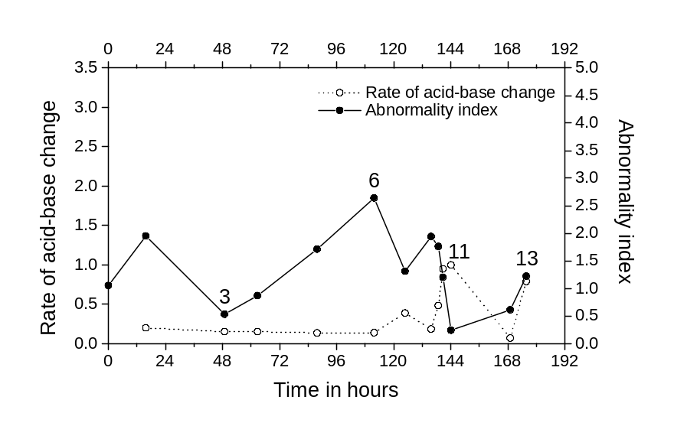
Figure 6–6. The tri-axial chart and the trend plots of the abnormality index and the rate of acid-base change for patient 3.

Discussion
In the present paper, a method for monitoring acid-base values of patients in an intensive care setting is described and demonstrated. The method is based on a tri-axial acid-base chart and two new quantitative acid-base monitoring parameters. One parameter monitors the abnormality of the acid-base status and the other monitors the rate of acid-base changes. The underlying mathematical model justifies the tri-axial coordinate paper of Hastings and Steinhaus [4]. In 1953, Cassels and Morse [5] used this coordinate paper of Hastings and Steinhaus to display acid-base reference values for children. Rispens et al. [6] made a case for the coordinate paper in 1974, while in 1980 Van Kampen [7] proposed to use the coordinate paper as a quality control instrument in the clinical chemistry laboratory. However, the Hastings and Steinhaus tri-axial coordinate paper never became popular in daily clinical practice and Hastings reports: ‘I still think that ... tri-axial coordinate paper ... is ideal for plotting acid-base paths, but I have never been able to persuade anyone else that this is so, so I've stopped trying to do so.’ [8].
The tri-axial coordinate paper of Hastings and Steinhaus was solely used as a graphical tool to visualise acid-base values and acid-base paths. A major advantage of the method presented in the present paper, however, is that the tri-axial chart results from an underlying mathematical model that enables the quantification of the chart. An extra advantage of the method is that values can be displayed against a background of reference data. The method is flexible in the sense that any reference distribution can be used. An ICU can thus build its own reference model and associated chart.
Use of the tri-axial acid-base chart in daily clinical practice may well be advantageous, since it has been shown that a graphical display of data yields a faster and more accurate interpretation as compared to numerical displays [9-11]. Moreover, the tri-axial configuration of the chart ensures that the effects of both respiratory (PaCO₂) and metabolic (a[]) components on the acid-base status of arterial blood, are simultaneously and equally assessed. This is more difficult in other acid-base charts [12-15]. For instance, in a plot of PaCO₂ versus pH, the emphasis lies on the respiratory component while in a plot of a[] versus pH (the Davenport diagram), PaCO₂ is missing. In fact, only a tri-axial configuration is faithful to the intrinsic two-dimensional relationship between all three acid-base values, as dictated by the Henderson-Hasselbalch equation.
The two monitoring parameters (acid-base abnormality and rate of acid-base change) extract information from raw acid-base measurements that is contained within the data but normally remains hidden. The monitoring parameters may well be useful in future acid-base monitoring systems. Single cut-off values could be set so that alarms are generated in cases of abnormal or unstable acid-base situations. They must, however, be seen as an addition to, and not a replacement of, the original acid-base values. Therapeutic actions after an alarm can then still be based on the original values.
Particularly with the advent of continuous intra-arterial blood gas measurement devices, such a screening system may be very valuable, and even indispensable, in pre-processing the vast amount of data that will be generated by such devices [16].

Acknowledgement
The authors wish to thank Dr. R. N. M. Weijers for carefully reading the manuscript.

References
1. Stamhuis IH, Bezemer PD, Kuik D. Evaluation of univariate ranges with a multivariate standard. J Clin Epidemiol 1988; 41:359-366.
2. Madias NE, Adroqué HJ, Horowitz GL, et al. A redefinition of normal acid-base equilibrium in man: Carbon dioxide tension as a key determinant of normal plasma bicarbonate concentration. Kidney Int 1979; 16:612-618.
3. Hekking M, Lindemans J, Gelsema ES. Design and representation of multivariate patient-based reference regions for arterial pH, PaCO2 and base excess values. Clin Biochem 1995; 28:581-585.
4. Hastings AB, Steinhaus AH. A new chart for the interpretation of acid-base changes and its application to exercise. Am J Physiol 1931; 96:538-540.
5. Cassels DE, Morse M. Arterial blood gases and acid-base balance in normal children. J Clin Invest 1953; 32:824-836.
6. Rispens P, Zijlstra WG, Van Kampen EJ. Significance of bicarbonate for the evaluation of non-respiratory disturbances of acid-base balance. Clin Chim Acta 1974; 54:335-347.
7. Van Kampen EJ. Throwing a curve at laboratory error. Diagn Med 1980; March/April:55-61.
8. Hastings AB. Part I: acid-base measurements In Vitro. Introductory remarks. In: Whipple HE, ed. Current concepts of acid-base measurement. New York: The New York Academy of Sciences, 1964; 1-274; vol 133.
9. Cole WG, Stewart JG. Human performance evaluation of a metaphor graphic display for respiratory data. Meth Inform Med 1994; 33:390-396.
10. Elting LS, Bodey GP. Is a picture worth a thousand medical words? A randomized trial of reporting formats for medical research data. Meth Inform Med 1991; 30:145-150.
11. Bennett KB, Flach JM. Graphical displays: implications for divided attention, focused attention, and problem solving. Hum Factors 1992; 34:513-533.
12. Cohen ML. A computer program for the interpretation of blood gas analysis. Comput Biomed Res 1969; 2:549-557.
13. Goldberg M, Green SB, Moss ML, et al. Computer-based instruction and diagnosis of acid-base disorders. J Am Med Assoc 1973; 223:269-275.
14. Bernauer J, Bender HJ, Hartung HJ, et al. Graphic presentation of blood gas data. Int J Clin Monit Comput 1984; 1:93-95.
15. Siggaard-Andersen O. An acid-base chart for arterial blood with normal and pathophysiological reference areas. Scand J Clin Lab Invest 1971; 27:239-245.
16. Roupie EE, Brochard L, Lemaire FJ. Clinical evaluation of a continuous intra-arterial blood gas system in critically ill patients. Crit Care Med 1996; 22:1162-1168.

