Predicting hospital mortality of ICU patients from arterial acid-base measurements

Marcel Hekking, Rob J. Bosman, Durk F. Zandstra, Rob N.M. Weijers, Edzard S. Gelsema

Submitted for publication in Intensive Care Medicine

Abstract
Objective: to develop and compare new mortality prediction models (MPM) that are based on arterial acid-base variables.
Design: logistic regression analysis of prospectively collected data.
Setting: a 20 bed medical-surgical intensive care unit (ICU) in the ‘Onze Lieve Vrouwe Gasthuis’, an inner-city teaching hospital in Amsterdam, The Netherlands.
Patients: consecutively admitted patients in the period of January 1997 to May 1998.
Measurements and main results: for 2430 consecutive ICU admissions, hospital mortality was predicted using four MPMs: APACHE II, SAPS II, MPM₀ II, and MPM₂₄ II. Discriminating power was assessed with Receiver-Operator-Characteristics (ROC) curves while calibration was assessed with Hosmer-Lemeshow’s C*g values. Although discriminating power was acceptable (area under the curve [AUC] of 0.809, 0.835, 0.810, and 0.746 for APACHE II, SAPS II, MPM₀ II, and MPM₂₄ II, respectively), calibration was poor as demonstrated by large C*g values with p-values smaller than 0.001.
Using multiple logistic regression analysis on data coming from 1770 consecutively admitted patients, new MPMs were developed based on each of the three arterial acid-base variables: pH, carbon-dioxide partial pressure (PaCO₂), and base excess (BE). A fourth model was based on the Mahalanobis distance d of Chapter Error: Reference source not found (MPM_{d}). The single-variable based MPMs showed good discriminating power but calibration was poor. MPM_{d} however, showed good discrimination (AUC of 0.863) and excellent calibration (C*g of 8.87, p-value is 0.54).
Conclusions: when predicting mortality of ICU patients on the aggregate level, MPM_{d} could be useful at our ICU. MPM_{d} awaits prospective validation at our ICU and other ICUs.

Introduction
Predicting hospital mortality for patient groups has become an integral part of critical care practice. Most of the mortality prediction models (MPM) use prognostic indices (PI) that are mathematical transformations of severity scores. With a severity score as input, such models yield a probability of dying in the hospital – a value between zero and one – for the individual patient. By dividing observed hospital mortality by predicted hospital mortality for groups of patients, standardised mortality ratios (SMR) are obtained. SMRs are widely used to compare the performance of intensive care units, either in time or to other units [1].
Most of the common MPMs, such as the Acute Physiology And Chronic Health Evaluation II (APACHE II) [2], the Simplified Acute Physiology Score II (SAPS II) [3], and the Mortality Prediction Model II (MPM II) [4], use physiological measurements. The most deranged values of these variables during the first hours after Intensive Care Unit (ICU) admission are extracted from the patient charts. These MPMs perform adequately at the aggregate level, but lack the calibration and discrimination to be used in the individual patient. They are very sensitive to items like sampling rate, sampling method and artefacts [5, 6]. Moreover, the whole process of extracting, interpreting, and managing the necessary data items is time-consuming and is a source for both inter-observer and intra-observer variability [7].
Haemodynamic variables describe physiologically important abnormalities in critically ill patients and often form the basis of an MPM [8, 9]. The haemodynamic, respiratory and/or metabolic status of the patient is most effectively reflected in arterial acid-base measurements. The objective of the present study is to develop and compare various acid-base based MPMs using the arterial blood gas analyses of the first 24 hours of ICU treatment.

Materials and methods
Data for the classical MPMs (APACHE II, SAPS II, MPM₀ II, and MPM₂₄ II) was collected over a 17-months period: January 1997 to May 1998. Data for the development of the acid-base based MPMs was collected over a 13-months period; April 1997 to May 1998. If a patient was admitted more than once to the ICU, only the first admission was used. Data for the classical MPMs was routinely extracted for all ICU admissions. Data for the acid-base based MPMs (arterial blood gas measurements) was automatically collected using a microcomputer installed at the ICU with a direct link to the laboratory of Clinical Chemistry and Haematology of the ‘Onze Lieve Vrouwe Gasthuis’ (see Section Error: Reference source not found for set-up). Blood gas measurements included: arterial pH, PaCO₂ in mmHg, base excess (BE) in mmol/l, a[] in mmol/l, PaO₂ in mmHg, and arterial oxygen saturation. Measurements were performed in duplicate on a Corning 288 (Chiron Diagnostics, The Netherlands) blood gas analyser. Specific approval of the Ethics Committee was not required since data was primarily collected for clinical purposes. No extra blood samples were taken.
For APACHE II, SAPS II and MPM₀ II, the following types of patients were excluded: burn patients, post-operative cardio-surgical patients, and patients with a length of stay (LOS) in the ICU of 8 hours or less. For MPM₂₄ II, patients with a LOS of 24 hours or less were excluded. For the acid-base based MPMs no exclusion criteria were applied.
Mortality predictions according to APACHE II, SAPS II, MPM₀ II and MPM₂₄ II were calculated for individual patients according to the respective guidelines [2-4]. Charting of the necessary variables was performed according to standard procedures at our ICU: the nursing staff entered at least one value for each variable per hour. The attending physician performed the necessary data-extraction (for calculation of APACHE II, SAPS II and MPM II) 24 hours after ICU admission or on discharge from ICU if discharge was within 24 hours. The physicians had explicit instructions not to record values induced by suctioning, changes of medication pumps, etc. Only sustained, clinically relevant physiological changes were recorded. Only arterial blood gas analyses were used in the data collection. Continuous percutaneous saturation monitoring information was not extracted for use in the scoring systems. Data extraction as described above is routinely performed at our ICU for all ICU admissions (approximately 1900/year).
Acid-base based MPMs were developed using multiple logistic regression analysis. This technique aims to find a linear relationship between n predictor variables x_{i} and the logit, which is the natural log of the ratio p / (1 – p):
logit = 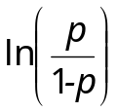 = β₀ + β₁x₁ + β₂x₂ + … β_{n}x_{n}, (7–1)
where p is the probability of y = 1, y being a dichotomous (0,1) outcome variable [10-12]. The weights β_{i} are iteratively optimised in such a way that the predictor variables explain a maximum of variation in the outcome variable y. Having found the optimal weights, the probability of y = 1 for an individual case can be determined as: e^{logit} / (1 + e^{logit}), where e is the base of the natural logarithm.
Table 7–1. Coding of age
age | after coding
[ª0 – 10)^{b} | 0
[10 – 20) | 1
[20 – 30) | 2
[30 – 40) | 3
[40 – 50) | 4
[50 – 60) | 5
[60 – 70) | 6
[70 – 80) | 7
[80 – 90) | 8
[90 – 100) | 9
[100 – 110]^{c} | 10
ªfrom and including
^{b}to and excluding
^{c}to and including
For each single arterial acid-base variable, an MPM was designed using multiple logistics regression analysis: MPM_{pH}, MPM_{PaCO2} and MPM_{BE}. The outcome variable in each model was hospital death (y = 1). Predictor variables included: 1) type of admission, (surgical or non-surgical), 2) age on a continuous scale (see Table 7–1 for scale), and 3) the largest absolute z-score |z| (|x - m|/s) in the first 24 hours after ICU admission as calculated with the means and standard deviations of Table 7–2. Typically, |z| runs from zero upwards with larger values indicating a more severe deviation of the acid-base measurement at hand.
Table 7–2. Means (m) and standard deviations (s) used for calculating absolute z-scores.
 | m | normal range | s
pH | 7.40 | 7.35 – 7.45 | 0.025
PaCO₂ | 40 mmHg | 35 – 45 | 2.5
BE | 0 mmol/l | -3 – 3 | 1.5
Standard deviations s are derived from the normal range by assuming this range to be 4 standard deviations wide.
The absolute z-score |z|, however, only indicates the degree of deviation in a single acid-base measurement. We recently developed a method for expressing the deviation in pH, PaCO₂ and BE simultaneously with a single multivariate statistical index: the Mahalanobis distance d (Equation Error: Reference source not found). This index takes into account the interrelationships between the variables as observed in a multivariate reference distribution of acid-base measurements [13-19]. In this case, the multivariate reference distribution OLVGbe was used. Based on the Mahalanobis distance d, we developed a fourth mortality prediction model (MPM_{d}). Outcome and predictor variables remained the same as in the single-variable MPMs with the exception that the largest |z| was replaced with the largest d as found in the first 24 hours after ICU admission.
According to good modelling practice [20] we performed a 10-fold cross-validation on the acid-base based MPMs. We divided the total data set with n cases into 10 partitions of n/10 cases with an equal ratio of non-survivors and survivors. The mortality predictions of the patients in each partition were then calculated using the coefficients as estimated with a multiple logistic regression analysis of the data in the union of the remaining nine partitions. Multiple logistic regression analyses were performed with SPSS for Windows, release 7.5.
To quantify and compare the discriminating power (i.e. the ability to discriminate between survivors and non-survivors) of the resulting MPMs, non-parametric Receiver-Operator-Characteristics (ROC) curves were used. These curves were generated by plotting pairs of true-positive ratio (sensitivity) and false-positive ratio (1-specificity) as they appear using each mortality prediction in a data set as a cut-off point between survival and non-survival. The area under the curve (AUC) is a measure of discriminating power and is expressed in the range of 0.5 to 1. An AUC of 0.5 means zero discriminating power while an AUC of 1 indicates an optimal discrimination between survivors and non-survivors. AUCs were calculated according to the method of Hanley and McNeil [21]. Comparisons were made with the method of DeLong for comparing multiple AUCs derived from the same data [22]. DeLong’s test statistic is χ²-distributed with k-1 degrees of freedom (df), where k is the number of AUCs. The hypothesis of equal AUCs was rejected if a p-value was smaller than 0.05.
The goodness-of-fit (i.e. the ability to correctly predict the probability of death or survival) of the respective MPMs was assessed with a calibration plot and with the C*g test statistic as proposed by Hosmer and Lemeshow [10, 23]. A calibration plot is constructed by sorting the mortality predictions in de data set and plotting the actual mortality rate against the predicted mortality rate in adjacent strata of 10% predicted mortality. For the calculation of C*g, the sorted mortality predictions were grouped into 10 deciles, each containing ≈ n/10 cases. C*g was then calculated as:
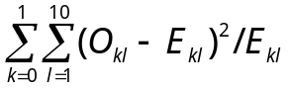, (7–2)
where O_{kl} is an observed number of persons, E_{kl} is an expected number of persons, k indicates the survivor (0) and non-survivor (1) group, and l the decile. This test statistic is χ²-distributed with 10 degrees of freedom [10]. The hypothesis of good fit was rejected if a p-value was smaller than 0.05.

Results
There were 2430 ICU admissions in the 17-months data acquisition period, 1770 occurred in the 13-months period. Patient characteristics can be found in Table 7–3. Figure 7–1 shows the ROC curves and the calibration plots for the classical MPMs (AUCs in brackets). MPM₂₄ II has the worst discriminating power (AUC of 0.746). SAPS II is the best discriminator, having a statistically significant larger AUC (0.835) than both APACHE II (DeLong’s χ² = 5.57, df = 1, p-value = 0.018) and MPM₀ II (DeLong’s χ² = 3.96, df = 1, p-value = 0.047). Goodness-of-fit, however, is poor for each model as demonstrated by the significantly large C*g values in Table 7–4. The calibration plot in Figure 7–1 confirms this finding: all models overestimate mortality in almost every 10% predicted mortality stratum.
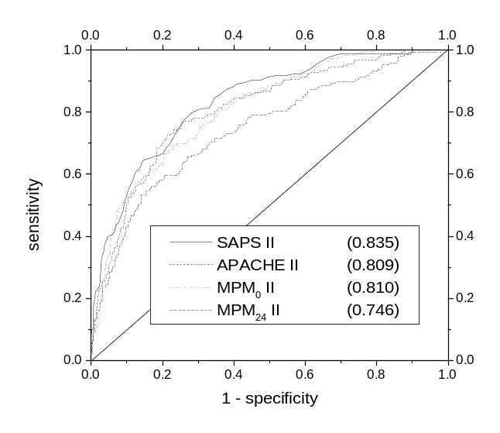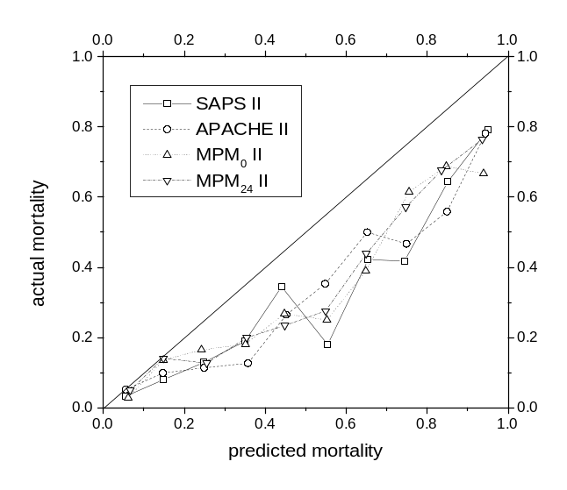
Figure 7–1. ROC curves (left) and calibration plots (right) for the classical MPMs. Between brackets the AUCs of the ROC. The line of identity in the calibration plot (line with slope 1) indicates the ideal situation: predicted mortality rate is equal to actual mortality rate.
Figure 7–2 presents the ROC curves for the acid-base based MPMs. The smallest AUC (MPM_{PaCO2}) is larger than the largest AUC as found among the classical MPMs (SAPS II). MPM_{BE} shows the largest AUC (0.879). The second-largest AUC is that of MPM_{d} (0.863). The difference between both AUCs is statistically significant (DeLong’s χ² = 8.459, df = 1, p-value = 0.004). The AUC for MPM_{d} is larger than the AUC of MPM_{PaCO2} (DeLong’s χ² = 10.014, df = 1, p-value = 0.002) and larger than the AUC of MPM_{pH} although the latter difference is not statistically significant (DeLong’s χ² = 3.698, df = 1, p-value = 0.054).
In Table 7–5, the goodness-of-fit results for the acid-base based MPMs are presented; MPM_{d} shows the best fit with a small C*g value of 8.87 (p-value = 0.54). MPM_{BE} has the largest discrepancy between actual and predicted frequencies for survival and non-survival with a p-value of 0.05 for the Hosmer-Lemeshow’s C*g value.
Table 7–3. Patient characteristics.
 | total |  |  | classical MPMs |  |  |  |  |  | acid-base MPMs
 |  |  |  | MPM₂₄ II |  |  | other^{b}
 | n |  | % | n |  | % | n | % | n |  | %
Number of patients | 2430 |  | 100 | 498 |  | 100 | 811 | 100 | 1770 |  | 100
Died in hospital | 263 |  | 10.8 | 148 |  | 29.7 | 183 | 22.6 | 189 |  | 10.7
Age in yearsª | 34, 66, 83 |  |  | 30, 67, 85 |  |  | 29, 66, 86 |  | 36, 67, 83
LOS in daysª | 0.38, 0.96,  7.08 |  |  | 1.04, 3.13,  20.8 |  |  | 0.42, 1.63, 13.0 |  | 0.46, 0.96, 7.06
Surgical
Cardiovascular | 49 | 2.0 |  | 15 | 3.0 |  | 46 | 5.7 | 38 |  | 2.1
Multiple trauma | 36 | 1.5 |  | 16 | 3.2 |  | 29 | 3.6 | 21 |  | 1.2
Heart valve surgery | 273 | 11.2 |  | - | - |  | - | - | 206 |  | 11.6
Peripheral vasc. surg. ^{c} | 64 | 2.6 |  | 22 | 4.4 |  | 61 | 7.5 | 55 |  | 3.1
Haemorrhagic shock | 19 | 0.8 |  | 9 | 1.8 |  | 16 | 2.0 | 14 |  | 0.8
Chronic cardiov. dis.^{d} | 1241 | 51.1 |  | - | - |  | - | - | 918 |  | 51.9
Gastrointestinal | 104 | 4.3 |  | 48 | 9.6 |  | 94 | 11.6 | 78 |  | 4.4
Haematological | 2 | 0.1 |  | 2 | 0.4 |  | 2 | 0.2 | 1 |  | 0.1
Renal | 11 | 0.5 |  | 3 | 0.6 |  | 11 | 1.4 | 8 |  | 0.5
Metabolic | 2 | 0.1 |  | 0 | 0.0 |  | 2 | 0.2 | 2 |  | 0.1
Neurological | 4 | 0.2 |  | 1 | 0.2 |  | 4 | 0.5 | 3 |  | 0.2
Respiratory | 126 | 5.2 |  | 31 | 6.2 |  | 107 | 13.2 | 93 |  | 5.3
Total surgical | 1931 | 79.5 |  | 147 | 29.5 |  | 372 | 45.9 | 1437 |  | 81.2
Non-surgical
Cardiovascular | 270 | 11.1 |  | 192 | 38.6 |  | 230 | 28.4 | 183 |  | 10.3
Gastrointestinal | 23 | 0.9 |  | 16 | 3.2 |  | 21 | 2.6 | 17 |  | 1.0
Haematological | 2 | 0.1 |  | 2 | 0.4 |  | 2 | 0.2 | - |  | -
Renal | 14 | 0.6 |  | 12 | 2.4 |  | 14 | 1.7 | 10 |  | 0.6
Metabolic | 10 | 0.4 |  | 6 | 1.2 |  | 10 | 1.2 | 7 |  | 0.4
Neurological | 47 | 1.9 |  | 17 | 3.4 |  | 38 | 4.7 | 23 |  | 1.3
Respiratory | 133 | 5.5 |  | 106 | 21.3 |  | 124 | 15.3 | 93 |  | 5.3
Total non-surgical | 499 | 20.5 |  | 351 | 70.5 |  | 439 | 54.1 | 333 |  | 18.8
ª5th, 50th and 95th percentile, respectively ^{c} Peripheral vascular surgery
^{b}APACHE II, SAPS II, and MPM₀ II ^{d} Chronic cardiovascular disease
LOS, length of stay.
In Figure 7–2, the calibration plot for MPM_{d} can be found. The calibration line more closely follows the line of identity than for any of the classical MPMs.
Table 7–4. Hosmer-Lemeshow’s C*g values for the classical MPMs.
predicted mortalityª | died |  | survived |  |  |  | predicted mortality | died |  | survived
 | O^{b} | E^{c} | O | E | n |  |  | O | E | O | E | n
APACHE II |  |  |  |  |  | SAPS II
[0-4.2) | 1 | 2.0 | 80 | 79.0 | 81 | [0-4.2) |  | 2 | 1.8 | 74 | 74.2 | 76
[4.2-7.6) | 5 | 4.8 | 76 | 67.2 | 81 | [4.2-7.2) |  | 0 | 4.2 | 78 | 73.8 | 78
[7.6-10.9) | 7 | 7.4 | 75 | 74.6 | 82 | [7.2-10.6) |  | 6 | 7.2 | 79 | 77.8 | 85
[10.9-17.7) | 8 | 11.4 | 72 | 68.6 | 80 | [10.6-16.7) |  | 7 | 10.2 | 72 | 68.8 | 79
[17.7-26.2) | 7 | 17.4 | 74 | 63.6 | 81 | [16.7-26.6) |  | 7 | 17.1 | 77 | 66.9 | 84
[26.2-37.8) | 12 | 25.9 | 70 | 56.1 | 82 | [26.6-39.2) |  | 15 | 27.6 | 71 | 58.4 | 86
[37.8-51.6) | 18 | 35.7 | 63 | 45.3 | 81 | [39.2-53.0) |  | 25 | 36.2 | 58 | 46.8 | 83
[51.6-65.3) | 29 | 46.5 | 52 | 34.5 | 81 | [53.0-70.0) |  | 27 | 53.1 | 60 | 33.9 | 87
[65.3-81.6) | 44 | 59.3 | 37 | 21.7 | 81 | [70.0-86.1) |  | 39 | 62.6 | 42 | 18.4 | 81
[81.6-100] | 52 | 72.2 | 29 | 8.8 | 81 | [86.1-100] |  | 55 | 67.0 | 17 | 5.0 | 72
Total | 183 | 282.5 | 628 | 528.5 | 811 | Total |  | 183 | 287.0 | 628 | 524.0 | 811
C*g = 118.5, df = 10, p << 0.001 |  |  |  |  |  | C*g = 130.6, df = 10, p << 0.001
MPM₀ II |  |  |  |  |  | MPM₂₄ II
[0-5.3) | 0 | 3.0 | 80 | 77.0 | 80 | [0-14.5) |  | 3 | 5.1 | 47 | 44.9 | 50
[5.3-7.8) | 2 | 5.6 | 82 | 78.4 | 84 | [14.5-22.6) |  | 10 | 9.2 | 40 | 40.8 | 50
[7.8-12.4) | 9 | 8.0 | 73 | 74.0 | 82 | [22.6-29.5) |  | 6 | 13.2 | 44 | 36.8 | 50
[12.4-18.7) | 9 | 12.2 | 72 | 68.8 | 81 | [29.5-36.5) |  | 10 | 16.4 | 40 | 33.6 | 50
[18.7-24.9) | 11 | 17.5 | 71 | 64.5 | 82 | [36.5-42.4) |  | 11 | 20.0 | 40 | 31.0 | 51
[24.9-34.9) | 18 | 23.6 | 63 | 57.4 | 81 | [42.4-50.4) |  | 10 | 23.1 | 40 | 26.9 | 50
[34.9-47.3) | 18 | 33.1 | 63 | 47.9 | 81 | [50.4-58.6) |  | 15 | 27.3 | 35 | 22.7 | 50
[47.3-60.9) | 21 | 44.1 | 60 | 36.9 | 81 | [58.6-70.5) |  | 20 | 32.3 | 30 | 17.7 | 50
[60.9-79.9) | 41 | 57.8 | 40 | 23.2 | 81 | [70.5-80.3) |  | 28 | 37.7 | 22 | 12.3 | 50
[79.9-100] | 54 | 68.4 | 24 | 9.6 | 78 | [80.3-100] |  | 35 | 41.1 | 12 | 5.9 | 47
Total | 183 | 273.3 | 628 | 537.7 | 811 | Total |  | 148 | 225.3 | 350 | 272.7 | 498
C*g = 91.6, df = 10, p << 0.001 |  |  |  |  |  | C*g = 73.16, df = 10, p << 0.001
ªas a percentage
^{b}O = observed number of subjects
^{c}E = expected number of subjects
It should be stressed that the deviation from the line of identity in the upper part of the graph is due to the limited number of subjects in the upper strata of mortality prediction. This occurs when a well-calibrated model is used on an ICU where the mortality overall is very low since, per definition, there will be only a limited number of subjects in the strata with high probabilities of dying.
Hence, considering both discriminating and predicting power, the model based on the Mahalanobis distance (MPM_{d}) seems to perform better than any other acid-base based MPM and better than any of the classical MPMs. MPM_{d} shows excellent calibration (small C*g value) and good discrimination (large AUC)
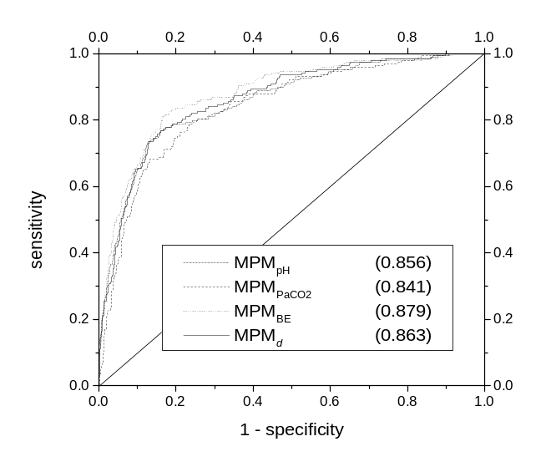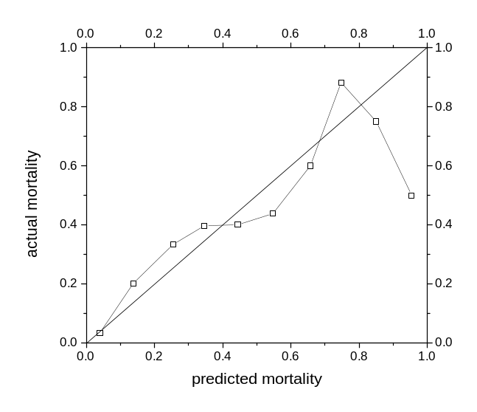
Figure 7–2. ROC curves for the acid-base based MPMs (left) and the calibration plot (right) for MPM_{d}.
Table 7–6 shows the results of the multiple logistic regression analysis for MPM_{d} as performed on the entire data set without cross-validation. For each predictor variable, the table presents an estimation of the coefficient β, its standard error (SE), and an associated odds ratio (OR). For the predictor variable admission type the OR indicates the decrease in the probability of dying for a surgical patient versus a non-surgical patient. For the continuous variable age the OR indicates the increase in the probability of dying for every 10 years of increase in age. There is a 1.5 fold increase in the probability of dying the hospital for every increase of 10 years. For the Mahalanobis distance the OR indicates the increase in probability for every unit increase of the index value, which is about 1.6 fold.

Discussion
Much of the discussion around mortality prediction models seems to be centred around the main question ‘What is the model going to be used for?’. Three major areas of application can be distinguished: prediction of individual patient outcome, quality assessment and comparison of ICUs, and the stratification of ICU patients for clinical trials [20, 24]. It is generally agreed upon that the ICU scoring systems now available are not suited for predicting individual outcome [24-26]. Even if an MPM were to be designed that could adequately predict individual patient outcome, there would still be ethical discussions about whether, and if so, how to use this model as a decision aid [24].
Hence, MPMs at the present moment are most useful for comparing groups of patients within a single ICU. This comparison of patient groups is especially useful when doing clinical research. For instance, when comparing different treatments or drugs on the ICU, one has to have a way to ensure that patients receiving the placebo and patients receiving the actual treatment or drugs are comparable with respect to their severity of illness. The second use of MPMs is comparison of well-defined groups of patients between ICUs (case-mix adjusted). When MPMs are used for such purposes, the emphasis must be on good calibration rather than on good discrimination [20].
Table 7–5. Hosmer-Lemeshow’s C*g values for the acid-base based MPMs.
predicted mortality | died |  |  | survived |  |  |  |  |  | predicted mortality | died |  | survived
 | O | E | O |  | E | n |  |  |  |  | O | E |  | O |  | E |  |  | n
MPM_{pH} |  |  |  |  |  |  |  |  | MPM_{PaCO2}
[0-1.5) | 1 | 1.8 | 177 |  | 176.2 | 178 |  |  | [0-2.2) |  | 0 | 2.6 |  | 177 |  | 174.4 |  |  | 177
[1.5-2.2) | 2 | 3.2 | 176 |  | 174.8 | 178 |  |  | [2.2-2.7) |  | 5 | 4.4 |  | 172 |  | 172.6 |  |  | 177
[2.2-2.9) | 4 | 4.4 | 173 |  | 172.6 | 177 |  |  | [2.7-3.6) |  | 3 | 5.5 |  | 173 |  | 170.5 |  |  | 176
[2.9-3.5) | 6 | 5.6 | 171 |  | 171.4 | 177 |  |  | [3.6-4.0) |  | 5 | 6.7 |  | 172 |  | 170.3 |  |  | 177
[3.5-4.3) | 7 | 6.9 | 170 |  | 170.1 | 177 |  |  | [4.0-5.2) |  | 10 | 7.9 |  | 168 |  | 170.1 |  |  | 178
[4.3-5.3) | 10 | 8.4 | 166 |  | 167.6 | 176 |  |  | [5.2-5.8) |  | 4 | 9.8 |  | 175 |  | 169.2 |  |  | 179
[5.3-6.9) | 9 | 10.6 | 169 |  | 167.4 | 178 |  |  | [5.8-6.6) |  | 13 | 10.8 |  | 164 |  | 166.2 |  |  | 177
[6.9-11.0) | 10 | 15.1 | 167 |  | 161.9 | 177 |  |  | [6.6-9.7) |  | 20 | 14.1 |  | 157 |  | 162.9 |  |  | 177
[11.0-33.7) | 51 | 37.0 | 126 |  | 140.0 | 177 |  |  | [9.7-38.3) |  | 48 | 41.1 |  | 129 |  | 135.9 |  |  | 177
[33.7-100] | 89 | 96.0 | 86 |  | 79.0 | 175 |  |  | [38.3-100] |  | 81 | 86.7 |  | 94 |  | 88.3 |  |  | 175
Total | 189 | 189.1 | 1581 |  | 1580.9 | 1770 |  |  | Total |  | 189 | 189.5 |  | 1581 |  | 1580.5 |  |  | 1770
C*g = 11.18, df = 10, p = 0.34 |  |  |  |  |  |  |  | C*g = 14.03, df = 10, p = 0.17
MPM_{BE} |  |  |  |  |  |  |  |  | MPM_{d}
[0-1.4) | 2 | 1.7 | 175 |  | 175.3 | 177 |  |  | [0-1.6) |  | 1 | 1.9 |  |  | 176 |  | 175.1 |  |  | 177
[1.4-2.0) | 2 | 2.9 | 176 |  | 175.1 | 178 |  |  | [1.6-2.2) |  | 2 | 3.4 |  |  | 175 |  | 173.6 |  |  | 177
[2.0-2.5) | 0 | 4.0 | 177 |  | 173.0 | 177 |  |  | [2.2-2.9) |  | 2 | 4.5 |  |  | 175 |  | 172.5 |  |  | 177
[2.5-3.2) | 5 | 5.1 | 172 |  | 171.9 | 177 |  |  | [2.9-3.6) |  | 5 | 5.7 |  |  | 172 |  | 171.3 |  |  | 177
[3.2-4.0) | 3 | 6.4 | 174 |  | 170.6 | 177 |  |  | [3.6-4.4) |  | 7 | 7.0 |  |  | 170 |  | 170.0 |  |  | 177
[4.0-4.9) | 13 | 7.8 | 164 |  | 169.2 | 177 |  |  | [4.4-5.4) |  | 9 | 8.7 |  |  | 168 |  | 168.3 |  |  | 177
[4.9-6.6) | 4 | 10.1 | 173 |  | 166.9 | 177 |  |  | [5.4-6.9) |  | 9 | 10.7 |  |  | 168 |  | 166.3 |  |  | 177
[6.6-10.7) | 19 | 14.5 | 158 |  | 162.5 | 177 |  |  | [6.9-10.7) |  | 15 | 14.8 |  |  | 162 |  | 162.2 |  |  | 177
[10.7-32.4) | 44 | 35.7 | 133 |  | 141.3 | 177 |  |  | [10.7-34.3) |  | 50 | 37.6 |  |  | 127 |  | 139.4 |  |  | 177
[32.4-100] | 97 | 101.0 | 79 |  | 75.0 | 176 |  |  | [34.3-100] |  | 89 | 94.8 |  |  | 88 |  | 82.2 |  |  | 177
Total | 189 | 189.1 | 1581 |  | 1580.9 | 1770 |  |  | Total |  | 189 | 189.1 |  |  | 1581 |  | 1580.9 |  |  | 1770
C*g = 18.17, df = 10, p = 0.05 |  |  |  |  |  |  |  | C*g = 8.87, df = 10, p = 0.54

We demonstrated that APACHE II, SAPS II, MPM₀ II, and MPM₂₄ II show acceptable degrees of discrimination (large AUCS) for our ICU, but a poor calibration (large Hosmer-Lemeshow’s C*g values). Over the whole spectrum of mortality predictions, each model predicted a higher mortality than was actually observed (see Figure 7–1). This can be explained in two ways: the scoring systems are not calibrated for our patient population, or our ICU performs better than expected. Moreover, after applying the exclusion criteria inherent to the respective models, only 811 of the initial 2430 patients remained for which APACHE II, SAPS II, and MPM₀ II predictions could be calculated. The bulk of the 1611 discarded records were post-operative cardio-surgical patients. As post-operative cardio-surgical patients comprise the majority of our ICU admissions, exclusion of these patients severely hampers the ability of the models to describe the nature of our ICU.
Table 7–6. Results of a multiple logistic regression analysis on the total data set of 1770 patients for MPM_{d.}
 | βª | SE(β) | OR | 95% CI
Admission type (1 = surgical, 0 = non-surgical) | -2.0624 | 0.1934 | 0.13 | 0.09 – 0.19
Age on a 10 year scale | 0.4249 | 0.0697 | 1.53 | 1.33 – 1.75
Largest d^{b} in first 24 hours after ICU admission | 0.4727 | 0.0637 | 1.60 | 1.42 – 1.82
Constant | -4.6069 | 0.5189
ªestimated weight
^{b}Mahalanobis distance
SE=standard error; OR=odds ratio, and CI=confidence interval
As an example, a 30-year-old surgical patient with a d of 10 has a 16-fold (10 × 1.60) higher chance of dying in the hospital than a similar patient with a d of 0. Predicted mortality for this patient is: e-4.8242 + (-2.0147 * 1) + (0.4329 * 3) + (0.4928 * 10) / (1 – e-4.8242 + (-2.0147 * 1) + (0.4329 * 3) + (0.4928 * 10)) = 0.35.
There are also more general disadvantages of the classical MPMs. The number of data items necessary to predict mortality ranges from 95 to 130 items [27, 28]. The manual extraction of these data is a very time-consuming process. The issue of intra-observer and inter-observer variability in data-extraction has to be explored further [29]. Even if the problem of observer variability is solved, problems concerning the manual charting method still remain. Errors in manual vital signs recording occur in approximately 20% of the nursing shifts [30]. The most elegant solution to this problem seems to be the implementation of a Patient Data Management System. However, none of the commercially available Patient Data Management Systems has a solid extraction method for these data [31]. The classical MPMs are very sensitive to items like sampling rate, sampling method and artefacts [5, 32, 33]. Problems with lead-time bias, case-mix differences and external (international) validation of the models keep cluttering the critical care literature [34-38].
MPM_{d} seems to be an attractive model for the prediction of mortality at our ICU: discriminating power is good and calibration is excellent. MPM_{BE} has a significantly better discrimination but its calibration, however, is less than MPM_{d}. It is not surprising that models based on invasive haemodynamic variables perform well in predicting hospitality mortality outcome of ICU patients. They reflect the physiological status of a patient and especially physiological instability is the primary determinant of mortality [9]. In this light, it is interesting to observe that MPM₂₄ II has the worst discriminating power (AUC of 0.746) in this study. MPM₂₄ II hardly uses any physiological data, since it is mainly based on acute and chronic diagnoses. The reason why MPM_{d} is superior over the single-variable acid-base MPMs may be that it incorporates information of all three separate acid-base variables. Furthermore, since the Mahalanobis distance is based on a reference distribution of data coming from ICU patients of our own ICU, it may more closely represent relevant deviations in arterial acid-base status than an absolute z-score for a single acid-base variable.
MPM_{d} has several advantages over the classical MPMs. Collection of data is simple and straightforward: age, type of admission (surgical, non-surgical), and the arterial blood gas analysis with the largest d during the first 24-hour after ICU admission. No exclusion criteria were used: all 1770 consecutive admissions were included. The Mahalanobis distance based MPM has been developed on all ICU admissions. Selker [39] defined a number of desirable features of an ICU mortality prediction model: 1) sufficiently accurate and easy to use in real-time clinical settings, 2) based on the first minutes of hospital presentation, 3) not affected by whether a patient is hospitalised, 4) based on data collected in the usual care of patients, 5) integrated into a computer system, 6) independent of the diagnosis related groups system, and 7) open for inspection and testing. Although MPM_{d} does not fulfil all requirements, some of the more important points are covered. The analysis of the arterial acid-base status has become an indispensable part of ICU patient care and arterial acid-base values are routinely measured (point four) for a majority of ICU patients, often right at the start of ICU admission (point two). As regards point five, for this study results of the arterial acid-base measurements were sent from the central clinical chemistry laboratory back to the ICU and automatically recorded on a microcomputer installed at the ICU. Therefore, no extra data extractions are necessary. Moreover, MPM_{d} is based on objectively measurable variables rather than on subjective diagnostic systems (point six). However, since arterial punctures are not common outside the hospital, MPM_{d} does violate point three of Selkes’ list. Also, since reference distributions need to be constructed for ICUs separately, MPM_{d} cannot be unconditionally transferred from one ICU to another. Point seven may therefore be difficult to adhere to if inspection and testing is to be performed in ICUs other than the one for which the MPM_{d} was designed.
It must be stressed that the number of patients for the development of MPM_{d} was limited (1770). Therefore, MPM_{d} awaits prospective validation in the same ICU. Other future research may focus on the extension of the multivariate reference model with other variables, for instance arterial PaO₂. Another line of research is extension of the model to other ICUs.

Acknowledgement
We thank J. van Leeuwen (department of Clinical Chemistry and Haematology) for assistance in linking the microcomputer to the laboratory of Clinical Chemistry and Haematology.

References
1. Becker RB, Zimmerman JE: ICU scoring systems allow prediction of patient outcomes and comparison of ICU performance. Crit Care Clin 1996; 12:503-514
2. Knaus WA, Draper EA, Wagner DP, et al: APACHE II: a severity of disease classification system. Crit Care Med 1985; 13:818-829
3. Le Gall JR, Lemeshow S, Saulnier F: A new Simplified Acute Physiology Score (SAPS II) based on a European/North American multicenter study. J Am Med Assoc 1993; 270:2957-2963
4. Lemeshow S, Teres D, Klar J, et al: Mortality Probability Models (MPM II) based on an international cohort of intensive care unit patients. J Am Med Assoc 1993; 270:2478-2486
5. Bosman RJ, Oudemans van Straaten HM, Zandstra DF: The use of intensive care information systems alters outcome prediction. Intensive Care Med 1998; 24:953-958
6. Suistomaa M, Ruokonen E, Takala J, et al: Lack of standardised data collection causes bias in APACHE II and SAPS scores. Intensive Care Med 1997; 23:545
7. Féry-Lemonnier E, Landais P, Loirat P, et al: Evaluation of severity scoring systems in ICUs-translation, conversion and definition ambiguities as a source of inter-observer variability in Apache II, SAPS and OSF. Intensive Care Med 1995; 21:356-360
8. Yeung HC, Lu MW, Martinez EG, et al: Critical Care Scoring System--new concept based on hemodynamic data. Crit Care Med 1990; 18:1347-1352
9. Sarmiento J, Torres A, Guardiola JJ, et al: Statistical modeling of prognostic indices for evaluation of critically ill patients. Crit Care Med 1991; 19:867-870
10. Hosmer DW, Lemeshow S: Applied logistic regression. New York: Wiley-Interscience, 1989, Barnett V, Bradley RA, Stuart Hunter J, Kadane JB, eds., Wiley series in probability and mathematical statistics
11. Kollef MH, Schuster DP: Predicting intensive care unit outcome with scoring systems. Crit Care Clin 1994; 10:1-18
12. Ruttimann UE: Statistical approaches to development and validation of predictive instruments. Crit Care Clin 1994; 10:19-35
13. Jolliffe IT, Morgan BJT: Principal component analysis and exploratory factor analysis. Stat Meth Med Res 1992; 1:69-95
14. Hekking M, Lindemans J, Gelsema ES: Design and representation of multivariate patient-based reference regions for arterial pH, PaCO2 and base excess values. Clin Biochem 1995; 28:581-585
15. Albert A, Harris EK: Multivariate interpretation of clinical laboratory data. New York: Marcel Dekker Inc, 1987, Owen DB, Cornell RG, eds., STATISTICS: Textbooks and Monographs; vol 75
16. Boyd JC, Lacher DA: The multivariate reference range: an alternative interpretation of multi-test profiles. Clin Chem 1982; 28:259-265
17. Slotnick HB, Etzell P: Multivariate interpretation of laboratory tests used in monitoring patients. Clin Chem 1990; 36:748-751
18. Solberg HE: Multivariate reference regions. Scand J Clin Lab Invest Suppl 1995; 222:3-5
19. Winkel P, Lyngbye J, Jörgensen K: The normal region - a multivariate problem. Scand J Clin Lab Invest 1972; 30:339-344
20. Angus DC, Pinsky MR: Risk prediction: judging the judges. Intensive Care Med 1997; 23:363-365
21. Hanley JA, McNeil BJ: The meaning and use of the area under a receiver operating characteristic (ROC) curve. Radiology 1982; 143:29-36
22. DeLong ER, DeLong DM, Clarke-Pearson DL: Comparing the areas under two or more correlated receiver operating characteristic curves: a nonparameteric approach. Biometrics 1988; 44:837 - 845
23. Lemeshow S, Hosmer DW: A review of goodness of fit statistics for use in the development of logistic regression models. Am J Epidemiol 1982; 115:92 - 106
24. Sherck JP, Shatney CH: ICU scoring systems do not allow prediction of patient outcomes or comparison of ICU performance. Crit Care Clin 1996; 12:515-523
25. Schäfer JH, Maurer A, Jochimsen F, et al: Outcome prediction models on admission in a medical intensive care unit: do they predict individual outcome? Crit Care Med 1990; 18:1111-1118
26. Lemeshow S, Klar J, Teres D: Outcome prediction for individual intensive care patients: useful, misused, or abused? Intensive Care Med 1995; 21:770-776
27. ICNARC Case Mix Program Dataset Specification by the Intensive Care National Audit & Reserach Centre. Londen, England, 1995
28. Bosman RJ: Dutch National Intensive Care Evaluation (NICE) datadictionary.
29. Ledoux D, McKinley S, Fisher M, et al: Assessment of interobserver correlation of the APACHE II score. Intensive Care Med 1998; 24:14
30. Hammond J, Johnson HM, Varas R, et al: A qualitative comparison of paper flowsheets vs a computer-based clinical information system. Chest 1991; 99:155-157
31. de Keizer NF, Stoutenbeek CP, Hanneman LA, et al: An evaluation of Patient Data Management Systems in Dutch intensive care. Crit Care Med 1998; 24:167-171
32. Taylor DEM, Whamond JS: Reliability of human and machine measurements in patient monitoring. Eur J Intensive Care Med 1975
33. Pollack MM, Patel KM, Ruttimann U, et al: Frequency of variable measurement in 16 pediatric intensive care units: influence on accuracy and potential for bias in severity of illness assessment. Crit Care Med 1996; 24:74-77
34. Rowan KM, Kerr JH, Major E, et al: Intensive Care Society's APACHE II study in Britain and Ireland-II: Outcome comparisons of intensive care units after adjustment for case mix by the American APACHE II method. Br Med J 1993; 307:977-981
35. Beck DH, Taylor BL, Millar B, et al: Prediction of outcome from intensive care: a prospective cohort study comparing Acute Physiology and Chronic Health Evaluation II and III prognostic systems in a United Kingdom intensive care unit. Crit Care Med 1997; 25:9-15
36. Nouira S, Belghith M, Elatrous S, et al: Predictive value of severity scoring systems: comparison of four models in Tunisian adult intensive care units. Crit Care Med 1998; 26:852-859
37. Dragsted L, Jorgensen J, Jensen NH, et al: Interhospital comparisons of patient outcome from intensive care: importance of lead-time bias. Crit Care Med 1989; 17:418-422
38. Murphy-Filkins R, Teres D, Lemeshow S, et al: Effect of changing patient mix on the performance of an intensive care unit severity-of-illness model: how to distinguish a general from a specialty intensive care unit. Crit Care Med 1996; 24:1968-1973
39. Selker HP: Systems for comparing actual and predicted mortality rates: characteristics to promote cooperation in improving hospital care. Ann Intern Med 1993; 118:820-822

