Chemometric analysis of acid-base measurements

A multivariate approach

ISBN: 90-9013351-8

© M. Hekking, 1999

Chemometric Analysis of Acid-Base Measurements. A Multivariate Approach.

Thesis Erasmus University Rotterdam.

No part of this book may be reproduced without permission of the author.

**Acknowledgement**

The work presented in this thesis was partly supported by a grant for scientific research from the ‘Onze Lieve Vrouwe Gasthuis’ (Amsterdam, The Netherlands) and the ‘St. Elisabeth Ziekenhuis’ (Tilburg, The Netherlands).

Financial support by IMRO TRAMARKO bv for the publication of this thesis is gratefully acknowledged.

Chemometric analysis of acid-base measurements

A multivariate approach

chemometrische analyse van zuur-base metingen

Een multivariate benadering

PROEFSCHRIFT

ter verkrijging van de graad van doctor aan de   
Erasmus Universiteit Rotterdam op gezag van de Rector Magnificus Prof.dr. P.W.C. Akkermans M.A.   
en volgens besluit van het College voor Promoties.

De openbare verdediging zal plaatsvinden op

woensdag 22 december 1999 om 15:45 uur

door

Marcel Hekking

geboren te ’s-Gravenhage

Promotiecommissie

Promotor Prof.dr. E.S. Gelsema

Overige leden: Prof.dr. H.A. Bruining

Prof.dr.ir. H.L. Vader

Prof.dr.ir. A. Hasman

Co-promotor Dr. J. Lindemans

THE FAR SIDE by Gary Larson

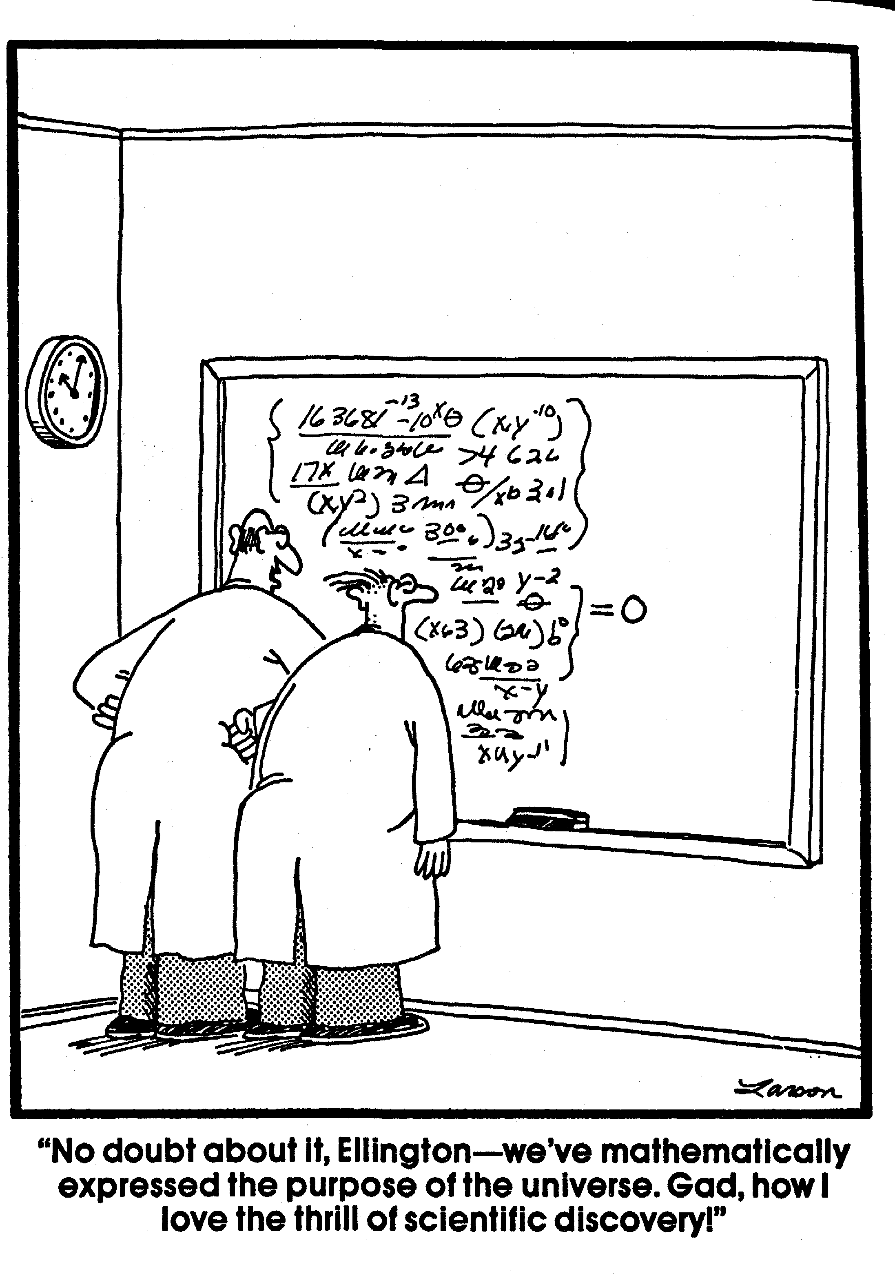

THE FAR SIDE © FARWORKS, INC. Used by permission of UNIVERSAL PRESS SYNDICATE. All rights reserved.