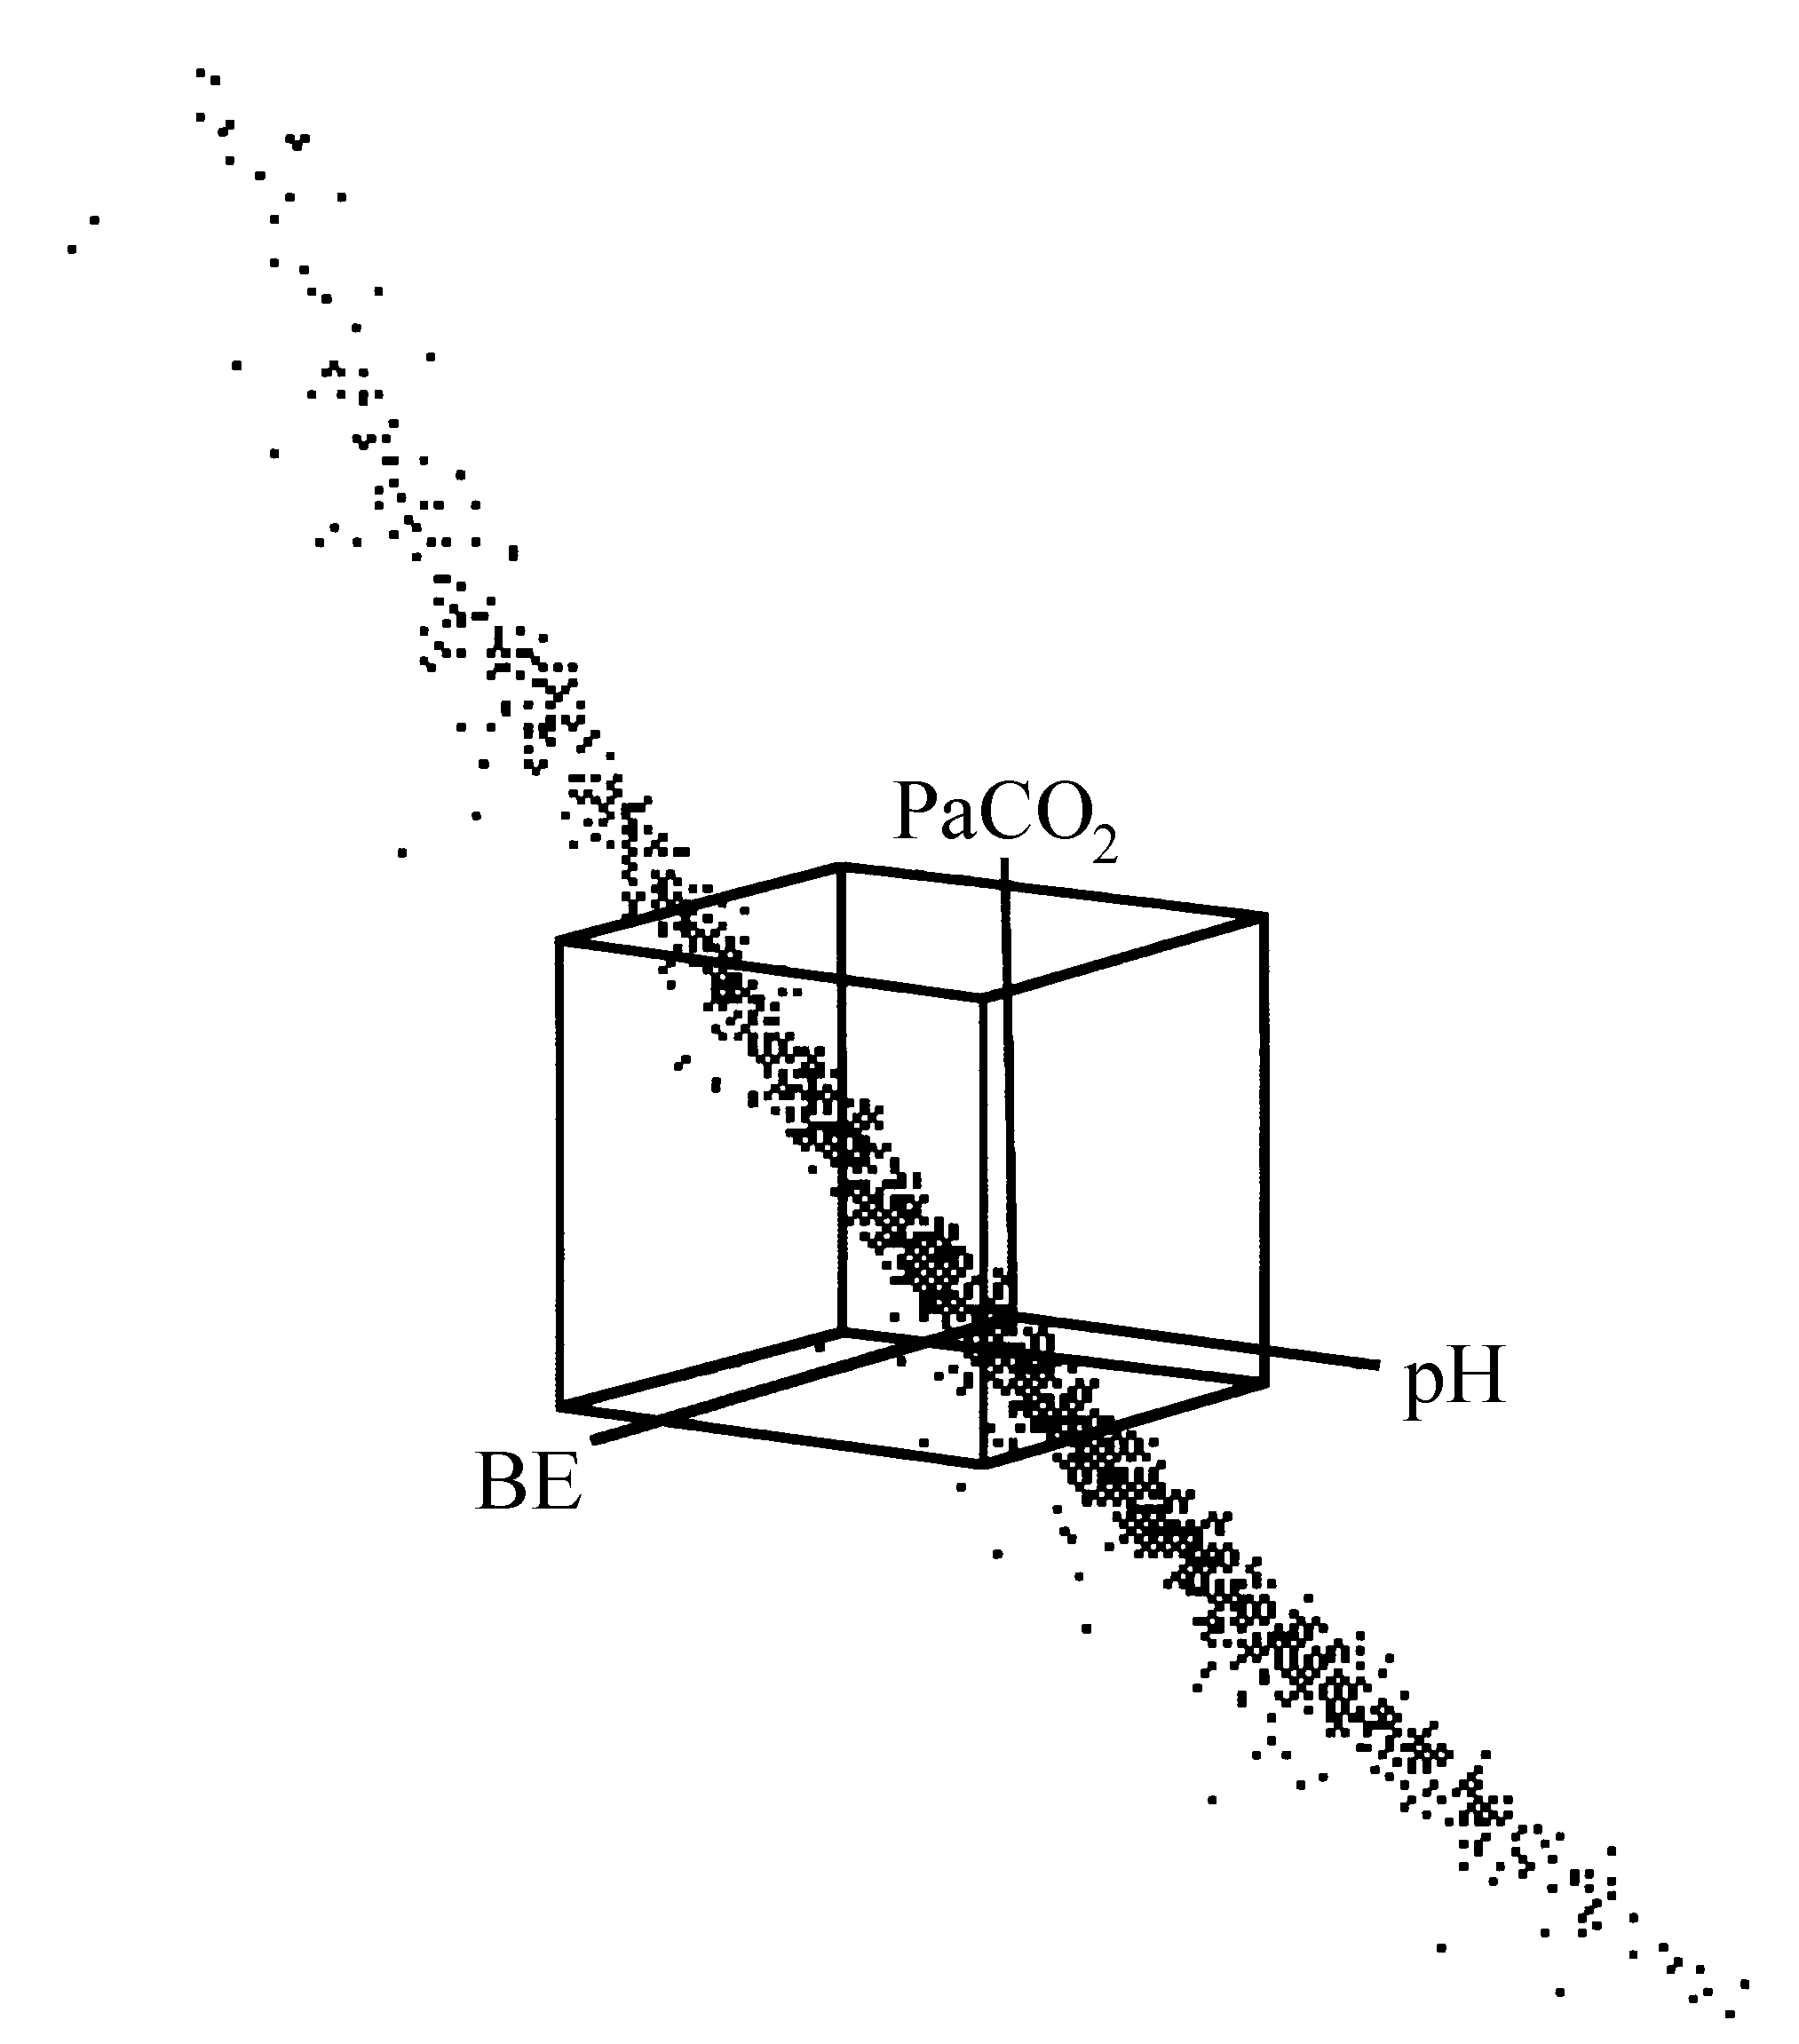

Figure 2–1. Three-dimensional view of a rotated pH, PaCO2 and base excess (BE) data set. The cube represents the 95% reference volume as defined by the 95% univariate reference intervals of Error: Reference source not found.

igure 2–2. Projections of the 1500 acid-base observations on the plane spanned by the fir



Figure 2–3. Box-whisker plots as a function of the distance from the mean in the PC1-PC2 plane for data set OLVGbe. SDS stands for ‘standard deviation score’.



Figure 2–4. Box-whisker plots as a function of the distance from the mean in the PC1-PC2 plane for data set OLVGab.



Figure 2–5. Histogram and normal probability plot of the 1500 third principal component values (PC3) of the OLVGab data set.



Figure 2–6. Histogram and normal probability plot of the 1500 third principal component values (PC3) of the ELIab data set.